

Assessment 1
Blogging to communicate

Programme: BA Business and Management
Module: Marketing Fundamentals
Module Code; LCBB4004
Student: Marieta Marinova
Student ID: 2217644
Lecturer: Tushara Balendran

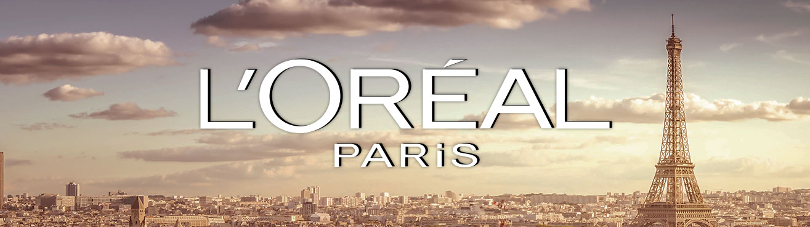

BLOG

By Marieta Marinova

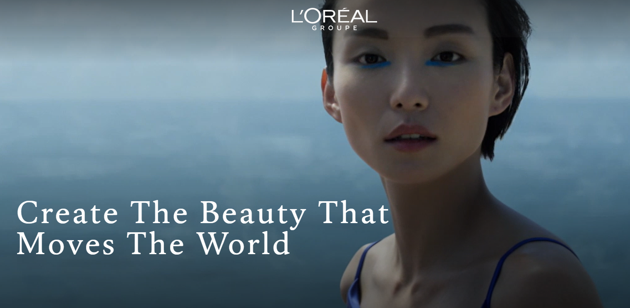

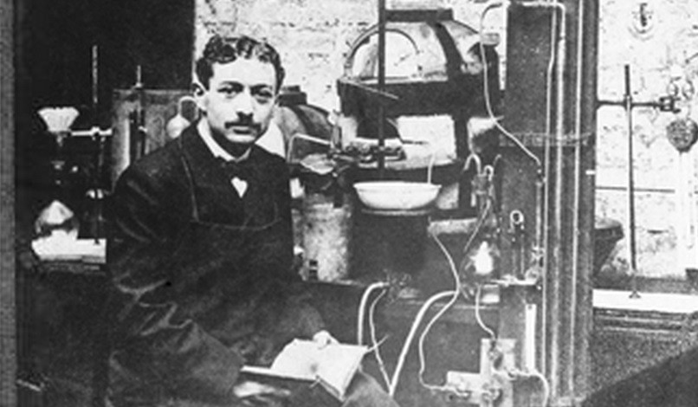
Eugene Paul Louis Schueller (1881-1957)
The year is 1909 when un a young chemist on his way to becoming the funder of the L’Oreal Group. Everything started with his formula for one of the first hair dyes he assembled and sold to hairdressers in Paris.
According to Loreal’s heritage, its founder Eugene Schuller was born in Paris, France, on 20 March 1881 and identified as “The poor pastry boy” who created an Empire. The son of two hard-working pastry shop owners, he was growing up to be an ambitious and successful young man with top grades in all his classes. Still, he also put much effort into the same time studying and got up early to help his parents prepare the pastries every day. After his baccalaureate degree, Eugene studied for two years; in 1900, he joined the Institute of Applied Chemistry. Moreover, he succeeded excellently and finished first in his class. In 1904 after his graduation. Eugene took a position as a laboratory assistant until, one day, his laboratory was visited by the owner of a large barbershop
who hunted to help develop a safe synthetic product for women to dye their hair. Schueller agreed to help and work for the barber as an excellent opportunity to become a Barber’s technical advisor. Eugene soon realised he deserved more and didn’t want to depend on anybody’s orders, so he left that business very soon.

L’OREAL in 1909
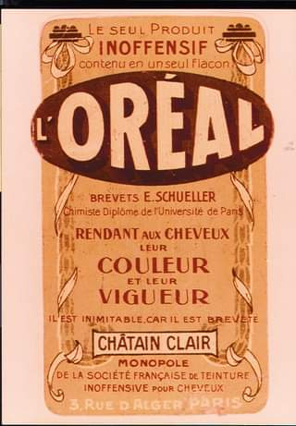
The ambitious young Schueller began experimenting with developing hair dye; at that period, hair dyes were not widely used because is considered toxic by French women. After two years of testing even on himself and exploring many disappointments, he created a product with good quality that is safe for use. He founded his own company that he named “The Societe Francaise De Teintures, Inoffensives Pour Cheveux”, which means “Safe Hair Dye Company of France.”
The first Loreal Brand name and logo. Because the first name that Eugene chose for his brand was a bit of a mouthful, he soon changed it to “Loreal”, which stands for the combination of two words:
Auriel is a popular hairstyle of that period
Aureole means “Halo.”

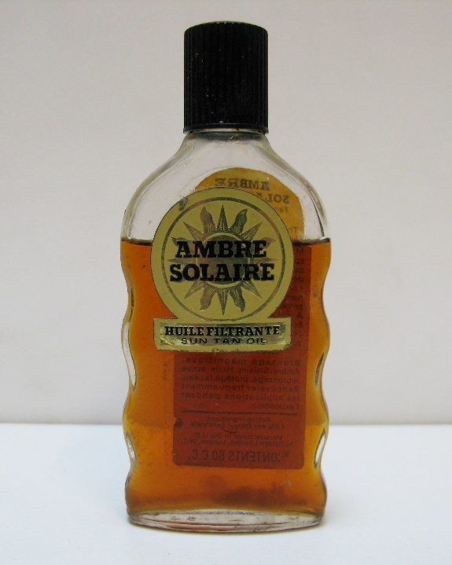
From 1910 the products were sold in Austria and Italy. By 1914, six more markets were added: Hungary, Germany, Belgium, Netherlands, Switzerland and Russia. After the World War, he expanded the distribution market and the variety of his products, from hair lotions to lipsticks and other cosmetic products. Loreal launched the very first sunscreen product, “Ambre Solaire.”

LOREAL’S PRODUCTS AND PACKAGING
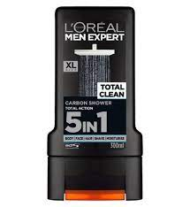
Nowadays, Loreal is a well-known company that tries to satisfy consumers’ needs by targeting demographic segments such as different ages, gender, lifestyle and social status from middle to upper class. Examples are anti-ageing creams, products for males, females and kids, and many others that Loreal provides.
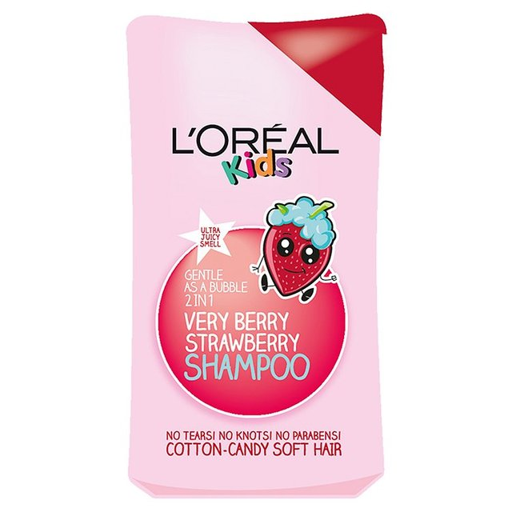
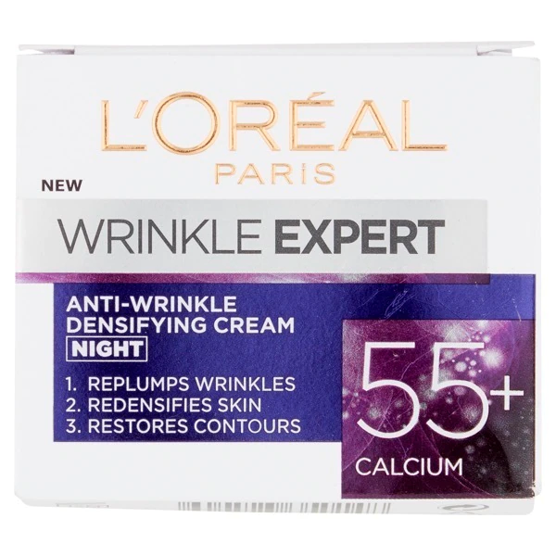
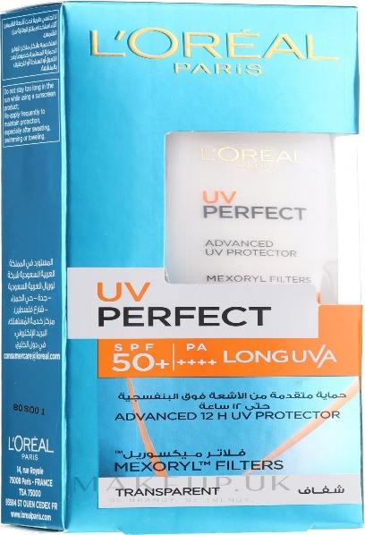
Anti-wrinkle creams for ages 30+, 45+, and 55+, and creams and serums for the young generation provide hydration or help with acne and prone skin.

With various products, Loreal’s sunscreen helps protect the skin in winter and summer with different levels of protection. Loreal’s products also offer cosmetics with SPF factors, such as foundation makeup that provide sun protection, and a variety of shades for different skin types, and a diversity of shades.

In fact, all products from the Elvive series across Europe are 100% recycled plastic.
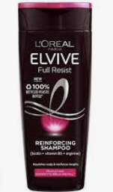
Moreover, the products are cruelty-free, without animal testing since 1989.
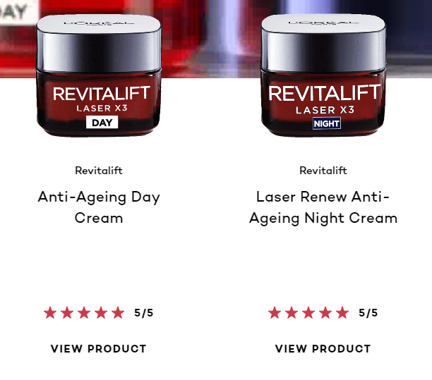
The improvement is upcoming. Currently, not all Loreal packages are recyclable, but according to Loreal’s Plastic and Package Policy, by 2025, all plastic used for packaging will be 50% suitable for recycling and procured from bio sources. In the same way, 100% of the products in plastic packages will be refillable, reducing plastic consumption and protecting the environment.

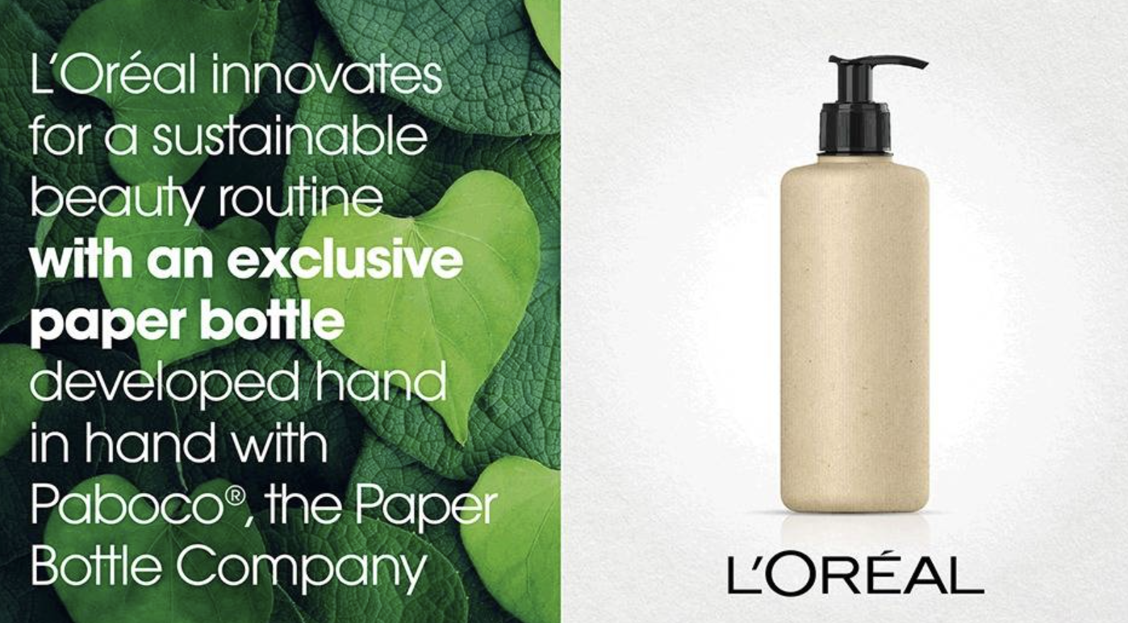
The newest innovation that L’Oreal uses in packaging is the paper bottle.

The design of the packages varies from plastic bottles and paper bottles to their premium quality facial products often come in glass jars and bottles that keep the product last longer. L’Oreal tries its best to preserve the environment. Keeps its products protected and satisfies the customers with high-quality products, save for the user and easy for storage.
Pericycle is a company that produces food-grade PP quality packages, which help to L’Oreal keep good standards in packaging.
LOREAL PRICING

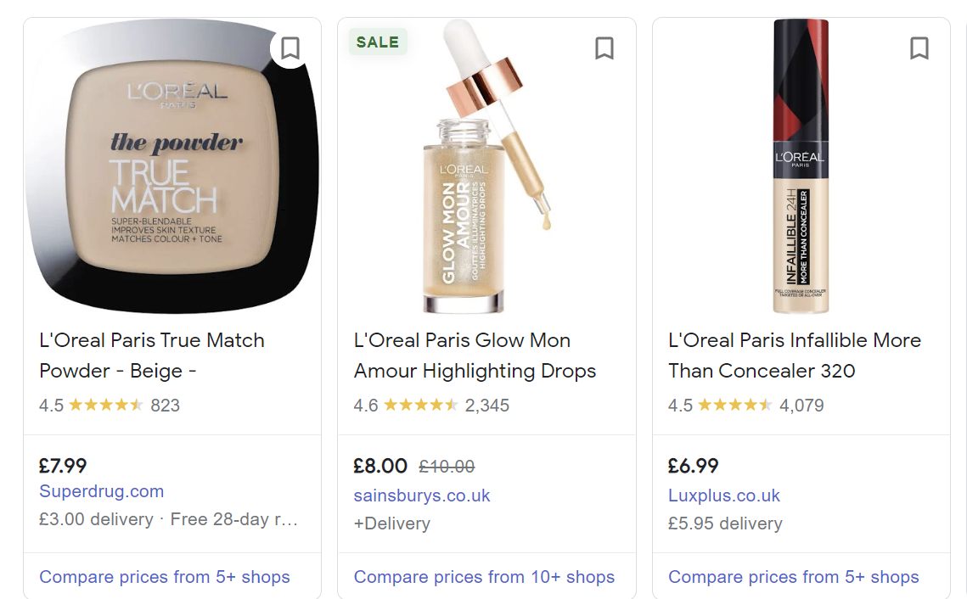
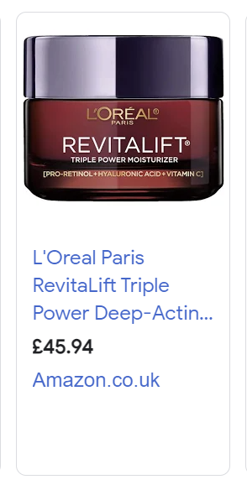
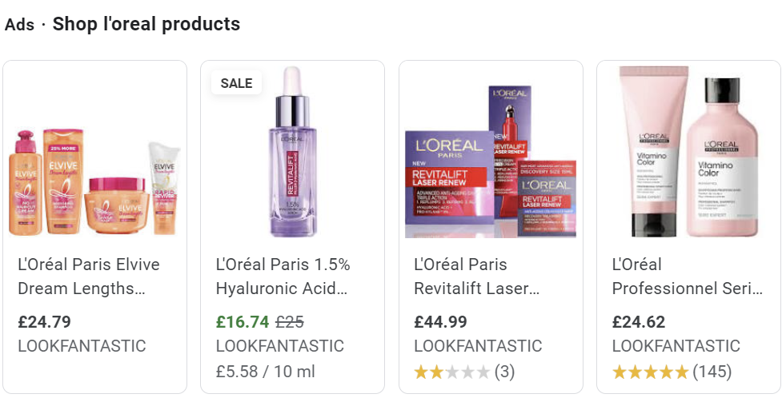
Loreal’s prices vary from facial powder for £7.99 to face creams for £45.94

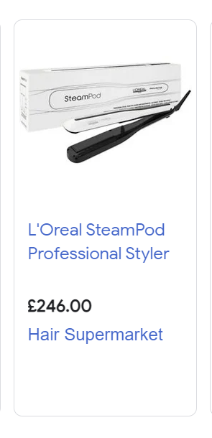

Improving every day to satisfy customer’s needs, Loreal began with hair dye over a century ago. Nowadays the variety is enormous, and one of the latest innovations that the brand put on the market is a hair straightener. The product has a water tank that prevents the hair from burning and damaging, makes the hair look silk and smooth and keeps it hydrated.
L'OREAL PROMOTION
Loreal’s mission is to give customers a chance to show who they are and help them feel comfortable and gain their self-esteem. “Because we are worth it.” The motto that the brand use and the celebrity who said precisely these words is the actress, Eva Longoria.
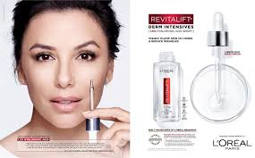
Eva’s face has been very well recognised in Loreal’s advertisements. Famous persons and brand awareness, and what is the connection between them? This is an example of how celebrity bias can influence and reflect a customer’s decision to choose a brand over another. One of the advantages is that superstars can attract attention to the adverts. Another benefit is that sympathy for celebrities can build trust in attracting potential customers. The disadvantage might be a celebrity’s reputation. “Celebrity endorsement” is one of the strategies Loreal uses.

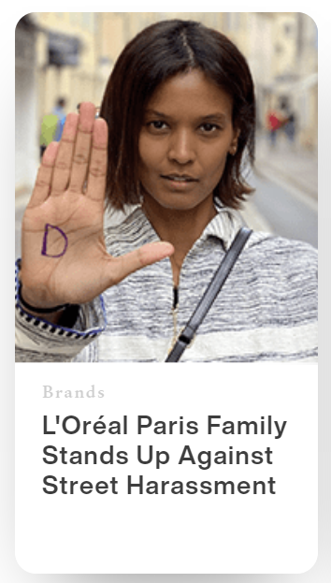
Loreal Group supports people in over 130 countries worldwide against street harassment; Loreal’s mission is to offer men and women the most innovative products and remind them to respect each other.
Loreal participates so many activities, that support empowering people, and businesses and taking care of the environment.

Digital technologies are an invariable part of people’s life nowadays, especially the young generation. So, another space where Loreal promotes the internet platforms and social media such as Instagram, Facebook, Twitter, LinkedIn and YouTube. Access to: Instagram Page: https://www.instagram.com/lorealparis/
Facebook Page: https://www.facebook.com/LOrealParisUK/ Twitter Page: https://twitter.com/lorealgroupe?lang=en
YouTube Page: https://www.youtube.com/channel/UCgmvz6qxtga4W6n1mfmM0Zw
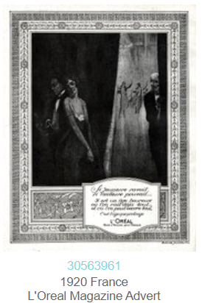
Also, the original Loreal website has so much information provided about the brand, here is a link to Loreal’s web page https://www.loreal.com/en/
Loreal Magazines and Newspapers were extremely popular ten-fifteen years ago before smartphones and technologies have become a daily routine, the company still advertises on television, and in different famous magazines. Sourced by: The Advertising Archives few Loreal Magazines over the years, this is proof of how they are improving. Nowadays is so easy to get access of seeing their products and what they offer via E-mail, television, the internet and social media and magazines.

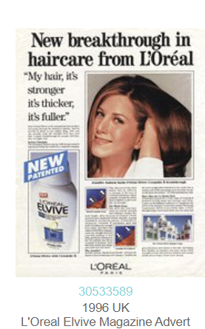
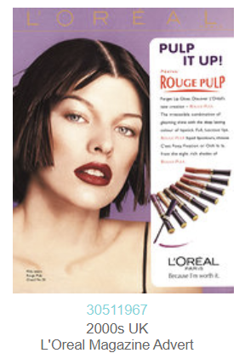
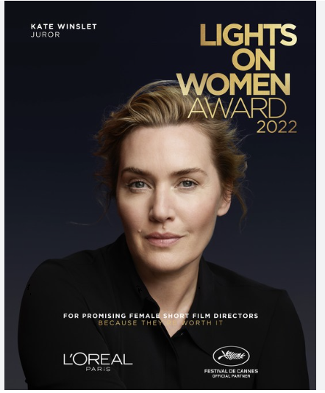
2022
LOREAL LOCATION AND DISTRIBUTION
The brand worldwide available at: Europe, USA, Latin America, Africa, Asia and Middle East.
Loreal providing only E-Commerce for the moment in some countries such as Russia, Turkey, Ukraine and Romania.
The company have located stores in Paris and in many cities where the brand sells its products direct to the customer.
In the cities and counties where the Official Loreal Store is not available, they still distribute. And all products are available in multi-brand retail stores and for example DM, Lilly, Boots etc.
Lorel owns more than thirty other brands, also very well-known brands among which; are Garnier, Maybelline NY, NYX, Mixa and Essie etc. They are available worldwide in multi-brand retail stores and other stores.
Locations of some of the stores where L’Oreal cosmetics are available.

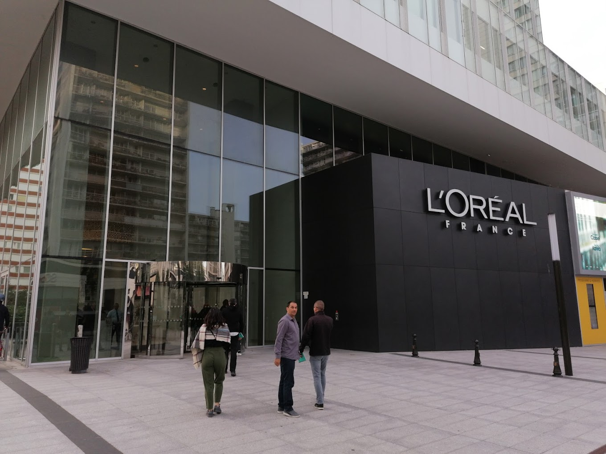
Store located in France 30 Rue d’Alsace, 92300 Levallois-Perret
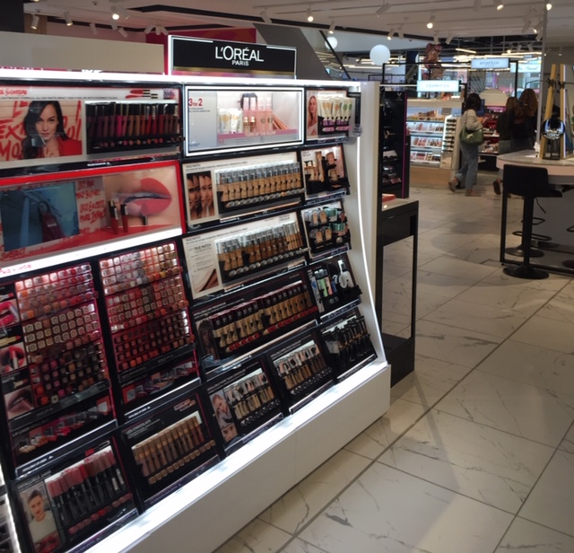
Loreal stands in Boots store in London City, located in Covent Garden just across the tube-station.
Loreal is hybrid in selling and distributing, selling directly to the customers via walk-in stores, supplying the retailers and distributing all around the world. To conclude, the brand is highly available worldwide, and anyone can access its products. Also, the pricing compared to the quality is very good; people from different standards of living from the middle and upper class will have a chance the have Loreal products and experience the excellent products.
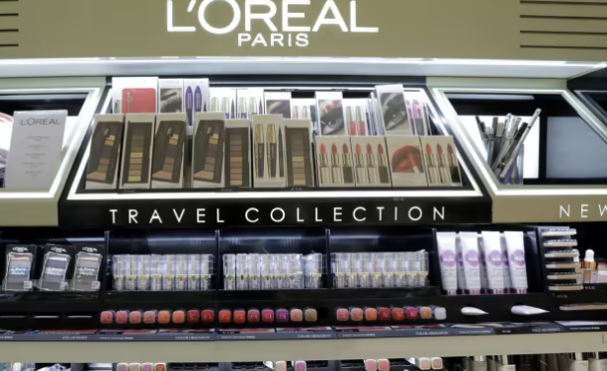
Loreal Products have a vast range of products, no matter where you are or where you there are travel sets of products with a proper size that the flying companies require, for example. These products are available everywhere, especially in Loreal stands at the Airports Duty-free stores.
As a pioneer, L’Oreal has over a century of existence. Successful from any perspective, the company reach what they want, and the main mission is Universalization. The brand is universal, pricing, valuable, and highly available worldwide.

L’Oreal products are available in-store in Kolkata, India.
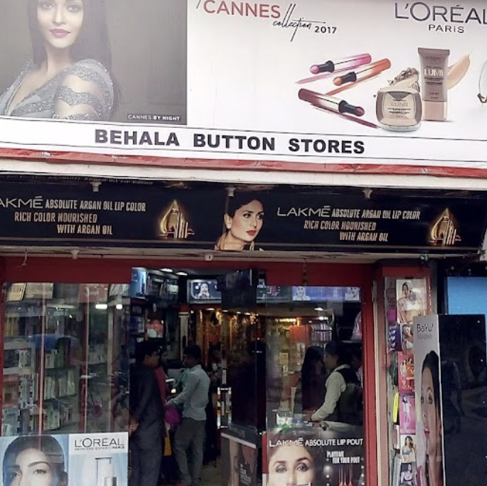

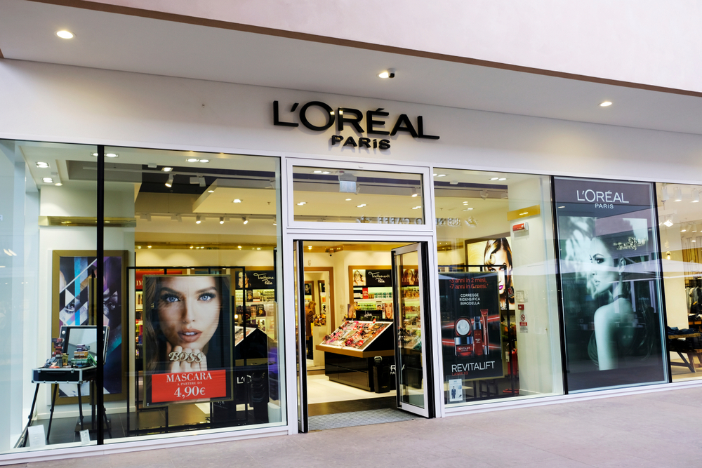
Store location: Bangkok, Thailand

L’Oreal innovations
Loreal offers the customers with online skin consultation, to help them
finding the right product for any specific skin needs.
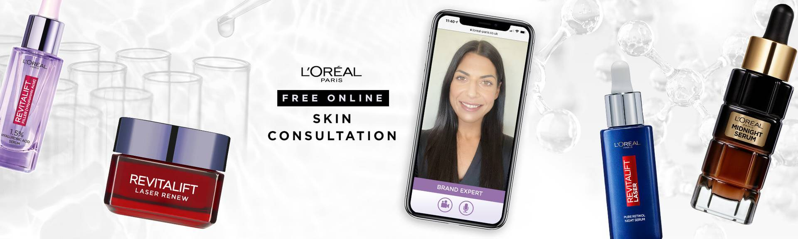

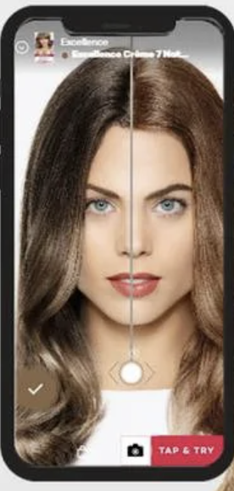

Applications such as Tap and Try, help customers to consider the right hair colour or lipstick.
How does it work? Using the devise camera put virtual colours on the reflection so customers can decide easily what they need.

Reference list
Business Stories (2022) The Poor Pastry Boy Who Invented L’Oréal Paris [video]. Available at: https://www.youtube.com/watch?v=Ix93B1URCMc (Accessed: 13 November 2022).
Loreal Group (2022) Chemist, Entrepreneur, Founder of L’Oréal. Available at: https://www.loreal.com/en/articles/group/visionaries-eugene-schueller/ (Accessed: 13 November 2022).
Loreal Group (2022) Consumer Products Division. Available at: https://www.loreal.com/en/consumer-products-division/ (Accessed: 22 November 2022).
Loreal Group (2022) News/Commitment. Available at: https://www.loreal.com/en/news/commitments/loreals-latest-innovation-for-more-sustainable-packaging-the-paper-bottle/ (Accessed: 23 November 2022).
Loreal Group (2022) Stand Up. Available at: https://www.loreal.com/en/news/brands/loreal-paris-stand-up/ (Accessed: 21 November 2022).
Valdares, B.B. (2022) ‘What is Loreal’s marketing strategy?’, Brenda Valdares [blog]. 21 June. Available at: https://blucactus.blue/what-is-loreals-marketing-strategy/ (Accessed: 21 November 2022).
The advertising archives. (n.d) Sample of ‘Loreal’ Collection. Available at: https://www.advertisingarchives.co.uk/?service=category&action=show_content_page&language=en&category=31 (Accessed: 24 November 2022)
Loreal Finance (2020) Loreal worldwide. Available at: https://www.loreal-finance.com/eng/other/loreal-worldwide#:~:text=In%202019%2C%20LOr%C3%A9al%20confirmed%20its,Europe%20and%20Africa%2C%20Middle%20East. (Accessed: 24 November 2022).
Loreal Group (2022) For the planet. Available at: https://www.loreal.com/en/commitments-and-responsibilities/for-the-planet/ (Accessed: 23 November 2022).
Retail in Assia (2021) ‘Loreal announces financial results’. Available at: https://retailinasia.com/in-trends/loreal-announces-financial-results/ (Accessed: 24 November 2022).
Loreal Paris (2022) Virtual try on. Available at: https://www.loreal-paris.co.uk/virtual-try-on (Accessed: 24 November 2022).
Loreal Paris (2022) Makeup, Skincare etc. Available at: https://www.loreal-paris.co.uk/ (Accessed: 24 November 2022).

