Research Methods & Data Analysis

Data Analysis

Lee Joseph
P097298

2019
Lee Joseph (P097298)
Data Analysis
1/9/2019
Contents
Introduction 3
Research study 3
Hypothesis 4
Investigation, Data Analysis, Tools and Techniques 4
Frequency Distributions 4
Descriptive Statistics 7
Measures of central tendency 7
Measures of Variability 8
T-Test 10
Outliers – The Grubbs Test 11
Identified Factors 13
Conclusion 13
Bibliography 15

Table of Figures
Figure 1: Data set 3
Figure 2: Hypothesis 4
Figure 3: Ordered Data Set 4
Figure 4: Frequency Distribution 5
Figure 5: Mature Students Tally 5
Figure 6: Young Students Tally 5
Figure 7: Mature Students Negatively Skewed 6
Figure 8: Mature Students Negatively Skewed (2) 6
Figure 9: Young Students Bimodal Distribution 6
Figure 10: Young Students Bimodal Distribution (2) 7
Figure 11: Mean, median, mode Chart 7
Figure 12: Measures of Central Tendency 8
Figure 13: Measures of Variability 8
Figure 14: Measures of Variability (2) 9
Figure 15: Complete table of Descriptive Statistics 9
Figure 16: Hypothesis 10
Figure 17: T-Test P = 0.10 10
Figure 18: T-Test P = 0.01 10
Figure 19: T-Test P = 0.02 11
Figure 20: Mature Students Grubs Table 11
Figure 21:Young Students Grubs Table 12
Figure 22: Mature Students Gcrt = 2.29 12
Figure 23: Mature Students Gcrt = 2.41 12
Figure 24: Young Students Gcrt = 2.29 13
Figure 25: Mature Students Gcrt = 2.41 13

Introduction

Statistical thinking is the concept or process of the involvement of dealing with multiple measurements [1] providing the opportunity to analyse and gain an understanding of the information or data that has been collected [2] . Statistics started from when humans were able to count and recognise the need and measurement of these numbers. Numbers soon evolved within the spoken languages to have a requirement and identification of outcomes. This implementation started around the 17th Century, where population data was first starting to be collected. From these first collected data sets, scientists moved forward to create tools to answer certain questions about the newly gathered data sets, such as Francis Galton who implemented a correlation coefficient tool to study and investigate the nature of human intelligence. From the early 20th century testing on averages and groups for example advanced, and to date, the many early tools have evolved to more sophisticated tools and techniques to explore data and assist in statistical investigations [2], to cover various levels of complexity and provide an understanding of thus data including the ability of providing simple visual representations of the data.

Research study

A research study has been completed which investigated the differences of mature and younger students in relation to their university experiences satisfactions. This study was concentrated on a total of 20 students evenly divided between the categories of mature and young students. The following investigation will help to provide an understanding to the data set and assist in identifying if there is a significant difference between the two categories.
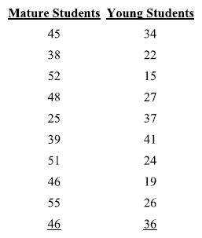
Figure 1: Data set

Hypothesis
In order to progress through the investigation, a hypothesis is required to demonstrate the interest in finding the truth around the hypothesis, for example finding how particular groups differ from each other in a particular way [3]. Particular statistic procedures are followed to test the hypothesis although it is distinctively difficult to prove a hypothesis is true, It is viewed that implementing statistical techniques are more beneficial to provide a view and prove that a hypothesis is incorrect or false[3].
In relation to this research study the following hypothesis has been created. The null hypothesis defined by H_{o} is that age does not affect university satisfaction scores, where the alternative hypothesis defined by H₁ is that age does affect the university satisfaction scores, where $µ_{0}$ is representing Mature students and $µ_{1}$ is representing young students.
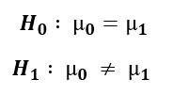
Figure 2: Hypothesis

Investigation, Data Analysis, Tools and Techniques
The following sections of this report identify the techniques used to analyse the data set.

Frequency Distributions
As Frederick L. Coolidge identifies, Frequency distributions are seen as the most important technique to provide a basic graphical representation of a given data set[4]. The first task of the analysis of the given data set is to order the data accordingly to gain the ability of displaying the data via the implementation of a frequency distribution. The first task is to order the data sets from the smallest values through to the highest values.
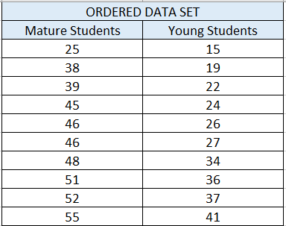
Figure 3: Ordered Data Set
From the ordered data set and to complete a frequency distribution, the Range, No of classes and the class interval/width is required to be calculated.
The Range (R) = the max score minus the min score[5].
The No of Classes is chosen to be that of K = 7
The class width (W) = The Range (R) / The No of Classes (K)[5].
The class width for the mature students is W = 30 / 7 = 4.285714286.
The class width for the young students is W = 26 / 7 = 3.714285714.
Once the class width has been calculated these figures are then required to be rounded up to the next whole number, where as J Armand identifies that this method of rounding up, does not follow the usual rules of rounding up numbers[6]. The Class width for mature students is W = 5 and the class width for younger students is W = 4. All results can be seen below in figure 3.

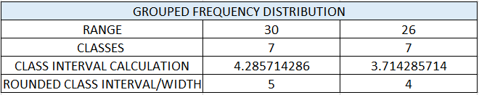
Figure 4: Frequency Distribution
Once the frequency calculations have been completed a frequency distribution chart is completed via the method of using a tally system, which assists to provide a visual representation of the tally.
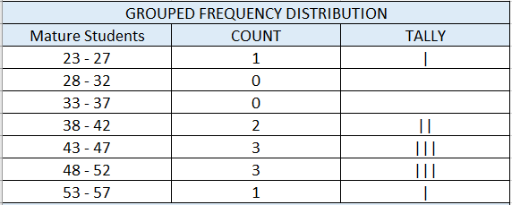
Figure 5: Mature Students Tally
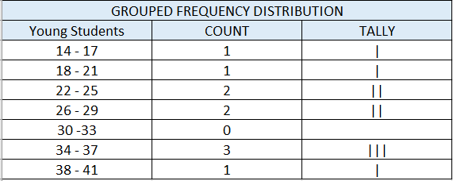
Figure 6: Young Students Tally
From the use of the frequency distribution charts, the frequency distribution diagrams can then be implemented.
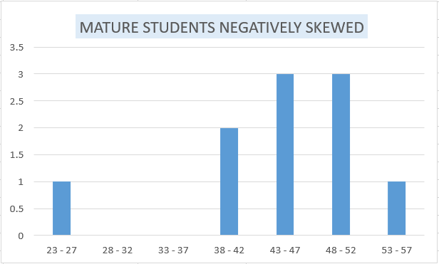
Figure 7: Mature Students Negatively Skewed
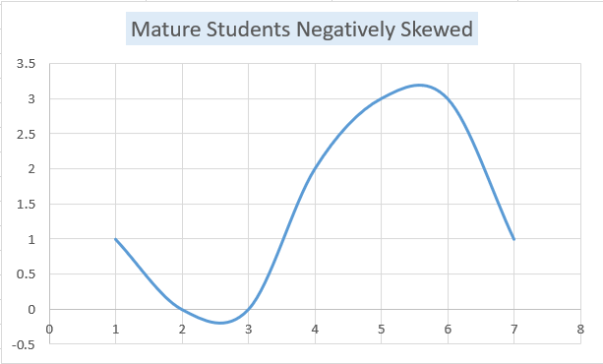
Figure 8: Mature Students Negatively Skewed (2)
From figures 6 & 7, the Mature students are seen to be negatively skewed where the scores are mainly being discovered above the mean[7].
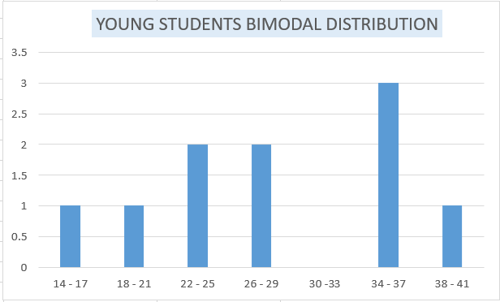
Figure 9: Young Students Bimodal Distribution
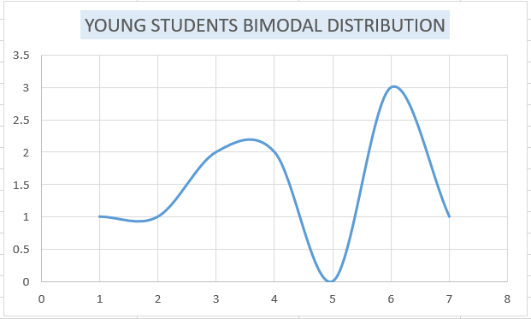
Figure 10: Young Students Bimodal Distribution (2)
From figures 8 & 9, the young students are seen to be bimodally distributed, where the distribution has two modes or two peaks[8].

Descriptive Statistics

Measures of central tendency
The measure of central tendency is implemented to assist in summarising the measures of the data set providing a numeric description. Central tendency is compiled of up to four commonly used measures[9], although for the nature of the given data set the following will be used:
- Mean: The average of the data set [9]
- Median: The given middle value of the data set [9]
- Mode: The most frequently occurring value of the data set [9]

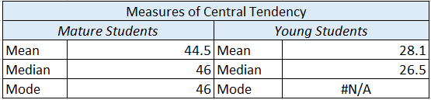
Figure 11: Mean, median, mode Chart

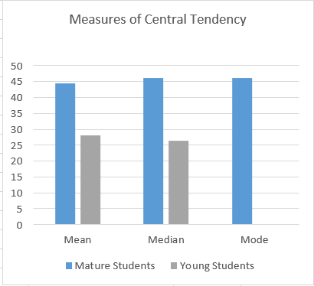
Figure 12: Measures of Central Tendency
From the measures of central tendency, figure 10 has been created to assist in providing a more visual aid to the data. From figure 10, it is observed that the mature students have a significantly higher mean, median and mode from that of the young students, where the young students do not have any mode at all.

Measures of Variability
The measures of variability provide a view of the differences of a data set, where an estimate is provided of how the data set is spread out or even how it is clustered together. Measures of variability are:
- Range: Highest – the lowest score[8]
- Variance: mean of squares of deviation scores[8]
- Standard Deviation: square root of the variance[8]

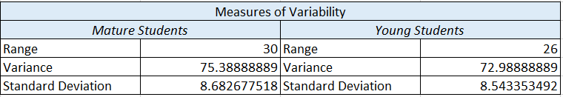
Figure 13: Measures of Variability
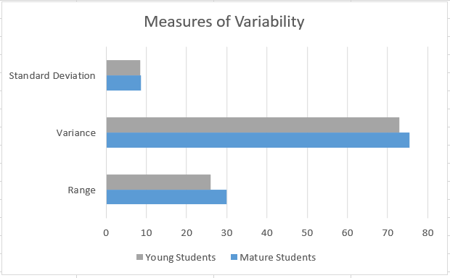
Figure 14: Measures of Variability (2)
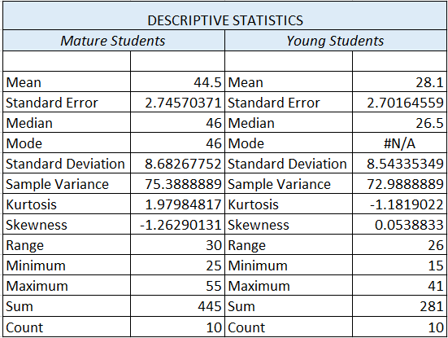
Figure 15: Complete table of Descriptive Statistics

T-Test
The t-test or two sample test is implemented to assist in the identification on whether the means of populations are different. The t-test is focussed on using small data sets[10].
Referring to the hypothesis stated:
Figure 16: Hypothesis
The creation of this hypothesis is in the view of implementing a one-tailed t-test[9], where the difference is viewed on which direction or how µ_{Mature} is larger or smaller than µ_{Young.}
The test will be completed using 3 separate levels of significance:
- P = 0.10
- P = 0.01
- P = 0.02
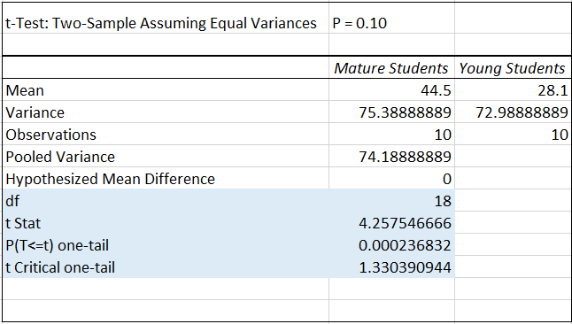
Figure 17: T-Test P = 0.10
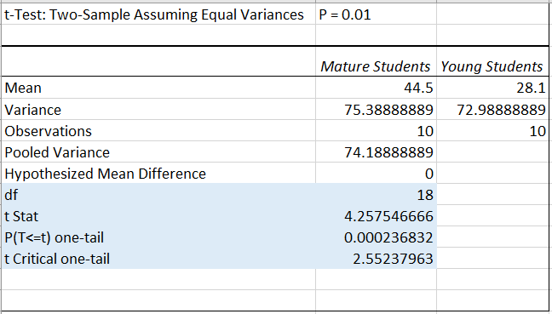
Figure 18: T-Test P = 0.01

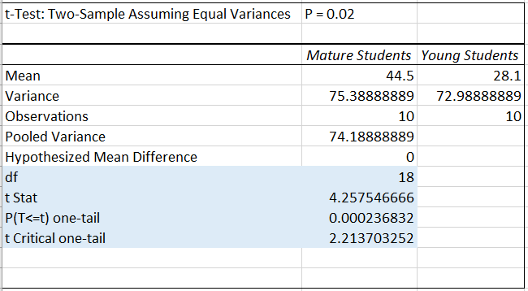
Figure 19: T-Test P = 0.02

Outliers – The Grubbs Test
An outlier within a dataset is an identified value that is not and should not be a part of the dataset. Should any outliers be a part of a dataset, the process of analysing the dataset will be affected in relation to calculating the population mean and standard deviation. The outliers should be removed from the datasets to continue with the accurate data analysis process.
Any identified outliers should be noted and included within a data analysis report, A Rankit plot can assist in the representation of the outliers. The method to identify outliers within a given data set recommended by the International Organisation for Standardisation is the Grubbs test[11].
The Grubbs test is implemented to identify any outliers that are within the given data sets[12].
Two separate Grubbs tests were conducted on both the Mature and Young students data sets.
Using both a 97.5% confidence level with the G_{crt} = 2.29 along with a 99% confidence level with the G_{crt} = 2.41. All four tests did not identify any outliers within the given datasets, as identified in figures 22,23,24,25 below. The Grubs calculations can be seen in figures 20 & 21.
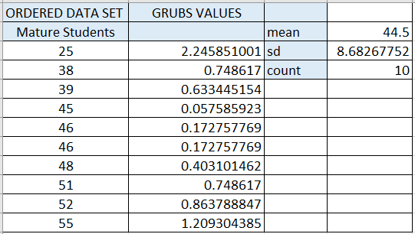
Figure 20: Mature Students Grubs Table
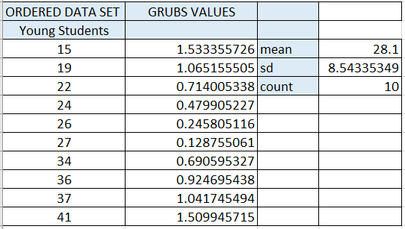
Figure 21:Young Students Grubs Table
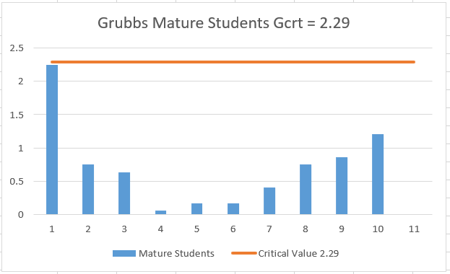
Figure 22: Mature Students Gcrt = 2.29
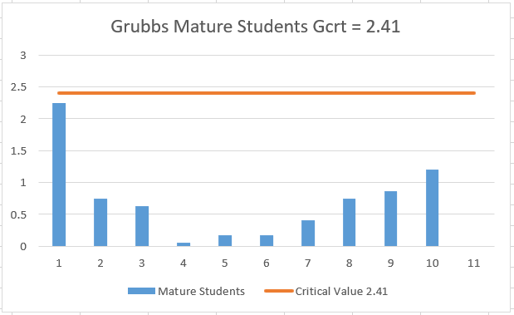
Figure 23: Mature Students Gcrt = 2.41
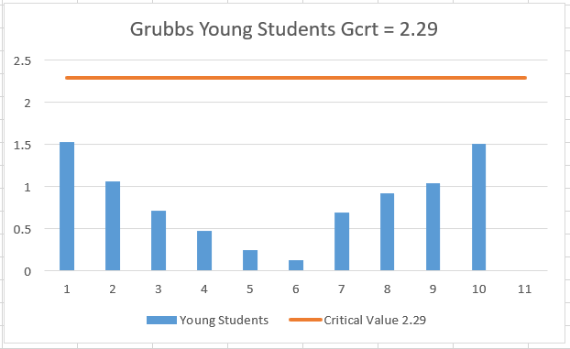
Figure 24: Young Students Gcrt = 2.29
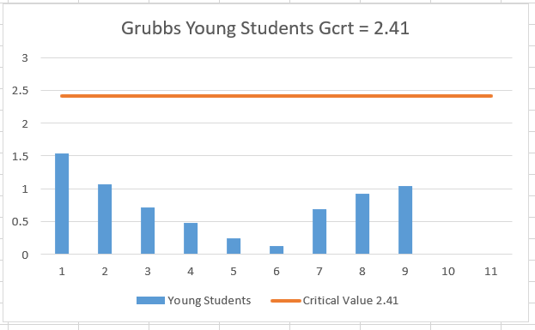
Figure 25: Mature Students Gcrt = 2.41

Identified Factors
The following factors have been identified which is viewed that can affect the current or future results
- Data set could be larger to provide more in-depth analysis with the use of a Z-Test
- There is no indication on consistency of variable such as courses being taken, difference of lecturers delivering the content along with what different assessment types are being implemented i.e. exams assignments etc.
- No indication of exact age brackets separating the mature & young student groups

Conclusion
From reviewing the results of the completed data analysis techniques, T_{opt} is greater than the T_{crt} where the P(T<=t) value falls at 0.000236832 consistently, which provides the low probability that these differences have appeared by chance, thus providing a statistically significant difference within the data set.
Due to this the null hypothesis is to be rejected, where the alternate hypothesis is to be accepted of that mature students have a higher experience satisfaction level than that of young students. This is also identified with the mean of the mature students being 44.5 and younger students being 28.1 with a total difference of 16.4.

Bibliography

[1] J. L. Phillips, How To Think About statistics, Sixth Edit. New York: W.H.Freeman and Company, 2000.
[2] N. J. Salkind, Statistics for People Who Think They Hate Statistics, Fith Editi. Los Angeles: Sage, 2014.
[3] J. H. Kranzler, Statistics For The Terrified, Sixth Edit. London: Rowman & Littlefield, 2018.
[4] F. L. Coolidge, Statistics A Gentle Introduction, First. London: SAGE Puublications, 2000.
[5] M. J. Kiemele, S. R. Schmidt, and R. J. Berdine, Basic statistics Tools For Continuous Improvement, First. Colorado Springs, Colo.: Air Academy Press, 2000.
[6] J. Armand, “SCIENCING: How Do I Calculate Class Width,” 2018. [Online]. Available: https://sciencing.com/do-calculate-class-width-8516043.html. [Accessed: 03-Jan-2019].
[7] F. Clegg, Simple Statistics, First. Cambridge: Cambridge Univ. Press, 2001.
[8] J. H. Kranzler, Statistics for the Terrified, Fourth Edi. Hemel Hempstead: Prentice-Hall, 2009.
[9] M. C. Fleming and J. G. Nellis, Principles of Applied Statistics, Second. Wiltshire: South-Western Cengage Learning, 2000.
[10] D. Rumsey, Intermediate Statistics for Dummies, First. Hoboken: Wiley Publishing Inc, 2007.
[11] D. B. Hibbert and J. J. Gooding, Data Analysis for Chemistry: An Introductory Guide for Students and Laboratory Scientists, First. New York: Oxford University Press, USA, 2006.
[12] J. K. Taylor and C. Cihon, Statistical Techniques for Data Analysis, Second. CRC Press, 2004.

