STUDENT NAME: Steluta Pascuta
Student Code: 1816339
Lecturer: Abdi Rahman
Module Title: Personnel Resourcing Development



Table of contents
1. Introduction…………………………………………………………………….page 3/9
2. Task 1…………………………………………………………………………..page 3-4/9
3. Task 2……………………………………………………………………………..page 5/9
4. Task 3……………………………………………………………………………..page 6/9
5. Task 4 ……………………………………………………………………………..page7/9
6. Conclusion……………………………………………………………………….page 8/9
7. References ……………………………………………………………….……page 9/9

Introduction
The purpose of this report is to prove a critical understanding of the organizational and business industry, in which professional employees work. Next to that throughout the assignment there will be described internal and external factors that are influencing the recruitment process, the selection process, the socialisation process, performing and also factors that influencing employees to work above targets. Some aspects that will be analysed in the assignments are things such as the P.E.S.T.L.E technique, the HRM functions such as the recruitment and the selection process, the factors that are influencing the diversity, culture and equality in a business environments and one last thing that is going to be discussed has to do with the techniques and procedures that are used in order to push employees forward to working harder and harder at the workplace.
In addition to the theoretical aspects that are about to be introduced in the assignment, all of the mentioned aspects will be related to the Genting Hotel Birmingham, which a luxury hotel locate next to Resort World Arena which is very close to the airport.
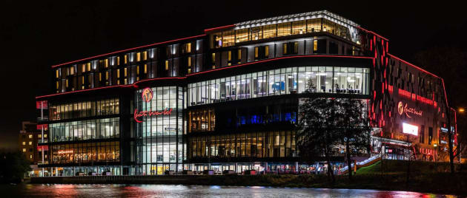

TASK 1- PESTLE technique.
PESTLE stay for the abbreviation of the external factors political, economic, social, technologic, legal and environmental.
The PESTLE analysis allows the managers team to notice the most important macroeconomic factors that are influence the way that the business will develop in the future. However, the PESTLE analysis is very useful in many industries and environments including the hospitality industry and this because using this analysis the people overseeing the economic area of the hotel as well as the marketing section will notice how it is developing and what are the weaknesses affecting the economic development in the environment
Travel and hospitality industry are very much affected by political, social and economic factors (Qiu& Zhang 1995) Thinking about the Genting hotel the pestle analysis is based on:
Political Factors- because it is an international hotel it has multiple political factors that could influence the hotel negatively. One factor being UK and London leading in Europe, when the hospitality industry was considered as being one of the main factors influencing the Economy of the country. However, people use to say that Brexit is one of the biggest issues related to the hospitality industry, however in accordance to what Robin Rossmann (2015) said, “Brexit is only one of many factors weighing on the future of the hospitality industry”
Economic Factors- the economic factors are the factors that are related to the goods, services and money and it is very important that the administrative team has all the costs under control because otherwise it could be really bad for the hotel (Thomas Bush 2016). In the Genting hotel, their economic state is currently very good and this because they tend to maintain a balance.
Social Factors- are easy to notice in a hotel like Genting hotel and this because it is visited by plenty of people from all ages and regarding to the fact that the hotel is next to the airport and the arena. However, the social factors are factors such as: lifestyles, education level, sex orientation, the income level (PESTLEanalysis Contributor)
Technological factors-are one of the most important and this because it is continuously improving, and the Genting hotel needs to catch the step-in order to avoid unsatisfying guests. Therefore, that modern technology is very much used internal because the employees could easily have access to
Legal Factors- legislative policies such as data protection, health and safety, risk management are just some examples of the legislative policies that are influencing the hotel overall and this because there are legal procedures that need to be followed all the time in order to ensure that the hotel is running safely.
Environmental factors- are also called ecological factors and usually there are factors such as: the change of climate, the recycling, and the availability of energy… The environmental factors are highly affecting the willingness of a guest to buy something, for example, who needs heaters in when there is a nice weather.


The recruitment processes
“Recruitment is the process of attracting, monitoring, selecting and onboarding a qualified person suitable for the job” (Anshuman Sahaya 2017). However, the recruitment processes have changes a lot over the years and this because of the large amount of qualified and experienced people

The recruitment process is following few stages, these stages are: identifying the hiring need, devise a recruitment plan, write a job description, advertise the position, recruit the position, review applications, hold interviews, applicant assessment, background check, decision, reference check, decision, reference check, job offer, hiring. The mentioned steps are essential in the process and this because using this you have the more credibility of the people that are coming to you for the job.
Effectiveness of the recruitment process:
The recruitment process is effective, but to make it even more effective the ones in charge of the recruitment process must: ¬Look internally before externally- which means that the employers must firstly look at existent employees and see if there could be someone to fit perfectly on the position that you have to offer and if not then to look for the external people looking for jobs
¬Hire the sure “thing”- this meaning that the employers are suggested to pick the candidate that is already working in the job industry that is offered.

The selection process
Selection is the process of choosing the applicants that are fitting the most for the job position that is offered. It the process during which applicants are being interviewed and during which the employers are testing their abilities and skills once with their knowledge in the industry (Recruitment and Selection 2016)
As in the recruitment process, the selection process has some essential steps to follow as well: ¬Preliminary Interviews
¬Checking references
¬Medical Examinations
¬Final Approval
¬Evaluation of the Selection Programme
¬Final Selection
¬Blank application
¬Record each application
¬Selection Tests
¬Selection Interview

Therefore, the selection process is more than effective and this because it gives to the employer the opportunity to choose the applicants that fit the most for the job position. The person that fir the most would be someone that already has the experience for the job which has been accumulated from previous work experience. As Barbar (1998) said “To make the selection process effective there is the aim of generating a large pool of candidates and after that the aim of choosing the best ones out of them”
Factors affecting equality in Genting Hotel
Equality is one of the most important aspects in a business and this because “delivering workplace quality makes good business sense” (Lazzari Z. 2019), this meaning that everyone must be feeling safe when being in the hotel. The main factors why there are equality issues in most of the hotels (Including Genting Hotel), is because people tend to discriminate people because of their age, race, sexual orientation, gender, pregnancy, disability…, thing that according to the Equality Act 2010 is illegal.
Factors affecting diversity in Genting Hotel
Diversity in the workplace, over the years started to bring advantages to many environment, especially hospitality industry and this because employers started to avoid the culture applicants are coming from, their sexual orientation and all those other factors that used to influence the way diversity is promoted (Give a Grad a Go 2019). However the factors that are affecting diversity are related for example, to the stereotyping in workplace. “Stereotypes most of the times are referring to the overgeneralized expectations and beliefs about the characteristics and traits of social outgroup members” (Fiske 1988), the stereotyping is most of the time focused on age and gender.

Factors affecting the culture in Genting Hotel
The culture the main thing that is describing the personality of the business. Therefore, Culture is the character of the hotel, it is what makes the hotel unique” (ERC 2019). When it comes to the factors affecting the culture in Genting Hotel, the main factors are: Leadership, Management, Workplace practice, policies, people, mission visions and values, the work environment… there are more other factors that are influencing the culture, but the main thing that can prevent in some ways some of the mentioned factors are the employees and the employers as if they are working together to respects all the things that are supporting them to make the environment work in the way it needs it will solve things slowly.
Task 4- Methods to apprise the Performance Management
The constant apprise matters a lot in all business environments including the hospitality industries and this because “the employee performance improvement helps to boost employee productivity and bring advantages in the hotel” (Kiss flow 2019). There are five modern methods that can be used to improve the productivity of employees. The five methods are:
- Management by objectiveness (MBO) - employee and managers are identifying, plan, organize and communicate goals, all together.
- 360-Degree Feedback- within this strategy the employees are holding conversation within the manager once in a year during which they discuss what everyone done ok and what not.
- Assessment Centre Method- In this method the employees are required to take part in activities that are testing their social-related behaviour.
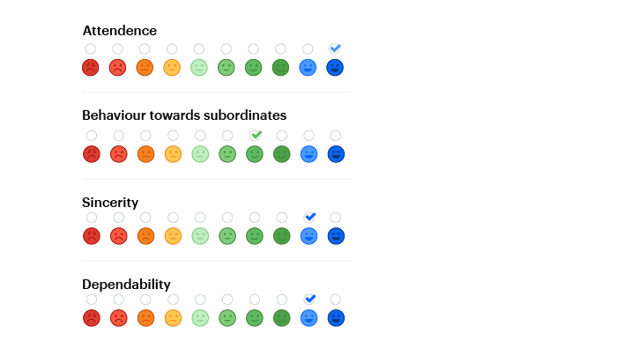
4. Behaviourally Anchored Rating Scales (BARS) - within which the employee’s activities are linked with a specific personality characteristic.

- Psychological Appraisals- this is taking place with the aim of discovering hidden skills and abilities of employees.

Conclusion
As a conclusion to everything that has been said, the Genting hotel is considering all the internal and external factors when managing the hotel. Therefore, all the employees are trying their best to improve their work constantly and to bring advantages at the work place. Next to that, the equality, diversity and culture of the hotel is being promoted. One of the most effective things in the hotel are the selection and recruitment process and this because it allows the employers to choose the ones that are most suitable for the job position that is offered.

REFERENCE PAGE
Barber A.E. (1998), “Personnel Recruitmen”, [available on: http://sk.sagepub.com/books/recruiting-employees, accessed on 02/02/2020]
Bush T. (2015), “Economic Factors affecting business”, [available on: https://pestleanalysis.com/economic-factors-affecting-business/, accessed on 02/02/2020
ERC (2019), “Workplace Culture: What it is, why it matter and how to define it”, [available on: https://www.yourerc.com/blog/post/workplace-culture-what-it-is-why-it-matters-how-to-define-it, accessed on: 05/03/2020]
Fiske, S. T. (1998). Stereotyping, prejudice, and discrimination. In D. T. Gilbert, S. T. Fiske, & G. Lindzey
(Eds.), The handbook of social psychology (4th ed., Vol. 2, pp. 357–393). Boston: McGraw-Hill.
Fiske, S. T. (1998). Stereotyping, prejudice, and discrimination. In D. T. Gilbert, S. T. Fiske, & G. Lindzey
(Eds.), The handbook of social psychology (4th ed., Vol. 2, pp. 357–393). Boston: McGraw-Hill.
Fiske, S. T. (1998). Stereotyping, prejudice, and discrimination. In D. T. Gilbert, S. T. Fiske, & G. Lindzey
(Eds.), The handbook of social psychology (4th ed., Vol. 2, pp. 357–393). Boston: McGraw-Hill.
Fiske, S. T. (1998), “Stereotyping, prejudice, and discrimination”, in D. T. Gilbert, S. T. Fiske, & G. Lindsey (Eds.), the handbook of social psychology (4th ed., Vol. 2, pp. 357–393). Boston: McGraw-Hill [found on: https://emilkirkegaard.dk/en/wp-content/uploads/Todd_D._Nelson_Handbook_of_Prejudice_StereotypiBookos.org_.pdf, accessed on: 05/03/2020]
Give a Grad A go 2019 “What is diversity in the workplace”,[available on: https://www.giveagradago.com/news/2019/08/what-is-diversity-in-the-workplace/424, accessed on: 05/03/2020]
Kissflow 2019 “A definitive guide to employee performance appraisal methods”, [available on: https://kissflow.com/hr-process/performance-management/employee-performance-appraisal-method/, accessed on: 05/03/2020]
PESTLEanalysis Contributor (2015), “Social Factors Affecting Business”, [available on: https://pestleanalysis.com/social-factors-affecting-business/, accessed on: 02/03/2020]
Rossmann R. (2015) “Brexit and the future of the hospitality industry”, [available on: https://www.raconteur.net/business-innovation/brexit-and-the-future-of-the-hospitality-industry, accessed on: 02/03/2020]
Recruitment and selection (2016), “The recruitment and selection processes”, [available on: https://www.tutorialspoint.com/recruitment_and_selection/recruitment_and_selection_tutorial.pdf, accessed on: 03/03/2020]
Lazzari Z. (2019, “Definition of equality in the workplace”, [retried from: https://smallbusiness.chron.com/definition-equality-workplace-14653.html, accessed on 05/03/2020]

