Rubens Malaguti (2501521)
Design and Implementation of a Relational Database System

Table of Contents
Scenario Introduction 2
Task 1 3
Scenario Analysis 3
Entity Relationship Diagram 4
Data Structure Development 5
Validation and Testing 8
Task 2 12
References 13

Scenario Introduction
The EcoRide scheme is an initiative which offers rental bikes for people through public locations such as parks, train stations and university campuses. Riders are able to pick up and drop off bikes from any station. This contributes to greener transport and encourages healthier commuting. Currently, EcoRide relies on paper forms and basic spreadsheets to manage its operations, which leads to mismanagement problems such as booking redundancies, the inability to track bikes, poor visibility into the availability and condition of bikes, and inaccurate rental reports.
The purpose of this assignment is to design and develop a relational database system that will improve the efficiency of EcoRide’s business. A database would allow for the efficient registration of riders, the management of electric bikes, including the type, condition and location of each bike and the maintenance history of each bike, along with the recording of each rental transaction by date and cost, as well as tracking staff involvement for servicing bicycles. Additionally, the database will be developed following industry data modelling techniques, normalised to 3rd normal form (3NF), and will include sample data and practical queries, aiming to improve data integrity, track bike availability, and manage overall operations for EcoRide through this assignment.

Task 1

Scenario Analysis
When looking at the EcoRide electric bike rental scheme, it consists of six main entities: Station, Rider, Bike, Rental, Staff, and Maintenance. This was accomplished by using an established entity-relationship extraction technique based on the assignment requirements specifications.
The Station entity stores all relevant information about physical rental locations, such as StationID (Primary Key), Name, and Capacity. The Rider entity stores user details and contains the following fields: RiderID (Primary Key), Email, and Phone. The Bike entity contains all basic information about bikes and stores the following data: BikeID (Primary Key), Bike type, and Bike condition. It is also connected to the Station entity through the Docks relationship, which is a one-to-many. The Rental entity holds information about each transaction and contains several fields: RentalID (Primary Key), Start Time of rental, and Cost; this is connected to the Riders entity through “Makes” and the Bikes entity through “Used In”, which is a one-to-many relationship. The Staff entity is responsible for managing the bikes' maintenance and contains the following fields: StaffID (Primary Key), FirstName, and Staff Role description. The Maintenance entity stores details of servicing activities and contains several fields, such as MaintenanceID (Primary Key), ServiceDate, and ServiceOutcome. And this is connected to the Bike entity through “Has” and to the Staff entity through “Performs”, which is a one-to-many relationship.
This database structure provides a much more effective tracking of all riders, bikes, rentals, and maintenance, and ensures the integrity of all data associated with the EcoRide electric bike rental scheme when compared to the previous spreadsheet tracking.

Entity Relationship Diagram
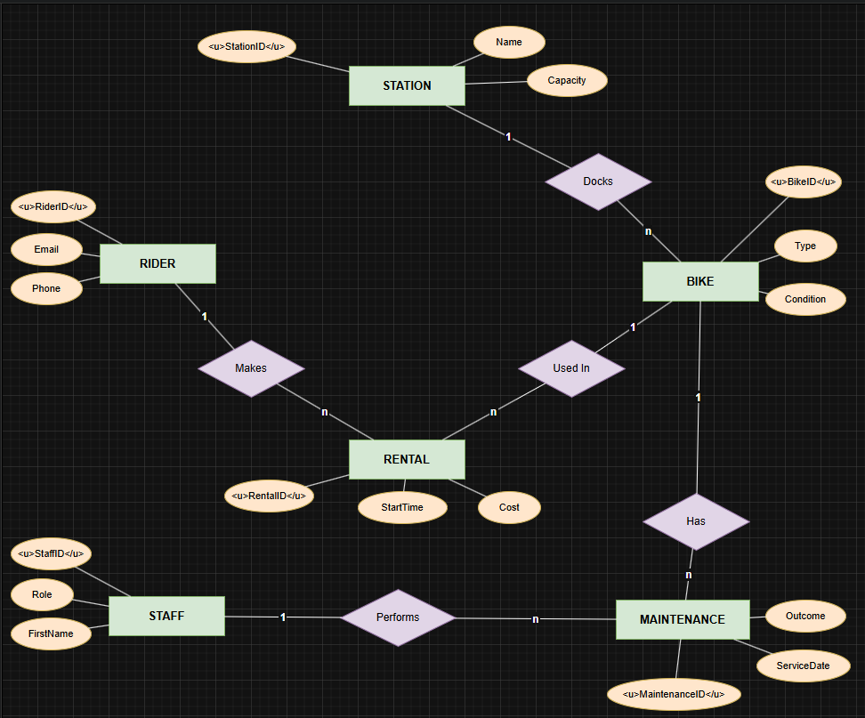
Fig 1 (Entity Relationship Diagram)
The ERD visually identifies and shows the structure of the EcoRide database. The major entities are Stations, Riders, Bikes, Rentals, Staff, and Maintenance, each with attributes and primary keys. The relationships between the entities have been represented in the diagram by showing it as follows, A Station has a Dock which has many Bikes (1:N); many rentals are made by a Rider (1:N); and a Bicycle is used in many rentals (1:N), A Bicycle more than one maintenance record (1:N); and the staff carry out many maintenances (1:N). All relationships are linked with their foreign keys to enforce referential integrity. This ERD serves as the foundation for the relational database design for the EcoRide scheme and meets its operational requirements by providing an efficient means to track bikes, riders, rentals, and maintenance activities [5].

Data Structure Development
The relational database was designed following the entity relationship diagram and was created using Microsoft Access, with 6 normalised tables. As shown in Figure 2 below, refer to the Design View of each table in the ERD. The Station table consists of the following columns: StationID (AutoNumber Primary Key), Name (Short Text), and Capacity (Number).
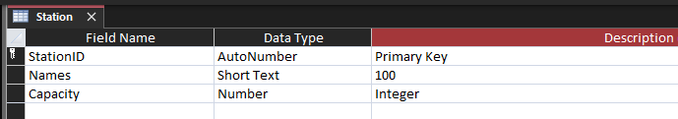
Fig 2 (Station Table Design View)
The Rider table consists of: RiderID (AutoNumber Primary Key), Email (Short Text), and Phone (Short Text).
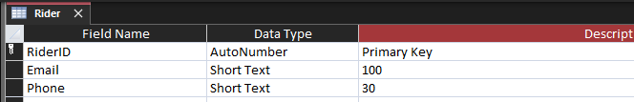
Fig 3 (Rider Table Design View)
The Bike table consists of: BikeID (AutoNumber Primary Key); StationID (Number- Foreign Key to Station), Type (Short Text), and Condition (Short Text).
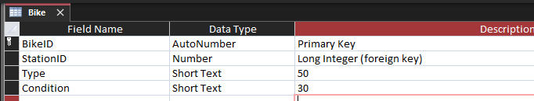
Fig 4 (Bike Table Design View)
The Rental table consists of: RentalID (AutoNumber Primary Key); RiderID (Number - Foreign Key); BikeID (Number - Foreign Key); StartTime (Date/Time); and Cost (Currency).

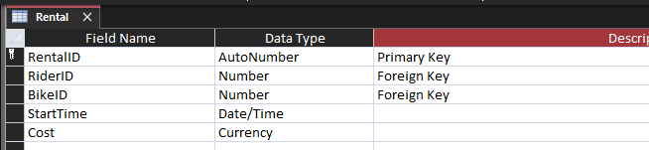
Fig 5 (Rental Table Design View)
The Staff table consists of: StaffID (AutoNumber Primary Key), FirstName (Short Text), and Role (Short Text).
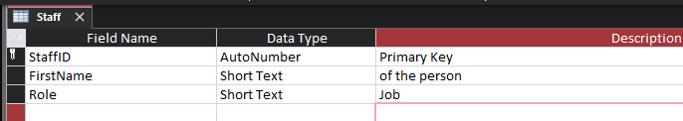
Fig 6 (Staff Table Design View)
The Maintenance table consists of: MaintenanceID (AutoNumber Primary Key); BikeID (Number - Foreign Key); StaffID (Number - Foreign Key); ServiceDate (Date/Time); and Outcome (Short Text).
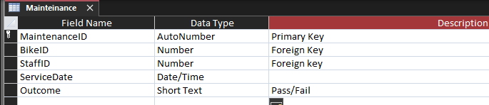
Fig 7 (Maintenance) Table Design View
The primary key uniquely identifies a row in a table, while foreign keys are created with enforced referential integrity and cascade update options to ensure data consistency across related tables [2].

Normalisation Compliance
The development and design of the ECO Ride database were executed in accordance with the Third Normal Form (3NF) to eliminate redundancy and dependency issues.
Step one comprised organising the data into tables in accordance with First Normal Form (1NF). The tables contained no repeating groups. The second step removed all partial dependencies from the database by using Second Normal Form (2NF). Every non-key attribute in each table now depends entirely on the primary key. The last step removed all transitive dependencies from the database by the Third Normal Form (3NF). None of the non-key attributes in any of the tables is dependent on any of the other non-key attributes in the tables.
An example of this normalisation compliance is that “RIDER” contact information is located only in the RIDER table and can be referenced using the RIDER ID in the RENTAL table. Neither the condition nor the location of any BIKE is stored in any other table other than the BIKE table. By designing these six tables (STATION, RIDER, BIKE, RENTAL, STAFF, and MAINTENANCE) in their normalised 3NF state, the ECO Ride database ensures document integrity, eliminates redundancies, and supports the efficient operation and maintenance of the ECO Ride system. [2]

Sample Data Population
Realistic data samples were used to create a database that reflects how the EcoRide scheme will work in practice. Six tables were created that contained meaningful data: five stations, seven riders, five staff members, ten bikes connected to the five stations, eight rental transactions, each with different rental transaction dates and rental costs, and eight maintenance records. The data represents operational scenarios that could be expected for EcoRide's scenario, such as bikes operating in a “Good” or “Needs Service” condition; Active rentals being completed across various stations, and maintenance of bikes being performed by different staff members. This sample data was used as test data to validate queries against the database and the functionality of the EcoRide scheme. Figures 8 to 13 show how the sample records from the six database tables were populated, and provide an example of the expected functionality of EcoRide.

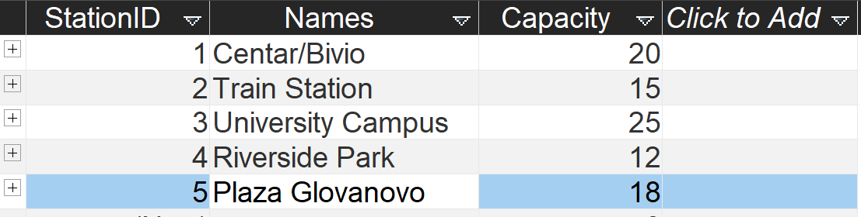
Fig 8 (Station Table data view)
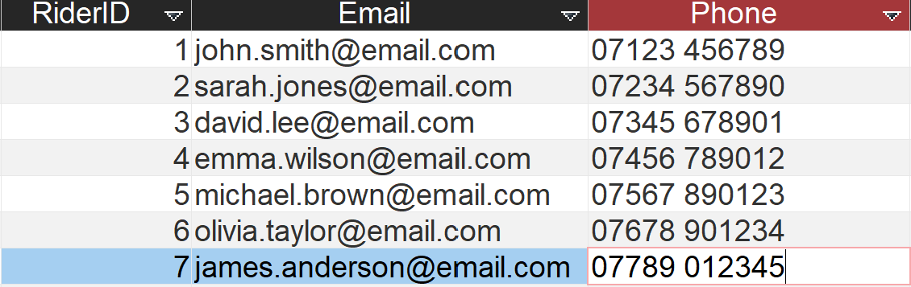
Fig 9 (Rider Table data view)
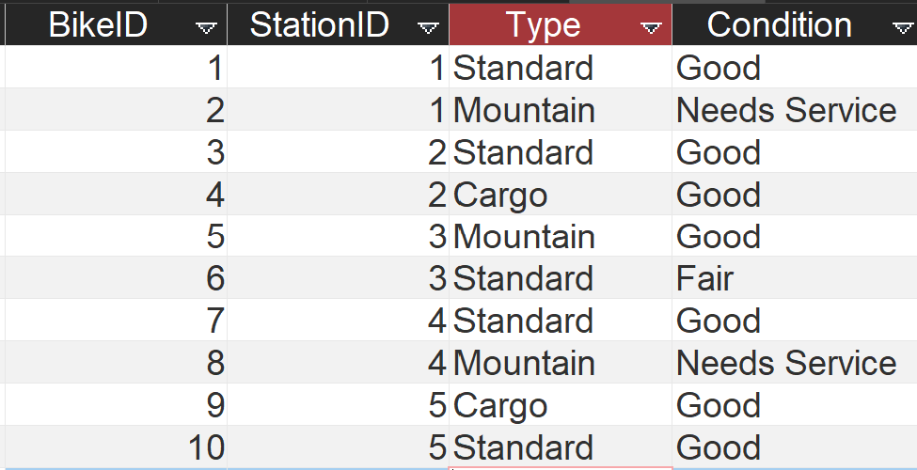
Fig 10 (Bike Table data view)
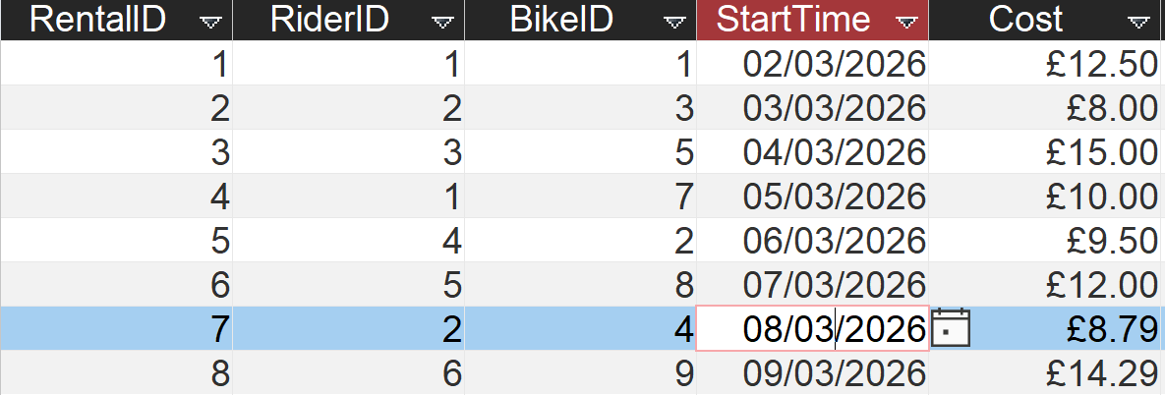
Fig 11 (Rental Table data view)

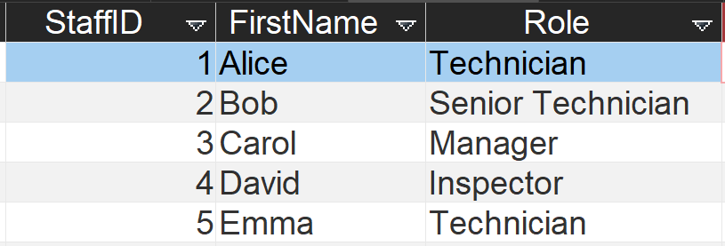
Fig 12 (Staff Table data view)
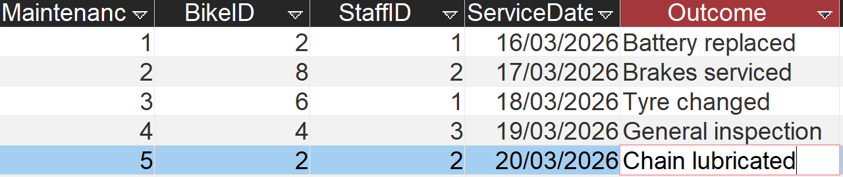
(Fig 13 Maintenance Table data view)

Query Development
To demonstrate the operational requirements of the EcoRide database, six SQL queries were created in Microsoft Access to demonstrate how well the SQL Database can fulfil these requirements. These query results provide relevant information about the availability, maintenance, rental patterns and staffing of bikes within the system. Each query has been designed to provide information tailored to its specific purpose.
The "Bikes Currently Out on Rental" query returns active rentals with full information about the rider and the bike.
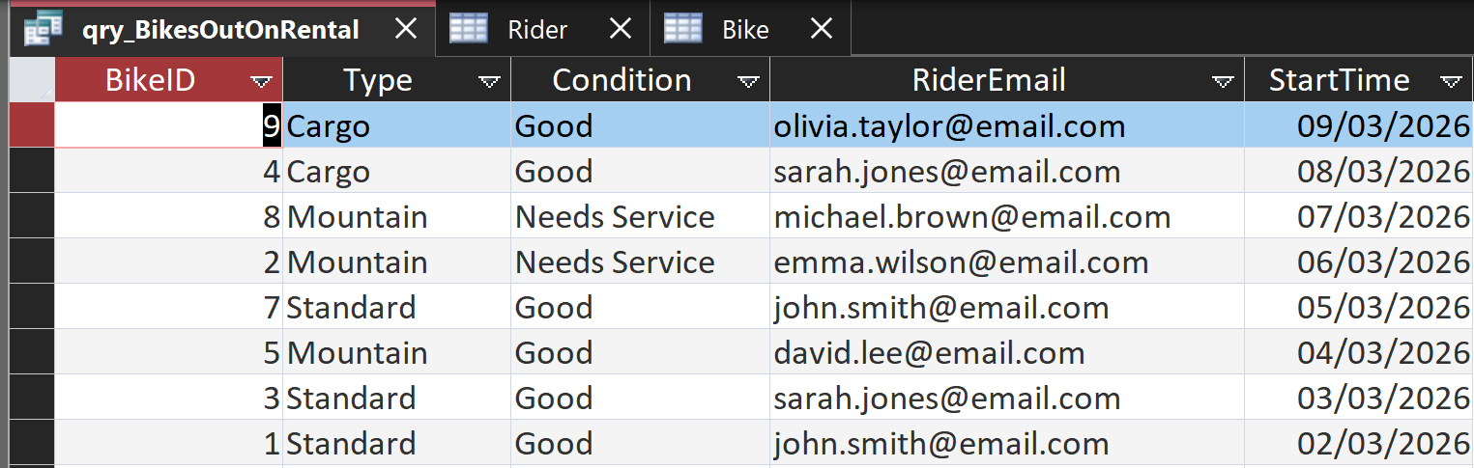
Fig 14 (Bikes rented Query)
The "Bikes Needing Service" returns the current location of all bikes that are listed as "Needs Service."
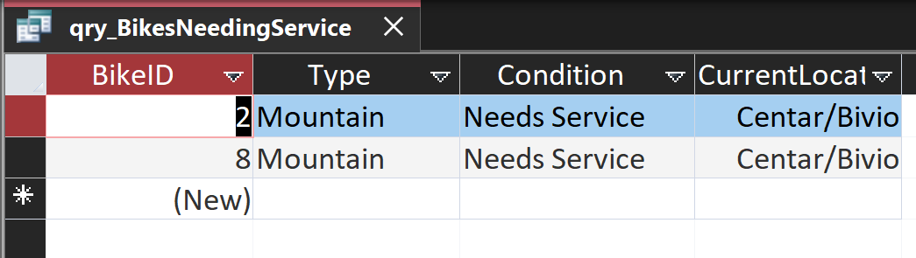
Fig 15 (Bikes needing service Query)
3) The "Most Frequently Rented Bikes" query generates statistics based on the number of rentals for each bike.
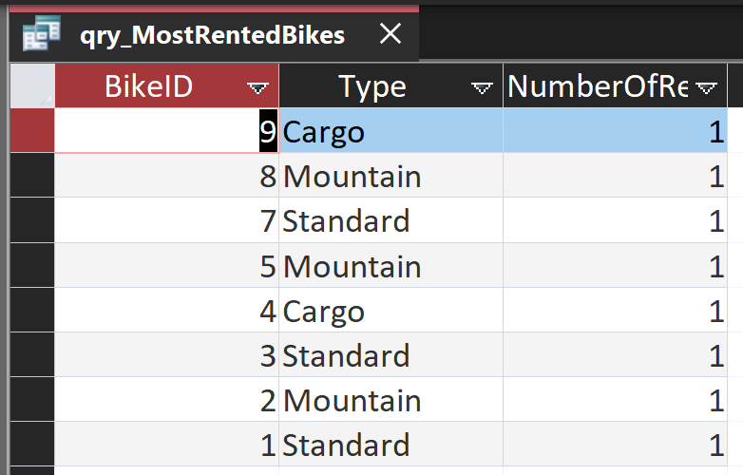
Fig 16 (Most Rented Bikes Query)
4) The "Rental History for a Specific Rider" query returns all past and present rentals for any implementation of a rider in the system.
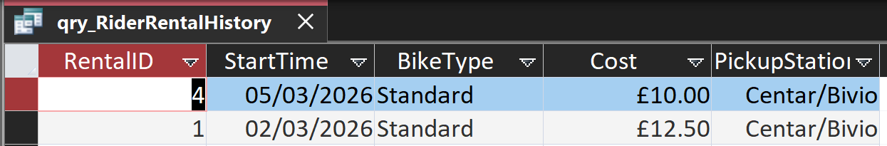
Fig 17 (Rental History Query)
5) The "Number of Available Bikes per Station" query provides the number of operational bikes at each station.
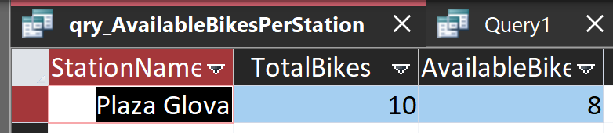
Fig 18 (Available Bikes per Station Query)
6) The "Maintenance History" report displays the complete service history of each bike, along with who has serviced that bike.
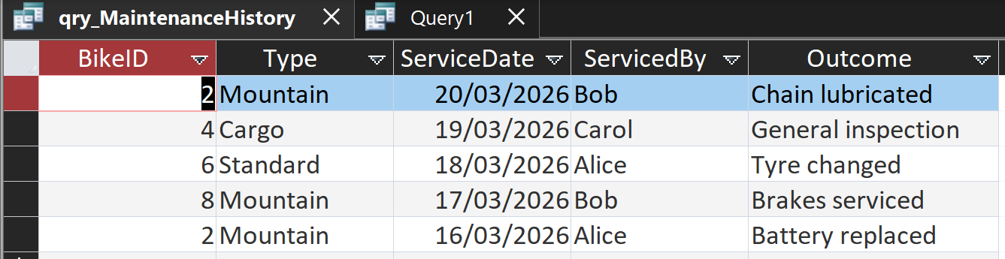
Fig 19 (Maintenance History Query)

Validation and Testing
Validation and testing were conducted to confirm the functionality of the EcoRide database and to ensure that it meets the requirements of the electric bicycle rental system. The testing methodology focuses on referential integrity, validated data types, primary key constraints, and the assessment of the database functionality using the previously used queries, as outlined in the principles of relational database testing. [2]
By trying to create a record with an invalid foreign key, I have verified the referential integrity test. An error message saying “you cannot add or change a record because a related record is required in the table Station” was generated when a StationID value of 99 was entered into the Bike table, as there is currently no corresponding StationID of 99 in the Station table, as shown in the figure below.
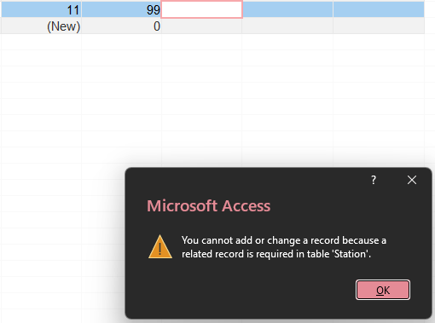
Fig 20 (Invalid Foreign Key Test)
Similarly, when entering a value of 67 for RiderID, which doesn't correspond to an existing rider in the Rental table, I received the error message "You cannot add or change a record because a related record is required in table 'Rider'” as shown in the figure below. These two test instances confirm that the foreign keys used to create the relationships between the tables are properly enforced and also enforce referential integrity, thus preventing the creation of orphan records. [2].
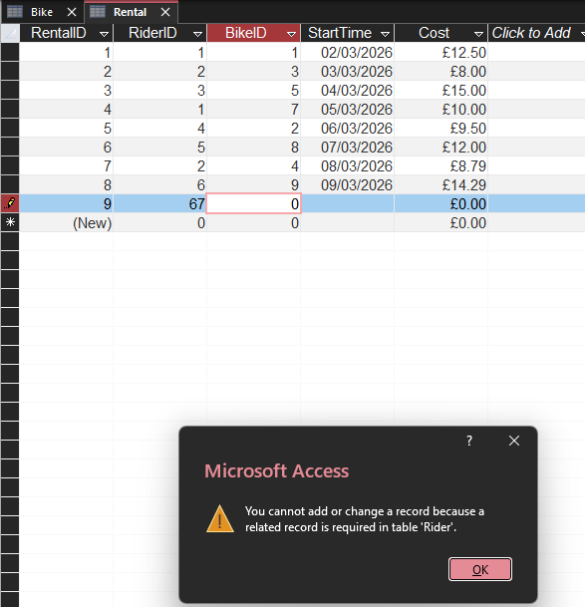
Fig 21 (Invalid RiderID Test)
Another test is entering the letters A and F into the Cost column in the rental table, which is defined in the design view as Currency. The following error message was displayed by Access: "The value you entered does not match the Currency data type in this column." As shown in the figure below
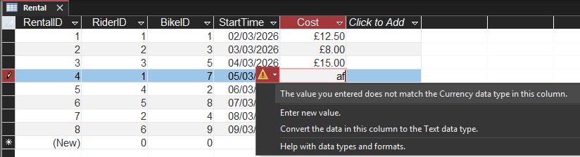
Fig 22 (Invalid Data Type Test)
Secondly, when entering the value "hello" into the StartTime column, which is defined as Date/Time, the following error message was displayed: "The value you entered does not match the Date/Time data type in this column." Microsoft Access successfully rejected both attempts, thus verifying that the appropriate data types impose input validation. As shown in the figure below.
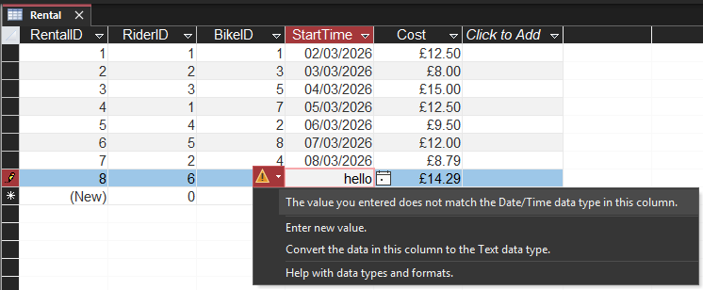
Fig 23 (Invalid Data Type 2 Test)
To test a realistic database usage scenario, functional testing was used. To test this, multiple rental records for the same bike were added with overlapping rental dates to identify double-booking scenarios, as shown in the figure below.
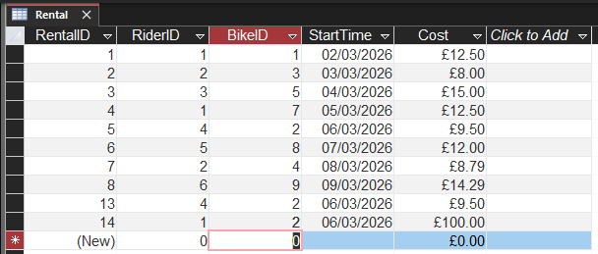
Fig 24 (Overlapping Rental Date Test)
The previously executed query "Bikes Currently Out on Rental" retrieved all rentals currently activated. For instance, the query found that for BikeID 2, many additional active mountain bike rentals were marked "Needs Service." Therefore, the "Bikes Currently Out on Rental" query provides excellent visibility into which bikes are currently in use and helps staff avoid double-bookings. As the testing method utilised for rent-to-own bikes, most bike-sharing systems employ it to provide visibility into available supply and prevent operational conflicts [3].
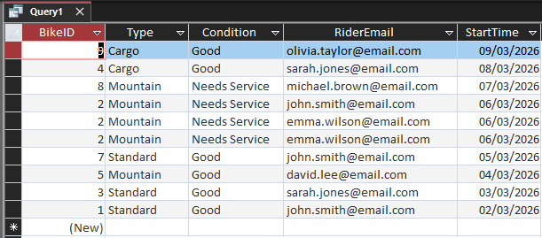
Fig 25 (Same Bike Rent Test)

Task 2

Design Decisions, Summary and Reflection
To create a database structure that is both affordable and functional enough to accomplish the EcoRide objectives, six entities were selected based on the defined ecological objectives: Station, Rider, Bike, Rental, Staff, and Maintenance, with appropriate referential integrity enforced to avoid data inconsistency (2). The platform chosen is Microsoft Access because it provides a straightforward visual interface for creating tables, defining relationships between tables, and developing queries, making it an ideal tool for illustrating relational concepts at this level. The database includes fully normalised tables with realistic sample data, along with six practical queries that simulate daily operations, such as tracking active rentals and identifying bikes requiring service.
Problems arose during development, especially when creating relationships in Access, with error messages such as “the database engine could not lock the table” and “a related record is required.” This would occur whenever the tables were open or when the relevant foreign keys had been incorrectly entered. This was resolved by closing all of the objects and then following the correct data entry order. Data type validation also needed to be tested to ensure that fields like Cost and StartTime would not accept invalid entries. In general, the project successfully converted the old, inefficient system into an organised, structured relational database that improves data entry accuracy and makes business operations more efficient. For future iterations of this project, some features that could be integrated into the application include a ReturnDate field with automatic duration calculation, constraints to prevent two rentals for the same bike from occurring at the same time, and an easy-to-use user interface.

References
[1] T. J. Wallace, A. C. Taliaferro and W. P. Hinkle, "Defense Governance & Management Improving the Defense Management Capabilities of Foreign Defense Institutions; Using a Relational Database (FOCIS) to Improve Defense Force Planning and Budgeting An Overview for Project Leaders," 2017. Available: http://www.jstor.org.uwtsd.idm.oclc.org/stable/resrep36503
[2] Y. Bai, d. IEEE Xplore (Online service) and p. Wiley,SQL server database programming with visual basic.net : concepts, designs and implementations, Hoboken, New Jersey: John Wiley & Sons, Inc, 2020. doi: 10.1002/9781119608493
[3] H. Florian, et al., "Probabilistic Petri Nets Model for Assessing Temporal Variations of the Number of Bikes in Bike-Sharing Stations", 2022 IEEE International Conference on Automation, Quality and Testing, Robotics (AQTR), pp. 1–5. [Online].doi: 10.1109/AQTR55203.2022.9802065.
[4] C. -F. Andor and V. Varga, "Visual representation methods for relational and non relational database structure and operations - a common interface based on conceptual graphs", 2022 International Conference on Electrical, Computer, Communications and Mechatronics Engineering (ICECCME), pp. 1–8. [Online].doi: 10.1109/ICECCME55909.2022.9987904.
[5] P. G. T. H. Kashmira and S. Sumathipala, "Generating Entity Relationship Diagram from Requirement Specification based on NLP", 2018 3rd International Conference on Information Technology Research (ICITR), pp. 1–4. [Online].doi: 10.1109/ICITR.2018.8736146.

