Change Makers
e-Portfolio Assignment
1909160 Mark l. e. Vaughan
December 2020
L5 - Changemakers: Creativity and Value Creation (ACCA5033)

Table of Contents

Contents
Table of Contents 2
e-Portfolio 3
Task 1 – Mind Map. 4
Task 2 – Image-based Video presentation. 5
Task 3 – Video presentation. 6
Task 4 – Academic poster. 7

e-Portfolio

Link to e-Portfolio : URL:https://sites.google.com/d/1ldSKZGF0vWFYCNf5FqIB9TW_7M-Yj4W7/p/1wyWAvJS-S16QflWQr4xSWFfz_EAPeol8/edit

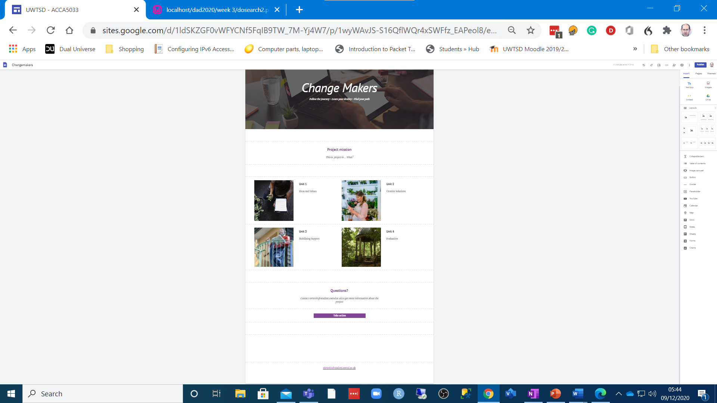

Task 1 – Mind Map.

Link: https://sites.google.com/d/1ldSKZGF0vWFYCNf5FqIB9TW_7M-Yj4W7/p/1tA2-aNIfvPOh76PtqCeqjiB8nbvM93jc/edit

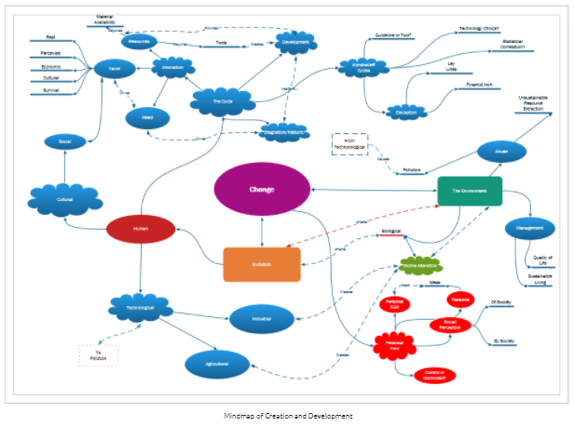

Task 2 – Image-based Video presentation.

Link: https://sites.google.com/d/1ldSKZGF0vWFYCNf5FqIB9TW_7M-Yj4W7/p/1zuhwCMVrUxl2gJyKmcD1UyLEZ30fe7bN/edit

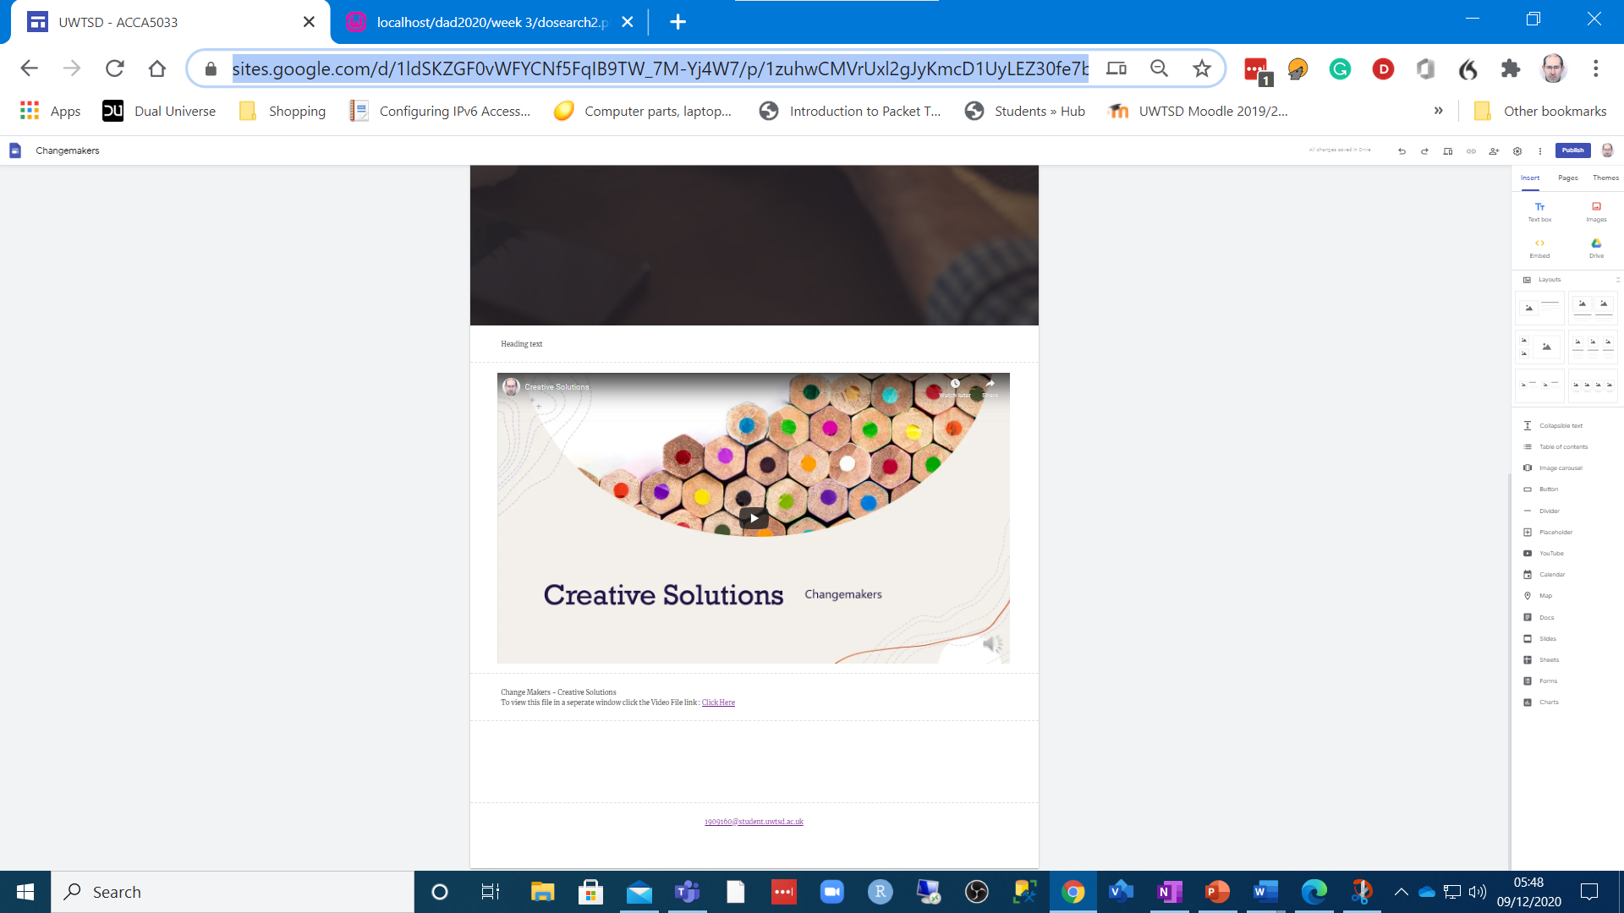

Task 3 – Video presentation.

Link: https://youtu.be/6LWVnWBgegY

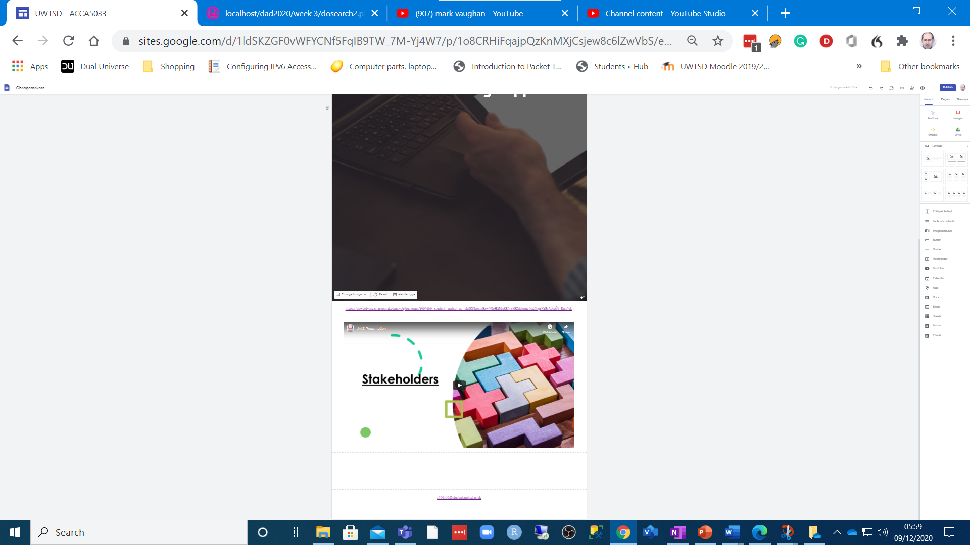

Task 4 – Academic poster.
Link: https://sites.google.com/d/1ldSKZGF0vWFYCNf5FqIB9TW_7M-Yj4W7/p/1BXjVfGSKw2JNrFDcroX9fMR7WAOiSbe1/edit



