Search
Ai and Machine learning

Gordon Dickers
Daniel Algie (1706977)
Contents
Introduction 2
Maze program 2
User guide 2
Creating the programme 3
Further development 4
Hill climbing 5
State space 6
Eight tile problem 9
Manhattan distance 11
Conclusion 12
References 13
Appendix 14
Main.cpp 14
Variables.h 20

Table of Figures
Figure 1-welcome menu 2
Figure 2-shows maze hit dead end 2
Figure 3-shows maze continuing once passed dead end 3
Figure 4-shows completed maze 3
Figure 5- sets the size of array 3
Figure 6-move around maze 4
Figure 7-state space diagram [1] 6
Figure 8-hill climb search [9] 7
Figure 9-local maximum [9] 8

Introduction
This assignment will explore into what is hill climbing and how hill climbing works. Will then show how to solve an eight-tile problem and will then show how to solve the problem using another algorithm the Manhattan distance algorithm. This assignment will also showcase in how a program was created to search a room and check for products and determine if the correct products and all products were found.

Maze program
The object of this project was to create a programme to run and read in a files content. The files were mazes created to simulate searching for items in a room and the program will search throughout the maze searching for items once all items are found it will display the map and the route that the programme took to find these items.

User guide
When the programme is run it will display a selection of options this is where the user will decide which maze (room) they wish to search the user has an option of 4 mazes and the option to quit.
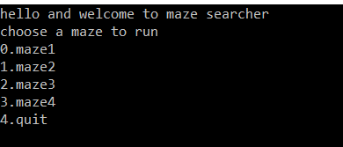
Figure 1-welcome menu
Once the user has chosen the maze, they wish to use the programme will load automatically and will display the map and will begin checking the maze and calculating the start position of the maze (s). Once the start position has been designated the programme will move one step at a time if the next step has a wall (#) an item (@) or an empty space. If there is an empty space or an item the programme will move to that space in the maze if there is a wall the programme will check up, down, right and left to find the next available white space once it has moved into the space or item it will change on the map to a v to set the programme has visited this area. For any reason that while the programme runs a maze and comes to a dead end the programme will realise and will backtrack to a different point in the maze where a new route can be used.
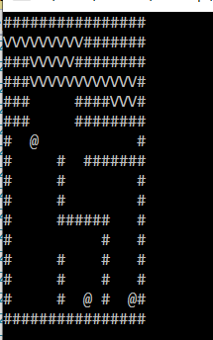
Figure 2-shows maze hit dead end
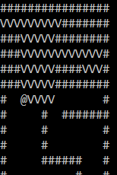
Figure 3-shows maze continuing once passed dead end
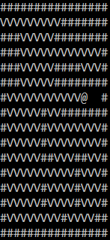
Figure 4-shows completed maze

Creating the programme
When creating the programme, it was set out to be dynamic so that whichever size the maze was from the file read in it would create a 2d array [1] to the same size to create the number of rows and columns needed to fit the maze.

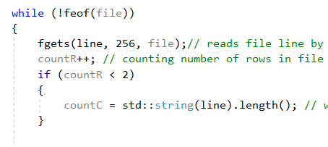
Figure 5- sets the size of array
What the code above does is read the file and counts the number of lines read in from the file to set the number of rows needed and counts the number of symbols and gaps in each line to work out how many columns will be needed for the array [1] to store these values.
Setting the character to move around the maze (v) was created by checking if the next space in the array was a wall, empty space ,already visited or an item to do this the programme needed to be able to check the next character in the columns array to see if it was a wall if it was a wall it would use the rows array to check if the character above is a wall and if the character below was a wall if there was a space then it would push the coordinate onto the stack and if all options were making it not able to move then it would push off the top of the stack and move back to the last visited and would check again for another route if the same problem arises it would pop off the stack and keep backtracking till new route was available.

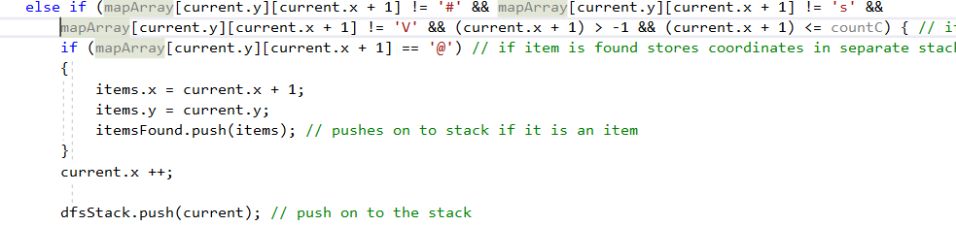
Figure 6-move around maze
The image above shows the code on how if the position on the maze is not equal to a wall or the start position then set the coordinate to visited this is checking to the left of the current visited coordinate it also set that if the coordinate is equal to an item (@) then set these coordinates into a separate stack to show where the coordinates of the item found was.

Further development
Due to the time scale to complete this project there are a few issues which arise that could not be rectified in time, but these issues are
- The switch statement will close once the programme has been run once after trying different solutions this was not able to rectify in time it was set out that it would keep looping until the user decides to quit originally was set up with if statements but changed.
- Making it able for the user to pause the maze running for their convenience and unpausing the programme it was tried by using the kbhit function [2] it is still in the code but commented out if wish to see but the issue was that it would stop the project instead of pausing when trying to rectify the issue it is to use a getch function [3] instead and eating the variable to set the system to pause.

Hill climbing
Hill climbing [4] is a search algorithm which will loop in increasing value until it reaches a peak where no neighbour value is higher, for example if someone is climbing a cliff they will climb until they reach the top of the peek and when reach the top of the hill the climber has reached the highest point, hill climbing algorithm works in the same way.
There are a few different types of hill climbing [5] [6] [7]
- Simple hill climbing this is where it will only check the neighbouring node (next node) and check if it is greater if the node is not greater then it will not move to the next node and finish at the highest point.
- Steepest-ascent hill climbing this will examine all the neighbouring nodes of the current state and will continue to check every node which is closet to the goal state
- Stochastic hill climbing this selects a neighbouring node at random and decides weather to move to the node or examine another.
The features of hill climbing [5] [6]
- Heuristic function takes all the potential nodes and compares for the best route for the node to travel this does take more time than other methods but will show the best option it will generate all possible positions and will evaluate if that was the correct decision if the solution has found all available nodes will finish or else it will go back to first node and start again.
- The greedy approach checks both neighbouring nodes and will check with which solution is better and move to that node. Using the mountain climb as an example if there are two paths it will check both paths and give best option if one is going down and one is still going to higher altitude it will choose the higher altitude option.

State space
The state space is a graphical approach to show how the states of search against the value of our object function.

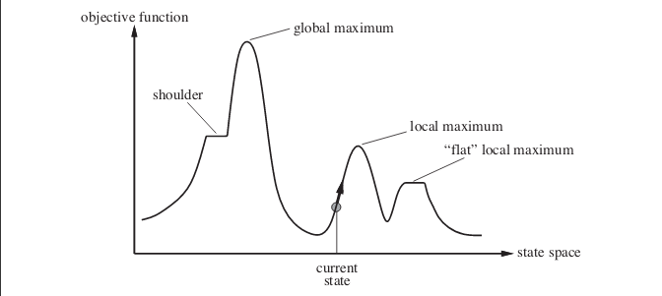
Figure 7-state space diagram [1]

- Local maximum [6] [7] [8] this is a state which is better than all of its neighbouring nodes but it is the highest of the neighbouring nodes and greater value of the current node but it is not the highest point but due to the next neighbouring node lower value the algorthium will thing this is the highest point and finish. Due to this a problem to resolve this is to use a backtracking technique which will maintain a list of visited states and if it reaches a state which is highest out of the two nodes can back track and tack a different path.
- Plateau or flat maximum [7] [8] [6] this is where all neighbouring nodes have the same value making it difficult to choose a path. This can be rectified by using bidirectional search where different to hill climbing it will search from both the begin and goal nodes to check a path and will end when the both paths meet each other.
- Ridge is where the local maximum is reached because both neighbouring nodes are of decline.
- Shoulder it is a plateau that has an uphill edge.

Hill climbing search
With hill climb search it will be shown how hill climbing works with the image below to show how it searches for the shortest values to reach the end for this example was used to show how M would be the global value.

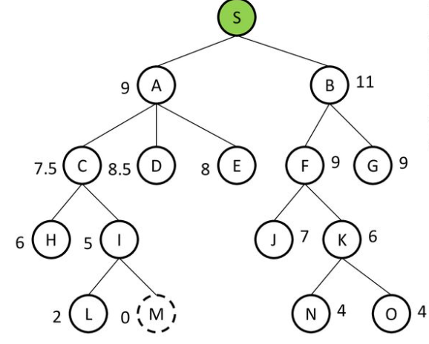
Figure 8-hill climb search [9]

Input [S A9 B11, A9 C7.5 D8.5 E8, C7.5 H6 I5, L2 M0 ]
Output [A9,C7.5,I5,M0]

S = start position
M = global maximum

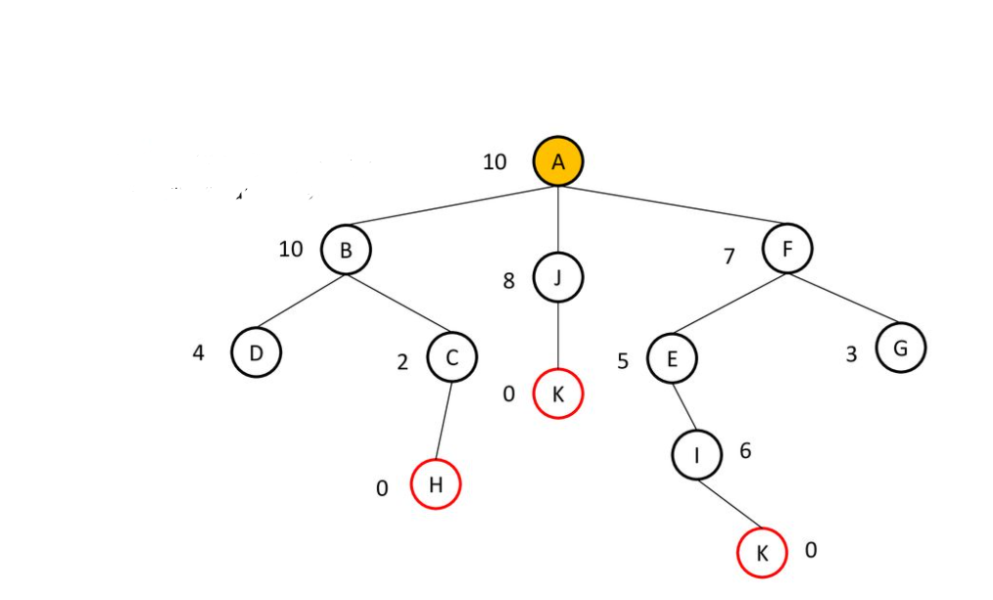
Figure 9-local maximum [9]
For the above image we are going to use the same logic to find a path to either h, j or k
Input [A10 B10 J8 F7, F7 E5 G3]
Output [A10, F7, G3]
This is where a problem lies with in hill climbing though G3 is not the correct valuable it was the best solution and has become the local maximum [7] instead due to the nodes not being able to move because the neighbour next is greater the algorithm things it has reached the end and finished.

Eight tile problem
The eight-tile problem is to solve a 9 grid with 8 numbers not in order and to solve by only moving one number at a time.
Using hill climb to solve the tile problem and using heuristic value, that will need to be calculate how many numbers are out of place and setting the heuristic value to that value and work out the best state to complete the puzzle [10] [11].
With the puzzle showing that there are 5 numbers out of place then it will be set that the heuristic value is current starting from 5. To work out the next move it needs to be looked at that the empty space has 3 visiting nodes next to it so currently there are 5 numbers out of place and can only swap the empty space with a neighbouring node (number) that leaves 3 options the 2,5 and 8 can be moved into the current position [12].
Because the game is to reach all out of positions numbers to move to correct position the heuristic value will need to reach 0 to show all numbers are in there correct position so if the heuristic is 5 and the numbers available at the time is 5,2 and 8 then it was worked out by which number moved would be a greater state out of place by doing this we calculate that if the 2 or 8 was moved then the heuristic value would be 6 numbers out of place but if the 5 was moved it would change the heuristic value to 4 showing that a correct tile has been moved in place below you will see exactly how this was achieved.

Heuristic f() = h

3 | 1 | 2
6 | 5
7 | 4 | 8

h = 5 the number of numbers out of place
h = 6, 6, 4 six numbers would be out of place if the 2 was moved and 6 numbers if the 8 was moved but if the 5 is moved then there will be 4 numbers out of place
3 | 1 | 2
6 |  | 5
7 | 4 | 8

h = 4
h = 5 ,5,5 ,3

3 | 1 | 2
6 | 4 | 5
7 |  | 8
h = 3
h= 4,4,2

3 | 1 | 2
6 | 4 | 5
 | 7 | 8
h=2
h = 3,1

3 | 1 | 2
 | 4 | 5
6 | 7 | 8

h=1
h=3,2,0

 | 1 | 2
3 | 4 | 5
6 | 7 | 8

h=0

Manhattan distance
To work out the heuristic of the grid using Manhattan you first need to calculate how many numbers are out of position and then count the number of steps it will take for each number to be in the correct place for example if the number 8 was in tile number 1 spot it would take 4 moves to put in the correct spot this works similar to the same way as using hill climbing but instead of working out how many are out of place at all time instead how many more moves it will take to complete [14] [15].

3 | 1 | 2
6 | 5
7 | 4 | 8

1+1+1+1+1 = 5

3 | 1 | 2
6 |  | 5
7 | 4 | 8
1+1+1+1=4

3 | 1 | 2
6 | 4 | 5
7 |  | 8

1+1+1=3

3 | 1 | 2
6 | 4 | 5
 | 7 | 8

1+1=2

3 | 1 | 2
 | 4 | 5
6 | 7 | 8

1

 | 1 | 2
3 | 4 | 5
6 | 7 | 8

0

Comparing Manhattan to hill climbing
While testing and using both options for the 8 tile problem both solutions worked out the exact same amount of moves this was because for all the positions out of place were all one position out of place but if the nine tile problem was a bigger grid for instance grid of thirty six then it would be better to determine which algorithm works best by choice. It was estimated that the Manhattan distance algorithm was the best choice due to working out how many spaces each number was out of place instead of using hill climbing to work out with each move how many numbers were still out of place this has more potential for the 8 tile problem to be stuck due to always picking the lowest solution and could end up with out the grid being complete.

Conclusion
In conclusion the programme created to solve the maze was a success there was a few issues that need to be rectified to make more user friendly but due to time scales and writing of user guide this will be rectified later. Writing of the 8 tile solution and hill climbing has taught a lot and will be looking at more solutions to the 8 tile problem with A* and breath first search to see how they compare when working out a solution.

References

[1] | alex, “learncpp,” 15 november 2015. [Online]. Available: https://www.learncpp.com/cpp-tutorial/6-14-pointers-to-pointers/. [Accessed 06 december 2020].
[2] | m. team, “microsoft docs,” 4th febuary 2020. [Online]. Available: https://docs.microsoft.com/en-us/cpp/c-runtime-library/reference/kbhit?view=msvc-160. [Accessed 2nd december 2020].
[3] | g. f. geeks, “geeks for geeks,” 4th march 2020. [Online]. Available: https://www.geeksforgeeks.org/getch-function-in-c-with-examples/. [Accessed 3 december 2020].
[4] | S. Russell and P. Norvig, in artificial intelligence a modern approach , new jersey , p. 94 to 112.
[5] | D. Partridge, artificial intelligence and software engineering, new york : American management association .
[6] | g. f. geeks, “geeks for geeks,” 21 august 2019. [Online]. Available: https://www.geeksforgeeks.org/introduction-hill-climbing-artificial-intelligence/. [Accessed 28 november 2020].
[7] | j. t. point, “java t point,” [Online]. Available: https://www.javatpoint.com/hill-climbing-algorithm-in-ai#:~:text=A%20hill%2Dclimbing%20search%20might,could%20find%20non%2Dplateau%20region.. [Accessed 4 december 2020].
[8] | R. Gour, “medium,” 14 march 2019. [Online]. Available: https://medium.com/@rinu.gour123/what-is-heuristic-search-techniques-hill-climbing-in-ai-9b01ab0575da. [Accessed 6 december 2020].
[9] | Upasana, “edureka,” 25 november 2020. [Online]. Available: https://www.edureka.co/blog/hill-climbing-algorithm-ai/. [Accessed 28 november 2020].
[10] | Y. Y. Muljana, “slide player,” 2020. [Online]. Available: https://slideplayer.com/slide/15497810/. [Accessed 4th december 2020].
[11] | p. u. o. pennsylvania, “intro into ai”.
[12] | b. c. search, “beyond classic search”.
[13] | i. h. search, “kalev kask,” 2014.
[14] | n. i. o. s. technology, “nist,” [Online]. Available: https://xlinux.nist.gov/dads/HTML/manhattanDistance.html. [Accessed 26 november 2020].
[15] | andrew, “adrew,” [Online]. Available: https://www.andrew.cmu.edu/course/15-121/labs/HW-7%20Slide%20Puzzle/lab.html. [Accessed 02 december 2020].
[16] | S. R. Davies, c++ for dummies 5th edition, indiana: Wiley publishing inc, 2004.

Appendix
Here you will find the code for the maze searcher programme

Main.cpp
#include <iostream>
#include <fstream>
#include <string>
#include <stack>
#include <vector>
#include <conio.h>
# include "variables.h"

using namespace std;
stack <position> dfsStack;
stack <position> itemsFound;
void creatingSizeOfArray(FILE* file, int& countR, int& countC)
{
map map;

char line[256];

while (!feof(file))
{
fgets(line, 256, file);// reads file line by line
countR++; // counting number of rows in file
if (countR < 2)
{
countC = std::string(line).length(); // working out number of characters in coloum by the length of the line read in
}

/*countC = strlen(buffer);*/
}
countR--;// minus one due to the file reading in extra line
countC--;
cout << countR << endl;
cout << countC << endl;
}
void printmap(int& countR, int& countC, char**& mapArray) // prints the map

{
system("CLS"); // clear the screen everytime the map is re called
// Output Map
for (int i = 0; i < countR; i++) {
for (int j = 0; j < countC; j++) {

cout << mapArray[i][j]; // outputting map
}
cout << "\n";
}
cout << "\n";
}
void readingInFIle(FILE* file, int& countR, int& countC, char**& mapArray)
{
map map;

map.rows = countR, map.cols = countC; // setting the size of the maze columns and rows

// Open File

// Find a way to count rows and columns of file here... Update size variables!

// Allocate array
mapArray = new char*[map.rows]; //crating a 2d array to store maze
for (int i = 0; i < map.rows; i++) {
mapArray[i] = new char[map.cols];
}

rewind(file); // rewind file if necessary
// Buffer to store character
char charBuffer;
for (int i = 0; i < map.rows; i++) {
for (int j = 0; j < map.cols; j++) {
charBuffer = fgetc(file);
if (charBuffer == '\n') {
// if new line
charBuffer = fgetc(file);// reads in file character by character
}

mapArray[i][j] = charBuffer; // filling in the array with maze from file character by character
}
}

printmap(map.rows, map.cols, mapArray);// displays map

// Close File
fclose(file);

}

void dfspushing(int& countR, int& countC, char**& mapArray)
{
int goalCount = 0;
int goalsFound = 0;
map map;
position startpos, current, items;
for (int y = 0; y < countR; y++)
{
for (int x = 0; x < countC; x++)
{
if (mapArray[y][x] == 's') // checking the maze to see and set where start position is
{
startpos.x = x;// setting the start position for the stack
startpos.y = y;
}

else if (mapArray[y][x] == '@') // checks the maze for the amount of items in it
{
goalCount++;
}
}
}
cout << "Number of goals to find " << goalCount << endl;

current = startpos; // setting the position for the maze to start
mapArray[current.y][current.x] = 'V';
dfsStack.push(current); // push on to the stack

bool pauseButton=false;
bool scanning = true; // while true will search the maze until all items are found
while (scanning) //keeps going until whole maze is searched
{
bool look = true;

while (look) //will check each coordinate to see if there is a item or a wall or empty space
{
/*while (pauseButton)
{
if (pauseButton == button)
{

}
}*/

//while (!_kbhit()) was used for trying to pause progrrame
//{
if (current.x >= 0 && current.x <= countR && current.y >= 0 && current.y <= countC) // Check inside the map
{

if (mapArray[current.y][current.x - 1] != '#' && mapArray[current.y][current.x - 1] != 's' && mapArray[current.y][current.x - 1] != 'V' && (current.x - 1) > -1 && (current.x - 1) <= countC) { // if items in maze don't = a wall # or start position then set it to a v for vistied in the maze looking right
if (mapArray[current.y][current.x - 1] == '@')
{

items.x = current.x - 1;
items.y = current.y;
itemsFound.push(items);
}
current.x--;
//mapArray[current.y][current.x] = 'V';
dfsStack.push(current); // push on to the stack
/*current.x += 1;*/
}
else if (mapArray[current.y][current.x + 1] != '#' && mapArray[current.y][current.x + 1] != 's' && mapArray[current.y][current.x + 1] != 'V' && (current.x + 1) > -1 && (current.x + 1) <= countC) { // if items in maze don't = a wall # or start position then set it to a v for vistied in the maze looking left
if (mapArray[current.y][current.x + 1] == '@') // if item is found stores coordinates in separate stack
{
items.x = current.x + 1;
items.y = current.y;
itemsFound.push(items); // pushes on to stack if it is an item
}
current.x ++;

dfsStack.push(current); // push on to the stack
/*current.x -= 1;*/
}
else if (mapArray[current.y - 1][current.x] != '#' && mapArray[current.y - 1][current.x] != 's' && (current.y - 1) > -1 && mapArray[current.y - 1][current.x] != 'V' && (current.y - 1) <= countR) { // if items in maze don't = a wall # or start position then set it to a v for vistied in the maze lookng up
if (mapArray[current.y - 1][current.x] == '@')
{

items.x = current.x;
items.y = current.y -1;
itemsFound.push(items); // push the item found on to iem stack
}
current.y --;

dfsStack.push(current); // push on to the stack
/*current.y += 1;*/

}
else if (mapArray[current.y + 1][current.x] != '#' && mapArray[current.y + 1][current.x] != 's' && mapArray[current.y + 1][current.x] != 'V' && (current.y + 1) > -1 && (current.y + 1) <= countR) { // if items in maze don't = a wall # or start position then set it to a v for vistied in the maze looking odwn
if (mapArray[current.y + 1][current.x] == '@')
{

items.x = current.x;
items.y = current.y + 1;
itemsFound.push(items);
}
current.y ++;
//mapArray[current.y][current.x] = 'V';
dfsStack.push(current); // push on to the stack
/*current.y -= 1;*/

}
else
{
/*mapArray[current.y][current.x] = 'b';*/
current = dfsStack.top();
dfsStack.pop();

}

//}

printmap(countR, countC, mapArray);//prints map

if (mapArray[current.y][current.x] == '@')
{
// found a goal
//Add to the total
goalsFound++;// add each item on map

printmap(countR, countC, mapArray);
cout << "item found" << endl;
if (goalsFound == goalCount) // if all items reach the gaol count
{
cout << "all items found " << goalCount << endl;
look = false; // once all goals found will end loop
scanning = false; // once all goals are found will end loop and move onto pushing the stack
break;
}
}
mapArray[current.y][current.x] = 'V';

}

}
}
//print out the cells looked in

cout << "Start X=" << startpos.x << "Y=" << startpos.y << endl; // displaying the start positions
for (int i = 0; i < goalCount; i++)
{
items = itemsFound.top();
cout << "item " << i + 1 << " ("<<"x " << items.x << "," <<"y" << items.y << ")" << endl; // displays all points where the items were found
itemsFound.pop(); // pops of coordinates from item found stack
}
cout << "all positions searched " << endl;
while (!dfsStack.empty())
{

current = dfsStack.top();
dfsStack.pop();
cout << " Y=" << current.y << "X=" << current.x << endl; //displaying all coordinates that were used and saved in the stack

}
current.x = 1;
}

int main()
{
map map;
FILE* file = NULL;
char choice ;
bool quit = false;
char answer;
cout << "hello and welcome to maze searcher" << endl;
do
{
cout << "choose a maze to run\n0.maze1\n1.maze2\n2.maze3\n3.maze4\n4.quit" << endl;
cin >> choice;
switch (choice) {
case '0':fopen_s(&file, "maze.txt", "r");
quit = false;
break;

case '1':
case'p':fopen_s(&file, "maze2.txt", "r");
quit = true;
break;
case '2': fopen_s(&file, "maze3.txt", "r");
quit = true;

break;
case '3': fopen_s(&file, "maze4.txt", "r");
quit = true;
break;
case '4':
cout << "thanks for checking out maze searcher hopefully you'll be back soon " << endl;
quit = true;
return 0;
break;
default:
{

cout << "invalid inpute please try again " << endl;
cin >> choice;

}
break;

}

} while (!choice==4 );
creatingSizeOfArray(file, map.countR, map.countC);
readingInFIle(file, map.countR, map.countC, map.mapArray);
dfspushing(map.countR, map.countC, map.mapArray);

return 0;
}

Variables.h
#pragma once
class map
{

public:
FILE * file;
int countR=0, countC=0;
char** mapArray;
char ** visitedArray;
int rows, cols;
private:
};

typedef struct {
int x;
int y;

} position;

