Module Handbook 2026-27 (f/t & p/t)
The Thought Experiment
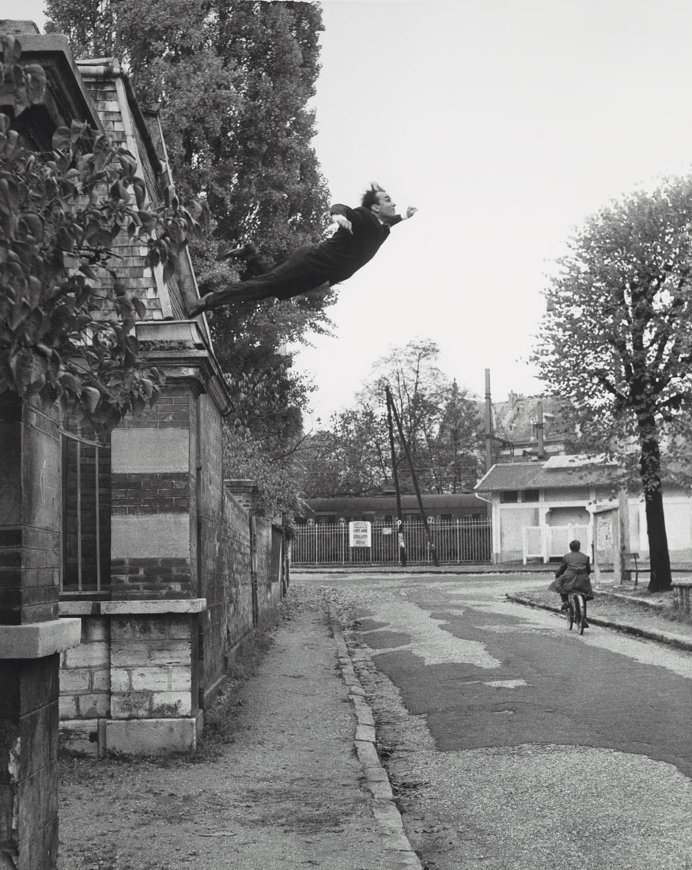
Yves Klein, Leap into the Void. 1960.
The Thought Experiment
20 Credits. MA, MDes
Module ADDA7007
Module Co-ordinator: Martin Bush
The Thought Experiment is conducted at the beginning of the Masters programmes in Art & Design Contemporary Dialogues, in order to shake you out of any medium-specific comfort zone or established working methods, and jump start a creative journey. This is not to say you cannot practice with any given medium, but it is considered timely at the outset of the Contemporary Dialogues course to provide you with an opportunity to discover research methods pertinent to the acquisition of experiential – as opposed to cognitive – knowledge, in a light-hearted, but equally serious, introduction to the programme. The Thought Experiment is conducted over a six-week programme of sessions designed to widen creative potential, to engender dialogues across critical practices, and to explore and test the range of research methods available to practitioners in the visual arts.
The Thought Experiment is designed to facilitate radical thinking, creating a platform where you will be encouraged to explore ideas and processes beyond those already established as a professional artist/designer returning to education, beyond those developed for the 3rd year/level 6 of undergraduate study, or beyond those conventionally considered as typical for the start of a postgraduate course. The focus of this module is lateral creative thinking and innovation. It aims to encourage risk, to challenge conventional constructs and develop strategies for open, non-prescribed thought. This module is delivered through workshops, group seminars, and a speed tutorial event. It concludes with the production of a body of research leading to a presentation/event to consolidate this research.
The idea is to focus on process rather than imagining an end result - to concentrate on the journey rather than the destination. The over-arching objective is to enhance creativity of thought, through experimental methodology.
The Thought Experiment ends with a live ‘Pecha Kucha’ style presentation of ideas which is time limited to 4 mins and 33 seconds, a reference to the artist/composer, John Cage 4’33”, 1952. (The original format for a Pecha Kucha is normally 6 mins 40 seconds comprising 20 slides for 20 seconds each.) We have made it much more open, and as suggested by the Cage reference, considerate for example, of the time within the frame of an art or design event.
The Thought Experiment’s Pecha Kucha allows for any type of creative method of presentation from the performative to film, from demonstration to shared participatory experiment, with the commonality of the 4 min and 33 second time frame, and that it is shared collectively. All we ask is that the presentation is creative and has some form of embodied presence – beyond that you can be as obtuse or conceptual as you feel fit, in order to demonstrate the findings of your personal experiment.
(NB: Humour is a great aid in these presentations as is the ability to engender profound thoughts in your audience)
This is a research-based module which leads to the testing of an idea through, for example, material processes, performance, text, video documentation, sound, situation, and site response.
The Pecha Kucha presentation will form half of the mark for the module with the other half comprised of research submitted in a digital or physical format.
This module will form a research foundation and conceptual methodology for the next phase of your studies, leading to the Collaborative Dialogues module on the Masters Portfolio, and as part of your research processes for all modules going forward.
NB: The idea is not to illustrate your thought experiment but use it to perceive the world differently and as a ‘fire-starter’ for your own personal creative journey. In this module we embrace failure and success equally in the realm of ideas. Your idea may not work, but we reward application, innovation, and enthusiasm.
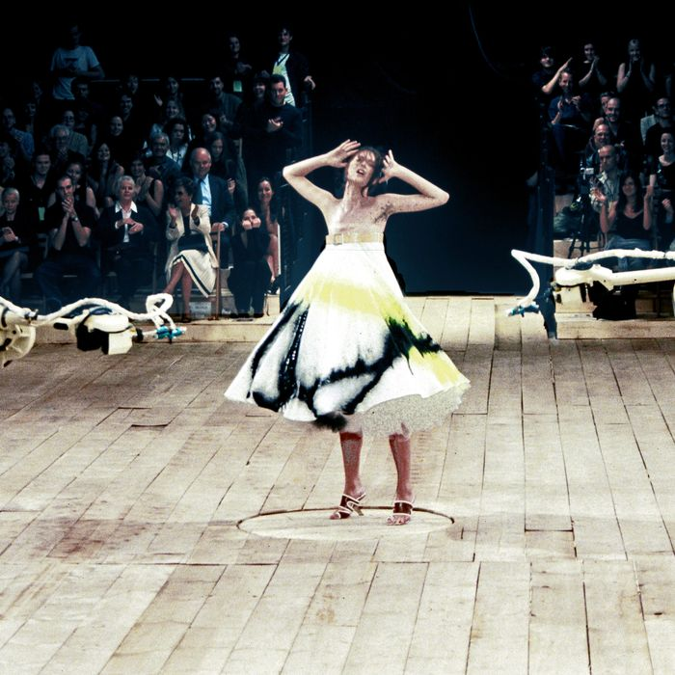
Alexander McQueen, No.13 catwalk show. 1999.

Thought Experiment: Timetable
For full-time students the Pecha Kucha takes place on Friday 6th November 2026.
For part-time students the Pecha Kucha takes place on Friday 4th December 2026.

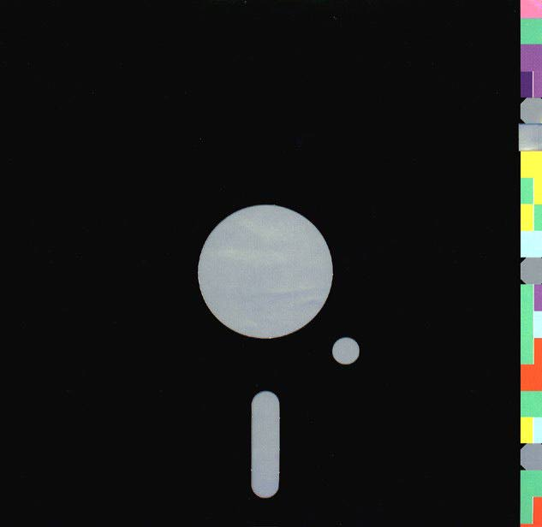
Peter Saville – Blue Monday 12” record cover. 1983.

INDUCTION WEEK Friday 25th September 2026.
Welcome Day – Starts 10.00am Round Reading Room, Alex Campus. (AAG06)
Staff Introductions
Course Structure
Campus Tours
(times vary for each Pathway)
Pathway Meetings
3.00pm – 4.00pm
Student Voice, Student Services, Welsh, etc.
General Library Induction
Use your library induction session to research an artist/designer/practitioner outside your own practice, who works with the notion of ‘everyday life’.

WEEK 1 Friday 2nd October 2026.
11.00 – 12.30 in Alex Reading Room (AAG06)
Introduction, Briefing and Thought Experiment selection
Introduction to the project with Martin Bush. In this session you will select your initial Thought Experiments. These will be used to stimulate ideas and begin the research process. In the session we will run through dates, requirements, submission, making your experiment choice, outcome presentation formats, and physical/digital submissions.

Tutorials for full-time and part-time students
(times/days organised independently with your Pathway Leader)
There will be opportunities for all students to have a weekly, 20 minute, one-to-one or group tutorials throughout the module with your Pathway Leader.

WEEK 2 Friday 9th October 2026.
11.00 – 12.30 in Alex Reading Room (AAG06)
The Thought Experiment – Launchpad.
Lecture with Martin Bush covering central themes as a launchpad for your creative journey.
Tutorials for full-time and part-time students
(times/days organised independently with your Pathway Leader)
There will be opportunities for all students to have a weekly, 20 minute, one-to-one or group tutorials throughout the module with your Pathway Leader.

WEEK 3 Friday 16th October 2026.
11.00 – 12.30 in Alex Reading Room (AAG06)
The Encounter
Lecture with Martin Bush that considers the distinction between recognition and an encounter.
Tutorials for full-time and part-time students
(times/days organised independently with your Pathway Leader)
There will be opportunities for all students to have a weekly, 20 minute, one-to-one or group tutorials throughout the module with your Pathway Leader.

WEEK 4 Friday 23rd October 2026.
11.00 – 12.30 in Alex Reading Room (AAG06)
Speed Tutorials
The tutorial to the power of n, an experimental event involving multiple staff and students from across disciplines based on a form of ‘speed dating’. Prepare for multiple perspectives on your work in a short period of time, all aimed at brainstorming in the service of your ‘thought experiment’. Students drop in and out of face-to-face tutorials during this timeframe. Expect your tutorial to last just 3 or 4 minutes. In these tutorials you will also catch advice being given to other students which will also be useful. We advise you to do as many as possible. Evidence of participation will be required in your final submission.
Tutorials for full-time and part-time students
(times/days organised independently with your Pathway Leader)
There will be opportunities for all students to have a weekly, 20 minute, one-to-one or group tutorials throughout the module with your Pathway Leader.

WEEK 5 Friday 30th October 2026.
11.00 – 12.30 in Alex Reading Room (AAG06)
Artificial Intelligence
This lecture explores the present and future potential of generative artificial intelligence as a creative tool.
Tutorials for full-time and part-time students
(times/days organised independently with your Pathway Leader)
There will be opportunities for all students to have a weekly, 20 minute, one-to-one or group tutorials throughout the module with your Pathway Leader.

WEEK 6 Monday 2nd to Thursday 5th November 2026.
Digital upload and prep (full-time students only)
Full-time students must provide and upload any digital presentation materials in preparation for Fridays’ Pecha Kucha. You will be sent a OneDrive link.
Pathway leaders will organise and help each student to upload submissions on to a specified and supplied OneDrive link in preparation for the main event on the Friday. If you are creating a live performance, you must ensure this has been organised for your timetabled Pecha Kucha presentation.
(Students and Pathway Leaders are responsible for ensuring files/performances/props are ready for presentation on the Friday at the allocated time.)
The Pecha Kucha runs for the whole of Friday 6th and to ensure we run to time, you will need to upload any of your digital files that you want to show during your Pecha Kucha presentations, such as videos, power points, sound scores, imagery, stills, etc. Please organise with your Pathway Leader as early as possible by the 5th November.

WEEK 6 Friday 6th November 2026.
9.00 – 17.30 in Alex Reading Room (AAG06)
Student Pecha Kucha Presentations (full-time students only)
Deadline for module submission (full-time students only)
The Pecha Kucha presentation day for full time and part time students. Everyone is welcome to join the audience. Quick fire presentation mode is to be utilised as creatively as possible in order for you to give a snapshot of your research trajectory during the project. All necessary media material is uploaded and prepared before the event onto a designated OneDrive to ensure for a fluid series of presentations that enable the smooth running of the day. The building of this media will take place throughout the week preceding the presentations and should be done in collaboration with your Pathway Leader. Pathway Leaders must also receive ALL physical submissions, digital files and URL links to all students’ research work and any blogs along with passwords on this day.

WEEK 7 – 8 Friday 13th, Friday 20th, and Friday 27th November 2026.
Tutorials for part-time students
(times/days organised independently with your Pathway Leader)
There will be opportunities for all students to have a weekly, 20 minute, one-to-one or group tutorials throughout the module with your Pathway Leader.

WEEK 9 – 10 Friday 27th November to Thursday 3rd December 2026.
Digital upload and prep (part-time students only)
Part-time students must provide and upload any digital presentation materials in preparation for Fridays’ Pecha Kucha. You will be sent a OneDrive link.
WEEK 10 Friday 4th December 2026.
9.00 – 11.00 in Alex Reading Room (AAG06)
Student Pecha Kucha Presentations (part-time students only)
Deadline for module submission (part-time students only)
The Pecha Kucha presentation day for part-time students. Everyone is welcome to join the audience. The format is identical to the full-time students Pecha Kucha.

MODULE CODE: ADDA7007
TITLE: The Thought Experiment
LEVEL: 7
CREDITS: 20

AIM(S)
- To provide an ‘experimental space’ to explore the boundaries of the student’s current medium specific practice by finding creative solutions to a research question stimulated by ‘new’ modes of thinking.
- To widen the student’s creative potential, engender dialogues across critical practices and encourage exploration and experimentation with a range of research methods, strategies and practices available across diverse art and design disciplines.
- To enable the student to develop individual and innovative approaches to the recording, collating and application of new knowledge and experience within their creative practice.

LEARNING OUTCOMES
Upon the successful completion of this module, the student should be able to demonstrate the ability to:
- navigate opportunities for experimentation with a high level of skill and critical thinking;
- critically analyse, interpret and evaluate complex information related to art and design concepts and theories, and produce modified conceptions;
- professionally communicate conceptual ideas and experimental practices.

INDICATIVE CONTENT
- The undertaking of a ‘thought experiment’ regarding self and experience, which will test assumptions regarding the definition and boundaries of each individual’s discipline and extend their current practice.
- Systematic approaches to project planning, research documentation and information retrieval.
- The free-associative creating and planning of a design research project from indeterminate or external stimulus that is process led and does not necessarily have a prescribed outcome or object.
- Cross-disciplinary experimentation, including collaborative working, performative and non-material practices.
- Historical and current models of experimental presentation modes; e.g. Pecha Kucha, blogging and social media platforms.
- Research sources and methodologies. These involve the examination and application of relevant paradigmatic methodologies derived from a range of sources across the history of art, design and ideas.

LEARNING AND TEACHING STRATEGY
The module will be delivered across a number of creative disciplines that constitute the Creative Dialogues Postgraduate Portfolio. Initially these disciplines will be clustered using descriptive constructs of Art (A) and Design (D) as investigative strands. Seminars and tutorials will introduce the concepts of open-ended experiment and the potential of ‘play’ and ‘experimental working’ in art and design. As the module progresses the A & D strands will be encouraged to interlace through seminars and the use of the Virtual Learning Environment. For example, ‘speed tutorial’ events will be utilised to give the students quick access to multi-faceted feedback from practitioners outside their specific area of creative practice and encourage trans-disciplinary discourse. The module culminates in a presentation ‘event’ at which opportunities for future collaborative dialogues across the portfolio will be established and formalised.
The allocation of teaching to deliver the module is:
Activity type Hours Percentage
Scheduled learning 48 24%
Independent Learning 152 76%
Placement learning - -
TOTAL 200 100%

ASSESSMENT
Assessment Component 1 – 100%
Coursework – Portfolio (5000-word equivalent /10 elements).
Exemplar
A student-initiated project, presented as a portfolio of exploratory creative work, which demonstrates experimental practice and conceptual thinking. The work can be communicated in any suitable format (analogue or digital) and may comprise of a combination of any of the following elements e.g. drawings, sketchbooks, visual diaries, samples, prototypes, computer models, video recordings, artefacts etc. This body of experimental work will be communicated at a trans-disciplinary ‘event’ using any appropriate and effective communication modalities, for example, a ‘Pecha Kucha’ style creative presentation, a video, interactive experiences, digital or physical prototypes.
Assessment Summary
Activity type Percentage
Written exam -
Coursework 100%
Practical -
TOTAL 100%

EDUCATION FOR SUSTAINABLE DEVELOPMENT (ESD)
Does the module contribute to ESD? Yes.
This module embeds sustainability through innovative pedagogies such as the speed tutorials that allow for cross-disciplinary working as outlined in the ‘Futures Fit Framework’ (2012). The module has been designed to challenge student’s perceptions and experiment with their thoughts and ideas within a collaborative teaching and learning environment. The ‘UNESCO Five Essential Pedagogic Approaches’ are central to the teaching and learning approach of this module, students will be challenged to think critically and creatively and explore a vision for a sustainable future.

BIBLIOGRAPHY
Essential
Baggini, J. (2010) The Pig That Wants to be Eaten: And Ninety-Nine Other Thought Experiments, London: Granta Books.

Bishop, C. (ed) (2006) Participation, London: Whitechapel Art Gallery.

Cave, P. (2008) Can a Robot be Human? 33 Perplexing Philosophy Puzzles, London: Oneworld Publications.
Collins, H. (2010) The Theory and Practice of Research for the Creative Industries, Worthing: AVA Publishing.
Csikszentmihalyi, M. (2013) Creativity: The Psychology of Discovery and Invention, New York, Harper Collins.
Fletcher, A. (2001) The Art of Looking Sideways, London: Phaidon.
Kaprow, A. (2003) Essays on the Blurring of Art and Life, Berkeley: Univ. of California Press.
Pol Droit, R. (2002) 101 Experiments in the Philosophy of Everyday Life, London: Faber & Faber.
Robinson, K. (2011) Out of Our Minds: Learning to be Creative, Minnesota: Capstone Publishing.
Recommended
Barbour, R. (2013) Introducing Qualitative Research: A Student’s Guide, California: Sage Publications.
Brotchie, A (1995) A Book of Surrealist Games. Colorado: Shambhala Publications Inc.
Doherty, C. (2009) Situation, London: Whitechapel Art Gallery.
Glasner, B (2008) Patterns 2: Design, Art and Architecture. Basel: Birkhäuser GmbH.
Hemmings, J (Ed) (2014) Cultural Threads. London: Bloomsbury.
Ingledew, J. (2011) The A-Z of Visual Ideas: How to Solve Any Creative Brief. London: Laurence King.
Lynch, D. (2006) Catching the Big Fish: Meditation, Consciousness and Creativity, New York: Penguin.
Newman, H (2001) Performancemania, London: Matt’s Gallery.
Norman, D. A. (2005) Emotional Design. Why We Love (or Hate) Everyday Things, New York: Basic Books.
Plummer, H (2012) The Architecture of Natural Light, London: Thames and Hudson.
Rowley, S (ED) (1999) Reinventing Textiles Volumes 1, 2, 3. Canterbury: Telos Art Publishing.
Trott, D. (2016) One + One = Three: A Masterclass in Creative Thinking. Basingstoke: Pan MacMillan.
Background
Auslander, P. (2008) Liveness: Performance in a Mediatised Culture, London: Routledge.
Colchester, C. (1993) The New Textiles: Trends and Traditions, London: Thames and Hudson.
Coverly, M. (2010) Psychogeography, London: Pocket Essentials.

Goldsmith, K. (2011) Uncreative Writing: Managing Language in the Digital Age, New York: Columbia University Press.
Kumar, R. (2014) Research Methodology: A Step-by-Step Guide for Beginners, California: SAGE Publishing.
Loxley, J. (2006) Performativity, London: Routledge.

McEvilly, T. (2010) Yves the Provocateur: Yves Klein and Twentieth Century Art, New York: McPherson & Company.
Perkowitz, S. (2001) Universal Foam. The Story of Bubbles – from Cappuccino to the Cosmos, New York: Vintage Books.
Stracey, F. (2014) Constructed Situations: A New History of the Situationist International, London: Pluto Press.
Surowiecki, J. (2006) The Wisdom of the Crowds: Why the Many are Smarter Than the Few, London: Abacus.
Journals
Creativity Research Journal (Taylor & Francis)
Rhizomes online journal www.rhizomes.net
Websites
www.culturemachine.net
www.droog.com
http://www.imaginaryscience.org
www.necronauts.org
www.notbored.org
http://www.patakosmos.com
http://pataville.blogspot.co.uk
www.slowlab.net
www.ubu.com
www.wired.com
http://xkcd.com
http://www.yveskleinarchives.org

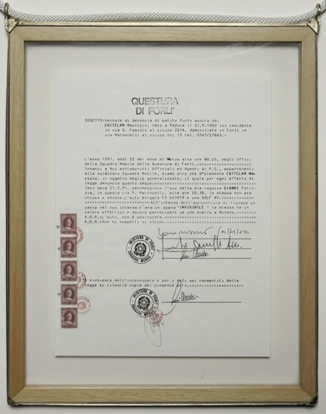
Maurizio Cattelan Denunzia 1991.
The Italian provocateur's police report concerning the theft of an invisible artwork from his car.
Photograph: Hayward Gallery.

