INDIVIDUAL BUSINESS MODEL CANVAS

STUDENT NAME: GINA STEFANUTA

STUDENT ID: 2120011

MODULE TITLE: Entrepreneurship BMIH5001

LECTURER’S NAME: CHARLOTTE JOYNER

Total word count: 2000 words

Table of Content
Part 1 Essay 3
Introduction 3
Main Body 4
Conclusion 8
Part 2: Reflective Section 8
Reference list 10

Part 1 Essay

Introduction
For this particular assignment, the hospitality business related to a cafe is being considered named the Cafechino Cafe for addressing the BMC (Business Model Canvas) to justify the total resources and the allocation and gathering of funds and other related aspects while proposing the business venture to start. The proposed plan for opening this cafe is to offer interactive coffee products to customers from both local and international domains. Furthermore, the Cafechino cafe will also offer home delivery options and a dedicated online platform to order and also offer free delivery of services for the order maximum of 10 Km of range, as an initiative to attract more customers. As stated in the survey of 2022, the UK hospitality sector of the UK has generated around £16.42 billion which indicates a higher market share of the hospitality sector (Statista, 2023). The primary aim of this assignment will mostly involve addressing the BMC framework on this proposed Cafechino coffee brand and estimating the various allocations and requirements of the funds to be gathered for the commencing of this business.

Main Body
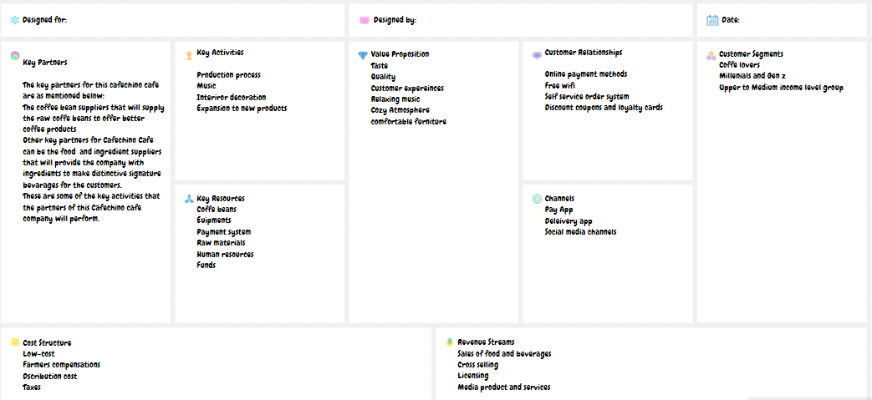
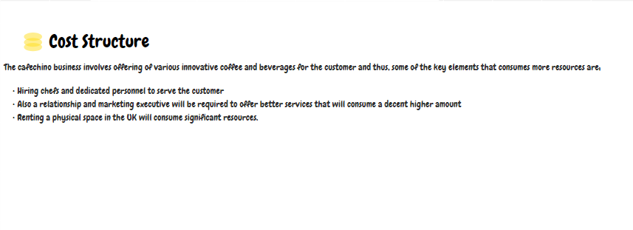
Figure 1: Business Model Canvas framework on Cafechino cafe brand
(Source: Created by the learner)
Every company while proposing their brand and its multiple associated activities, especially before starting the business, has various types of key elements that need to be identified including the primary proposition of the business plan. The key resources to be required for the conducting of this business along with offering various identification of the resources that will be needed for the operations of this business plan. These variables and elements within the operations of the proposed business are some of the key and significant elements to consider before opening this business. Furthermore, better identification of this mentioned key element involved while opening and operating the new business can be conducted effectively using the Business Model Canvas (BMC) framework. In the opinion of Sadikin et al. (2023), the Business Model Canvas can be defined as the particular set of models and strategic management modem that assists the business entrepreneurs in visualising, observing, designing and framing multiple required and key elements required for better and sustainability of this proposed business plan. Similarly, in this case, offering an enhanced and strategic tool for management can be much more impactful to offer better visualisation and identification of key resources and funds allocations needed for the starting of this cafe named Cafechino cafe in a competitive market like the hospitality sector of the UK.
By observing Figure 1 in the appendix, the key partners for the opening and operating of this Cafechino cafe, the partners are required that be in charge of offering various raw materials and other supplying of the raw materials to engage the customers with the final coffee and beverage products. For example, as per the choice, the coffee beans supplier and innovative beverages and food suppliers are identified as the key and primary partners for conducting this business named Cafechino Cafe to engage more local and international tourists. Therefore, justifying the choice of partners for this Cafechino cafe brand. Furthermore, the following sections of the BMC framework address the key activities that this Cafechino cafe business will endure and incorporate. As per the survey of 2023, around 65% of the respondents preferred hot coffee in the UK (Statista, 2023). Furthermore, this Cafechino cafe also offered activities to attract more customers. For example, the Cafechino cafe business will offer 10 Km of free delivery services for online or home delivery. Also, the BMC model has addressed the specific set of resources that the company also needed while initiating this business (Saad et al., 2023). For example, the BMC for this Cafechino cafe business has also stated various key resources that will act as a primary solution to offer a wider range of customer satisfaction, such as a loyal team of employees and a physical existence rented for initiating the Cafechino cafe project.
Apart from offering free deliveries for orders within 10 Km the cafe cafechino brand will also offer sustainable packaging and offer free crackers for any orders above £20. This can be considered as the unique features that will boost the existence of this Cafe Cafechino brand. Furthermore, the cafe will start with its physical existence at 16 Piccadilly, London W1J 0DE, London UK. This location is ideal for the Cafe Cafechino brand as it will be present around the Shaftesbury Memorial Fountain which is one of the tourist spots in London. Furthermore, considering the location, the Cafe Cafechino brand also has competitors such as Hotel Café Royal, WFM Coffee Bar, and Perks & White Coffee, St James's Market. Moreover, Coffee Omega UK Ltd and Kafea Terra UK Limited are some of my primary suppliers from which the Cafe Cafechino will obtain the coffee maker and the raw coffee beans. Also, as stated in the figure in the appendix, the key activities involved while opening this business involve the distribution of various cake products and innovative coffee drinks such as Irish coffee, Espresso Martini, Cappuccino, hot coffee and many other interactive coffee-oriented products.
One of the primary and considerable driving forces for any business is the higher market value and potential of the UK market for the sustainability of the brand (Amoah et al., 2023). As reviewed and estimated by the current market survey, the hospitality sector of the UK has observed a growth of around £11.28 billion from the previous year, also the market size of the hospitality sector of the UK is expected to reach around £19.76 billion in the year 2023 (Statista, 2023). Thus, can be considered as one of the most observable driving impacts that can contribute towards the success of multiple business ventures and also significantly contribute towards facing multiple limitations while commensing any specific business. Likewise, considering the current hospitality market value in the UK, it can be further estimated as one of the driving forces to consider for the operations of this Cafechion Cafe outlet in and around the UK. However, as stated by Arshad et al. (2023), competitors or competitive rivalries have a considerable external impact on the business and can also limit their operational capabilities. For example, considering the current market structure of the UK, there were around 25,892 in the year 2019 (Statista, 2023). That are considerable limitations to the operations of this proposed plan of opening the Cafechino Cafe outlet in and around the hospitality sector of the country. However, even though the cafe outlet numbers and the competitive rivalries of the country are higher, the Cafechino cafe brand can operate and obtain sustainability as the market share of the hospitality is higher which indicates the steady demand and also reflects the consumer potentiality. Thus, suggesting from the critical overview of the UK market, the Cafechino cafe can sustain the highlighted competitive market by proposing and offering something extra to attract more customers. For example, the value proposition as stated in the BMC model suggests that the cafe brand will offer free home delivery within the range of 10 km. Also, the Cafechino cafe brand will have higher customer engagement and CSR implications by offering only sustainable packaging of the coffee and beverages.
This is another section of the essay that consists of involving of various impacts and consists of an evaluation of driving forces that consist of higher customer demands for coffee in the UK. The higher customer demand for any product is one of the driving forces that significantly contributes to the sustaining impact of any business and also contributes to obtaining and serving a higher number of customers (Jayaraman et al., 2023). For example, supporting the statement, Costa Coffee which is one of the renowned brands in the UK, generated around £1.1 Billion in revenue in the year 2022 (Statista, 2023). Furthermore, in the year 2022, over 30% of coffee consumers in the UK drink coffee multiple times a day, whereas around 24% of the respondents have claimed that they prefer coffee once a day (Statista, 2023). Thus, considering the example of the relevant competitors of the Cafechino brand in the UK, and highlighting the frequency of coffee consumption by the consumers of the UK. Furthermore, the Cafechino company event though has a higher number of competitors in the UK hospitality sector, but with the higher demand for coffee products and the annual revenue earned by the Costs Coffee brand while operating in the UK, it can be evaluated as one of the driving force for this proposed business plan that can contribute towards its sustainability. However, as stated by Roberts et al. (2023), a sudden spike in the demand for the product in the sector can also limit the operations of the company and result in a limited impact on the brand. Similarly, the Cafechino cafe brand as this is an SME organisation initially is lacking abundant back office employee force to serve as a backup to the company at the time of a sudden spike in the coffee demand that can limit or impact the operations of the brand negatively.

Conclusion
Therefore, after completing this essay and conducting this BMC model on the proposed plan business venture of opening a Cafechino cafe brand it can be considered as one of the effective frameworks to justify identified requirements from the allocation of funds to the source of obtaining the funds and also predicting the key partners and key proposition that this Cafechino cafe will provide. Furthermore, multiple driving forces were conducted and identified that can impact and evaluate critically to better justify the situation.

Part 2: Reflective section
The Gibbs reflective cycle theory can be defined as a specific set of theories that involves effective strategies of reflecting the past experiences and also offers a distinctive pathway for evaluating the past experiences of any personnel (Ezezika et al., 2023). Some of the stages of this Gibbs reflective cycle involve;
Description stage; The primary stage of description involves a detailed description and complete overview of past experiences that highlight the key elements to notice (Bhat et al., 2024). Similarly, in my case, as I was attending the business management module, the lecturer was delivering knowledge regarding the multiple factors to consider regarding the BMC. It can also be considered that various entrepreneurial theories such as Entrepreneurship innovation theory, Cultural theories and other related theories were also discussed. Also, in the class, an entrepreneurial test (refer to appendix) is being conducted to evaluate my overall entrepreneurial skills and probable factors to consider for starting my own business.
Feelings stage; This is the next stage of the theory, which demonstrates and most emphasises the overview of the feelings possessed by any personnel while participating in their past (Kostoulas 2024). Similarly, in my case, while I was concentrating in class and learning about various entrepreneurial theories and the importance of the BMC model, due to my poor communication skills, I failed to understand the importance and impact of these Cultural theories in entrepreneurship. Thus, after evaluating the feelings I can claim that I have obtained excited and yet demotivated feelings due to my poor communication aspects. Apart from that, after conducting the entrepreneurial tests, I felt both excited and depressed at the same time, after revealing that my autonomy skills scored around 33% which is comparatively much lower. however, I have achieved sufficient scores in risk-taking and self-control of 67% and 75% respectively (refer to appendix).
Evaluation stage
This is the stage that mostly aims to evaluate the specific set of feelings and justify the probable reasons for the feelings of any personnel (Adeani et al., 2020). Similarly, as the lecturer was delivering knowledge regarding multiple theories of entrepreneurship due to my poor communication skills I felt too shy to ask about the importance of Cultural theory in entrepreneurship. Evaluating my entrepreneurial test result, and after reviewing my skills potential, I felt discouraged once as my autonomy skills were not profound enough to run my own business. Whereas, I have also gained comparatively better scores in risk-taking and self-control which have motivated me and resulted in my feelings.
Analysis stage
The key aim of this Gibbs reflective theory is to analyse and utilise the chance to make sense of the feelings the personnel have while experiencing and reviewing past experiences (Ezezika and Johnston, 2023). While conducting, the class demonstrating and evaluating the importance of involving multiple areas of entrepreneurial perspective, due to my poor communication skills and the involvement of the class full of learners I got tense and obtained incomplete learning regarding the importance of the cultural theory. Thus, this can be considered as the primary reason for my feeling of demotivated while engaging in the class. Analysing my entrepreneurial test result, I felt a bit discomfort and started questioning my ability to achieve my dream of becoming an entrepreneur, which resulted in my depressed feelings. But after addressing the possible measures and analysing my strengths I have gained significant moral strength and motivation to commence my journey towards becoming an entrepreneur
Conclusion stage
The conclusion stage is the second last section of the Gibbs reflective cycle that highlights multiple factors regarding demonstrating the key observations and learnings that the personnel has identified while evaluating past experiences (Zhan et al., 2023). Similarly, in my case, while evaluating my past experiences I have identified the knowledge gap in terms of identification of various important Cultural Theory implementations for becoming an effective entrepreneur. Also, after conducting the entrepreneurial tests, it is much more significant to demonstrate that my business autonomy skills are poor and can also be concluded that this skill needs to be improved using effective means. However, in the conclusion stage, it is also important to mention that apart from my autonomy skills, I have strong risk-taking and management experiences and also demonstrate significantly higher self-control that assists in business decision-making (refer to appendix).
Action Plan stage;
This is the final stage of Gibbs's reflective cycle which states the formulation of a specific set of plans of action to develop the skill or knowledge gap identified while reviewing the past information (Zafeer and Maqbool, 2023). Similarly, I have identified that my communication skills need to develop which is also the primary requirement for becoming an entrepreneur in my career. Thus, I have decided to enrol myself on communication skill development schemes to recover my identified skill gap while conducting this business management module course. Lastly, it has been decided that I will take the autonomy business extra class to improve my autonomy skills which are lacking compared to my other traits as described in the entrepreneurial tests, to tackle and handle entrepreneurial decisions more accurately.

Reference list
Adeani, I.S., Febriani, R.B. and Syafryadin, S., 2020. Using GIBBS’reflective cycle in making reflections of literary analysis. Indonesian EFL Journal, 6(2), pp.139-148.
Amoah, J., Bankuoru Egala, S., Keelson, S., Bruce, E., Dziwornu, R. and Agyemang Duah, F., 2023. Driving factors to competitive sustainability of SMEs in the tourism sector: An introspective analysis. Cogent Business & Management, 10(1), p.2163796.
Arshad, M.Z., Arshad, D., Lamsali, H., Alshuaibi, A.S.I., Alshuaibi, M.S.I., Albashar, G., Shakoor, A. and Chuah, L.F., 2023. Strategic resources alignment for sustainability: The impact of innovation capability and intellectual capital on SME's performance. Moderating role of external environment. Journal of Cleaner Production, 417, p.137884.
Bhat, N., Dahal, A., Gurung, S. and Sapkota, B., 2024. Implementing Reflective Writing at a Newly Established Health Science Academy of Nepal: Exploring a Novel Practice, Overcoming Obstacles and Recommendations. Journal of Medical Education and Curricular Development, 11, p.23821205231221724.
Ezezika, O. and Johnston, N., 2023. Development and implementation of a reflective writing assignment for undergraduate students in a large public health biology course. Pedagogy in Health Promotion, 9(2), pp.101-115.
Ezezika, O. and Johnston, N., 2023. Development and implementation of a reflective writing assignment for undergraduate students in a large public health biology course. Pedagogy in Health Promotion, 9(2), pp.101-115.
Jayaraman, K., Jayashree, S. and Dorasamy, M., 2023. The effects of green innovations in organizations: Influence of stakeholders. Sustainability, 15(2), p.1133.
Kostoulas, A., 2024. Challenging normative influences in refugee and migrant education: Reflections of a trainee teacher cohort. Teaching and Teacher Education, 139, p.104454.
Roberts, H., Milios, L., Mont, O. and Dalhammar, C., 2023. Product destruction: Exploring unsustainable production-consumption systems and appropriate policy responses. Sustainable Production and Consumption, 35, pp.300-312.
Saad, A.M., Dulaimi, M. and Zulu, S.L., 2023. A systematic review of the business contingencies influencing broader adoption: modern methods of construction (MMC). Buildings, 13(4), p.878.
Sadikin, A., Naim, S., Asmara, M.A., Hierdawati, T. and Boari, Y., 2023. Innovative strategies for MSME business growth with the business model canvas approach. Enrichment: Journal of Management, 13(2), pp.1478-1484.
Statista, 2023.Cafes and coffee shops in the United Kingdom (UK) - statistics & facts. [online] available at:<https://www.statista.com/topics/3650/cafes-and-coffee-shops-in-the-united-kingdom-uk/#topicOverview> [Accessed on 19th January 2024]
Statista, 2023.Coffee consumption trends in the UK - statistics & facts. [online] available at:<https://www.statista.com/topics/11463/coffee-consumption-trends-in-the-united-kingdom/#topicOverview> [Accessed on 19th January 2024]
Statista, 2023.Coffee market in the UK - statistics & facts. [online] available at:<https://www.statista.com/topics/6188/coffee-market-in-the-uk/#topicOverview> [Accessed on 19th January 2024]
Statista, 2023. Hot or iced coffee consumption preference in the United Kingdom 2022. [Online] available at:<https://www.statista.com/statistics/1407102/hot-or-iced-coffee-consumption-preference-uk/#:~:text=Hot%20or%20iced%20coffee%20consumption%20preference%20in%20the%20United%20Kingdom%202022&text=During%20a%20survey%20conducted%20in,a%20share%20of%2065%20percent.> [Accessed on 18th January 2024]
Statista, 2023.Number of coffee shop outlets in the United Kingdom (UK) from 2009 to 2019. [online] available at:<https://www.statista.com/statistics/978010/coffee-shop-numbers-united-kingdom-uk/#:~:text=Number%20of%20coffee%20shops%20in,Kingdom%20(UK)%202009%2D2019&text=The%20number%20of%20coffee%20shop,previous%20year's%20total%20of%2025%2C486.> [Accessed on 19th January 2024]
Statista, 2023.Selected leading coffee shop chains in the United Kingdom (UK) as of January 2023, by number of units. [online] available at:<https://www.statista.com/statistics/297863/leading-coffee-shop-chains-in-the-united-kingdom-uk-store-number/> [Accessed on 19th January 2024]
Statista, 2023. UK hotel industry market size 2013-2023. [online] available at:<https://www.statista.com/statistics/1364712/hotel-industry-market-size-uk/#:~:text=In%202022%2C%20the%20market%20size,reach%2019.76%20billion%20British%20pounds.> [Accessed on 19th Januray 2024]
Zafeer, H.M.I., Li, Y. and Maqbool, S., 2023. An Approach to Progress Learning Outcomes: International Graduate Students’ Engagement in Reflective Practice and Reflective Journal Writing during Pandemic. Sustainability, 15(3), p.1898.
Zhan, T.T., Wang, L.L., Wang, Y. and Sun, C.J., 2023. Master of nursing specialist experiences of an internship through the use of written reflections: A qualitative research study. Heliyon, 9(2).

Appendix


