SAMUEL KWASI GYIMAH
1908216
BMSW4001
ACADEMIC AND EMPLOYABILITY SKILLS

LECTURER: SHAO LAN

REFLECTIVE REPORT ON MY LEARNING IN THIS MODULE

INTRODUCTION
(Driscoll, 1994) 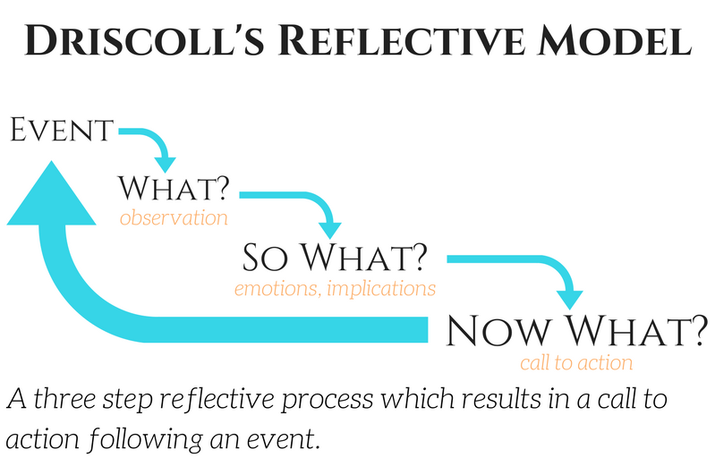
In this report I am going to reflect on my learning about Curriculum Vitae (CV), Covering Letter, Presentation, and Communication. I will use Driscoll’s reflective model throughout the reflection. I have not had the opportunity in my life to make use of any of these topics in my working life. I have lived in Italy for a long time. All that time, I worked in a factory and did not make any application whatsoever. Since 2013, when I relocated here from Italy, I have been working in the same care company.
CV
I had my first training in CV writing by the Job Centre to apply for the job I am still doing. It is clear up to this point that my knowledge about CV writing was very scanty at the time of enrolment. The topic was new when it was being treated last term. At the start all seemed scary, asking myself if I could ever write a CV that would stand out for me to be invited for interview. I got the idea that if I were able to write one, it would be enough for all job applications. After going through the lectures, the scary feeling began to fade away. For practising purposes, I have applied for a position as a manager in two different Care homes and I was invited for interview. According to Morgan, (2017) CV is not a list of everything I have done in the past and one CV is not to be used in every application I make to different organisations. An online profile of myself is important on my CV.
Any organisation seeking a new employee is asking through the job description and specification; ‘do you understand me, can you help me’? Through my CV I respond to this request. Therefore, I try to structure my CV to suit the company, hence avoiding one CV to different companies. Online profile will make right people get to see my CV and call me for interview. I do agree with Morgan. This understanding about CVs will lead me on to secure a high position in the NHS after graduating.
COVERING LETTER
I did not have much knowledge about Covering Letter just as I lacked knowledge about CVs. At the start of the class to deal with the topic ‘Covering Letter’, I said to myself it was better if I missed the class. I have never written a covering letter but I am working, meaning covering letter is not that relevant. I was somehow angry. At this point I got reminded of Stephen R. Covey’s book ‘The 7 Habits of Highly Effective People’. My anger would not make me better but my values. Being angry would make me ignorant because I would not have the proper mindset to learn about covering letters. Vision of the future strengthened me to be present in the lecture hall and to set my mind on the lectures. I was being proactive. (Covey, 2013).
I was so much happy after the class because the knowledge I had about Covering Letters strengthened me and motivated me to start looking elsewhere for better job than what I am doing now. I have now come to understand that covering letters do not repeat what is in the CV. My achievements and experiences in the past are expressed in the CV. My suitability to jobs being applied for is expressed in the covering letters. Prior to writing covering letter I am to fish for such information as the name of the Recruiter. The knowledge about the recruiter makes covering letter looks personal. ‘Dear Samuel’ instead of Dear Sir/Madam could be written in the covering letter. Yours sincerely would be the ending. In the covering letter CV must always be referred to. (Morgan, 2017).
Covey and Morgan are all right in their given information. Usually, when one is happy then good behaviour may follow. It takes a disciplined character that upholds values to act positively in unhappy mood. Every recruiter wants someone who understands the company he is recruiting for to join the team. Feedback on in-class exercise on covering letter is another useful tool in my learning. It was a verbal feedback because of Covid-19.
PRESENTATION
In religious place of worship I sometimes do presentation or preach to the congregation. I have preached or presented to a congregation of about 300 before. With this experience, I thought I had acquired all the presentation skills needed. Last term we had a group presentation in the Digital Skills Module. Around the time of preparation, and at the day of presentation, it was clear that the skills I had already was not academic presentation skills. Working in the group made it more difficult. I was also lacking in the IT skills. This negative experience worsened my position on Presentation. In this term when we treated ‘Public Speaking’ or Presentation I was relieved. I had a better understanding of the subject. No more panicking.
“We are what we repeatedly do. Excellence is not an act, but a habit.”- Aristotle.
Disciplining myself and keeping the habit of preparing well before any Presentation I will definitely come out satisfied. After Preparing my notes, knowing my audience and my goals what is left for me is rehearsing. In Presentation, rehearsal is very important. Through rehearsal I will identify what I can remember and what I cannot. (Morgan, 2017)
Preparing is good for presentation going well. “By failing to prepare you are preparing to fail”-Benjamin Franklin, a founding father of the United States. However, over-preparing can cause problems when a surprise crops up.
I have learnt to keep a balance between relying on my preparations and my knowledge. If the computer, from which my slides and notes are displayed, should crash in the course of the presentation, I can continue to deliver from my knowledge. However, if I do not keep the balance I would be forced to restart or to stop completely.
EFFECTIVE COMMUNICATION
I have understood now that without effective communication all the society will be a chaos. I have my personal experience at my workplace as a case study for reflection. I work with a company that renders services to the elderly in their own homes: (Community Care Company). Verbal communication through the mobile phones is the type used mostly at the workplace. I was out in the town and a coordinator wanted to give me a message concerning a service-user. Precisely I was by A 127, a very busy road with big trucks. I received the phone call alright. The message did not get to me because at that moment a noisy big truck pulled up and even blew the horn. This coordinator reported me to the Manager that she spoke to me but I refused to respond. In fact, when I later got to a calm area I called back but she had already reported me so she did not bother. The manager questioned me and my response was: I did not receive any message from the coordinator.

(Shannon, 1948) 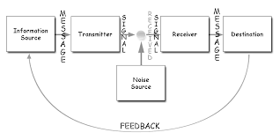
After going through this topic I became relieved and understood that, Noise Source which in my case, was the noise from the truck truncated the communication. The coordinator knew she had given me the message but it did not get to me.
In this unfortunate situation we see the noise source effect. There is an advantage of this model. Knowing the noise source makes it possible to eliminate. The feed back from receiver to the message source confirms how the message transmitted was received. .In my case the coordinator, the message source, did not have the feedback.
Nonverbal is a type of communication. Someone may be expressing themselves verbally but their nonverbal expression would determine their honesty or otherwise.
Active listening and assertiveness bring transparency in information processing.
(Maund, 2017)
CONCLUSION
After successfully going through this course, and attaining my BSc degree, I would aim at changing my working position. CV and Covering Letters, very important tools in searching for jobs would be in my learning plans all the time. Presentation would be part of me to enable me sell myself when the time comes. Effective communication, the energy for the success of all businesses will be practised all the time.

References
Reference list
Covey, S.R. (2013). 7 Habits Of Highly Effective People. Simon & Schuster Ltd.
Driscoll, J. (1994). Reflective practice for practise. Senior Nurse, 13, pp.47–50.
Maund, A. (2017). Certificate in higher education : skills for the workplace student yearbook. London: Sage Publications.
Morgan, P. (2017). The Business Student’s Guide To Study and Employability. London: Sage.
Shannon, C.E. (1948). A Mathematical Theory of Communication. Bell System Technical Journal, [online] 27(3), pp.379–423. Available at: http://worrydream.com/refs/Shannon%20-%20A%20Mathematical%20Theory%20of%20Communication.pdf [Accessed 1 Mar. 2019].
‌

“We are what we repeatedly do. Excellence is not an act, but a habit.”- Aristotle

