
ACADEMIC AND EMPLOYABILITY SKILLS
  - BMSW4001_BIRM

Reflective report

Lecturer:Doreen Nyaa Amundam
Student: Nicoleta Damian(2120244)

Contents
Introduction 1
REFLECTIVE WRITING 1
MODELS OF REFLECTION 2

Reflection abouT Writing the academic report………..…………………3-5
GroUp presentation experience…………………………………………………5-8
Personal development plan ………………………………………………………..9
Conclusion………………………………………………………………………………….10

ReFerence list ……………………………………………………………………………11

Introduction
‘By three methods we may learn wisdom: First, by reflection, which is noblest; Second, by imitation, which is easiest; and third by experience, which is the bitterest.’ Confucius
This quote explain in a great way why reflecting is important and how it can improve and impact on our development and growth as professionals.
As you presume this reflective report will be composed with reflections about writing the first assessment, which was an academic report with the title ‘ What is the most effective way to motivate staff?’ as well as our group presentation which we presented in week 8.
I assume this will catch your attention as lots of useful information is going to be noted, for example different models of reflection ( Gibbs model of reflection, The Era cycle). A personal development plan is going to be provided which is going to make an great impact in the future and will develop our professional skills.

Reflective Writing
Have you ever think about what you can change and improve after reading a book, watching a movie, or maybe listening to somebody’s presentation?
The answer to this question is the beginning of reflection, which makes us think and express feelings, thoughts and even helping to create a better version.
What is reflective writing and how it can be applied?
Reflective writing becomes formal or informal writing around a particular topic once it has been introduced in writings or public, and it uses emotional states, remembrances, or opinions. Reflective writing is frequently utilised to respond to what was read and to retrieve information out of a particular occurrence, work of literature, as well as learning experience which has been provided. It could be used to identify major points and to generate innovative suggestions about a topic. Reflective writing is an essential approach for enhancing writing through creating opinions quite formed but also accurate, and for improving ability to think critically.
However, reflective writing isn't solely for private reasons. In an academic context, reflective writing is being used to investigate your reaction to an unique adventure or fragment of work. Once implemented to rational reflection or exploratory handling, reflective writing can be methodical. Started by reflection to get a sense about where you're going throughout your writings. The process of analysing your continuous professional development (CPD) actions is known as critical reflection. It inspires you to recognise connections among developmental projects and their outcomes, letting you to adequately reconfigure activities, behaviour patterns, as well as instructional goals. Also it stimulates acknowledgement of the intent of every CPD action, what you are particularly obtaining from them, but also prospective suggestions for the future improved performance.
Critical Reflection is an important part of learning additional knowledge, and that also enhances your ability to react to obstacles, quickly resolve, control emotions, maintain effective partnerships, and deal with stress on a wider scale.
Models of reflection
Along all the reflective models as The Era Cycle(2013), Kolb’s Model (1984), Driscoll’s what model ( 1990), I can promptly say that Gibb’s Model of reflection is the one I am going to use for this reflective task. Every model applies a gently different direction, but they all comprise the same phases. The primary difference is indeed the series of steps included or the level of detail selected by their founders.
Gibb's reflection model is made up of six steps. It is among the most sophisticated reflective models, and you may discover getting numerous steps in the process to advise you comforting. Gibb's cycle has six stages: descriptions, feelings, evaluation, analysis, conclusion and action plan.
As we studied in week 8 Gibb's model, like others, starts with an overview of perception being mirrored on. Then it motivates us to pay attention to our emotions about the expertise, during and after it.
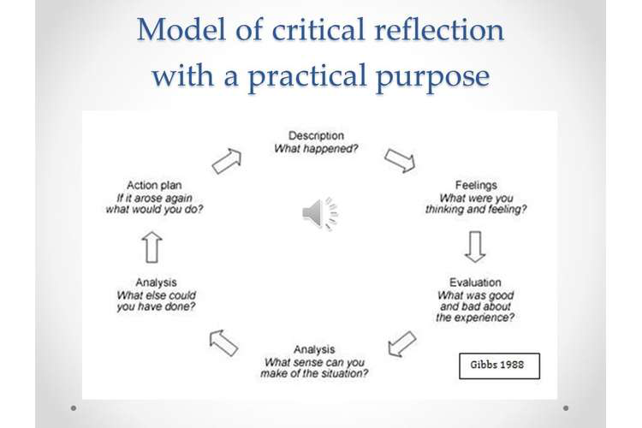

Reflection about writing The Academic report (task 1)
The academic report is one of the most used by professionals during their careers. For me writing my first academic report intitled ‘What is the most effective way to motivate staff?’ has been a wonderful experience. The academic report consisted of what are the best ways that staff can be motivated.
Researching and note taking are some of the best actions that can help in writing an academic report. Researching for me represents a tool for expanding knowledge and providing learning, a way to better comprehend problems and inform the public, aids our commercial success, enables us to debunk untruths and endorse facts. It is a method for identifying, assessing, and seizing possibilities and instils a fondness of, and self belief in, reading, writing, analysing, as well as communicating valuable knowledge.
Researching for that particular report I found quite easy, as we already were having four sources given during second week. An important part that we studied and which also helped a lot was Google scholar, where to find sources become the easiest part.
Taking notes makes writing easier and helps as well with managing time which represents an important part on writing a report.
Time management is the practise of organising well how allocate the time among various activities or preferences. Improved routines and productivity improvements are among the advantages of managing time. Effective time organisation sharpens your concentrate, boosts your esteem, and enables you to arrange your time more efficiently.
Proper time management assists managers, employers, and companies in reaching their objectives. Prudent time management enhances work harmony and pleasure. Effective time management as well helps reduce stress and enables you to improve your performance more quickly and easily.
The drafting of a piece of writing begins with an examination of the writing process. The writer need to use his prewriting notations to ascertain a piece's concentrate. It might entail narrowing the article's spotlight and possibly recognising an intent for the component.
After finishing a rough draught, the writer must begin the first edit of his task. Editing is an ongoing cycle, not just a moment occurrence. Whenever a writer wants to edit the writing, he is looking for misspellings. Some of those are generally spelling, grammatical errors, capital requirements, and formatting errors (paragraphs). It is best if an author is motivated to modify as much of material as possible.
The academic report represented a great opportunity to understand and start using all mentioned above, as all those points are critical in writing a great piece of work. As I mentioned researching is the key point in making a professional report, as it presume writing the report using facts.
Note making represents represents a critical point which is linked with time management skills, as I did not take notes about all the ideas discussed during sessions, but just the most important ones, it took me a bit more time to remember and find the needed information. This becomes a crucial part of the whole writing process. As I said these two steps go hand by hand and make writing easier. In my case all the notes I took gave a hand of help, but I noticed that as more notes you take as more prepared you become and at the same time you can spend more time on making the research more qualitative.
As time management represents for me an important criteria I can promptly say that trying to write correctly and precisely during drafting will reduce the time used to final edits. In my case, this step created a huge impact on time management.
Generally saying, the academic report has been a new experience, which definitely will help on becoming a professional and a leader in the future. The experience gained by writing it is definitely useful as well as the task 1 showed me how important notes making is.

Group presentation experience
There are several job vacancies and specialisations in which a company's performance is partially predicated on the level of their presentation. The manner in which the speech was delivered influences a portion of the assessment or analysis. In relation to developing effective tactics or alternatives, an efficient group must be skilled at successfully displaying its concepts. It is critical that the team's suggestions are properly expressed, regardless of the type of speech in which they are participating. The achievement of a powerpoint is determined by how the viewing public understand or receives it. As a result, a team must value the effectiveness of their slides just as much as the value of their other team works.
The best approach to displaying any of it is to be prepared to describe it obviously, in simple definitions, and also to illustrate pertinent points that affect the company choices. The way suggestions are introduced can greatly affect a presentation. A team's specialist stance with a person or company can be enhanced if the group offers a unique presentation, but it could also be reduced unless the team makes a terrible presentation.
The goal of the group presentation is to find and give details about a writing that will be useful in group discussions. The presentations would then serve as an introduction to the work and will assist others within the session in determining what this is about.
Our week 7-8 group presentation was about a job advertisement. Our team did an excellent job on the session . We attempted to talk with the colleagues and convince them with the job description. Our demonstration was created in this manner. We were self - assured during the speech and were available for questions from peers about viewing public choices, and more notably, they were capable of expressing our concepts.
Behind the great final results was a huge effort and some minor challenges.
As team members interact properly among each other, they are better able to cooperate and operate with each other to achieve a shared objective. Good communication within a team makes for improved across each, project implementation, and teammates partnership.
This was the weakest part of our group presentation as we did not collaborate until the last day before presentation. I also represents an key target for the future improvements.
Conducting research is critical for coming up with new concepts and ensuring that we are using the highest suitable methods to try and convince prospective employees. Research can find responses to questions that really are essential to applicants, completing knowledge gaps and improving the way staff work.
At this point our group worked as a great and individually we researched potential jobs and all qualifications and ways to motivate potential employees. After that part we chose as a group the best ideas and make them up together to make a brilliant job advertisement.
Presentation design is essential in promoting the target, enabling message comprehension, as well as eliciting responses from the potential employees.
In our presentation we mainly used graphic images to explain the salary, holidays and opportunities linked to working at that company.

A great presentation requires you to predict the probable questions and make a decision which group member would then respond to every one ahead of time. Everyone must be awake and prepared to react to discussions that the speaker is unable to address.
Be well-versed and well-informed; everyone on the team must make an effort to comprehend what has been displayed.
Bring supporting documents and any support needed reviews to the speech.
Be encouraging and present a united front. What could be more upsetting to a public than just a group that has differences of opinion and begins trying to argue with others during a presentation.
As it happened in our case, we discussed who and when is going to present each slide of the PowerPoint, but when we meet the point to present a couple of our group members presented it just by themselves and didn’t let others to present as it was planned in advance. If was a disappointment for the team members that wanted to present their slide and they did not get a chance to do so.
This is one target that we must develop in the future team work.
Looking back at the presentation and the feedback received from our peers, the presentation was great but presenting it had lower marks than the presentation by itself. As we had all five 5 marks from the peers for the presentation organisation, working as a team and professionalism and just marks of 4 for public speaking.
In my vision we should work more on group collaboration and public speaking as for example, I was disappointed when I did not have a chance to speak to my peers, but I am really glad that we had the highest feedback and we achieved it by working together.
It was an impressive experience and a point to reflect on how we can improve and work more closely, ingenious as a team, these challenges are going to be some key points in my personal development plan (PDP).
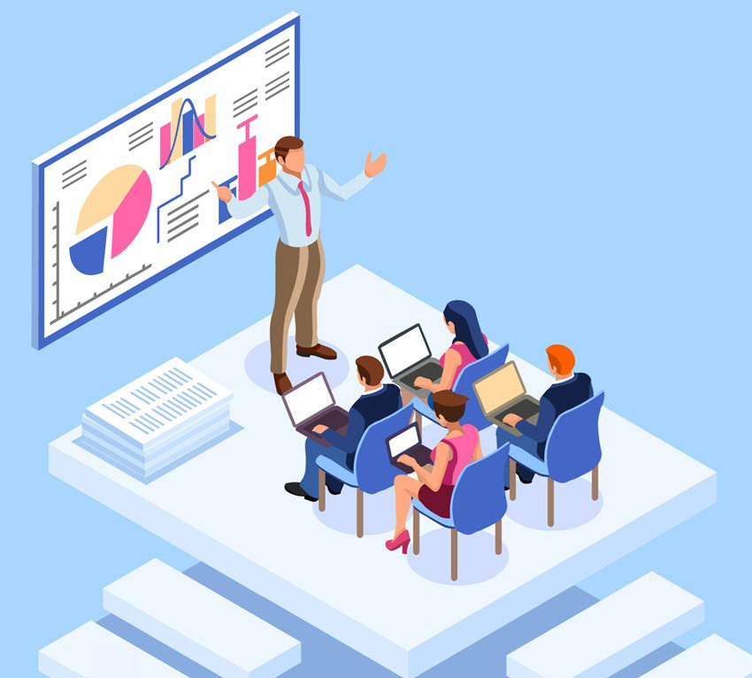

Personal development plan (PDP)

Personal Target | How will I achieve this? | How will this improve my academic or employability prospects? | How will I know that I have achieved this? | When will I achieve this by?
1.Make more notes during session and manage my time more efficient | By writing more during the lesson and make priorities regarding time management | It is going to make writing assessments more easier and improve my writing. | By experiencing that writing is becoming more easy to do, and my marks are very good | By next assessment
2.Improving the way we communicate during group work | Talking and explaining to the group | It will make our future presentations more developed and interesting | During group work | Next group presentation
3.All members will speak when presenting to the public | By talking to the group and make sure that we are going to speak in order | It is going to help in a better presenting the ideas to the public and peers | After we present the next group work | Shortly after presentation

Conclusion
This Academic and Employability Skills Module was an excellent experience to study and gain skills for becoming a good professional. The following are the soft skills that we succeeded in establishing during this module at the University of Wales Trinity Saint David:
Communication abilities.
Collaboration in groups and teams.
Time management is essential.
Problem-solving and critical thinking.
Accepting constructive criticism.
In future module my aim is to develop budgeting and money management skills, which in my opinion is an important part of a prosperous career and growth our development as professionals. It has been an exceptional learning experience and I am sure that future modules are going to be as impressive and effective as Academic and Employability Skills Module was.

Reference list
Grammar.yourdictionary.com. 2022. What Is Reflective Writing?. [online] Available at: <https://grammar.yourdictionary.com/for-students-and-parents/what-is-reflective-writing.html> [Accessed 18 March 2022].
Seofiles.s3.amazonaws.com. [online] Available at: <https://seofiles.s3.amazonaws.com/seo/media/cache/d1/e6/d1e6994281779b4ef58371c0f7b02d74.jpg> [Accessed 2 April 2022].
Libguides.cam.ac.uk. 2021. LibGuides: Reflective Practice Toolkit: Models of reflection. [online] Available at: <https://libguides.cam.ac.uk/reflectivepracticetoolkit/models> [Accessed 23 March 2022].
The University of Edinburgh. n.d. Gibbs' Reflective Cycle. [online] Available at: <https://www.ed.ac.uk/reflection/reflectors-toolkit/reflecting-on-experience/gibbs-reflective-cycle> [Accessed 3 April 2022].
My Essay Point |. n.d. Importance of teamwork: United We Stand, Divided We Fall | My Essay Point. [online] Available at: <https://myessaypoint.com/importance-of-teamwork-united-we-stand-divided-we-fall/> [Accessed 30 March 2022].

