Academic and Employability Skills
(ACCC4000)

Table of Contents
Task No. | Task Title | Page No
1.1 | Personal Overview | 03
1.2 | Self-introduction | 04
1.3 | Key points learnt during preparing PowerPoint presentation | 04
2.1 | Required skills for successful higher education learning | 05
2.2 | Required employability skills | 06
2.3 | Self-evaluation | 07
2.4 | Compare and contrast the skills | 08
3.1 | Goals | 09
4.1 | Look after the data | 10
4.2 | The possible disasters for data damage | 11
4.3 | Potential threats of Cryptowall virus | 11
 | Conclusion | 11
 | Appendices | 12
 | References | 13

Section 1:
1.1 Personal Overview:
Priyank Patel
Mobile.No:+447404680269
Email.Id:priyank1015@gmail.com
Objective
To obtain a responsible position in an organization where knowledge, experience, achievement & hard work will allow me the opportunity to prove myself, become a successful and hard-working human being, work with the social and growth of the organization.
Education
- Pursuing Bachelor Degree in Bsc Cloud Computing From University Of Wales Trinity Saint David London.
- 10th SSC Pass From Board Of Education Gandhinagar, In Vadodara March 2010 With 69%.
- Diploma in Computer Engineering Pass From Sigma Institute Of Technology.
skills
Time management, problem solving, ability to work alone or as a part of team, excellent typing skills, enthusiastic and reliable, strong interpersonal skills, MS Office, programming languages, positive attitude, hardworking, Ability to maintain a strict level of confidence, good observation skills, self driven, excellent customer service and communication skills, sales skills, ability to handle cash and change.
Work experience
i)Nov 2017 To Date, Thornton Heath Post Office (Customer service adviser)
Role:
- selling stamps and dealing with letters and parcels
- paying out pensions and benefits
- accepting bill payments
- dealing with vehicle registrations and car tax
- checking passport and driving license applications
ii)Jan 2016 – Mar 2017, D-Mart Mall (Part time-Sales assistant)
Role:
- Serving and advising customers
-Arranging goods in display and on shelves
-Rotating and replacing stock
-Promoting extra products
-Taking cash and card payments and making sure the till balances
-Dealing with returns
-Meeting sales targets
-Welcome and greets customers
-Accurately describe product features and benefits
-Ascertain customer’s needs and wants
-Maintain a fully stocked store
-Actively involve in the receiving of new shipments
-Keep up to date with product information
Native Language: Hindi, Gujarati
Advance Language: English
Additional Information: Driving License, passport

1.2 Self-introduction
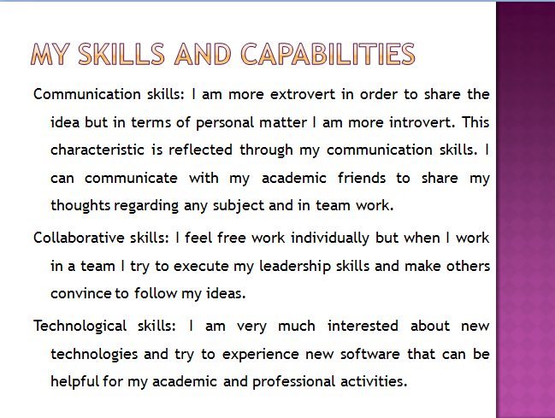

1.3 Key points learnt during preparing PowerPoint presentation
I have prepared PowerPoint presentation several times and every time I learn something. This time the key things I have learnt are listed below-
- Simple content and design: I used to think that more information and exclusive design is very important for a good presentation, but this time I learnt that simple content and design make audience interested to the presentation.
- Importance on key words: In presentation slides I have learnt to give more importance of key words that is a good technique to grab the attention of the audience.
- Use of colors: Use of contrast color make the presentation content clear and more understandable for the presenter and the audience.
- Number of slides: The number of slides should be limited that helps the presenter make the presentation concise and specific. On the other hand, audience also feels comfortable to pay their attention.
- Avoid capital letters: It is better to avoid using all capital letters in a work that helps to read the presentation content.
- Avoid reading from slide: It is very odd to see someone just reading from the slide. So, it’s best to have a hand note for assistance during presentation.
- Avoid questions during presentation: It is difficult to take questions during presentation rather it will be effective to take questions after the presentation is over.
Section 2: Skills evaluation
2.1 Required skills for successful higher education learning
In higher level of education means in college and universities the learning style is different and the skills required for to learn academic things are also different from the skills executed in secondary or higher secondary level education. In higher level education the students need to link up their existing skills with professional skills so that a student can be ready to meet an employer’s basic employment demands (Bingham and Drew, 2014). So, here a student from higher education has to focus to develop his/her existing skills to meet employers demand and be ready for the professional life. Some skills those are required for successful higher educational learning is discussed below-
Adaptive thinking skills: This is a digital world where the things are changing fast. The development of new technologies and software in academic and professional field are influencing the academic institutions and business organizations to adapt these developments. So, students need to prepare their mind to adapt these kinds of changes. In academic environment students require this skill to adapt latest content in academic coerces and adapt the new updates in different software.
Communication skills: This is one of the most important skills that is important for both students and professionals. For students the communication skills is required to communicate with their teachers, other students and team members. In this digital age the academic communication is taking place in tallest communication Medias like video conferring and social medias.

Collaboration skills: In modern day educational system, team work is more preferred than individual performance because it helps to establish a favorable relation and involve every student in any academic task. Through formal team building or informal team building process, inside or outside the classroom students learn to adjust with other individuals. Collaboration skill is reflected through teamwork where students learn to exchange their idea and problems to find out suitable solution (Chaita, 2016).
Critical thinking and problem solving skill: This is another most important skill for higher level students because most of the teaching process prefers critical and analytical thinking to understand the academic contents. Here the contents are more real experience focused than theoretical. This skill helps the students to develop their analytical capability to find out the answers of any question.
Innovation and creativity: This skill is required for students to think about the solutions of questions out of the box that is helpful to make difference form others. It is also important in order to ask questions that help to gather knowledge on specific topic from different point of view. For higher education the teaching style are more case study focused where the answer are not specific and accurate. Students need to execute their innovativeness and creativity to get a suitable solution of those problems.
Self-management skill: This is another very important skill required for higher study students to play pioneer role in any situation when others are not interested for solving any problem. This skill is necessary to work independently even in a team to meet personal goal and objectives.

2.2 Required employability skills
Employability skills are not only essential to get a good job but also helpful to get ready to cope up in any professional environment (Gallagher, 2011). In other word it can say that the employability skills are those skills preferred by employers to find out the perfect individual for appropriate job. In student life especially in higher education students try to develop these kinds of skills to improve their readiness for meeting employers’ basic demands. Some employability skills are discussed below-
Communication: Communication skill is required for any kind of job but based on the job description and job specification some job demand good speaking skills and some other job demand good writing skills. The main point of communication skills is an individual has to be professional and confident in face-to-face and over the phone, e-mail and other medias communication.
Teamwork: In modern day professional environment most employers prefer team effort rather individual achievements. The reason is team effort is more effective to solve any problem or achieve any objectives. So, the job seekers have to prepare their mind-set to work in a team and work through collaborating with each other. So, the most important factor in teamwork is to have the mentality to share ideas and thoughts with other team members and also have the attitude to help others in any situation which drives to achieve any objectives.
Problem solving skills: In professional environment problems came in different form and as a good employee it is very important to know how to solve those problems. In response to different problems the solutions are also different. Innovative and creative thinkers can play key role to find out effective solutions. Solving problems in a team is another way of solving problem that skill is also very effective.
Technology: In this digital age most of the employers look for techno slave people who have in-depth knowledge about modern day technologies and skills in professional software. For example, in accounting job employers demand good knowledge and skill in tally software and excel that is an added expertise for job candidates. Similarly in other functional and technical job different technological skills help a candidate mane differentiation form others from employers’ point of view.
Initiative and enterprise: This skill is very important for a job candidate to transform new ideas and plans into action. It is also necessary to find out opportunities and utilize them in a job environment. Employers look for this skill because the individual who has this skill is capable to adapt any situation and perform naturally.
2.3 Self-evaluation
As a part of self-evaluation a SWOT analysis is conducted below where I have identified my personal strengths, weaknesses, opportunities and threats-
Strengths | Weaknesses
- I am very interested to learn new things  - I can take decision quick in crucial situation  - I try to energize other and feel happy to make others happy  - I am good to work under pressure and manage work within deadline | - I prefer helping other keeping incomplete own work  - I usually don’t prefer other’s suggestion in decision making  - I think much communication interrupts effective performance during work
Opportunities | Threats
- Most of the course teachers allow work in a team  - Most of the teachers rotate role in team that creates opportunity to lead a team  - Most of the courses provide opportunity to develop employability skills | - The cultural diversity sometimes make the communication difficult for me  - My lack of employability skills is putting me backward

2.3.1 Personality type
Based on an online test with 60 different questions I have tested my personality type where I have found that my personality is a commander type personality. Actually my personality is evaluated form 5 different perspectives as listed below-
Mind: How I react within the environment and my surroundings is evaluated this personality factor. According to the test I am more extroverts that introvert. That means I am more interested to share my feelings and ideas with other people but in terms of very personal matters and emotions I like to control them personally without sharing them with others. From that perspective my introverted mindset is revealed.
Energy: Energy means the mental energy that is used to analyze anything. From the point of this personality trait it is evaluated that I am intuitive and observant when I try to analyze anything. So, I actually try to take decision based on the intuition that is developed from experience and based on observation about my surroundings.
Nature: Nature means the decision making nature of an individual that actually reflected through his personality. According to the test I am give more importance on logic than emotions. But I like to balance between them in order to make any decision because I think that becomes more effective.
Tactics: This personality trait evaluates the approaches in terms of decision making, planning and any other type of job. According to the personality evaluation test it is found that I am more judgmental than prospectus for making any decision, planning and doing my own job.
Identity: Identity is another personality trait evaluated in this personality test where it actually states how confident or confused an individual is in terms making decision and taking any step. From that point of view I am self-confident but also very confused regarding taking any decision. This actually impacts my decision and overall behavior and performance. So, I think I am lot to improve in this area.

2.4 Compare and contrast the skills
The results are analyzed based on the initial description of my skills in the PowerPoint presentation and on the self-evaluation. This analysis is conducted based on some skills-
Communication skills: In initial description I have mentioned that I am more extroverts and this is actually reflected when I communicate with my academic friends and professional friends. On the other hand, my introversion character in terms of communication is reflected in terms of personal matters. According to the self-evaluation I have found that my communication skills are appropriate to meet my academic objective and in professional life it will not be a major problem for me.
Collaborative skills: According to my initial description I feel comfortable work individually but in team I try to influence others. I used to think that it is good to do so. But according to the self-evaluation I have found that this is my weakness not to accept other’s decision.
Problem solving skills: According to initial description I am good at it but according to self-analysis I have realized that I am very much influenced by emotions that hinder to make effective decision and solve any problem.
Decision making skills: Based on the initial description I am very confident about making any decision where according to the self-evaluation I discovered that I am almost 50% confused about my decisions.

2.4.1 Learning from the exercise
Through the self-evaluation and analyzing the results with my personal thoughts about my skills, I have learnt some important things as listed below-
- It is better to evaluate self performance and skills from others point of view that gives accurate results like from my team member, teacher or employer’s point of view.
- It is always good to consider others opinion and suggestions that helps to improve self-skills.
- Individual achievement can improve self-confidence but for consistence performance and achievement team work is more effective.

Section3: Action plan
An action plan is very effective to execute the planed things in real life and understand the effectiveness of the plan. Here an action plan is prepared to improve my higher learning and employability skills. My action plan is focused on two goals- short-term goal and long-term goal as listed below-
3.1 Goals
Short-term goal:
- To improve self-confidence and decision making skills I have to emphasis on team work and for that it is essential for me to attend in team meetings regularly within class and outside in upcoming courses.
- The teachers who are emphasizing on team work in class let him select the team lead and make myself adjustable under their leadership.
- Outside the class or office meet the team members to share own idea and thoughts to make myself comfortable working in a team rather perform individually.
Long-term goal:
- Involve in social activities where most of the work is done in a team that will help to improve my overall team working capability and experience.
- Take some leadership and collaborative working academic course that will help to relate my real life experience with theoretical knowledge.

Section 4: Application
4.1 Look after the data
For data protection it is better to backup the data but it is also important how the backup strategy should work. Here a possible solution can be store the data in 3 different places that will ensure maximum confidentiality of the data as described below-
In Personal computer: As the first stage the personal data including academic and professional information can be stored in a personal computer that is frequently used. But in that case it is very important to use authentic and reliable data protection software and update it regularly.
In cloud storage system: As second option those data can be stored in any reliable and authentic cloud storage system as backup. I terms of the any damage of personal computer backup this backup will work.
External data storage system: Any good quality external storage devices can be used to backup the data. In that case it is necessary to update the latest data consistently in that device.
4.2 The possible disasters for data damage
My PC can be hacked and all the data can be hacked as well so in that case it will be very difficult to take preparation or arrange all the data properly. In that case my other backup system can help me to get those data back.
Just before a presentation if the data carried in my devices is destroyed that time it cause huge problem for others in my team to deliver a good presentation. At that time any of the backup system can help me out.
4.3 Potential threats of Cryptowall virus
Cryptowall virus actually active in online when an internet user connects his PC with internet the possibility of attract of this virus increases. Through online advertisement, e-mail, web pages this virus becomes active and more important that the user can not notice the activities of this virus. The threats in remarkable because the personal data and files stored in the computer is encrypted by this virus and demands an encryption key to the user when it becomes active. Without that key it’s not possible for the user to restore his files. There is only way to restore the data is the payment demanded by the cryptowall hacker. It makes the PC totally unable to use.
Section 5: Conclusion
Higher level students should develop such skills those are useful in their professional life and also try to practice those skills in academic life. It is effective because in academic life it’s possible to get change to learn again and again without getting any significant punishments like in professional life.
Section 6: Appendices:
Appendices 1: Personality sample test questionnaire and result
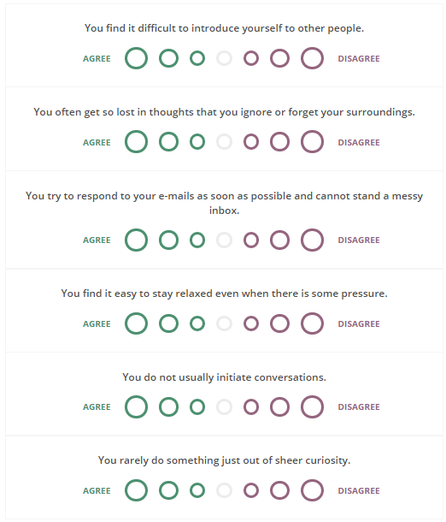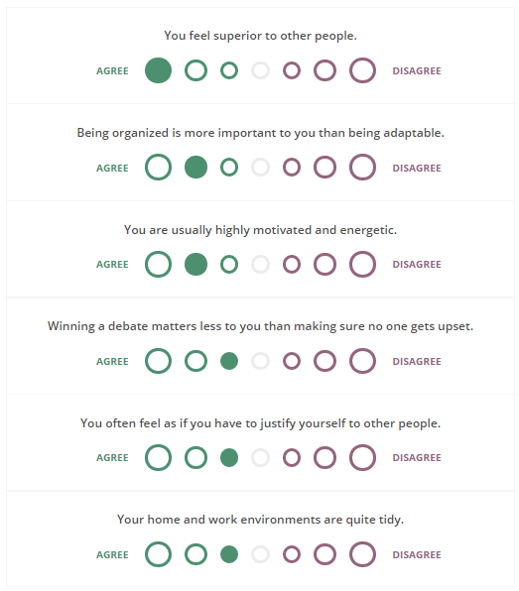
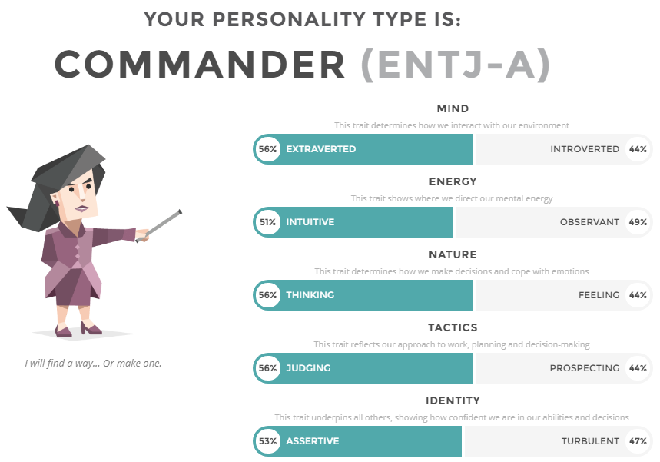

References:

Bingham, R. and Drew, S. (2014), The Guide to Learning and Study Skills: For Higher Education and at Work. Gower Publishing Ltd.

Chaita, Mercy V. (2016), Developing Graduate Employability Skills: Your Pathway to Employment. Universal-Publishers.

Gallagher, K. (2015), Essential Study and Employment Skills for Business and Management Students. Oxford University Press.

Roos, L (2014), The Effects of Career Development on Employment and Recidivism Among Juvenile Offenders. Universal-Publishers.

Ganobcsik-Williams, L. (2016), Teaching Academic Writing in UK Higher Education: Theories, Practices and Models. Palgrave Macmillan.

Trought, F. (2016), Brilliant Employability Skills: How to stand out from the crowd in the graduate job market. Pearson Education Limited.

Parry, G. and Blackie, P. (2015), Managing Higher Education in Colleges. A&C Black.

