How to reflect on evaluations and feedback, like those in the Learning Journal for example…
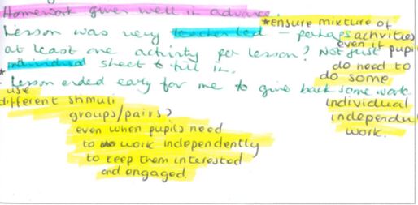

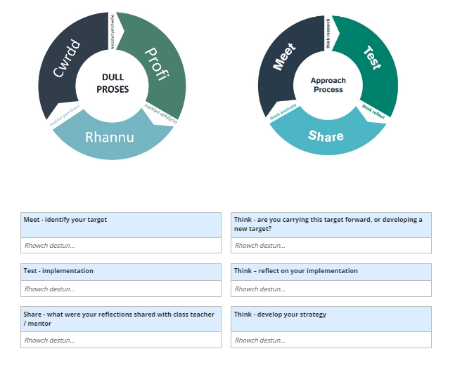
by using the weekly reflection template in the PLP…

Using the targets identified in the student-teacher’s Learning Journal above, here is an example that might assist you with your own weekly reflections:

- Meet - Identify your target.
Make reference to QTS standard and previous feedback

In this step you need to make a note of your target from previous feedback and link it to the QTS standards. This target could be something that has been noted in feedback on more than one occasion during the week, a target you and your mentor have agreed on, or a part of a lesson you taught you’d like to reflect on and explore in more depth.

The target in the Learning Journal above relates to the student-teacher’s use of a variety of appropriate activities which make the lesson less teacher-led. This is linked to the following QTS standard:

Pedagogy: Advancing
Blended learning experiences:
The student-teacher understands the selection, use and justification of a range of imaginative approaches to meet pedagogic challenges to the benefit of all learners.

2. Think - Develop your strategy.
This should be informed by named sources (this can include professional dialogue). Be specific.

This is where you consider how you are going to address your target. What strategy, method, approach, or intervention do you intend to implement, and why? Your choice of strategy will be informed by any number of sources, and you need to refer to them here.

Some examples of sources might include:

- Professional and/or academic literature
- Lead lectures/curriculum studies at university
- Your observations of others teaching
- Discussions with your mentor/tutor/other colleagues
- A blog/Twitter by someone in the field of education

3. Test - Implementation
Where, when and how have you tested it?

This is where you make a note of where, when and how you tried out your strategy – which class, what day, what time of day, how did you try it out? All of these things will have impacted in some way on the implementation of your strategy, and you can reflect on this in the next step of this reflective cycle.

4. Think – Reflect on your implementation
What worked? What didn’t?

In addition to reflecting on what worked and what didn’t with your implemented strategy, you should also consider questioning why it worked, and why it didn’t work.

In your reflections, the following prompts may be of use to you as you analyse the effectiveness of your implemented strategy:

What would you say to a person who said…
…the learners didn’t move forward in their learning today?
…the learners didn’t meet the learning objectives?
…the use of success criteria was effective?
…the level of work wasn’t appropriate for the learners?
…the learners had clear guidance and instructions?
…the learners had no idea how to be successful?

5. Share
What were your reflections shared with the class teacher or your mentor?

Discussing your reflections with others is a way of engaging in professional dialogue and assessing your progress towards achieving your target. These are some questions you may wish to consider when it comes to sharing your reflections:

How will you use…
…your reflection today to move forward?
…your personal research to improve teaching and learning?
…the feedback from weekly evaluation meetings to improve your pedagogy?

6. Think
Are you carrying this target forward, or developing a new target?

Meeting targets isn’t a tick box exercise – it’s not always a matter of meeting one target before moving onto the next. In this step of your reflections, consider what further work needs to be carried out on your target, and whether it might be combined with another target.

For example, we started this reflective cycle with a target which involved a student’s use of a variety of appropriate activities which make the lesson less teacher-led (Pedagogy: Advancing - Blended learning experiences). How might this be further developed to include a target the student-teacher has been given relating to e.g. managing the learning environment, differentiation or assessment?
Now begin your next weekly reflection.

