Introduction to Computer Systems

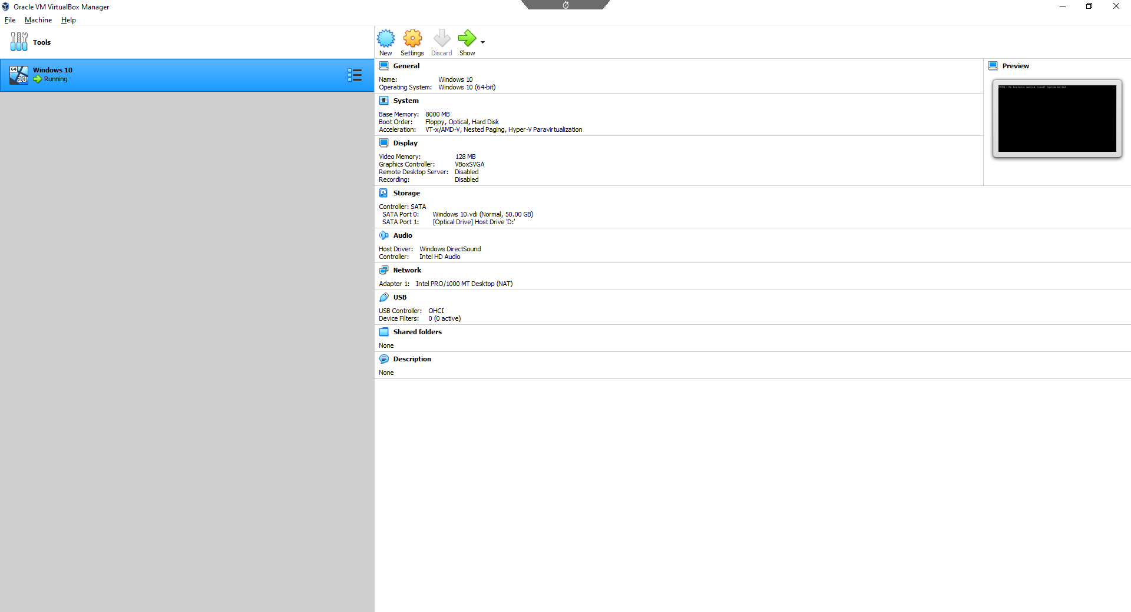
We’re using the virtual box manager to set up our new windows on a virtual device so we won’t have to completely restart windows on the main computer. This will also be easier for us to set up things like apps and programs because of the virtual machine only uses the ram and storage you give it.

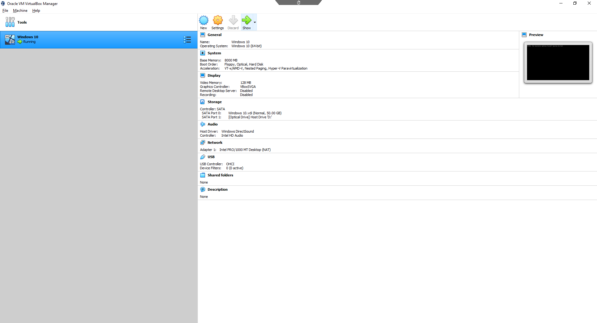
On this slide I’m about to run the program that will allow us to go into the virtual machine and start the new windows on the new machine.

Here shows all of the specifications of the machine and what we will be running on the virtual machine as well.
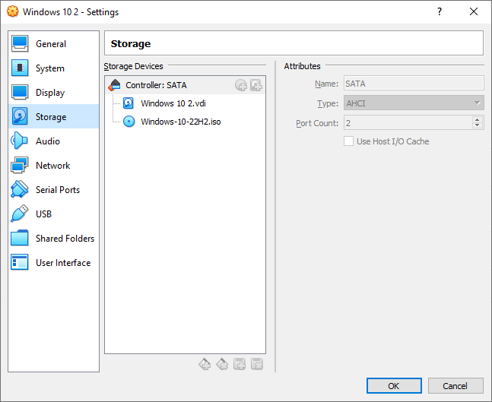
We needed to get the windows 10 download or otherwise trying to start a fresh PC without a desktop software will not run. So, we have to download the windows 10 starter and from our files drag and drop into the this storage place in the windows 10 2 settings.
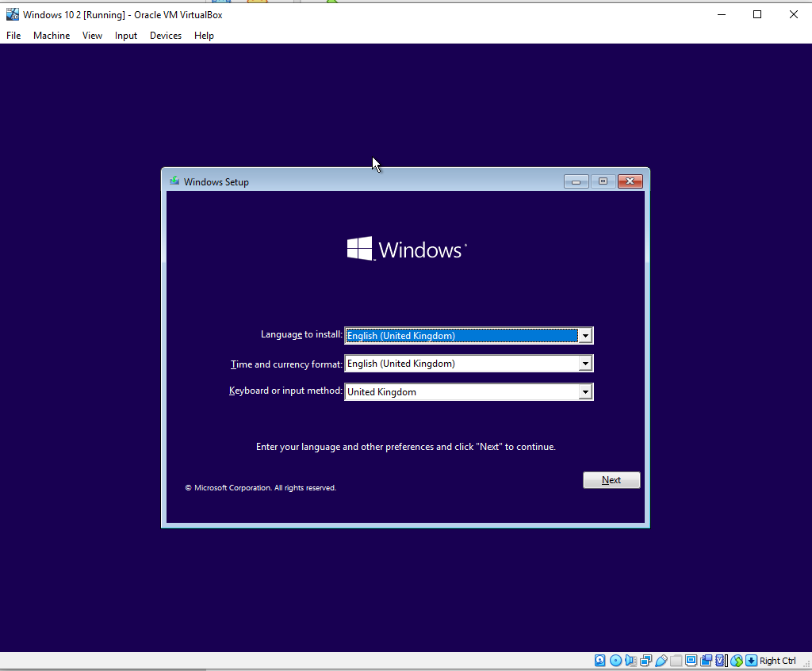
This was the first screen for the set up of windows 10. It’s pretty basic as it sets your windows to whatever language you want to us, time and currency format on the PC and your keyboard and input methods.
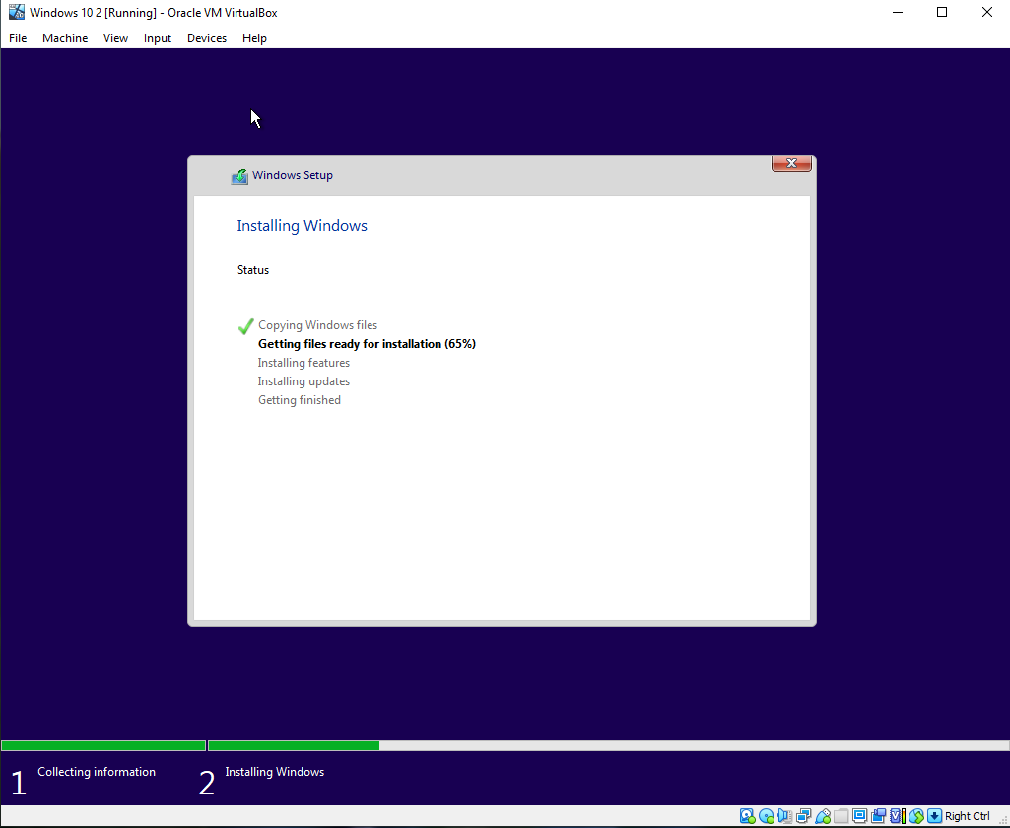
This is installing the windows; you have to wait for this is be completed otherwise you won’t be able to access your PC through windows 10. Currently it installing the important stuff like files, features and updates.
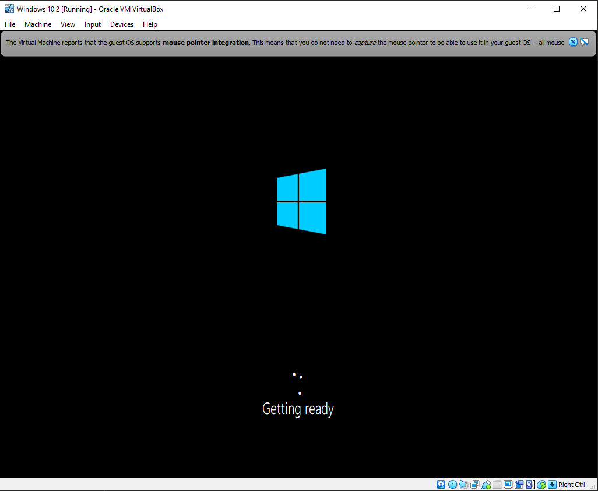
This is the screen after the last after the installation of all of the features and files. Windows is still updating in this screen so just let it do its own thing which is what I’m doing in this screenshot.
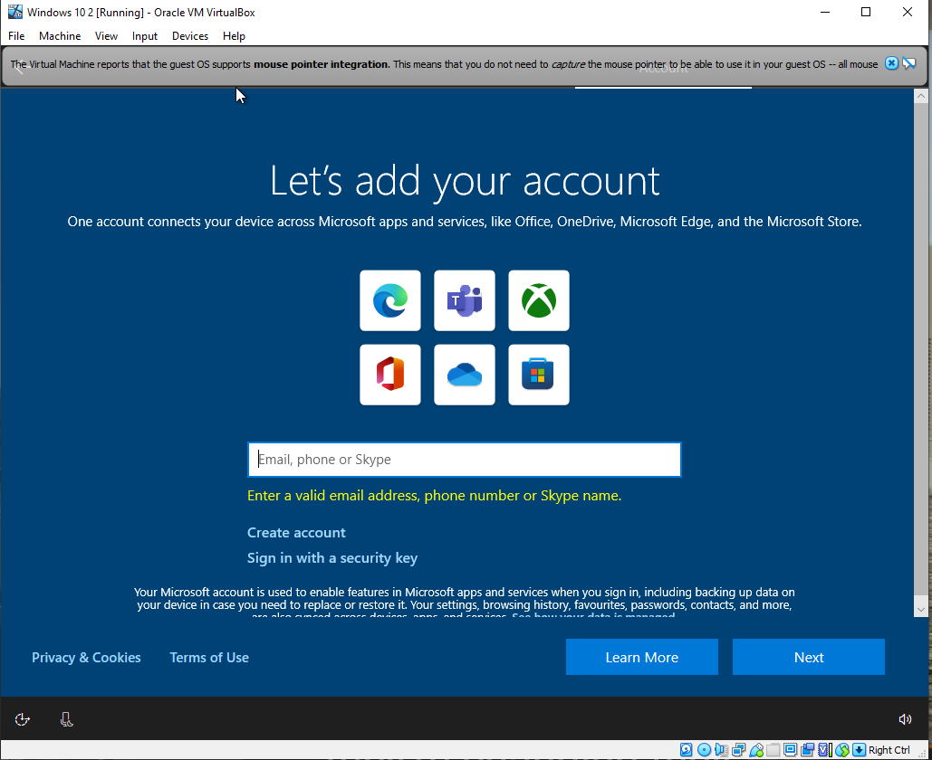
So for this section you can customize your own windows to your own liking. For me I like to have a very flashy windows with nice colours for example Purple. This makes your desktop stand out from the rest and it is what you want at the end of the day.
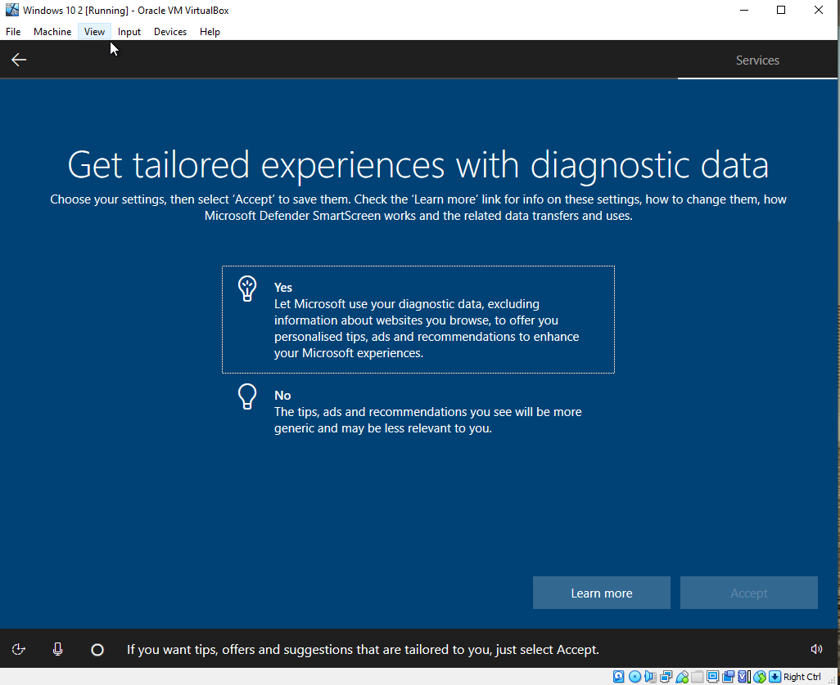
This is another customization that allows you to chose options. So like I said above you chose what’s best for you and to your own liking.
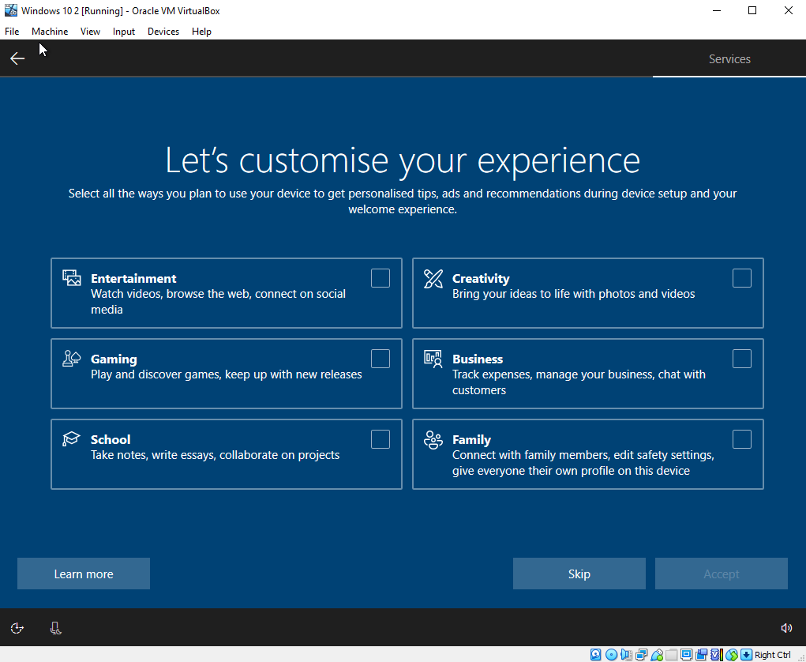
This is another customization tap that allows you to chose on what you want on your desktop tap, ads, pop ups or recommended items or things. For example, I chose “Entertainment “and “Gaming”. This allows me to only have these two items pop up for me.

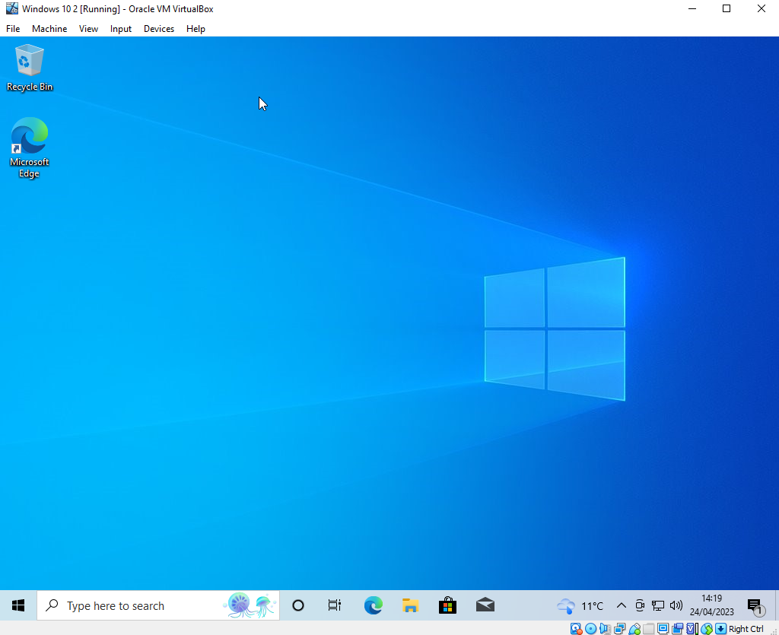
This is the final windows screen when you finish with the installation. Now you can do whatever you want! I suggest installing important applications like anti-virus, google, CCleaner etc. Now if you want to you can go into your windows settings and customize even more things with your windows which I suggest!
With clean fresh windows make sure you don’t click on dubious links or emails that can cause a virus. This can cause your windows to crash and your PC to fail and we don’t want that when you have a fresh PC.

Computer Networking Principles

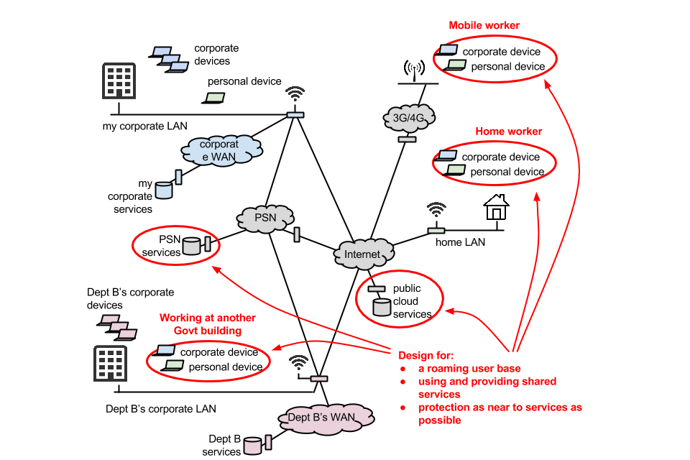 [1]
What is a computer network?
A computer network is two or more computers connected to cables or wireless and they exchange data and resources.
A computer network is built out of hardware aka router, cables, and access points. This allows operating systems and businesses to run and thrive of this network. [2]
Computer network types
There are multiple types of different computer networks. For example, LAN (local area network), WLAN (wireless local area network), WAN (wide area network), PAN (personal area network), SAN (Storage area network), CAN (campus area network) and VPN (virtual private network). All of these networks have different uses and purposes, and they’re each as important as the next and we use these networks every day. [2]

Important terms and concepts
For terms and concepts there are multiple aspects for example, IP address, Nodes, Routers, Switches, Ports and Network cable types. [2]

Bibliophagy
[1]
[2]

