
Program: Master of Business Administration
Module: Strategic Management
Module Code: LCMB7003
“A Strategic Management on Starbucks in the Geographic Location of UK”
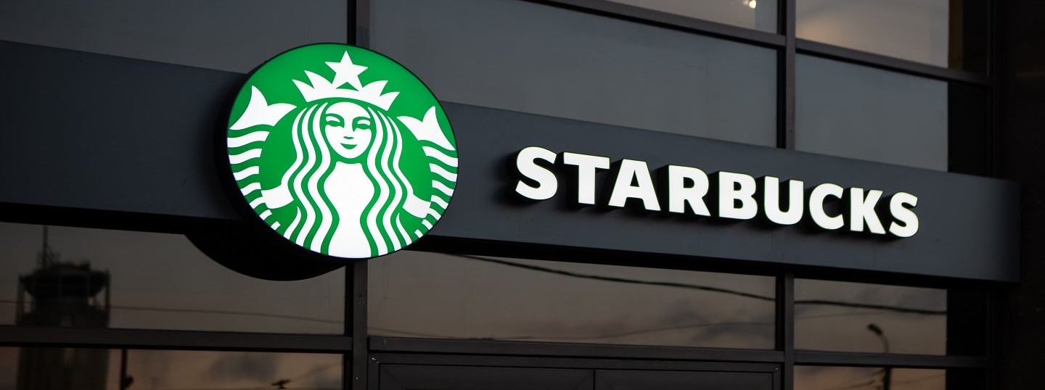
Name: Yaxit Devchandbhai Devani
Student Number: 2532154
Lecturer Name: Balendran Kandasamy

Word Count: 5374

AI Declaration
I declare that all the content of this report is my own original work and that I did not write any part using artificial intelligence. The ideas, analysis, interpretations and arguments, as well as the written work, are my own. The information used from external sources has been cited and credited to the appropriate sources in line with academic integrity principles and the assessment policy of the institution.

Executive Summary
This report assesses Starbucks UK's strategic position in a very competitive branded coffeehouse market. Strong brand equity, digital capabilities, customer loyalty and the "third place" experience offer critical differentiation, while growing labour and input costs, climate-related supply risks, value-conscious consumers and heavy competition limit profitability. The PESTEL and VRIO analyses suggest that the Starbucks brand and integrated digital ecosystem are the strongest resources that Starbucks has but have yet to generate strong operating returns. The CSR analysis demonstrates a moderate to strong relationship with business goals in the areas of responsible sourcing, environmental actions and community involvement, and the Balanced Scorecard identifies the need to link partner capability, process efficiency and customer experience with recovery related to financial goals. Strategically, Starbucks UK should focus on broad differentiation, market penetration and product development, enhance personalised Rewards engagement, increase store productivity and selectively expand. Such measures can improve resiliency, bring profitability and maintain competitive advantage.
Table of Contents
1.0 Introduction 6
2.0 Section 1: Strategic Management Report – Starbucks UK 6
2.1 Organisational Context and Overview 6
2.2 External and Internal Analysis 9
2.2.1 PESTEL Analysis 9
2.2.2 VRIO Analysis 13
2.2.3 SWOT Analysis and Strategic Synthesis 16
2.3 Comprehensive and Holistic view of the Organisation 17
2.3.1 Corporate Social Responsibility and Strategic Alignment 17
2.3.2 Balanced Scorecard 19
2.4 Strategic Choices and Implementation 22
2.4.1 Strategic Choices at the Business Level using Porter's Generic Strategies 22
2.4.2 Identifying and Validating the Appropriate Strategy using Ansoff Growth Strategy 23
2.4.3 Delivering Optimum Performance and Competitive Advantage using RBV Analysis 24
2.4.4 Potential Challenges and Mitigation Solutions 26
3.0 Section 2: Self Reflection 27
3.1 Overview- Reflection Using Kolb’s Reflective Cycle 27
3.1.1 Concrete Experience 27
3.1.2 Reflective Observation 27
3.1.3 Abstract Conceptualisation 28
3.1.4 Active Experimentation 29
4.0 Conclusion 29
Reference List 30

1.0 Introduction
Competitive, evolving consumer demand, fast digitalisation and sustainability pressures define the UK-branded coffeehouse sector. In this environment, Starbucks UK is constantly evaluating its resources, capabilities and strategic priorities to determine if they are adequate to maintain its differentiation and ability to create customer value. This report comprehensively examines the organisation's strategic position by analysing its external and internal position, corporate social responsibility, performance viewpoints and strategic choice. It then examines the potential of suitable strategic actions to improve resilience, facilitate sustainable profitable growth and help to ensure Starbucks UK's competitive advantage over time.

2.0 Section 1: Strategic Management Report – Starbucks UK

2.1 Organisational Context and Overview
Historical development: Starbucks was founded in 1971 in Seattle by Jerry Baldwin, Zev Siegl and Gordon Bowker, where they sold whole-bean coffee, tea and spices. Strategic transformation picked up steam following Howard Schultz's arrival in 1982 and the company's acquisition in 1987, making it an experiential coffeehouse. In 1998, Starbucks opened its first European market with its store in the UK on King's Road, London. The UK was then followed by the biggest EMEA market. In FY2025, Starbucks Coffee Company (UK) Ltd had a total of 1,304 stores and reported revenue of £556.3m, while the operating loss was £29.8m, indicating the trade-offs between market size and value creation (Starbucks, 2024; Starbucks, 2026a).
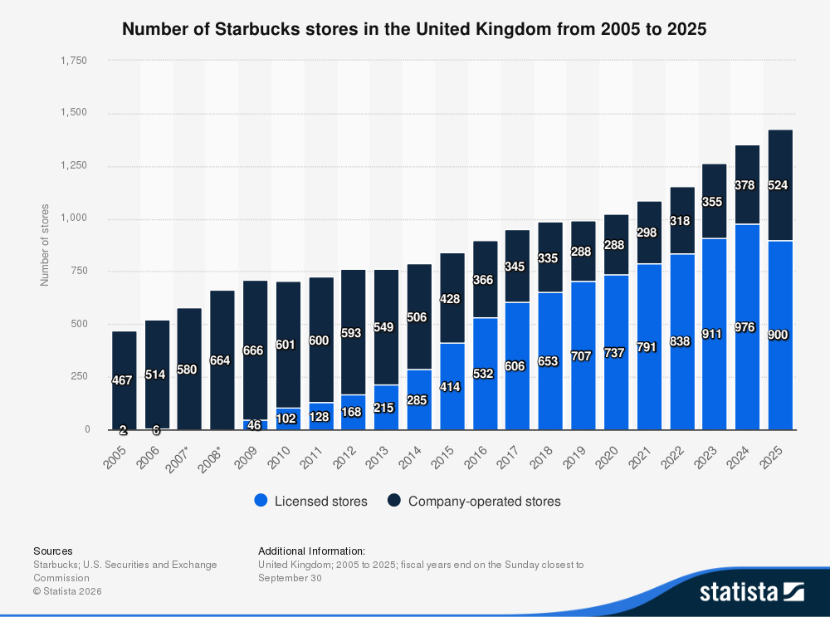
Figure 1: Number of Starbucks Stores in the United Kingdom, 2005–2025, by Licensed and Company-Operated Stores
(Source: Statista, 2023)
Mission and strategic vision. The mission of the company is to be "the premier purveyor of the finest coffee in the world, inspiring and nurturing the human spirit – one person, one cup and one neighbourhood at a time" (Starbucks, 2025). Instead of coming up with a particular vision for the UK, it is expressed in the "Back to Starbucks" strategic direction: "To bring back the quality of the coffee, the skills of the baristas, welcome the coffeehouses and the "third place" in between work and home (Starbucks, 2026b). Strategically, this further distinguishes the product based on experience and connection, and not on principal price.
Business model: Starbucks UK has a hybrid business model (company operated/licensed). The 23.5 Degrees acquisition is projected to change this ratio to 40:60, meaning that at the end of FY2025, 40% of all stores will be company-operated, while 60% will be licensed, giving the company more control over its operations and retaining the scalability of a licensing arrangement (Starbucks, 2026a). Digital channels are a complement to the physical store; Rewards accounted for 42% of the sales in the UK in FY2025, and 2.4 million people were active members of a rewards scheme, boosting customer data, loyalty and repeat purchases.
Industry and market position: In the UK, the market for coffee shops is growing, with 12,313 outlets and a value of £6.8 billion in 2026, as there is a high level of demand and competition in the industry (World Coffee Portal, 2026b). The Starbucks coffee chain has over 1,400 outlets in the UK and is third in rank by number of outlets behind Greggs and Costa Coffee, with the latter having over 2,700 outlets (World Coffee Portal, 2026a). It is therefore not an overpowering position. Starbucks is in a relatively high-touch, experiential niche with brand equity, digital interaction and expansion of the format as backstops, as shown in Figure 2. But the competition for traffic, value proposition, experience, and positioning of coffeehouses like Costa, value proposition coffee boutiques like Greggs, and speciality chains like Caffè Nero and Pret adds extra stress to the coffee-as-food chain.
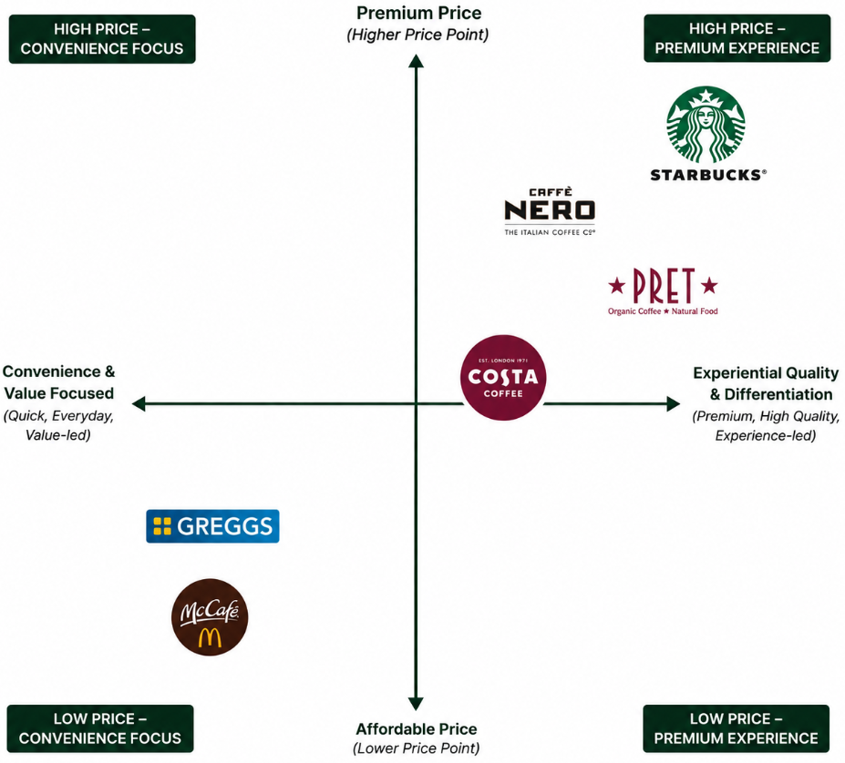
Figure 2: Perceptual Positioning of Starbucks and Selected Competitors in the UK Branded Coffee-Shop Market
(Source: Idea obtained from World Coffee Portal, 2026a)

2.2 External and Internal Analysis

2.2.1 PESTEL Analysis
PESTEL is used to systematically assess the macro-environmental forces which impact strategic performance, but its value for the manager is to prioritise the forces based on the consequences to the organisation of the individual forces, not to discuss the individual forces in isolation. The framework, applied to Starbucks UK, shows pressures are interdependent when they come to the margins of operations, as well as customer value, digital engagement and long-term supply resiliency.
Political: Labour is one of Starbucks' key costs, which has been raised by the UK's fiscal policies. The rate of employer National Insurance contributions increased from 13.8% to 15%, and the threshold for paying secondary National Insurance contributions fell from £9,100 to £5,000 (HMRC, 2025). Starbucks UK reported that there was a 7.8% rise in wage and benefit costs in FY25, which was partly due to NIC contributions (Starbucks, 2026). There is, then, a strategic threat in terms of a decline in operating leverage on a large physical estate, rather than taxation. This makes labour productivity more important, as well as efficiency and disciplined choices over company expansion versus licensed expansion.
Economic: Starbucks is fighting the counter-intuitive trend of rising demand for coffee, while falling economics. UK CPI inflation slowed to 2.6% in June 2026 while prices in restaurants and hotels increased 4.4% compared to the same period last year (ONS, 2026). As the business of a UK-based coffee chain grows, Starbucks UK experienced a rise in its cost of goods sold of 10.1% and recorded an operating loss of £29.8 million even as the revenue of the company climbed to £556.3 million in FY2025 (Starbucks, 2026). However, the market for branded coffee shops grew to £6.8 billion, with 12,313 outlets, experiencing a 5.5% rise in sales (World Coffee Portal, 2026). This means that growth is an opportunity, but not one that can be pursued without an increase in unit economics, or else it may only be a means of widening revenue without a gain in profitability.
Social: A polarisation of demand between affordability and differentiated premium experiences of coffee consumption in the UK; iced coffee, matcha and other premium hospitality are changing the picture of coffee consumption (World Coffee Portal 2026). Starbucks seems to be listening: The company is seeing sales of cold beverages in the UK grow by 11.8% in FY2025, while its matcha sales have jumped 68% and seasonal products accounted for 10% of the company's sales (Starbucks, 2026). But, as Rancati et al. (2024) show, the combination of atmosphere, employee service and the quality and price of the coffee all contribute to the coffee-store experience and loyalty, and price/value is one of the most important sources of chain-coffee dissatisfaction, as Altun et al. (2025) identify. Starbucks thus needs to make sure that innovation does not create "experiential value" that consumers can feel but does not lead to premium pricing to justify it.
Technological. Digital capability offers a huge opportunity to be able to enhance the convenience, personalisation and retention of customers at the same time. Starbucks Rewards accounted for 42% of UK sales in FY2025, with an active membership of 2.4 million, while Mobile Order & Pay volumes rose by 28% (Starbucks, 2026). Londoño-Giraldo et al. (2024) discovered that the convenience and engagement factors have a significant positive impact on restaurant loyalty when using their mobile apps. However, the strategic trade-off that technological efficiency brings is that there could be too much transaction orientation that reduces the interaction between the barista and the "third place" differentiation of Starbucks. Digitalisation must then be used in addition to – not instead of – the customer experience.
Environmental: Starbucks is impacted both above and below the water. In the key Brazilian Arabica coffee production areas, Freitas et al. (2024) show that the effects of temperature and precipitation changes on Arabica coffee phenology and production increase the uncertainty in coffee supply and prices in the long term. The UK EPR charges for domestic packaging waste collection are £423 per tonne for plastic packaging waste collection, and £461 per tonne for fibre-based composite packaging waste collection in 2025–26 (PackUK, 2025). These pressures are likely to cost the business more, but Lee et al. (2023) demonstrate that an environmentally conscious image of the coffee shop can be beneficial to consumer repurchase intention. Sustainability is then a source of resiliency in the supply chain and a possible differentiating point.
Legal: Labour regulation further underscores the need for a workforce strategy, as it is expected to continue to play a significant role in the future. From April 2026, the National Living Wage will rise by 4.1% to £12.71 per hour for workers over 21 years (Low Pay Commission, 2026). In addition, the Employment Rights Act 2025 will be implemented in the future, with the new rights to guaranteed hours, reasonable shift notice and compensation for short-notice changed work coming into effect in 2027 (Department for Business and Trade, 2026). This increases the potential scheduling and hiring expenses for Starbucks while potentially helping to retain employees and provide more consistent service, helping to turn some of the regulatory challenges into better human-capital performance.

Table 1: PESTEL Synthesis and Strategic Priorities for Starbucks UK
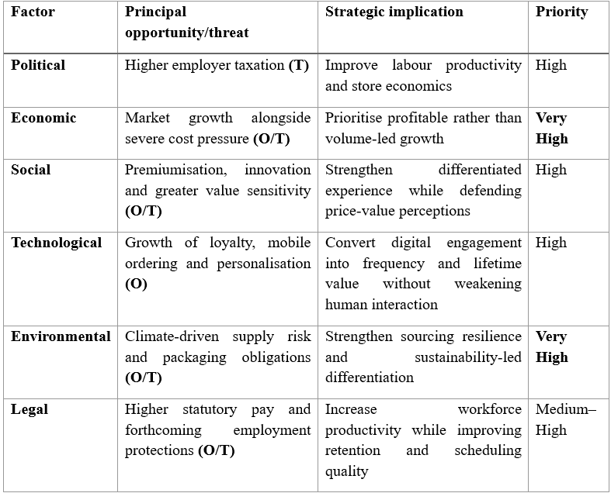
Strategic judgement: Across the board, the biggest challenges are margin pressures due to labour and input costs, and the vulnerability of supply due to climate change, while the biggest opportunities are market growth, digital loyalty and changing premium consumption. The external analysis thus indicates that Starbucks UK should not seek scale alone; there needs to be experiential differentiation in order to achieve sustainable performance, and this needs to be married to productivity, supply resiliency and better conversion of digital engagement into profitable customer relationships.

2.2.2 VRIO Analysis
The resource-based view (Barney, 1991) suggests that firms can gain long-term competitive advantages if they possess resources that are valuable, rare and hard to imitate, and the resource is organised in the firm. If it is applied to Starbucks UK, one must be able to differentiate between resources that allow people to participate and those that can create a defensible advantage.
The first and foremost is Starbucks brand equity and its premium positioning, which it has throughout the world. It's a brand with over 20 years of experience, a unique visual identity and a place to build brand associations that allow for differentiation and customer trust. While there are established competitors, the two attributes of global name recognition and heritage and scale are relatively rare and path-dependent, making it harder to imitate Starbucks.
Second, it has a digital ecosystem that connects Starbucks Rewards, Mobile Order & Pay and customer information. Rewards also made up 42% of UK sales in FY2025, with 2.4 million people active and mobile-order volumes up by 28%, highlighting the importance of Rewards for repeat sales and convenience and personalisation (e.g., Starbucks, 2026). In contemporary RBV research, the focus lies on the fact that digital resources, in addition to their stand-alone characteristics and functions, are advantageous when they are complemented by other organisational resources (Valentowitsch et al., 2024).
Third, the network of Starbucks stores as well as the hybrid licensing approach gives flexibility in terms of accessibility and expansion in the UK market. In FY2025, the estate had a total of 1,304 stores, with 398 being operated by the company and 906 being licensed stores (Starbucks, 2026). However, physical scale is not uncommon and can be matched by a well-resourced competitor, so the network can offer competitive parity rather than a competitive advantage. Besides, Starbucks' in-house coffee-sourcing and product-innovation capability helps them ensure a steady supply of coffee, to launch new seasonal products and to quickly respond to shifting consumer preferences. But competitors can duplicate the individual drinks and sourcing practices, and this proves valuable but ultimately not inimitable for continued success.
Finally, Starbucks' differentiation strategy has always been around the capability of the baristas and the “third-place” experience they provide. They do that in the service, atmosphere and the relationship with the human being, but there are equivalent experiential offers throughout brands. It is not only their rarity that makes them an advantage, but the staffing, training and execution as well.
Table 2: VRIO Analysis of Starbucks UK
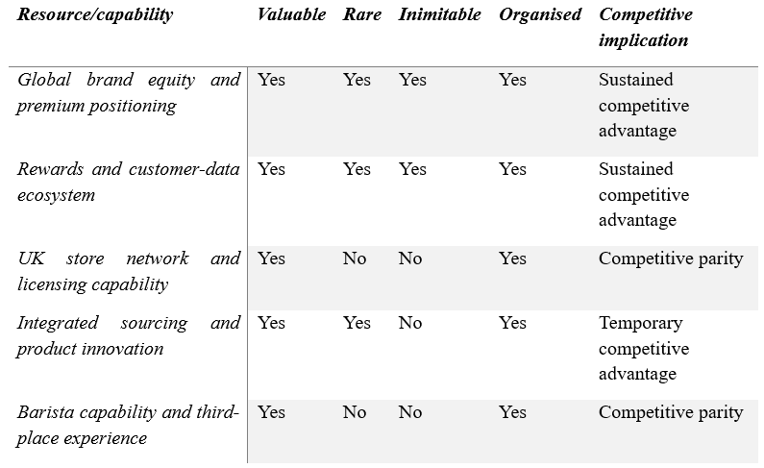
Starbucks can take these resources through its organisational tools, namely, its licensing framework, digital capabilities and brand requirements. The addition of 23.5 Degrees brings 113 Starbucks stores to its portfolio and is projected to change the ratio of operated/licensed stores to 40/60, from 30/70 (Starbucks, 2026).
Strategic judgement: Starbucks UK has a lot of resources, but only two of them (branded and the integrated digital ecosystem) meet all 4 VRIO conditions. This is important since FY2025 still recorded a £29.8 million operating loss on the back of revenue growth, indicating that the possession of resources does not necessarily result in superior economic returns (Starbucks, 2026). The challenge within is then one of transforming defensible brand and customer data into greater productivity, improved experiential value and profitable differentiation.

2.2.3 SWOT Analysis and Strategic Synthesis
The SWOT matrix combines information from the external PESTEL analysis and the internal VRIO analysis, highlighting what Starbucks UK can do and what would help or hinder value creation.
Table 3: SWOT Analysis of Starbucks UK

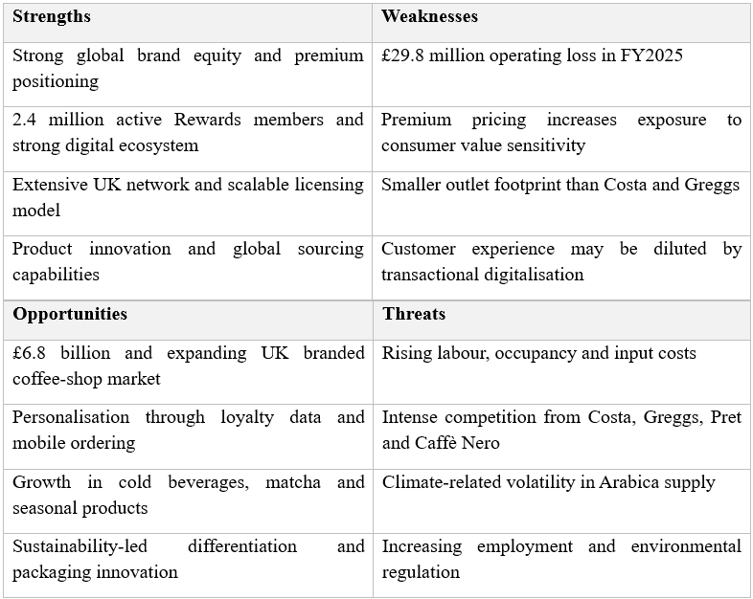
Strategic synthesis: The main problem Starbucks UK faces is, however, not a shortage of resources but the inability to turn its unique assets into a successful asset. Strong differentiation from brand equity, but subdued returns due to value-based competition, cost inflation, and digital loyalty. In terms of business strategy, Starbucks ought to leverage customer data, product innovation and experiential positioning, and work to make stores more productive and the supply chain more resilient, moving from a growth-centric to a more sustainable performance.

2.3 Comprehensive and Holistic view of the Organisation

2.3.1 Corporate Social Responsibility and Strategic Alignment
Carroll's Pyramid represents corporate responsibility in economic, legal, ethical and philanthropic terms. These dimensions, when applied strategically, provide a way to assess if Starbucks' obligations lead to the creation of stakeholder value and support the commercial goals of the company instead of operating as an afterthought philanthropy (Carroll, 1991).
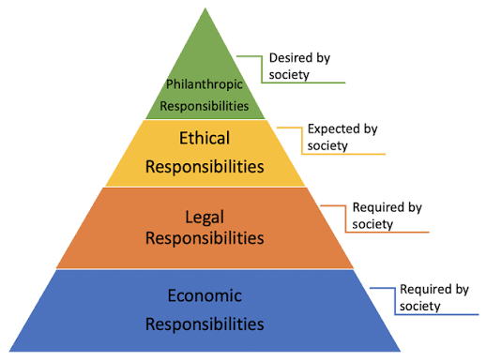
Figure 3: Carroll's Pyramid
(Source: Carroll, 1991)
Economic responsibility: The CSR of Starbucks should ultimately help to create commercially sustainable value. It specifically ties purpose to growth, resilience and efficiency in its FY25 Impact Report, and it notes that it has invested about $200 million to date in coffee sustainability (Starbucks 2026). While the commitment to investing in the protection of premium quality and supply resilience is part of Starbucks UK's goal, the strategic validity of such investment is contingent on its effectiveness in driving better economic outcomes and not being an isolated sustainability investment.
Legal responsibility: Regulatory obligations around employment and packaging requirements ensure business sustainability and business legitimacy. But regulatory compliance can only be a minimum market expectation and thus does not provide any differentiation on its own. It is therefore essential that Starbucks makes compliance more than an obligation it meets, but also part of the company's best practices, especially in the areas of responsible employment and circular packages.
Ethical responsibility: This dimension is aligned most strongly with strategy. Starbucks' current obligations include C.A.F.E. Practices sourcing, regenerative agriculture, and, by 2030, 100% of its customer-facing packaging is to be reusable, recyclable or compostable (Starbucks, 2026). Also, credible CSR is connected with customer delight and revisit intention (Bhat et al., 2024). The implementation, however, is not consistent: the first 2025 recyclable and home compostable European cup for Starbucks was, for example, introduced to selected European markets in 2015, excluding the UK, which suggests that the company's ambitions do not align with the markets in which it operates.
Philanthropic responsibility: Starbucks has donated £6 million to Hubbub since 2018, to support more than 260 community spaces across the UK, and to help recycle over five million cups. This enhances the legitimacy of the community and solidifies Starbucks' proposition to build a relationship with the customer using its coffeehouse, but philanthropic activity must be perceived by the stakeholders as having a credible link with the core business.
Table 4: Carroll’s CSR Dimensions and Alignment with Starbucks UK’s Business Objectives
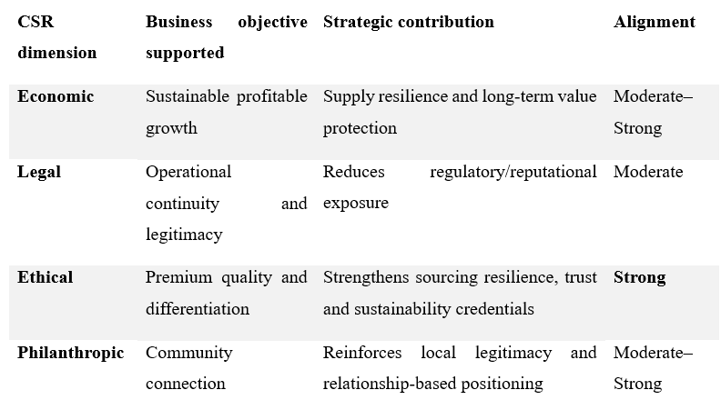
Strategic judgement: Overall, the level of consistency between the CSR strategy and business objectives is moderately good, with the areas of responsible sourcing, environmental resilience and community engagement showing the best integration. But there is a need for greater UK-specific delivery and measurable impact to make sure that CSR drives trust, differentiation and value for stakeholders every time.

2.3.2 Balanced Scorecard
The balanced scorecard proposed by Kaplan and Norton (1992) combines financial data with data derived from customers, internal processes, and learning and growth to provide a way to articulate the organisation's mission and strategy into measurable priorities. Modern studies also focus on the BSC as a unified system of strategic performance indicators instead of separate indicators (Kumar et al., 2024). Not only does this apply to Starbucks UK—its current mission focuses on premium coffee and relationships with others and the community- but the Back to Starbucks initiative is also all about inviting coffeehouses, barista craft and meaningful customer relationships.
Table 5: Proposed Balanced Scorecard for Starbucks UK
Perspective | Mission/strategy alignment | Strategic objective | KPI/current baseline | Consultant-proposed target | Strategic initiative
Financial | Sustainable growth must financially support investment in premium coffeehouses and customer experience. | Restore profitable UK growth and improve store economics | Revenue: £556.3m; operating loss: £29.8m (FY2025) | Achieve ≥3% operating margin within 24 months while maintaining positive revenue growth. | Optimise underperforming stores, improve labour productivity and prioritise high-return formats/refurbishments.
Customer | Supports the mission of nurturing human connection and the Back to Starbucks “third-place” proposition | Increase loyalty, perceived value and experiential differentiation | Rewards: 42% of UK sales; 2.4m active members | Increase Rewards contribution to ≥50% of sales and active membership by ≥15% within 24 months. | Personalised Rewards offers, stronger in-store hospitality and targeted experience-led promotions.
Internal Business Processes | Supports consistent handcrafted quality, convenience and welcoming coffeehouses | Improve service efficiency without weakening customer interaction | Mobile Order & Pay volumes +28%; 21 refurbished stores increased profit contribution | Reduce order-fulfilment time by 10% within 18 months and improve refurbished-store contribution year-on-year | Workflow redesign, better digital-order sequencing, targeted refurbishment and store-level productivity reviews
Learning and Growth | Skilled and engaged partners enable coffee craft, inclusivity and human connection. | Strengthen barista capability, inclusion and workforce stability | Over 11,000 UK partners completed BSL training | Achieving 95% annual completion of core service/coffee training and reduce employee turnover by 10% from the FY2026 baseline within 24 months. | Coffee-craft development, inclusive service training, coaching and leadership-development pathways

The financial front is also a pressing strategy, due to the fact that revenue growth – as well as a £29.8 million operating loss in FY25 – proved to be an insufficient measure of success. Therefore, the barometer of growth for Starbucks needs to be measured in store contribution and margin, not in the number of outlets per se.
From the customers' perspective, Starbucks' mission becomes measurable in customer loyalty and experiential outcomes. The studies on the environment of coffee shops have shown that customer experience is multidimensional, highlighting the importance of managing the quality of products, the service interaction and the atmosphere, in addition to digital convenience (Rancati et al., 2024).
The other aspect is from inside the system: Starbucks' 21 FY2025 refurbishments drove store profit contribution, and Mobile Order & Pay grew 28%, suggesting a potential opportunity for an integrated approach of estate improvements and digital efficiency. But efficiency shouldn't dehumanise the human connection that is the basis of differentiation.
Lastly, the perspective of learning and growth is the enabling one. Starbucks UK's BSL programme, which has been implemented by over 11,000 partners, is just one example of the potential impact of workforce development to build capability and include customers. Thus, the BSC's cause-and-effect logic is that if a partner is more capable, the internal processes will be better, which will lead to a higher level of customer experience and customer loyalty, and ultimately to better financial results, which is the mission of Starbucks and a part of the company's strategic renewal.

2.4 Strategic Choices and Implementation

2.4.1 Strategic Choices at the Business Level using Porter's Generic Strategies
Starbucks UK's main strategy is to differentiate itself from competitors, not necessarily in terms of cost; it is not for that reason that these are not all its competitors. Strong global brand equity, premium beverages, store ambience, product innovation, personalisation and Starbucks Rewards are all factors that support its differentiation. As per Jackson and Nichols (2022), revenue in the UK was £556.3m; sales of Rewards more than doubled 45% to 42% of total UK sales, and membership was at 2.4million. These attributes contribute to the added value of the product for the customer and enhance customer loyalty.
Table 6: Porter's Generic Strategies of Starbucks
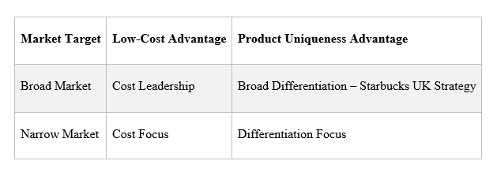
Starbucks is facing a great deal of pressure. In the UK, the market for coffee shops is worth £6.1 billion, with 11,456 shops in total, with the Costa, Greggs and Starbucks groups competing against one another on a big scale (Nissa, Amalia and Muzallifah, 2026). No one owns any one of these strengths, but the strengths of each can be summarised as: Accessibility and value, price and food convenience, freshness and convenience, and authenticity and artisanal quality for independent and speciality cafés.
Starbucks's strategy is not to engage in cost leadership since its pricing would be subject to intense competition, which could jeopardise Starbucks's premium brand (Alnoor et al., 2022). Instead, Starbucks will need to strengthen their experience-based differentiation with the Rewards program, tailored offers, new beverages, and the digital platforms they provide to accommodate its premium offering and purposefully target one of its customer base segments who are more value-sensitive (Olubiyi, 2024). This is especially relevant because of the growing focus of consumers on value for money in the UK, which is experiencing fierce competition.

2.4.2 Identifying and Validating the Appropriate Strategy using Ansoff Growth Strategy
The Ansoff Matrix takes into account four growth options. The high risk is diversification of new products and new markets); new product into existing markets is product development; new product into new markets or locations is market development; and increased sales of existing products in existing markets is market penetration.
The first ones that come to mind are the ones for Starbucks UK's market penetration and product development. Increased Starbucks rewards, personalised promotions, mobile order and pay and frequency are all factors that bring about market penetration (RISK, 2023). Rewards sales grew 45% in 2025, representing 42% of UK sales, while the number of active members increased 41% to 2.4m. The results show that there is a huge opportunity to deepen the digital customer journey to increase customer retention, visits and average spend per visit.
Product development should follow as well, providing seasonal drinks and food and customised items to better facilitate sales opportunities as well as solidify Starbucks' Broad differentiation strategy (Jia, 2023). The company's growth seems to stem from new stores, with 92 stores opening in the UK during 2025, which could potentially drive up costs and margins.
Starbucks should concentrate on penetrating customers and product innovation instead of relentless growth and build sustainable revenue streams and competitive advantage through its Rewards ecosystem and product differentiation.

2.4.3 Delivering Optimum Performance and Competitive Advantage using RBV Analysis
According to the Resource Based View (RBV) this sustainable competitive advantage is associated with the existence of valuable, rare and difficult to imitate resources, which are well organised. The following is a list of Starbucks UK's key resources.
Table 7: Resource Analysis
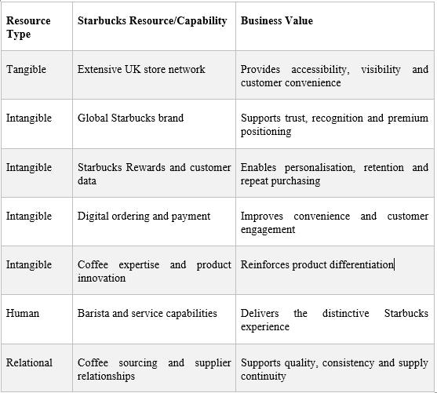
The resources support Starbucks UK's Broad Differentiation strategy but merely owning them is no advantage by implementing a well-coordinated set of resources and capabilities that creates the advantage.
There is still some non-performance challenges. Starbucks' operating margin in the international segment dropped from 14.9% to 10.8% in FY2025, down from the previous year, and operating income for the segment was down to $223.2 million, which included restructuring and promotion costs. Revenue rose some 6% and transactions 2% in the UK but operating loss was £29.8mn, which was partly driven by inflationary pressures on COGS of 10.1% and wages and benefits of 7.8%. The challenge for Starbucks is, therefore, to leverage all their unique resources, focus on cost and data-driven decision making to make it profitable to be different (DESI, 2025). Brand and consumer data and the integrated digital platform are thus the greatest sources of sustainable advantage for Starbucks, as they can make each product for their own customers, but not easily achieve the combined value. According to Mailani et al. (2024), data-driven personalisation, employee capacity, and operational efficiency should therefore be Starbucks's focus in order to transform resources into better long-term outcomes.

2.4.4 Potential Challenges and Mitigation Solutions
Cost inflation and margin pressure: Starbucks UK has four strategic challenges. While on the other hand, costs have increased and margins have been put at risk, threatening profitability, FY2025 COGS increased by 10.1% and wages and benefits increased by 7.8%. Starbucks needs to boost labour productivity, procurement efficiency and retail efficiency and maintain service quality (Thi et al., 2023).
Intense competition and value-conscious consumers: As there are many stores competing for customers' attention, and customers are worried about value, Starbucks's high price positioning may be compromised. By 2026, the British coffee market was valued at £6.8 billion, and was split into 12,313 brands, many of which were relatively inexpensive and others were premium. Starbucks should utilise some Rewards offers and bundles and also custom-made promotions, instead of broader price cuts.
Over-expansion risk: Expansion may decrease returns if expansion sites do not perform as well. While Starbucks has announced the opening of 92 stores in the UK for FY2025 and has announced over 75 new locations for FY2026, the key for expansion will be to focus on data-driven site selection, customer demand and the returns expected at the store level (Nichols and Jackson, 2025).
Premium differentiation versus affordability: It's important to strike a balance between premiumisation and affordability. Starbucks should continue to provide high-quality coffee and have high customer expectations and should make their products easily accessible and provide personalised incentives for their Rewards program (Zhang and Hey, 2024). This way, it's possible to grow the business without compromising on long-term brand equity while addressing the affordability concerns.

3.0 Section 2: Self Reflection

3.1 Overview- Reflection Using Kolb’s Reflective Cycle
In the Starbucks UK strategic analysis, I get a chance to put the strategic-management theory into practice with an actual company instead of it being a study of the theoretical application. This study includes Starbucks' situation analysis considering external and internal influences, an examination of the strategic choices available and an investigation into the importance of resources, CSR and performance measures for achieving competitive advantage in the industry. The Kolb's reflective cycle is utilised to critically examine my approach to the study, my challenges in undertaking such study and what I learned from the task and how it helped to grow my strategic-management ability.

3.1.1 Concrete Experience
I first significantly focused on Starbucks in the UK market rather than global market as I knew that a strategic analysis would be more relevant if I could focus geographically. Prior to PESTEL, VRIO, SWOT, Porter's Generic Strategies, Ansoff, and the Balanced scorecard, I conducted some data extraction and gain deep knowledge on the company reports, UK industry evidence and information regarding the competition (Mohamed, Rashid and Alqaryouti, 2022). The most significant learning was that the strength of the brand also supports to understand the key to the Starbucks' situation. All these were relevant factors of the current UK performance, customer behaviour, competition and cost pressures to be considered.

3.1.2 Reflective Observation
Beginning, I had some difficulty in connecting the academic structures with the actual business evidence. Begin by looking for information without formulating a plan. This method had the potential to yield a descriptive analysis instead of an evaluation. So, I began to be more discerning about evidence, namely, if there was evidence that presented a strategic judgement (Marshall et al., 2022). In addition, Starbucks and Costa and Greggs, and Pret and independent cafes were compared to show how their competitors provide value for the customer via their price, convenience, accessibility or speciality positioning.
Further I experience issue to the difference between correlation and strategic causation and how each was demonstrated and analysed. For example, there might well be great Rewards performance, but I knew that there were other ways in which revenue could improve they might effective customer engagement and engaged well. I did look at all the financial, customer and operations data and started to question my original thinking (Sinnaiah, Adam and Mahadi, 2023). This has assisted me to critically assess evidence and not to say that the company's strategy is effective if the company gives a positive performance, without considering other factors that could impact on the company's positive performance.

3.1.3 Abstract Conceptualisation
The strategic analysis helped me to deepen my understanding of strategic frameworks as decision-making process tools and not as theoretical models. Porter's analysis revealed Starbucks' cost leadership as a disadvantage and that Broad Differentiation may be a more appropriate strategy in the long run, whereas market penetration and product development were identified as realistic growth options, which were suitable in the short run, with the aid of Ansoff's analysis (Reale et al., 2023). In addition, RBV also found that brand equity, rewards, digital capabilities and customer data can only be a sustainable asset when well-coordinated. Additionally, I found that theory, evidence from the company and industry conditions need to be triangulated for effective strategic recommendation.
This analysis made me reconsider the meaning of competitive advantage, from a static to a dynamic perspective. Starbucks is a valued brand, their digital offering and ecosystem is valuable, but there are others who can continue to develop their equivalent. Hence, I discovered the importance of continually reallocating resources, adapting to the environment and aligning the organisation. This provided some effective feedback on the need to have a continual evaluation process for a strategy and not a strategy that is picked and then hoped to remain the same.

3.1.4 Active Experimentation
I would use this learning with strategic projects in the future by setting up strategic questions and then gathering evidence. As opposed to collecting too much data, I would first define the main challenge of the organisation and then focus on the most applicable frameworks and then look for specific information that could be used to test the assumptions of the strategy. I'll also be doing competitor benchmarking and performance data at an earlier stage in the process. It would be beneficial to Starbucks to measure how successful any new programs and initiatives will be in terms of differentiation and how well they will aid in improving customer engagement and operational efficiencies (Reale et al., 2023). I'm also going to take some of the issues of implementation risks, measurable KPIs and implications to stakeholders, before coming up with recommendations.
Reflection has enhanced evidence-based strategic judgement as it demonstrates how Starbucks analysis has evolved from information gathering to evidence-based judgements. Most importantly, it was recognised that to be successful, a strategy must fit into the market, competitive position and the ability to implement a strategy in the organisation. Furthermore, I gained increased certainty that I'm not assuming that growth is equal to strategic success but rather am making a critical comparison of the alternative. In the future, I will engage in strategic-management activities in a more systematic manner, applying reliable evidence, an appropriate framework, analysing competitors and measuring results in a way that enables me to make recommendations that are theoretically valid and practically feasible.

4.0 Conclusion
Starbucks UK is in a good position but now has some competition from the point of view of its customers thanks to its global reputation, its approach to customer experience, its use of digital tools and its Rewards program. The analysis indicates that the best business-level strategies are to maintain Broad Differentiation and Market Penetration and Product Development are the most potential growth strategies in the short-term. Moreover, RBV is a case in point of how the intangible resources of the enterprise can be used to generate sustainable competitive benefits if they are co-ordinated appropriately, which is the case of Starbucks. But profitability is at risk due to inflation, competition and affordability pressures, and expansion risks. However, Starbucks must also combine two important strategies: innovation for customers and personalisation through digital channels, and selective expansion and operational efficiency, whilst maintaining the credibility of their pledges and active commitments to their CSR strategy. This all-encompassing strategy can enhance competitive edge and enable long-term sustainable performance.

Reference List
Journal sources
Alnoor, A., Khaw, K. W., Al-Abrrow, H., and Alharbi, R. K. (2022). The hybrid strategy on the basis of Miles and Snow and Porter’s strategies: An overview of the current state-of-the-art of research. International Journal of Engineering Business Management, 14, 18479790221080214. https://journals.sagepub.com/doi/abs/10.1177/18479790221080214
Altun, Ö., Saydam, M.B. and Gunay, T. (2025). Unraveling customer experiences in chain coffee shops through online reviews. British Food Journal, 127(6), pp. 1895–1909. https://doi.org/10.1108/BFJ-11-2024-1160
Barney, J. (1991). Firm resources and sustained competitive advantage. Journal of Management, 17(1), pp. 99–120. http://diglib.globalcollege.edu.et:8080/xmlui/bitstream/handle/123456789/704/00483.pdf?sequence=1&isAllowed=y
Bhat, D.A.R., Amar, S. and Sharma, V. (2024). Examining the impact of corporate social responsibility on customer delight, customer revisit intention and sustainable destination building: An empirical study of the hospitality industry. Business Strategy & Development, 7(1), e343. https://www.researchgate.net/profile/Dada-Ab-Bhat/publication/378442693_Examining_the_impact_of_corporate_social_responsibility_on_customer_delight_customer_revisit_intention_and_sustainable_destination_building_An_empirical_study_of_the_hospitality_industry/links/6613afe3a7c907287a4d30ee/Examining-the-impact-of-corporate-social-responsibility-on-customer-delight-customer-revisit-intention-and-sustainable-destination-building-An-empirical-study-of-the-hospitality-industry.pdf
Carroll, A.B. (1991). The pyramid of corporate social responsibility: Toward the moral management of organisational stakeholders. Business Horizons, 34(4), pp. 39–48. https://www.academia.edu/download/66961771/0007-6813_2891_2990005-g20210504-32440-14h6rri.pdf
DESI, D. E. (2025). The resource-based view (rbv) approach as the main foundation for achieving sustainable competitive advantage through the VRIO framework. Qawwam: The Leader’s Writing, 6(1), 30-38. https://www.jurnalfuad.org/index.php/qawwam/article/view/389
Freitas, C.H. de, Coelho, R.D., Costa, J. de O. and Sentelhas, P.C. (2024). A bitter cup of coffee? Assessing the impact of climate change on Arabica coffee production in Brazil. Science of the Total Environment, 957, 177546. https://doi.org/10.1016/j.scitotenv.2024.177546
Jackson, M., and Nichols, M (2022). Starbucks Strategy Analysis Final Paper. https://trace.tennessee.edu/server/api/core/bitstreams/e5d7f35e-9327-478c-93b5-cd654402729d/content
Jia, X (2023). Strategic management of enterprise development through optimisation of economic relations. http://eprints.kname.edu.ua/68891/1/14%20m073_Xibei%20Jia.pdf
Kaplan, R.S. and Norton, D.P. (1992). The balanced scorecard—measures that drive performance. Harvard Business Review, 70(1), pp. 71–79. https://images.template.net/wp-content/uploads/2016/04/11122659/balanced-scorecard-key-performance-indicators.pdf
Kumar, S., Lim, W.M., Sureka, R., Jabbour, C.J.C. and Bamel, U. (2024). Balanced scorecard: trends, developments, and future directions. Review of Managerial Science, 18, pp. 2397–2439. https://link.springer.com/content/pdf/10.1007/s11846-023-00700-6.pdf
Lee, W., Seo, Y. and Quan, L. (2024). Consumer behavior toward eco-friendly coffee shops: moderating effect of demographic characteristics. Journal of Foodservice Business Research, 27(6), pp. 951–975. https://doi.org/10.1080/15378020.2023.2214059
Londoño-Giraldo, B., López-Ramírez, Y.M. and Vargas-Piedrahita, J. (2024). Engagement and loyalty in mobile applications for restaurant home deliveries. Heliyon, 10(7), e28289. https://scholar.google.com/scholar?output=instlink&q=info:6-9Y0iEUZRYJ:scholar.google.com/&hl=en&as_sdt=0,5&scillfp=16694843661738874110&oi=lle
Mailani, D., Hulu, M. Z. T., Simamora, M. R., and Kesuma, S. A. (2024). Resource-based view theory to achieve a sustainable competitive advantage of the firm: Systematic literature review. International Journal of Entrepreneurship and Sustainability Studies, 4(1), 1. https://pdfs.semanticscholar.org/e326/0c5d2859c24bb49a8aa4ad0bc7de2ea3342e.pdf
Marshall, T., Keville, S., Cain, A., and Adler, J. R. (2022). Facilitating reflection: a review and synthesis of the factors enabling effective facilitation of reflective practice. Reflective Practice, 23(4), 483-496. https://www.tandfonline.com/doi/abs/10.1080/14623943.2022.2064444
Mohamed, M., Rashid, R. A., and Alqaryouti, M. H. (2022). Conceptualising the complexity of reflective practice in education. Frontiers in psychology, 13, 1008234. https://www.frontiersin.org/journals/psychology/articles/10.3389/fpsyg.2022.1008234/full
Nichols, M., and Jackson, M. (2025). BUAD 457-Starbucks Strategy Analysis. https://voljournals.utk.edu/cgi/viewcontent.cgi?article=3641andcontext=utk_chanhonoproj
Nissa, S. F., Amalia, N. D., and Muzallifah, N. (2026). Global Marketing Strategy and Competitive Advantage: Starbucks International Expansion Performance. Journal of Economic Studies, 1(4), 373-380. https://ejournal.risetanakbangsa.id/jeta/article/view/1285
Olubiyi, T. O. (2024). Improving customer experience through differentiation capability: The rise of competition among Africa’s consumer goods companies. PaperASIA, 40(5b), 230-240. https://www.compendiumpaperasia.com/index.php/cpa/article/view/233
Rancati, G., Nguyen, T.T.T., Fowler, D., Mauri, M. and Schultz, C.D. (2024). Customer experience in coffee stores: A multidisciplinary Neuromarketing approach. Journal of Consumer Behaviour, 23(1), pp. 243–259. https://www.researchgate.net/profile/Gaia-Rancati-3/publication/371408423_Customer_experience_in_coffee_stores_A_multidisciplinary_Neuromarketing_approach/links/64821758d702370600dc33d5/Customer-experience-in-coffee-stores-A-multidisciplinary-Neuromarketing-approach.pdf?origin=journalDetail&_tp=eyJwYWdlIjoiam91cm5hbERldGFpbCJ9
Reale, C., Salwei, M. E., Militello, L. G., Weinger, M. B., Burden, A., Sushereba, C., ... and Anders, S. (2023). Decision-making during high-risk events: a systematic literature review. Journal of Cognitive Engineering and Decision Making, 17(2), 188-212. https://journals.sagepub.com/doi/abs/10.1177/15553434221147415
RISK, S. (2023). A MULTI-MODEL APPROACH TO MANAGING A PRODUCT PORTFOLIO. Teaching Business and Economics, 17. https://ebea.org.uk/wp-content/uploads/2023/06/EBEA_TBE_Spring23_PROOF3.pdf.pagespeed.ce.u04aB-y6gu.pdf#page=17
Sinnaiah, T., Adam, S., and Mahadi, B. (2023). A strategic management process: the role of decision-making style and organisational performance. Journal of work-applied management, 15(1), 37-50. https://www.emerald.com/jwam/article/15/1/37/247227
Thi, U. N., Van, M. H., Mahmud, I., and Thuy, L. V. T. (2023). Innovation and the sustainable competitive advantage of young firms: A strategy implementation approach. Sustainability, 15(13), 10555. https://www.mdpi.com/2071-1050/15/13/10555
Valentowitsch, J., Kianpour, F., Fritz, T. and Burr, W. (2024). Doing business in the digital age: Towards an adjusted resource-based model. Journal of Competences, Strategy & Management, 12, pp. 1–22. https://www.jcsm-journal.de/JCSM/article/download/100/47
Zhang, J., and He, Y. (2024, May). The Effectiveness of Starbucks’ Loyalty Program Across Different Culture (UK: Edinburgh; China: Kunming). In 9th International Conference on Financial Innovation and Economic Development (ICFIED 2024) (pp. 601-611). Atlantis Press. https://www.atlantis-press.com/proceedings/icfied-24/125999599
Website, Government, Corporate and Industry Sources
Department for Business and Trade (2026). Make Work Pay: ending one-sided flexibility – reforms of zero hours and similar contracts. GOV.UK. Available at: https://www.gov.uk/government/consultations/make-work-pay-ending-one-sided-flexibility-reforms-of-zero-hours-and-similar-contracts
Low Pay Commission (2026). The National Minimum Wage in 2026. GOV.UK. Available at: https://www.gov.uk/government/publications/the-national-minimum-wage-in-2026
Office for National Statistics (ONS) (2026). Consumer price inflation, UK: June 2026. Office for National Statistics. Available at: https://www.ons.gov.uk/economy/inflationandpriceindices/bulletins/consumerpriceinflation/latest
PackUK (2025). Extended Producer Responsibility for Packaging: 2025 base fees. GOV.UK. Available at: https://www.gov.uk/government/publications/extended-producer-responsibility-for-packaging-2025-base-fees/extended-producer-responsibility-for-packaging-2025-base-fees
Starbucks (2024a). Starbucks files UK and EMEA accounts for the fiscal year ended October 2023. Starbucks Stories EMEA. Available at: https://stories.starbucks.com/emea/stories/2024/starbucks-files-uk-and-emea-accounts-for-the-fiscal-year-ended-october-2023/
Starbucks (2024b). Starbucks UK launches industry-leading training programme teaching store partners British Sign Language, elevating the Starbucks experience for deaf and hard of hearing customers. Starbucks Stories EMEA. Available at: https://stories.starbucks.com/emea/stories/2024/starbucks-uk-launches-industry-leading-training-programme-teaching-store-partners-british-sign-language-elevating-the-starbucks-experience-for-deaf-and-hard-of-hearing-customers/
Starbucks (2025a). Our Starbucks mission. About Starbucks. Available at: https://about.starbucks.com/stories/2025/our-starbucks-mission/
Starbucks (2025b). Starbucks redesigns its iconic white takeaway cup in Europe for rollout across the region. Starbucks Stories EMEA. Available at: https://stories.starbucks.com/emea/stories/2025/starbucks-new-home-compostable-cup/
Starbucks (2025c). Starbucks x Hubbub: building stronger, greener communities, together. Starbucks Stories EMEA. Available at: https://stories.starbucks.com/emea/stories/2025/starbucks-x-hubbub-building-stronger-greener-communities-together/
Starbucks (2026a). Starbucks files UK and EMEA accounts for the fiscal year ended September 2025. Starbucks Stories EMEA. Available at: https://stories.starbucks.com/emea/stories/2026/starbucks-uk-and-emea-accounts-fiscal-year-ended-september-2025/
Starbucks (2026b). Back to Starbucks: A new licensee model for UK growth. Starbucks Stories EMEA. Available at: https://stories.starbucks.com/emea/stories/2026/back-to-starbucks-a-new-licensee-model-for-uk-growth/
Starbucks (2026c). Starbucks 2025 Impact Report: progress, investments and results across coffee, opportunity, community and environment. About Starbucks. Available at: https://about.starbucks.com/press/2026/starbucks-2025-impact-report-progress-investments-and-results-across-coffee-opportunity-community-and-environment/
World Coffee Portal (2026a). Starbucks wants to become the UK’s largest coffee chain. Here’s how it plans to do it. World Coffee Portal. Available at: https://www.worldcoffeeportal.com/news/starbucks-wants-to-become-the-uks-largest-coffee-chain-heres-how-it-plans-to-do-it/
World Coffee Portal (2026c). The UK coffee shop market is changing fast: here’s what you need to know in 2026. World Coffee Portal. Available at: https://www.worldcoffeeportal.com/analysis/the-uk-coffee-shop-market-is-changing-fast-heres-what-you-need-to-know-in-2026/
Statista (2023). Starbucks: Number of stores UK 2018 | statista. [online] Statista. Statista. Available at: https://www.statista.com/statistics/218388/number-of-starbucks-stores-in-the-uk/
HM Revenue & Customs (HMRC) (2025). April 2025 issue of the Employer Bulletin. GOV.UK. Available at: https://www.gov.uk/government/publications/employer-bulletin-april-2025/april-2025-issue-of-the-employer-bulletin
World Coffee Portal (2026b). £6.8bn UK branded coffee shop market achieves 3.5% outlet growth – full story + data download. World Coffee Portal. Available at: https://www.worldcoffeeportal.com/news/6-8bn-uk-branded-coffee-shop-market-achieves-3-5-outlet-growth-full-story-data-download/

