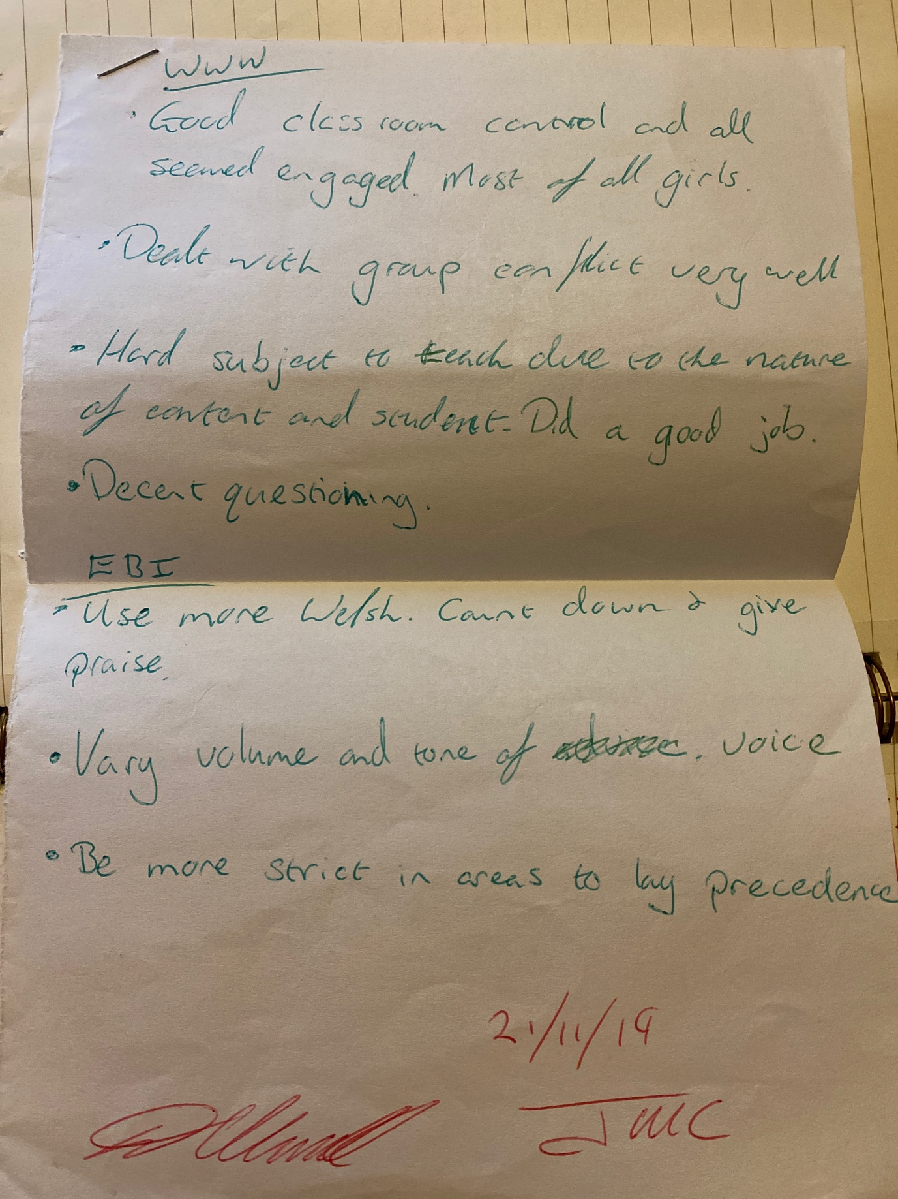

This is a note from my mentor, commenting that I should make further use of Welsh within my lessons. 21/11/2019

This is a note, again from my mentor, showing that I have made an effort to include Welsh within my lessons since being encouraged to do so, and this has developed to a much better level over time.


