Name
Student number
EVIDENCE OF LEARNING
E portfolio
Learning in the Digital Era – BMPL4007
Maryam rahouf.
Tutor Sadie france

Table of Contents
Task 1 – Preparing for Higher Education 2
Task 2- Mind map 3
Task 3- Presentation Link (please email the link to your tutor also) 6
Task 4- Reflection 7
Introduction 7
Gibb’s Reflective Model 7
Description 7
Feelings 8
Evaluation 8
Analysis 9
Conclusion 9
Task 6- Reference List 13

Task 1 – Preparing for Higher Education
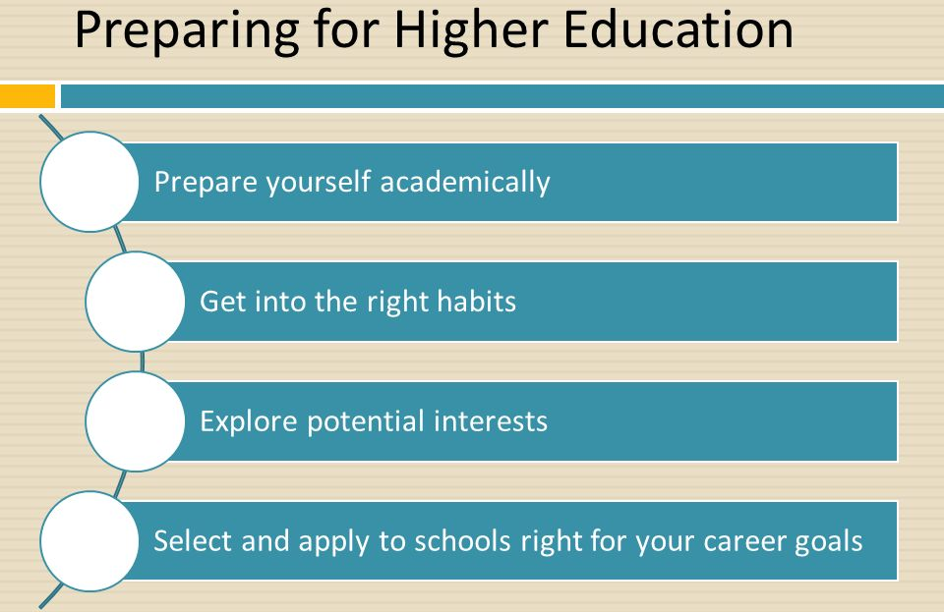
Figure 1 Preparing for Higher Education
Source: McChesney and Aldridge (2021)
Careful planning and an understanding of the admissions process are required for preparing for higher education. By reading resources like Shulman's textbook, Johnson's journal article, Parker's newspaper story, and the NCES research report, prospective students may get essential insights and strategies for navigating this crucial period. By developing key skills, submitting a strong application, and keeping up with developments in higher education, students may increase their chances of success in school and in their career.
According to the study conducted by Knight and Cooper (2019), a complete guide delves into the complexities of the college admissions process. It covers a wide range of issues, such as selecting the correct college, comprehending admissions standards, preparing for standardised exams (SAT, ACT), writing motivating essays, and receiving financial help. This resource is intended to be a starting point for students and parents. Moreover while talking about fostering quality teaching in higher education, a study conducted by Mlambo, Silén and McGrath (2021) reflected the findings emphasise the significance of being adequately prepared for the transition from high school to college. The necessity of establishing crucial abilities such as time management, research habits, and critical thinking is emphasised throughout the text. It also emphasises the need of obtaining guidance from school counsellors and engaging in extracurricular activities in order to enhance college preparedness.
In contrast to the above, Gunnarsdóttir et al. (2021) illustrated about empowering global higher education in Times of higher education in 2022. The above study provides useful tips to future college students. It discusses subjects including writing the ideal résumé, maximising personal qualities, preparing for college interviews, and meeting application deadlines. The post emphasises the necessity of being real in job applications as well as providing unique experiences and thoughts. This can be further explained by many scholars that careful planning and an understanding of the admissions process are required for preparing for higher education. In addition, by reading resources like Edna's textbook, Deborah's journal article, Parker's newspaper story, and the NCES research report, prospective students may get essential insights and strategies for navigating this crucial period. By developing key skills, submitting a strong application, and keeping up with developments in higher education, students may increase their chances of success in school and in their career.

Task 2- Mind map
Becoming a Digital Learner: Interconnected Themes and Concepts for Career Preparation
Being a digital learner is essential in today's technologically advanced workplace. This mind map illustrates how the interconnected themes and concepts pertinent to this topic help prepare individuals to enter their chosen professions.

Figure 2Mind Map Themes
Digital Literacy: | The foundation for becoming a digital learner is developing digital literacy skills. This comprises the ability to traverse digital tools, evaluate online information, and utilise technology effectively for communication, collaboration, and problem-solving (Sulich and Rutkowska, 2020). It also includes the capacity to use digital technologies successfully for communication, cooperation, and problem-solving.
Information management: | Digital learners need to develop the skills necessary to organise, store, and retrieve information efficiently. This entails using file management systems to organise data, creating bookmarks, and taking notes electronically (Volpe et al., 2019).
Critical Thinking: | Digital learners need to strengthen their critical thinking skills. It requires examining data, evaluating sources, and testing presumptions in a digital environment (Børte, Nesje and Lillejord, 2023). Students that possess critical thinking abilities may make informed decisions and overcome difficult problems in their chosen areas.
Collaboration and Digital Communication: | These skills are essential for professional success in the digital age. Online communication etiquette should be understood by digital learners, who should also utilise these platforms for team projects and engage in virtual collaboration (Ketelhut et al., 2020).
Online research and evaluation: | Online research and evaluation are skills that digital learners need to master. This includes comprehending search strategies, selecting reliable sources, and evaluating the dependability of information (Wan, Jiang and Zhan, 2021). These skills are essential for keeping up with advancements in their respective industries.

Being a digital learner is a multifaceted process that calls for the development of a number of connected concepts and themes. By focusing on digital literacy, information management, critical thinking, digital communication and collaboration, as well as online research and evaluation, people may become more prepared to work in their desired professions. The combination of these skills helps students to thrive in an increasingly digital world, adapt to technological advancements, and engage in lifelong learning.


Task 3- Presentation Link
Double click this voice recording

Task 4- Reflection
Reflecting on the Experience: Beginning University, Adopting Online Learning, and Handling First Assignments

Introduction
The beginning of one's academic career at a university ushers in a multitude of new experiences, challenges, and opportunities for one's intellectual and personal development. This reflective essay dives into my experiences transitioning to university life, changing to online learning, and navigating the process of generating my first projects. Both of these transitions were challenging for me. Using the Gibbs reflective approach, I will do an in-depth analysis of the most significant events, feelings, and learning outcomes that occur during my journey.

Gibb’s Reflective Model
The Reflective Model developed by Gibbs is a well-known model that may be used to guide one through the process of engaging in reflective thinking. Graham Gibbs is the one who invented this paradigm, which provides a structured method for investigating events, determining key aspects, understanding emotions, evaluating findings, and developing insights (Farrell and Brunton, 2020).

Description
When I first started college, particularly at a time when I had to study from a distance, there were different challenges and changes. The swift shift to internet-based platforms demanded both adaptability and perseverance from its participants. Due to the fact that the virtual world was new to me but gradually developed confidence in my ability to navigate the digital landscape by being proactive in my usage of online resources such as the university's learning management system and several academic databases (Budur, 2020). By using this method of reflection, I have the opportunity to get a deeper understanding of my thoughts, behaviours, and learning processes, which paves the way for both personal growth and advancement. The planned and methodical approach that Gibbs' Reflective Model takes is a significant benefit me of using this model. The paradigm may be broken down into a number of discrete phases, including a description, feelings, assessment, analysis, conclusion, and action plan. By giving clarity and direction, this structure guarantees that all facets of the experience are thoroughly studied. This framework ensures that all parts of the experience are thoroughly investigated. I am encouraged to explore my own experiences from a variety of angles by Gibbs's suggested paradigm, which may be found here.

Feelings
During the beginning stages of my experience with online education, I went through a range of emotions. I was overloaded with information, but it encouraged me to use the resources I had to their fullest potential. Because the classes were offered in a virtual format, it was often difficult to communicate with the other students and the instructors. On the other hand, participation in online discussion boards and virtual study groups helped bridge the distance, boosting collaboration and a sense of community (Pather et al., 2020). I feel like keeping a reflective notebook or document in which I may write my ideas, observations, and insights. I will seek comments from mentors, peers, or academics to obtain new insights on my experiences. To correctly capture information, practise active observation and concentration throughout events.

Evaluation
The process of writing my first assignments provided an opportunity for both reflection and growth. In the beginning, I had a hard time properly structuring my thoughts and managing my time effectively. By using online writing guidelines and gaining guidance from professors during virtual office hours, I was able to improve my writing talents and construct a systematic approach to the preparation and execution of assignments (Velle et al., 2020). In addition, I was able to develop a more methodical approach to preparing and completing assignments. Reflecting on the description of the incident, analysing the emotions involved with it, critically assessing the experience, analysing the pertinent aspects, and making conclusions are the steps that I can take to acquire a thorough knowledge of the situation and its influence on my own growth. In light of reflecting my own experience Use note-taking strategies to quickly document significant parts of the incident. In order to give a clear framework for contemplation, I use particular and concrete instances in my explanations. To recognise and describe my emotional reactions, I must practise emotional awareness and self-reflection.

Analysis
When I thought back on the challenges I faced, I saw how important it was to be flexible and to make proactive use of the tools available online. By embracing technology and researching the digital platforms that the institution offers, I was able to get access to a wide variety of material, such as academic papers, online tutorials, and electronic books. Not only did these tools help me learn more about the subjects at hand, but they also encouraged me to think critically and pursue independent research (Bozkurt et al., 2020). I will consider the possible causes of my feelings and their influence on my experiences. Moreover, I will investigate a variety of emotions, both pleasant and negative, to obtain a thorough grasp of my knowledge.

Conclusion
Beginning college and transitioning to online education may be challenging experiences, but they also provide opportunities for growth on a personal and intellectual level. By actively connecting with online resources, forming connections with classmates and teachers, and asking for assistance when it was necessary, I was able to overcome the challenges and acquire valuable skills. My first experience with writing an assignment turned out to be a significant learning curve, which led to improvements in my time management skills, organisational skills, and academic writing. This path of self-reflection has highlighted the need of resiliency, adaptability, and making use of the vast variety of online tools that are readily available to enhance the quality of the educational experience. I will do the following things in order to better enhance my reflective practise by adopting Gibbs' Reflective Model, I will set aside time for introspection after big events or at regular intervals

Task 5- Personal Development Plan
Student Name |  | Student Number |  | Module |  | Code
 |  |  |  | Learning in the Digital Era |  | BMPL4007  BMPS4009
What goals do I want to achieve? | How will I measure my progress? |  | What resources or support will I need? |  | How is the objective relevant to my personal aspirations? | What is the timeframe for the achievement of my goals?
Specific | Measurable |  | Achievable |  | Relevant | Timebound
Build my presenting and public speaking abilities. | Development in public speaking settings is shown by positive comments and increasing self-assurance. |  | Enrol in a workshop or course on public speaking during the following three months to gain knowledge and confidence. |  | Deliver at least three presentations to a small group of people while seeking criticism to improve my abilities. | 2 months
Enhance time management skills | To show better time management, finish at least two projects or activities that have deadlines. |  | To establish deadlines and prioritise work, use a time management tool like a productivity app or a planner. |  | Set up distinct chunks of time for concentrated work and reduce interruptions. | 1.5 months
Study project management | Effectively complete a project while adhering to timelines, spending limits, and quality requirements. |  | Enrol in an online project management course or read the recommended books during the next six months. |  | On at least one personal project, use project management approaches to set goals and track development. | 6 months
Develop my networking and interpersonal interactions abilities. | Create and nurture at least three new professional relationships via communication and collaboration on a regular basis. |  | Attend trade shows, seminars, or networking functions to network with thought leaders in my field. |  | Participate actively in discussions and knowledge-sharing activities in professional online forums. | 4 months

Action Steps | Resources | Measures to achieve
Step 1 | For public speaking and presentation skills | - Enrol in a reputed institution's public speaking course.  - Use online tools and publications like Dale Carnegie's "The Quick and Easy Way to Effective Speaking" to hone your strategies.  - Seek mentorship or assistance from seasoned speakers in my network.
Step 2 | For time management skills | - Make advantage of productivity tools like Todoist or Trello to keep track of tasks and deadlines.  - Read books like David Allen's "Getting Things Done" to learn about time management strategies and techniques.  - Establish a schedule and give self-control top priority to ensure better time management.
Step 3 | For project management knowledge | - Become a student of an online project management course offered by a respected organisation like the Project Management Institute (PMI) or Coursera.  - Seek advice from academic publications like "A Guide to the Project Management Body of Knowledge" (PMBOK Guide).  - Make an effort to volunteer or shadow project managers inside my company.
Step 4 | For networking and relationship-building | - Attend seminars, workshops, and networking events that are connected to your business.  - Utilise professional networking platforms like LinkedIn to establish connections with subject matter experts.  - Actively participate in discussions, add to them, and provide assistance when required.

Task 6- Reference List
Børte, K., Nesje, K. and Lillejord, S., 2023. Barriers to student active learning in higher education. Teaching in Higher Education, 28(3), pp.597-615.
Bozkurt, A., Jung, I., Xiao, J., Vladimirschi, V., Schuwer, R., Egorov, G., Lambert, S., Al-Freih, M., Pete, J., Olcott Jr, D. and Rodes, V., 2020. A global outlook to the interruption of education due to COVID-19 pandemic: Navigating in a time of uncertainty and crisis. Asian Journal of Distance Education, 15(1), pp.1-126.
Budur, T., 2020. The role of online teaching tools on the perception of the students during the lockdown of Covid-19. International Journal of Social Sciences & Educational Studies, 7(3), pp.178-190.
Farrell, O. and Brunton, J., 2020. A balancing act: a window into online student engagement experiences. International Journal of Educational Technology in Higher Education, 17(1), pp.1-19.
Gunnarsdóttir, I., Davidsdottir, B., Worrell, E. and Sigurgeirsdóttir, S., 2021. Sustainable energy development: History of the concept and emerging themes. Renewable and Sustainable Energy Reviews, 141, p.110770.
Ketelhut, D.J., Mills, K., Hestness, E., Cabrera, L., Plane, J. and McGinnis, J.R., 2020. Teacher change following a professional development experience in integrating computational thinking into elementary science. Journal of science education and technology, 29, pp.174-188.
Knight, M. and Cooper, R., 2019. Taking on a new grading system: The interconnected effects of standards-based grading on teaching, learning, assessment, and student behavior. NASSP Bulletin, 103(1), pp.65-92.
McChesney, K. and Aldridge, J.M., 2021. What gets in the way? A new conceptual model for the trajectory from teacher professional development to impact. Professional development in education, 47(5), pp.834-852.
Mlambo, M., Silén, C. and McGrath, C., 2021. Lifelong learning and nurses’ continuing professional development, a metasynthesis of the literature. BMC nursing, 20, pp.1-13.
Pather, N., Blyth, P., Chapman, J.A., Dayal, M.R., Flack, N.A., Fogg, Q.A., Green, R.A., Hulme, A.K., Johnson, I.P., Meyer, A.J. and Morley, J.W., 2020. Forced disruption of anatomy education in Australia and New Zealand: An acute response to the Covid‐19 pandemic. Anatomical sciences education, 13(3), pp.284-300.
Sulich, A. and Rutkowska, M., 2020. Green jobs, definitional issues, and the employment of young people: An analysis of three European Union countries. Journal of environmental management, 262, p.110314.
Velle, L., Newman, S., Montgomery, C. and Hyatt, D., 2020. Initial teacher education in England and the Covid-19 pandemic: Challenges and opportunities. Journal of Education for Teaching, 46(4), pp.596-608.
Volpe, R.L., Hopkins, M., Haidet, P., Wolpaw, D.R. and Adams, N.E., 2019. Is research on professional identity formation biased? Early insights from a scoping review and metasynthesis. Medical education, 53(2), pp.119-132.
Wan, Z.H., Jiang, Y. and Zhan, Y., 2021. STEM education in early childhood: A review of empirical studies. Early Education and Development, 32(7), pp.940-962.

