Student Self Evaluation Form

PLEASE COMMENT ON AREAS IN WHICH YOU FEEL THAT YOU HAVE PERFORMED WELL | PLEASE COMMENT ON AREAS you feel that you need TO DEVELOP
I feel I have provided enough information to build a good ‘profile’ of the learner. Allowing me to discuss and suggest relevant learning strategies and drawing linking to literature. | I feel I could have possibly gathered more information on the learner which could have been included within the assignment. This may have resulted in a more detailed investigation.
Student’s Name | Richard Lewis | Date | 29.5.18
Student’s Signature | Richard Lewis
This section repeats in brief the common assessment criteria detailed on previous pages. The extent to which these are demonstrated by you determines your mark. Using these criteria, tick the box that best indicates the level of achievement you feel you have achieved with regard to each of them.
Common Assessment Criteria Applied
Common Assessment Criteria Applied | REFER |  | D |  | C |  | B | A
 | OUTRIGHT FAIL | UNSATISFACTORY | SATISFACTORY | GOOD |  | VERY GOOD |  | EXCELLENT
1. Subject Knowledge and Understanding (which includes using research-informed literature and knowledge and understanding of the subject)
2. Intellectual Skills (Analysis)
3. Pedagogic and Professional Applications (Practical Application and Deployment)
4. Key Transferable Skills

Word Count - 4867
‘Supporting pupil progress: a detailed analysis of one child’s holistic development, with justification for the next steps in learning.’

Introduction
Within the scope of this assignment a detailed profile of one selected pupil will be discussed and analysed using relevant literature. The assignment will be split into the following sections. Firstly, the learner and school will be introduced to provide information and context for the assignment. Next, the method of data collection will be discussed. Following that, the current achievements of the student of focus will be analysed. To conclude, next steps will be suggested for progression of learning for the student, justifying suggestions through connections to relevant literature.

The school in which the information was gathered is located within a large housing estate which is a communities first housing area (Estyn, 2011). There are approximately 301 pupils attending the school as of 2017 (My Local School 2017). The majority of pupils attending the school live within the surrounding area. Although, some pupils attending the special training facility, travel from further afield. According to My Local School (2017) the percentage of pupils who are entitled to free school meals is approximately 55.1%, which is significantly higher than the national average of 17.8% reported by Welsh Government (2017). This statistic could be seen as one indicator that the type of area the school is located, is that of a deprived area. The percentage of pupils requiring additional learning needs is around 27.5% and around 8.1% of pupils receive support for English as an additional language (My Local School, 2017).
For the purpose of this assignment the pupil of focus will be referred to as ‘Pupil A’. ‘Pupil A’ is a 6-year-old, year 2 student who has been a part of the school since nursery and lives within the local area. ‘Pupil A’ comes from a family that speaks Polish as the primary language and rarely communicates using English language at home. ‘Pupil A’ receives limited classroom-based support for English as an additional language and is also following an individualised education programme for speech delay. ‘Pupil A’ receives free school meals each lunchtime. ‘Pupil A’ is a middle to lower attaining student across the curriculum. ‘Pupil A’ is best described, by the class teacher, as an ‘all-rounder’ when it comes to subjects through the curriculum. ‘Pupil A’ comes across as a hard worker that applies themselves to every task. ‘Pupil A’ socialises with multiple social circles during breaktimes, from different groups within their class and from other classes. ‘Pupil A’ has an older sister within the same school, who is currently in year 6. ‘Pupil A’s’ attendance is of a high level and rarely misses a day of school. ‘Pupil A’ comes across as a very happy student that enjoys attending school and socialising with friends.

Data collection
The assignment will adopt the Mosaic Approach developed by Clark (2011), as a method of data collection. This approach was chosen to ensure pupil voice was at the forefront of the research. To ensure the child was able to express their own views and attitudes toward learning, qualitative data was collected utilising multiple methods. Collecting qualitative data ensured that a ‘profile’ of the pupil could be built around attitude, skills and knowledge (ASK model, Nottingham, 2013) regarding their own learning. Data was collected and interpreted by means of the three stages mentioned within the Mosaic approach. These are:
Stage one – Gathering children’s and adults’ perspectives of learning.
Stage two – Discussing and analysing the material gathered.
Stage three – Making justified decisions on possible changes.
‘The Mosaic Approach’ (Clark, 2011).

To ensure data was collected and collated from all areas of student learning, various methods of collection were utilised such as; Observations, photographs, interviews/discussions with the child and their teacher and samples of work. These various methods helped to build a learning ‘profile’ of the student. The ‘profile’ covers areas such as; the pupil’s attitude towards learning within the classroom, the way in which the pupil interacts with learning environment and the skill level and knowledge of the pupil. Once the information had been collected and collated, the data was analysed to determine ‘Pupil A’s’ current achievement. From this, next steps to help move the learning on have been suggested.

Prior to the educational data collection, it was essential to follow ethical guidelines suggested by BERA (2011) to ensure participants were protected and shown respect throughout. The first point of action was to seek consent for the research activity to commence. Firstly, asking permission from the school and class teacher by way of a pre-prepared form being signed (see appendix 10). Secondly, to seek voluntary consent from the focus pupil. Article 16 of The United Nations Convention on the Rights of the child (2015) states that children have the right to privacy and their name, families and home should be protected. BERA (2011), also suggests the researcher must recognise that any participant has the right to withdraw from an activity. It was mentioned to the focus pupil that they “do not have to take part in the research activity if they do not want to” and that no reason would be required. The researcher verbally discussed with the student, the types of activities the project will involve such as; informal interviews and discussions about work completed. ‘Pupil A’ was happy to take part in the research and gave voluntary consent to commence data collection.

There were multiple methods of data collection used for this assignment, to ensure all areas of the child’s learning were accessible. Webb et al (1966) argue that data collection methods used alone can be perceived as sub-standard in comparison to the use of multiple methods. One type of method used was observation, Grigg (2015) suggests that observation can be complex and time consuming, however he advocates it is an essential process within a school environment. Both participant and non-participant methods of observation were utilised during the data collection period. This was to ensure different views and behaviours of the learner were captured. Participant observation can be described as a researcher interacting with participants and becoming a part of their community (Driscoll, 2010). The researcher asks questions and partakes in discussions, as well as making mental notes along the way (Driscoll, 2010). Non-participant or, unobtrusive observation (Webb et al., 1966), is described as the researcher not interacting with the student directly, but observes their behaviour from a distance (Driscoll, 2010). Both forms of observation have strengths and limitations, Devereux and Miller (2003) suggest that participant observation can be difficult to manage. As notes are being made in short breaks (Grigg, 2015), a momentary lapse in concentration can result in a key observation being missed. However, committing to this form of observation can provide the researcher with rich and detailed data. Participant observation allows the researcher to immediately check understanding and feelings toward an activity. Bernard (1994) proposes that researchers must first build a rapport with a student and act in such a way that they blend into the children’s community, resulting in the learners continuing to act naturally. That way rich and truthful findings can be collected. DeWALT and DeWALT (2002) believe that utilising participant observation as a method can help to develop a holistic understanding of an individual.
Non-participant observation also has its strengths and limitations. A limitation could be that a child’s behaviour is misinterpreted, on the surface they may come across as comfortable and content with a task or activity, but the child might be having issues or ill feelings toward it. This may result in a missed opportunity for the researcher to gather important data. Lee (2000) proposes a justification for the use of non-participant observation methods is that a researcher is able to witness a child during their most natural behaviour. This will allow the researcher to observe the child’s social interaction with others and their environment as well as observing general behaviour.
Informal interviews/discussions were also utilised during the data collection for this assignment Webb et al (1966) suggests that interviews can act as a foreign element for students. Lee (2000) advocates that interviews can create attitudes and responses based on the questions that are asked. In this instance a child may answer a question in such a way because they think ‘that’ response is what the researcher wants to hear. However due to the nature of the interviews being informal, the method of data collection was more of a discussion based. These discussions were based around feelings towards learning in school, favourite subjects or areas within the school and also their general feelings and attitudes. Based on this understanding the ‘interviews’ were not recorded in any way, to ensure the student remained comfortable to discuss areas of their school life. Other methods of data collection utilised were, discussions with the pupil’s teacher, who was able to provide their own thoughts and opinions on the attitude and learning of the pupil. As well as samples from workbooks which will be discussed in further detail.

Analysis of learner
The second stage of the assignment will discuss and analyse the material gathered, building a learner profile for ‘Pupil A’. The information gathered will be synthesised into a picture of ‘Pupil A’s’ current achievement and attitude toward learning. The following part of the assignment will look at ‘Pupil A’s’ achievement in various areas such as Literacy, Numeracy, Personal and Social Development, Welsh language development and physical development. The ‘ASK’ model developed by James Nottingham (2013) will be utilised, using data collected to determine the attitude, skills and knowledge of the student in focus, across the curriculum (see figure 1).
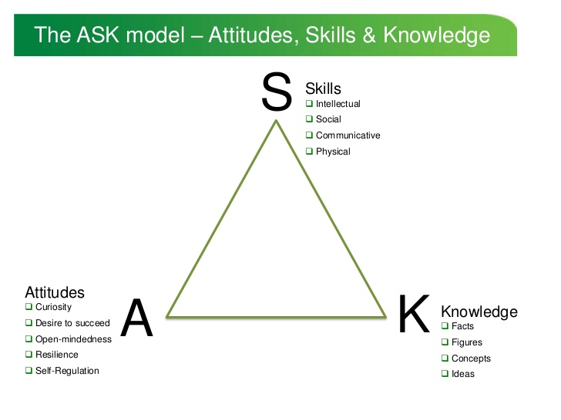
(Figure 1 – ASK Model James Nottingham 2013).

Prior to any information being gathered on the student ‘Pupil A’ and the researcher embarked on a tour around the school visiting various locations of interest, starting from within the classroom. ‘Pupil A’ was given permission to visit any part of the school but decided to stay within the foundation phase wing, asking if there was a reason for staying within foundation phase, the students response was “I like it here”. There were three places of interest that the student stopped to discuss in detail, the first being a comfortable looking reading area within the classroom (see appendix 2). ‘Pupil A’ jumped onto the sofa and picked up a ‘reading buddy’ in the form of a plush Disney character toy. Asking why the student liked this area was returned the response “me and [two pupils names were mentioned] like to read and play with the toys”. Immediately ‘Pupil A’ mentioned they liked to work in this area with fellow pupils. The next area the student visited was an outdoor area shared with two other classes just outside the classroom. ‘Pupil A’ showed the researcher ‘the house’ which was made from a shed and had various utensils located within it, again referencing playing in this area with ‘friends’. The student told the researcher that the class “do work out here” on occasions and that they enjoyed being outside of the classroom. The final place the student visited was an area outside of the classroom, in the foundation phase hall where the students eat their lunch. ‘Pupil A’ ran over to a locked cupboard to check if it was open. Had it have been open the student would have shown the researcher various types of physical education equipment that was stored there such as balls, hoops, cones etc. ‘Pupil A’ described a dance session that they had taken part in for PE one session and how ‘fun’ it was.

Based on initial observations of the student and the areas of interest it can be understood that ‘Pupil A’ enjoys working and playing with friends inside and outside of the classroom. This immediately drew a comparison to ‘cooperative learning’ and Vygotsky’s (1978) theory of social constructivism. Vygotsky (1978) suggests that children learn and develop skills through social interactions. ‘Pupil A’ also spoke of ‘doing work’ outdoors being ‘fun’ suggesting that they enjoy learning outside of the classroom. Welsh Government (2009) advocate that the outdoors is an ideal environment for experiential learning. This type of learning allows students to move around, take risks and encourages them to be creative (Welsh Government, 2009). The final point to mention is how ‘Pupil A’ enjoyed a dance session during a PE session within school, this drew links to ‘active learning’ and ‘physical literacy’. Active Learning is described as students experiencing ‘concrete experiences’ and ‘learning by doing’ (Kolb, 1999). Whereas Physical literacy is described as developing fundamental movement skills (Canadian Sport for Life no date), allowing the child to develop holistically not just purely in an academic focus.

The researcher discussed ‘Pupil A’s’ current achievement and development over the year with the student’s class teacher. The class teacher described ‘Pupil A’ as a very pleasant student who works hard. As mentioned previously in the assignment, ‘Pupil A’ speaks English as an additional language (EAL). The class teacher had mentioned that they believe this has acted as a barrier to achievements throughout school. Although ‘Pupil A’ has been a part of the school since nursery, their primary language spoken at home is Polish. This means that ‘Pupil A’, as with other EAL learners has two main responsibilities in everyday school life, they must ensure they are able to understand the English language and to learn the skills through areas of the curriculum (Milton Keys Council 2004). Students are provided with success criteria before and after tasks within the class (see appendix 1) which they are required to fill out using ‘a star or a wish’ to determine how confident they are with each point. This could well be the first challenge ‘Pupil A’ faces, having to interpret the meaning of each point independently to make a decision on their own performance. At times the pupil may require support from a teacher or teaching assistant to understand what is expected of them. That being said, based on observations and discussions, ‘Pupil A’s’ written and spoken and reading of English is of a good standard, it is evident that they have worked hard to understand the language over their time within school.

Language, Literacy and Communication (LLC)
The class teacher informed the researcher that ‘Pupil A’ is currently expected to achieve an outcome 4a for LLC which is in line with their forecast at the beginning of the year. However, it is slightly under the expected achievement of outcome 5 for the end of foundation phase. The class teacher mentioned that to get over into outcome 5, minor improvements are required in all three areas, oracy, reading and writing. Based on observations and working with the student, ‘Pupil A’ is at a satisfactory level for LLC. Appendix 3 shows a piece of work where the student is initially given support from the teacher along with some scaffolding. ‘Pupil A’ is then encouraged to complete the work independently. The piece of work is of a good standard however the range of vocabulary is very limited and could have been extended further to include more detail. Had there have been a student of a higher attainment working with ‘Pupil A’ there could have been a model to follow, resulting in an improvement. Another piece of work (see appendix 4) shows the student writing about the life cycle of a butterfly. Time connectives were provided as a form of scaffolding along with a word bank which were utilised by the student. However, the use of vocabulary was, again, limited and could have been extended. Also, there is evidence of the pupil using two lines to complete a word as well as writing onto the other page to fit a word in. It appears that along with reading and understanding instructions, using an increasing vocabulary whilst writing is something that ‘Pupil A’ finds challenging. Learning as an EAL student could be preventing ‘Pupil A’ from developing the necessary skills to increase knowledge of these subjects which is a difficult obstacle to overcome. However, the next part of this assignment will discuss strategies to implement that could aid in the enhancement of learning for ‘Pupil A’.

Mathematical Development
As with LLC the class teacher informed the researcher of ‘Pupil A’s’ current achievement within Mathematical Development (MD) and a comparison to forecasts made at the beginning of the year. ‘Pupil A’ is on course to achieve an outcome 4a for MC which again, is in line with the teacher’s estimation and just under the expected achievement of outcome 5. This shows that the student is working at an expected level based on progressions throughout school, however there are areas that could be improved. With support, it appears ‘Pupil A’ is competent enough to complete the work provided to them during numeracy lessons. Examples of work are with, sums and money (see appendix 5), reading and understanding fractions (see appendix 6) and reading and following coordinates (see appendix 7). Through observation and discussion with teaching assistants it appears the next step for ‘Pupil A’ is to become more independent. Areas in numeracy that ‘Pupil A’ finds difficult are, Time and developing strategies for solutions such as higher number addition and multiplication tables to solve problems. ‘Pupil A’ relies on support from the teacher and teaching assistant when they are unsure of a task or activity.

Personal and Social Development, Well-being and Cultural Diversity (PSD)
Through discussion with ‘Pupil A’s’ teacher it appears as thought the student is working above the estimated outcome at the start of the year. ‘Pupil A’ is currently expected to achieve an outcome 6C for PSD. It is clear to see from observations that ‘Pupil A’ is confident working and cooperating with groups and appears to enjoy that way of working. ‘Pupil A’ has no issues with working with any other member of the class and as mentioned previously has multiple social circles outside of the classroom. There have been multiple occasions where ‘Pupil A’ has allowed a partner to express their view or idea before expressing their own, which speaks volumes of the type of student ‘Pupil A’ is. One area of focus that ‘Pupil A’ may find difficult at times is concentrating for large periods of time, which may be down to lack of support of understanding a task. Leading on from this ‘Pupil A’ should be encouraged to use materials and resources to improve their own learning when a teacher or teaching assistant is not available.

Physical Development
‘Pupil A’ has a fantastic attitude toward physical development and is beginning to understand why exercise and a healthy lifestyle is so important. The student will regularly discuss the contents of their lunchbox and how ‘healthy’ each item is. ‘Pupil A’ applies themselves during PE sessions and appears to enjoy exercising. In addition to PE sessions the school take part in a ‘mile a day’ initiative, where the whole of foundation phase wing attempt to run a ‘mile’ during the final break time of each day. ‘Pupil A’ is regularly seen jogging for the whole time, only stopping to speak with friends or a teacher.

Welsh Language Development
This is arguably the most difficult area for ‘Pupil A’, as the introduction of welsh is the third language for them to read, write and speak. Again, the success criteria for each task is provided in English which can be confusing for other students let alone a student who is learning with three languages. However, ‘Pupil A’ has a fantastic attitude toward welsh and appears to enjoy lessons focused on the language (see appendix 8 for an example of welsh work).

Utilising the three areas of the ASK model (Nottingham 2013) ‘Pupil A’ will be discussed through each section. Firstly, the attitude of ‘Pupil A’ is extremely positive, they understand how important attending school and learning is to their development. ‘Pupil A’ appears passionate about understanding a task fully before moving on or taking a ‘short cut’ to a problem. The area where ‘Pupil A’ is let down is their skill level, however this may be down to an understanding of what is required more than the skill level itself. The lack of understanding can lead to the wrong skills being implemented which can therefore result in no progression in knowledge. It appears that support needs to be provided to ‘Pupil A’ at the route of each activity. The next section will discuss possible methods and strategies that could be utilised.

Next steps
The following section will suggest and discuss strategies that may help ‘Pupil A’ to enhance their learning, drawing upon relevant literature to justify suggestions made. It is a large responsibility for the teachers to ensure they provide students with enough support, challenges and resources for effective learning to occur. Grigg (2015) suggests that the core purpose of schools is to promote learning. Turner-Bisset (2001) advocates that ‘expert teachers’ must be aware of all kinds of knowledge, skills and processes. Signifying that they must be aware of effective ways in which students learn. Grigg (2015) suggests that teachers should concentrate more on learning strategies rather than learning styles. This is due to children learning and adapting new ways of thinking. That being said, it is clear that children learn in different ways and Pritchard (2009) suggests that the individual learning styles of students should be considered and incorporated into planning. Cowley (2013) states that children are different to each other in more than just attainment levels. Children differ in areas such as: cultural or social backgrounds, different interests, different kinds of motivation as well as many more. She believes that getting to know students and how they ‘tick’ can help in providing effective support for learning.

Based on information gathered for this assignment one of the main targets identified for ‘Pupil A’ is to provide them with support for English language. Discussions with the teacher and minor observations indicate that support in this area could help towards ‘Pupil A’ achieving the expected outcome 5 in literacy and mathematical development. Another area is to become more independent during lessons and less reliant on support from the class teacher or teaching assistant. A final target is to provide ‘Pupil A’ with opportunities to participate in active learning allowing them to explore their own understanding during activities.

One of the most important steps to take with ‘Pupil A’ is to implement strategies to help with any potential language barrier, ensuring the student has access to information that will help them. Arnot et al (2004) such strategies as ‘Task Simplification’, ‘Peer Support’ and ‘References to home culture’. Employing one of these strategies will not only help ‘Pupil A’ to understand information more clearly but could also provide them with a confidence boost to complete tasks more efficiently. Milton Keynes Council (2004) approve that ‘buddying up’ would be an effective strategy to set a good example for the language. They also suggest that providing ‘Visuals’ and partaking in ‘Practical Activities’ can prove effective.

One of the strategies of learning that will be discussed is Cooperative learning. Johnson and Johnson (1999) describe cooperative learning as, when a group of students work together to accomplish a common goal. Cooperative learning should include elements such as, face to face interaction, individual accountability and good use of collaborative skills (Johnson and Johnson 1999). USAID (2009) explain that effective cooperative learning is dependent on the type of talk that is taking place. They suggest that when students discuss a question or problem, they are more likely to understand it and thus are more likely to identify a solution. Based on information gathered on ‘Pupil A’ it is evident that they enjoy working and playing with fellow students. Vygotsky (1978) believes that people develop knowledge and skills through social interactions with others. He suggests cooperating with others can help to promote cognitive development. Schaffer (1996) suggests that when a student participates in a task or activity with someone who can demonstrate basic strategies, it allows the student to become more confident and competent. However, Felder and Brent (2007) suggests that students of a higher attainment level tend to complain about being held back by their peers. Felder and Brent (2007) also propose that knowledgeable and patient practitioners find ways to address such problems if they arise. Encouraging group work within the classroom will allow ‘Pupil A’ to interact and discuss with fellow students in an attempt to accomplish a common goal. This will allow each student to benefit from each other’s strengths (USAID 2009). Working with students who have a more natural understanding of the English language can help ‘Pupil A’ to interpret the information provided more effectively. Appendix 9 shows an example of ‘Pupil A’ completing a piece of work working with fellow students, the encouragement of ‘team work’ allowed the student to understand how the activity was to be completed.

Drawing on a moment shared with ‘Pupil A’ in which they described ‘doing work outside’ being ‘really fun’ it could be understood that another form of learning to enhance their learning would be the incorporation of outdoor learning. The Council for Learning Outside of the Classroom (LOTC 2009) promote that it is essential to provide regular opportunities to learn and explore in an outdoor environment. Welsh Government (2009) advocate that being outdoors enhances all aspects of a child’s development. Ensuring a child develops holistically allows them to develop more rounded skills leading them to learn more efficiently and more importantly, retain that learning. LOTC (2009) suggest that young children predominantly learn through physical experiences. Providing a chance to work in an outdoor environment allows more space to utilise resources that would not normally be available to use indoors, such as PE equipment, mud kitchens and water works. Giving students more freedom to explore and develop their own understanding, falls in line with Piaget (1976) theory of cognitive constructivism. This theory is described as providing learners with the independence to draw on their own conclusions rather than being told the ‘correct’ answer. Providing students with an opportunity to learn in this way can result in more effective learning occurring, as the learner can develop a further understanding of the underlying factors of a question or problem.

Leading on from outdoor learning another type of learning that would be recommended, is the increase in active or experiential learning. Experiential Learning is defined as “the process whereby knowledge is created through the transformation of experience” (Kolb 1984, p. 41). This theory suggests that students ‘learn by doing’ and understand information and process through concrete experiences (Kolb et al 1999). As stated by Milton Keynes Council (2004) a way in which an EAL student could be supported is through practical activities, that can be organised with minimal information.

Exploring the classroom environment, one idea that could be implemented is to encourage the students to become more independent, by providing a work station or working wall. These areas can change depending on the activity at hand and should be specifically tailored to reflect the most current lesson or topic. Incorporating this into planning may prove to be ‘extra work’ but can prove effective over a time. Along with the work stations a ‘Three before me’ scheme could be introduced. ‘Three before me’ is a strategy that requires students to interact with students and the classroom before asking a teacher for support. For example:
1. Think of different ways they could approach the question or problem.
2. Ask a fellow student for support.
3. Find a work station to help identify solutions to the problem.
The introduction of this strategy will encourage students to find a solution to a problem without direct support from a teacher or teaching assistant. Thus, becoming a more independent learner.

Conclusions
Looking specifically at ‘Pupil A’ it can be suggested from the data gathered that speaking and reading English as an additional language has acted as a barrier in their learning. Drawing upon relevant research the different strategies mentioned above are suggestions that could aid in the development from outcome 4 into the expected outcome 5. It would be unrealistic to assume that the school would be able to afford full time support which is why these more cost-effective measures could be implemented. As Pritchard (2009) states, facilitators should be constantly aware of the ever-changing learning styles of students. These measures may work initially, but a change in the type of learning of students may result in no progression through these suggestions. This is where the teacher must again take a step back to analyse the learners and what they believe could work moving forward. This is, assuming that time is available to observe, interview and analyse pieces of work of the learners. Due to the lack of free time available during school hours this could prove difficult to cover all learners. In that case a basis or foundation of learning provisions could be provided to provide students with a variety of different opportunities.
This assignment has provided an insight into understanding the amount of work and effort required from schools and practitioners to ensure all students are given equal opportunities to achieve their potential. Continually utilising effective assessment for learning strategies is essential within teaching. The use of these strategies provide information on the way in which students are learning and if current measures are aiding in the learning of all children.

References
Arnot, M., Schneider, C., Evans, M., Liu, Y., Welply, O. and Davies-Tutt, D. (2004) School approaches to the education of EAL students. University of Cambridge Faculty of Education
BERA. (2011). Ethical Guidelines for British Research. British Educational Journal. London.
Bernard. (1994) cited in, Kawulich, B. B. (2005) Participant Observation as a Data Collection Method. Forum: Qualitative Social Research.
Canadian Sport for Life. (no date) An introduction to Physical Literacy. Physical Literacy.
Clark, A, (2011) Ways of seeing: using the Mosaic approach to listen to young children’s perspectives.
Council for Learning Outside the Classroom. (2009) Benefits for Early Years of Learning Outside the Classroom. Crown.
Cowley, S. (2013) The Seven T’s of Practical Differentiation. Sue Cowley Books Ltd.
Devereux and Miller (2003) cited in, R, Grigg (2015) Becoming an Outstanding Primary School Teacher. Second Edition. Routledge Taylor & Francis Group.
DeWALT and DeWALT (2004) cited in Kawulich, B. B. (2005) Participant Observation as a Data Collection Method. Forum: Qualitative Social Research.
Driscoll, D. L. (2010) Introduction to Primary Research: Observations, Surveys, and Interviews. Writing Spaces: Readings on Writing, Volume 2.
Felder, R. M. and Brent, R. (2007) Cooperative Learning. N.C. State University.
Grigg, R. (2015) Becoming an Outstanding Primary School Teacher. Second Edition. Routledge Taylor & Francis Group.
Johnson, D. W. and Johnson, R. T. (1999) Cooperative Learning Work. Theory into Practice, Vol. 38, No. 2, Building Community through Cooperative Learning (Spring, 1999), pp. 67-73. Taylor and Francis Group.
Kawulich, B. B. (2005) Participant Observation as a Data Collection Method. Forum: Qualitative Social Research.
Kolb, D. A (1984) cited in Kolb, D. A., Boyatzis, R. E., Mainemelis, C. (1999) Experiential Learning Theory: Previous Research and New Directions. Weatherhead School of Management.
Kolb, D. A., Boyatzis, R. E., Mainemelis, C. (1999) Experiential Learning Theory: Previous Research and New Directions. Weatherhead School of Management
Lee, R. M. (2000) Unobtrusive methods in social research. Open University Press. Buckingham – Philadelphia.
Milton Keynes Council. (2004) Supporting pupils with English as an Additional Language. Children and Young People’s Service.
My Local School (2017) Accessed via http://mylocalschool.wales.gov.uk/School/6702073?lang=en
Nottingham, J. (2013) ASK Model accessed via https://www.slideshare.net/jabulani4/develop-ask
Piaget, J. (1978) cited in, R, Grigg (2015) Becoming an Outstanding Primary School Teacher. Second Edition. Routledge Taylor & Francis Group.
Pritchard (2009) cited in, R, Grigg (2015) Becoming an Outstanding Primary School Teacher. Second Edition. Routledge Taylor & Francis Group.
Schaffer (1996) cited in, R, Grigg (2015) Becoming an Outstanding Primary School Teacher. Second Edition. Routledge Taylor & Francis Group.
Turner-Bisset (2001) cited in, R, Grigg (2015) Becoming an Outstanding Primary School Teacher. Second Edition. Routledge Taylor & Francis Group.
Webb et al (1966) cited in Driscoll, D. L. (2010) Introduction to Primary Research: Observations, Surveys, and Interviews. Writing Spaces: Readings on Writing, Volume 2.
Welsh Assembly Government. (2009) Foundation Phase Outdoor Learning Handbook. Department for Children, Education, Lifelong Learning and Skills.
Welsh Government (2015) The United Nations Convention On The Rights of the Child.
Welsh Government (2015) Foundation Phase Framework. Curriculum for Wales.
Welsh Government School Census Results (2017) Statistical First Release. Statistics for Wales.
USAID Cambodia. (2009) Cooperative Learning: Theory and Practice. Schools for life program.
Vygotsky, L. (1978) cited in, R, Grigg (2015) Becoming an Outstanding Primary School Teacher. Second Edition. Routledge Taylor & Francis Group.

Appendices
Appendix 1 – Example of Success Criteria

Appendix 2 – Reading Area

Appendix 3 – Instruction writing

Appendix 4 – Butterfly life cycle

Appendix 5 – Money

Appendix 6 – Fractions

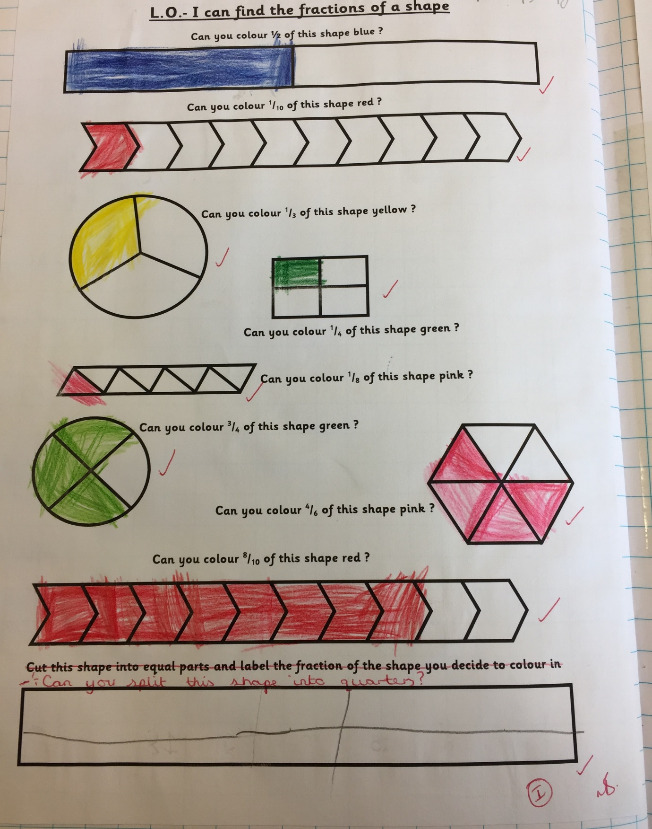

Appendix 7 – Coordinates

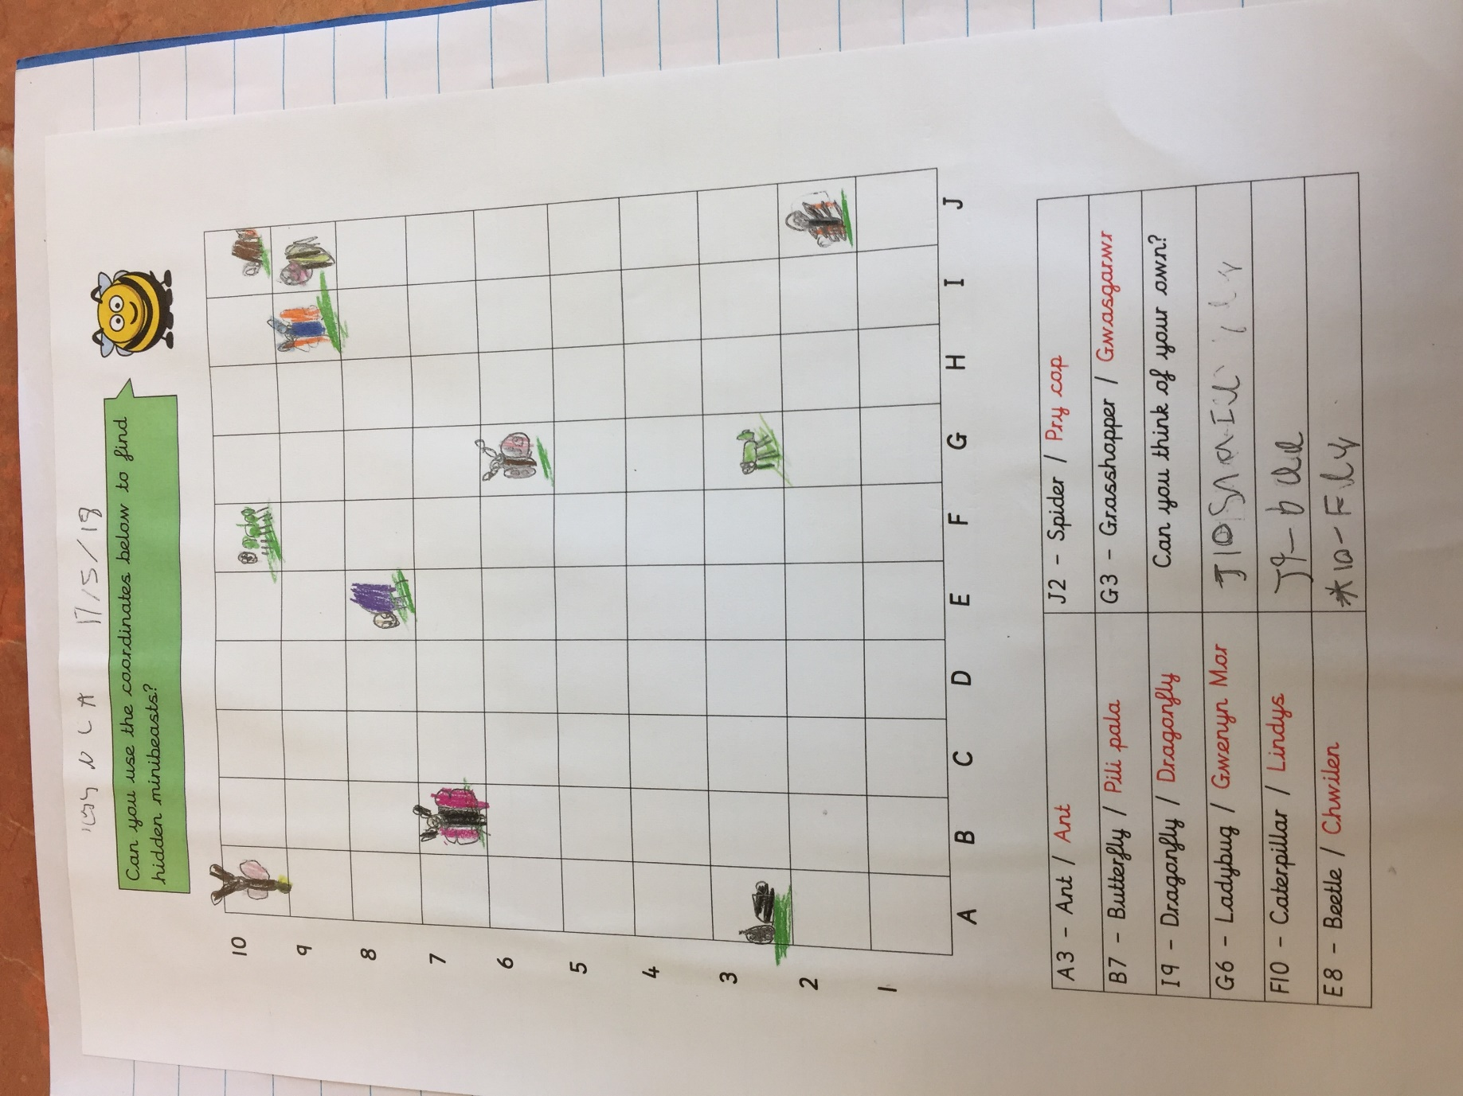

Appendix 8 – Welsh
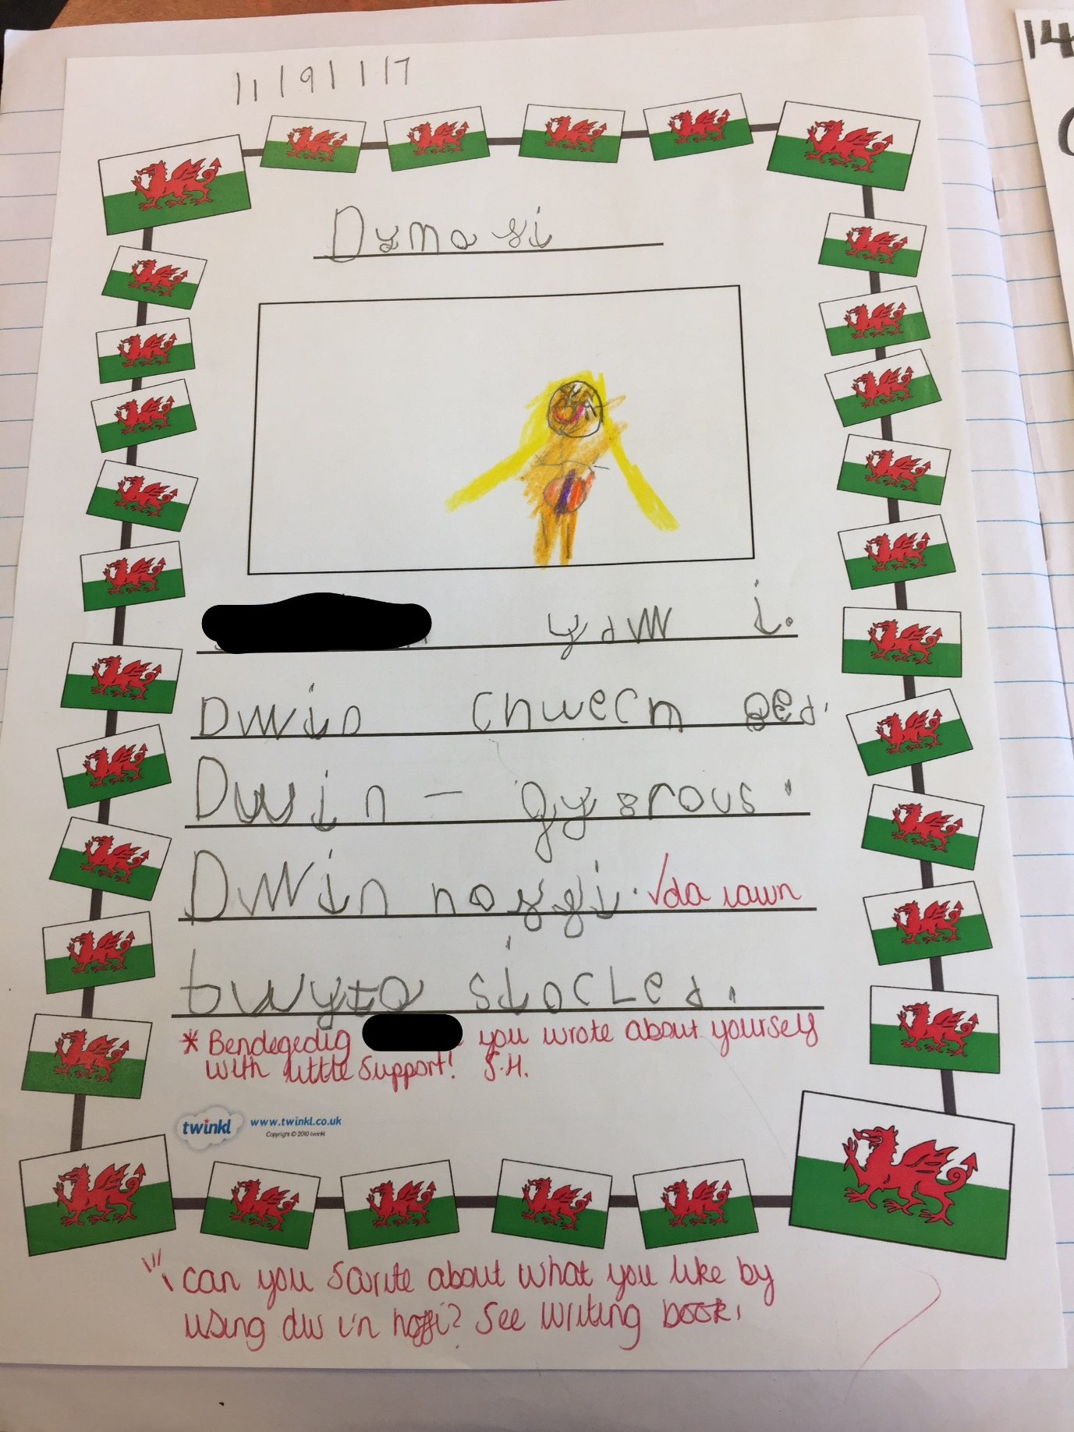

Appendix 9 – Independent Work Sheet
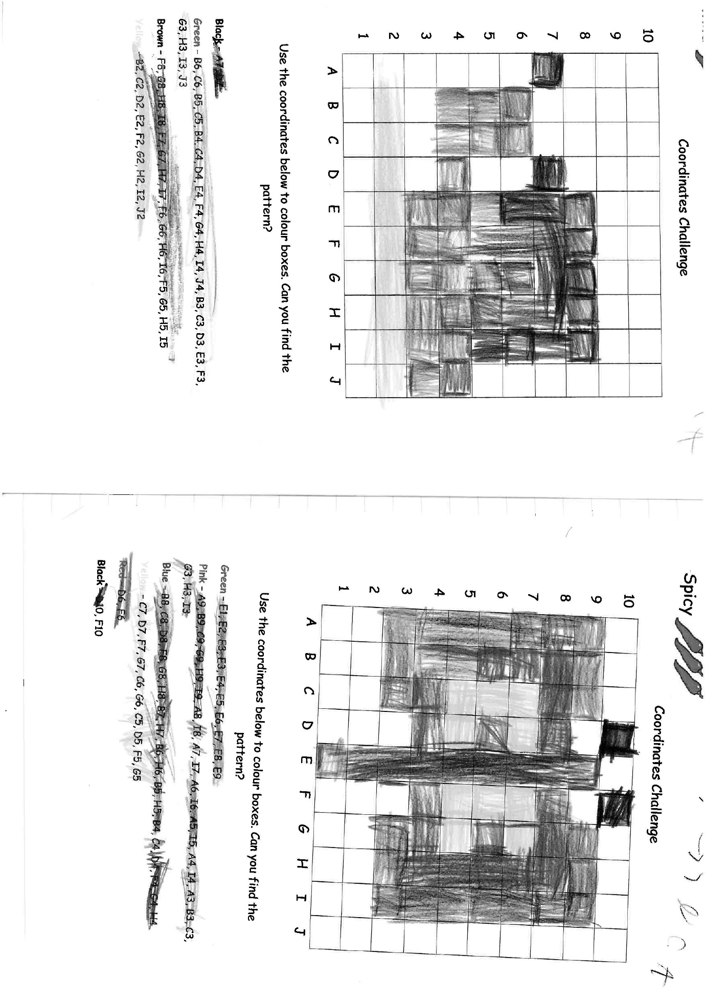


Appendix 10 – Consent Form

RE: Primary PGCE student assignment: permission and confirmation that work has been undertaken in school for assignment ‘School Development and Pupil Progress’, Summer 2018.

Dear class/senior mentor,
For the university module named above, trainees are required to identify one learner within the class in which they are based and, over the course of the Professional Teaching Experience, explore their learning in detail. The evidence that they need to gather could include:
- observation;
- asking the learner to identify places/things that help him/her learning;
- discussing what helps the pupil learn and how they feel about learning with the pupil and/or teacher;
- collecting samples of work which might show something about the learner’s progress and development.
They are asked to focus on knowledge, attitude and skills in language, mathematics, wellbeing and at least two other areas of the curriculum to gain an holistic picture of the child. They then suggest the next steps for the learner, and indicate how these will be achieved. Trainees are expected to undertake this work independently whereever possible, and have been given ethical guidelines to follow (although undertaking the work above would be in line with typical classroom practice). The trainees have been asked not to reveal the identify of the learner or the school within their assignment. Students have been asked to:
- Seek permission for this work (by consulting with the class teacher and learner)
- Provide verification that the work has taken place.
We would therefore be grateful if you could confirm that permission has been sought and that tasks have been undertaken by signing below:

STUDENT NAME (PLEASE PRINT): RICHARD LEWIS 1700426

SCHOOL NAME (PLEASE PRINT): CLASE PRIMARY SCHOOOL

SENIOR MENTOR/CLASS MENTOR NAME (PLEASE PRINT):

NATASHA BLOWS

SENIOR MENTOR/CLASS MENTOR NAME (PLEASE SIGN):

NATASHA BLOWS

If you have any queries regarding this, please contact the Programme Lead Helen Lewis: h.e.lewis@uwtsd.ac.uk


Many thanks in advance,

Helen Lewis, 5.3.18

