University of Wales Trinity Saint David

Torsion of Shafts
Pablo Model Rodrigues
2503092
BEng Engineering Programmes
01/01/2026
Mechanics and Dynamics
(ACHA4026)
Word Count: 1393

Table of Contents
1.Introduction 3
2. Experimental Procedure 4
3. Results 6
4. Analysis 8
4.1 Calculation method 8
4.2 Graphical analysis 9
4.3 Discussion of results 10
5. Conclusion 11
6. Evaluation 12
6.1. Methods used 12
7. Further Work 13
7.1. Methods used 13
8. Reference List 14

1.Introduction
Torsion is common in engineering applications involving circular shafts, such as drive shafts, wheel axles, and transmission components. When a torque is applied, the shaft twists along its length, producing stress in the material and a deformation known as the angle of twist. According to Shigley et al. (2015), “any moment vector collinear with an axis of a mechanical part is called a torque vector, because the moment causes the part to be twisted about that axis. A bar subjected to such a moment is in torsion.” Understanding this behavior is important because excessive torque can lead to permanent deformation or component failure.
The study of torsion allows engineers to predict how shafts will behave under applied loads and avoid excessive angular displacements, vibrations, or damage to components. For a circular shaft operating in the elastic region, the angle of twist depends on the applied torque, the shaft length, the shaft diameter, and the stiffness of the material. This stiffness is defined by the shear modulus, which relates shear stress to shear strain and remains constant as long as the material behaves elastically (Twigg, 2007).
This experiment investigates the torsional behavior of shafts using the ES5. By applying known torques and measuring the resulting angle of twist, the shear modulus of the material can be experimentally determined and compared with reference values.

2. Experimental Procedure
The torsion experiment was performed using the ES5 shaft torsion apparatus, mounted on a laboratory table. A rod was placed horizontally between a fixed chuck and a rotating chuck, ensuring correct shaft alignment. The distance between the chucks defined the effective length of the shaft subjected to torsion. For this experiment, three different types of materials were used: Aluminum, Brass, and Steel, all with the same size specification (To verify the correct diameter of the shafts, a caliper tool was used).
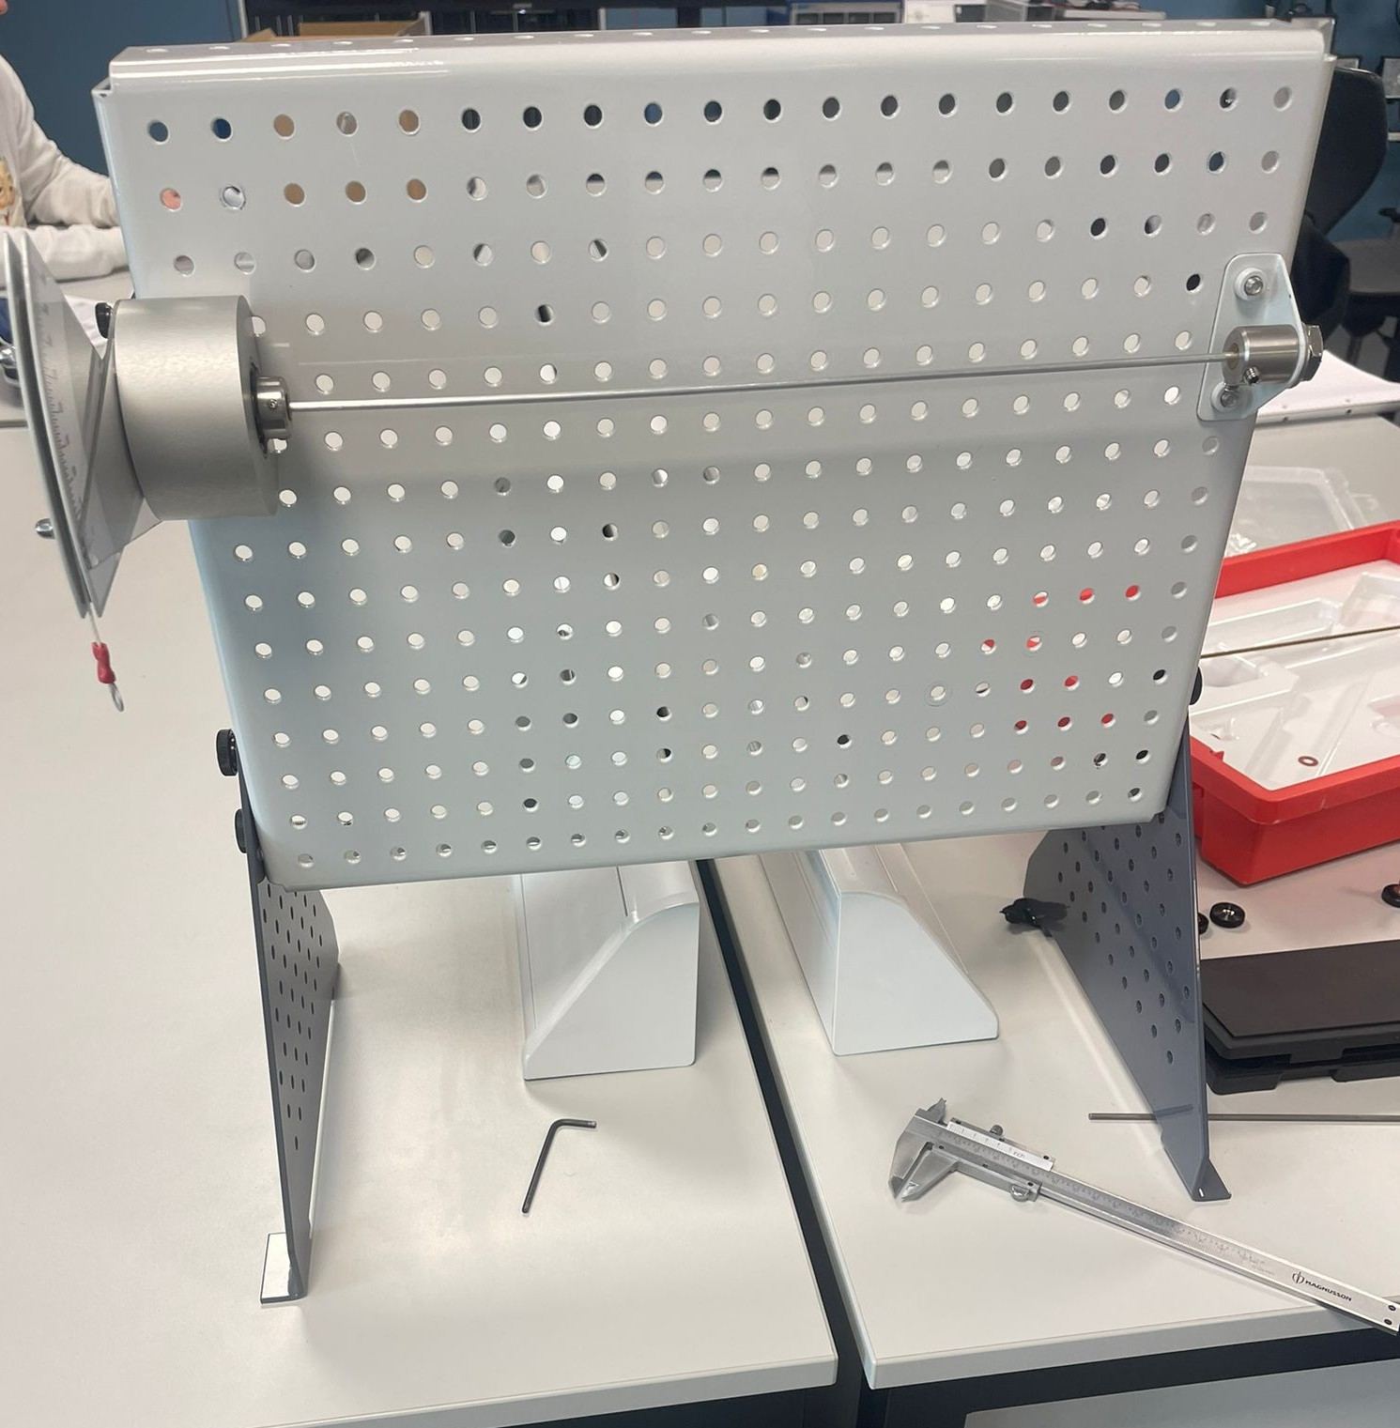
Figure 1: ES5 torsion test apparatus mounted on the workbench, showing the circular shaft positioned between the fixed and rotating chucks before load application.

Before applying the load, the rotating chuck and torque arm were set to zero to maintain the initial angle. Torque was applied to the shaft by placing weights on the torque arm, producing a controlled torsional load. The applied force created a torsion proportional to the mass and length of the lever.
For each applied load, the angular displacement was recorded using a dial gauge on the rotating chuck. The load was applied slowly to minimize the effects of dynamic load and friction.
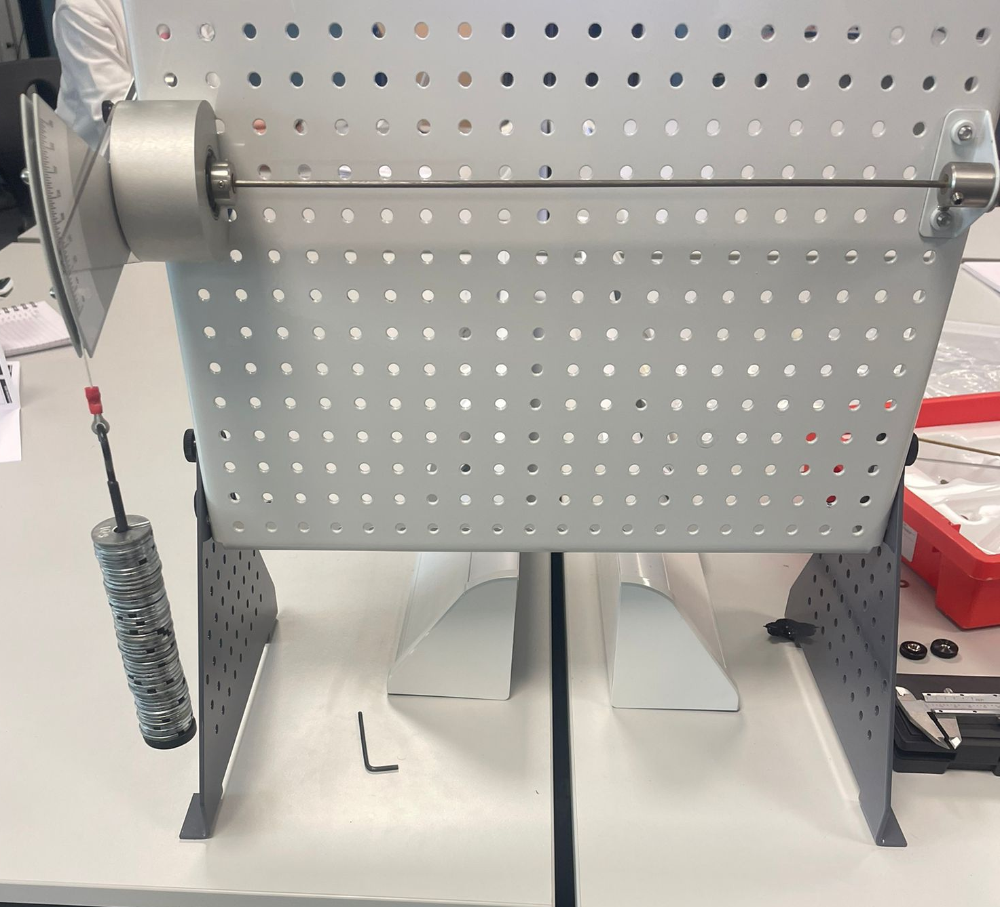
Figure 2: Torque arm and applied masses used to generate a controlled torsional load on the circular shaft.

3. Results
This section presents the experimental data collected during the torsion laboratory for steel, brass, and aluminum samples. The recorded values ​​include the applied load, the calculated torque, and the measured angular displacement.

Table 1- Brass
 |  |  | Shaft Modulus
Load (m) (g) | Load (W) (N) | Torque (T) (Nm) | Twist Angle (deg) | Twist Angle θ (rad) | TL | Jθ (×10⁻¹²)
100 | 0.98 | 0.098 | 6.5 | 0.113 | 0.033 | 1.024
200 | 1.96 | 0.196 | 13.5 | 0.236 | 0.066 | 2.14
300 | 2.94 | 0.294 | 19.5 | 0.34 | 0.099 | 3.083
400 | 3.92 | 0.392 | 25.5 | 0.445 | 0.133 | 4.036
500 | 4.9 | 0.49 | 31.5 | 0.55 | 0.166 | 4.988
Material: Brass |  | L=0.34m |  | D=3.1mm | J= 9.07x10̄ ¹²

Table 2- Aluminium
 |  |  | Shaft Modulus
Load (m) (g) | Load (W) (N) | Torque (T) (Nm) | Twist Angle (deg) | Twist Angle θ (rad) | TL | Jθ (×10⁻¹²)
100 | 0.98 | 0.098 | 8.5 | 0.148 | 0.033 | 1.34
200 | 1.96 | 0.196 | 16.5 | 0.287 | 0.066 | 2.60
300 | 2.94 | 0.294 | 24 | 0.418 | 0.099 | 3.79
400 | 3.92 | 0.392 | 32 | 0.558 | 0.133 | 5.06
Material: Aluminium |  | L=0.34m |  | D=3.1mm | J= 9.07x10̄ ¹²

Table 3- Steel
 |  |  | Shaft Modulus
Load (m) (g) | Load (W) (N) | Torque (T) (Nm) | Twist Angle (deg) | Twist Angle θ (rad) | TL | Jθ (×10⁻¹²)
100 | 0.98 | 0.098 | 3.5 | 0.061 | 0.033 | 0.553
200 | 1.96 | 0.196 | 6 | 0.104 | 0.066 | 0.943
300 | 2.94 | 0.294 | 8 | 0.139 | 0.099 | 1.26
400 | 3.92 | 0.392 | 10.5 | 0.183 | 0.133 | 1.659
500 | 4.9 | 0.49 | 13 | 0.226 | 0.166 | 2.049
Material: Steel |  | L=0.34m |  | D=3.1mm | J= 9.07x10̄ ¹²

This section presents the results collected in the torsion lab performed on circular shafts made of steel, brass, and aluminum. The recorded data includes the applied load, the calculated torque, the measured angle of twist, and the corresponding calculated values ​​of TL and Jθ. The results are presented in tables for each material, allowing for direct comparison under the same weight load.

4. Analysis
To analyse the data collected in the laboratory, the torsion equation for circular shafts was applied. Rearranging this relationship gives a linear relation between TLand $Jθ$, where the slope of the graph corresponds to the shear modulus, G, of the material. The shear modulus represents the resistance of a material to deformation under shear loading and is directly related to the torsional behaviour of shafts (Zammit, 1987).
The torsional behaviour of shafts is governed by elastic shear deformation. When materials operate within the elastic range, the shear deformation is proportional to the applied shear stress. As stated by Ashby and Jones (2012), “similarly, shear deformation is proportional to shear stress, with T=Gy, where G is the shear modulus”. This relationship provides the theoretical basis for determining the shear modulus from the experimental results.

4.1 Calculation method
The experimental analysis was based on the torsion equation for a solid circular shaft operating within the elastic region:
$$θ=\frac{TL}{JG}$$
Rearranging the equation gives:
$$TL=G(Jθ)$$
The applied load was converted from mass to force using W=mg, and the applied torque was calculated using T=Wr, where $r$is the length of the torque arm. The angle of twist measured in degrees was converted into radians.
The polar second moment of area of the shaft was calculated using:
$$J=\frac{πd^{4}}{32}$$
Using the shaft length L, the values of TL and $Jθ$ were calculated for each applied load. These values were then used to plot graphs of TL versus $Jθ$ for each material.
The shear modulus G was obtained from the gradient of the straight-line trend obtained from the graph, calculated as:
$$G=\frac{(TL)}{(Jθ)}$$
The value of G was determined from the slope of the best-fit line and expressed in gigapascals (GPa).

4.2 Graphical analysis

Figure 3 – TL versus Jθ for brass
The TL versus Jθ graph for brass also shows a linear trend. From the slope of the line, the shear modulus was found to be approximately 33.8 GPa, indicating elastic torsional behaviour.

Figure 4 – TL versus Jθ for aluminium
The TL versus Jθ graph for aluminium shows a linear relationship with a lower gradient compared to steel and brass. The shear modulus obtained was approximately 26 GPa, which is within the expected range for aluminium.

Figure 5 – TL versus Jθ for steel
The TL versus Jθ graph for steel shows a clear linear relationship, indicating elastic behaviour. The gradient of the graph gives a shear modulus of approximately 78.7 GPa, which is consistent with expected values.

4.3 Discussion of results
The experimental values ​​of the shear modulus obtained for steel, brass, and aluminum were close to the standard reference values, indicating that the experimental method was reliable. Small differences between the experimental and theoretical values ​​can be attributed to factors in the clamping system, incorrect shaft diameter measurement with the caliper, and dial gauge reading errors.
Despite these potential sources of error, the linearity of the TL versus Jθ graphs shows that all specimens remained in the elastic region during the test.

5. Conclusion
This experiment investigated the torsional behavior of circular shafts made of steel, brass, and aluminum using the ES5 torsion apparatus. By applying torque and measuring the angle of twist, the shear modulus of each material was determined. The results showed a linear relationship between TL and Jθ for all specimens, indicating elastic behavior during the test. This confirms the theoretical relationship between torque, angle of twist, and shear modulus for circular shafts in torsion (Avallone and Baumeister, 1998). The experimental values ​​of the shear modulus obtained were approximately 78.7 GPa for steel, 33.8 GPa for brass, and 26 GPa for aluminum. These values ​​are close to published reference values, demonstrating that the experimental method produced reliable results (Beer et al., 2015). Therefore, the experiment demonstrated the basic principles of torsion and the effect of material stiffness when a twist angle is applied.

6. Evaluation
Although care was taken to minimize errors, some were unavoidable due to the equipment and measurement methods used. Small errors in reading the angular scale may have affected the calculated shear modulus values. Additionally, shaft misalignment and friction within the clamping system may have influenced the measured angle of twist. These factors are common in manual torsion experiments and should be considered in the final results.

6.1. Methods used
- The rotary chuck was zeroed before each test to minimize the initial angular measurement error.

- Weights were applied in parts and kept within the elastic range to avoid permanent deformation of the samples.

- The shaft diameter was measured and verified by more than one student to increase accuracy.

- Despite these precautions, small errors can still occur during manual reading of the angular scale.

7. Further Work
Further improvements to the experiment could be achieved by using digital sensors to measure the angle of twist with greater precision and reduce human reading error. Repeating the experiment with a larger number of loads could improve the results and allow for a more detailed analysis of torsional behavior. Additionally, testing shafts with different lengths and diameters would provide a deeper understanding of the influence of torsional stiffness, but only one shaft measurement was available.

7.1. Methods used
- The use of a digital angle measurement system could improve the accuracy of torsion angle readings.

- Increasing the number of tests on each material.

- Testing more materials and shaft diameters would allow for a more precise comparison of torsional behavior.

- Having more samples to test the material's elasticity and being able to reach the torsional limit, to learn how the material deforms and does not return to its initial position.

8. Reference List
Ashby, M.F. and Jones, D.R.H. (2012) Engineering Materials 1: An Introduction to Properties, Applications and Design. 4th edn. Oxford: Butterworth-Heinemann, p. 36.
Avallone, E.A. and Baumeister III, T. (1998) Marks’ Standard Handbook for Mechanical Engineers. 10th edn. New York: McGraw-Hill, pp. 5.36–5.37.
Beer, F.P., Johnston, E.R., DeWolf, J.T. and Mazurek, D.F. (2015) Mechanics of Materials. 7th edn. New York: McGraw-Hill Education, pp. 167-169.
Shigley, J.E., Budynas, R.G. and Nisbett, J.K. (2015) Mechanical Engineering Design. 10th edn. New York: McGraw-Hill Education, p. 123.
TecQuipment Ltd. (2012) Engineering Science: Torsion Kit ES5 – Guidance Notes. Nottingham: TecQuipment Ltd.
Twigg, P. (1996) Science for motor vehicle engineers. London: Arnold, pp.103.
Zammit, S.J. (1987) Motor vehicle engineering science for technicians, Level 2. Harlow: Longman, pp. 91–92.

