E-Portfolio Evidence of Learning

Name: Shaida Bi
Student number: 1912979
Module code: BMHP5014_BIRM
Module Title: Changemakers: Creativity and Value Creation
Lectures Name: Dr Azora Hurd
Unit 1: Task 1 and 2
Submission date: 19/02/2021

Task 1

Global Pandemic COVID –19 affecting the elderly and vulnerable

1 Covid-19
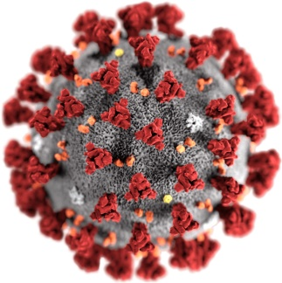 (Image Library | CDC Online Newsroom | CDC, 2021)
This Global pandemic started in a meat market in Wuhan China.

2 Where it came from
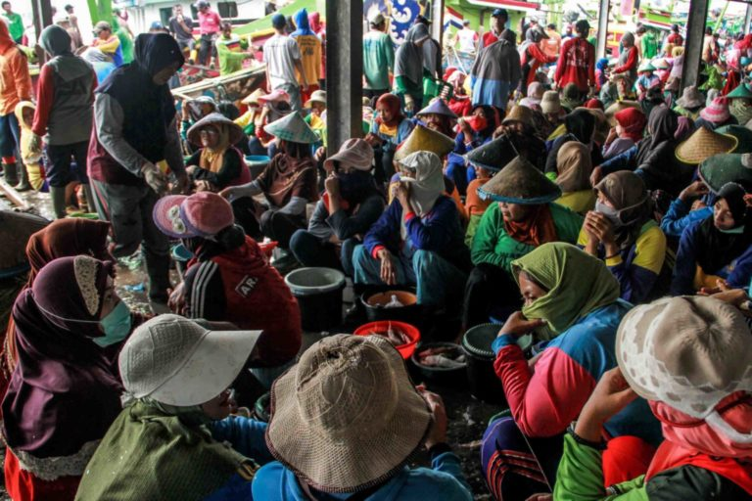 Google images (accessed, 10 Feb 2021).
COVID 19 was reported in Dec 2019 but reports show it has been here since as early as Nov 17, 2019
It was originated from Bats how it jumped to people is unknown.
3 How it transmits
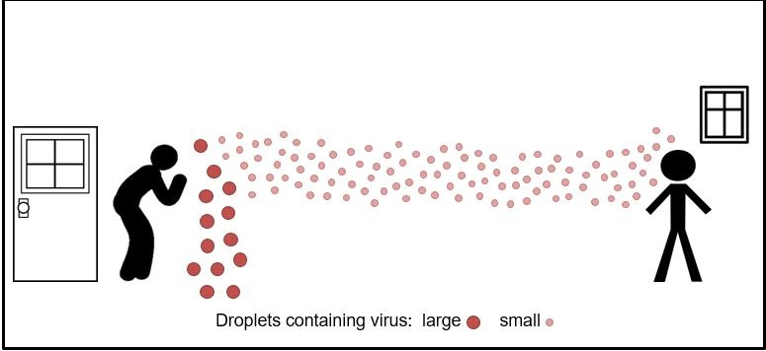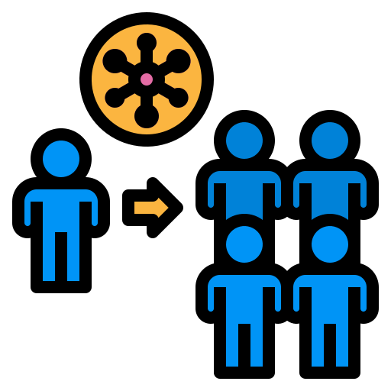Bing images (accessed, 10 Feb 2021).
COVID transmits through Close contact it spreads from the mouth and nose when you cough, and sneeze, speak or breathe heavily through droplets containing the virus.

4 How we can help stop the spread
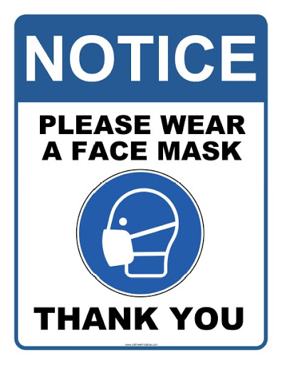 (Wear Face Mask Sign - AllFreePrintable.com, 2021)

Some of the things we can do and work together as a nation are:
- Wear face masks
- Not mix with other households
- Isolate if you have the virus

5 Government Guideline
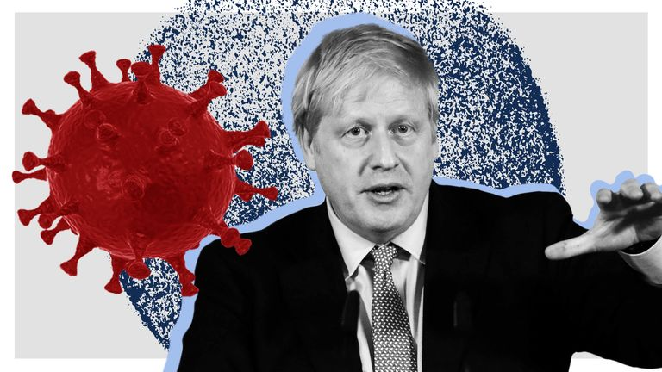(Coronavirus: What hospital tests will Boris Johnson have as he battles COVID-19? 2021)

Our PM Boris Johnson has put in laws to help spread the virus for example:
- Social distancing
- Shielding
- Tier system
- Work from home
- Restrictions on travel
All these rules are in order to keep us safe and protected from the virus.

6 How this is affecting the world Economy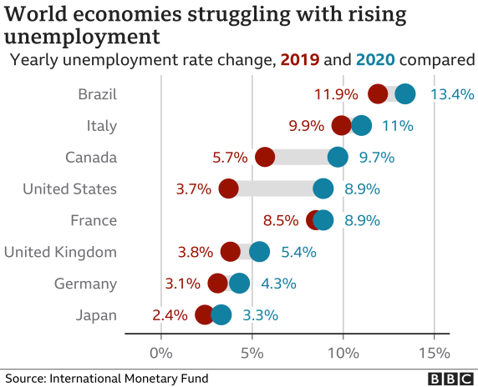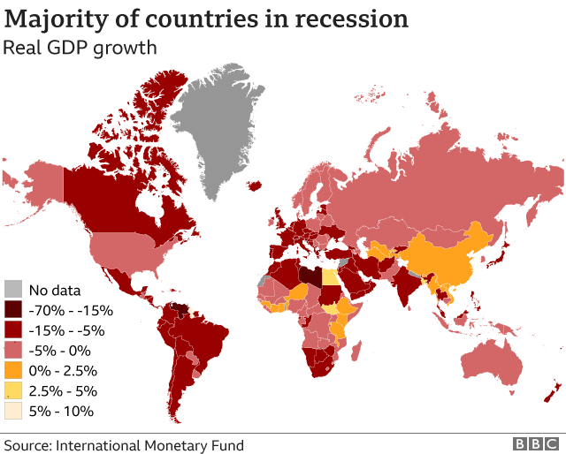(Coronavirus: How the pandemic has changed the world economy, 2021)
The pandemic has reached almost the whole of the world this has affected:
- A lot of people have lost their jobs
- A lot of countries are in recession
- Travel industry has been badly damaged business trips and holidays have been cancelled
- Tourism industry has also crumbled

7 Treatment
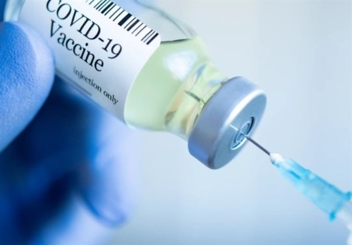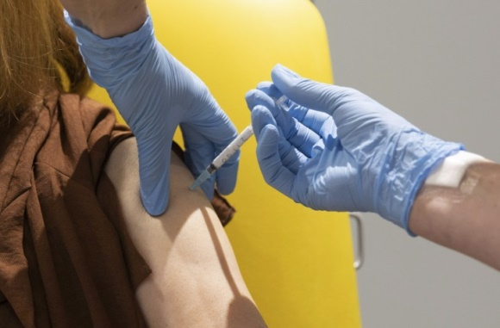Google images (accessed 29 Jan 2021)
There is Vaccination for covid-19 but is only given to high-risk groups like:
- Over 65+
- Vulnerable
- People who work with care or live-in care homes
- Social care workers

8 Things that can be put in place to help Elderly and vulnerable

The most important thing is to create a solution for every age group to be able to be offered the COVID vaccination, so everyone is safe, and not only half the population or certain family members, as this can still spread the virus and there are more variant’s and it is not confirmed that the vaccination will protect us from that. More Vaccinations should be available as there are not enough for everyone. And another thing that can be done is a care plan for the elderly and vulnerable that are shielding as they are very restricted in their own houses and some don’t have family to care for them so if the community health visitors or the GP surgery can put in a strategy for Example,
- Going to meet housebound people or even offer them a vaccination at home
- Telephone calls a couple of times a week, so they don’t feel left out.
We as a community can also make a neighbourhood group where we can check up on the people that have no family, offer to help with getting there shopping and just saying hello or have a chat just so nobody feels left out. We should do this with the Guideline set by the Government and keep social distancing and face covering in place.

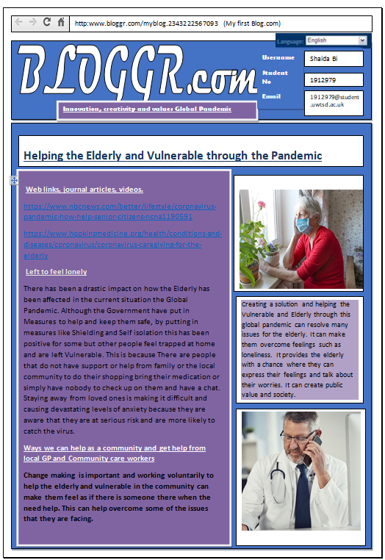
Task 2

Reference list
Artley, A., (2020). Coronavirus: How to Help and Give Back - HelpGuide.org. Helpguide.org. <https://www.helpguide.org/articles/healthy-living/coronavirus-how-to-help-give-back.htm>(10 February 2021).
Brahma, D., Chakraborty, S. and Menokee, A.,( 2020). The early days of a global pandemic: A timeline of COVID-19 spread and government interventions. Brookings. https://www.brookings.edu/2020/04/02/the-early-days-of-a-global-pandemic-a-timeline-of-covid-19-spread-and-government-interventions (9 February 2021).
Caspi, E., (2021).A Perfect Storm.ChangingAging.https://changingaging.org/covid-resources/a-perfect-storm/> (9 February 2021).
https://www.hopkinsmedicine.org/health/conditions-and-diseases/coronavirus/coronavirus-caregiving-for-the-elderly
https://www.nbcnews.com/better/lifestyle/coronavirus-pandemic-how-help-senior-citizens-ncna1190591
Jones, L., Palumbo, D. and Brown, D., (2021). Coronavirus: How the pandemic has changed the world economy. BBC News. https://www.bbc.co.uk/news/business-51706225 (9 February2021).
Mallapaty, S., (2020). Where did COVID come from? WHO investigation begins but faces challenges. Nature.com. https://www.nature.com/articles/d41586-020-03165-9(9 February 2021).
Routley, N., (2020). Visualizing What COVID-19 Does to Your Body. Visual Capitalist. <https://www.visualcapitalist.com/visualizing-what-covid-19-does-to-your-body/>(10 February 2021).

