

MSc Property and Facilities Management

`Strategic Property, Finance and Procurement`

Lecturer: Dr Deborah Hughes
Module code: ACBA7008

Student name: Gareth Leek
Student ID number: 2126325
Submission deadline: 10th January 2023

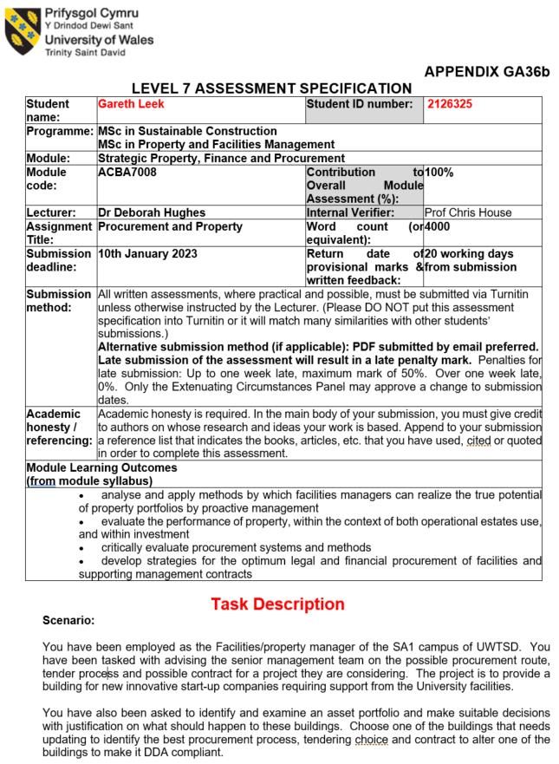

Table of Contents
1.0 INTRODUCTION 5
2.0 RESEARCH AND ANALYSIS 6
2.1 Procurement strategy 6
2.2 Procurement routes 7
2.2.1 Traditional 7
2.2.2 Design and build 8
2.2.3 Management contracting 9
2.2.4 Construction management 9
2.2.5 Collaboration 9
2.3 Tender process 10
2.3.1 Open tendering 10
2.3.2 Selective tendering 11
2.3.3 Negotiated tendering 11
2.3.4 Single stage tendering 11
2.3.5 Two stage tendering 12
2.3.6 Framework tendering 12
2.4 Contracts 12
2.4.1 NEC 13
2.4.2 JCT 13
2.5 Strategic property review 14
2.6 Disability legal framework 15
3.0 RECOMMENDATIONS 16
3.1 University 16
3.2 Housing association 17
3.2.1 Strategic portfolio review 17
3.2.2 DDA (Equalities Act) modernisation 18
4.0 CONCLUSION 20
5.0 REFERENCES 21
6.0 BIBLIOGRAPHY 24
7.0 APPENDIX 1 27
7.1 APPENDIX 2 29
7.2 APPENDIX 3 31
7.3 APPENDIX 4 33
7.4 APPENDIX 5 34
7.5 APPENDIX 6 37
7.6 APPENDIX 7 39
7.7 APPENDIX 8 40
7.8 APPENDIX 9 41
7.9 APPENDIX 10 42
7.10 APPENDIX 11 43
7.11 APPENDIX 12 44
7.12 APPENDIX 13 45
7.13 APPENDIX 14 46
7.14 APPENDIX 15 47
7.15 APPENDIX 16 48

Word count: 4,389

1.0 INTRODUCTION

The purpose of the report is to provide the client with procurement and property recommendations in relation to several different scenarios.

The first scenario requires the identification of the most suitable procurement route, tendering and contract for a new building, for UWTSD. The intended use is for innovative start-up companies and will be located within the university’s SA1 campus.

The second scenario involves reviewing a cross section of a housing associations property portfolio, with a view to providing recommendations with accompanying rationale for future use.

An extension to the second scenario, requires the identification of a single property that needs modernisation, to meet the requirements of the Disability Discrimination Act (DDA). Thereafter advise the most suitable procurement route, tendering and contract.

In practice there a variety of options and combinations in scope, with varying advantages and disadvantages for all scenarios. This paper endeavours to explore all options and identify the best fit with accompanying rationale, whilst being considerate of the nuances created by the university/housing association, which can influence outcomes.

2.0 RESEARCH AND ANALYSIS

2.1 Procurement strategy
According to BSI (2020), `procurement is the process which creates, manages, and fulfils contracts`. Furthermore, the CIOB (2010) state, `procurement is essentially a series of considered risks – each method has individual strengths and weaknesses`.

It is essential due time and consideration is given to formulate a strategy by the client.

A BSI framework for the development of a procurement strategy is detailed below:

Figure 1: Framework for the development of a procurement strategy

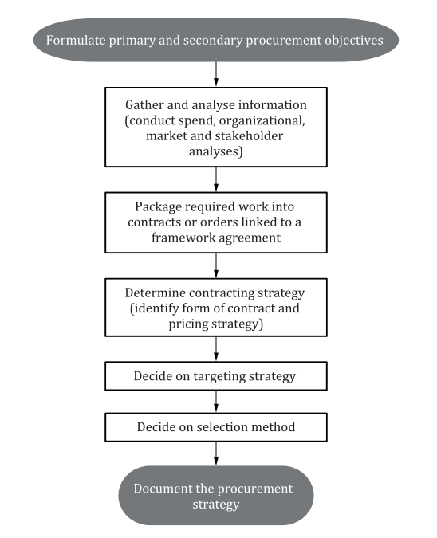
Source: (BSI, 2022)

OGC (2007) remarks `the primary consideration in the procurement of construction projects is the need to obtain best value for money in the whole life of the service or facility`. Appendix 13 visualises the procurement strategy advocated by the OGC.

An essential dependency needed for route determination, is for the client to intrinsically identify key objective criteria. `Project need, payback criteria, brief, affordability, objectives, time, speed of change and risk are all identified as factors influencing procurement route`, according to Jones (2018).

Tookey et al, (2001) states `The onus is on the client to make the right procurement choice because it is accepted that clients cost/quality/time requirements dictate the most appropriate procurement method`. Therefore, the clients’ expectations and status of the variables should influence the optimal procurement route.

2.2 Procurement routes
`The procurement route delivers the procurement strategy. It includes the contract strategy that will best meet the client’s needs`, Finch (2011).

Influencing factors which determine the optimum procurement route include, cost, quality, risk, time, and finance. Dr. Martin Barnes developed the triangle of objectives, also known as the Iron Triangle. The triangle establishes that scope, cost, and time are interconnected to quality. The organisations determination of these variables is vital for project success.

The 5 procurement routes for building/construction works are:

- Traditional
- Design and build (D&B)
- Management contracting (MC)
- Construction management (CM)
- Collaboration

The NBS graph below illustrates the most popular procurement routes used in the UK.

Figure 2: Procurement routes chosen.
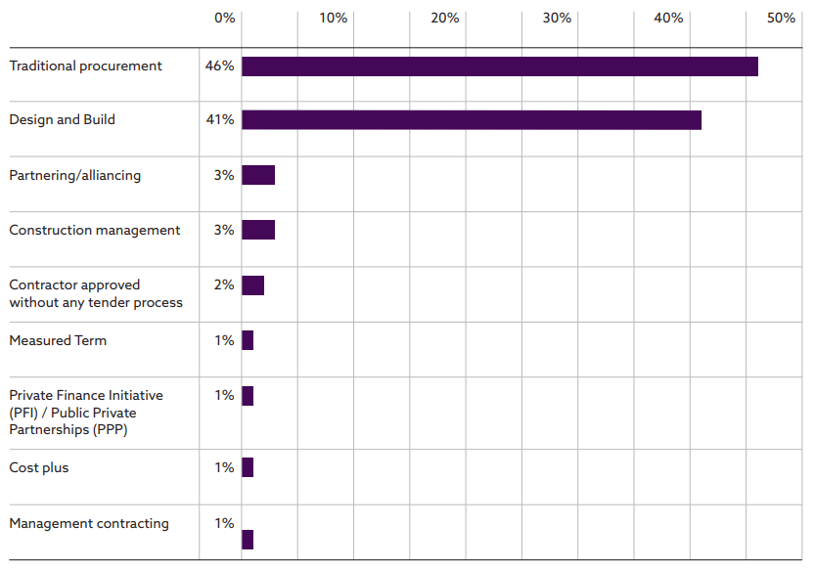
Source: NBS (2018)

2.2.1 Traditional
`The traditional method, which was developed in the nineteenth century is probably still the most adopted UK route, particularly for inexperienced or occasional construction clients. A key feature of this approach is separation of the design from the construction phase`, states Morledge et al, (2021).
The architect/design team are appointed by the client. The delivery contractor is also appointed, normally after a tender process. The contractor has the additional responsibility for coordinating subcontracted works, it is unable to self-deliver.

Traditional procurement is a linear method, meaning one task needs to finish before another task commences.

Table 1: Traditional, advantages and disadvantages
Advantages | Disadvantages
- Suits complex projects.  - Project fully designed and specified.  - Client`s quality standard is likely to be met.  - Tenders will be like for like basis.  Cost  - Certainty because full design developed.  - Monitoring through all build stages.  - Contractually agreed prices for variations, identified in advance. | - Slow during pre-construction phase, not suitable for fast-track projects.  - High number of stakeholders, due to multiple client appointments.  - Initial costs can be expensive prior to confirmation of total project costs. (Architect/designers)  - Higher risk is retained by client, due to closer design proximity.

2.2.2 Design and build
`Design and build, relies on the client expressing a clear performance brief at the outset and leaving the main contractor to determine its own means to complete the project in line with the required cost, time, and quality parameters`, according to Mosey (2009).

D&B, therefore, can be a turnkey solution. As the full design and construction stage are delivered by a single contractor and contract. The contractor accepts most responsibility (including risk) for the project, for receipt of a fixed financial sum.

Table 2: D&B, advantages and disadvantages
Advantages | Disadvantages
- Single contractor accountable, improving communication and reducing need for client construction information sharing.  - Speed. Some stages overlap, build can commence before full design completion.  - Suitable for most client capability levels. Note client-side consultant may be beneficial, depending on capability levels.  - Lower client risk exposure, as majority transferred to the contractor.  Cost.  - Budget, earlier identification of costs in scope.  - Price certainty. | - Reliance on single contractor, trust required.  - Quality. Contractor can maximise profits, by sourcing cheaper labour, products.  - Loss of design control, limited liability.  - Contractor will not be master of all construction specialisms.  Cost.  - No like for like comparison.  - High costs, for design variation.  - Risk retention factored into costs.

2.2.3 Management contracting
Taylor Wessing (2019) states, `the Management Contractor is not required to carry out any construction works but instead is paid a fee to manage construction works carried out by others. The Management Contractor in effect provides services and not works. Whilst the Management Contractor enters into and enforces Works Contracts, crucially, they are not responsible for the Works Contractor's performance`.

Table 3: MC, advantages and disadvantages
Advantages | Disadvantages
- Fast tracking, as some works packages can commence in advance of others.  - Good for complex projects.  - Fully designed in advanced, by stages.  - Quality can be high, as subcontracted works undertaken by specialists.  - Design changes more easily accommodated.  - Competitive tendering. | - Challenge for inexperienced clients.  - No cost/time certainty, before construction commences.  - More risk is retained by the client.  - Early stages snagging can cause claims for later packages.  - Client needs to provide upfront resource for brief.

2.2.4 Construction management
According to Morledge et al (2021), for CM `the client does not allocate risk and responsibility to a single main contractor. Instead, the client employs the design team, and a construction manager is engaged`.

Table 4: CM, advantages and disadvantages
Advantages | Disadvantages
- CM able to contribute to design.  - Design changes more easily accommodated.  - Fast tracking, as some works packages can commence in advance of others.  - Lower prices as client appoints all trade contractors direct. | - Challenge for inexperienced clients.  - No cost/time certainty, before construction commences.  - Reliance on competent construction manager.  - Management of design team needed to ensure timely delivery of design.

2.2.5 Collaboration
Morledge et al (2021) express, `at the heart of modern procurement approaches are the appointment of integrated supply chains where the parties in the supply chain have a long-term objective to work together to deliver added value`.
This route was popularised in the public sector following the `Rethinking Construction` report publication. Within the report Egan (1998) signifies, `project members could collaborate with each other in developing construction techniques and skills and exchanging ideas for increasing efficiency and quality`. The 2007 OGC `Achieving Excellence in Construction Procurement` guides, consolidates this view.

Joint venture (2 or more companies sharing risk/reward) and partnering/alliance (encouragement of openness and transparency between contractual parties) are both included within the collaboration umbrella term.

Table 5: Collaboration, advantages and disadvantages
Advantages | Disadvantages
- Avoids duplication of efforts.  - Supplier relationships need to be good.  - Brings expertise to the project.  - Good for unformed, complex projects.  - Potential for economies of scale benefits. | - Could lead to a loss of organisational capability.  - Difficult to manage due to scale impacting time and cost.  - Negative effects on the wider market.  - Conversely may be diseconomies of scale.

2.3 Tender process
CIPS (2022) proclaim, a `tender is a formal offer or bid from a potential supplier looking to win a contract for works or services, usually submitted in writing`. The tendering process is the `bidding process, to obtain a price and how a contractor is actually appointed`, according to Garner, (2014).

The following types of tender processes have been reviewed:

- Open tendering
- Selective tendering
- Negotiated tendering
- Single stage and Two stage tendering
- Framework tendering

The NBS graph below illustrates the most popular tender process used in the UK.

Figure 3: Tender routes chosen
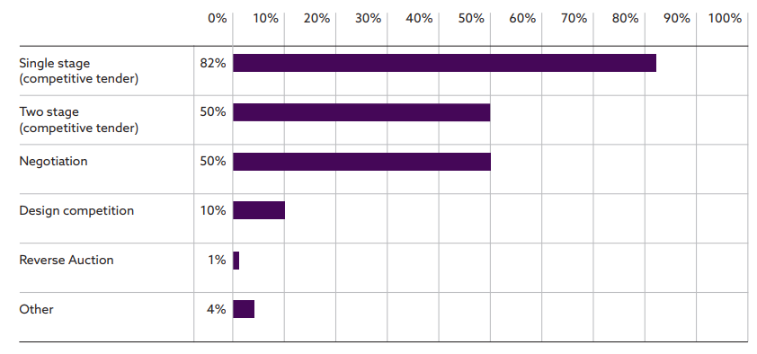
Source: NBS (2018)

2.3.1 Open tendering
According to Designing Buildings (2021), open tendering `allows anyone to submit a tender to supply the goods or services that are required. Generally, an advert will be placed giving notice that the contract is being tendered, offering an equal opportunity to any organisation to submit a tender`.

Table 6: Open, advantages and disadvantages
Advantages | Disadvantages
- Competition and thus value.  - No favouritism, from transparency.  - Contractor opportunities. | - Slow, large contractor pool.  - Unproven contractors bidding for works, increasing client risk.

2.3.2 Selective tendering
Finch (2011), describes this as `the invitation of tenders from firms on a pre-approved or ad hoc list, chosen because they meet certain minimum standards in general criteria such as financial standing, experience, capability and competence`.

Selective tendering can be used in parallel with single or two stage tendering.

Table 7: Selective, advantages and disadvantages
Advantages | Disadvantages
- Quicker versus open tendering.  - Good for complex projects/contracts.  - Increased client confidence. | - Excludes some contractors.  - High end price, due to reduced competition.

2.3.3 Negotiated tendering
According to Garner (2014), `a negotiated tender is effectively a single-stage tender with a single contractor who returns with an initial price. This is then negotiated with the client’s professional team`.
This route is normally used for specialised contracts, where the project outcomes are difficult, yet essential to achieve or where a contractor has a monopoly over goods/services.

Table 8: Negotiated, advantages and disadvantages
Advantages | Disadvantages
- Reduction in tendering cost.  - Speed, as tendering is reduced.  - Earlier contractor engagement.  - Client confidence with trusted contractor. | - No competition can result in higher costs.  - Loss of innovation from market.  - Poor public image, caused by lack of transparency and competition.

2.3.4 Single stage tendering
`Single-stage tendering, also known as traditional tendering, is when a client issues a tender for the whole project, with all the relevant information provided at the point of issue. The process seeks to ensure that the client is able to secure a competitive price and to this end, the contractor may decide to price aggressively in order to secure the project`, writes Simons (2021).

The main objective of this tender stage is to identify a confirmed price from inception.

Table 9: Single stage, advantages and disadvantages
Advantages | Disadvantages
- Identification of preferred contractors/exclusion of poor contractors.  - Competitive price. | - One opportunity for key decisions or cost could increase disproportionately.  - Reduced contractor involvement.

2.3.5 Two stage tendering
`Many employers use two-stage tendering to involve contractors at an earlier stage. It enables the employer and the selected contractor to work in collaboration during the second stage, with the contractor able to input on the design, buildability and value engineering aspects of the project whilst arriving at its final price for the works`, writes Lexis Nexis (2019).

`Two-stage tendering has fast become the accepted method of procurement in the construction industry but must be set up and controlled effectively`, states Hudson (2015).

Table 10: Two stage, advantages and disadvantages
Advantages | Disadvantages
- Contractor involvement at earlier stage, reduces risk.  - Partial competition.  - Time. Overlap of design and tendering. | - Programme may require a tendering period.  - Lack of competition in second stage.

2.3.6 Framework tendering
`Open tenders are usually advertised for firms to apply to be on a framework and eventually included on a smaller framework of contractors/consultants. Once the framework/approved list is agreed then any further work will only be selected from the framework/ approved list`, describes Garner (2014).

This type of tendering suits a high volume of pipeline works, as contractors are pre-vetted, costs identified.

Table 11: Framework, advantages and disadvantages
Advantages | Disadvantages
- Can reduce procurement costs for large quantity of contracts.  - Greater amount of work created so improved competitiveness of contractors.  - Delivery resilience of pipeline works as several pre-approved contractors onboarded. | - Upfront work to create framework is resource intensive for the tender process.

2.4 Contracts
The delivery of projects and commercial management is driven by a construction contract. The FMB (2022) note, `a written contract for building work demonstrates you provide a professional service to clients, and it helps to ensure you and your client are clear on what has been agreed. Contracts can also help to prevent misunderstandings`.

There are a number of construction contracts covering the following terms:

- Fixed price (lump sum)
- Cost plus (cost of works plus fee on top)
- Maximum Price (guaranteed sum)
- Unit Price (when materials cannot be measured in advance)

Several contract providers used within the construction industry, noted in Figure 4. The Joint Contracts Tribunal (JCT) and New Engineering Contracts (NEC) being the preeminent in the UK.

Figure 4: Contracts chosen.
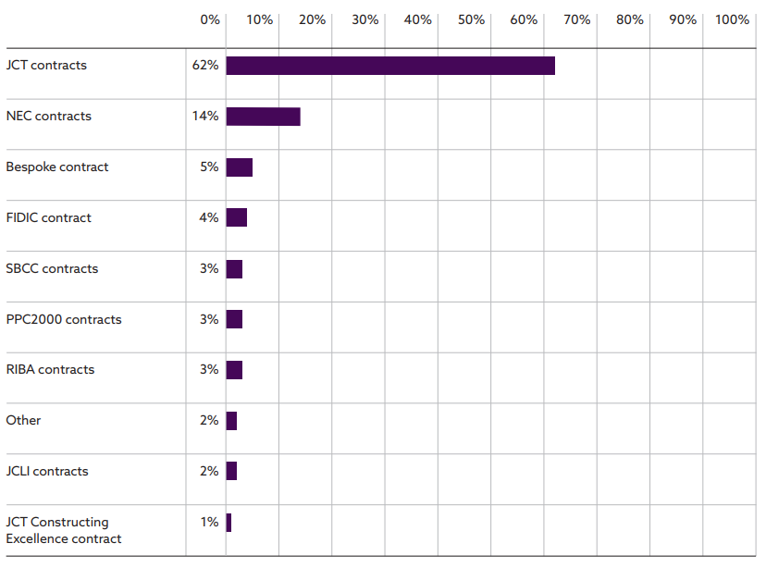
Source: NBS (2018)

A contract which can span international legislation and a popular choice for organisations undertaking works not within their homeland is, Fédération Internationale Des Ingénieurs-Conseils (FIDIC).

Despite being originally aligned to English law principles, Udom, (2014) comments `FIDIC contracts have successfully incorporated the principles of other legal systems especially the civil law system`.

2.4.1 NEC
`NEC is a family of contracts that facilitates the implementation of sound project management and procurement principles and practices, as well as defining legal relationships`, NEC (2022).

Two clauses in NEC4, set it apart from its competitors:

- Spirit of mutual trust and cooperation, which encourages collaboration.
- Early warning process ensures all parties have line of sight of emerging issues.

`The aim of NEC has always been to stimulate good project management`, remarks ICE (2022).

More information can be found on the NEC suite of contracts, including their benefits in Appendix 2.

2.4.2 JCT
`The Joint Contracts Tribunal suite of contracts are one of the most popular forms of construction contract in England and Wales. The JCT produces standard forms of construction contracts, as well as guidance notes and additional documentation, such as sub-contracts and collateral warranties, for use on a variety of construction projects`, writes Lexology (2021).
There are some differences with the JCT suite, setting it apart from its competitors:

- Payment section is very clear.
- Design risk comprehensively detailed.

Lexology (2021) remark further, `Crucially, a JCT contract defines each partner’s tasks and responsibilities in order to assist the project’s delivery`.

More information can be found on the JCT contracts, including their benefits in Appendix 3.

2.5 Strategic property review
According to BSI (2018a), `an organization should conduct evaluations of its asset portfolio, asset management and asset management system in order to ensure their continuing suitability, adequacy and effectiveness` and BSI (2014), `defines asset management as the “coordinated activity of an organization to realize value from assets`.

A management system is commonly used as a framework to manage, a recognised industry system is BS ISO:55001, Asset Management.

A component of good asset management is the development of a Strategic Asset Management Plan (SAMP). This is a `key executive-level documented information which presents a narrative on why and what the organization plans to do in managing its asset portfolio and developing its asset management capability, in order to enable the achievement of the organizational objectives`, writes BSI (2018a).

See Appendix 16 for BSI SAMP concept diagram.

The BSI suite of asset management guidance documents, references the need to optimise the value of an asset, which can be `tangible or intangible, financial or non-financial, and includes consideration of risks and liabilities. It can be positive or negative at different stages of the asset life` states BSI, (2014).

PAS 280:2018, Through-life engineering services (TES) – Adding business value through a common framework – Guide, provides further clarity and a common framework to adopt. Noting a building is described as a major asset within its guidance, as its overall life is measured in decades.

A pictorial extract from the guide, can be found within Appendix 8.

To carry out a strategic property review, an organisation must intrinsically review its business fundamentals in parallel with the assets condition and capability to deliver its strategic aims.

Some of the common factors influencing a sites value are detailed in table 12 overleaf.

Table 12: Building value factors
Factor | Description
Utilities | Is a reliable utilities infrastructure needed? (electricity, foul sewerage, broadband etc)
Transport | Are good transport links required to the site/building for customers, staff etc?
Location | Is the location of the building suitable/important? urban, rural?
Condition | What condition is the building in (fabric/structure) What is its ability to continue to for fill operational requirements/strategic direction?
Age | Is the age of the building important?
Size | Is the size aligned to current/future?
Corporate Identity | Does the building match the corporate image the business wants to portray?
Corporate objectives | Does the building for fill the future vision of the organisation?
Energy efficiency | What is the operational spend on electricity, how important is this? Is the building efficient or a drain on financial resources?
Net Zero, Corporate, Social Responsibility (CSR) | Can the site meet future Net Zero targets? Is it aligned to organisations responsible business agenda?
Growth | Does the site align to growth aspirations?
Leasehold/Freehold/Tenant | Is the property freehold, leasehold, tenant?
Stakeholders | Does the property align to its stakeholders’ expectations?
Capability | Does the organisation have the capability to maintain and operate the site?
Legislation | Does the site introduce additional risk that may need to be managed at cost? asbestos, reinforced autoclaved aerated concrete etc.
Climate | Is climate important for the building?

2.6 Disability legal framework
In October 2010 the Equalities Act was given Royal ascent. It replaced the Disability Discrimination Act and other discriminatory Acts, related to race and age. Noting, the DDA still remains law in Northern Ireland.

The implication of the Act means `employers must make reasonable adjustments to make sure workers with disabilities, or physical or mental health conditions, are not substantially disadvantaged when doing their jobs`, United Kingdom Government (2022).

Accompanying building regulations provide information about enabling access/egress to buildings, inclusive of disabled users for facilities and thoroughfare, they are referred to as Approved Document M: Volume 2 – Buildings and Dwellings.

3.0 RECOMMENDATIONS
To inform the report’s recommendations a brief high-level overview and assumptions of the university and housing association operations was completed, located within Appendix 1 (university) and Appendix 6 and Appendix 7 (housing association).

3.1 University
The following recommendations have been identified as the best corporate fit, to successfully construct a new building, for innovative start-up companies at the university SA1 site:

- PROCUREMENT ROUTE: Design and build
- TENDER PROCESS: Selective tender process
- CONTRACT: NEC4 Engineering and construction contract, Option A

Rationale
To determine the most appropriate procurement route, a strengths and weaknesses analysis was completed, results recorded within Appendix 4. Assumptions previously referenced in Appendix 1, were incorporated into scoring.

The result determined the most appropriate route is D&B, via direct award. The design will be relatively straight forward, if in keeping with existing buildings. Lessons learnt from previous SA1 developments should be included.

The procurement route provides price certainty and reduces the wider project risks upon the client, an assumption anticipated as influential for senior management, vital to providing commitment in a downturn economy. This route could expedite the project, however as the build objective is not the university’s main core function (academia), time should be utilised to source the right contractor and enhance the employer’s requirements/performance specifications, to influence end build quality.

Morledge et al (2021), encourages to mitigate the loss of control of the design/specification `first by taking great care in selecting the contractor to carry out the work and secondly by clearly specifying the requirements and constraints of the project, generally in the form of detailed performance specifications`.

This route would suit capability levels, client side. It is assumed the university’s property professionals core responsibilities align to maintaining and delivering a facilities management service. The consequence of the additional work arising from the project would increase risk tolerance, if capability levels do not align. The D&B route partially negates this.

UWTSD has an excellent reputation, therefore poor execution of a showcase build would be detrimental to the university’s image/continued profits. Noting construction is a large offering of the academic courses provided, failure could create a phase of uncomfortable communications. D&B is the best route to delegate a high proportion of project risk.

A selective tender process would be the best tendering option for the university. It supports engagement with trusted/known contractors, who have already successfully delivered at SA1, supporting the reputation narrative. The contractors are equally aware of the client`s expectations and construction issues UWTSD core business create. Alternative tender processes would prolong the preconstruction phase and elevate the risk of an unproven contractor undertaking the works.

For the contract, both NEC and JCT offerings are fit for purpose mechanisms. Assuming recent builds at SA1 determine contractor, relationships are cordial, making contract disputes due to personality and corporate fit frustrations, unlikely.

Therefore, the recommendation to pursue a NEC contract has been determined because it is recognised as the most user friendly, promotes collaboration and fully protects the client, the ICE (2022) state, `the contracts are written in plain English with a straightforward structure and are designed to be easily understood`.

See Appendix 11 for more information about the NEC 4 – Option A contract.

See Appendix 15 for recommended client next steps.

3.2 Housing association

3.2.1 Strategic portfolio review

The following recommendations have been determined for the housing association property portfolio:

Table 13: ateb housing association strategic property review results
Building | Recommendation
Meyler House | Dispose
Johnston Stores | Dispose
Upper Market Street | Dispose
Rhiannon House Shop and Flats | Dispose
Kensington Court | Retain
De Clare Court | Retain
Hanover Court | Retain
Caldey Court | Retain

Property management information is recorded within Appendix 7.

Rationale

To determine the above results, a calculation was undertaken to identify the suitability of the building against the factors detailed in table 12. A scoring approach allows the reader to quickly ascertain where the focus of the organisation’s priorities should be targeted. It supports decision making and scheduling of pipeline activities.

Results are recorded in Appendix 10, with accompanying narrative of the scoring system applied.

There is a noticeable division of results recorded. Therefore, the identified threshold for action was determined at 700.

The results confirm assumptions, which can be speculatively drawn from Appendix 7. Properties identified for disposal are predominately of poor quality, operationally inefficient, in remote locations and aesthetically inferior. Those recommended to remain contrast this.

See Appendix 15 for recommended client next steps.

3.2.2 DDA (Equalities Act) modernisation
Following a desktop study, Hanover court has been selected for modernisation, its purpose is residential flats and was built in the 1980s, therefore it is unlikely to fully meet the current building regulations, part M and in turn the requirements of the Equalities Act.

The following adjustments are required:

- Disabled car parking provision needs to be introduced.
- Upgrade external handrails to meet accessibility requirements.
- Signage and wayfinding overhaul.
- Remodelling an apartment bathroom to current building regulations, in readiness for new tenant, is also required.

See Appendix 9 for a visual representation of external adjustments identified.

The following route to market is recommended to execute the works:

- PROCUREMENT ROUTE: Management contracting
- TENDER PROCESS: Selective, single stage tender process
- CONTRACT: JCT Management Building Contract

Rationale
Due to the differing package of works in scope (line marking through to bathroom fit out) this route would be most suitable. A management contractor can be appointed to deliver the differing packages of works. Due to the works diversity, they do not need to be executed concurrently. A consequence of this route is more risk retained by the client; however, the total works should be relatively low value considering the organisations anticipated annual property expenditure.

The management contractor can execute the works with minimal client oversight.

The client will need to provide an upfront brief, so internal capability should be reviewed to undertake this. Management contracting promotes high quality, which is in line with ateb`s strategic aims and noting some of the adjustments needed are for the front of house, the route supports this.

Cost certainty is not provided by this route, but anticipated value, competitive tendering can mitigate exploitation.

Selective, single tender process would ensure high quality and value, whilst reducing pre-construction resource, for a predicted low spend.

A specific JCT Management Building Contract is recommended, this has been developed specifically for this route. It is very low value to purchase and affords the client contractual protection. This JCT contract has been identified using the JCT flow diagram. Recorded within Appendix 14.

More information about JCT Management Building Contract can be found in Appendix 12.

See Appendix 15 for recommended client next steps.

4.0 CONCLUSION
The options available to the client to execute the procurement works for the university and housing association appear complex. However, by allocating time to identify what is important to the client, undertaking due diligence, considering the iron triangle theory, and utilising the readily available tools, the identification of the most suitable pathway is achievable.

The university and housing association drew contrasting recommendations for the procurement piece, which underpins the influence of the variable factors and how they impact the identification of the most appropriate solution.

The strategic portfolio review follows a similar process: know where you are going, what you want, whats important etc. Then record findings in a priority matrix to determine results, which can be crossed referenced with management information.

The rationale, thought process, and methodology detailed within the recommendations has been developed from reviewing and utilising recognised literary and industry guidance. Therefore, is credible and can be pursued with confidence.

5.0 REFERENCES

BSI, 2020. BS ISO 10845-1. Construction procurement - Part : Processes methods and procedures. London: BSI Standards.
BSI, 2022. BS ISO 22058. Construction procurement -Guidance on strategy and tactics. London: BSI Standards.

BSI, 2014. BS ISO 55000. Asset Management, Overview principles and terminology. London: BSI Standards.

BSI, 2018a. BS ISO 55002. Asset management — Management systems — Guidelines for the application of ISO 55001. London: BSI Standards.

BSI, 2018b. PAS 280. Through-life engineering services – Adding business value through a common framework – Guide. London: BSI Standards.

CIOB, 2010. Procurement in the construction industry. Bracknell: Chartered Institute of Building. [Online]
https://www.ciob.org/industry/research/Procurement-Construction-Industry
(Accessed on: 02 December 2022)

CIPS, 2022. What is tendering? [Online].
https://www.cips.org/intelligence-hub/quality-measurement/tender-process
(Accessed on: 02 December 2022)

Designing Buildings, 2021. Tender processes for construction contracts. [Online]
https://www.designingbuildings.co.uk/wiki/Tender_processes_for_construction_contracts
(Accessed on: 08 December 2022)

Egan, J., 1998. Rethinking Construction. London: Department of Trade and Industry.
FMB, 2022. 11 benefits of FMB building contract templates. [Online]
https://www.fmb.org.uk/resource/11-benefits-of-fmb-building-contract-templates.html
(Accessed on: 02 December 2022)

Finch, R., 2011. NBS Guide to Tendering: for construction projects. London: NBS, part of RIBA Enterprises Ltd
Garner, J., 2014. Tendering Strategies, 1st Edition. London: Royal Institution of Chartered Surveyors

Hudson, K., 2015. Is two-stage tendering working? [Online]
https://www.turnerandtownsend.com/en/perspectives/is-two-stage-tendering-working/
(Accessed on: 02 December 2022)

ICE, 2022. New Engineering Contract. [Online]
https://www.ice.org.uk/what-is-civil-engineering/what-do-civil-engineers-do/new-engineering-contract-nec/ (Accessed on: 03 December 2022)

JCT, 2008. Deciding on the appropriate JCT contract. London: Sweet & Maxwell Ltd

Jones, G., 2018. Developing an Effective Procurement Strategy. [Online]
https://www.rics.org/globalassets/rics-website/media/training--events/cpd-foundation/20180918-london-developing-an-effective-procurement-strategy-cpdf-sw.pdf
(Accessed on: 02 December 2022)

Lexis Nexis, 2019. What is two stage tendering? [Online]
https://www.lexisnexis.co.uk/legal/guidance/what-is-two-stage-tendering
(Accessed on: 02 December 2022)

Lexology, 2022. What is a JCT Contract. [Online]
https://www.lexology.com/library/detail.aspx?g=e8ec7f9a-ba59-4c88-950f-0ce611169509
(Accessed on: 03 December 2022)

Morledge, R., Smith, A.J. and Appiah, S.Y., 2021. Building Procurement, 3rd Edition. Wiley.com.

Mosey, D., 2009. Early contractor involvement in building procurement contracts, partnering, and project management. Ames, Iowa: Blackwell.

NEC, 2022. NEC Contracts. [Online]
https://www.neccontract.com/
(Accessed on: 03 December 2022)

NBS, 2018. National Construction Contracts and Law Report. Newcastle upon Tyne: NBS, part of RIBA Enterprises Ltd.

OGC, 2007. Procurement and contract strategies. London: Hanscomb Limited.

Simons, J., 2021. Single stage vs two stage tendering. [Online]
https://www.scape.co.uk/news/2021/single-stage-vs-two-stage-tendering
(Accessed: 08 December 2022)

Taylor Wessing, 2019. Management Contracting. [Online]
https://www.taylorwessing.com/en/insights-and-events/insights/2019/12/management-contracting
(Accessed: 14 December 2022)

Tookey, J., Murray, M., Hardcastle, C., & Langford, D., 2001. Construction procurement routes: re-defining the contours of construction procurement. Engineering, Construction, and Architectural Management, 8(1), 20–30. [Online]
https://doi.org/10.1108/eb021167
(Accessed on: 01 December 2022)

Udom, K., 2014. A brief introduction to FIDIC contracts. [Online]
https://www.thenbs.com/knowledge/a-brief-introduction-to-fidic-contracts
(Accessed on: 08 December 2022)

United Kingdom Government. Equality Act 2010: guidance. [Online]
https://www.gov.uk/guidance/equality-act-2010-guidance#:~:text=Print%20this%20page-,Overview,strengthening%20protection%20in%20some%20situations.
(Accessed on: 06 December 2022)

UWTSD, 2022. Mission and Vision. [Online]
https://www.uwtsd.ac.uk/mission/#:~:text=is%20dedicated%20to%20realising%20the,all%20aspects%20of%20sustainable%20development.
(Accessed on: 01 December 2022)

6.0 BIBLIOGRAPHY

BSI, 2020. BS ISO 10845-1. Construction procurement - Part : Processes methods and procedures. London: BSI Standards.

BSI, 2022. BS ISO 22058. Construction procurement -Guidance on strategy and tactics. London: BSI Standards.

BSI, 2014. BS ISO 55000. Asset Management, Overview principles and terminology. London: BSI Standards.

BSI, 2018a. BS ISO 55002. Asset management — Management systems — Guidelines for the application of ISO 55001. London: BSI Standards.

BSI, 2018b. PAS 280. Through-life engineering services – Adding business value through a common framework – Guide. London: BSI Standards.

CIOB, 2010. Procurement in the construction industry. Bracknell: Chartered Institute of Building. [Online]
https://www.ciob.org/industry/research/Procurement-Construction-Industry
(Accessed on: 02 December 2022)

CIPS, 2022. What is tendering? [Online].
https://www.cips.org/intelligence-hub/quality-measurement/tender-process
(Accessed on: 02 December 2022)

Connaughton, 1994. Value by competition : a guide to the competitive procurement of consultancy services for construction. Construction Industry Research and Information Association.

Designing Buildings, 2021. Tender processes for construction contracts [Online]
https://www.designingbuildings.co.uk/wiki/Tender_processes_for_construction_contracts
(Accessed on: 08 December 2022)

Egan, J., 1998. Rethinking Construction. London: Department of Trade and Industry.
FMB, 2022. 11 benefits of FMB building contract templates. [Online]
https://www.fmb.org.uk/resource/11-benefits-of-fmb-building-contract-templates.html
(Accessed on: 02 December 2022)

Finch, R., 2011. NBS Guide to Tendering: for construction projects. London: NBS, part of RIBA Enterprises Ltd.
Fong, & Lung, B. W.2007. Interorganizational Teamwork in the Construction Industry. Journal of Construction Engineering and Management, 133(2), 157–168. [Online]
https://doi.org/10.1061/(ASCE)0733-9364(2007)133:2(157) (Accessed on: 02 December 2022)

Garner, J., 2014. Tendering Strategies, 1st Edition. London: Royal Institution of Chartered Surveyors

Hackett, Robinson, I., & Statham, G.,2007. The Aqua Group guide to procurement, tendering & contract administration (Rev. and updated ed.). Blackwell.

Hudson, K., 2015. Is two-stage tendering working? [Online]
https://www.turnerandtownsend.com/en/perspectives/is-two-stage-tendering-working/
(Accessed on: 02 December 2022)

ICE, 2022. New Engineering Contract. [Online]
https://www.ice.org.uk/what-is-civil-engineering/what-do-civil-engineers-do/new-engineering-contract-nec/ (Accessed on: 03 December 2022)

JCT, 2008. Deciding on the appropriate JCT contract. London: Sweet & Maxwell Ltd.

JCT, 2017. Tendering 2017. Practice Note, London: Thomson Reuters (Professional) UK Limited, trading as Sweet & Maxwell.

Jones, G., 2018. Developing an Effective Procurement Strategy. [Online]
https://www.rics.org/globalassets/rics-website/media/training--events/cpd-foundation/20180918-london-developing-an-effective-procurement-strategy-cpdf-sw.pdf
(Accessed on: 02 December 2022)

Lexis Nexis, 2019. What is two stage tendering? [Online]
https://www.lexisnexis.co.uk/legal/guidance/what-is-two-stage-tendering
(Accessed on: 02 December 2022)

Lexology, 2022. What is a JCT Contract. [Online]
https://www.lexology.com/library/detail.aspx?g=e8ec7f9a-ba59-4c88-950f-0ce611169509
(Accessed on: 03 December 2022)

Lowry, D., 2017, The Complete Guide to Facility Management, California: Create space.

Lupton, S., Stellakis, M., Which Contract? Choosing the appropriate building contract. 6th Edition. London: RIBA Publishing.

Morledge, R., Smith, A.J. and Appiah, S.Y. 2021 Building Procurement, 3rd Edition. Wiley.com.

Mosey, D., 2009. Early contractor involvement in building procurement contracts, partnering, and project management. Ames, Iowa: Blackwell.

NBS, 2018. National Construction Contracts and Law Report. Newcastle upon Tyne: NBS, part of RIBA Enterprises Ltd.

NEC, 2022. NEC Contracts. [Online]
https://www.neccontract.com/
(Accessed on: 03 December 2022)

OGC, 2007. Procurement and contract strategies. London: Hanscomb Limited.

Simons, J., 2021. Single stage vs two stage tendering. [Online]
https://www.scape.co.uk/news/2021/single-stage-vs-two-stage-tendering
(Accessed: 08 December 2022)

Taylor Wessing, 2019. Management Contracting. [Online]
https://www.taylorwessing.com/en/insights-and-events/insights/2019/12/management-contracting
(Accessed: 14 December 2022)

Tookey, J., Murray, M., Hardcastle, C., & Langford, D., 2001. Construction procurement routes: re-defining the contours of construction procurement. Engineering, Construction, and Architectural Management, 8(1), 20–30. [Online]
https://doi.org/10.1108/eb021167
(Accessed on: 01 December 2022)

Udom, K., 2014. A brief introduction to FIDIC contracts. [Online]
https://www.thenbs.com/knowledge/a-brief-introduction-to-fidic-contracts
(Accessed on: 08 December 2022)

United Kingdom Government, 2010. Access to the use of buildings approved document M. Newcastle Upon Tyne: NBS, part of RIBA Enterprises Ltd.

United Kingdom Government, 2010. Equality Act 2010: guidance. [Online]
https://www.gov.uk/guidance/equality-act-2010-guidance#:~:text=Print%20this%20page-,Overview,strengthening%20protection%20in%20some%20situations.
(Accessed on: 06 December 2022)

UWSTD, 2022. Mission and Vision. [Online]
https://www.uwtsd.ac.uk/mission/#:~:text=is%20dedicated%20to%20realising%20the,all%20aspects%20of%20sustainable%20development.
(Accessed on: 01 December 2022)

7.0 APPENDIX 1
Overview – University of Wales Trinity St David

Formed in 2010, the University of Wales Trinity Saint David (UWTSD) is a higher education establishment offering a variety of academic undergraduate and postgraduate courses, including:
- Arts
- Construction
- Computing
- Law
- Nursing and
- Theology.

Therefore, a modern, vibrant, and inclusive property portfolio, with accompanying facilities is required to support the delivery of the diverse courses in scope. The current portfolio is predominately South Wales centric, with additional campuses located in London and Birmingham.
The UWTSD’s new SA1 waterfront campus and innovation quarter development, in the city’s maritime quarter, sits next to the marina and a five-mile stretch of sandy beach.

Picture 1: UWTSD SA1 Campus

Source: UWTSD (2022)

Picture 2: Aerial View SA1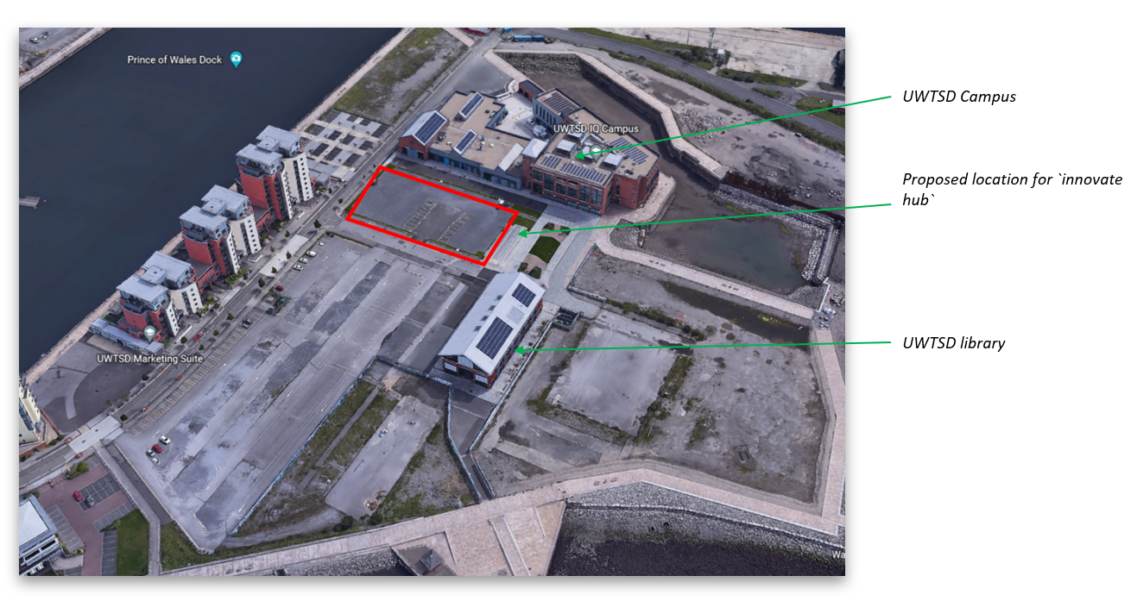
Source: Google Earth (2022)

UWTSD Mission Statement and Vision

Our Mission
Transforming Education; Transforming Lives

Our Vision
Our vision is to be a University for Wales, with a commitment to the well-being and heritage of the nation at the heart of all that we do. Central to our vision is the promotion and embedding of a dual-sector educational system which educates learners of all ages and backgrounds, and stimulates financial, development in our region, across Wales and beyond.
Source: UWTSD (2022)

Assumptions:

- Client`s construction capability is restricted to a small Facilities Management team, access to wider UWTSD construction lecturers for project delivery support is not realistic. Therefore client has a small amount of construction experience.
- Recent SA1 developments have been undertaken successfully and collaboratively with previous contractors.
- Time is not a key driver as the works do not impact the University’s core business, higher education, however notionally commencement is expected in financial year 2022/2023.
- Client does not accept a high level of risk, due to reputational image, close alliance with Government and reliance on continued revenue.
- Cost certainty is important as funding needs to be in alignment with annual budget setting and increased financial risk that the economic downturn has created.
- The innovation hub is a straightforward build but requires some innovation from the market to determine on trend looks and finishes, with considerate sustainability and technological requirements.

7.1 APPENDIX 2
New Engineering Contracts

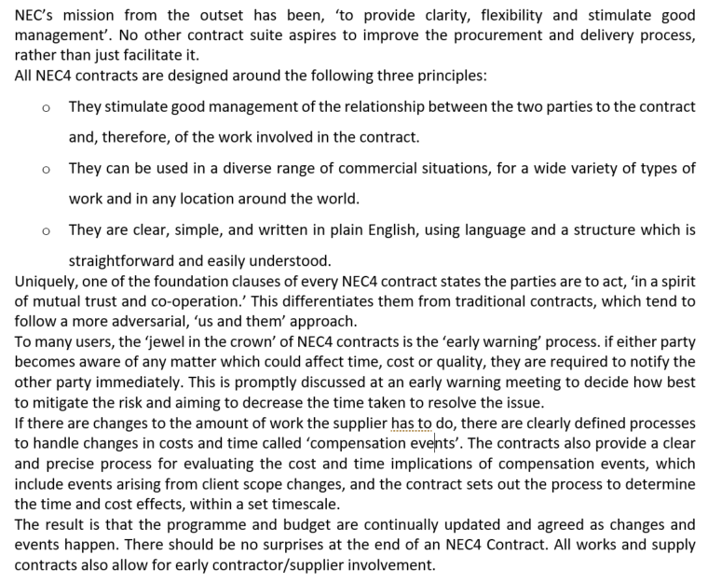
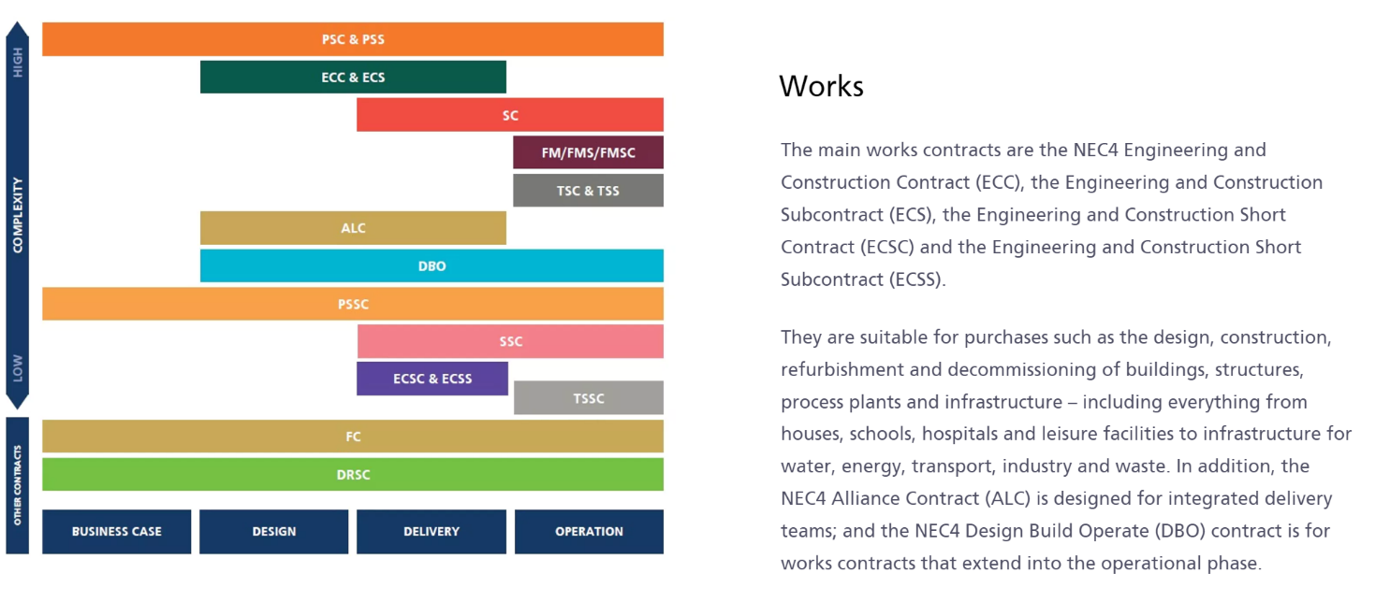

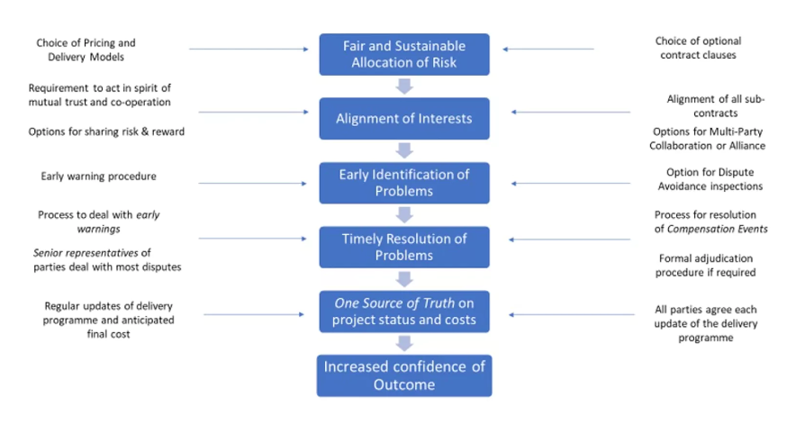
Source: NEC (2022)

7.2 APPENDIX 3
Joint Contracts Tribunal

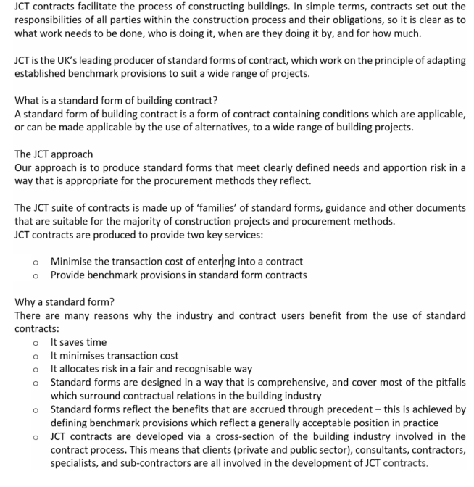

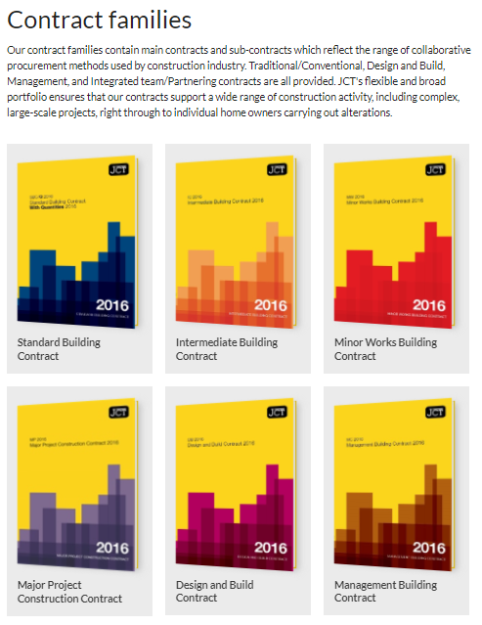
Source: JCT (2022)

7.3 APPENDIX 4
Procurement route identification- university
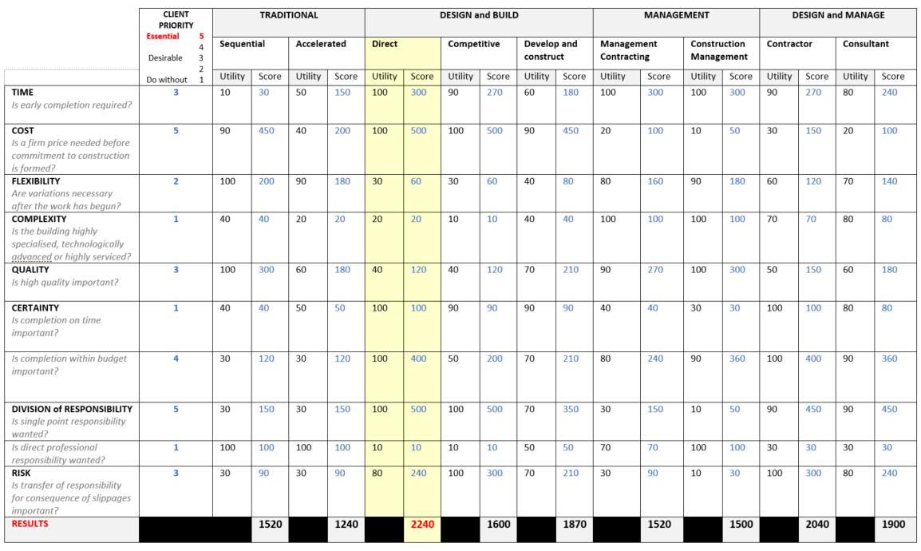

Source: Taken from Morledge et al (2021) who cited Skidmore and Marsden (1998)

7.4 APPENDIX 5
Procurement route selection checklist

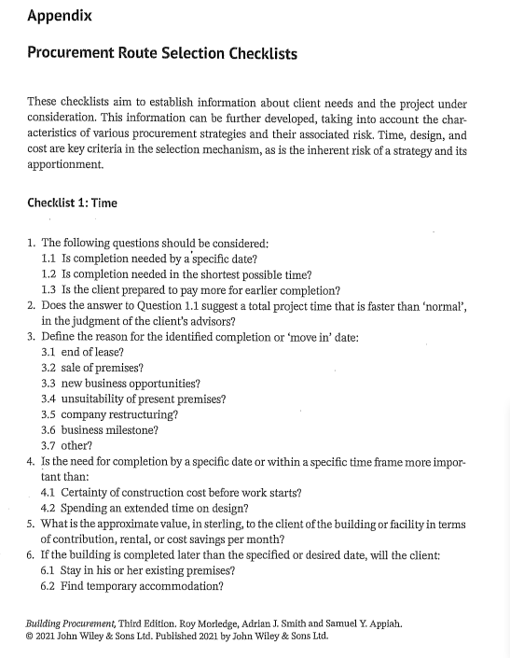

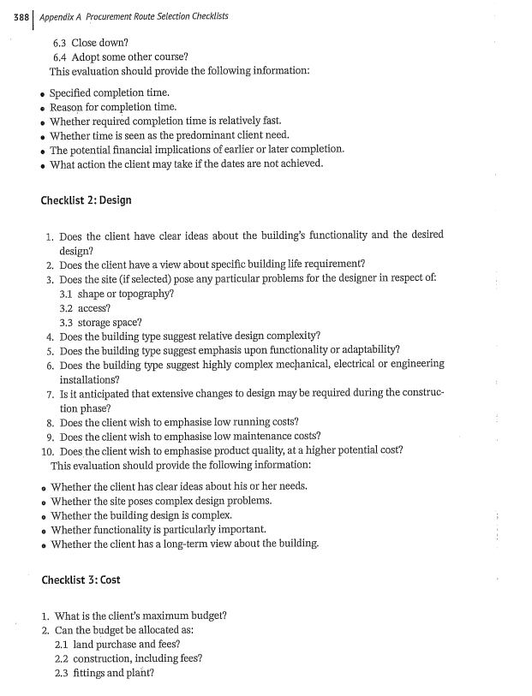

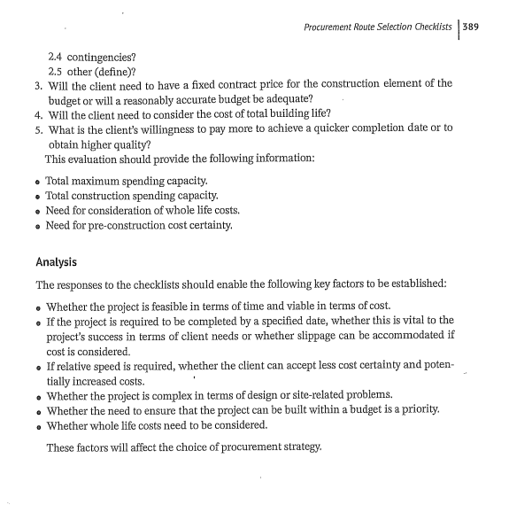
Source: Morledge et al (2021)

7.5 APPENDIX 6
Overview – Asset portfolio and procurement strategic review

ateb was founded in 1981 as Pembrokeshire Housing Association.

Our Purpose – We believe that better living starts with a place that we can call home.

A home is more than just a house; it’s a safe, stable, secure environment from which people can live their lives. Not everyone can achieve this without help, we will create a variety of solutions to help and support people and communities to make more homes. Our Purpose:

This means that we must find creative ways of:
- Responding to housing need.
- Helping people to maintain their occupation contract.
- Support communities to build capacity and be self-sufficient.
- Regenerate communities through social, economic, environmental and physical programmes.
- Help older and vulnerable people to stay in their homes and communities where their lifestyles change.

Vision

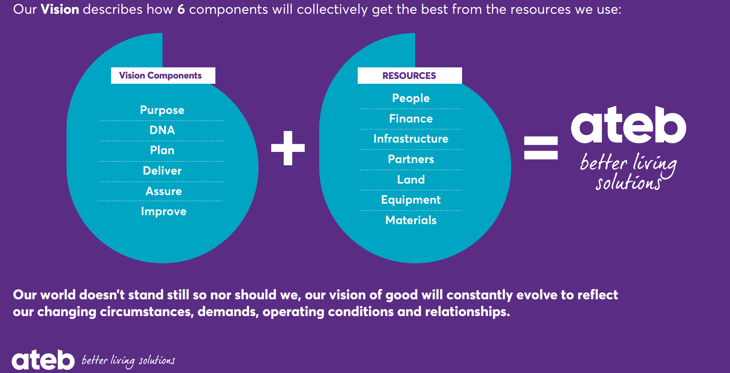

Strategic aims

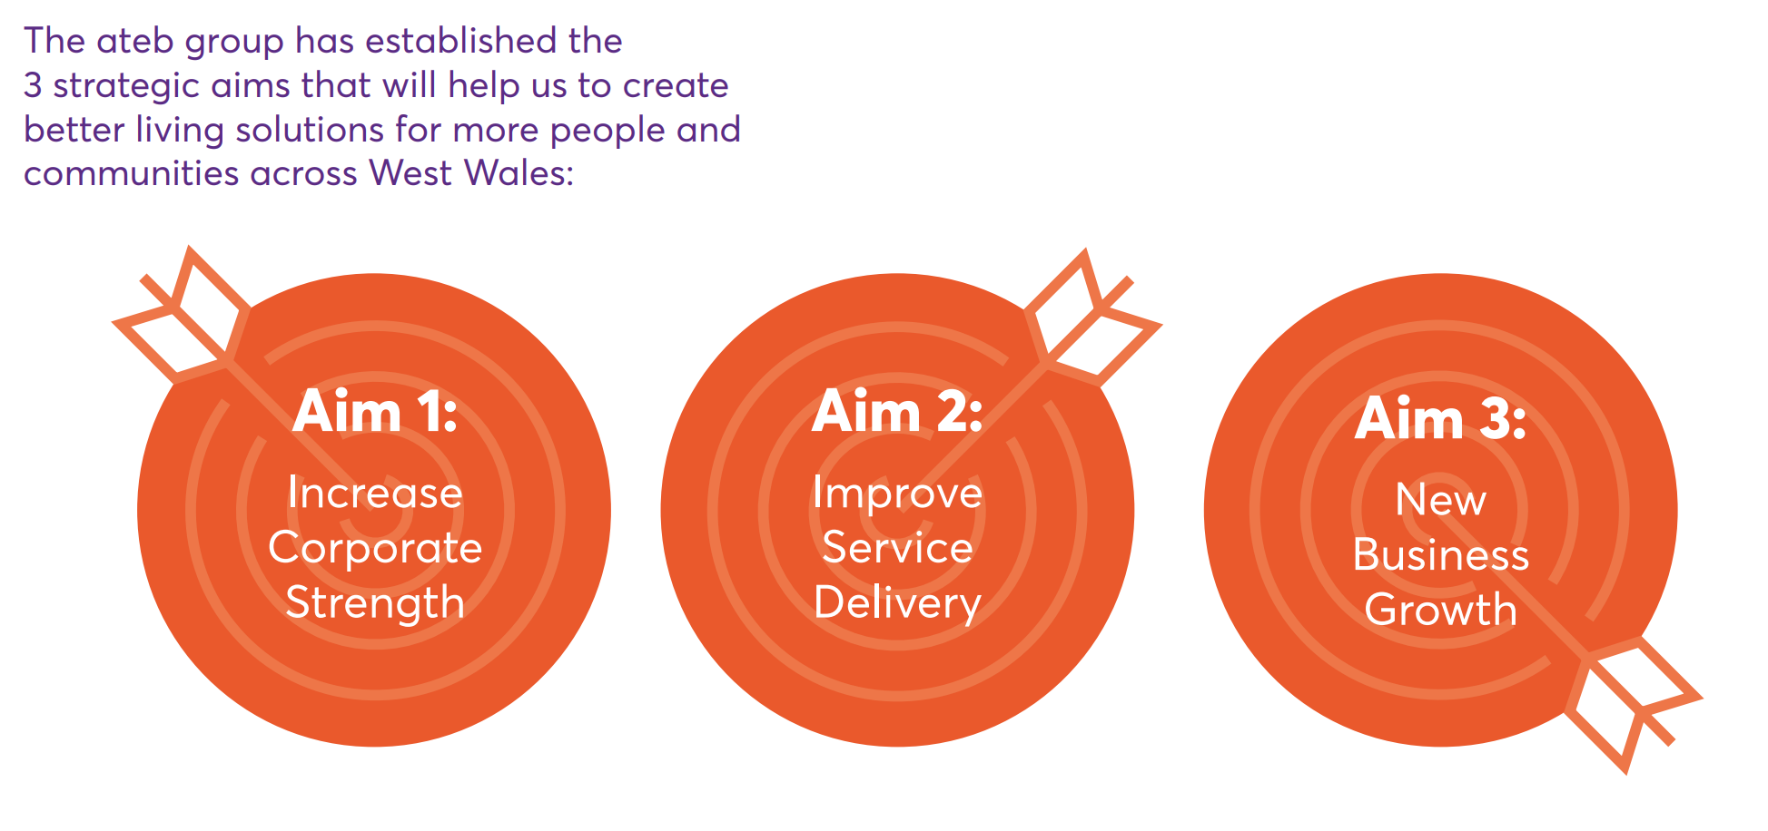

Source: ateb (2022)
Assumptions:

- Strategic aims identify growth and quality.
- As the organisation is closely affiliated to the public sector, it has ambitions to achieve Net Zero in line with the government targets for Welsh public bodies.
- Covid19 has expedited home working for ateb staff and therefore a reduction in office space can be realised.
- Existing care homes are fully occupied, and demand is high.
- All pre 2000s buildings, contain asbestos.

7.6 APPENDIX 7
ateb property portfolio

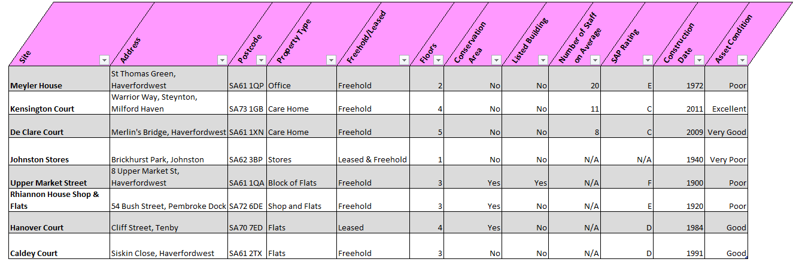

Source: ateb (2022)

7.7 APPENDIX 8
Common framework for TES

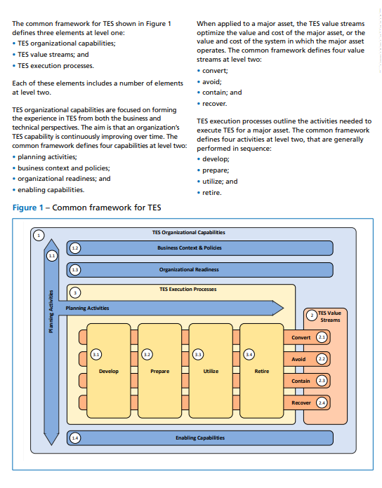

Source: BSI (2018b)

7.8 APPENDIX 9

Hanover Court- external accessibility adjustments

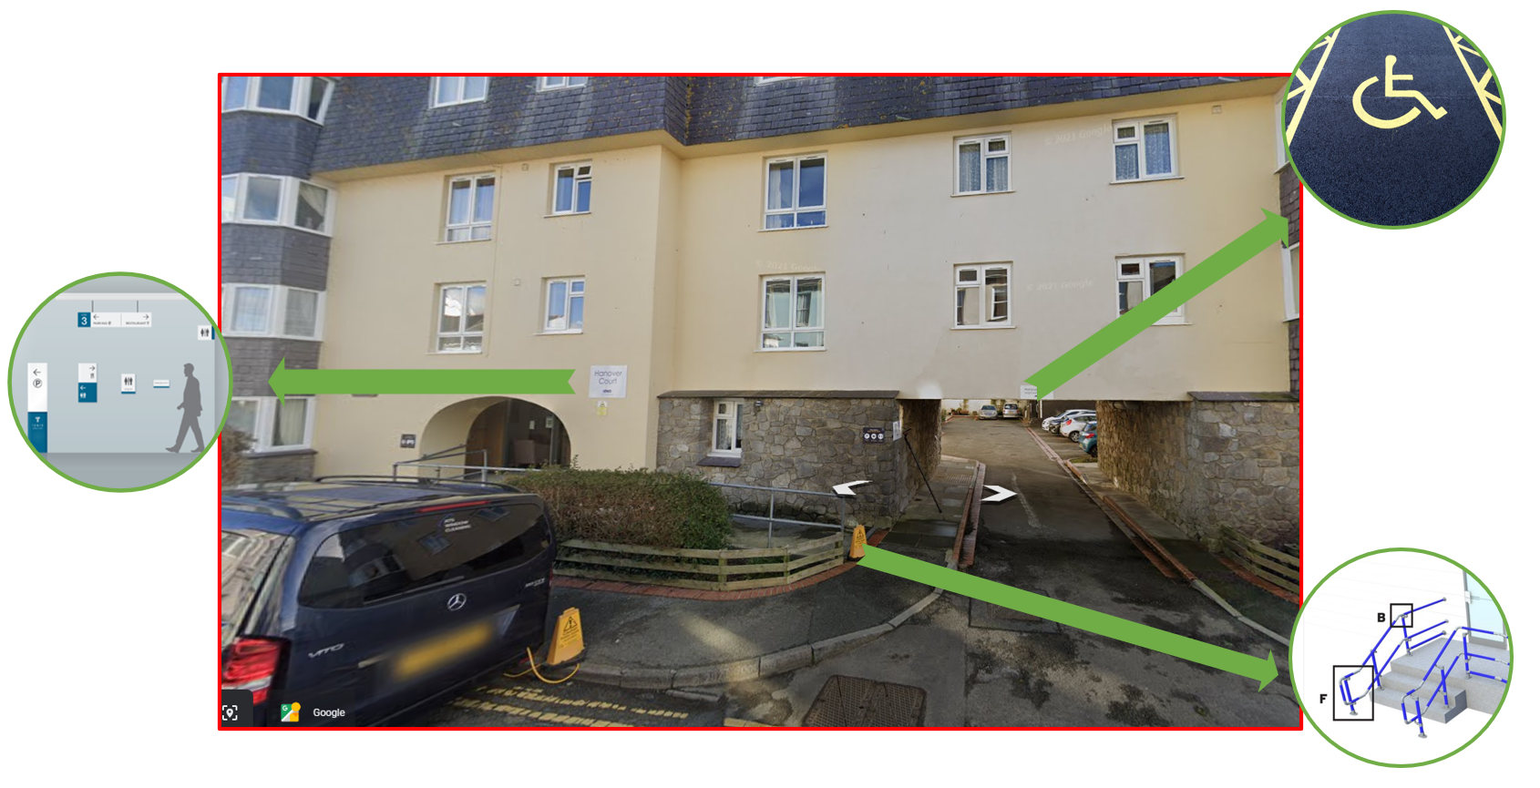
Source: Google street view

7.9 APPENDIX 10

Strategic property analysis results – housing association
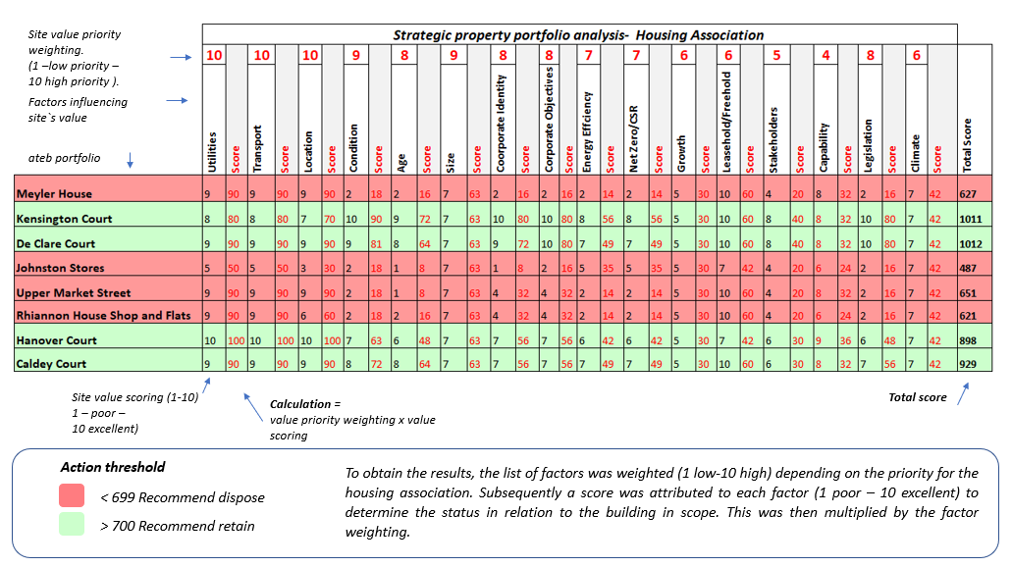

7.10 APPENDIX 11
NEC 4: Engineering and construction contract- Option A



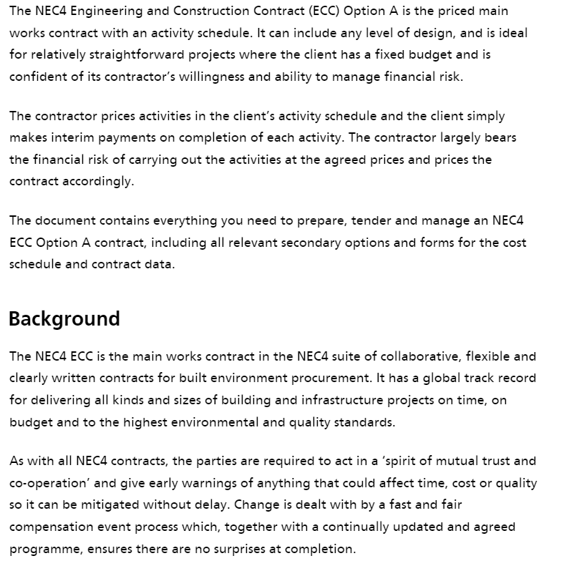
Source: NEC (2022)

7.11 APPENDIX 12
JCT Management Building Contract

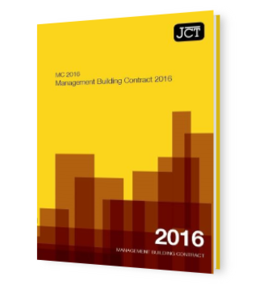

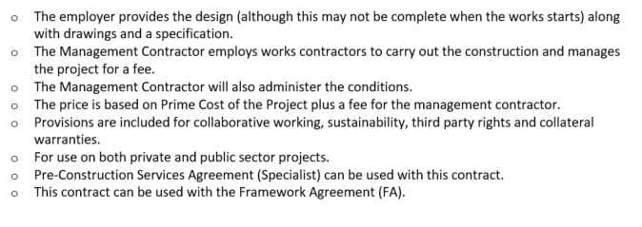

Source: JCT (2022)

7.12 APPENDIX 13

OGC Procurement and Contract Strategies

Procurement strategy and procurement route
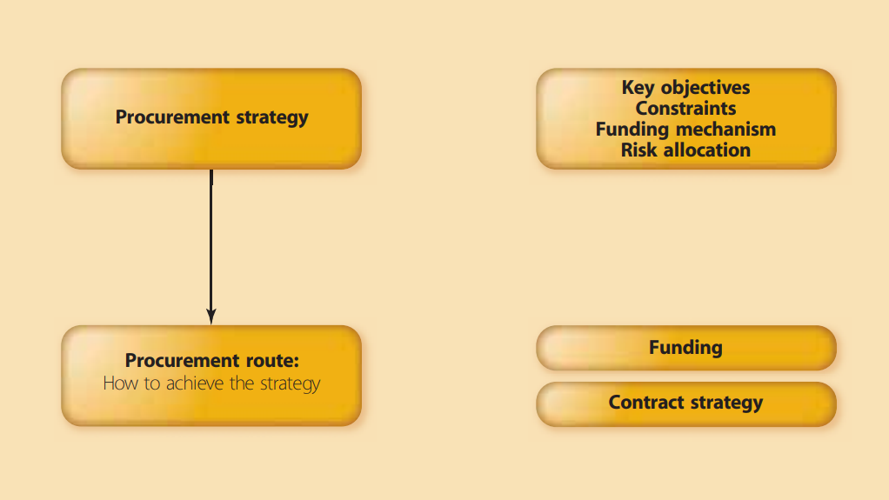

Procurement process

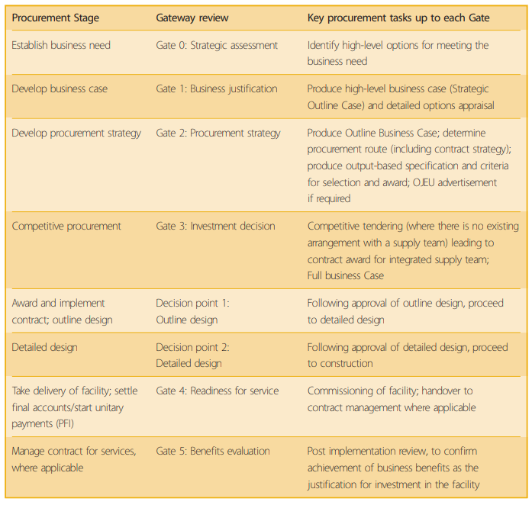

Source: OGC (2007)

7.13 APPENDIX 14

Guide to selecting the appropriate JCT main contract- Housing association
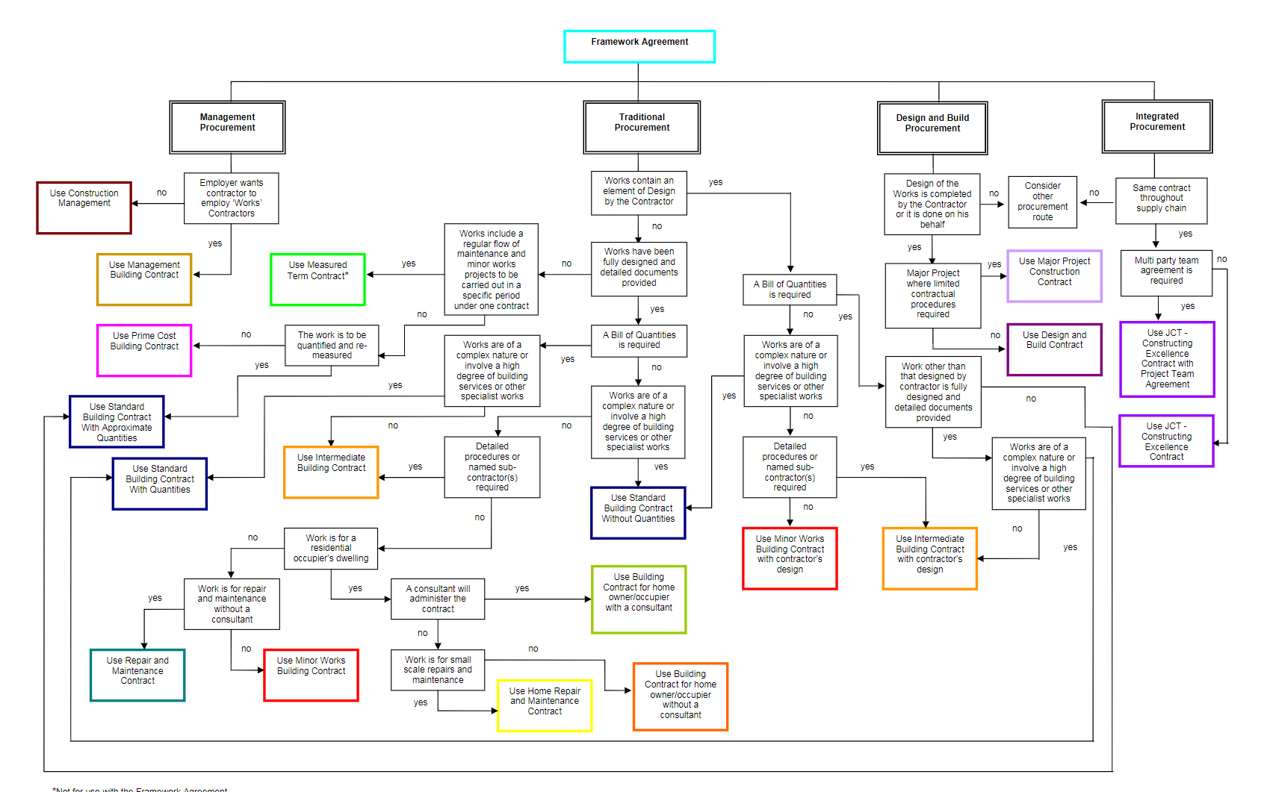
Source: JCT (2008)

7.14 APPENDIX 15
Client recommended next steps

University
- Complete a procurement route checklist, example detailed in Appendix 5, to confirm assumptions.
- Upon completion, revisit the strengths and weaknesses procurement systems analysis matrix.
- Complete a capability and capacity review of client-side project delivery resource. Consider additional client-side consultancy support, if needed.
- Explore known, proven, competent contractors to gauge their interest, with a view to commencing works in calendar year 2023.
- Identify and schedule client side, appropriate NEC training in readiness.

Housing association – Strategic portfolio review
- Consider appointment of a legal property professional to interpret lease clauses/dilapidations requirements, with a view to exiting, subletting, or selling the property in scope, duly making budget provisions.
- Review the impacts of stakeholders, tethered to the buildings identified for disposal and formulate a project plan. (Depending on estates strategy, a provision for the deployment of staff at existing/new sites may be required).
- Update SAMP to reflect strategic intentions, with accompanying responsibilities and timelines.
- Review retained assets, to identify readiness/next steps for the organisation to meet strategic objectives and wider legislative commitments, such as net zero.

Housing association - DDA (Equalities Act) modernisation
- Firstly, the client should commission an accessibility audit, by competent authority. Findings can be used to formulate a scope of works and inclusion of additional improvements.
- Review internal capability for scope of works/design, consider external competent resource, if needed.

7.15 APPENDIX 16

SAMP concept

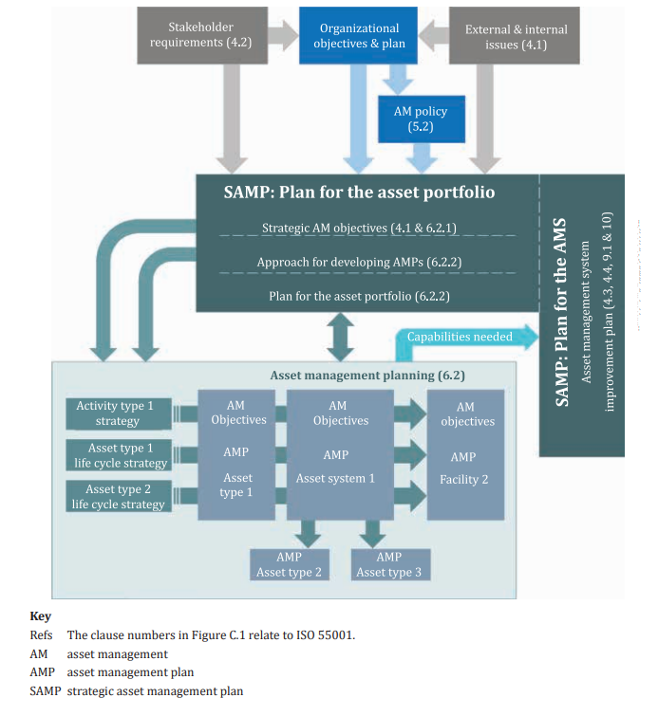

Source: BSI (2018b)

End.

