Abstract
This report details the systems engineering investigation into a remote rocket firing capability.
Principles of Systems engineering
ACDA4005

Table of Contents
Table of figures 2
Introduction 3
Overview 4
Process 5
Gun table 6
Description 6
Requirement 6
Stated 6
Assumed 6
Design 7
Traverse and elevation 7
Lifting and positioning 7
Conclusions 8
Mounting the weapons system 9
Launch tube 9
Clamps 9
Sights 9
Loading 10
Setup and safety 10
Testing 10
“V” Diagram 10
Conclusions 11
References 12

Table of figures
Figure 1: V model diagram [2] 5
Figure 2: Mounting rails with "T" bolts 6
Figure 3: "V" diagram 11

Introduction
The requirement is for a review into the existing remote rocket firing platform and what is necessary for the design of clamps to fix a new rocket system. The report will breakdown the overall requirement into separate, distinct areas and investigate the integration of these areas to fulfil the customer requirement.
Systems engineering is the process of developing a system which operates according to the requirements utilising a number of disciplines [1, p. 3]. It is necessary to review what the technical requirements are for both the gun table and for the design of new clamps along with the environments they are expected to be used in and any safety concerns [1, p. 29]. The review of the firing system investigates not just the system as a whole but also requires reviews of the sub-systems which are present and the interaction and integration of these within the wider system. [2, p. 1.2]
No specific rocket systems are discussed in order that the report remain unclassified and is restricted to the firing of shoulder launched rocket systems or smaller breach loaded rocket or recoilless rifle systems. The cost of components has not been considered as this will be subject to government commercial procurement costs and strategies. The manufacture time has also not been considered as the variety of the systems which would be fired and each trial have different requirements. Due to the variation in customer requirements and weapon systems it is not possible to conduct a Quality Function Deployment on them.

Overview
The firing of small and medium sized, foreign, anti-tank rockets is a requirement for many different types of trials. Due to the nature of foreign weapons the safety of the systems cannot be guaranteed as domestic or NATO weapon systems can. As a result of this, man-firing of these system is not permitted, and they are fired remotely.
Current trials require rockets to be fired at ranges from 50m up to 1000m depending on the trial requirements and the system being fired. The existing firing setup is based on a gun table which has clamps specifically designed to secure each system with a safety camera and a firing mechanism.
Although the current setup works and has proven effective on trials it has evolved from available equipment as individual trials have occurred. This has resulted in many areas where the setup of a trial and its conduct could be changed to improve safety, efficiency and trials results. A systems engineering approach to a redesign of the existing gun table will be undertaken along with the required approach to designing clamps for a generic weapons system.

Process
The author will review the customer requirements and the current design, identify future requirements and conclude for the gun table and the mounting of the weapon system as two separate areas.
One of the models utilised is the “V” model Figure 1 which considers the requirements through the design phase and into testing and operational acceptance of a system.
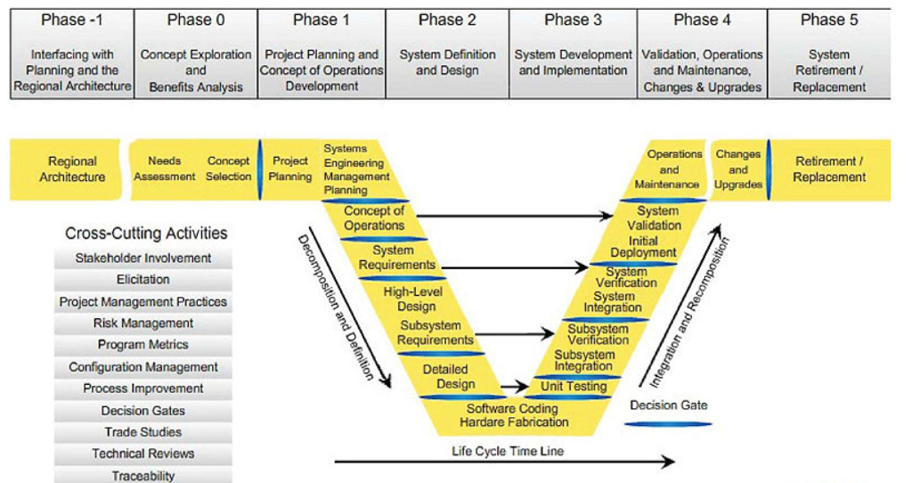
Figure 1: V model diagram [3]
This can be broken down into three broad areas which will need to be considered. These are:
- Design
  - This is the design of the gun table and any modifications which will need to be completed on it.
- Integration
  - This is the integration of anything to the gun table. This will include sub-systems such as any interface plates or clamp blocks required for mounting a weapons system or the integration of cameras and other surveillance equipment.
- Through life support
  - This will include things such as the upkeep of the gun table and the ensuring it is fit for use both before and after trials. [4, p. 10]

Gun table
For the existing gun table mount the author will review the existing table, identify any issues and potential solutions [5].

Description
The gun table was designed for mounting medium calibre guns of 20-50mm calibres for test firings and is over 50 years old. It is of a steel construction, weighing approximately 900kg and has no forklift lifting points or lifting shackle points. The top of the gun table has two parallel mounting rails which are being able to be elevated and depressed, allowing mounting brackets to be fixed with “T” bolts (Figure 2).
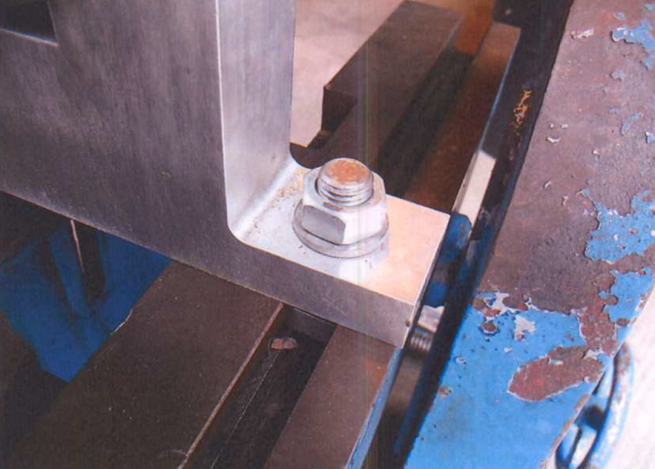
Figure 2: Mounting rails with "T" bolts
The current design is limited by a number of factors. The controls for traverse and elevation are not located in areas which make it easy to manipulate and the bolts on the locking mechanism for the traverse are not standard size being neither metric nor imperial sizes.

Requirement

Stated
The requirement is for a gun table which is able to mount rocket systems for use in outdoor trials, in inclement weather conditions. The gun table must have variable traverse and elevation to allow for aiming.

Assumed
There are some assumed requirements for the gun table.
- The traverse and elevation cannot be nudged off alignment once set
- It must be able to be transported between storage and trials areas
- It must be able to be set level
  - Due to the accuracy of the weapon systems being fired a visual indication using a spirit level is sufficiently accurate.
- The operator must be able to setup and use all equipment whilst wearing all necessary PPE
  - PPE may include gloves, eye protection, body armour and ballistic helmets along with cold weather equipment.
- All equipment conforms to legislation and regulatory requirements

Design
The general design for the existing gun table is robust enough for trials however there are modifications which would allow it to better fulfil the customer requirement. The exact requirements, including accuracy, vary between trials, weapon systems and customers, however as a minimum the gun table must be able to mount and fire different systems at ranges from 50-1500m.

Traverse and elevation
Traverse and elevation of the gun table can be controlled either manually or remotely.
The current controls use a screw mechanism to both elevate and traverse the top of the gun table. This mechanism is reliable with minimal maintenance and preparation, however future designs will require the handles to be placed in more accessible areas. As the handles are required to be operated in adverse weather conditions the handle will require further design. In cold weather the handles will need to be operated whilst the user is wearing gloves. To allow this the handle will need to be large enough to be held whilst wearing gloves. Additional design features can include a knob fixed to the handle and changing the texture of the handle to improve grip and the ease of rotation.
Electrically controlled motors to traverse the rig has both benefits and downfalls. The primary benefit of having motors controlling the traverse and elevation is that it allows the setting and aiming of the gun table to be conducted remotely improving the safety to the operators. It also allows the operator to input and capture the elevation angles required for each range for different systems. The choice of motors and drivers can impact on the accuracy of the gun table, however for rocket systems this becomes largely irrelevant due to the accuracy of these systems. Electronic systems, however, are less reliable and are more susceptible to adverse weather conditions.
To identify the angle of traverse and elevation adding markings to the gun table would allow improve the ability of the operator to set it prior to firing.

Lifting and positioning
The current gun table has no lifting points for either cranes or forklift which impacts its movement and positioning on trials sites. Once placed there are no fine controls on the gun table to allow it to be levelled or to determine that it is level. Modification to the base of the gun table are necessary to facilitate movement and setting of the gun table.
Adjustable feet at each corner of the gun table, along with spirit levels, would allow fine adjustment to level it on the trial site. the addition of forklift points and crane lifting points would allow for better movement of the gun table around storage locations, onto and off vehicles and on trials sites. Markings noting the centre of gravity and mass of the gun table would be required to confirm with the Lifting Operations and Lifting Equipment Regulations 1998 (LOLER). [6]

Conclusions
A complete redesign of the gun table would not be required however modifications to the existing gun table would improve the ability to conduct trials. Modifications to the control mechanisms would be required to improve the efficiency and accuracy of the gun table. Having manual controls with the texture designed to improve grip, along with a knob on each to control the elevation and traverse would allow the gun table to be used in all weather conditions and whilst using PPE. Markings on the gun table showing elevation and traverse would be required to improve laying of the gun table on target.
Forklift and crane lifting points would be required, along with markings for the centre of gravity and mass, to improve the ability to move and transport the gun table. Fitting adjustable feet and spirit levels would increase the ability to level the table.

Mounting the weapons system
In order to mount a weapon system to the gun table mounting brackets are required to clamp the launch tube to the mounting rails. Due to the different sizes and shapes of launch tubes separate clamp sets will be required for each weapon system, however there will be a common interface with the gun table. For the purposes of this report the design considerations and requirements are not for a specific weapon system but what would be considered for a new system.

Launch tube
Prior to the construction of clamps the dimensions of the launch tube are required. Each weapon system has different features which require different design considerations. Launch tubes may be extendable which can impact on the location of clamps and where they are placed on the launch tube.
The position of the launch tube within the clamps and the clamps on the gun table must ensure that when the fins of the rocket are deployed on launch, they cannot hit the gun table or other parts of the setup. A failure to do this may result in the rocket changing direction in flight and impact safety on the range [7, p. 5].

Clamps
As most rocket systems are recoilless the clamps are only required to support the launch tube and hold it without changing position whilst loading and arming. The clamps cannot, however, secure the launch tube too hard. Depending on the materials the launch tubes are constructed of clamping the launch tube too hard can either crack the launch tube or impede the passage of the rocket through on launch. Both of these could result in a breach in the side of launch tube and premature detonation of the rocket causing damage to the equipment and the range. The existing clamps for the different weapon systems are of a steel construction, are heavy and can make aiming the systems difficult. Inserting 3D printed collars or rubber inserts to the clamps will allow the launch tubes to be gripped without applying unnecessary force onto the launch tube. This will also allow for expansion and contraction of the clamps and launch tube due to temperature changes resulting from the weather or repeated firing of the launcher.
The sections of the clamps and the fixings to the gun table will require bolting together. The exact design for securing the clamp sections will depend on the shape of the launch tube however when tightened it shouldn’t twist the launch tube. Using square bolts with a head of a slightly smaller diameter than the rails on the gun table will allow the clamps to be easily fitted. Adding spirit levels into clamps will allow the operator to ensure the clamps and the launch tube are level prior to firing.

Sights
It is necessary on trials to accurately aim the weapon system and as such the weapons sights are used to aim. Sights can be either fixed or detachable and are often fitted on either the left-hand side or the top of a launch tube. Some sights, often on extendable launch tubes, are locked into position until the weapon is ready to fire when they pop up from the launch tube. The clamp locations must not impinge on the mounting of the sights or prevent them from moving into position when the launch tube is armed [8, p. 11].
Any design of the clamps must enable the operator to look through the sights as designed. Depending on the weapon system this may involve cut outs or holes in the clamps however each design would be individual to each system.

Loading
Some weapon systems, such as RPG-7, require loading prior to firing. There are three common loading methods, front loading, rear loading and breach loading. Front loading systems are loaded base first into the front of the launch tube and often have the warhead protruding and from the front of the launcher. Rear loaded systems are loaded warhead first into the rear of the launch tube and often require a connection to be made to the firing circuit. Breach loading systems have the system loaded into a breach, generally to the rear. For all systems the clamps, gun table and other features of the setup cannot prevent the operation of a breach or the loading of the system [7, p. 5].
The loading of the systems must not interfere with any aspect of the setup and the mounting and aiming must not be dislodged on loading as this will impact on the accuracy of the system causing potential safety issues and be detrimental to the trial objectives.

Setup and safety
The setup for each weapon system will differ however the are some common features which are required for each system. These include camera, microphones and firing mechanisms.
As the weapon systems are required to be fired remotely the firing mechanisms on each requires modification, something which varies for each system. For systems which use triggers the options for operating them remotely are solenoids and using metron actuators. Solenoids apply a pressure to the trigger acting in the same way as a finger whilst metrons fire a pin into the trigger when initiated. For trials purposes a solenoid is comparatively slow and cannot be connected to other instrumentation which the metron can. Although metrons are the most effective method of initiating the system there is a slight risk of initiation by RF so suitable shielding and RF protection is required.
To ensure the firing mechanisms initiate properly and to identify potential reasons for faults a camera is required to view the trigger. As many rocket systems are initiated using a percussion cap a microphone is required to ensure the percussion cap initiates. Both the camera and the microphone are required in the event of a misfire for the operator to determine the cause and the next safe steps. The camera and microphone would need to be able to operate in adverse weather conditions and be connected by a cable to a monitor in the remote firing location.

Testing
Testing of the system is necessary as it allows identification of any design flaws and allow for any necessary redesign. Before the final clamp is manufactured it may be necessary to 3D print the clamps to ensure the design fits the launch tube and allows the operator to use the sights. Once the clamps have been manufactured it will be necessary to assemble the complete system prior to a trial and practice drills such as loading and unloading.

“V” Diagram
The above fit in with the sub-system design and detail design stages on the “V” diagram while the ensuring they can integrate and the testing fits into the testing and variation stages on the other side of the “V” diagram (Figure 3).

Figure 3: "V" diagram

Conclusions
The specifics of each set of clamps and the mechanism for firing differ for each weapon system however there are common features. There most be a generic interface between the gun table and the clamps and their location on both the gun table and the launch tube must ensure that it is not possible for the fins of the rocket to catch on the gun table or any other equipment. The design of the clamps must not grip the launch tube too hard and must allow for the operator to determine it is level and see through the sights to aim. For safety it is necessary for the operator to view the trigger or firing mechanism and to hear whether any percussion cap has fired. All equipment must be able to operate in adverse and changing weather conditions and manage fluctuation in the temperature of the launch tube.

References

[1] | National Aeronautics and Space Administration, NASA Systems Engineering Handbook SP-2016-6105 Rev2, NASA, 2016.
[2] | NATO Advisory Group for Aerospace Research and Development, “Systems Engineering, AGARD Lecture Series No. 164,” NATO, AGARD, 1989.
[3] | United States Department of Transportation, “ITS Professional Capacity Building Program,” [Online]. Available: https://www.pcb.its.dot.gov/standardstraining/mod02/ppt/m02ppt.htm. [Accessed 21 04 2020].
[4] | O. Sudlow, “A Systems Engineering Approach to the Re-balancing of the UK's Shipbuilding Industry,” Defence College of Management and Technology, Cranfield University, 2006.
[5] | R. Morgan, “Root Cause Analysis,” [Online]. Available: https://moodle.uwtsd.ac.uk/pluginfile.php/346797/mod_resource/content/1/Root_Cause_Analysis_Part_1.pdf. [Accessed 21 04 2020].
[6] | HMG, “Lifting Operations and Lifting Equipment Regulations 1998,” 13 04 2029. [Online]. Available: https://www.hse.gov.uk/work-equipment-machinery/loler.htm.
[7] | “DSTL/TR90278 (Report classified)”.
[8] | “DSTL/TR78293 (Report classified)”.
[9] | “DSTL/DOC45756 (Report classified)”.
[10] | R. Morgan, “The Systems Engineering Process,” 2019. [Online]. Available: https://moodle.uwtsd.ac.uk/pluginfile.php/313621/mod_resource/content/1/The%20Systems%20Engineering%20Process.pdf. [Accessed 21 04 2020].

