University of Wales Trinity Saint David
Wales Institute of Science

Electrical Control Systems
ACHA4010

Evan Arthur
2304605
06/04/2025
Contents
1 Task 3 1
1.1 Scope Time Division Calculations (3) 1
1.2 Function Generator output square wave (3) 1
1.3 Capacitor charge and discharge wave marked at correct points. (3) 2
1.4 Basic Capacitor Calculations (3) 2
1.5 Capacitor discharge table (2) 3
1.6 Plot log(V) Gradient (2) 5
1.7 Gradient Calculations and Compare(4) 6
1.7.1 Gradient Calculations 6
1.7.2 Comparison table 6
1.8 Capacitor Uses (5) 6
1.9 Inaccuracies Question (4) 7
2 References 8

Task 3

Scope Time Division Calculations (3)
$$R=10Ω$$
$$C=10µF$$
$$τ=R*C=10 ×\left(10×{10}^{-6}\right)=100µs$$
$$∴40τ=40 \left(10×\left(10×{10}^{-6}\right)\right)=4ms$$
$$Function Generator Freq. =\frac{1}{40τ}=\frac{1}{4×{10}^{-3}}=\frac{1}{0.004}=250Hz$$

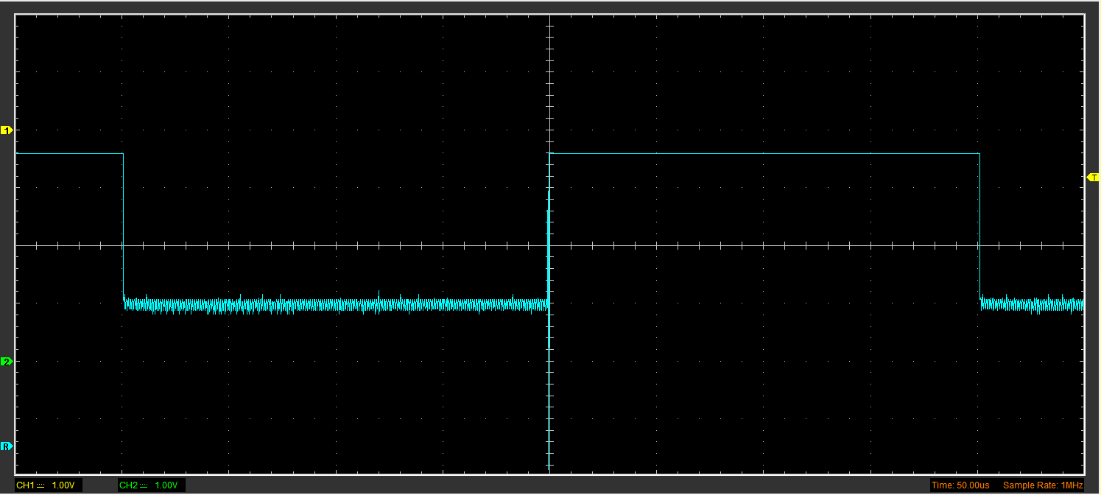
Function Generator output square wave (3)
Figure 1 - Function Generator Square Wave
Figure 1 shows the square wave function probed from the function generator, viewed through the oscilloscope. The function generator used during the test was set to a frequency of 250Hz – this means the time between each peak was 1/250 or 0.004s.

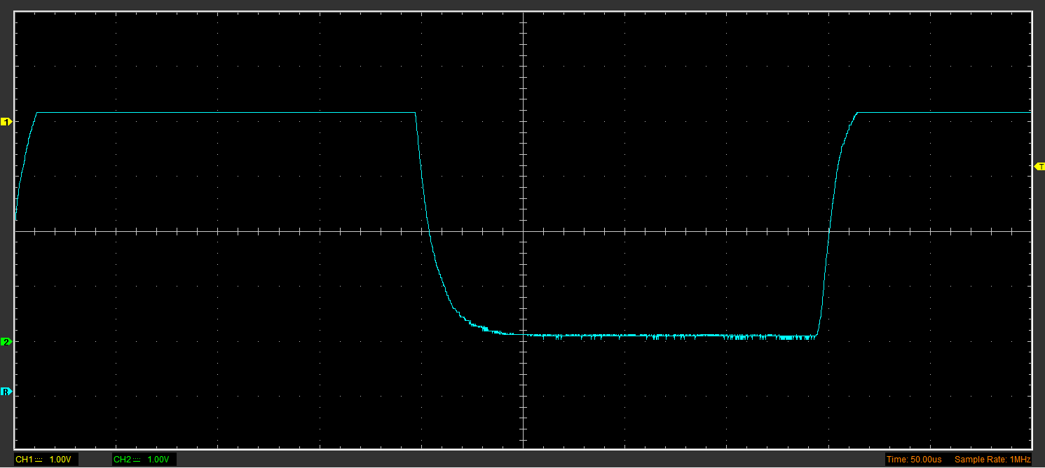
Capacitor charge and discharge wave marked at correct points. (3)
Figure 2 - Charge & Discharge Wave
Figure 2 shows the capacitor charging and discharging. This is shown in the smoothed curves of discharge (curving down) and charge (curving up), the purpose of a capacitor is to store charge that can be released, or discharged, rapidly. For example, this is very useful when considering applications such as camera flashes.

Basic Capacitor Calculations (3)
Looking at Figure 2, the time taken to Charge is approximately 25.00us or 0.000025s. From this, the Capacitance can be worked out by dividing the time by the resistance:
$Capacitance=\frac{Time}{Resistane}=\frac{0.000025}{10}=0.0000025F or 2.5µF$
Following this, the time taken to discharge is approximately 50.00us or 0.00005s.
$$Capacitance=\frac{Time}{Resistace}=\frac{0.00005}{10}=0.000005F or 5µF$$

Capacitor discharge table (2)
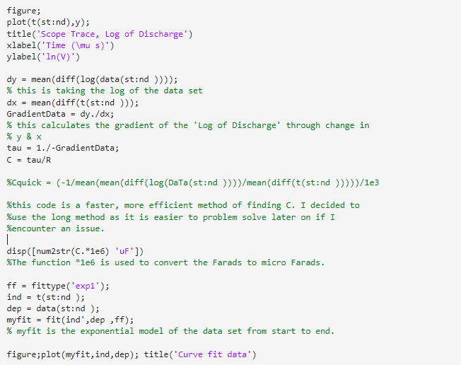
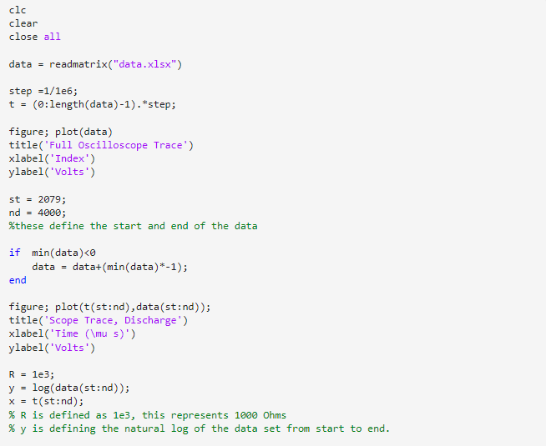
This table has not been filled in due to using MATLAB to find the gradient as this will use the complete data set rather than 10 random points – therefore delivering a gradient of higher accuracy which better represents the data set being processed. Figure 3 shows the MATLAB code used, with explanation as to why and how the code works.

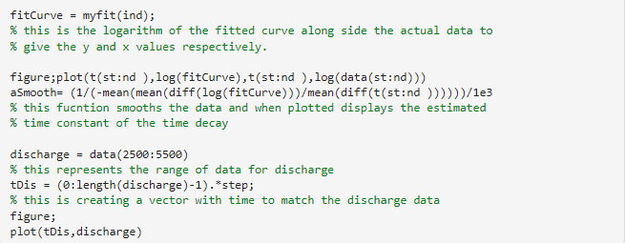

Plot log(V) Gradient (2)
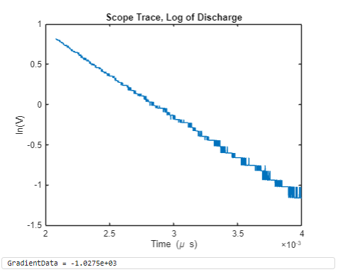
Figure 3 - ln(V) vs Time
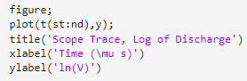
Figure 3 displays the relationship between Time and the natural log of Voltage. This gives a very linear negative trend. This graph was produced using MATLAB, the code is as follows:

Gradient Calculations and Compare(4)

Gradient Calculations
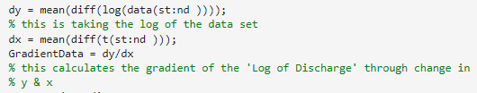
This graph displays the natural log of Voltage against Time. From this, the change in x (dx) can be divided by the change in y (dy) to give the gradient of the line. This was done using in MATLAB using the code:
This gives a gradient of -1.0275 x 10^3 or 0.0010275.
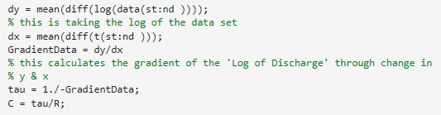
To work out Capacitance using this, the equation $C= -\frac{1}{R×slope}$ The code used to calculate this was as follows:

Comparison table
 | Capacitance | Delta | Percentage difference
Actual | 1 µF | x | X
Marker Calculation | 5 µF | +4 µF | +400%
Gradient Calculation | 0.97321 µF | -0.02679 µF | -2.679%

Capacitor Uses (5)
Capacitors can be and are used throughout all aspects of electrical engineering. In motorsport, they are commonly found within race/track cars often as a power smoothing module. They can also be used as a way of storing energy such as in Formula 1 and Formula E with the Energy Recovery Systems (ERS) - they are also often used within the ignition in high performance vehicles to generate precise and powerful sparks, ensuring strong and consistent sparks to start the combustion cycles.
Moving over to more automotive areas, the capacitor can also be used within the start-stop system some modern cars have for fuel efficiency. This is primarily to provide instant high power which is needed to restart the engine. Used also in sound systems within vehicles to ensure a constant supply is fed to the speakers, reducing drops in sounds quality. Another use is in some automatic transitions – to ensure a smooth shift by maintaining a predictable and stable power source.
In motorcycles, capacitors are still just as common. Used as a form of surge protection, able to store any surge of energy and discharge it slowly and predictable. Also found in anti-theft systems/alarms as this helps the battery remain healthy while the bike is turned off. Finally, capacitors can also be found within Electronic Fuel Injection (EJI) systems to help smooth the supply and eliminate any fluctuations in voltage that could cause over or under fueling within the engine.

Inaccuracies Question (4)
During any experiment, several factors can contribute to inaccuracies in the results, particularly those related to cables and connections. Faulty or improperly connected cables can introduce unwanted noise or signal interference, leading to unreliable data. Inaccurate calibration of channels in measuring instruments, such as oscilloscopes, can further amplify these errors producing misleading results (Fluke, 2025). Additionally, issues with the ground wire, such as poor connections or damage can cause oscillations known as ringing which will distort the measurement signals and lead to more errors (Picotest, 2025). The quality of the bandwidth connection to the oscilloscope is also crucial; a poor or unstable connection can introduce noise, reduce the precision of measurements and even cause some data points to be missed altogether. These issues are particularly critical in high precision experiments where small inaccuracies can significantly affect the final outcomes (EEtimes, 2025) Therefore, ensuring proper connections, calibrations and bandwidth is essential for reliable results.

References

EEtimes, 2025 – Date accessed, 04/04/2025 –
https://www.eetimes.com/how-to-reduce-digitizing-oscilloscope-delta-time-errors/

Fluke, 2025 – Date accessed, 04/04/2025 –
https://www.fluke.com/en-gb/learn/blog/electrical-calibration/understanding-and-dealing-with-high-frequency-error-sources

Picotest, 2025 – Date accessed, 04/04/2025 –
https://www.picotest.com/oscilloscope-mistakes-part-2/?srsltid=AfmBOoolNo9aT-mXMQOgV1aFggGir5LrOobh_X5KN1O45anzs3VZDCd9

