

DESIGN THINKING AND INNOVATION
THROUGH DIGITAL TRANSFORMATION
A design thinking portfolio for LocalLoop UK
Programme | BA Leadership and Management Skills in the Workplace
Module | Design Thinking and Innovation
Module Code | LCLM6002
Assessment Title | Design Thinking and Innovation through Digital Transformation
Student Name | Daniel Stoican
Student ID | 2228042
Word Count | 4029 Words

Contents
Introduction 3
Task 1: Key Opportunity Areas in the UK Market 4
Integrated Local Commerce Platforms 4
Smart Rural and Suburban Delivery Coordination 5
Digital Marketing and Customer Relationship Support 6
Inclusive Digital Payments and Trust Services 7
Comparative Assessment of Opportunity Attractiveness 7
Task 2: Applying the Five Stages of Design Thinking 8
Empathise with Affected Users 8
Define the Problem and Causal Map 9
Ideate through Brainstorming and Selection 10
Prototype the Minimum Viable Product 11
Test, Measure and Refine 11
Viability, Scalability and Sustainability of LocalLoop UK 12
Risks, Ethics and Implementation Controls 13
Conclusion 13
References 14

Introduction
The online shopping has revolutionized the market in the United Kingdom because of its rapid development. The small retailers, service firms, local manufacturers, rural consumers and delivery partners now will require a digital interface with convenient payment opportunities and high frequency fulfilment. Nonetheless, websites, social media, stock, payments and delivery are still separate tools that are used by many small businesses. This adds a burden both in financial terms and efforts, and poor customer experiences. Design thinking can be used to this range of portfolios, through the definition of which opportunities can be viable as a venture, and further developing a single idea through the empathise, define, ideate, prototype and test. It analyses the pain points, gaps, technology, scalability, sustainability, desirability, feasibility and viability and it is achieved with the assistance of causal mapping and organised brainstorming. LocalLoop UK is the suggested venture of a primitive digital enterprise and collaborative delivery service amongst smaller city centres independent retailers and communities. The report believes that it is a good opportunity as long as the service is easy to use, compatible with bad connectivity and it is demonstrating commercial value in case of a controlled local pilot.
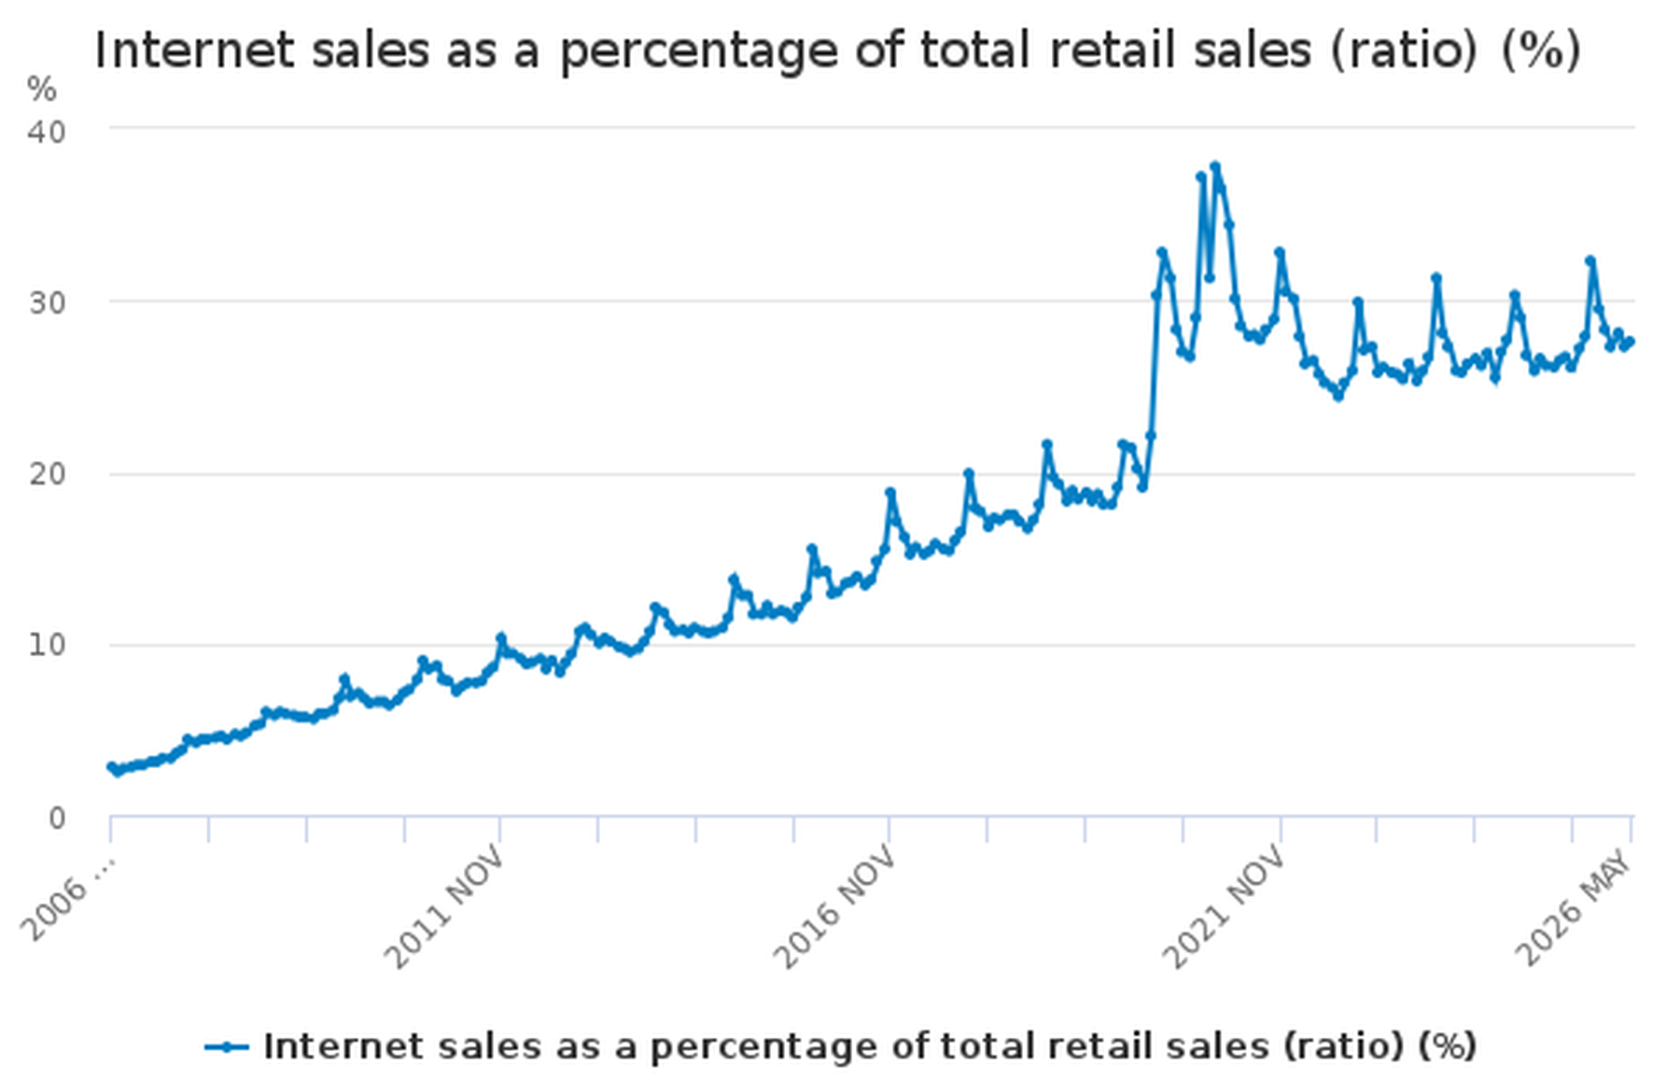
Figure 1. Internet sales as a percentage of total UK retail sales.
Source: Office for National Statistics (2026), 2. Design Thinking Lens and Analytical Framework
Design thinking is a methodology that deals with problems of uncertainty and is human-centred. People start with it, makes early tests and learns with cycles. It is opposite to analytical thinking that under usual conditions breaks down an issue with which we are familiar and then decides the most useful solution. It is an opposite of critical thinking, which is mainly a question of the powerfulness of facts and reasoning. System thinking is concerned with how relationships in a more systemic system and design thinking converts those relationships into experiments that are usable. The two approaches are hand-in-hand. The systems thinking maps brainstorm, evidence on critical thinking test and design thinking define and experiment the venture. Research shows that design thinking involves empathy, reframing, visualisation, collaboration, experimentation and tolerance of ambiguity, however, of which organisational circumstances and the practice itself depend (Micheli et al., 2019; Nakata and Hwang, 2020; Rösch et al., 2023).

Task 1: Key Opportunity Areas in the UK Market
The most promising opportunities are where the need of customers is already known but the delivery of such services is still disjointed. Reviews of policies show that there has been no relationship between ambition and the reality of digital implementation in SMEs, and that the online retail sales grew by 19.2 per cent to 27.4 per cent in 2019 and 2025 respectively in the UK (ONS, 2026; Department for Business and Trade, 2025a; UK Government, 2025).

Integrated Local Commerce Platforms
The first one is an inclusive trade board to the small retailers, market suppliers, local manufacturers and service gives. Fragmentation is their key negative aspect. A store is able to promote itself in Instagram, place an order in WhatsApp, get cash in a card connection, save in a spreadsheet and deliver with a phone call. The owner turns into the manual link, which brings mistakes, vague stock and sluggish service. Rural and suburban buyers also have a problem locating local products due to the number of local businesses located on different pages and profiles, not connected with each other.
The market gap does not consist of non-existence of e-commerce software. The functions have already the large platform of functioning. The gap is a low-complexity service that is established on the basis of small firms. To become a merchant, one must be capable of creating a mobile booth, quickly, accept the imported merchandise, collect social orders, put together stock and decide on which to collect or deliver. Product description can be done by artificial intelligence, simple messages can be translated and recommended reorder levels can be suggested.
The opportunity is strong due to scalability. Now numerous domains are put into place using custom modules and the more they participate the more value there is in the local network. Yet, stiff competition is the drawback of current marketplaces and web developers. LocalLoop under no circumstances should be developed to become a mere one of the general online shop tools. Onboarding with assistance, social-order capture and shared fulfilment should be its strength, and it should have local discovery. This sustainability is enhanced as existing businesses are able to get a share of the cake without creating more premises. Nonetheless, abandoning of digital growth can boost packaging and delivery as well.

Smart Rural and Suburban Delivery Coordination
The second opportunity is the possibility of pooled last-mile delivery when there are fewer parcels and longer routes in a destination. Tight delivery options, uncollected packages, and unreliable delivery time are the reasons why consumers are usually presented with them. Prices by a individual courier can absorb the gap between small retailers, and the price of the personal van is expensive, and is underutilized. Transportation to distribution sources is inefficient, and they cannot keep up speed.
Market gap This is a neutral coordination layer which converts orders generated by several local businesses into coordinated plans of neighbourhood routes. LocalLoop might provide adv Woebly times, pick up stations and merchant accommodation centers. Orders would be grouped by routing software and delivery and collection confirmed by a driver app. The customers were either allowed to take a slow cheap green slot or could pay a little more to be granted priority. Connectivity is also being strengthened improving feasibility without infrastructure being even. Ofcom cited evident rural disparities in here, as coverage in full-fibre and at gigabit, whilst national coverage and uptake remained high. Access to technical capabilities is not the only mechanism that is reported by small firms; capability, cost and confidence barriers are also reported (Ofcom, 2025; Ofcom, 2026; Department for Business and Trade, 2025b).
The most beneficial is the route consolidation. The number of parcels per route can be increased to reduce the number of cost per drop as well as unnecessary mileage. Footfall can be generated in the collection points of the villages, but late preparation, the variability of the demand and the distance can spoil the route economics. Scalability is thus to pursue a cluster model, town, or villages around, one a time. The metrics of sustainability should be in terms of kilometres per parcel, rate at the first attempt at delivery and type of vehicle. Van Electric Van can be deployed in planned regional routes and cargo bikes in busy town centres.
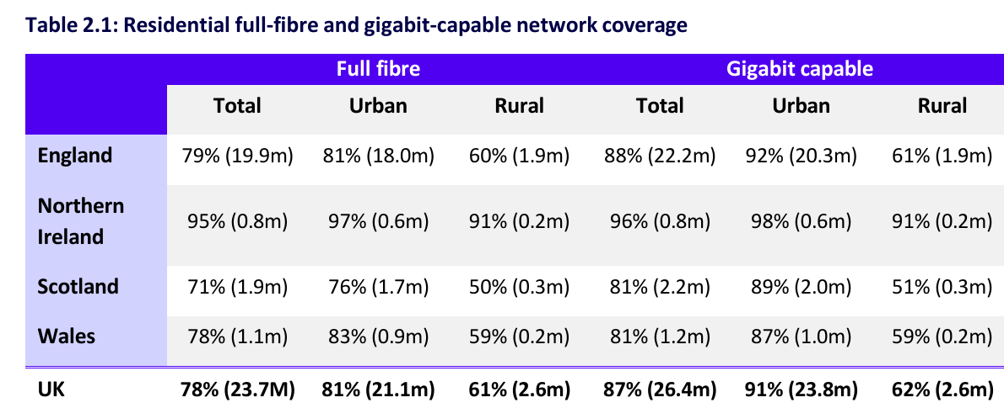
Figure 2. Residential full-fibre and gigabit-capable network coverage by urban and rural area.
Source: Ofcom (2025)

Digital Marketing and Customer Relationship Support
The third opportunity is practical digital marketing and customer relationship support for small firms. More than a large number of owners know customers on a personal level yet they hardly post as frequently or provide messages and make unspecialized offers without distinctions. The pain does not simply consist of skills deficit only. It too is non-time. Retailer is not able to spend hours on researching the advertising tools and focusing on customers and stock handling.
The market gap is an inbuilt assistant which converts the normal business venture into simple marketing ventures. LocalLoop had the option to provide updates with consent, solicit reviews, propose content and indicate repeat-buying tendencies, and the owner will approve each message. The motivation as to why this human control is relevant is that, automated contents are erroneous, redundant or touchy. Its enablers are technology that consists of analytics and low-cost messaging interfaces, customer relationship management and generative AI. With design thinking, these technologies could be connected with the real working practice, instead of being lost in the complications of an enterprise system (Magistretti et al., 2021; Bogers et al., 2022; Oliveira et al., 2024).
The scale and retention-strengthening can be achieved through the co-location of fulfilment, communication and sales. It lacks trust. Corporations and businesses will be concerned that they will lose their brand voice or even customer information. The system should therefore elaborate on why each suggestion appears, obtaining express permission of marketing, and allowing the easy exportation of data. By helping local companies to maintain their clients and not necessarily buy new publicity, sustainability is attained. However, online support may encourage unnecessary usage, thus visible features of merchants such as repair, refill, source locally and low-waste should be advertised by the service.

Inclusive Digital Payments and Trust Services
Inclusive payment and trust support is the fourth opportunity. Transaction fees, fraud risk, unfriendly terms of chargeback and unwanted providers, and the experience at the digital checkout of small businesses does not match the expectations of customers regarding the quick process. Other clients may abandon shopping as a result of a complex registration, or small selection of payment options. Delivery partners need the assurance that an order is paid, and merchants need to be able to settle on a short time and reconcile easily.
The market gap is a trusted payment layer that is based on local commerce. LocalLoop is not to become a bank. It should also provide a way of integrating controlled payment providers collectively and providing their services using one easy-to-use interface. Merchants were able to view fee and automatic reconciliation, and customers were able to use cards, wallets or secure links. Helping the ordering should always stay open either by telephone or by a shop attendant who has authorization and the money stored somewhere safe.
Payments eliminate friction and yield trusted demand data. This is the weakness of vulnerability and dependence on third parties. Even any failure or alteration of policy can impact the entire platform. The company should possess a variety of payment partners, not hold all the information about cards and have a clearly established incident plan. It has good scalability as the workflows around payments can be reused, but internationalizing would impose new legal and tax needs. This should include the social sustainability. Digital-first need not be digital-only. Big text, understandable language, easy contrast, choices of a guest checkout and assisted support are necessitated.

Comparative Assessment of Opportunity Attractiveness
The four regions are interrelated, yet not equally valued in venture. A marketing assistant enjoys a symbiotic copying service, payment services are controlled and pure courier model requires capitalization even prior to the demand being secured. The integrated commerce platform would be more attractive because it can start off as a software, acquire experience as the occurrence of the transactions brings fulfilment with time. Low differentiation is the most significant threat to it. The most viable idea is a local business and coordination site that is hybridized though with a small first market.
Desirability will be high since the merchants will save time, reach the customers who are within their reach and deliver to them cheaply. The consumer wish is determined by a lack of alternatives, fixed price and certain slots. Medium and high in the feasibility, integration and routing can be considered also. During the pilot, viability will be medium since there will be a low volume of orders, but it will increase as merchants and customers will be concentrated within a single cluster. An environmental sustainability only profits through consolidation of deliveries and also by reducing the number of trips that fail. The model is therefore geared towards the scheduled routes, pick-up points and achievable service conditions (UNCTAD, 2024; World Economic Forum, 2024). All in all, one can state that LocalLoop UK offers the best combination as it offers the remedy to a number of problems, as opposed to just a service.
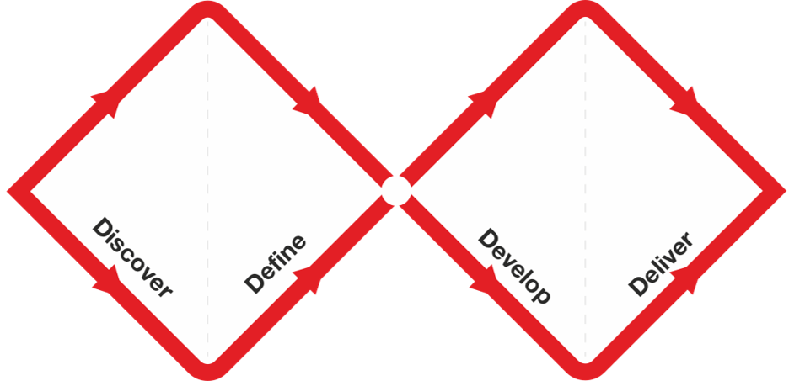
Figure 3. The Design Council Double Diamond framework.
Source: Design Council (2019)

Task 2: Applying the Five Stages of Design Thinking
LocalLoop UK is a mobile-first service that assists independent retailers to sell online and distribute local delivery capacity. The former is a single market town in the UK, and the villages. The concept is developed with an assessment of empathy, definition, ideation, prototyping and testing. The test material may prompt a reformulation of the problem, or may even preclude initially attractive feature.

Empathise with Affected Users
Empathy stage needs to learn behaviour within a context as opposed to enquiring of the users what they claim to want only. The first group of the research group is independent retailers and less than ten employees. The researchers team would have to keep track of stock preparation, enquiries, recording and reconciliation of payments of orders and owners on time wastage and non-favoured tools. The second one is rural and suburban and varied consumers. The effects of discovery and abandonment and missed-delivery can be implemented in diary studies. The waiting, route, safety and income issues can be introduced by a ride-along by delivery partners.
Conclusions drawn are that merchants ought to value simplicity, consumers reliability and clarity of routes in their driving but it is all speculation. The other weaknesses that are usually associated with innovation projects are that they interview digital confident volunteers and design to them. The sample must contain businesses that have been rejected e-commerce, users who have access needs and communities having weak signals. It should be agreed, confidentiality and voluntariness.
Each group will be documented on an empathy map as regards what they say, think, do and feel. Discovery, payment, fulfilment and support would be a customer journey. The evidence must be coded in to repeating needs like control, affordability, trust, visibility and assistance. The existing research on Welsh creative industries and SME toolboxes proves the advantages of user-centred, context-suited and adaptable methods, and the official research proves that the management practices and digital confidence have an effect on the adoption (Suhaimi et al., 2024; Demir et al., 2025; ONS, 2025).

Define the Problem and Causal Map
The proposed problem statement is as follows: simple and cheap solution to integrating online selling with a reliable local fulfilment needs to be suggested as an independent retailer in rural and suburban locality within the UK, disjointed tools, time constraints and lack of density (between offerings) of delivering works available make the existing tools in the UK hard to manage and not profitable. It logs the users, need, cause and consequence without the prescription of an app.
The system is revealed in a causal map. Lack of skills and poor returns and set up discourage digital adoption. Ineffective adoption causes decreased visibility of the products of the locale and keeps the amount of orders online limited. Each delivery is costly due to small volume. High delivery cost, would send home customers and merchants, this would again decrease volume. Late deliveries cause additional travelling miles, customer grievances and mistrust. Loss of trust translates to low buy back and further depleting the business case. Assisted onboarding solutions, shared catalogues, shared routes, tools and repeat-order tools, and leverage points.
The definition phase has to delimit boundaries as well. LocalLoop is not intending on countrywide next day delivery, holding warehoused inventory of products and taking over regulated payment companies on the first launch. It will focus on the local discovery, organise orders and scheduled fulfilment. This helps in safeguarding the pilot against feature growth.
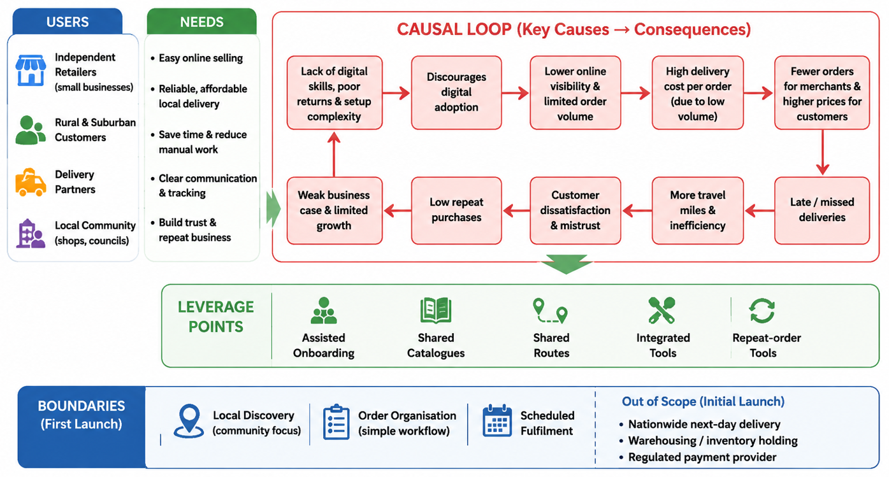
Figure 4. LocalLoop UK - Problem & Causal Map
Source: Self-Created

Ideate through Brainstorming and Selection
The ideation process must begin with a question How might we: How might we serve a small local retailer who needs to receive an online order and fulfil it in less than five minutes without having to learn a couple of systems? Two or three merchants, consumers, drivers, specialists, a council representative, a designer and a developer should be involved in a workshop. There is no-one who can boss around with the quiet generation. Affinity mapping and reverse thinking can then be used on ideas to combine, challenge the ideas.
The potential ideas include one-page storefront, orders to WhatsApp, weekly communal village delivery, smart boxes, pick-up at the shop, tele-assistance checkout, reusable boxes, smart item description, predictive demand, driver route sharing and loyal to a slot programme. Each of these options should be rated based on their user value, effort, revenue, accessibility, environmental impact and measurability.
The selected concept is a combination of six elements. They are onboarding guided, shared local marketplace, simple checkout, stocking of merchandise, pre-arrange jointly delivered and tracked products. The use of smart lockers is kept as a second alternative since the installation price might be prohibitively expensive to invest in the initial testing. Autonomous cars and drones are not welcomed due to their introduction of legal/technical risk to the issue without resolving the immediate adoption problem. Diversity is generated by structured brainstorming, whereas false confidence can be generated by workshop energy. To pick, evidence of empathy work and operational data should thus be utilized (You, 2022; Design Council, 2019; Habiger et al., 2022).

Prototype the Minimum Viable Product
The minimum viable product should test the full service journey with the smallest reliable system. Merchant functions would consist of, onboarding, catalogue, stock status, order alerts and fulfilment choice. Local discovery, guest checkout, payments, fulfilment choice and tracking would be some consumer functions. Mechanisms to provide routes and scanning and proof of delivery would be offered with the support of an administrator dashboard.
The prototype in the beginning must be low-fidelity. Paper screens and clickable wireframes can be used to test the language, sequence and accessibility before coding. Five of the merchants and ten consumers should complete items and mistakes should be observed by researchers. A sandbox payment service and a simple routing engine would form the second prototype which would be a progressive web application. The interface can even be left to be filled manually at the point where automation might not be needed yet.
MVP should not include sophisticated advertising, complicated accounting, countrywide shipping and dynamic pricing. The essence of the issue is the answer to the question as to whether a single workflow can improve the number of successful local orders with a reasonable cost. There should be an accessibility building not as an accessibility addition. It should be able to navigate through the interface using the keyboard, high contrast, plain English, easy to read error messages and low bandwidth pages. Items or deliveries on short notice carry a stop by merchandise. The entire fee and anticipated window must be presented to a consumer prior to payment.

Test, Measure and Refine
Testing should run as a twelve-week pilot with twenty retailers, three delivery partners and at least one hundred and fifty consumers. It should consist of a market town and the villages. The initial weeks onboarding and collection should be experimented before the addition of demand-supported delivery slots.
The test involves behavioural and commercial measurements. The merchant activation and task time must indicate if the firms are releasing products, accept orders and work effectively. The actions that consumers need to be aware of are; do checkout, do buy again, a delivery option, first time delivery success and customer satisfaction. They are supposed to include operational indicators, which include parcels per route, driver waiting time, cost per drop, kilometres per parcel and support contacts. Pilot target contains at least seventy per cent active merchants, ninety-five per cent accuracy in orders, ninety per cent first attempt delivery and repeat-purchase rate over thirty per cent after twelve weeks.
Relevance of qualitative testing applies. The numbers can be explained by interviews post journeys. In case consumers forfeit checkout due to unclear delivery date, alter wordings then alter price. In the circumstances where there is no collection of goods by merchants, the good will either need barcode importation or simple replacement with goods that are currently available. In the case of low density of routes, the team should minimize the area covered by the services or concentrate on the days to deliver.
Build, measure and learn cycles will be followed on a weekly basis, after which refinement will be done. Similar task script will be utilized in comparison of major changes. The pilot needs to revert to a good decision which he/she needs to proceed, pivot or stop. Adding because of the fact that the team likes the idea would be counter to design thinking.

Viability, Scalability and Sustainability of LocalLoop UK
The business model will incorporate a merchant subscription, a small order commission, and delivery coordination margin. The plans are as cheap as £19 or £39 a month. Three per cent commission is equal to the income and delivery charges are transparent. This would give 3480 per month average on an average subscription of £120 merchants occupying an average cluster of 120 merchants, and an average cost of say £29. There would be four thousand orders a month of the average order of £25 required on a commission of £3, 000. To add a coordinate margin of 1 pound to each order with which we fulfilled a difference will add a pound forty thousand. The total amount of revenue would be £10,480 monthly. Assuming there was a fixed cluster cost of the same, fixed cost £7,500; and variable support costs of £1,600, the estimated operating contribution will be 1,380.
The growth does not have to be immediate on a national level and must be geographic. There should be enough pooled route repeat business in the clusters. Local operations are flexible with platform being reused. Partnership recruitments that are done on cooperation basis with councils, business improvement districts, chambers of commerce and rural community groups can reduce the cost of recruiting people. Later the accounting systems, courier networks and lockers can be connected via open interfaces.
Sustainability of the economy is brought about by recurring merchant values and disciplined unit economics. Social sustainability is provided by order accessibility and more effective local businesses and decent work. Sustainability of the environment relies upon real behaviour. The platform must provision the default as grouped slots, display lower fee as a result of flexible deliver and report emission route. It cannot boast of all online orders being being green a lengthy journey through the countryside to take a single order can end up being worse than picking up.

Risks, Ethics and Implementation Controls
LocalLoop is exposed to strategic, operational and ethical risks. Digital exclusion could the users who have poor connectivity, or lack of confidence or accessibility requirements. Low-data pages, guest checkout, telephone assistance and collection-point support should be provided. The second one is the risk of privacy. The system will contain contact information related to the customer, address and the order history and performance records of the merchants. Another risk is cybersecurity since links to payments, accounts of merchants and delivery addresses are a source of fraud. Some of the controls are multi-factor authentication, tokenisation, restricted access, testing and incident reporting. Algorithms tools also have to be controlled.
Makeer of operations (merchants) is important in timely preparation and foreseeable/reasonable delivery operations. Service standards, feedback by drivers and open payments regulations are needed. It should not be greenwashed on the platform. It must release actionable kilometres per parcel and first attempt delivery rates as opposed to general assertions. The Technology Adoption Review warns that the skills, investment and lopsided diffusion are the limiting factors in the realization of productivity gains in the UK. The budget that LocalLoop makes should therefore include onboarding and behaviour changing and not to predict software transforming firms.

Conclusion
Digital commerce creates opportunities beyond major cities, but strong ventures must solve practical problems rather than copy urban platforms. Integrated commerce, pooled delivery, customer relationship support, inclusive payments emerged as key valuable areas in the analysis. Their overall value is more potent as retailers are under a single workflow. LocalLoop UK strikes back with local discovery channel, convenient ordering and delivery on demand. The five step proliferates why it is optimal to begin with observation and causal map as opposed to coding in the venture. The first item has to be restricted, quantifiable and subject to dismissal. It is preferable since it spares retailers time and makes local access (access that the consumer can rely on). The concept of feasibility is based on the presence of technologies and controlled functions. The viability relies on thick clusters and repeat orders. Sustainability relies on fusion, equitable involvement and sincere quantification. The idea is not an established one.

References
Bogers, M.L.A.M., Garud, R., Thomas, L.D.W., Tuertscher, P. and Yoo, Y. (2022) ‘Digital innovation: transforming research and practice’, Innovation: Organization & Management, 24(1), pp. 4–12. doi: 10.1080/14479338.2021.2005465.
Demir, F., Saur-Amaral, I. and Ferreira Polónia, D. (2025) ‘Enabling innovation capabilities: a design thinking toolbox for SME strategic transformation’, Administrative Sciences, 15(10), 384. doi: 10.3390/admsci15100384.
Department for Business and Trade (2025a) SME Digital Adoption Taskforce: Final Report. London: Department for Business and Trade. Available at: https://www.gov.uk/government/publications/sme-digital-adoption-taskforce-final-report/sme-digital-adoption-taskforce-final-report (Accessed: 15 July 2026).
Department for Business and Trade (2025b) Understanding Technology Adoption among UK SMEs. London: Department for Business and Trade. Available at: https://assets.publishing.service.gov.uk/media/688a438aff8c05468cb7b0f0/sme_tech_adoption_dbt_report.pdf (Accessed: 15 July 2026).
Design Council (2019) Framework for Innovation: Design Council’s Evolved Double Diamond. London: Design Council. Available at: https://www.designcouncil.org.uk/our-resources/framework-for-innovation/ (Accessed: 15 July 2026).
Habicher, D., Erschbamer, G., Pechlaner, H., Ghirardello, L. and Walder, M. (2022) ‘Transformation and design thinking: perspectives on sustainable change, company resilience and democratic leadership in SMEs’, Leadership, Education, Personality: An Interdisciplinary Journal, 3, pp. 145–156. doi: 10.1365/s42681-022-00028-x.
Magistretti, S., Pham, C.T.A. and Dell’Era, C. (2021) ‘Enlightening the dynamic capabilities of design thinking in fostering digital transformation’, Industrial Marketing Management, 97, pp. 59–70. doi: 10.1016/j.indmarman.2021.06.014.
Micheli, P., Wilner, S.J.S., Bhatti, S.H., Mura, M. and Beverland, M.B. (2019) ‘Doing design thinking: conceptual review, synthesis, and research agenda’, Journal of Product Innovation Management, 36(2), pp. 124–148. doi: 10.1111/jpim.12466.
Nakata, C. and Hwang, J. (2020) ‘Design thinking for innovation: composition, consequence, and contingency’, Journal of Business Research, 118, pp. 117–128. doi: 10.1016/j.jbusres.2020.06.038.
Ofcom (2025) Connected Nations 2025: UK Report. London: Ofcom. Available at: https://www.ofcom.org.uk/siteassets/resources/documents/research-and-data/multi-sector/infrastructure-research/connected-nations-2025/connected-nations-2025-uk-report.pdf (Accessed: 15 July 2026).
Ofcom (2026) Connected Nations Update: Spring 2026. London: Ofcom. Available at: https://www.ofcom.org.uk/phones-and-broadband/coverage-and-speeds/connected-nations-update-spring-2026 (Accessed: 15 July 2026).
Office for National Statistics (ONS) (2025) Management Practices and the Adoption of Technology and Artificial Intelligence in UK Firms: 2023. Newport: ONS. Available at: https://www.ons.gov.uk/economy/economicoutputandproductivity/productivitymeasures/articles/managementpracticesandtheadoptionoftechnologyandartificialintelligenceinukfirms2023/2025-03-24 (Accessed: 15 July 2026).
Office for National Statistics (ONS) (2026) Internet Sales as a Percentage of Total Retail Sales (Ratio) (%), Series J4MC. Newport: ONS. Available at: https://www.ons.gov.uk/businessindustryandtrade/retailindustry/timeseries/j4mc/drsi (Accessed: 15 July 2026).
Oliveira, M., Zancul, E. and Salerno, M.S. (2024) ‘Capability building for digital transformation through design thinking’, Technological Forecasting and Social Change, 198, 122947. doi: 10.1016/j.techfore.2023.122947.
Rösch, N., Tiberius, V. and Kraus, S. (2023) ‘Design thinking for innovation: context factors, process, and outcomes’, European Journal of Innovation Management, 26(7), pp. 160–176. doi: 10.1108/EJIM-03-2022-0164.
Suhaimi, S.N., Walters, A. and Ward, J. (2024) ‘Design thinking mindset: a user-centred approach toward innovation in the Welsh creative industries’, International Journal of Design Creativity and Innovation, 12(4), pp. 238–257. doi: 10.1080/21650349.2024.2383410.
UK Government (2025) Technology Adoption Review. London: Department for Science, Innovation and Technology. Available at: https://assets.publishing.service.gov.uk/media/67bc6c0456452cd29258cf6f/technology-adoption-review.pdf (Accessed: 15 July 2026).
UNCTAD (2024) Digital Economy Report 2024: Shaping an Environmentally Sustainable and Inclusive Digital Future. Geneva: United Nations Conference on Trade and Development. Available at: https://unctad.org/system/files/official-document/der2024_en.pdf (Accessed: 15 July 2026).
World Economic Forum (2024) Transforming Urban Logistics: A Path to Sustainable and Efficient Last-Mile Delivery in Cities. Geneva: World Economic Forum. Available at: https://www.weforum.org/publications/transforming-urban-logistics-a-path-to-sustainable-and-efficient-last-mile-delivery-in-cities/ (Accessed: 15 July 2026).
You, X. (2022) ‘Applying design thinking for business model innovation’, Journal of Innovation and Entrepreneurship, 11, 59. doi: 10.1186/s13731-022-00251-2.

