Graduate Diploma in Professional Learning- SLD/PMLD

Module Title: Diversity of Learning

Module no: M6X02187

Title: Assessment Component 1.

1811104

Eirian Griffiths

Assessment Component 1

This is a case study of a pupil with a diagnosis of autism spectrum disorder (ASD). Jordan (1999, p.7) points out that autism “has only been defined as a condition since the early 1940’s”. ASD is characterised by impaired social reciprocity, atypical communication skills and repetitive behaviours (Hyman and Levy 2013). Casanova (2019, p.27) states “autism is defined as a neurodevelopmental condition, a term that indicates an impairment in the normal development and/or growth of the brain”. Also, as someone with autism, it is useful to examine Lawson’s view of ASD which is that it is “about brain configuration leading to a specific cognitive style. Of course, personality and an amalgam of other things (e.g. culture, upbringing, IQ, education) add to this picture” (Lawson 2011, p.29). For this case study the pupil with ASD, for the purpose of anonymity, will be referred to as ‘Max’. Max is 10 years old with a main diagnosis of ASD. This study will seek to identify the learning styles of Max and reflect upon how his disabilities present themselves, alongside the impact this has on his learning and development.

The Visual-Auditory-Kinaesthetic (VAK) model was developed as a way to understand learning styles. Gholami and Bagheri (2013, p. 700) note “the original VAK concepts were first developed by psychologists and child teaching specialists such as Fernald, Keller, Orton, Gillingham, Stillman and Montessori, starting in the 1920's”. Pearson (1996-2019, p.1) writes about the idea that everyone has a set learning style is a complete myth and it is a “great example of a scientific theory that has become warped through retelling in non-academic settings, the original message becoming lost in fiction”. Geake (2010, pp.12-13) uses neuroscience to explain the flaws of the statement that everyone has a dominant learning style, stating that “input modalities in the brain are interlinked: visual with auditory; visual with motor; motor with auditory; visual with taste; and so on”. It can be determined that though we may prefer to learn in certain ways, these are not clear cut and there are interconnected pathways within the brain. Reiner and Willingham (2010, pg. 34) advocate that “learning is equivalent whether students learn in the preferred mode or not”.

An important factor in understanding how learning proceeds was developed by Howard Gardner’s work on multiple intelligences. Gardner provided a set of nine different intelligences, which include linguistic; logical-mathematical; musical; spatial/visual; kinaesthetic; interpersonal; intrapersonal; naturalistic and existential that as individuals we display more or less of, according to each individuals’ intellectual make-up (Pritchard 2014). Allen, Scheve and Nieter (2011) draw attention to the fact that the educational theory and psychology communities have scrutinised Gardner’s intelligence theory by arguing it is based on intuition rather than data. However, Gardner (2011, p.64) recognises and points out that “there is not, and there can never be, a single irrefutable and universally accepted list of human intelligences” but “there is a need for a better classification of human intellectual competences”. Reid (2005, p.59) supports that “the key point about Gardner’s approach is that it recognises the diversity of children”; there is less of a predominant focus on language skills and ensures all intelligences are considered equally.
The next part of this case study will examine how the intelligences can be applied when working with children with ASD as little reference is made to individual learning styles amongst work on the education of individuals with ASD. Hirstwood and Smith (2014) support that learning styles can be used when working with children with ASD as they will make use of a range of distinct learning styles to develop understanding and make sense of their world. Rao and Gagie (2006, p.1) agree that “understanding preferred learning styles (taking in information, processing information, and expressing understanding) will ensure success in helping individuals with autism”. Williams, as someone with autism, was keen to examine each individual’s preferred learning style due to the fact it is usually heavily suggested that all autistic people are visual learners. Williams (cited in Chown 2017) expresses a view different to Temple Grandin’s (2016, p.3) ‘I think in pictures’ approach, explaining that although this may be true for some, it isn’t true for all and points out “there is no simplistic division between auditory-verbal non-autistic thinkers (thinking in words) and visual-picture autistic spectrum thinkers (thinking in pictures)” (Chown 2017, p. 126). Trembath (2015) supports the point that all children with autism aren’t necessarily visual learners and their study highlighted the need to understand individual differences in autism.
Looking at the multiple intelligences in relation to Max, an important area to focus on is kinaesthetic as his favourite activities are movement based. Max enjoys going on the trampoline, swimming and using exercise balls. When on the yard, he will use scooters, bikes and is always seeking equipment to climb. Outside play is scheduled as an activity itself as this is a high motivator for Max and he benefits from being given regular movement breaks. Hutton (2013, p.1) supports that kinaesthetic learners “have difficulty sitting still for extended periods of time”. Hirstwood and Smith (2014, p.1) also touch upon how kinaesthetic learners can be affected emotionally as they point that “long periods of sitting will cause restlessness and anxiety”. Healy (2018) found that when providing physical activities for youths with autism benefits were shown in a variety of areas, including “improving motor skills, skill-related fitness, social functioning and muscular strength and endurance” (Healy 2018, p.1). Therefore providing Max with regular opportunities to move throughout the day seems beneficial for his learning. Using specialist rooms in school, such as the ball pool, can also support Max in other areas of learning as well as physical development. For example, if learning something with a mathematical focus about shapes and colours, Max could take part in physical activities to stand on a circle/square or place coloured balls into corresponding pots. Also exploring construction materials can support Max’s mathematical development, such as making sets of objects as seen in his IEP (Appendix 1). Cumine, Dunlop and Stevenson (2010) note that to make sense of social rules and conventions for children with autism, subskills such as turn-taking can be developed through physical ‘to and fro’ games with balls, balloons and bubbles. In addition, Max takes part in The Daily Mile Initiative which supports children to be fitter, healthier, and more able to concentrate in the classroom (The Daily Mile 2019).
Another important area to focus on when examining the multiple intelligences in relation to Max’s learning is spatial/visual. Janzen (as cited in Rao and Gagie 2006, p.26) emphasises visual support is essential so that children with autism can process the whole message. The National Autistic Society (NAS) (2018, p.1) note that “visual supports can help to provide structure and routine, encourage independence, build confidence, improve understanding, avoid frustration and anxiety, and provide opportunities to interact with others”. Cohen and Gerhardt (2016) point out that everyone uses visual support in some aspect of their lives; therefore, it makes sense to incorporate a wide range of visual support for people with autism who cannot verbally communicate with ease. Types of visual aids to support children with autism are using symbols, pictures, photos, and or/words as a system of communication or scheduling system, conceptual maps or graphic organisers, motivational systems and social stories (Cohen and Gerhardt 2016, p.xii). Max benefits from using an individual vertical photograph schedule to support him know what activities are taking place and when. As explained by TEACCH (2019), a schedule gives direction and supports children organise and predict daily events. This lessens any anxiety about not knowing what will happen next. A schedule also supports students to transition independently between activities. In addition, it can encourage motivation as children will be able to see when an enjoyable activity is taking place. The importance of using a visual schedule for Max is included within the information on his one page profile (Helen Sanderson Associates 2019) in Appendix 2.
Before examining the development of Max, it is important to consider how and why development is assessed and measured. Through assessing development the progress of an individual is checked. From assessments, any difficulties would be highlighted and this is turn would inform a diagnosis. As a result, interventions would be planned and the provision for the individual is determined. Jean Piaget “arguably the most influential of the cognitive theorists” (Bates 2019, p.50) proposed a cognitive stage of development framework. Piaget’s belief is that the construction of knowledge is based on an individual’s experiences, which are influenced by emotional, biological and mental stage of development (Bates 2019). Though criticisms of Piaget’s work include that the stages offered only a snapshot of development, too much emphasis being placed on logical and mathematical thinking, over-generalised findings and there was insufficient emphasis on social and emotional aspects of thought, it cannot be denied that Piaget’s major achievements where in creating a sense of curiosity about how children learn (Pound 2008, p.38). When looking at assessment it is important to identify that currently the curriculum in Wales is changing as there is a “national mission is to raise standards, reduce the attainment gap, and deliver an education system that is a source of national pride and public confidence” (Welsh Government 2019a, p.1). The Welsh Government (Welsh Government 2019b, p.1) is taking steps to place a focus on “using teacher assessment as a means to inform better learning and teaching” and “teacher assessment data and National Reading and Numeracy Test data at a school, local authority and regional consortia level will no longer be published”.
In this case study it is important to look at Maslow’s hierarchy of needs. Maslow (cited in Pichère 2015, p.5) structured human needs into five levels: physiological, security, recognition, esteem and accomplishment (Appendix 6). Max is not yet toilet trained and therefore requires support to have his basic needs met. In addition, as highlighted in Max’s one page profile (Appendix 2) he has a self-chosen restricted diet and requires adult supervision at lunch times. Toileting needs and hunger needs are at the bottom of Maslow’s hierarchy of needs and Max requires support for these needs to be met. If Max did not have adult support it can be surmised that the impact of his disability on his learning would be even greater.
In having a diagnosis of ASD, Max will have difficulty in one or more of Wing’s triad of impairments in autism; social- impaired, deviant and delayed social development, especially interpersonal development; language and communication- verbal and non-verbal and thought and behaviour, impoverished imagination (Jordan and Powell 1995, p.2). Wing (1996, p.92) writes that these three impairments are a “common thread connecting all autistic disorders”. Children with ASD also experience repetitive behaviours/stimming, special interests, sensory issues and have a preference for routines (ASDinfoWales 2015, p.13). All these factors have an impact on Max and his learning and development and these factors must be addressed in order for Max to access the curriculum in a meaningful way (Mesibov and Howey 2016).
The challenges that children with ASD face in communication, social interaction, repetitive and restricted behaviours, activities, interests and sensory processing all need to be considered when examining how the curriculum is best taught (Mesibov and Howey 2016, p.13). Max displays all of these above traits, as detailed in his IEP (Appendix 1), one page profile (Appendix 2) and statement of special needs (Appendix 5). Mesibov and Howey (2016) note that more traditional teaching styles and curriculum delivery use social and verbal communication as a means of developing shared understanding. However, children with ASD do not understand the shared meaning within a social classroom context. As children with ASD think in different ways, more traditional teaching and learning styles need to be reconsidered as they do not fulfil the best interests of these learners. Mesibov and Howey (2016, p. 14) stress “the importance of promoting access and entitlement to a meaningful curriculum for learners on the spectrum cannot be overstated”. Jordan (2005, p.116) supports this by noting a child with ASD “like any other child, is entitled to a broad and relevant (not necessarily balanced) curriculum to meet his or her needs”.
Max’s low level of social interaction and communication will have an impact on his learning; however, this does not mean that Max lacks any social interaction and communication skills. In regards to social interaction Max likes intensive interactions games, such as being scared or tickled. As included in Max’s one page profile (Appendix 2), he can be playful but with familiar people; so he needs time to get to know the person. Also in regards to communication skills, the information provided shows us that Max communicates through gesture, eye contact and some vocabulary. Though as Max is ten, his communication skills are below a typically developing child who would be able to read fluently and write a story (Hobart and Frankel 2004).

Appendix 3 shows Max’s current stage of development against developmental norms (Hobart and Frankel, 2004). Gaps become evident in Max’s cognitive and language development from eighteen months onwards. Max’s social and emotional and cognitive and language development are in stark contrast to his physical development, with gross motor skills reaching 8-12 years old as Max can swim. This developmental norm is line with Max’s chronological age and is therefore much closer than Max’s cognitive and language development levels, thus in line with his primary need on his statement of special needs and his diagnosis of ASD (Appendix 5). Therefore Max requires input into developing ways of communicating in order for him to make progress with his communication skills. Cohen (2006, p.132) note that picture or picture-word systems of communication are used to support children with autism as many children with autism have good visual skills but have difficulty in processing and producing speech. Max’s verbal communication is encouraged with the use of symbols on a sentence strip during activities that are highly motivating for Max. Using Max’s interests to encourage his verbal communication has made a significant positive difference and Max uses more words spontaneously. This is in-keeping with the teaching standards in Wales. Implicit within the standards is that teachers build relationships with children that enable them to gain insight into their interests and preferred ways of learning, which in turn shows a developed awareness of activities that inspire, motivate and challenge children (Welsh Government 2019c).

The final triad of impairment, imagination and flexibility of thought “is an inability to imagine things, which have not already been experienced” (Hale 1998-2019, p.1). Mesibov and Howey (2016, p.18) state that children with ASD are often rigid in their thinking and lack the flexibility needed to access all areas of the curriculum. Adding that repetitive behaviours and preferred interests can also restrict how a child with ASD progresses in school. It is apparent that this triad of impairment affects Max as his Annual Person Centred Review report (Appendix 4) states he likes familiar routines, a highly structured environment and following a visual schedule. The triad of impairments, if not correctly addressed, could cause anxiety for Max and any child with ASD. Adults who have an understanding and appreciation of how ASD can affect an individual and consider the unique characteristics of each individual are those best suited to meet the needs of learners with ASD. It could be hypothesised that if Max worked with an adult who lacked understanding appreciation and empathy, this too could impact on his learning and development. As part of an intersessional task looking at how children learn, the importance of an adult’s role on a learners’ development was highlighted. Charlesworth (2017, p.35) agrees that adult support “is always critical to children’s learning”.

From the evidence gathered it can be concluded that Max has a number of possible learning styles that need to be considered to ensure progress in his learning and development. Charman et al. (2011, pp.23-25) support the use of imaginative and individualised methods of adapting the curriculum for children with ASD which ensure activities are fun, motivating and relevant. In summary, a focus needs to be placed on the fact that all children with autism are individuals. As encapsulated by Jordan (1999, p.113) who states “each person’s development will be individualistic, depending on the interaction between their abilities and disabilities, the environments they are in and the education and training they receive”.

References
ASDinfoWales (2015) Autism: A Guide for Mainstream Primary Schools. [Online] Available at: https://www.asdinfowales.co.uk/resource/2015_Autism-A-Guide-for-Mainstream-Primary-Schools-ENG.pdf (Accessed: 14th August 2019).

Allen K., Scheve, J. and Nieter, V. (2011) Understanding Learning Styles Making a Difference for Diverse Learners. USA: Shell Education.

Bates, B. (2019) Learning Theories Simplified and how to apply them to teaching. 2nd
edn. London: SAGE Publications Ltd.

Casanova, E.L. and Casanova, M.F. (2019) Defining Autism A Guide to Brain, Biology, and Behavior. London and Philadelphia: Jessica Kingsley Publishers.

Charlesworth, R. (2017) Understanding Child Development. 10th edn. USA: Cengage Learning.

Charman, T., Pellicano, L., Peacy, L. V., Peacy, N., Forward, K. and Dockrell, J. (2011) What is Good Practice in Autism Education? [Online] Available at: https://research-management.mq.edu.au/ws/portalfiles/portal/83300571/82950951.pdf (Accessed: 19th August 2019).
Cohen, M.J, and Gerhardt, P.F. (2016) Visual Supports for People With Autism A Guide for Parents & Professionals. 2nd edn. USA: Woodbine House.

Cohen, S. (2006) Targeting Autism What We Know, Don't Know, and Can Do to Help Young Children with Autism Spectrum Disorders. 3rd edn. London: University of California Press, Ltd.

Cumine, V., Dunlop, J. and Stevenson, G. (2010) Autism in the Early Years A practical guide. 2nd edn. Oxon: Routledge.

Chown, N. (2017) UNDERSTANDING AND EVALUATING AUTISM THEORY. London and Philadelphia: Jessica Kingsley Publishers.

Gardner, H. (2011) Frames of Mind The Theory of Multiple Intelligences. USA: Basic Books.

Geake, J. (2010) ‘Neuromythologies in education’, in Howard-Jones, P. (ed.) Education and Neuroscience Evidence, Theory and Practical Application. London and New York: Routledge.

Gholami, S. and Bagheri, M.S (2013) Relationship between VAK Learning Styles and Problem Solving Styles regarding Gender and Students' Fields of Study. [Online] Available at: http://www.academypublication.com/issues/past/jltr/vol04/04/08.pdf (Accessed: 12th August 2019).

Grandin, T. (2006) Thinking in Pictures And Other reports from My Life with Autism. London: Bloomsbury Publishing Plc.

Hale, A. (2008-2019) What is Autism Spectrum Disorder? [Online] Available at:
http://www.hale.ndo.co.uk/autism/definition.htm (Accessed: 19th August 2019)

Healy, S. (2013) Does physical activity have special benefits for people with autism? [Online] Available at: https://www.autismspeaks.org/expert-opinion/does-physical-activity-have-special-benefits-people-autism (Accessed: 12th August 2019)

Helen Sanderson Associates (2019) ONE-PAGE PROFILES. [Online] Available at: http://helensandersonassociates.co.uk/person-centred-practice/one-page-profiles/ (Accessed: 14th August 2019)

Hirstwood, R. and Smith, C. (2014) Learning Styles and Autism. [Online] Available at: https://www.hirstwood.com/course-notes/autism-pages/learning-styles-and-autism/ (Accessed: 19th August 2019)

Hutton, S. (2013) Helping Kinesthetic Learners Succeed. [Online] Available at: https://www.education.com/magazine/article/kinesthetic_learner/ (Accessed: 12th August 2019)

Hobart, C. and Frankel, J. (2004) A Practical Guide to Child Observation and Assessment. 3rd edn. UK: Nelson Thornes Ltd.
Hyman, S.L. and Levy, S.E. (2013) ‘Autism spectrum disorders’, in Batshaw, M.L., Roizen, N.J. and Lotrecchiano. G.R. (ed.) Children with Disabilities. 7th edn. Baltimore: Paul H. Brookes.

Jordan, R. (2005) ‘Autistic Spectrum Disorders’, in Lewis, A. and Norwich, B. (ed). Special teaching for special children? a pedagogies for inclusion. England: Open University Press.

Jordan, R. (1999) Autistic Spectrum Disorders An Introductory Handbook for Practitioners. London: David Fulton.

Jordan, R. and Powell, S. (1995) Understanding and Teaching Children with Autism. Chichester: John Wiley and Sons.

Lawson, L. (2011) The Passionate Mind How People with Autism Learn. London and Philadelphia: Jessica Kingsley Publishers.

Mesibov, G. and Howley, M. (2016) Accessing the Curriculum for Learners with Autism Spectrum Disorders Using the TEACCH programme to help inclusion. 2nd edn. Oxon: Routledge.

National Autistic Society (2018) Visual supports. [Online] Available at: https://www.autism.org.uk/about/strategies/visual-supports.aspx (Accessed: 12th August 2019).

Pearson (1996-2019) Learning Myth #1: Everyone has a set learning style. [Online] Available at: https://pearson.com.au/insights-and-news/supporting-students/learning-myth-1-everyone-has-a-set-learning-style/ (Accessed: 12th August 2019).

Pichère, P. (2015) Maslow's Hierarchy of Needs Gain vital insights into how to motivate people. France: Lemaitre Publishing.

Pound, L. (2008) How children learn - From Montessori to Vygotsky - educational theories and approaches made easy. London: Step Forward Publishing Limited.

Pritchard, A. (2014) Ways of Learning Learning Theories and Learning Styles in the classroom. 3rd edn. London and New York: Routledge.
Reid, J. (2005) LEARNING STYLES AND INCLUSION. London: Paul Chapman Publishing.

Rao, S.M. and Gagie, B. (2006) Learning Through Seeing and Doing: Visual Supports for Children With Autism. [Online] Available at: https://search-proquest-com.ezproxy.uwtsd.ac.uk/docview/201166057?accountid=130472&rfr_id=info%3Axri%2Fsid%3Aprimo (Accessed: 14th August 2019)

Reiner, C. and Willingham, D. (2010) The myth of learning styles. [Online] Available at: file:///C:/Users/griffe2.LEARNING/Downloads/The_Myth_of_Learning_Styles%20(1).pdf (Accessed: 12th August 2019).

TEACCH (2019) Services Across the Lifespan for Individuals with Autism Spectrum Disorder TEACCH® Autism Program. [Online] Available at: https://teacch.com/ (Accessed: 14th August 2019).

The Daily Mile (2019) What is The Daily Mile? [Online] Available at: https://thedailymile.co.uk/ (Accessed: 12th August 2019).

Trembath, D. (2015) Children with autism aren’t necessarily visual learners. [Online] Available at: http://theconversation.com/children-with-autism-arent-necessarily-visual-learners-42758 (Accessed: 12th August 2019).

Wing, L. (1996) The Autistic Spectrum A guide for parents and professionals. London: Constable & Robinson Ltd.

Welsh Government (2019a) A guide to Curriculum for Wales 2022. [Online] Available at: https://hwb.gov.wales/draft-curriculum-for-wales-2022/a-guide-to-curriculum-for-wales-2022 (Accessed: 19th August 2019).
Welsh Government (2019b) Assessment proposals to inform the development of statutory guidance. [Online] https://hwb.gov.wales/draft-curriculum-for-wales-2022/assessment-and-evaluation-framework/assessment-proposals/ (Accessed: 19th August 2019).

Welsh Government (2019c) Professional standards for teaching and leadership. [Online] Available at: https://s3-eu-west-1.amazonaws.com/hwb-live storage/fc/a7/a4/e2/e348428381e68434ea93f611/professional-standards-for-teaching-and-leadership-interactive-pdf-for-pc.pdf (Accessed: 19th August 2019)

Appendices
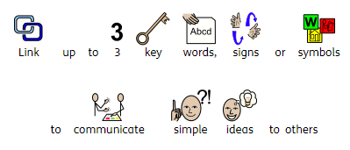
Name: |  |  |  | Teacher: |  |  |  |  | Date issued: May 2019

 |  | 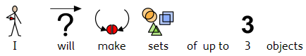  Mathematics |  |  |  | 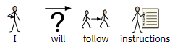  Languages, Literacy and Communication
 |  | 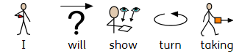
 |  | 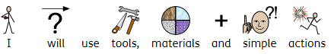

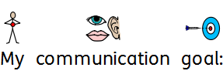
Appendix 1- IEP

*Name changed for anonymity

Learning together in a changing world

Creating Success for All

Keys to Success

Going for Gold!
Anelu am aur!
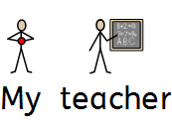
K- ‘Know’…You can do it! –  Ambitious, Capable Learners  (Mathematics, Language, Literacy and Communication: inc Welsh) | Max to show he can follow instructions with 3 key words, signs or symbols given on an individual basis.  (Task to be completed four times a week. 3/4 times correct.) | Listening P6
 | Max to show he can make sets of up to 3 objects.  (Task to be completed three times a week. 2/3 times correct.) | Number  P6
E- ‘Enjoy’ life and be happy!  Healthy, Confident Individuals  (Health and Wellbeing, THRIVE, Multi agency links) | Max to show turn-taking in familiar situations with minimal prompts. (Task to be completed five times a week. 3/5 times correct.) | Attention  P8
Y- ‘Yourself’ …Be ready for life!  Creative, Enterprising, ethical informed citizens  (Digital Competency, Independence, Transition, Work Awareness | Max to use tools, materials and simple actions to produce a piece of work. (Task to be completed twice a week. 2/2 times correct.) | Art and Design  P6

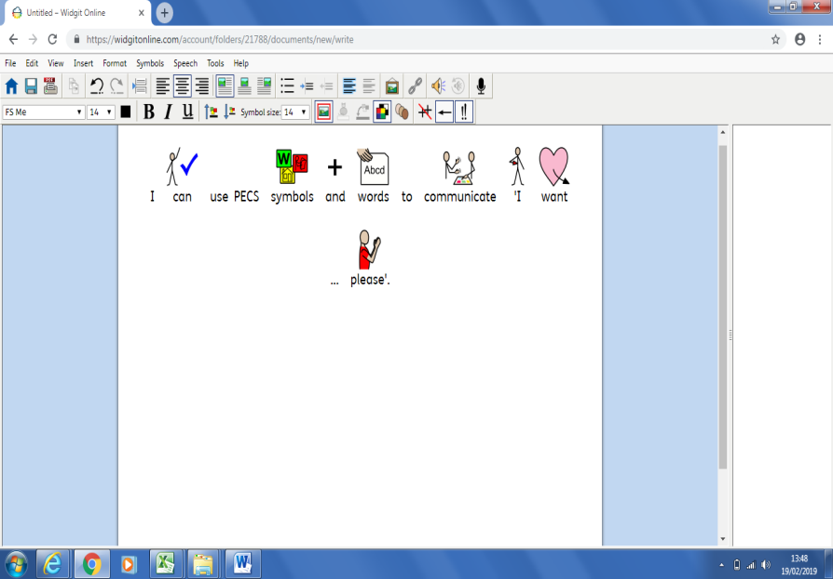

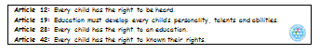

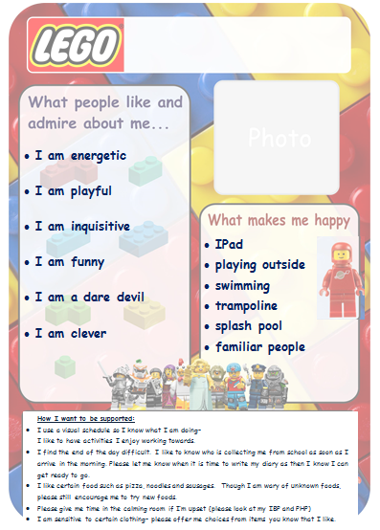
Appendix 2- One Page Pupil Profile

Appendix 3– Developmental norms chart (Hobart and Frankel 2004)

*Max’s levels of development.
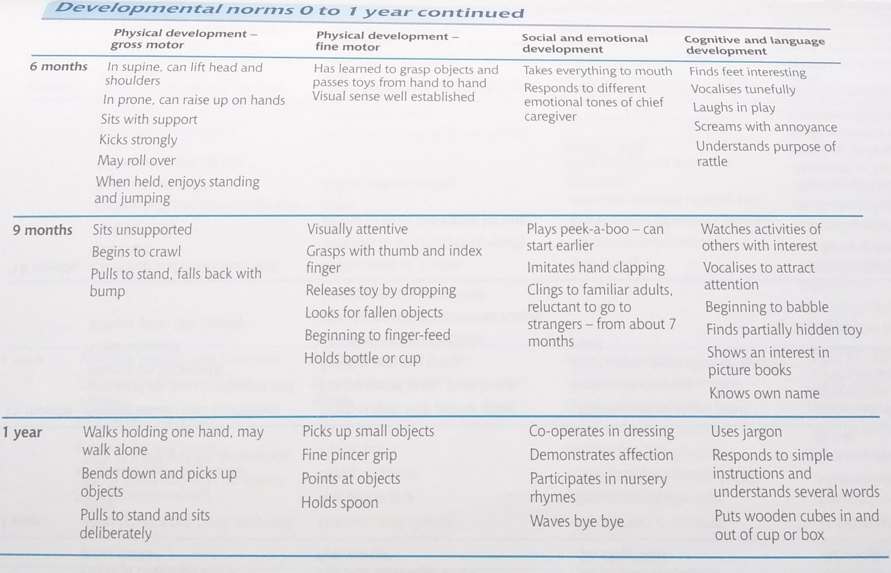
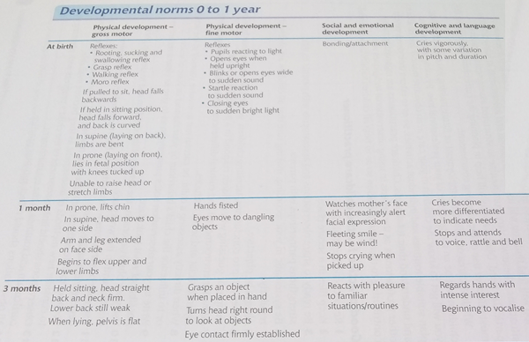
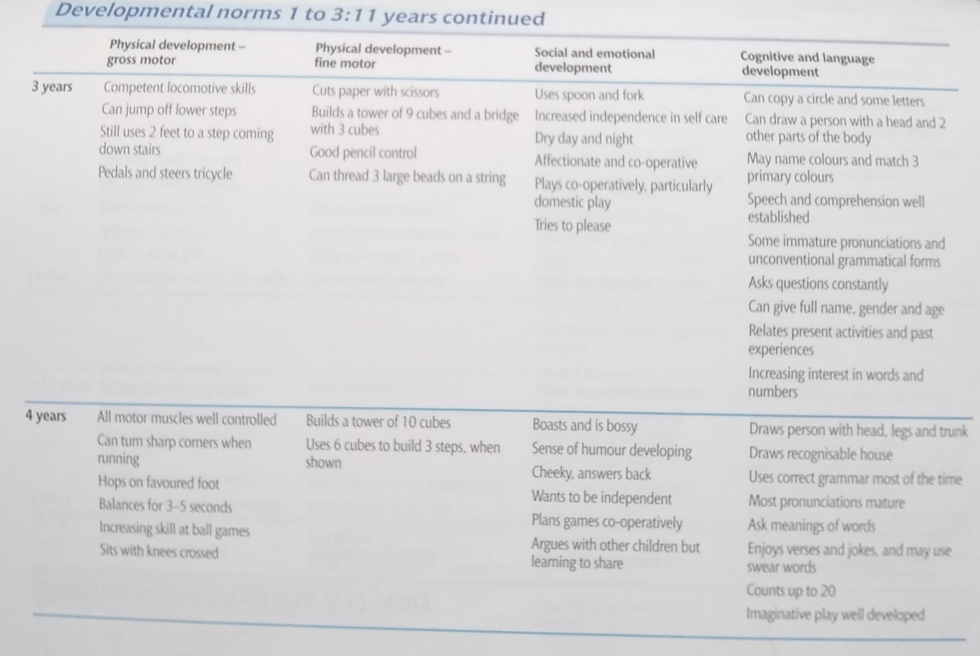
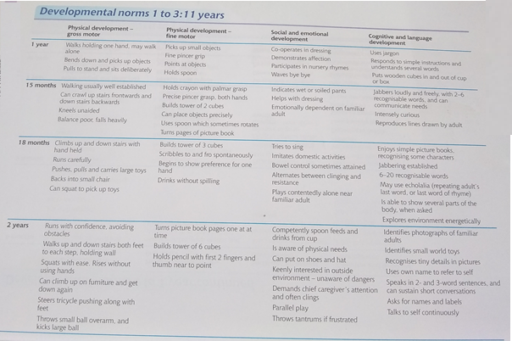
*Max’s level
*Max’s level
*Max’s level
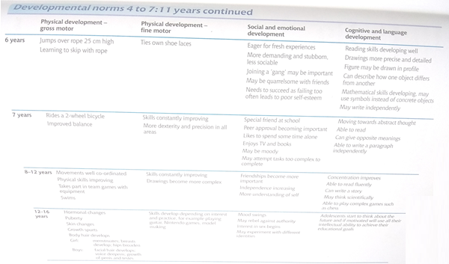
*Max’s level


Appendix 4- School Report for Person Centred Review
*Name changed for anonymity
“Know” …  You can do it!  Ambitious, Capable Learners  (Mathematics, Language, Literacy and Communication: inc. Welsh) | Comments/Assessments  Max follows instructions containing key words, for example, put the bowls on the table ready for snack. Max is able to select objects by function, for example, choosing a toothbrush to brush his teeth. Max combines single words or uses symbols to communicate meaning and engages in simple two-way conversations. Max listens and engages with stories with increasing attention. Max derives some meaning from a book and indicates what it is about. He uses picture cues when sharing a book. He shows interest in the content of a book and demonstrates ‘reading like’ behaviour. Max communicates ideas for scribing with adult support. For example, he will make a choice out of symbols for his News work. Max shows greater control in the use of fine motor skills in a range of activities. He can trace, overwrite or copy shapes and straight line patterns.  Max’s K IEP literacy Target this term focuses on speaking; he will be demonstrating he uses a vocabulary of over 50 words.  PIVATS  - Listening P5b  - Speaking P5c  - Reading P5a  - Writing P5b
Annual Aim: To be able to represent his name using letters or symbols (Writing P6)

“Enjoy” life and be happy!  Health, Confident Individuals  (Health and Wellbeing, THRIVE, Multi agency links) | Comments/Assessments  Max engages in regular physical activity beneficial to his health and well-being. He takes part in PE sessions every week and has access to the specialist facilities on a weekly basis, such as the hydrotherapy pool, splash pool, ball pool and trampoline that enhance his motor development skills.  Max has taken part in activities that cover the breadth of scientific enquiry, life processes and living things, materials and their properties and physical processes. Max can name simple objects, such as ‘egg’. He carries out simple verbal instructions, such as, get your diary. Max remembers events, for example, going to snack cupboard to get raisins.  Max recognises distinct features of objects. Max will repeat actions and modify them, for example, using a skateboard without support, then after losing balance; holding on to the wall to be able to skate.  PIVATS  Scientific enquiry P6b  Life processes and living things P6b  Materials and their properties P6c  Physical processes P6b  Max’s E IEP target this term involves him taking part in Attention Autism sessions designed by Gina Davies, a Specialist Therapist.
Annual Aim: Science- Confirm suggestions about what will happen (P6b)

“Yourself” …  Be ready for life!  Creative, Enterprising, Ethically Informed Citizens.  (Digital Competency, Independence, Transition, Work Awareness | Comments/Assessments  Max uses ICT to select and group objects, letters or images. Max will use ICT devises independently, for example the oculus and IPad. Max can make connections between devices and information on screen. Max can pick out shapes, symbols or characters.  PIVATS:  Finding things out P6c  Developing ideas and making things happen P5c  Exchanging and sharing information P6d  Max interacts with peers for work or play activities with adult support. Max shows initiative to take on a new or untried task. He will select and uses resources independently. Max can transfer his attention to a familiar task/activity. He can take part as a member of a group for a familiar or enjoyable joint activity with 1:1 support. Max understands that tasks/activities have simple routines with boundaries; and he will follow these rules with adult support.  PIVATS  Interacting and working with others P6c  Independent and organisational skills P8b  Attention P7a  Max’s Y IEP target this term focuses on developing his Independent and organisational skills; he be demonstrating he can use resources appropriately within activity.
Annual Aim: Link shapes, symbols and characters to communicate meaning (Developing ideas and making things happen P5c)

1b. Progress
What are the pupil’s strengths? What progress have they made over the last year?

e.g. Relationships with staff / peers. Communication skills – use of alternative communication aids. Perseverance. Arts / Sport / Music etc.
- Max likes familiar routines, a highly structured environment and following a visual schedule
- Using the trampoline
- Confidence in the water
- Using soft play equipment
- Use of IPad in ICT room
- Use of exercise ball outside

What is working?
What strategies are used to support pupil. Link to “What’s important to” and “What’s important for”.
- Max benefits from a small class setting
- Max benefits from a structured approach
- A range of activities for short periods of time
- Access to at least one of specialist rooms on daily basis; ball pool, light room, dark room, hydrotherapy pool, splash pool, ICT room and school library
- Max having time to himself
- Max has a high level of additional adult support which enables flexibility in response to Max’s behaviour and in relation to a bespoke package of activities.

What is not working? How could this be improved?

What isn’t going well? How do you know? What can be changed to make a positive difference? Attention Autism sessions have been introduced.
Provision to meet the pupil’s needs
2a. Please summarise the provision / resources put in place by school to address the pupil’s additional learning needs.
The structured class environment in class offers Max opportunities to work as a whole class, small group, in pairs and individually with an adult. Max also attends sessions including: Hydrotherapy, Rebound, PE, Music.

- Additional comments.

It has been a pleasure to observe the progress that Max has made in class. Max has developed strong relationships with both pupils and staff. Max is happy in school and actively takes part in a wide range of tasks and activities. Max likes going to all the specialist rooms, such as the ball pool, ICT room, light room, dark room, library, Touch Trust, swimming and the splash pool. Max has made progress in all areas of the curriculum and it has been a pleasure watching him develop his skills. Max has made measurable steps of progress in listening, speaking, reading, writing, using and applying, number, shape, space and measure, scientific enquiry, ICT, interacting and working with others, independent and organisational skills and attention in a range of activities.
This term Max has been completing activities linked to our topic of Pirates, Plans and adventures. For example, Max took part in ‘Talk like a pirate day’. In addition, Max has involved himself in Autumn themed activities, such as making hedgehog bread and a hedgehog collage using real leaves. Max has also explored Autumn fruit vegetables, such as apples, pears, pumpkins and potatoes.
Max has taken part in special whole school events, such as the Harvest festival and Children in Need. We have got lots of activities to look forward to as well, such as the zoo lab and Christmas. Max is a valued member of the class and I look forward to continuing to support him develop his self-esteem, confidence, motivation and independence.
Due to Max’s extremely complex needs there have been a series of multi-agency meetings/workshops and discussions. These take place on a regular basis.

Signed
Date
Designation

Appendix 5 – Statement of special needs
*Name changed for anonymity
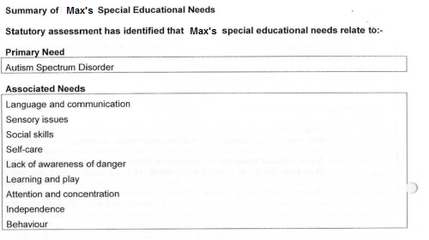
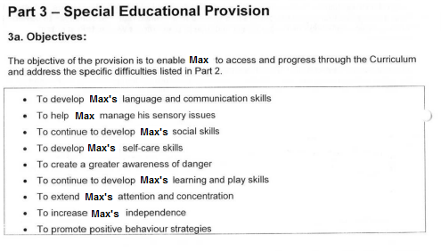

Appendix 6– Maslow’s Hierarchy of needs


