
Case Study- New Construction

Tomos Butterworth 2409888 | [Date] | Fundamentals of Construction Technology

Table of Contents
1.0- Offsite Construction 2
2.0- Forms of Construction 3
2.1- Brick and Block 3
2.2- Twin Timber Frame 4
2.3-Structural Insulated Pannel 5
3.0- Window Openings External Walls 5
3.1- Brick and Block 5
3.2- Timber Frame 6
3.3- SIPs 7
4.0- Roof Construction 7
4.1- Timber 8
4.2- SIPs 8
4.3- Brick and Block 9
5.0- Recommendations 10
6.0- Appendix 10
7.0- References 12

1.0- Offsite Construction
Offsite construction includes the designing, manufacturing, and fabrication of construction materials in a factory setting (Construction Placements, 2019). Many pieces of a house, or even full housing units, can be prefabricated in a factory and moved onto the site with ease, such as trusses for a roof (Construction Placements, 2019).
There are 4 main types of off-site construction (Off-site Construction Research Centre, 2024). One type of off-site construction is volumetric construction, consisting of constructing a 3d structure in a factory and bolting it in on-site, as shown in figure 1 (The Constructor, 2020). The framing usually consists of either concrete, steel or timber (The Constructor).
Another form of off-site construction is panelised construction, which consists of the construction of individual panels, such as walls, that can then be assembled on site (Off-site Construction Research Centre, 2024). This method would be the most viable for this project as it is commonly used in housing construction, as it is flexible and can be built specifically for the project, as shown in Figure 2 (Off-site Construction Research Centre, 2024).
The third type of offsite construction is hybrid modular construction which consists of a blend of the first two forms mentioned during this report, volumetric and panelised (Offsite Construction Research Centre, 2024) This form of offsite construction is regularly used for largescale projects such as hospitals or apartment blocks (Offsite Construction Research Centre, 2024). This method encompasses creating modular components in a factory off-site and then merged effortlessly with the previously mentioned panelised constructed structure (The Offsite Guide, n.d)
The fourth and final method of offsite construction is the component, or sub assembly method (Off-site Construction Research Centre, 2024). This method involves independent building sections, such as stairs, bathrooms, and services, are manufactured in a factory and then brought on-site and incorporated into the main structure (Off-site Construction Research Centre, 2024). This form of off-site construction is very commonly used in residential units, commercial buildings and industrial structures (Off-site Construction Research Centre, 2024). The benefits to using this construction method in this project would include reducing the work needed on site, which helps protect the workers, and by creating the building components in a factory setting allows for a high degree of control over quality of builds (Fleisher, 2024)

2.0- Forms of Construction
2.1- Brick and Block
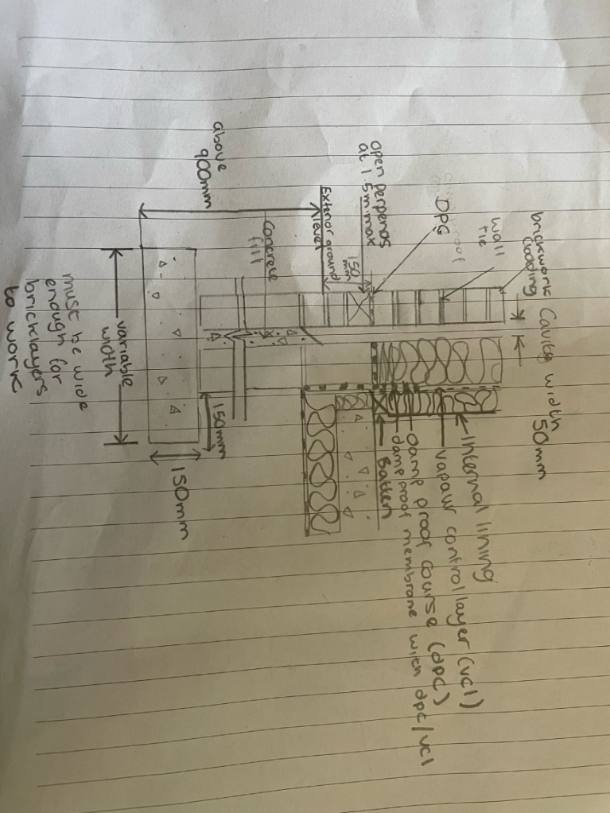
Brick and block cavity walls are one of the most popular methods of wall construction in the UK due to their thermal performance (Hunt, 2022) one of the most popular methods of brick and block cavity wall construction is stack bonded brickwork, which is where the bricks are assembled vertically, one on top of another to create a simple pattern with the stretchers being the face of the wall, as described by Patel (2024). Brick and block external cavity walls usually have a cavity of between 50 and 100mm between the outer and inner skins which must stay consistent from top to bottom, having wall ties to keep the walls stable (Volek and Dickenson (n.d). For the cavity brick and block proposed for this property, there are a few essential components to protecting the occupants as shown in figure 5. One of these components that is needed a brick and block cavity wall is the vapour control layer (VCL). The VCL is a thin plastic layer thats role is to restrict the movement of warm air from inside the property, such as respiration or cooking, into the inner components of the wall (Setherton, n. d). This helps to protect the insulation as if this becomes damp, it can affect its thermal performance (Creevy, 2024). Similarly, the damp proof course is crucial to keeping the moisture balance in the house. The damp proof course is used to prevent rising damp from condensing up the walls from the connection with the floor, typically being fixed 150mm above the ground (Muschialli, 2024). Thicker walls and materials tend to have better U values as they trap the heat in (Pullen, 2020). The typical U value for a brick and block walls insulation is around 0.3W/m2K, the highest of the 3 in this report and the worst insulation (Pullen, 2020).
Figure 5. Brick and Block Cavity Wall Construction (Aimch, 2021)

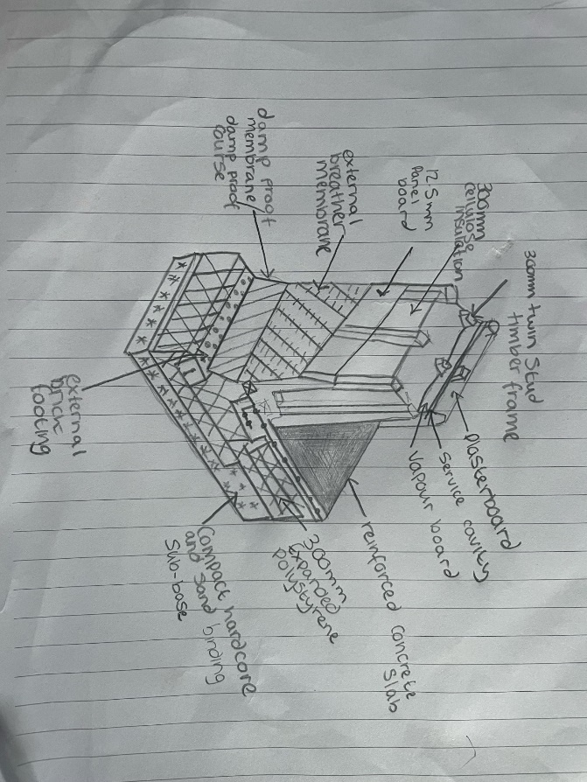
2.2- Twin Timber Frame
timber frame wall construction contains timber studs within the structural wall which allow it to sustain the loads imposed before moving them to the underground foundations (Stevenson and Cruickshank, 2023). There are a few important components in a timber frame that will help the U value of the construction. One of these crucial components is the internal vapour board. The internal vapour board prevents high levels of moisture from saturating the insulation material which helps reduce the risk of water condensing on the wall, causing mould to growth and causing structural failure (Donnelly, 2024). Timber must be kept dry as it is a hydroscopic material, drawing in water (Boehs, 2025). This means that, overtime, the timber can become saturated and develop rot, become softer and having less strength (Boehs, 2025). In figure 6, there is a cavity included between the plasterboard and vapour board. In this cavity in the wall, services can be threaded through (Mannok, n.d). This gives even more of an incentive for civil engineers to properly waterproof the walls, ensuring no electrics become damp. Typical timber frame construction such as the one proposed would have a U value of around 0. 29W/m2K, slightly lower than the brick and block U value (Pullen, 2020).
Figure 6. Twin Timber Frame Wall (Pinterest, n.d(a))

2.3- Structural Insulated Pannel (SIPs)
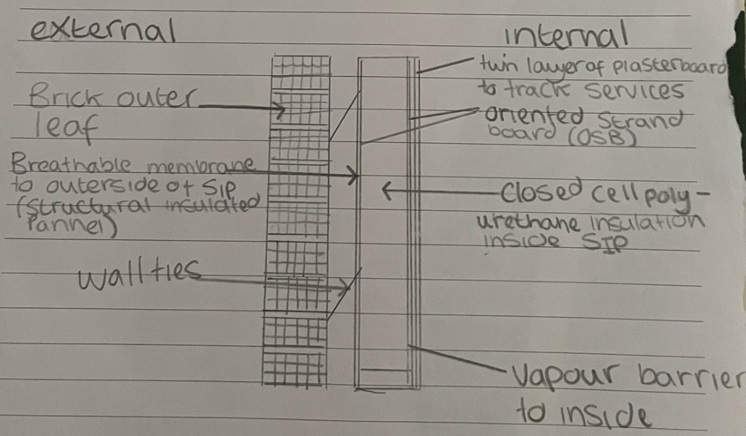
SIPs are a very innovative form of construction which involve an oriented strand board (OSB) connected either side of an insulated centre in between (Professional Builder, 2018). These SIPs are typically made using panelised offsite construction, as previously mentioned and displayed in figure 1. This means that each SIP can be made specifically the demands of this project (Professional Builder, 2018). In figure 7, wall ties are included to connect the two cavity walls, ensuring that they act as one system and don’t tear apart under external loads (Ancon, 2016). Sips walls are very well insulated, however, do cost more than traditional methods like brick and block and timber framing (Snell, 2020). Combining other insulating materials with the SIPs will give it an average U value of 0.27W/m2K, the lowest and best of the 3.
Figure 7. Typical SIP Cross Section (Eco Home Essential, n.d)

3.0- Window Openings External Walls
3.1- Brick and Block
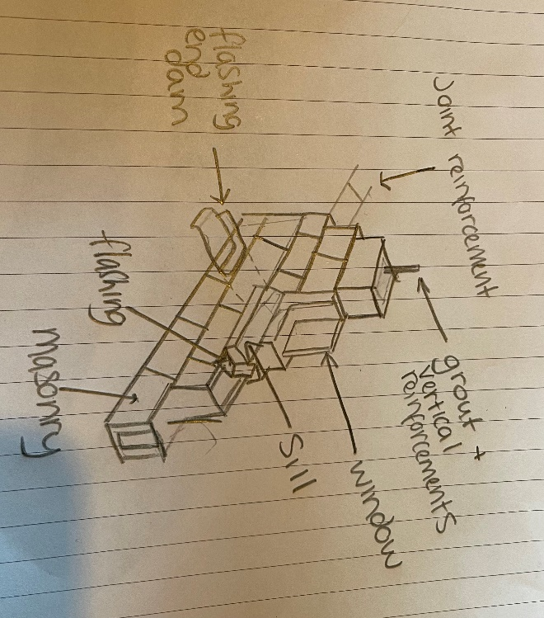
In this diagram, flashing is included in the window. The flashing is crucial as it is a defence between the weather outside and the Interior of the house (Bennett, 2024). With brick and block, offsite construction cannot take place as everything needs to take place on site. In figure 8, the diagram shows the wall using a joint reinforcement to ensure its stability. Reinforcement in masonry is typically steel bars mixed with cold-drawn wire, which is a type of wire stretched at room temperature (Concrete Masonry and Hardscapes Association, 2018). Timber framing uses a different type of joint reinforcement compared to the brick and block type. The masonry wall also incorporates a vertical reinforcement. These reinforcements are used to resist any tensile stresses acted upon the wall (Mason Contractors, n.d). A sill is also included in this diagram, being a crucial component for the window piece. The windowsill acts as a foundation for the window and to ensure no moisture can enter (Storables, 2024).
Figure 8. Sill Detail (Pinterest, n.d (b)

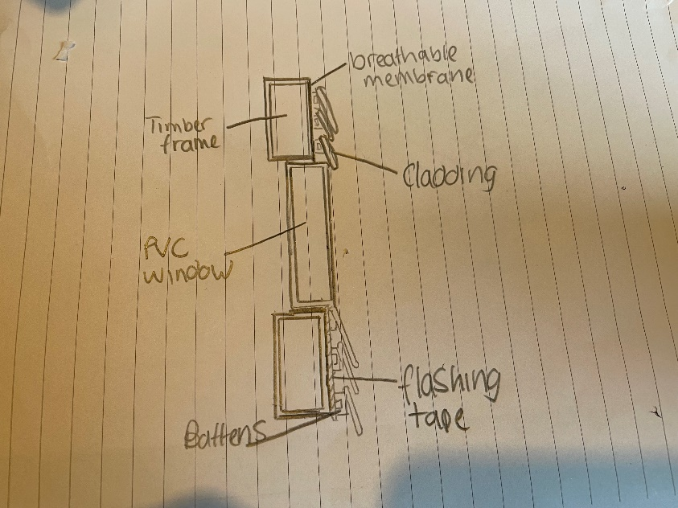
3.2- Timber Frame
In this timber frame window section, there is a breathable membrane. The breathable membrane acts a barrier from moisture, protecting the timber from any issues of rot or mould (Crosson, 2022). The section also includes flashing tape. The flashing tape also acts as a moisture barrier to protect the timber from becoming weaker (OSI Tough, n.d). This flashing tape can also be applied to masonry cavity walls, being able to withstand temperature lows of -6.5 Celsius to highs of 49 Celsius (OSI Tough, n.d). Timber battens are also commonly used in timber framing walls. These battens are crucial for the stability of the wall, becoming a stabilising point for the wall (Bekin, 2024). Timber battens are not only used in wall stabilisation but also commonly used in timber roofing, which will be discussed later in the report. Timber framing tends to be the cheapest method of wall construction, cheaper than SIPs and brick and block methods (Horizon, n.d)
Figure 9. Timber Frame Window Detail (Buildhub, 2020)
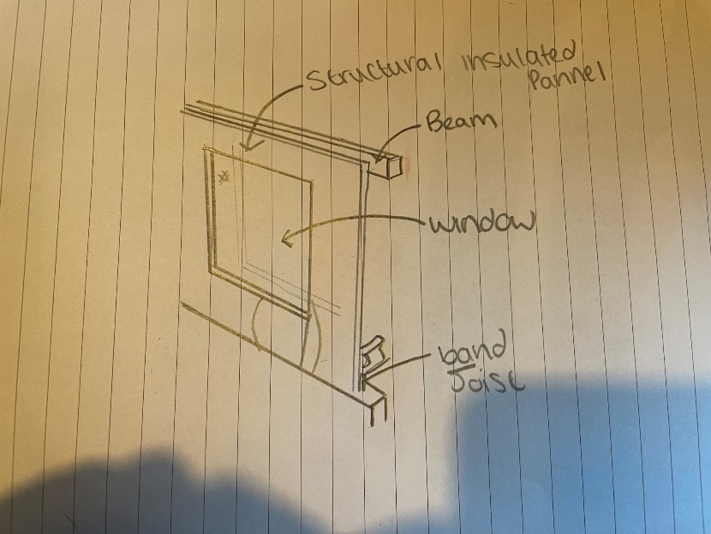
3.3- SIPs
In this diagram of a structurally insulated panel window opening, band joists are used. The band joists offer support to the floor and bear the load of the SIPs panel wall (HPD Construction, 2018). The beam is crucial to the structure, ensuring the SIPs board has somewhere to sit. SIPs walls are very good at ensuring that a room remains insulated whilst being thinner than typical brick and block and timber framing. SIPs walls remain so well insulated due to the insulating foam in the cavity, keeping all that heat in with the airtight panels (Dice Consult, n.d). These panel, however, cannot be modified after integration (Dice Consult, n.d). they are typically produced using offsite construction and cannot be modified or built for fit unlike brick and block and timber framing. Even though they can cost more than the other two methods, this method has a reduced construction time as it can be seamlessly put in place on site (Dice Consult, n.d).
Figure 10. SIPs window opening (Green Building Advisor, 2020)
4.0- Roof Construction
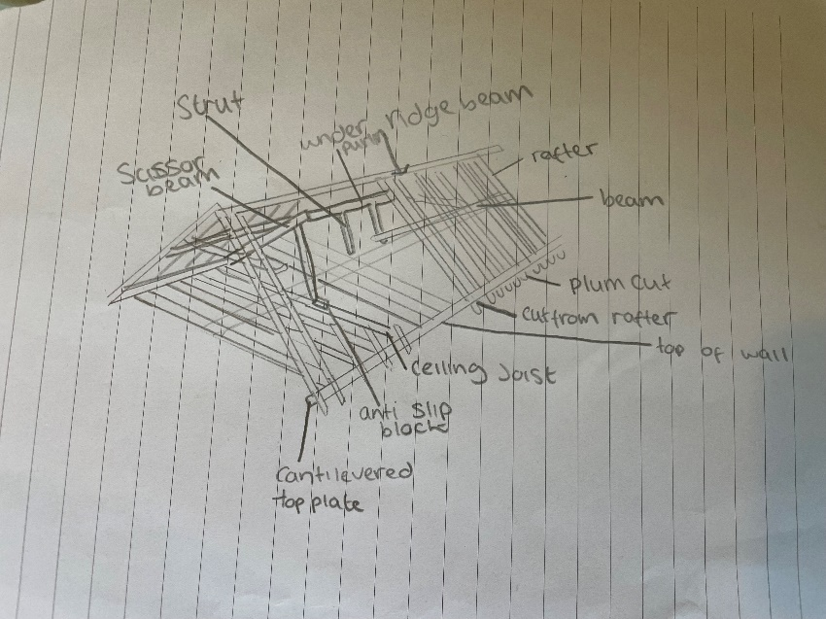
4.1- Timber
One crucial component to a timber roof is the rafter. Two rafters, placed on either side of the roof, are inclined at the top and are connected by the ridge beam (Ernst, 2023). The diagram also contains a ceiling joist which is important for its integrity. The ceiling joist runs horizontally and parallel to the rafters, running from wall to wall, transfer the external load from the roof to the walls which prevents it from collapsing outwards (Weekend Builds, 2022). The minimum U value that it must match is 0.18 (W/m2K) for domestic properties such as this property (Kingspan, 2023).
Figure 11. Timber Roofing (Pinterest, 2022)

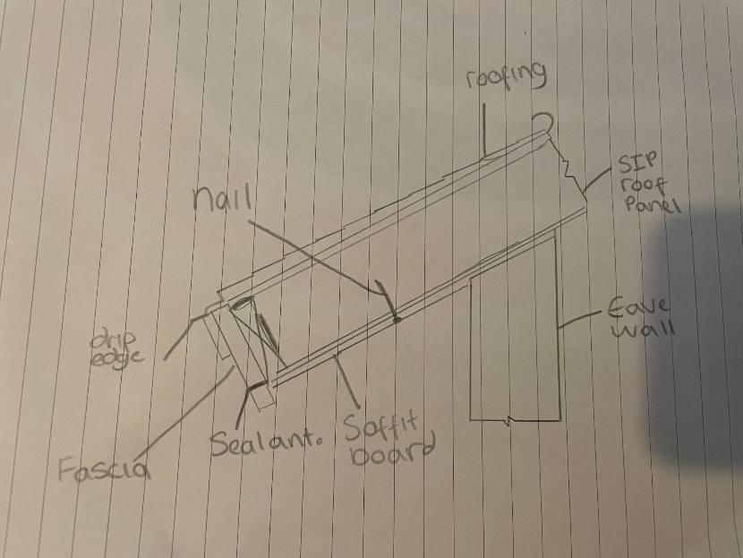
4.2- SIPs
In figure 12, a drip edge is shown. The drip edge is a type of metal flashing which is installed on the edge of the roof to prevent water from entering the house through the walls or leaking into the roof (Building Code Trainer, n.d). This is important as if moisture penetrates the SIPs panel, its u value will decrease. A fascia is also important to a roof as it further decreases moisture seeping into the wall components (Roofing Superstore, n.d). if insulation becomes saturated with moisture, it can affect its efficiency and reduce the U value.
Figure 12. SIPs roofing (Chaleff and Rogers, 2015)

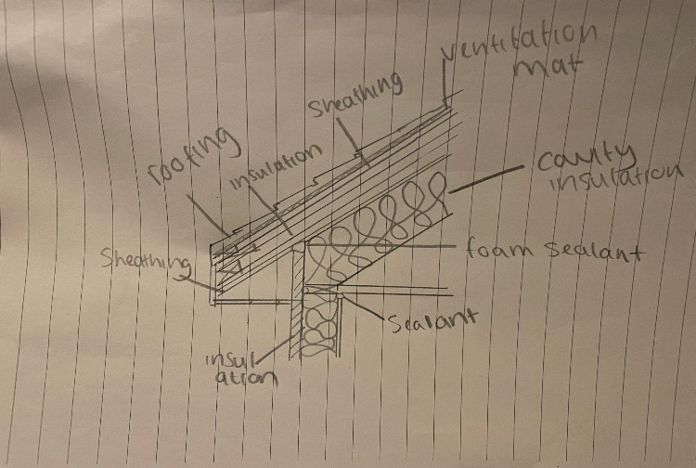
4.3- Brick and Block
One important component of a roof is the sheathing. The sheathing works as a foundation for all the components of the roof, acting as a solid surface for components to attach safely (Roof Troopers, 2024). If this fails, the roof system will also fail. The roof diagram also contains sealant in multiple places. Sealant is used on joints to prevent moisture saturation, preventing the insulation from degrading in terms of its U value (Scalisi, 2022).
Figure 13. Brick and Block Roof Junction (Green Building Advisor, 2012)

5.0- Reccomendations
The cheapest to construct for this project is a timber frame wall, however, it isn’t as insulated as SIPs walls (SIPs Eco Panels, 2021). SIPs are around 5-15% more upfront than the timber framing (SIPs Eco Panels, 2021). However, with a reduced construction time for SIPs, it can sometimes come out cheaper than brick and block and timber (SIPs Eco Panels, 2021). Brick and block is one of the easiest materials to source for workers and is reasonably cheap to purchase, however, it takes many workers to complete, causing prices to spiral (SIPs Eco Panels, 2021). To conclude, if you are looking for speed and ease of production with high insulation, SIPs are the right option. If you are looking for a cheaper option, timber is the right call. If you are looking for a more personalised and modifiable option, brick and block can be efficient.

6.0- Appendix

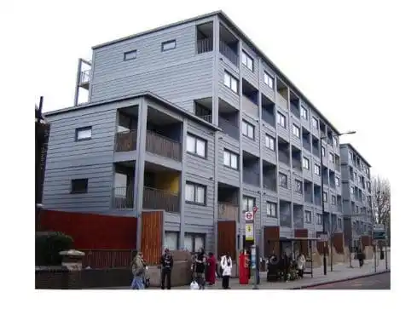
Figure 1- Volumetric Construction (The Constructor, 2020).

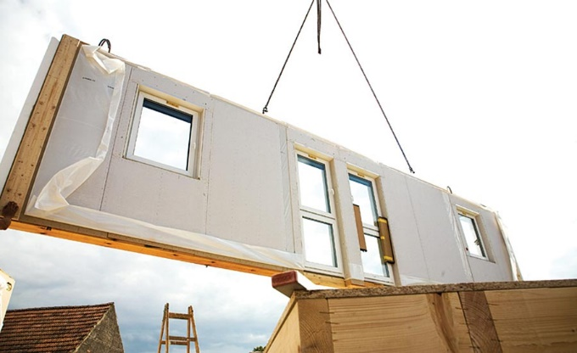
Figure 2- Panelised construction
(Duyka, 2022).

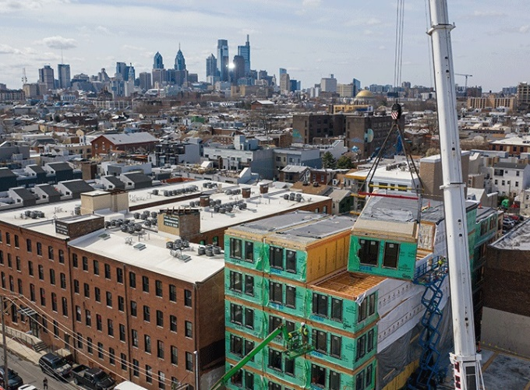
Figure 3- Hybrid offsite construction (Fleisher, 2024)

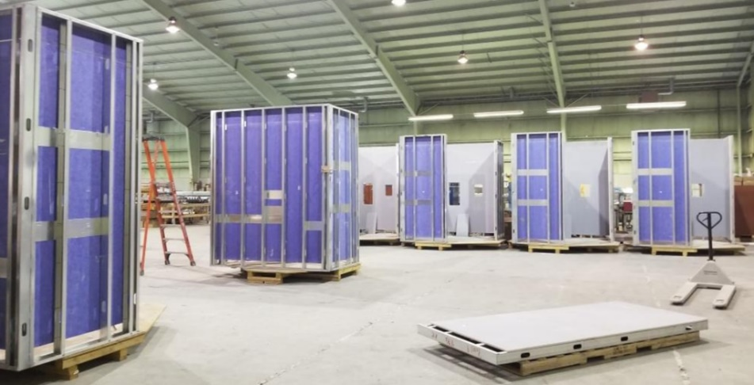
Figure 4- Component/ Sub assembly offsite construction (Fleisher, 2024)

7.0- References

Aimch (2021) DFMA Guide to Timber Panelised MMC System (Design for Manufacture and Assembly) p.10. Available at https://www.aimch.co.uk/images/docs/DFMA_Guide_to_Timber_Panelised_MMC_System_f.pdf (Accessed: 27 April 2025).
Ancon (2016) What is a wall tie? Available at: https://www.ancon.co.uk/blog/what-is-a-wall-tie (Accessed: 29 April 2025).
Bekin. M (2024) Timber cladding: the basics of battening, ‘Eco Choice’. Available at: https://ecochoice.co.uk/basics-of-timber-battening/#:~:text=Adding%20battens%20to%20the%20framework%20of%20your%20cladding,prevent%20water%20build-up%20and%20keep%20your%20timber%20dry. (Accessed: 1 May 2025).
Bennett. J (2024) How to Install Door and Window Flashing to Prevent Leaks, ‘Better Homes and Gardens’ Available at: https://www.bhg.com/home-improvement/exteriors/siding/how-to-install-flashing-around-windows-and-doors/ (Accessed: 30 April 2025).
Boehs. M (2025) What Happens When Wood Gets Wet? Exploring the Effects and Consequences, ‘Timberlake Trusswork’ Available at: https://timberlaketrussworks.com/what-happens-when-wood-gets-wet/ (Accessed: 29 April 2025).
Building Code Trainer (n.d) What Is a Drip Edge on the Roof and When Is It Required? Available at: https://buildingcodetrainer.com/what-is-a-drip-edge-on-roof/ (Accessed: 1 May 2025)
Buildhub (2020) Timber Frame Window Detail. Available at: https://forum.buildhub.org.uk/topic/16814-how-to-install-upvc-windows-in-timber-frame-clad-wall/ (Accessed: 30 April 2025).
Chaleff and Rogers (2015) SIPS roofing. Available at: http://www.chaleffandrogers.com/4/post/2015/06/sips-eave-of-destruction.html (Accessed: 1 May 2025).
Concrete Masonry and Hardscapes Association (2018) Steel Reinforcement for Concrete Masonry. Available at: https://www.masonryandhardscapes.org/resource/tek-12-04d/#:~:text=Reinforcement%20used%20in%20masonry%20is%20principally%20reinforcing%20bars,as%20nominal%20yield%20strengths%20for%20each%20steel%20type. (Accessed 30 April 2025)
Crosson. N (2022) Ask the Expert: What Type of Breather Membrane Should I Use Behind Wall Cladding? ‘Ecological Building Systems’. Available at: https://www.ecologicalbuildingsystems.com/post/ask-expert-what-type-breather-membrane-should-i-use-behind-wall-cladding (Accessed 30 April 2025)
Construction Placements (2019) What is Offsite Construction? Available at https://www.constructionplacements.com/offsite-construction/ (Accessed: 30 March 2025).
Creevy. O (2024) What to Do When Insulation Gets Wet, ‘Switchable’. Available at https://switchable.co.uk/what-to-do-when-insulation-gets-wet/#:~:text=When%20your%20insulation%20gets%20wet%2C%20the%20thermal%20performance,of%20blocking%20heat%2C%20it%20begins%20to%20transmit%20it. (Accessed: 27 April 2025).
Dice Consult (n.d) The Pros and Cons of Building with SIPs. Available at: https://diceconsult.co.uk/journal/the-pros-and-cons-of-building-with-sips (Accessed: 1 May 2025).
Donnelly. C (2024) Do You Need a Vapour Barrier for Internal Wall Insulation? ‘Green Match’. Available at: https://www.greenmatch.co.uk/insulation/walls/internal/vapour-barrier (Accessed: 28 April 2025).
Duyka. G (2019) Offsite Construction Gaining Momentum. ‘Walls & Ceilings’. Available at https://www.wconline.com/articles/92452-offsite-construction-gaining-momentum (Accessed: 31 March 2025).
Eco Home Essentials (n.d) Typical SIP Cross Section. Available at: https://www.eco-home-essentials.co.uk/sip-panel-home-kits.html (Accessed: 29 April 2025).
Ernst. L (2023) Rafter Roof Design [Step-By-Step Guide], ‘Structural Basics’ Available at: https://www.structuralbasics.com/rafter-roof-design/#:~:text=The%20rafter%20roof%20consists%20of%202%20rafters%20which,and%20the%20top%20%282nd%20rafter%20or%20ridge%20board%29 (Accessed: 1 May 2025)
Fleisher. G (2024) Understanding Offsite Construction: What It Is and Why It’s Gaining Popularity, ‘Modular Home Coach’ Available at https://modularhomesource.com/understanding-offsite-construction-what-it-is-and-why-its-gaining-popularity/ (Accessed: 13 April 2025)
Green Building Advisor (2012) Unvented Roof for Cold Climate. Wood Shingle Roofing Over Exterior Rigid Foam. Available at: https://www.greenbuildingadvisor.com/cad/detail/unvented-roof-for-cold-climate-wood-shingle-roofing-over-exterior-rigid-foam (Accessed: 1 May 2025).
Green Building Advisor (2020) SIPs window opening. Available at: https://www.greenbuildingadvisor.com/cad/detail/sip-framing-around-large-window-openings (Accessed 1 May 2025).

HPD Construction (2018) What Is a Band Joist in Construction? Available at: https://www.hpdconsult.com/what-is-a-band-joist-in-construction/ (Accessed: 1 May 2025).
Horizon (n.d) Timber Frame vs Brick Build: Which is Best for Your New Home Build?. Available at: https://htfmmc.co.uk/timber-frame-vs-brick-build-which-is-best-for-your-new-home-build/#:~:text=Timber%20frame%20is%20generally%20the%20more%20affordable%20build,system%20like%20SIPS%20can%20further%20enhance%20cost%20certainty. (Accessed 1 May 2025).
Hunt. D (2022) How House Walls Are Constructed in the UK, ‘Erikas Grig’. Available at: https://erikasgrig.com/how-house-walls-are-constructed-in-the-uk/ (Accessed: 26 April 2025).
Kingspan (2023) Insulating Timber Frame - How to meet the Building Regulation. Available at: https://www.kingspan.com/gb/en/knowledge-articles/insulating-timber-frame-meet-building-regulations/ (Accessed: 1 May 2025).
Mannok (n.d) Wall Insulation: Insulating timber frame cavity walls. Available at: https://mannokbuild.com/insulation-boards/wall-insulation/insulating-timber-frame-cavity-walls/ (Accessed: 29 April 2025).
Mason Contractors (n.d) Vertical Reinforcement. Available at: https://masoncontractors.org/glossary/vertical-reinforcement/#:~:text=Vertical%20reinforcement%20is%20used%20in%20masonry%20walls%20to,bars%20%28rebar%29%20should%20conform%20to%20ASTM%20A%20615. (Accessed: 30 April 2025)
Muschialli. W (2024). The Complete Guide to Damp-Proof Courses, ‘Newton Waterproofing’. Available at: https://www.newtonwaterproofing.co.uk/help-advice/the-complete-guide-to-damp-proof-courses/ (Accessed: 27 April 2025).
Off-site Construction Research Centre (2024) What are the different types of off-site construction? Available at https://blogs.unb.ca/ocrc/2024/07/different-types.php#:~:text=In%20this%20blog%2C%20we%27ll%20delve%20into%20the%20four,construction%2C%20hybrid%20modular%20construction%20and%20component%20%28sub-assembly%29%20construction. (Accessed: 30 March 2025).
OSI Tough (n.d) Fundamentals of Flashing Tapes. Available at: https://www.ositough.com/knowledge/articles/fundamentals-of-flashing-tapes.html#:~:text=It%20can%20be%20applied%20on%20most%20substrates%20%E2%80%93,low%20as%2020F%20and%20as%20high%20as%20120F. (Accessed: 1 May 2025)
Patel (2024) Stack Bond Brickwork – Aesthetic Appeal and Key Insights, ‘Brick & Bolt’. Available at https://www.bricknbolt.com/blogs-and-articles/construction-guide/stack-bond#:~:text=A%20stack%20bond%20is%20a%20type%20of%20brickwork,sides%20%28stretchers%29%20as%20the%20face%20of%20the%20walls. (Accessed: 26 April 2025)
Pinterest (n.d (a)) Twin Timber Frame Wall. Available at: https://in.pinterest.com/pin/732609064389127464/ (Accessed: 28 April 2025).
Pinterest (n.d (b)) Sill Detail. Available at: https://uk.pinterest.com/pin/662310688935500646/ (Accessed: 30 April 2025).
Pinterest (2022) Timber Roofing. Available at: https://uk.pinterest.com/pin/649010996294088798/ (Accessed: 1 May 2025).
Professional Builder (2018) The History of Structurally Insulated Panels. Available at: https://probuildermag.co.uk/features/history-structurally-insulated-panels (Accessed: 29 April 2025).
Pullen. T (2020) Which Wall Material Has the Best U Value? ‘Home Building’. Available at: https://www.homebuilding.co.uk/advice/which-wall-material-has-the-best-u-value (Accessed: 29 April 2025).
Roofing Superstore (n.d) A guide to fascia & soffit. Available at: https://www.roofingsuperstore.co.uk/help-and-advice/product-guides/guttering/a-guide-to-fascia-soffit/#:~:text=As%20mentioned%20previously%2C%20the%20fascia%20is%20used%20to,by%20smoothing%20out%20the%20edges%20of%20the%20roof. (Accessed: 1 May 2025)
Roof Troopers (2024) What Is Roof Sheathing? (Homeowner’s Guide). Available at: https://roof-troopers.com/blog/roof-sheathing/ (Accessed: 1 May 2025).
Scalisi. T (2022) Learn About Roof Sealants and How to Find the Right One for You, ‘Forbes’. Available at: https://www.forbes.com/home-improvement/roofing/roof-sealants/ (Accessed: 1 May 2025).

Setherton. G (n.d) How to Install a Vapour Control Layer, ‘Permagard’. Available at: https://www.permagard.co.uk/advice/installing-vcl-vapour-control-layer (Accessed: 27 April 2025).
SIPs Eco Panels (2021) SIPs vs Timber Frame vs Brick and Block: A Complete Comparison. Available at: https://www.sipsecopanels.co.uk/sips-vs-timber-frame-vs-brick-block-comparison/ (Accessed: 1 May 2025).
Snell. D (2020) Comparing Wall System Costs, ‘Home Building’. Available at: https://www.homebuilding.co.uk/advice/comparing-wall-system-costs (Accessed: 29 April 2025).
Stevenson and Cruickshank (2023) Timber frame construction: Everything you need to know, ‘Home Building & Renovating’. Available at: https://www.homebuilding.co.uk/advice/timber-frame-guide (Accessed: 28 April 2025).
Storables (2024) What Are Sills Used for in Construction. Available at: https://storables.com/diy/building-construction/what-are-sills-used-for-in-construction/#:~:text=Key%20Takeaways%3A%201%20Sills%20in%20construction%20provide%20structural,the%20overall%20integrity%20and%20success%20of%20construction%20projects. (Accessed 30 April 2025).
The Constructor (2020) What is Offsite Construction? Available at https://theconstructor.org/building/offsite-construction-features-methods/38319/ (Accessed: 30 March 2025).
The Offsite Guide (n.d) Eco-Friendly and Efficient: The Growing Appeal of Hybrid Modular Construction. Available at https://theoffsiteguide.com/articles/eco-friendly-and-efficient-the-growing-appeal-of-hybrid-modular-construction (Accessed: 7 April 2025).
Volek. D, Dickenson. C (n.d) Building a water-tight, thermally-efficient cavity wall, ‘The Brick Centre’ p.4. Available at: https://thebrickcentre.co.za/wp-content/uploads/2024/11/TN37_cavity_walling_2020-03.pdf#:~:text=%EF%82%B7%20In%20between%20the%20two%20masonry%20leaves%20is,from%20draining%20away%2C%20leading%20to%20damp%20and%20mould. (Accessed: 27 April 2025).
Weekend Builds (2022) What Are Ceiling Joists? [Complete Guide]. Available at: https://weekendbuilds.com/what-are-ceiling-joists/ (Accessed: 1 May 2025).

