Designing a Blended-Learning Model
for ESP Writing Class Based on Action Research

1. The aims of the research

This research is mainly aimed at building up a blended-learning model for ESP writing class to solve three problems that I have met in the teaching practice that will be further discussed on the rationale part. Therefore, basically speaking, it is an action research focusing on solving the pedagogical problems through investigating the teaching process of employing the theoretically based model by varied ways of collecting either quantitative or qualitative data and reflect on the effectiveness of the model so as to modify it into a more effective one in solving the problems. Based on the research, four main objectives will be achieved, which are listed below.
- To have a literature review of the blended learning in terms of its definition, and theoretical development especially in modelling.
- To learn the theoretical reference to the blended learning model aiming at solving the research questions including constructivism (philosophical basis of the blended-learning class design), Randy Garrison’s Community of Inquiry Model (theoretical guideline for online learning) and Merrill’s First Principles of Instruction (theoretical guideline for the instructions in the blended teaching) that will be applied in building up the blended-model.
- To design the blended–learning model for ESP writing class to solve the problems so as to answer the related research questions.
- To modify the model based on the teaching practice during which various methods of data collection will be used like questionnaire, focus group and online and face-to-face classroom observation.

2. The rationale and main conceptual themes for the investigation

This research is conducted for the purpose of improving the ESP writing class and, in this part, a detailed explanation on the reasons why this topic is finally chosen and why it is significant to explore before theoretical basis of the project is elaborated.

2.1 The rationale of the research
There are three reasons for choosing this research project which are in accordance with the three key terms shown in the title: ESP writing, blended learning and action research. In this part the significance of the investigation will be elaborated.
Firstly, the research on ESP writing is important since it meet the needs of not only the students who are eager to learn well on ESP courses, but also the teacher in solving pedagogical problems met in the teaching practice. In China, there is a growing demand for talents capable of international communication. English for Specific Purposes (ESP) has become a must for such talents to master specialized language skills, which make the course increasingly popular among college students. Based on large-scale social surveys, researchers in China found that the main purpose of Chinese college students to learn English is to use English as a communicative tool to obtain information needed by their major and express their professional thoughts through English (Huizhong Yang, 2010; Lijuan Wang,2016). While the demand for better ESP class from students increases, the problems arise in the teaching practice, among which three of them are prominent: 1) students are less interested in the traditional classroom teaching; 2) practice on ESP writing is not sufficient owing to the fact that there are at least 40-60 students in each class and each teacher has four to five such classes. therefore, it is impossible for the teacher to assign more writing practice with in-time feedback. Therefore, the improvement of students’ ESP writing is unsatisfactory. 3) cooperative learning is seldom found in and after class.
Secondly, the research on blended learning model provides a new perspective for class design which are more likely to be innovative in solving the problems of the traditional classroom teaching that have mentioned above (more detailed explanation will be in the conceptual part). However, although the advantages of blended learning have been widely supported, the modelling of a blended learning especially on ESP writing is not sufficient, which makes it significant to build up a ESP writing class model.
Thirdly, action research is a new attempt to evaluate the effectiveness of the model aiming at solving the problems of ESP writing.
According to Kemmis and McTaggart who put forward the most influential framework for the process of study, action research is a self-reflective spiral of cycles of improvement, each consisting of four phases: (1) planning; (2) acting; (3) observing; (4) reflecting, which can be clearly seen in the following figure.

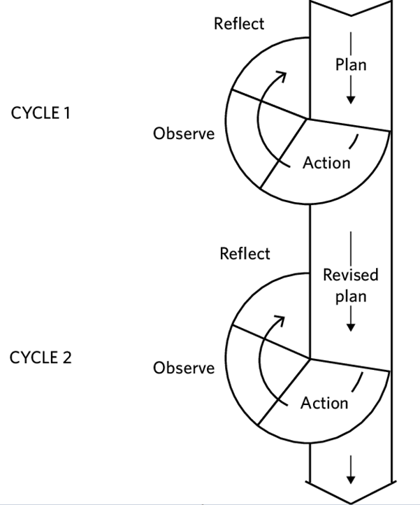
Figure 1: action research: spiral of cycles (Kemmis and McTaggart ,1988)

Different from other research method, action research in this research not only focuses on the problems arising in the actual teaching practice which the research questions are based on, but also testing answers to the research questions, that is to say testing the blended model for ESP writing class through action research. In the actual teaching practice, with teacher acting as the researcher, collecting data from their own classroom and online activities before reflections are made based on the data collected.
To sum up, the above-mentioned three key terms in the title contain the significance for the investigation aiming at answer the following three research questions by virtue of the blended learning model:

1) Does the blended learning model improve the students' interest in ESP writing?
2) Does the blended learning model promote cooperative learning in and after class?
3) Compared with the traditional teaching, does the blended learning model improve the students' writing proficiency.

The whole research plan can be briefly described like this: first, to build up a theory-based blended learning model for ESP writing class to solve the problems that are met in the teaching; second, to practice the model in the teaching to test the effectiveness of it by means of quantitative and qualitative study; third, to modify the model based on the analysis of the data collected and put forward the revised model for the next cycle of research. Generally speaking, the blended learning model should be tested in order to see whether the three questions have been solved:

2.2 Conceptual themes for the research project

Building up a blended model is a very complicated process in which the following key concepts and theories are to be elaborated, namely, blended learning, constructivism, Garrison’s Communities of Inquiry and Merrill’s First Principles of Instruction, all of which play their roles either acting as thematic basis or specific operational guidelines to design the model. In this part more detailed explanation will be made.

2.2.1 Blended learning
The term “blended learning” is used for the first time at the beginnings of 2000. (Güzer & Caner, 2014). Although there are three definitions, namely, (1) a combination of conventional learning and online web-based learning, (2) a combination of media and devices used to build e-learning, and (3) a combination of a pedagogic approach (White Lock and Jelfs, 2013), most studies relate blended learning to the combination of face-to-face learning and online learning (Yulia, 2017). This article will focus on the third definition of blended learning.
Although most frequently cited articles defining blended learning are in the definition period between 2003 and 2006 (Güzer & Caner, 2014), the discussion on what is blended learning began in earlier time. According to Harvi Singh & Chris Reed (2001, p.2) blended learning is about “optimizing achievement of learning objectives by applying the “right” learning technologies to match the “right” personal learning style to transfer the “right” skills to the “right” person at the “right” time. In this definition, four principles concerning the learning objective, personal learning style, diverse knowledge from different participates and “just-what-I-need, just-in-time” learning strategy are embedded. Then based on five case studies Russel T. Osguthorpe and Charles R. Graham (2003) enrich the meaning of blended learning by defining it as“…combines face-to- face with distance delivery systems…to maximize the benefits of both face-to-face and online methods” and by explaining the aim of using blended learning approaches : to find a harmonious balance which will vary for every course owing to instructional goals, student characteristic, instructor background and online resources. Here goals are further illustrated into six types, namely, pedagogical richness, access to knowledge, social interaction, personal agency, cost effectiveness and ease of revision. Although Osguthorpe and Graham explain in detail what is blend learning and what factors should be taken into consideration when defining the best balance of the blend, the factors that contribute to clear definition are still limited. Later, the factors that need to be considered increase with more and more research carried out. So comes the most cited article on blended learning from Garrison & Kanuka (2004) who hold that blended learning is a thoughtful and effective integration of classroom face-to-face learning experiences with online learning experiences owing to its countless possibilities of design in varied context. It is strongly proved that online-learning attributes to flexibility, reflection, interpersonal and teamwork skill development, motivation and collaborative learning and it provides a platform for the participates who have expanded time to learn, to question and reflect and to record what they have learned. Compared to online learning which is asynchronous, face-to- face learning is spontaneous and contagious. Therefore, they are complementary. Like Osguthorpe and Graham, Garrison & Kanuka focus on how to design and deliver blended learning and put forward five categories of issues pertaining to blended learning: policies and operations required to support blended learning approaches; planning in which the identification of needs, goals and objectives; potential costs; available resources and assessment process; financial, human and technical resources; scheduling of courses and support services that facilitate access to blended learning. With further research on blended learning being carried out, learner and instructor related variables are taken into consideration such as learners’ satisfaction, motivation, achievement, attitude, cooperativeness, knowledge retention, critical thinking skills and drop-out rate for at risk students. (Deliağaoğlu & Yıldırım, 2008; El-Deghaidy & Nouby, 2009; Akyüz & Samsa, 2009; Hughes, 2007; Melton et. al., 2009; Woltering et. al., 2009) and perceptions of participations (Akkoyunlu & Soylu 2008; So & Brush 2008; Chandra & Fisher 2009). The wide varieties of factors that affect blended learning make the situation so complicated that it is hard to consider them all when it is applied in the teaching practice, which is stated by Taylor, M. et. al. (2018): although students still prefer the time flexibility and increased teacher-student interactions using a blended learning, there are some new challenges such as learner differences, the requirement for more support for course design and better professional development and training.
So, this period of research in blended learning at the beginnings of 2000 emphasizes the factors that contribute to the most appropriate blend in the most suitable context. But owing to the lack of theoretical basis, the early research is not systematic and those variables are studied in isolation in massive articles. In recent years, various theories are incorporated into the studies of blended learning. For example, Al-huneidi & Schreurs (2012) apply constructivism and conversation theories to propose a Constructivism Based Blended Learning model for his course in which all the factors are integrated together with the core meaning of constructing knowledge by learners themselves through problem solving, teachers’ guidance and interaction and collaboration with students in blended learning. Although the model lacks evaluation, it has vital implications on the theory-based modelling which are to be used to design the blended-learning model for ESP writing class. In this research modelling the blended learning is based on three key concepts, each of which plays a role in the process of modelling, namely, constructivism, Community of Inquiry Model and First Principles of Instruction.
2.2.2 Constructivism
Constructivism can be studied from two perspective: Cognitive and social-cultural. Cognitive constructivism is developed by Jean Piaget, a Swiss developmental psychologist. The theory focuses on the relationship between ages and the cognitive development, known as the theory of development in which how children develop their cognitive abilities are studied. In this theory there is a point that is worth mentioning since it has implications on active learning. According to Jean Piaget (1977), learning is realized through active construction of meaning rather than passively received when the experience or the situation are out of their range of knowledge. Here imbalance emerges. In order to restore balance, they associate the new with the existing knowledge to reconstruct it to a higher level of thinking, which finally promote learning.
Another perspective of constructivism is pointed out by Vygotsky (1978) who states that the process of knowing is affected by people around him, community and culture, which means social and cultural support contribute to cognitive growth. Thus, at the beginning of learning, social support should be provided to facilitate learning. With the development of learning, the support is gradually decreased and independent learning can be realized. This is in fact a kind of scaffolding instructions done by teachers.
In my opinion, the two strands of constructivism analyze the cognitive process from different perspective and they are not contradicting with each other with one focusing on students’ learning process and the other on teachers’ instructions. And therefore, both of the key ideas can be applied to the design of the class in this research. Of course, only the theory of constructivism is not enough to build up the ESP writing model since it is too general for blended learning. However, it is the philosophical basis for all the stages of the class design, which means passive learning and teacher-centered class design is out of the consideration.

2.2.3 Randy Garrison’s Community of Inquiry Model (CoI)

For this blended learning design, the key theory will be one of the most influential frameworks for online learning research named Community of Inquiry Framework (CoI) by Randy Garrison, Terry Anderson and Walter Archer to operate originally in the context of "computer conferencing in higher education" aiming at online "asynchronous, text-based group discussions" (Garrison et.al., 2010, p.5). In other words, it is a model used to guide high education by virtue of online verbal communication media. The framework constitutes three core interactive elements: cognitive presence, social presence, and teaching presence, which can be clearly shown in the following figure.
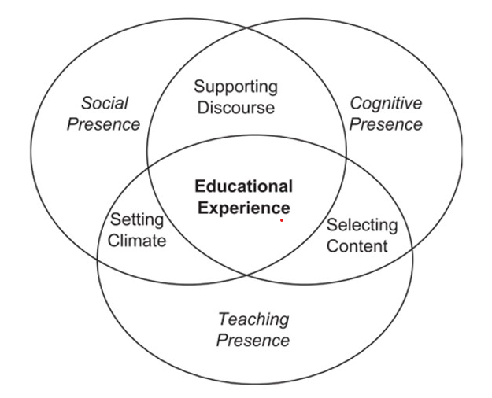
Figure 3: Randy Garrison’s Community of Inquiry Model (2001)

According to Garrison et. al. (2010), the model aims to provide an understanding and methodology to describe and measure the elements of a collaborative and dynamic online learning experience with the three ‘presences’ interacting with each other. To briefly speaking, the core meaning of social presence is to encourage open communication and create trust; cognitive presence focuses on reflective inquiry based on four stages of "triggering event, exploration, integration and resolution" (Garrison et.al., 2010) which is closely related to critical thinking and teaching presence provides the design, facilitation, and direction for a worthwhile educational experience, establishes the curriculum, approaches, and methods and moderates, guides, and focuses discourse and tasks (Garrison & Kanuka, 2004). The striking part of the CoI model is its significance to guide design of the online learning part in the blended learning.
With the online learning guideline of CoI by Garrison et. al., a clearer framework for online learning is presented. However, how to make the three ‘presences’ of online learning well instructed and how to incorporate online learning with the face-to-face traditional way of teaching and learning under the effective instruction in order to build up a blended model so as to solve the problems in ESP writing class are the next stage of theoretical exploration. That is to say, how to operate instruction to make a problem-solving blended model into practice will be the focus of this stage, in the context of which Merrill's First Principles of Instruction are applied.

2.2.4 Merrill's First Principles of Instruction

First Principles of Instruction effective instructions by Merrill (2002) is a guideline on effective instruction which is problem-centered and which is realized in four distinct phases: (a) activation of prior experience, (b) demonstration of skills, (c) application of skills, and (d) integration of these skills into real-world activities, which is clearly shown in figure 4. According to Merrill (2013), instruction is a “goal-directed activity” that aims to “structure a learning environment” to “promote effective, efficient, and engaging learning”. (all three quotations, please see p.6). Instruction is very important even in the modern time when social networking and extensive multi-media are widely imbedded in the learning. No matter the instructions are instructor-directed or learners’ self-chosen, so long as the principles are taken into consideration when designing the blended model, they can promote learning. Briefly speaking, effective instructions are realized when learners are engaged in solving real-world problems, when existing knowledge is activated as a foundation for new knowledge and when new knowledge is demonstrated to the learner, applied by the learner and integrated into the learner’s world.
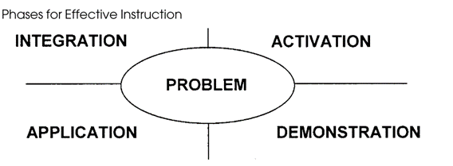
Figure 4: Merrill's First Principles of Instruction (2002)

To sum up, the above-mentioned theoretical exploration provides a framework from general to specific consideration of the model design: Constructivism lays a thematic foundation of the model – learner-centered active learning. Garrison’s CoI combines all the essential factors that influence the effectiveness of blended learning and therefore constitutes the basic structure of the model. Merrill’s First Principles of Instruction specifically guide the whole process of instruction in the three ‘presences.
After the model is built up, the testing of it will be implemented in the following three stages of action research --- acting, observing and reflecting the detailed explanation will be in the following parts since they are out of the theme of this part.

3. Research methodology
Briefly put, action research will be conducted in this research project through four phases, namely, planning, acting, observing and reflecting, during which data (evidence) will be collected and analyzed in mixed methods. In the planning phrase, the model is firstly built up and the data collection will be designed in accordance with the three research questions. In the acting phrase, the model is implemented during the middle term of the ESP course, before which the traditional way of face-to-face teaching method is used. The reason why the model is applied in mid-term is that a comparative study can be made with the same group of students acting as the subjects. In the third phase of observation, data will be collected based on the data collection design in the planning stage. In the fourth phase, reflections based on the analysis of the data will be made to evaluate the theory-based model on the effectiveness of solving the research questions.

3.1. The settings of data collection
This research is conducted in the whole teaching process of ESP writing. All the subjects are sophomores majored in arts and science except English majors, which means English is just one of their general foundation requisite and limited energy may be devoted to the study of English, especially in writing.

3.2 The methods of collect data and evidence collected
In this research data are mainly collected through the following ways: firstly, questionnaire at the end of the term; second, interview and focus group after the class of the whole term is over. thirdly, classroom and online observations of the students’ performance concerning the three research questions during the whole course before and after the blended learning model is applied and there are three kinds of evidence that will be collected in the research.
Firstly, responses to questionnaires that is based on the community of inquiry instrument developed by J.B. Arbaugh et. al. (2008) measuring social presence, cognitive presence and teaching presence. The results of the response can be used to find answers to the second research question concerning cooperative learning and can also indirectly answer the first question concerning the interest of the subjects.
Secondly, documents of students’ writing paper will be collected before the blended learning model is implemented in class in the mid-term and after the ESP writing class is over at the end of the term, which can be valuable to answer the third research question concerning writing proficiency.
Thirdly, responses to interview and focus group will be collected to find more information related to the three research questions in terms of the interest, collaboration and writing proficiency of the students. In addition, more valuable qualitative data from the interview and focus group will help to modify the model if content analysis of the data is employed.
3.3 The methods of analysing the evidence collected

Firstly, the data analysis for questionnaire will be made through SPSS to test whether the blended model can improve the interest of the learner on ESP writing and whether the model can promote the collaboration on line and in class so as to test the effectiveness of the model.
Secondly, a comparative study on the documents of students writing assignment will be made through marks based on the standard writing criterion in the standard examination.
Thirdly, content analysis through NVIVO will be used to the qualitative data from interview, focus group and observation of online and traditional classroom.
All the methods that are used in this research projects aim to test the blended learning model for ESP writing as well as modify it into a better one in blende learning.

4. The ethical issues in the research process

There are some ethical considerations for the research. First of all, in conducting questionnaire, a special notification will be listed at the beginning part of it, stating that replies of the questionnaire are never used to assess their course and names of the students are not required. Second, in order to ensure every student be treated fairly and their rights to be educated equally, the way of collecting data by control groups and experiment group is not used and comparison is made by dividing the term into two periods with the former period implementing the traditional one and the latter one the blended one. Thirdly, the students who are chosen as interviewee or the subjects of observation will be voluntarily based and all the detailed information in terms of protecting the students' confidentiality and the right to quit at any time will be put in the written agreement. Besides, all the data collected from students will be anonymous and all the data are collected after the assessment is finished for the sake of worries from students.

5 The timetable for the proposed project

The project will last about 2 years, which can be divided into three phases.
Phase one is the theoretical exploration aiming at building up the blended model and the design of the data collection including questionnaire and interview layout. It will last for 6 months.
Phase two is the real time teaching practice which last 16 weeks in the university, roughly about 6 months with 3 hours each week. In this period the first 6 weeks will be taught in a traditional face-to-face teaching and from week 7 blended learning will be implemented based on the theory model previously built up. In the whole 16 weeks quantitative and qualitative data will be collected.
Phase three is the data analysis and reflection, which lasts for a year including the writing of the research report.

Reference

Akkoyunlu, B., & Soylu, M.Y. 2008. A study of student’s perceptions in a blended learning environment based on different learning styles. Educational Technology & Society. 11(1), pp. 183-193.
Akyüz, H. İ., & Samsa, S. 2009. The effects of blended learning environment on the critical thinking skills of students. Procedia-Social and Behavioral Sciences. 1(1), pp. 1744-1748.
Al-huneidi, A. M., & Schreurs, J. 2012. Constructivism Based Blended Learning in Higher Education. IJET. 7(1), pp. 4–9.
Arbaugh, J.B et al., 2008. Developing a community of inquiry instrument: Testing a measure of the Community of Inquiry framework using a multi-institutional sample. The Internet and higher education, 11(3), pp.133–136.
Chandra, V., & Fisher, D.L. 2009. Students’ perceptions of a blended web-based learning environment. Learning Environment Research. 12, pp. 31-44.
Delialioglu, Omer & Yildirim, Zahide, 2008. Design and development of a technology enhanced hybrid instruction based on MOLTA model: Its effectiveness in comparison to traditional instruction. Computers and education, 51(1), pp.474–483.
EL-Deghaidy, Heba & Nouby, Ahmed, 2008. Effectiveness of a blended e-learning cooperative approach in an Egyptian teacher education programme. Computers and education, 51(3), pp.988–1006.
Garrison, D. R., & Kanuka, H. 2004. Blended learning: Uncovering its transformative potential in higher education. The internet and higher education. 7(2), pp. 95-105.
Garrison, D. Randy, Anderson, Terry & Archer, Walter, 2010. The first decade of the community of inquiry framework: A retrospective. The Internet and higher education, 13(1), pp.5–9.
Garrison, D.Randy & Kanuka, Heather, 2004. Blended learning: Uncovering its transformative potential in higher education. The Internet and higher education, 7(2), pp.95–105.
Güzer, B., & Caner, H. 2014. The past, present and future of blended learning: an in depth analysis of literature. Procedia - Social and Behavioral Sciences. 116, pp. 4596–4603.
Hanita Yulia, 2017. Readiness for Blended Learning viewed from the Students’ Attitude towards Learning Aspects. International Journal of Active Learning, 2(1), pp.15–26.
Hughes, G. 2007. Using blended learning to increase learner support and improve retention. Teaching in Higher Education.12(3), pp. 349-363.
Hui Zhong Yang. 2010. EAP in China. National Symposium on ESP Teaching and Research. Beijing, 22th July, 2010.
Kemmis, S. & McTaggart, R., 1988. The Action research planner. Victoria: Deakin University.
Lijuan Wang. 2016. On ESP teaching strategies. Foreign Language World. 177 (6), pp. 57-63
Melton, B., Graf, H., & Chopak-Foss, J. 2009. Achievement and satisfaction in blended learning versus traditional general health course designs. International Journal for the Scholarship of Teaching and Learning. 3(1), n1.
Merrill, M. D. 2002. First principles of instruction. Educational Technology Research and Development, 50(3), 43-59.
Merrill, M. D. 2013. First principles of instruction. San Francisco, CA: Pfeiffer.
Osguthorpe, R. T., & Graham, C. R. 2003. Blended learning environments: Definitions and directions. Quarterly review of distance education, 4(3), pp. 227-33.
Piaget J. 1977. The development of thought: Equilibration of cognitive structures. (A. Rosin, Trans). New York: The Viking Press.
Singh, Harvi, & Reed, Chris. 2001. A White Paper: Achieving Success with Blended Learning. Centra Software. (March), 1–11.
So, H J., & Brush, T.A. 2008. Students perceptions of collaborative learning, social presence and satisfaction in a blended learning environment: Relationships and critical factors. Computers & Education. 51(1), pp. 318-336.
Taylor, M., Vaughan, N., Ghani, S. K., Atas, S., & Fairbrother, M. 2018. Looking back and looking forward: A glimpse of blended learning in higher education from 2007-2017. International Journal of Adult Vocational Education and Technology (IJAVET). 9(1), pp. 1-14.
Vygotsky LS. 1978. Mind in society. Cambridge: Harvard University Press.
Whitelock, D. dan Jelfs, A. 2013. Editorial: Journal of Educational Media special Issue on Blended Learning. Journal of Educational Media. 28 (2), pp. 99 – 100.
Woltering, V., Herrler, A., Spitzer, K., Spreckelsen C. 2009. Blended learning positively affects students’ satisfaction and the role of the tutor in the problem-based learning process: Results of a mixed-method evaluation. Advances in Health Sciences Education. 14(5), pp.725-738.

