Developing Workplace Critical Thinking

Programme: BA (Hons) Leadership and Management Skills for the Workplace.
Module: Developing Workplace Critical Thinking.
Module code: BMSW5101.
Student Name: Andreea-Cristina Iliescu
Student Number: 2009203
Level 5 Term 1 Group 1.
Module lecturer: Akinseye Aluko
Assignment Title:
Part 1: Individual Business Report.
Part 2: Reflective Journal.

Table of contents:
Part 1: Report……………………………………………………………………………………...3.
Introduction……………………………………………………………………………………...…3.
Organisation Overview (Unilever)……………………………………………………………….4.
Concept of Workplace Beliefs, Attitudes and Values ……………………………………...….5.
Concepts Underpinning the Report……………………………………………………………..6.
Contingency Theory………………………………………………………………………………6.
Bureaucratic Management……………………………………………………………………….7.
Human Relations………………………………………………………………………………….7.
How Organisational Belief, Attitude and Values Influence or Affect Workplace Behaviour in the Context of Unilever……………………………………………………………………………8.
The Relevance of Bureaucratic Management………………………………………………….8.
Human Relations Management at Unilever…………………………………………………….9.
Contingency Theory in Unilever's Context……………………………………………………...9.
Different Interpretation of the Same Theories…………………………………………………10.
Recommendations for a Better Post-Covid Adjustment in Unilever………………………..11.
Conclusion………………………………………………………………………………………..12.
Part 2: Reflection Journal……………………………………………………………………….13.
Introduction…………………………………………………………………………………….....13.
Week 1…………………………………………………………………………………………....13.
Week 2…………………………………………………………………………………………....14.
Week 3………………………………………………………………………………………...….14.
Week 4…………………………………………………………………………………………….15.
Week 5…………………………………………………………………………………………….15.
Week 6…………………………………………………………………………………………….16.
Week 7…………………………………………………………………………………………….16.
Week 8…………………………………………………………………………………………….17.
Week 9…………………………………………………………………………………………….17.
References……………………………………………………………………………………18.19.

Part 1: Report
Introduction:
The beliefs, attitudes and values of an employee highly influence how they behave in the workplace, which roughly translates to workplace behaviour. However, in influencing the beliefs, attitudes and values of the workplace, the overall situation within the organisation plays a vital role. When the work environment is congenial, the employees are expected to give their best and work efficiently for the company. The opposite can be said for an unpleasant working environment (Hellriegel and Slocum, 2017). In other words, organisational attitude, beliefs, and values play a vital role in setting the acceptable workplace behaviour for a specific organisation. This report focuses on the impact of these factors in shaping the organisational behaviour for Unilever Plc. Throughout the report, the concept of organisational values, attitude and beliefs will be focused upon, even if the words are not used explicitly.

3

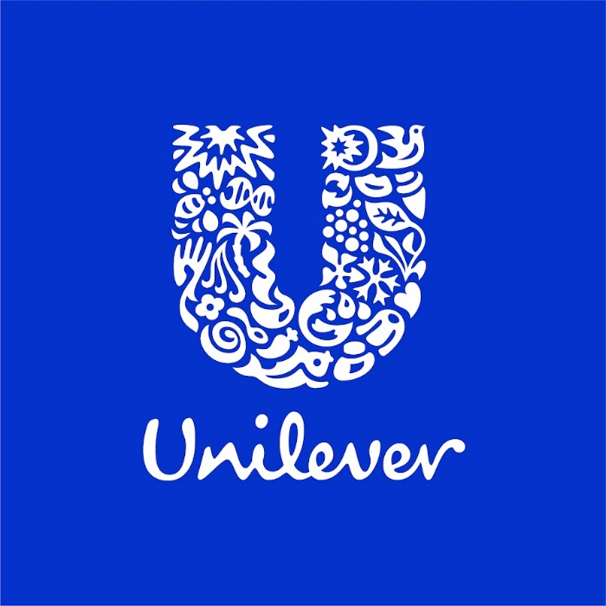
Figure 1: Unilever Logo (Unilever Global, 2022).

Organisation Overview (Unilever):
The corporate headquarters of Unilever PLC is located in London, England. To name just a few, Unilever makes everything from food and condiments to ice cream and vitamins and minerals to cleaning agents to pet food to toothpaste to deodorant to deodorant to deodorant to deodorant to deodorant (Unilever Global, 2022). The world's largest soap manufacturer, Unilever, is based in London. The company is the proud owner of 400 brands and serves in almost 190 plus countries. The reason behind such massive expansion over a period of almost a century is because of having very strong organisational practices that help to keep the values, beliefs, and attitudes in the right place.

4

Concept of Workplace Beliefs, Attitudes and Values:
These beliefs and attitudes are created over time by the influence of family, friends, society, and life experiences on the individual. As a result, by the time a person reaches adulthood, they are able to hold firmly held beliefs about nearly every aspect of life. The concepts are interconnected and complement each other in multiple ways.
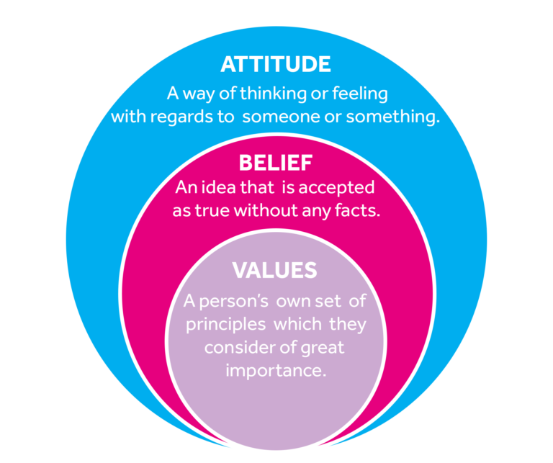
Figure 2: Concept of Values, Beliefs and Attitude (Uddin, 2022).

The image above gives a fitting explanation of human values, beliefs, and attitudes. Much like human values, beliefs and attitudes, the organisational ones are shaped as per the way in which an organisation manages its organisational culture and nurtures its employees (Hussain, Haque and Baloch, 2019). Many micro and macro factors shape the overall ideals of the employees of an organisation, which leads to the greater development of organisational or workplace behaviour.

5

Concepts Underpinning the Report:

Contingency Theory:
Contrary to popular belief, there is no ideal method to organise a corporation, lead a company, or make choices according to the contingency theory of organisational behaviour. Instead, the best course of action is contingent (or dependant) on the internal and external circumstances at the time of decision. In this course of the organisation's operations, contingent leaders are nimble in their selection and adaptation of brief strategies to meet the changing needs of the scenario at any given point in time (Burns, 2012). As time has progressed, the relatability of the contingency theory has increased drastically. Compared to even two three decades ago, managers have to face very rapid important decisions that could decide the fate of their organisations in the short or long run. How well the managers and leaders of an organisation manage the diverse situation also impacts organisational behaviour, both directly and indirectly (Al-Mahdy, Emam and Hassan, 2021).

6

Bureaucratic Management:
The world is full of bureaucracies. Non-elected officials enforce rules in this type of organisation, which is popular in both the public and private sectors. The Social Security Administration, the Environmental Protection Agency, and public universities are just a few examples of public sector bureaucracies. The United Kingdom has one of the country's oldest bureaucracies. Armed forces of the United Kingdom (Hussain, Haque and Baloch, 2019). There are two important components to Weber's theory of bureaucratic administration. To begin, a hierarchical organisational structure is required. On the other hand, individuals of the organisation and the organisation itself are subject to well established rational and legal decision-making standards. A company's aims can be achieved with the support of every component. It goes without saying that this form of management is quite popular in current times and helps to keep organisational or workplace behaviour in control by influencing the overall attitudes, beliefs, and values of the organisation (Burns, 2012).

Human Relations:
It is the goal of Human Relations Theory to better understand how the demands of individuals and groups influence their actions. Managing people necessitates a personal approach. Formal and informal aspects are shown to make up the organisation. The structure of a company is made up of its formal aspects (Hellriegel and Slocum, 2017). Interactions among employees are an example of an organisation's informal elements. As a result, the organisation is a social structure in its own right. Individual job satisfaction and the resulting motivation of the individual should be managed within this system. In particular, the way individuals interact within groups and the outcomes of group behaviour and performance is heavily emphasised in this course (Jones and Martain, 2016). The greater workplace behaviour is influenced highly by the personal beliefs, attitudes, and values of the employees.

7

How Organisational Belief, Attitude and Values Influence or Affect Workplace Behaviour in the Context of Unilever.
Unilever is no small company. With its branches spreading all around the world, Unilever is one of the top FMCG brands known to this planet. Especially in Asian households, it is difficult to find a single house that does not use any product of Unilever. Behind this tale of crafting a strong brand consisting of more than 400 sub-brands, there is a perfectly executed management strategy that has helped the organisation keep a balance among its workforce (Nejad, Nejad and Farahani, 2021). In terms of the theories underpinned in the previous section, the workplace behaviour of Unilever has been described in this section.

The Relevance of Bureaucratic Management:
Although having a democratic or comparatively free organisational structure or leadership structure seems ideal, it does not work so good in an organisational context, especially not for a global FMCG brand such as Unilever (Gill, 2022). Unilever has a very strict set of guidelines for its employees, managers and leaders to follow. The rules are quite clear, and there are separate rules for every situation possible within an organisation. The organisation structure is hierarchal in nature, and the decision-making ability rests mainly with the managers (Al-Mahdy, Emam and Hassan, 2021). Having a bureaucratic management structure itself is organisational belief, attitude and values in Unilever's context. Because there is a strict set of rules, the employees are bound to stay within their limits and act responsibly. The overall professional approach of the Unilever employees can be accredited to its set of rules and also its rigorous recruitment process. Through the rigorous recruitment process, the employees get to realise how prestigious Unilever is as a workplace (Aloy, 2022). They stay in their best behaviours and do their best to work efficiently. The workplace behaviour of the employees tends to stay professional and supportive towards the colleagues as the organisation also endorses such an environment. If there are any discrimination-related issues, Unilever is quite quick in addressing them. Because of having strict and well-maintained governance from the organisation, the overall workplace behaviour is regulated properly, and it helps in bearing superior results for Unilever globally (Cooper, Johnson and Holdsworth, 2018).

8

Human Relations Management at Unilever:
Unilever as a brand is quite responsible for managing employee wellbeing and welfare. To support team building within the organisation, Unilever influences its managers to mix with the employees and give them a somewhat comfortable working environment. Unilever is a good example of how to manage human resources effectively (Unilever Global, 2022). The company places a high priority on human rights and guarantees that its positive assurance procedure ensures that human rights are upheld. Unilever conducted employee self-assessments, external audits, and training to better understand its employees' points of view. Unilever's top executives understand that a happy workforce is essential to the company's long-term success. When a company invests so heavily in HR efforts, it breeds a sense of belongingness among the employees as well. Needless to say, the employees tend to have a very congenial relationship with each other because of the overall organisational atmosphere (Al-Mahdy, Emam and Hassan, 2021). When employees have a good relationship with each other, and the company endorses it, it automatically makes workplace behaviour more positive and productive.

Contingency Theory in Unilever's Context:
The world stood still in the wake of the Covid-19 pandemic. Within March, almost all the countries in the world were infected by the coronavirus, and there was widespread panic. Working from the psychical workstation because quite impossible. Unilever was one of the first companies in the world to declare working from home for its employees and managers. By taking this step, Unilever showed how it changed its decisions and working arrangements based on the situation at hand (Gill, 2022). The decision was not easy, but Unilever took it rapidly, considering the condition. When the employees and managers saw that their employer cared about their health and took a totally new working arrangement for the greater good, it delivered different messages (Aloy, 2022). The first message is Unilever's commitment towards its employees and the second message is the adaptability of the brand. These two messages got embedded into the workplace behaviour of the company (Taylor, 2020). Even after the panic situation, Unilever kept on operating efficiently throughout the pandemic. The seed of adaptability and commitment are sowed into the belief system of Unilever and its employees globally (Unilever Global, 2022).

9

Different Interpretation of the Same Theories:
There is almost no theory in the world that does not have opposing views. Even if theories are made based on scientific facts and research works, there will always be counterparties who have theories of their own. That is why there are so many theories in the world of management. It is not unlikely that certain organisations and individuals might have opposing or alternative views on how beliefs, values and attitudes influence workplace behaviour.
In the current global context, big organisations need hierarchal and bureaucratic management within to grow and prosper. It is almost impossible for big corporations such as Unilever to listen to each and every one of its employees. However, an employee or manager for a small creative art firm could oppose the bureaucratic management or leadership format (Cooper, Johnson and Holdsworth, 2018). Because in the bureaucratic form of management, there is a limited scope of expressing creativity, and that would be detrimental to artists. Similarly, a military general might not support the human relationship management strategy of Unilever. In the military, everything is very systematic, and anything that is not within the system is condemned badly. Although Unilever is a bureaucratic organisation, the company is not as strict as the military in the imposition of rules. Moreover, building relationships is highly appreciated in Unilever (Unilever Global, 2022).

10

Recommendations for a Better Post-Covid Adjustment in Unilever:
Bringing the concept of organisational belief, values and attitude are not that simple in all topics as its scope is vast and can be found in almost all topics. During the Covid-19 pandemic, the world has gone through a drastic change (Uddin, 2022). The same goes for Unilever's management. Some of these changes will have a permanent mark on workplace behaviour. To influence the workplace behaviour in the post-covid period positively, Unilever can take the following steps promptly:
- The work from home provision should not be stopped with the end of the pandemic. Rather, there should be provisions for working from home under special conditions for the employees, especially new mothers and differently-abled employees. This will boost the confidence of the employees and also give a positive message regarding the commitment of Unilever towards its employees (Cerutti and Grodoski, 2022).
- As personal safety will be of paramount importance to the employees and managers, Unilever can adopt a safer workplace by having sanitisers on every desk and cleaning the office premises multiple times in one day (Cooper, Johnson and Holdsworth, 2018). Although this is a tedious practice, the employees will feel safer working there, and the overall safe environment will help improve the workplace behaviour of the employees.
- In the wake of the pandemic, mental health issues started to become a big problem for the whole world. The same happened with Unilever. To minimise the severe effects, Unilever started training 1600 mental health champions in 2020 so that they could take care of themselves as well as their peers. Even after the pandemic goes away, Unilever should keep on training mental health champions at a lower scale so that the employee has emotional and mental support when they feel bad. The extended commitment towards mental health is something many employees look for in their workplaces. Not only that, but customers also prefer to buy products of socially and environmentally aware brands in general (Cerutti and Grodoski, 2022).
- After the pandemic, flexibility is not considered an amenity anymore. The best course of action for Unilever would be to have provision for different work arrangements where employees can ration between working in the physical plane and working from home (Cerutti and Grodoski, 2022). This will greatly enhance organisational efficiency and decrease dissonance among employees.
11

Conclusion:
Be it a brand as big as Unilever or a small local business that is trying to make itself bigger, having good workplace behaviour in place is quite important for growth and sustainability. When an organisation focuses properly on maintaining healthy organisational beliefs, attitudes and values, the organisation automatically develops a proper workplace behaviour congenial for the employees and the overall development of the organisation. Unilever managed itself well even amid the pandemic by making important changes that kept the spirit of the company going. If certain practices continue even after the pandemic, Unilever can keep on sustaining itself in the long run.

12

Part 2: Reflection Journal.

Introduction:
My journey throughout this module has been quite enlightening, to say the least. The teachings from the nine weeks have helped me change my perspective towards workplace practices. My views regarding the importance of values, beliefs and attitudes and their impact on organisational behaviour have changed drastically. Not only that, but I have also learned a lot about critical thinking and analysis. In this reflection report, I will be pointing out my biggest takeaways from each of the nine weeks of the module. A lot of topics have been covered during the learning and exercise sessions. I will try to focus on those experiences that have given me the best outcome.

Week 1:
One of the biggest takeaways from the first week was the different management theories that were introduced to me. It is not that I have not read management theories in the past. However, looking at the management theories briefly from an organisational point of view was quite unique. The theories were tagged with the concept of organisational beliefs, values, and attitude, and it was quite a new dimension (Beven, 2011). Most of the theories were not discussed at length as they were left for later weeks. I also felt quite intrigued knowing about deductive reasoning and inductive reasoning. The concepts were totally new to me. Not only was I taught about inductive and deductive reasoning with examples, but I have also explained the differences with elaborate examples. As per the learnings, deductive reasoning is more appreciated at the workplace as it makes more sense most of the time and has inductive reasoning could also give birth to false or wrong conclusions. Upon further inspection of my reasoning skills, I realised that I depended more on deductive reasoning than on inductive reasoning (Root, 2017). However, I wish to study further into the subject.

13

Week 2:

The second week put special emphasis on the concepts such as belief, attitude, and values. To me, these concepts meant the same thing before I took the class of the second week. However, after doing the class, my thoughts on these three intertwined concepts changed forever. After going through these concepts for a while, I tried to reflect on my personal experiences. My values regarding parents are that they should always be respected, and even if they are wrong, I should not quarrel with them and accept their requests unless those requests are totally unbearable. However, I have seen most of my friends living separate from their parents and being very casual in their conversation patterns (Becker, 2015). I do not drink and usually do not like to hang out with other people when they are drinking. Upon further investigation into this simple phenomenon, I realised that not drinking wine was a part of my beliefs and value, and my reluctance to hang out with people while they were drunk or where drinking is my attitude towards them. It baffled me to think how intertwined these concepts were (Beven, 2011).

Week 3:

The contents of week 3 were quite difficult for me to process as a lot of things were being thrown at me within a very short span. The distinction between creative thinking and critical thinking was not clear to me initially. However, now I have a better understanding of both. Of the two, the concept of critical thinking intrigued me more. As I wish to join as a manager in a big MNC, having good critical thinking ability will be of paramount importance to me. There are multiple stages to critical thinking skills starting off with observation and ending at self-regulation. An important observation regarding myself is that I tend to jump directly from the analysis stage to the self-regulation stage. However, there are three to four more steps in between these two steps. Critical thinking is about relating a theory or incident with the context in hand and deriving the lesson from it (Minner, 2019). I also found myself doing too much opportunity thinking, which means being optimistic and focusing on positive things. Overdoing it could be detrimental to anybody, and it has proved to be quite a harmful practice in my case multiple times. Since the recognition of this problem, I have tried my best to moderate my opportunity thinking skills and actually seek out opportunities when the time is right.

14

Week 4:

In one of our exercises during the fourth week, we were told to form a group of six members, where we would solve a specific problem using the scientific theory of management. We took a textbook case that was simple to decipher. It was related to a drop in sales of Blockbuster after Netflix hit the market. In reality, Blockbuster could never recover from the blow delivered to them by Netflix. But that is what made the case-solving more interesting (Becker, 2015). Each of the six members took their own time in analysing the problems and using the principles of scientific management in solving them. I specifically emphasised teamwork spirit and having defined administrative roles for reviving Blockbuster and tackling Netflix from 2009. However, the opinion of many of the teammates differed, and we even had small quarrels with each other. But then, when we started to think more critically and from a pragmatic point of view, it became quite obvious that the case could not be solved by individual elements of the scientific management but with proper rationing of all principles. The exercise did not only help me analyse more critically, but it also taught me how to better analyse while working in a team (McAdam, Miller and McSorley, 2019).

Week 5:

After a short recap of the belief, value and attitude concepts, the systems theory was introduced to us for the first time. If I said that I could perceive the theory while it was being taught, it would not be true. It took me some time and a bit of self-study to understand the whole concept of systems theory (Anderson, 2022). The systems theory showed how different departments, groups and individuals are part of an organisation and subsystems of the same organisation. As subsystems, each element plays a vital role in deciding the overall organisational values and workplace behaviour. For instance, if a person within an organisation gets away with discriminatory behaviour, it will be established within the organisation that discrimination is allowed in the workplace. It will decrease the productivity of minority people and increase the dominance of racist employees and managers. The systems theory made it more clear to me how organisational values, beliefs and attitudes actually influence organisational behaviour. The combination of subsystems ultimately dictates how the overall system works (Anderson, 2022).

15

Week 6:

In my opinion, Week 6 was one of the most enlightening weeks of this module. Decision-making was mixed with the concept of critical thinking during this week. For a manager, the decisions they take have consequences, much like dialogue options taken in many modern-day games such as The Witcher 3. While taking a decision, managers have to critically think about the actual outcomes and then come up with the most viable solution. I have always been a critical thinker, although the intensity is not that high yet (Kelly, 2022). Whenever I make decisions, I tend to analyse many outcomes and many possibilities and then come to a conclusion. When the contingency theory was mixed with the already complex phenomenon, things took an interesting turn. In the modern world, where problems are dynamic and diverse, a manager has to critically analyse all the environmental factors (recognised through PESTLE analysis) and then take decisions that will bear the best outcome. It is easier said than done (Cooper, Johnson and Holdsworth, 2018).

Week 7:

I am not the most innovative mind out there. Before participating in the lessons of week 7, my thoughts on innovation were linked with products only. But the exercises and lessons from the specific week change my thoughts. Innovation can also be found in processes. A manager or leader can take decisions in an innovative manner if they think in the right way (Jones and George, 2013). To be innovative, one has to ask the right questions. Rather than directly asking what the problem is, it is important to act on auxiliary questions that will lead to a better result. For instance, asking how others have solved the same problem, what went wrong in their approach, what similar problems have been solved in the past, etc., could provide important insights regarding creative thinking and decision making. Many organisations succeeded in becoming great because of how well they managed innovation and welcomed every opportunity to innovate products and processes.

16

Week 8:

The only constant in human life changes. By the time I reached week 8 of the module, I did not have to go through the whole class to know why the change was important. Before I took part in this module, a lot of concepts were unclear to me, and my lack of knowledge controlled how I approached different situations. But with my enhanced knowledge, I have already started changing my approach towards solving problems. For instance, when taking a decision, I try to be more pragmatic and less optimistic than required. I now take more time in making decisions so that they are not filled with mistakes. At the same time, I realise that taking decisions too slowly could be detrimental. That is why I have to change this approach as well and learn how to take swift decisions by critically thinking (Jones and Martain, 2016). Going through the different models of the change introduced in the 8th week, I was amazed to see the different ways in which simple problems related to change management can be solved. The ADKAR model intrigued me into researching more about change management, and I stumbled upon Lewin's Change management model and the Kubler-Ross grief management model (Jones and George, 2013).

Week 9:
The last week focused more on the ways in controlling performance within an organisation and also partially on change management. In essence, week 9's learning was an extension of Week 8's discussion of change management. The ways of controlling were explained from different dimensions, even financial dimensions. For instance, the concept of ratio analysis was discussed, and it was shown how ratio analysis could help monitor and evaluate the performance of an organisation. Aforementioned, the lesson on change management intrigued me to learn more about other change management models, such as Lewin's change management model (Burns, 2012). During the 9th week, there was an elaborate discussion on Lewin's change management model and much of my confusion regarding the model was removed. The different approaches to implementing change, such as the top-down approach and the bottom-up change approach, became quite clear to me. If I have to sum up, it has been a phenomenal experience for me in terms of learning, and I believe that all of this knowledge will help me become a better professional in the near future (Taylor, 2020).

17

References
Al-Mahdy, Y., Emam, M. and Hassan, T., 2021. Workplace spirituality and organisational citizenship behaviour among teachers in Bahrain: commitment as a mediator. Journal of Beliefs & Values, pp.1-19.
Aloy, G., 2022. Unilever and Mental Health Management. [online] Available at: <https://www.cnnphilippines.com/lifestyle/2020/11/5/safespaceoctober-championing-a-healthy-workplace-at-unilever.html> [Accessed 7 March 2022].
Anderson, P., 2022. What is Contingency Theory?. [online] Sites.psu.edu. Available at: <https://sites.psu.edu/leadership/2016/06/05/what-is-contingency-theory/> [Accessed 7 March 2022].
Becker, J., 2015. Nursing summit. Nursing Standard, 14(25), pp.9-9.
Beven, K., 2011. A manifesto for the equifinality thesis. Journal of Hydrology, 320(1-2), pp.18-36.
Burns, J., 2012. Leadership. New York, NY: Open Road Integrated Media.
Cerutti, K. and Grodoski, L., 2022. Five Post-COVID Behaviors and Attitudes that Will Reshape the Workplace. [online] Work Design Magazine. Available at: <https://www.workdesign.com/2020/06/five-post-covid-behaviors-and-attitudes-that-will-reshape-the-workplace/> [Accessed 7 March 2022].
Cooper, C., Johnson, S. and Holdsworth, L., 2018. Organisational behaviour for dummies. Chichester: Wiley.
Gill, S., 2022. Management development in Unilever | Emerald Insight. [online] Emerald.com. Available at: <https://www.emerald.com/insight/content/doi/10.1108/02621710110382150/full/html> [Accessed 7 March 2022].

18

Hellriegel, D. and Slocum, J., 2017. Organisational behaviour. Mason, OH: South-Western Cengage Learning.
Hussain, N., Haque, A. and Baloch, A., 2019. Management Theories: The Contribution of Contemporary Management Theorists in Tackling Contemporary Management Challenges. Journal of Yaşar University, 14, pp.156-169.
Jones, G. and George, J., 2013. Contemporary management. 12th ed.
Jones, R. and Martain, S., 2016. HRM fundamentals. Nollamara, W.A.: HRVET.
Kelly, R., 2022. [online] Business.com. Available at: <https://www.business.com/articles/management-theory-of-max-weber/> [Accessed 7 March 2022].
McAdam, R., Miller, K. and McSorley, C., 2019. Towards a contingency theory perspective of quality management in enabling strategic alignment. International Journal of Production Economics, 207, pp.195-209.
Minner, F., 2019. Emotions, language and the (un-)making of the social world. Emotions and Society, 1(2), pp.215-230.
Nejad, H., Nejad, F. and Farahani, T., 2021. Adaptability and Workplace Subjective Well-Being: The Effects of Meaning and Purpose on Young Workers in The Workplace. Canadian Journal of Career Development, 20(2).
Root, G., 2017. Organizational Change Done Right: Examples from the Giants of the Industry. [online] TINYpulse. Available at: <https://www.tinypulse.com/blog/3-examples-of-organizational-change-and-why-they-got-it-right> [Accessed 7 March 2022].
Taylor, F., 2020. The Principles of Scientific Management. La Vergne: Neeland Media LLC.
Uddin, B., 2022. [online] Business.com. Available at: <https://www.business.com/articles/contingency-management-theory/> [Accessed 7 March 2022].
Unilever. 2022. Unilever Global. [online] Available at: <https://www.unilever.com/> [Accessed 7 March 2022].

19

