Student Name: | Shazan Begum
Student Number: | 1712823
Module No: | BMSK5003
Module Title: | Understanding and Engaging in the Customer Experience
Lecturer Name: | Charles Oham

Introduction
In this assignment I will be talk about Driver and Vehicle Standards Agency for whom I work for as an Approved Driving Instructor. I will identify the factors that influence Driver and Vehicle Standards Agency’s (DVLA) ability to maximise customer value and critically analyse them. This will include looking at the annual report and what the executive member has suggested for improvement in terms of adding customer value. Furthermore I will identify the systems that support DVLA’s quality processes and provide a critical understanding of the extent to which I think those systems are effective in meeting customer requirement. In doing this critical analysis, I will look at the status of DVLA, where they were and where they want to be in regards to customer relation. Identify what CRM is and the benefits and challenges of developing and maintaining an effective CRM. The current touchpoint DVLA is using across board, E CRM and its functions and the effectiveness in meeting customer requirement and expectation. The five dimension of SERVQUAL model will be explored to see how DVLA meets them. I will talk about customer journey map and gaps in service and how I think this system can be effective in meeting customer requirement. This will follow with the DIRFT model where I will look at how “Do It Right the First Time” can have a positive effect in retaining customer satisfaction and loyalty. I will then look at evidence of service from the customers point of view. I will touch on ethical values for customers and how DVLA tries to meet them. I will finish with a conclusion.

Firstly, DVSA is a UK government organization that holds 48 million drivers and over 40 million vehicle records. Approved Driving instructors work under the umbrella of DVLA and not directly work for them but alongside them to improve services and meet customer demands. DVLA are adopting systems for quality measurements of Approved Driving instructors, this system can be accessed by the general public to report any misconduct of any nature while taking driving lesson.
Secondly, DVLA is a government run organisation and there are no competitors in the market therefore there is no competition. Being the only government run organisation providing such service does not mean they can get away with not providing a fair and good service to the customers they serve. In fact they have to put extra measures to make sure they are meeting the customer’s needs, by doing this well they are making sure the country has a law obeying nation when it comes to driving and vehicle standards. The DVLA has a reputation for delivering world-class standards of service (Transport, 2014). It is a trusted organisation that provide a wide range of services where brand and level of customer satisfaction are very high. They are already on a journey that will transform the way they operate. DVLA’s plan are both ambitious and relevant to the 21st century, although there are clear areas for improvement in particular in respect of efficiency. Mary Reilly, Department for Transport Non-Executive Director (2014) believes efficiency is hampered by the legacy IT infrastructure. It is identified there are some skills gap and investment should be made to improve the skills of staff particularly the higher education sector to begin the process of making DVLA an standard for government digital services. By implementing and investing DVLA can become a centre of excellence, be more efficient and further provide value for money for those who pay for the service and the tax payer. The goal of the organisation is to enable early efficiency savings and a reduction in the fees and charges that DVLA imposes on its service users.

In a competitive market there are competition on the market place on the basis of quality, price and time. Successful companies compete only on one of the criteria’s while few companies/organisations compete on two or three and remain economically practicable. However driving standards agency only needs to concentrate on meeting customer expectation and does not need to worry about competitors hence all three aspect need to be satisfactory.
DVLA is already on a journey of modernisation and has made immense progress and improvement with every aspect of the service they provide including the touch points they currently use to reach their client group. To improve customer service for customers with any aspect of driving and vehicle standards, one of the major improvement that was made was to the government services and information website where customers can get information, advice on the services available and lot more. The website is designed for customers to get simpler, clearer and faster access to all that is offered by DVLA (Information, 2019). DVLA has to be innovative for their customer as customers are their biggest assets. Customers are in permanent change, with becoming more demanding, more profiled, informed and know their own needs and desires.
There are many factors that influence DVLA’s ability to maximise customer value, below is a list of them but not inclusive.
- On-board cleanliness
- Comfort
- Courteous and helpful behaviour from operators
- Safety
- Punctuality
- Frequency of service
- Value for money
- Positive image
- Technology
- Touch points
- E commerce
- Responsive
- Reliable/loyalty
- Quality of service
- Efficiency of service
- Good customer service
- Ethics
There are mainly two parts to the service DVLA provides, the online booking of the service required and the service. To meet the requirement of customers who are using the online service initially to book the service needed, DVLA has websites, E commerce, different touch points and a good customer service department who deals with most quires over the phone or through different touch points. By having an effective customer relationship management in place by DVLA, they can make sure the customer’s basic needs are being met which are quality service, timely service and value for money. DLVA has many touch points that customers use to get in touch with them for a reliable, efficiency, punctual service and of course a safe system in terms of data protection. SERVQUAL model can be used to measure the service quality gap in reliability, assurance, responsiveness, empathy and tangible. A Customer journey map can be utilised to find out the smoothness of the customers journey from beginning to the end, which entail the actions customers take, what motivates them to take up the service, the questions they may ask themselves and the barriers they may come across. DIRFT model can be applied to make sure DVLA provides their service as Do It Right the First Time, this will build customer loyalty and reliability, although it is not a easy task for any organisation. In fulfilling all the aspect of customer’s needs and expectation, DVLA must also insure the ethical values are met, as customers do not only go for value for money but also consider social values when considering a product or service.

CRM is customer relationship management. It is about the ongoing relationship between people, suppliers and customers of goods and services through use of technology to manage interaction. Customers have reasonable expectations and are increasing when it comes to service from providers, these include quality product/service, timely service and value for money from a business relationship (Bergeron, 2002). CRM systems help organisations build customer relationships and streamline processes to increase sales, improve customer service and increase profitability. CRM system is also a process used by service providers to create consistency, repeatable and measurable results. CRM is also used to gather information about the customer and used to predict their behaviour.
It is better and cost effective for DVLA to provide a good customer service quickly rather than have a customers who are unhappy with the service they have received the first time.
Many companies and organisations fail to see customer service departments as a strategic function alongside marketing and sales rather it is seen as part of service strategy. Investments on CRM’s should be encouraged to avoid complaints escalating as escalation cost can drive legal, regulatory and risks costs.
DVLA (Transport, 2014) has identified there are areas for improvement on efficiency which can cost the organisation and the customers hence the organisation is exploring on improving their services. They have identified there are skills gap within the service hence training for staff is needed and digital systems need to be up graded to meet electronic customer relationship management.
There are many benefits to having an effective CRM in place for the interest of both the customer and DVLA however, it is also very challenging to develop and maintain effective CRM E-CRM. Both customer and DVLA will agree benefits outweighs the challenges of effective CRM and E-CRM.
Organisation’s is challenged to balance customers expectation, retain their loyalty while ensuring there is minimum disruption to the organisation’s internal process. This can be achieved by having customer centric approach when any transaction takes place between service provider and customer. For example for many manufacturing companies today customer centricity becomes the key success factors. They need advanced production planning and control techniques to be more customer focused which benefit both parties (Elservier, 2017).
When DVLA is developing their CRM/ E-CRM system they must ensure they are creating a positive experience thereby retaining existing and loyal customers. To maintain an effective CRM the organisation must make sure they are proactive to any situation rather than be reactive. For example when an organisation has problem with their online customer services, they should inform their client/customers of the issues and when it is likely for the problem to be resolved. This may mean they use different touch points they have available to reach these clients or have a message on the screen of the website informing them of the situation and actions taken by the organisation. DVLA usually has a message on the online customer service website to inform their customer of any disruption to the service and when its likely to be fixed.
A very important factor to consider when an organisation is modelling their CRM is security and privacy, they are complex issues that involve technology, public policy and common sense. Security is referred to the ability of organisation to keep hackers and displeased employees from accessing and destroying company data. Privacy is more about keeping certain data away from prying eye and sharing them on a need to know bases. Systems are in place in DVLA of firewall and other hardware that regulates access to sensitive data.
To retain and maintain a sustainable CRM, organisations need to recruit and keep the right kind of people and continue to provide them with the right tools, training and motivation. They should be able to answer most questions and inquiries of the customer without the support of other managers and this should be done the first time. DVLA uses mailing list to email up to date information about driving roles and changes to approved driving instructors, this information is then passed onto the students (GOV.UK, 2019)
Touch points is the point of contact between the organisation and the customer. Customers and organisations can interact through multiple touch points although in some cases only one or two touch points are actually supported while, in other cases there are more potential touch points than customers can or want to access (Bergeron, 2002). The touch points DVLA and their customers use are; email, fax, mail, media, personal contact, retail outlet, telephone/mobile, word of mouth and web. Customers expect organisations to identify and cooperate with the customers through whatever method of touch point they decide to communicate with. Some customers also expect the organisation to recognize and remember them regardless of how they interact with the organisation. Hence it is crucial for customer service representatives and others who interact with the customers at a given touch point be able to access historical data about the customer.
For example, a customer who is trying to book a driving test with DVLA may choose to contact them through their website or telephone them directly. When the test is booked, the customer may went a confirmation of the booking sent to them by email or text message sent to their phone or even choose both method. When the customer contacts the DVLA again through their chosen method of touch point for any reason, DVLA would have their information as it was logged onto a system under the customers unique identity code/reference. A effective CRM in place will reflect this.

With changing technology, organisation are having to invest time and money on having their CRM as E-CRM. E-CRM is CRM on the web which include E commerce and other internet touch point services. Increasingly internet is becoming the important touchpoint.
E commerce is the sales of goods and services through internet. When information/data is gathered through e commerce sales transaction, these information/data are treated as an asset that can be sold for profit. This is where the ethics and beliefs of a company plays a big role.
Although web base sale is considered lower when compared to other sales, in some areas ecommerce sale is promising for example airline companies, they make lot of their sale on the web. All of DVLA’s services and product are sold on the web.
There are many benefits to ecommerce i.e. better information than other touchpoints, publishing cost is lower and the value is higher. It is also a very efficient tool to gather customer data that can be automatically stored in a database for future search and analyses. Due the increase of web use, organisations can increase the reach of CRM to a wider audience. To save on cost on call centre staffs, organisations are posting useful information and frequently asked questions on their websites. In order for any organisation to meet customer requirement and their expectation, it is vital to identify what has changed in regards to customer and what has stayed the same (Goodman, 2019).
Customer’s expectations for speed and convenience has changed. DVLA customers expect fast and efficient service from ranging to having able to access their website from any device to having a fast system to go through booking process. How customers gain information from DVLA service has changed. Customers expect to get information from many touchpoints as and when they choose to get it. They expect up to date information on the organisations website and can request paper copy. Other methods to get information can be internet searches, review sites and YouTube videos.
DVLA must make sure there is ease of doing business. Technology must be easy and simple to use with little bureaucracy or excessive information. Technology must be intuitive and provide immediate access to a human if things go wrong. There is a gap with this service in DVLA due to lack of training and systems in place.
With tight labour market an organisation has to go beyond good pay to retain high quality staff. Employers must ensure employees are empowered and successful and feel appreciated and see a career progression with the organisation.
Flexibility is important for the customers and service providers. Customer service must be tailored to the customers’ needs and their situation. Technology and front line staff must have empowerment informed by multiple approaches to resolve issues, where by a can do and risk taking culture is present. This is done well in booking department in DVLA, when student are trying to book test they have the option and flexibility to book tests on Saturdays at a extra cost due to their work life. Another example is at DVLA if they see a high demand for certain test centre they move the staff round to meet the customer’s needs.
There are three main areas that stays the same in terms of customers’ expectations. The customers expectation of service staff are staff should be empowered, empathetic and be able to explain their actions. If any issue does arise it should be followed through and ensure it does not happen again. One of the good actions of DVLA is that all their customer service staff are within United Kingdom which means when staff are dealing with customers they are aware of culture and they are easy to understand in terms of language and accent. Many customers get put off by customer service staff who do not understand what the customer want or is trying to tell them due to customer service based outside the country. Processes needed for service and the voice of the customer has not changed, it has been enhanced by technology and are available through more communication channels. The payoff of great service, customer complaints and market behaviour still exists that leads to similar quantifiable impacts of service on loyalty, margin, share of profit and word of mouth.
Managers in the service industry are under increase pressure to demonstrate that their services are customer oriented and that continues performance improvement is being delivered (Shahin, n.d.). Service quality is the customers overall judgement of the service provided in relation to the quality of expected. Service quality valuations are formed on judgements of outcome quality, interaction quality and physical environment quality.
It is believed there are five dimensions to represent service quality as shown on diagram bellow. SERVQUAL is service quality gap model in service quality measurement and is used by managers across many industry. It is used to identify customer gap between customers expectation and the service provided. Identifying the gap can have many benefits to the organisation and their customers i.e. increased customer retention, positive word of mouth bringing in more customers and increased revenues.

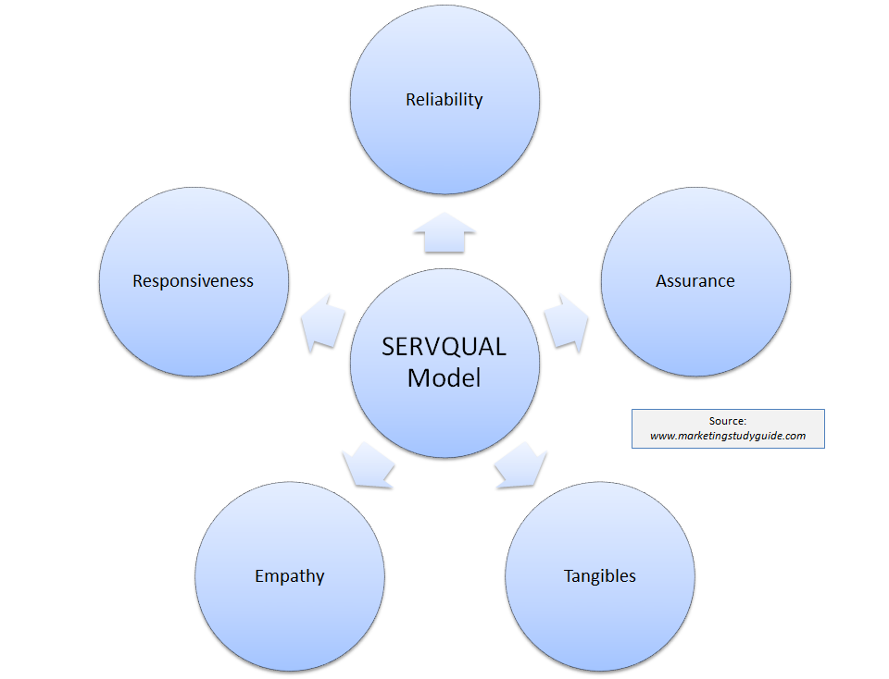

Figure 1: taken from google image.
Reliability- Customers expect a reliable reserve as promised and on time, performing services right the first time and maintain an error-free records. At DVLA every effort is made to deliver the service in time and as promised i.e. when driving test are booked and an examiner is off sick, replacement staff are booked in. This safes customers cost of rebooking the test and the cost of car hire. They also reimburse the customer if natural disasters takes place and the driving test does not take place.
Responsiveness- A prompt service to customers, keeping them informed when service will be performed, willingness and respond to customer’s requests and help. At DVLA they respond to customers request by closely monitoring the customers demand for test date and making sure there are more test dates are available.
Assurance- Employees who has the knowledge to answer customer question and make them feel safe with their transactions. There are room for improvement in DVLA for assurance, there are times when students call customer service team and they are not able to answer their quires.
Empathy- Customers want to be dealt with by employee in a caring manor, giving them individual attention and having customer’s best interest at heart. Staff who understand the needs of their customers. DVLA does empathise with their customers in certain aspects. When a student’s theory test is due to expire and they do not have much time to take the practical test and checking online for test date where waiting time is over 5 weeks, students are encouraged to call the customer service team for an earlier test date availability.
Tangibles- Employees with neat professional appearance. Modern and visually appealing facilities and materials. There is a gap in service from DVLA on this aspect, they have a very derelict buildings and facilities for customers to wait in. Their customer waiting areas can be improved to look appealing.
To maintain a sustainable relationship between a customer and the service provider it is vital for organisations to understand the customer experience. There are three parts to this interaction; customer journey, the touch points the customer interacts by and the environment in which this experiences occur. Customer journey map is a visual representation of the journey a customer has while experiencing a service or product. According to Richardson (2010) the more touch points you have the more complicated but necessary the journey map becomes.
Journey map is essential for DVLA to understand the questions the customers have, how they feel and the processes they go through, where the user has come from and what they are trying to achieve. It is a way of identifying the service gaps, user pain point and it generates new and innovative ideas. Time line is the starting point, next look at what happens at different stages. A frame work that is useful to look at is; Action – Motivation – Questions – Barriers (Richardson, 2010).
Actions, what actions are the customer taking to move to the next stage? One of the actions maybe they are researching about the product or services available through different touch points i.e. online research, mail, adverts or even a phone to a friend/family.
Motivation, what is motivating the customer to move to the next stage? what emotions are they feeling and have they found what they are looking for?
Questions, what are the uncertainties or jargon and other issues preventing the customer from moving to the next step?
Barriers, what are the structural, process, cost. Implementation or other barriers in the way of moving to the next steps?
This process certainly is not the only way to do a journey map of a customer, each organisation will have its own way of carrying out their customers journey map and this may include having further steps to the framework. It is also important to understand the journey is often non-linear. Some customers may jump from awareness straight to purchasing, customers are not inclined to do research. This usually happens where there has been a strong recommendation from previous service user, a friend or from a family member for example. In DVLA for example, when a customer is trying to book their practical driving test, they usually ask their friends or family about which test centre is best or where they passed their test and according to this they book their test. They do not really ask the driving instructor for advice on this or conduct any research of their own to find out which test centre has the highest pass rate or the best facility.
DIRFT model are used by some organisation to strategically manage the customer experience and maximize customer satisfaction, loyalty and thus revenue. The acronym DIRFT or Do It Right the First Time is usually the goal of many organisation/company.
A organisation must commit to doing the job right the first time (Juran, 2010). A customers needs and expectation must be met consistently through consistent delivery of product and services from organisation and this not a tranquil task for organisations. Despite organisations best intentions with training and resources in place, organisations often fail to do it right the first time. This is where tactical service in customer experience is crucial, this consists of two parts; setting expectations and expecting the customer to use the product/service and if the experience of the customer is not perfect then orchestrating the customers interactions with the service process. For an organisation to set expectations and helping customers get the most from the product/service are essential to strategic customer service. Customers interaction with the service department can benefit organisations at times because it highlights opportunities to solve problems and prevent future problems, increase loyalty and generate positive word of mouth.
Goodman (2019) states most customers do not complain and noncomplaining customers hurt your business. There are mainly four reasons the customers do not complain; customers think it will do no good, fear of damaging a long-term relationship, problem is aggravation but not critical and customers do not know where to complain. Dissatisfying customers need to tell the organisation about a problem otherwise it cannot be resolved.
Customer satisfaction and loyalty can be regained or installed even if the organisation did not do it right the first time, by breaking down barriers to complaining and providing all available communication channels when customers is using the product or service.
Customers know when a service is provided or delivered by DVLA through many ways. It can be through physical presence of service for example, a customer receiving their driving licence in the post or letter of confirmation of appointment booked for a service with DVLA. Evidence of service can be experience through the touch point they use to contact the client to confirm information, appointment booked or a reminder of even the service they booked.
Ethics are becoming more important to customer’s and suppliers of product and services. More and more organisation are having to change or alter their practices to meet the ethical needs to survive and to avoid legal expenses. Also due to the fact customers do not only go for value for money but also for social values and they will boycott brands that do not act ethically ( Mintel, 2019). Ethical values will differ from organisation to organisations depending on the nature of their service or product. DVLA considers its ethical sourcing for example with low environmental impact. They recycle paper and are moving towards using technology and online services to avoid sending paper trail for information to their customers.

Conclusion
In this assignment I started off with a brief description and back ground information about Driver Vehicle Licencing Agency and of the factors influencing DVLA’s ability to maximise customer value. Furthermore I analysed the model can/are used currently to meet these factors by DVLA. I then talked about what customer relationship management is and how DVLA has gap in their CRM system and through their annual report they have identified them. Benefits and challenges of developing and maintaining effective CRM was analysed. The current touch points used by the organisation and their customers and how E-CRM is becoming more important and relevant to the organisation to use and develop. The effectiveness in meeting customer requirement and expectation and how DVLA is meeting them. SERVQUAL model, Customer Journey map and DIRFT model which gave an inside into customer satisfaction and loyalty, was discussed for its effectiveness in meeting customer needs in DVLA and the improvement that can be made. This followed with evidence of service from the customer point of view and then I touched up on ethics in DVLA.

Refences
Bergeron. B., (2002). Essentials of CRM. United States of America: John Wiley & Sons.
Lierop. V, M. et al, (2017). What influences satisfication and loyalty in public transport. Trnsport Review, Volume 38(i).
Elservier, (2017). Customer Centric production planning and controlin job shops: A simulation optimization approach. Journal of Manufacturing System, Volume Volume 43, Part 1.
GOV.UK, (2019). Working for DLVA. [Online]
Available at: www.gov.uk
[Accessed August 2019].
Group. M., (2019). animal Welfare tops consumers' ethical wish list. [Online]
Available at: http://www.mintel.com/press-centre/food-and-drink/74-of-consumers-list-animal-welfare-among-the-top-factors-which-make-a-food-brand-ethical
[Accessed August 2019].
Information, G. S. a., (2019). GOV.UK. [Online]
Available at: www.gov.uk
[Accessed Saturday August 2019].
A. Goodman. et al, (2019). Strategic Customer Service. 2nd Edition ed. United States of America : HarperCoolins Leadership.
Juran. J., (2010). Juran's Quality Handbook. Sixth Edition ed. New York: McGraw-Hill.
Richardson, A., (2010). Using Customer Journey Maps to Improve Customer Experience. Harvard Business Review.
Shahin, D. A., n.d. SERVQUAL and Model of Servic Quality Gaps. Department of Management, University of Isfaha, Iran.
Transport, D. f., (2014). A Review of DVLA, London: Assets Publishing Service .
https://www.marketingstudyguide.com/wp-content/uploads/2013/08/servqual-model1.png

