
Early Disease Prediction Using Electronic Health Record Data
A Cross-Disease Study of Diabetes, Heart Disease, and Sepsis
A dissertation submitted in partial fulfilment of the requirements for the degree of
Master of Science in Data and Artificial Intelligence
by
Utsav Bodarya
Student ID: 2434902
Department of M.sc Data & AI
Academic Year 2025–2026

Declaration
I, Utsav Bodarya, declare that the work presented in this dissertation is my own, except where due acknowledgement has been made in the text. The work has not been submitted, in whole or in part, for any other degree at this or any other institution. All datasets used in this study are publicly available and properly cited. The source code accompanying this dissertation was developed by the author for the purposes of this project.
Signed: Utsav Bodarya
Date: 29/04/26

FORM OF CONSENT

I , Utsav Bodarya, hereby consent that my Project, submitted in candidature for the M.Sc. Applied Computing degree, if successful, may be made available for inter-library loan or photocopying (subject to the law of copyright), and that the title and abstract may be made available to outside organisations.

Signed : Utsav Bodarya

Date : 29/04/26

Acknowledgements
I would like to express my sincere gratitude to my dissertation supervisor for the guidance, patience, and constructive feedback provided throughout this project. Their suggestions during the early phases helped me narrow what was originally an over-ambitious scope into a focused, achievable comparative study.
I am thankful to the curators of the PIMA Indians Diabetes Database, the UCI Cleveland Heart Disease dataset, and the PhysioNet/Computing in Cardiology 2019 Challenge dataset for making clinical data freely available to the research community. Without these open resources, reproducible research in healthcare machine learning would not be possible.
I would also like to thank the wider open-source community whose tools — particularly scikit-learn, NumPy, pandas, matplotlib, and seaborn — formed the technical backbone of this project. Special thanks to my course peers for the many discussions on imbalanced data, evaluation metrics, and the everyday frustrations of model debugging.
Finally, I am grateful to my family for their unwavering support during the long evenings and weekends that this work required.

Abstract
Early prediction of chronic and acute disease from Electronic Health Record (EHR) data is one of the most actively investigated problems in clinical machine learning, and yet there remains little consistency in how methods are compared across diseases of fundamentally different epidemiological character. Most published studies focus on a single condition, a single dataset, and a single class of models, which makes it hard to disentangle algorithm quality from dataset quality. This dissertation addresses that gap by building a unified, reproducible machine learning framework and applying it identically to three clinically and statistically distinct prediction tasks: type-2 diabetes onset using the PIMA Indians dataset (n = 768), coronary heart disease using the UCI Cleveland dataset (n = 303), and in-ICU sepsis onset using the PhysioNet/CinC 2019 Challenge dataset (n ≈ 31,200 hourly records).
Five widely-used supervised learning models — Logistic Regression, Random Forest, Support Vector Machine, Gradient Boosting, and a Multi-Layer Perceptron — were trained under an identical preprocessing pipeline consisting of median imputation, stratified 80/20 splitting, standard scaling, random oversampling of the minority class restricted to the training fold, and 5-fold cross-validated grid search for hyperparameter tuning. All models were evaluated on a held-out test set using accuracy, precision, recall, F1, and AUC-ROC.
Across the three diseases, no single model dominated. SVM achieved the highest test AUC for diabetes (0.8215) and sepsis (0.9997); Logistic Regression achieved the highest AUC for heart disease (0.9578) and the highest mean AUC across all three tasks (0.9234). Random Forest and Gradient Boosting were competitive but did not justify their additional complexity on the smaller datasets. The simplest model — Logistic Regression — was both the most consistent performer and the most interpretable, an outcome that aligns with a growing literature recommending simpler, transparent models for high-stakes clinical decisions. Feature importance analysis recovered clinically plausible drivers in every case (glucose and BMI for diabetes; thalassemia and number of major vessels for heart disease; lactate and respiratory rate for sepsis), which supports the construct validity of the pipeline.
The study contributes (i) a reproducible, sklearn-only pipeline that runs end-to-end on three public datasets without proprietary dependencies; (ii) a head-to-head comparison of five models under identical evaluation; and (iii) an honest accounting of dataset-specific limitations, including the patient-level structure of the PhysioNet sepsis data which inflates apparent performance. The findings reinforce the case for cautious, interpretable, and disease-specific modelling in clinical AI rather than the search for a single dominant algorithm.
Keywords: machine learning, electronic health records, diabetes, heart disease, sepsis, classification, AUC-ROC, class imbalance, feature importance, clinical decision support.

Table of Contents
Declaration 2
Acknowledgements 3
Abstract 4
Table of Contents 6
List of Figures 10
List of Tables 11
Chapter 1 Introduction 12
1.1 Background and Motivation 12
1.2 Problem Statement 13
1.3 Aim and Objectives 14
1.4 Research Questions 15
1.5 Significance and Contribution 15
1.6 Scope and Limitations 16
1.7 Structure of the Dissertation 16
Chapter 2 Literature Review 18
2.1 Introduction 18
2.2 Electronic Health Records and Clinical Decision Support 18
2.3 Machine Learning in Healthcare: An Overview 19
2.4 Diabetes Prediction: A Review 20
2.5 Heart Disease Prediction: A Review 21
2.6 Sepsis Prediction: A Review 22
2.7 Class Imbalance in Clinical Prediction 23
2.8 Comparative Studies 24
2.9 Summary and Research Gap 25
Chapter 3 Methodology 26
3.1 Research Approach 26
3.2 Datasets 26
3.2.1 PIMA Indians Diabetes Database 26
3.2.2 UCI Cleveland Heart Disease Dataset 27
3.2.3 PhysioNet/Computing in Cardiology 2019 Sepsis Dataset 27
3.2.4 Summary of Dataset Properties 28
3.3 Preprocessing Pipeline 28
3.3.1 Stage 1 — Type Coercion and Initial Cleaning 28
3.3.2 Stage 2 — Imputation of Missing Values 29
3.3.3 Stage 3 — Train/Test Split 29
3.3.4 Stage 4 — Standard Scaling 29
3.3.5 Stage 5 — Random Oversampling of the Minority Class 30
3.3.6 Pipeline Order Justification 30
3.4 Models Compared 30
3.4.1 Logistic Regression 31
3.4.2 Random Forest 31
3.4.3 Support Vector Machine 31
3.4.4 Gradient Boosting 31
3.4.5 Multi-Layer Perceptron (Artificial Neural Network) 32
3.5 Hyperparameter Tuning 32
3.6 Evaluation Metrics 33
3.7 Implementation and Computational Environment 34
Chapter 4 Results and Analysis 35
4.1 Overview 35
4.2 Diabetes (PIMA Indians) 35
4.2.1 Cross-Validation Performance 35
4.2.2 Test-Set Performance 35
4.2.3 Feature Importance 38
4.3 Heart Disease (UCI Cleveland) 39
4.3.1 Cross-Validation Performance 39
4.3.2 Test-Set Performance 39
4.3.3 Feature Importance 42
4.4 Sepsis (PhysioNet) 42
4.4.1 Cross-Validation Performance 42
4.4.2 Test-Set Performance 43
4.4.3 Feature Importance 45
4.4.4 Caveat: Interpreting the Sepsis AUC 46
4.5 Cross-Disease Comparison 47
4.6 Summary 49
Chapter 5 Discussion 50
5.1 Interpretation of Findings 50
5.2 Cross-Disease Patterns 51
5.3 Comparison with Prior Work 52
5.4 Clinical and Practical Implications 53
5.5 Limitations 54
5.6 Threats to Validity 55
Chapter 6 Conclusion and Future Work 56
6.1 Summary of the Dissertation 56
6.2 Contributions 56
6.3 Future Work 57
6.4 Closing Remarks 58
References 59

List of Figures
Figure 4.1 ROC curves for the five classifiers on the PIMA Diabetes test set.
Figure 4.2 Test-set performance metrics for the five classifiers on the PIMA Diabetes dataset.
Figure 4.3 Confusion matrix for the best-performing model (SVM) on the PIMA Diabetes test set.
Figure 4.4 Random Forest feature importances for the PIMA Diabetes dataset.
Figure 4.5 ROC curves for the five classifiers on the UCI Cleveland Heart Disease test set.
Figure 4.6 Test-set performance metrics for the five classifiers on the Heart Disease dataset.
Figure 4.7 Confusion matrix for the best-performing model (Logistic Regression) on the heart disease test set.
Figure 4.8 Random Forest feature importances for the Heart Disease dataset.
Figure 4.9 ROC curves for the five classifiers on the PhysioNet Sepsis test set.
Figure 4.10 Test-set performance metrics for the five classifiers on the Sepsis dataset.
Figure 4.11 Confusion matrix for the best-performing model (SVM) on the Sepsis test set.
Figure 4.12 Random Forest feature importances for the Sepsis dataset.
Figure 4.13 Cross-disease AUC heatmap (models × datasets).
Figure 4.14 Mean cross-disease AUC by classifier.

List of Tables
Table 3.1 Summary of the three datasets used in this study.
Table 4.1 Test-set performance of the five classifiers on the PIMA Diabetes dataset.
Table 4.2 Test-set performance of the five classifiers on the UCI Cleveland Heart Disease dataset.
Table 4.3 Test-set performance of the five classifiers on the PhysioNet Sepsis dataset.
Table 4.4 Mean test-set AUC by classifier across the three diseases.

Chapter 1 Introduction

1.1 Background and Motivation
Healthcare systems around the world are under sustained pressure. Populations are ageing, the burden of chronic disease is rising, and acute conditions such as sepsis continue to consume a disproportionate share of intensive-care resources. The World Health Organization estimates that noncommunicable diseases account for around three-quarters of all deaths globally, with diabetes and cardiovascular disease among the leading causes [1]. The International Diabetes Federation reported that in 2021 approximately 537 million adults were living with diabetes and projects this figure to rise to 783 million by 2045 [2]. Cardiovascular disease remains the single largest contributor to global mortality, with an estimated 18 million deaths each year attributed to heart disease and stroke [3]. Sepsis, a life-threatening organ dysfunction caused by a dysregulated host response to infection, is implicated in roughly one in five deaths worldwide and carries an in-hospital mortality of 25–30 percent in severe cases [4].
Set against this clinical backdrop is the rapid digitisation of medical records. Electronic Health Record (EHR) systems have become near-universal in high-income healthcare settings; in the United States more than 95 percent of non-federal acute-care hospitals had adopted certified EHR systems by 2015 [10]. This digitisation has produced an unprecedented volume of structured patient data — vital signs, laboratory results, medication histories, demographic information, and clinical notes — that in principle can be mined to identify patients at elevated risk of disease before that risk becomes clinically obvious. The promise of using this data to enable earlier diagnosis, personalised intervention, and more efficient resource allocation has motivated a large and growing body of work in clinical machine learning [5], [6], [7].
Machine learning (ML) is well suited to this task. Classical statistical methods such as logistic regression have been used in medicine for decades, but modern ML adds the ability to model high-dimensional, non-linear relationships among many variables simultaneously, often without strong distributional assumptions. Supervised classification, the focus of this dissertation, takes a set of features describing a patient and learns a function that maps those features to a clinical outcome label. When the function generalises well to unseen patients, it can serve as the computational core of a clinical decision support system [9].
However, three uncomfortable facts complicate this optimistic picture. First, performance varies enormously by disease and by dataset; a model that achieves an AUC-ROC of 0.95 on one cohort may achieve only 0.75 on another for the same condition, depending on the patient population, the features collected, the labelling convention, and the temporal structure of the data [9], [32]. Second, no single algorithm dominates across all clinical tasks. Tree-based ensembles such as Random Forests and Gradient Boosting often perform well on tabular EHR data, but logistic regression remains a strong baseline that is harder to beat than is sometimes acknowledged [39], [40]. Third, the published literature is fragmented: most studies focus on a single disease, a single dataset, and a small subset of models. The reader interested in cross-disease patterns is left to assemble those patterns from many incompatible papers — different splits, different metrics, different preprocessing, different definitions of the outcome.
It is this third gap that motivates the present dissertation. If we want to make general statements about how machine learning behaves on clinical prediction problems — about which algorithms are robust, which are fragile, what role data quality plays, and where simpler models are preferable to complex ones — we need head-to-head comparisons under identical methodology, applied to a panel of clinically distinct diseases.

1.2 Problem Statement
The central problem addressed in this dissertation is the absence of a uniform, reproducible comparative framework for evaluating machine learning models on multiple disease prediction tasks drawn from EHR-style data. Existing comparative studies typically vary along too many axes — dataset, preprocessing, model family, evaluation metric, and tuning protocol — to draw clean conclusions about which differences are attributable to the algorithm and which to the data. As a result, the practitioner who wishes to know whether, for example, a Gradient Boosting model is preferable to logistic regression for a new EHR prediction task has no principled basis for that choice, beyond intuition and the most recent benchmark headline.
More specifically, the problem can be decomposed into three sub-problems. The first is methodological: building a single preprocessing and modelling pipeline that handles three datasets of very different size, dimensionality, and class balance. The second is empirical: training, tuning, and fairly evaluating five algorithmic families on each dataset, then summarising the results in a way that supports cross-disease comparison. The third is interpretive: using feature importance and other tools to determine whether the models, when they perform well, are picking up on clinically plausible signals or merely exploiting artefacts of the data.

1.3 Aim and Objectives
The overarching aim of this dissertation is to design, implement, and evaluate a unified machine learning framework for early prediction of three diseases — diabetes, heart disease, and sepsis — and to use the resulting comparison to draw evidence-based conclusions about model behaviour on EHR-style clinical data.
To achieve this aim, the following specific objectives were set:
Objective 1: To curate three publicly-available clinical datasets — PIMA Indians Diabetes [20], UCI Cleveland Heart Disease [21], and PhysioNet/CinC 2019 Sepsis [23] — and bring them into a common analytic format suitable for supervised classification.
Objective 2: To design and implement a single, reproducible preprocessing pipeline that addresses missing values, feature scaling, train/test splitting, and class imbalance, applied identically to all three datasets to remove preprocessing as a confounding variable.
Objective 3: To train five widely-used supervised classifiers — Logistic Regression, Random Forest, Support Vector Machine, Gradient Boosting, and a Multi-Layer Perceptron — using cross-validated hyperparameter tuning on each dataset.
Objective 4: To evaluate all trained models on a held-out test set using accuracy, precision, recall, F1, and the area under the receiver operating characteristic curve, and to visualise the results through ROC curves, bar charts, and confusion matrices.
Objective 5: To extract and interpret feature importance from the best-performing tree-based models in order to assess clinical plausibility and to compare with the existing medical literature.
Objective 6: To synthesise findings across the three diseases, including a cross-disease AUC heatmap, in order to identify model-level and disease-level patterns that can guide future work in clinical prediction.

1.4 Research Questions
The objectives above are operationalised through the following research questions, which the remainder of this dissertation is organised to answer:
RQ1. How do five widely-used supervised classifiers (Logistic Regression, Random Forest, SVM, Gradient Boosting, and MLP) compare in their ability to predict diabetes, heart disease, and sepsis on standard public datasets when evaluated under identical preprocessing and tuning?
RQ2. Does any single algorithmic family consistently dominate across the three clinical tasks, or does the best model vary by disease in ways that can be linked to dataset size, dimensionality, or class balance?
RQ3. Do the feature importance scores produced by the best-performing tree-based models recover clinically plausible predictors that align with the established medical literature for each disease?
RQ4. What practical and methodological lessons can be drawn from a cross-disease comparison of model performance, and how should those lessons inform future work on clinical decision support?

1.5 Significance and Contribution
This dissertation contributes to clinical machine learning research in three concrete ways. First, it provides a reproducible end-to-end pipeline implemented entirely with mainstream Python libraries (scikit-learn, pandas, NumPy, matplotlib) and free of proprietary dependencies. The full source code, including the loaders, preprocessing, model definitions, and evaluation utilities, is structured into four modules totalling approximately 400 lines of Python — short enough to be readable, long enough to be useful. The pipeline can be re-run end-to-end on a standard laptop and produces identical results given the random seeds reported.
Second, the dissertation provides direct, head-to-head comparison of five modelling families on three clinically distinct datasets under matched conditions. Where previous comparative studies typically fix the dataset and vary the model, or fix the model and vary the dataset, the present work varies both in a controlled way and reports the resulting interaction. The cross-disease AUC heatmap presented in Chapter 4 is, to the author’s knowledge, the first such artefact to span exactly these three datasets under a single reproducible pipeline.
Third, the dissertation places strong emphasis on honest reporting. Modern clinical machine learning has been criticised for selective reporting and for headline numbers that fail to replicate in deployment [32], [40]. Throughout the present work, every reported number was generated by the accompanying code, and dataset-specific limitations — including the very high apparent AUC on the sepsis dataset, which is in part attributable to the patient-level structure of that data — are explicitly discussed rather than glossed over. This commitment to honest reporting is itself a small contribution to the methodological hygiene of the field.

1.6 Scope and Limitations
The scope of this dissertation is deliberately bounded. The work is confined to supervised binary classification on three publicly available structured tabular datasets. Free-text clinical notes, medical imaging, time-series modelling beyond the per-record level, and federated or privacy-preserving learning are out of scope, although several are signposted as future-work directions in Chapter 6. The five models compared cover a representative range of algorithmic families (linear, tree-ensemble, kernel, boosted-tree, and shallow neural network) but do not include every possible model — most notably, no deep recurrent or transformer architectures are evaluated, since the chosen datasets are tabular rather than sequential at the granularity used here.
The principal limitations should be stated up front. The PIMA and Cleveland datasets are small (768 and 303 records respectively), which inevitably caps the complexity that any model can learn and increases the variance of test-set estimates. The PhysioNet sepsis data, while larger, is structured at the hourly-record level rather than the patient level, which leads to optimistic evaluation when records are split rather than patients. None of the three datasets is contemporary; the diabetes data dates from the 1980s and the Cleveland data from 1989. The findings of this study should therefore be interpreted as informative of general modelling behaviour, not as directly deployable risk scores for current clinical use.

1.7 Structure of the Dissertation
The remainder of this dissertation is organised as follows. Chapter 2 reviews the relevant literature, beginning with the role of EHRs in healthcare and the rise of machine learning in clinical decision support, and then turning to disease-specific work on diabetes, heart disease, and sepsis prediction. Chapter 3 describes the methodology, including the datasets, preprocessing pipeline, models, hyperparameter tuning protocol, evaluation metrics, and implementation environment. Chapter 4 presents the empirical results — per-disease performance tables, ROC curves, confusion matrices, feature importance plots, and the cross-disease AUC heatmap. Chapter 5 discusses the findings, places them in the context of the existing literature, and considers their clinical implications and limitations. Chapter 6 concludes the dissertation, summarises the main contributions, and outlines directions for future work. A complete IEEE-style reference list closes the document.

Chapter 2 Literature Review

2.1 Introduction
This chapter situates the present work in the wider literature on machine learning for clinical prediction. The review proceeds in seven parts. Section 2.2 introduces the technological and policy context of Electronic Health Records and clinical decision support. Section 2.3 surveys the rise of machine learning in healthcare more generally. Sections 2.4, 2.5, and 2.6 review the disease-specific literature on diabetes, heart disease, and sepsis prediction respectively. Section 2.7 examines the methodological literature on class imbalance, which is a recurring problem in clinical data. Section 2.8 surveys comparative studies that, like the present work, evaluate multiple models on a single problem. Section 2.9 articulates the research gap that this dissertation seeks to address.

2.2 Electronic Health Records and Clinical Decision Support
An Electronic Health Record is a longitudinal digital record of a patient’s health information generated by one or more encounters in any care delivery setting. EHRs typically contain demographics, medical history, medications, allergies, immunisations, laboratory results, vital signs, radiology images, and clinical notes. The transition from paper records to EHRs has been one of the largest infrastructure shifts in modern healthcare; in the United States, federal incentives under the HITECH Act of 2009 drove EHR adoption from below 10 percent in 2008 to above 95 percent of acute-care hospitals by 2015 [10]. Similar adoption curves have been observed in the United Kingdom’s National Health Service and in many European and Asian healthcare systems.
Clinical decision support systems (CDSS) are software tools designed to assist healthcare professionals in making decisions about diagnosis, treatment, or care planning. Early CDSS were rule-based, relying on if–then logic curated by medical experts. The maturation of EHR data has shifted that paradigm: modern CDSS increasingly use statistical and machine-learning models trained directly on patient data to estimate probabilities of outcomes such as readmission, deterioration, or specific diagnoses. Goldstein et al. [9] provide a useful taxonomy of the methodological challenges that arise when developing risk prediction models from EHR data, including high dimensionality, missing-not-at-random patterns, label noise, distribution shift between training and deployment, and the heterogeneity of clinical populations.
Two influential recent commentaries — Beam and Kohane [7] and Topol [6] — argue that the next decade of clinical decision support will be defined by the convergence of EHR data with modern machine learning. Both authors caution, however, that the leap from research benchmark to deployed system is large. Issues of bias, fairness, accountability, regulatory clearance, and physician workflow integration are at least as important as raw predictive accuracy. The TRIPOD reporting guideline [40] was developed precisely because the medical literature on prediction models had become difficult to interpret and difficult to compare due to inconsistent reporting of methods and results.

2.3 Machine Learning in Healthcare: An Overview
The use of machine learning in medicine is not new. Logistic regression has been a workhorse of clinical risk modelling since at least the 1970s, and tools such as the Framingham risk score for cardiovascular disease are descended directly from such regressions. What has changed in the last fifteen years is the scale of available data, the maturity of open-source software, and the predictive performance achievable with modern algorithms. Rajkomar, Dean, and Kohane [5] survey the current state of medical machine learning and identify three classes of application: (i) descriptive (clustering patients, surfacing patterns), (ii) predictive (estimating the probability of a future outcome), and (iii) prescriptive (suggesting an action, such as a treatment). The present dissertation falls squarely into the predictive class.
Esteva et al. [8] provide a parallel survey, with a particular emphasis on deep learning. Their review covers landmark applications in dermatology, ophthalmology, radiology, pathology, and genomics, and notes that the success of deep learning in those domains has often been driven by the availability of very large labelled image datasets. The picture for tabular EHR data is somewhat different: in many head-to-head comparisons on tabular tasks, deep neural networks fail to outperform tuned tree-based ensembles such as Random Forests [11] or Gradient Boosting Machines [13], [17]. This empirical observation, reinforced by recent benchmarks on tabular data outside healthcare, has consequences for model selection in clinical prediction and is one of the motivations for the algorithmic mix studied in this dissertation.
On the methodological side, three review papers are particularly useful for the present work. Hastie, Tibshirani, and Friedman [46] provide the canonical textbook treatment of supervised learning, including detailed accounts of every algorithmic family used in this dissertation. Pedregosa et al. [16] introduce scikit-learn, the Python library on which essentially all the implementations in this work depend. Bergstra and Bengio [41] argue, against the conventional wisdom of grid search, that random search over hyperparameters is often more efficient; in this dissertation grid search is retained nonetheless, because the grids are small enough that exhaustive search is tractable, and because reproducibility of the exact configuration is desirable.
A final strand of the literature deserves particular attention: the case for interpretable models in healthcare. Rudin [39] argues forcefully that high-stakes decisions should not be made by black-box models when comparable accuracy is achievable with transparent ones, because post-hoc explanations of black boxes can themselves be misleading. Lundberg and Lee [26] develop SHAP, a unified framework for local explanations that has become widely used in clinical ML, and Ribeiro et al. [38] propose LIME, a similar local-explanation technique. The present dissertation does not implement SHAP, but it does report tree-based feature importances and discusses their plausibility against medical knowledge, which is a similar though coarser interpretability strategy.

2.4 Diabetes Prediction: A Review
Type-2 diabetes has been one of the most heavily studied targets for machine-learning prediction, in part because the PIMA Indians Diabetes Database [20] has been a standard benchmark since the late 1980s. The dataset, originally compiled by the U.S. National Institute of Diabetes and Digestive and Kidney Diseases, contains 768 records of female patients of Pima Indian heritage aged 21 and over, with eight predictor variables (number of pregnancies, plasma glucose concentration, diastolic blood pressure, triceps skin-fold thickness, serum insulin, body mass index, diabetes pedigree function, and age) and a binary outcome (diabetic / non-diabetic at five-year follow-up). The PIMA dataset is small by modern standards but is well-documented, free of identifying information, and structurally clean, which makes it a convenient testbed for new methods.
Smith et al. [20], in the original publication accompanying the dataset, used a connectionist learning algorithm called ADAP and reported a sensitivity of 76 percent and specificity of 76 percent at a chosen operating point. Subsequent studies have applied virtually every standard machine-learning method to this dataset. Sisodia and Sisodia [29], for example, compared Naive Bayes, decision trees, and SVM on the PIMA data and reported accuracies in the range 73–76 percent. Maniruzzaman et al. [28] compared Random Forest, Decision Trees, Adaboost, Naive Bayes, Gaussian Process, Logistic Regression, Linear Discriminant Analysis, and Quadratic Discriminant Analysis, with reported accuracies of 75–80 percent and AUCs around 0.81–0.86 depending on the protocol. Saito et al. [27] used a larger Japanese cohort to predict diabetes onset over a longer follow-up and reported AUCs of 0.86–0.93 with gradient boosting, suggesting that on richer cohorts, performance improves substantially.
Several methodological observations from this literature deserve highlighting. First, the PIMA dataset has a substantial number of physiologically impossible zero values in fields such as plasma glucose, blood pressure, and insulin, which on closer inspection represent missing data encoded as zero. Studies that fail to recode and impute these values typically report inflated performance, because the zeros become easy-to-classify outliers. The present dissertation handles this issue explicitly in preprocessing (Section 3.4). Second, the class balance is mildly imbalanced (about 65 percent negative, 35 percent positive), which is mild enough that simple sampling techniques are sufficient. Third, performance on the PIMA dataset has been roughly stagnant for two decades, with most published results clustering in an AUC band of 0.78–0.86. This stagnation is itself informative: it suggests a Bayes-error ceiling on the dataset that no amount of model sophistication can overcome.

2.5 Heart Disease Prediction: A Review
The UCI Cleveland Heart Disease dataset [21], [22] occupies a position in the cardiovascular ML literature analogous to that of PIMA in the diabetes literature. The original publication by Detrano et al. [21] applied a logistic-regression-based probability algorithm to detect coronary artery disease at four institutions, including the Cleveland Clinic. The dataset has 303 instances and 14 attributes (age, sex, chest-pain type, resting blood pressure, serum cholesterol, fasting blood sugar, resting ECG, maximum heart rate, exercise-induced angina, oldpeak, slope of peak exercise ST segment, number of major vessels coloured by fluoroscopy, thalassemia, and the diagnostic target). The original 14-attribute subset is widely used as a benchmark.
A systematic literature review by Ahsan, Luna, and Siddique [30] surveys 49 papers on machine-learning-based heart disease diagnosis published between 2003 and 2021. The authors find that Random Forest, Decision Tree, Naive Bayes, K-Nearest Neighbours, SVM, and Logistic Regression are all heavily represented, with reported accuracies on Cleveland-style data ranging from approximately 75 percent up to 95 percent. The review notes that performance varies dramatically with preprocessing choices and that direct comparison across studies is difficult because of inconsistent train/test splits, target labelling (binary vs. five-class), and feature subsets.
Mohan, Thirumalai, and Srivastava [31] proposed a hybrid approach combining Random Forest with a linear method on Cleveland data and reported accuracy of 88.7 percent and AUC of 0.92, which is among the higher reported figures in the literature. The present dissertation, using a deliberately simple pipeline, achieves a comparable test AUC of 0.958 with a tuned logistic regression model (Chapter 4), suggesting that the headline gains from elaborate hybrid models on this dataset may be smaller than is sometimes claimed once preprocessing is properly controlled.
From a clinical standpoint, the features that consistently emerge as most predictive in published Cleveland studies — chest-pain type, number of major vessels, thalassemia, exercise-induced ST depression, and maximum heart rate — align well with the established cardiology literature on coronary artery disease risk factors. This concordance between data-driven feature importance and clinical knowledge is reassuring and is one of the points the present dissertation revisits when discussing feature importance in Chapter 4.

2.6 Sepsis Prediction: A Review
Sepsis is qualitatively different from the previous two prediction targets. Whereas diabetes and heart disease are diagnosed at the patient level over a span of months or years, sepsis evolves over hours and is most usefully predicted at the bedside in real time. The Sepsis-3 consensus definition by Singer et al. [4] formalised sepsis as life-threatening organ dysfunction caused by a dysregulated host response to infection, operationalised by a change in the Sequential Organ Failure Assessment (SOFA) score of 2 or more points. Even before this consensus, the importance of early detection had been long established: each hour of delay in administering appropriate antibiotics is associated with a measurable increase in mortality.
The PhysioNet/Computing in Cardiology Challenge 2019 [23], [24] explicitly addressed early sepsis prediction. The challenge organisers released hourly clinical data — vital signs, laboratory results, and demographics — for over 40,000 ICU patients across two hospital systems, with sepsis labels provided per hour. The challenge attracted more than 100 teams; the top-performing entries used Gradient Boosting Machines and recurrent neural networks and achieved utility scores in the range 0.30–0.36 on the official challenge metric, which is a custom function that rewards predictions made several hours before sepsis onset and penalises false alarms. Reyna et al. [23] provide a thorough analysis of the top 10 entries and note that the most successful approaches combined feature engineering (lagged vital signs, summary statistics over recent windows) with tree-based ensembles.
Earlier work by Desautels et al. [33] on the MIMIC-III ICU dataset [36] reported AUCs of 0.74–0.80 for sepsis prediction four hours before onset, using a small set of vital signs. Komorowski et al. [34] used reinforcement learning rather than classification to learn optimal sepsis treatment policies. The eICU Collaborative Research Database [35] is another widely used multi-centre source for sepsis ML research and offers cleaner patient-level structure than the PhysioNet challenge data.
Two methodological points from this literature are particularly relevant to the present dissertation. First, the PhysioNet 2019 data is structured at the per-patient-per-hour level, which means that a naive record-level random split — as opposed to a patient-level split — places different time-points from the same patient into both training and test sets, leading to optimistically biased performance. The pipeline used in this dissertation employs record-level splitting because that is what the loader as written produces, and the inflated performance numbers are explicitly acknowledged in the discussion. Second, the PhysioNet data exhibits very heavy missingness — many laboratory variables have more than 60 percent missing entries — which forces aggressive imputation or column dropping. The present pipeline drops columns with more than 60 percent missing data and median-imputes the rest, which is a coarse approach but reproducible.

2.7 Class Imbalance in Clinical Prediction
Class imbalance is the rule rather than the exception in clinical prediction. Most diseases are rare relative to the population at risk; in the PhysioNet sepsis data fewer than 10 percent of patients develop sepsis during their ICU stay, and at the per-hour level the positive-class proportion is much lower still. Standard classifiers trained on imbalanced data tend to be biased toward the majority class, achieving high overall accuracy by simply predicting "no disease" for everyone. This is well documented in the imbalanced learning literature, of which He and Garcia [19] provide an authoritative overview.
Three broad families of techniques exist for addressing imbalance. The first is data-level resampling, in which the training set is modified to be more balanced. Random over-sampling duplicates minority-class examples; random under-sampling discards majority-class examples; and the Synthetic Minority Over-sampling Technique (SMOTE), introduced by Chawla et al. [18], generates synthetic minority examples by linear interpolation between an example and one of its k nearest minority neighbours. The second is algorithmic, in which the loss function is modified to weight the minority class more heavily; this is exposed in scikit-learn through the class_weight parameter on most classifiers. The third is threshold-moving, in which the model is trained as usual on the imbalanced data and the decision threshold is then adjusted post-hoc to suit a target precision–recall trade-off.
In the present dissertation, two of these strategies are used in combination. Random oversampling of the minority class to match the majority class is applied to the training fold only, after the train/test split, to avoid information leakage; this is the recommended practice in the imbalanced-learning literature [19]. In addition, the class_weight="balanced" option is used for Logistic Regression, Random Forest, and SVM, which causes scikit-learn to reweight the per-sample loss inversely to class frequency. SMOTE is not used in the present pipeline; while SMOTE is often more effective than naive oversampling, it is not part of base scikit-learn, and one of the design goals of this work was to keep dependencies minimal. The discussion in Chapter 5 returns to this choice as a limitation that future work could address.

2.8 Comparative Studies
A modest number of papers have explicitly set out to compare multiple machine-learning models on the same clinical prediction task, and a still smaller number have compared multiple models on multiple diseases. The systematic review by Ahsan et al. [30] is one example of the former for heart disease, and the comparative paper by Maniruzzaman et al. [28] is another for diabetes. Bertsimas et al. [37] take a different angle, focusing on the robustness of classifiers under distributional perturbation.
Genuinely cross-disease comparative work is rarer. Most large-scale benchmarks in the broader machine-learning literature use synthetic or non-medical data, partly because medical datasets are often subject to access controls. Where cross-disease comparisons do exist, they tend to focus on a single algorithmic family — for example, several papers compare Gradient Boosting variants across multiple clinical tasks but do not include logistic regression or neural networks as comparators.
The present dissertation occupies the intersection of these two strands: multiple models, multiple diseases, single pipeline. The closest comparable prior work is unpublished or buried in the appendices of larger studies. The methodological transparency of the approach taken here — fully open code, public datasets, reproducible random seeds, single tuning protocol — is the principal contribution.

2.9 Summary and Research Gap
In summary, the literature reviewed in this chapter establishes three points. First, EHR data and machine learning together represent one of the most promising avenues for improving early detection of disease, and there is now a substantial body of work on diabetes, heart disease, and sepsis prediction in particular. Second, despite the volume of published work, direct comparison across studies is hampered by inconsistent preprocessing, evaluation, and reporting; the methodological hygiene of the field is improving but remains uneven. Third, comparative studies that span multiple diseases under a single methodology are rare, which leaves the practitioner without principled guidance on how model performance varies across tasks.
This last point is the gap that the present dissertation addresses. Chapters 3 and 4 describe and execute a single pipeline that is identical in every respect except for the dataset itself, applied to three clinically distinct prediction problems. The result is a small but rigorous comparative study that complements the much larger literatures on each individual disease. Chapter 5 then interprets the findings against the prior work surveyed above, and Chapter 6 outlines the directions in which the work could naturally be extended.

Chapter 3 Methodology

3.1 Research Approach
This dissertation adopts a quantitative, experimental research approach. The work is empirical rather than theoretical: a fixed pipeline is designed, implemented, and applied to three datasets, and the resulting numerical performance metrics constitute the evidence on which conclusions are drawn. Within the broader taxonomy of research methods, the approach is best described as a comparative experimental study with controlled variables (preprocessing, tuning protocol, evaluation metrics) and free variables (dataset and model family). The aim is not to discover a new algorithm but to use existing algorithms to answer the research questions stated in Chapter 1.
A consequence of this design is that every claim made in Chapter 4 should be reproducible by re-running the accompanying code on the same datasets with the same random seeds. This commitment to reproducibility is operationalised through three specific choices: (i) the use of a single random seed (42) for all stochastic components, including train/test splitting, oversampling, cross-validation folds, and stochastic model initialisation; (ii) the deposit of all generated tables and figures alongside the source code; and (iii) the use only of public datasets and open-source software with stable, version-pinned APIs.

3.2 Datasets
Three datasets were used in this study. All are publicly available and have been widely used in prior work, which makes the results of the present dissertation easier to compare to existing benchmarks.

3.2.1 PIMA Indians Diabetes Database
The PIMA Indians Diabetes Database, originally compiled by the U.S. National Institute of Diabetes and Digestive and Kidney Diseases, contains 768 records of female patients of Pima Indian heritage aged 21 and over [20]. Each record consists of eight numerical features — Pregnancies, Glucose, BloodPressure, SkinThickness, Insulin, BMI, DiabetesPedigreeFunction, and Age — and a binary outcome label indicating whether the patient was diagnosed with diabetes within five years of the initial assessment. The class distribution is approximately 65 percent negative (500 records) and 35 percent positive (268 records). A well-known data-quality issue with this dataset is the encoding of missing values as zero in the Glucose, BloodPressure, SkinThickness, Insulin, and BMI columns; these zeros are physiologically impossible (a patient with zero blood pressure would not be alive) and are recoded to NaN in preprocessing.

3.2.2 UCI Cleveland Heart Disease Dataset
The Cleveland Heart Disease dataset, drawn from the UCI Machine Learning Repository [21], [22], contains 303 records collected by Detrano et al. [21] at the Cleveland Clinic Foundation. Each record consists of 13 features mixing demographic, vital-sign, and clinical-test variables — age, sex, chest-pain type (cp), resting blood pressure (trestbps), serum cholesterol (chol), fasting blood sugar (fbs), resting electrocardiographic results (restecg), maximum heart rate achieved (thalach), exercise-induced angina (exang), ST depression induced by exercise (oldpeak), slope of the peak exercise ST segment (slope), number of major vessels coloured by fluoroscopy (ca), and thalassemia (thal). The original target is an integer 0–4 indicating disease severity; following the dominant convention in the literature, the present dissertation treats values 1–4 as positive and 0 as negative, yielding a binary classification task. Six rows in the original distribution contain missing values encoded as "?", which are mapped to NaN; rows with too many missing values are dropped during preprocessing.

3.2.3 PhysioNet/Computing in Cardiology 2019 Sepsis Dataset
The PhysioNet/CinC 2019 Challenge dataset [23], [24] consists of hourly clinical observations from over 40,000 ICU patients across two hospital systems. Each row corresponds to one hour of one patient and contains vital signs, laboratory results, demographic information, and a binary SepsisLabel indicating whether the patient is currently within a labelled sepsis window. For the purposes of this dissertation a pre-processed CSV containing 20,000 hourly records was used, with the columns HR (heart rate), O2Sat (oxygen saturation), Temp (temperature), SBP (systolic blood pressure), MAP (mean arterial pressure), DBP (diastolic blood pressure), Resp (respiratory rate), WBC (white blood cell count), Creatinine, Lactate, Glucose, BUN (blood urea nitrogen), Age, Gender, and ICULOS (ICU length of stay in hours). The dataset has substantial missingness, with several laboratory variables (e.g. Lactate, Creatinine) missing in more than 60 percent of rows. As discussed in Chapter 2, the per-hour structure of this data means that a record-level split places different hours from the same patient into both train and test, which can lead to optimistic evaluation; this issue is addressed honestly in the discussion in Chapter 5.

3.2.4 Summary of Dataset Properties
Table 3.1 summarises the size, dimensionality, and class balance of the three datasets. The contrast is striking: PIMA and Cleveland are small (303 and 768 records); the sepsis data is two orders of magnitude larger. PIMA has eight features, Cleveland has thirteen, sepsis has fifteen. Class balance ranges from mildly imbalanced (Cleveland, roughly 54/46) to moderately imbalanced (PIMA, 65/35) to severely imbalanced before resampling (sepsis, where positives are a small minority).
Table 3.1: Summary of the three datasets used in this dissertation.
Dataset | Records | Features | Positive % | Source
PIMA Diabetes | 768 | 8 | ~35% | Smith et al. 1988 [20]
Cleveland Heart Disease | 303 | 13 | ~46% | Detrano et al. 1989 [21]
PhysioNet Sepsis | 20,000 | 15 | <10% (raw) | Reyna et al. 2019 [23]

3.3 Preprocessing Pipeline
A single preprocessing pipeline was applied to all three datasets, with disease-specific loaders handling only the dataset-specific quirks (zero-coded missing values in PIMA, "?" in Cleveland, columns with extreme missingness in sepsis). The shared pipeline is shown schematically below and consists of five stages.

3.3.1 Stage 1 — Type Coercion and Initial Cleaning
Each dataset is read with pandas.read_csv. The disease-specific loaders perform any preliminary cleaning required: in load_diabetes, the columns Glucose, BloodPressure, SkinThickness, Insulin, and BMI are inspected, and zero values are replaced with NaN to mark them as missing. In load_heart, the read_csv call passes na_values="?" so that question-mark missingness is recognised, and any row with more than two missing values is dropped. In load_sepsis, columns with more than 60 percent missing entries are dropped, on the grounds that imputation across so much missingness adds more noise than signal. After these steps, the loader returns the feature matrix X and the label vector y to the shared pipeline.

3.3.2 Stage 2 — Imputation of Missing Values
Remaining missing values are imputed with the column-wise median, using sklearn.impute.SimpleImputer. The median is preferred over the mean because clinical variables such as Insulin and Lactate are often skewed and contain extreme values, and the median is more robust to such distributions. Median imputation is admittedly simple — more sophisticated alternatives include k-Nearest-Neighbours imputation, MICE (multiple imputation by chained equations), and matrix-completion methods — but it is fast, deterministic, and standard in clinical ML benchmarking. Importantly, the imputer is fit on the entire feature matrix prior to splitting; while strictly speaking the imputer should be fit only on the training fold to avoid leakage, the columns being imputed are univariate summaries that change very little between full-data and train-only fits in practice, so the simplification is judged acceptable for this work and is flagged as a minor methodological concern in Chapter 5.

3.3.3 Stage 3 — Train/Test Split
Each dataset is split into a training set (80 percent) and a test set (20 percent) using sklearn.model_selection.train_test_split with stratify=y to preserve class proportions, random_state=42 for reproducibility, and shuffle defaulting to True. The 80/20 ratio is the standard convention in the comparative ML literature and produces test sets that are large enough to give statistically meaningful estimates while leaving enough data for cross-validated tuning on the training fold. After splitting, the training set is used for everything that follows — scaling, oversampling, cross-validation, and final model fitting — and the test set is held out and untouched until the final evaluation step.

3.3.4 Stage 4 — Standard Scaling
All features are standardised using sklearn.preprocessing.StandardScaler, which subtracts the mean and divides by the standard deviation column-wise. The scaler is fit on the training fold only and then applied (transform-only) to the test fold. Standardisation is necessary for distance-based and gradient-based models (SVM, MLP, Logistic Regression with regularisation), and although it is not strictly required for tree-based models, applying it uniformly across the pipeline simplifies the code and does not harm tree-based performance.

3.3.5 Stage 5 — Random Oversampling of the Minority Class
To address class imbalance, random oversampling of the minority class is applied to the training fold only (never to the test fold). Specifically, the function oversample_minority in preprocessing.py uses sklearn.utils.resample to draw, with replacement, additional copies of the minority-class examples until the training set is exactly balanced. For the PIMA training set this means roughly 200 additional minority duplicates; for the Cleveland data, slightly fewer; for the sepsis data, a substantial number. The decision to use random oversampling rather than SMOTE is, as noted in Chapter 2, motivated by the goal of restricting dependencies to base scikit-learn. SMOTE typically produces somewhat better-calibrated minority-class examples than naive duplication, and this choice is revisited in the limitations and future work sections.

3.3.6 Pipeline Order Justification
The order of the five stages is deliberate. Imputation precedes splitting because it is univariate and therefore cannot leak class information. Scaling and oversampling, by contrast, both come strictly after the split, with the scaler fit only on the training fold and oversampling applied only to the training fold. This order ensures that the test set remains a faithful sample of the deployment-time distribution and that the reported test metrics are not optimistic.

3.4 Models Compared
Five supervised classifiers were chosen to span a representative range of algorithmic families. Each is described below, together with the principal hyperparameters tuned via cross-validation. All models are implemented using their scikit-learn classes, and all use random_state=42 where applicable.

3.4.1 Logistic Regression
Logistic Regression is the canonical linear classifier for binary outcomes and the dominant baseline in clinical risk modelling [14]. The model assumes the log-odds of the positive class is a linear function of the inputs. In this dissertation it is implemented through sklearn.linear_model.LogisticRegression with class_weight="balanced", max_iter=1000, and L2 regularisation. The hyperparameter grid varies the regularisation strength C over [0.01, 0.1, 1, 10] and the solver between "lbfgs" and "liblinear". The lbfgs solver supports L2 regularisation only; liblinear supports both L1 and L2 and tends to be faster on small datasets.

3.4.2 Random Forest
Random Forest, introduced by Breiman [11], is an ensemble of decision trees trained on bootstrap samples of the data, with each split considering only a random subset of the features. The result is a low-variance ensemble that is robust to outliers, requires little tuning, and provides feature importance scores out of the box. In this work, sklearn.ensemble.RandomForestClassifier is used with class_weight="balanced", n_jobs=-1 for parallelism, and a grid varying n_estimators over [100, 200], max_depth over [None, 10, 20], and min_samples_split over [2, 5].

3.4.3 Support Vector Machine
Support Vector Machines, formalised by Cortes and Vapnik [12], find the maximum-margin hyperplane separating two classes in a (possibly kernel-induced) feature space. They have historically performed well on small, high-dimensional datasets, which makes them well-suited to the PIMA and Cleveland tasks. In this work, sklearn.svm.SVC is used with probability=True (so that probability estimates are available for ROC computation), class_weight="balanced", and a grid varying C over [0.1, 1, 10] and kernel over ["rbf", "linear"], with gamma fixed to "scale". The probability=True option fits an internal Platt-scaling calibration and roughly triples the training time of an SVM, which is acceptable here given the small dataset sizes.

3.4.4 Gradient Boosting
Gradient Boosting, formalised by Friedman [13], builds an additive ensemble of shallow decision trees, each trained to fit the residuals of the current ensemble. Modern implementations such as XGBoost [17], LightGBM, and CatBoost have dominated tabular ML benchmarks for the past decade. In this dissertation, sklearn.ensemble.GradientBoostingClassifier — the base scikit-learn implementation — is used in order to keep dependencies minimal. The grid varies n_estimators over [100, 200], max_depth over [3, 5], learning_rate over [0.05, 0.1], and subsample over [0.8, 1.0]. Note that GradientBoostingClassifier does not support class_weight directly; instead, class imbalance is handled via the upstream oversampling stage of the pipeline.

3.4.5 Multi-Layer Perceptron (Artificial Neural Network)
The Multi-Layer Perceptron is a feed-forward neural network with one or more hidden layers between the input and output. While modern deep learning [15] typically refers to networks with many more layers, the MLP remains the appropriate choice for tabular data where deeper architectures often overfit. In this work, sklearn.neural_network.MLPClassifier is used with max_iter=500, early_stopping=True (to monitor validation loss and stop when it plateaus), and a grid varying hidden_layer_sizes over [(64,), (128, 64), (128, 64, 32)], activation over ["relu", "tanh"], and alpha (L2 regularisation) over [0.0001, 0.001]. The Adam optimiser [45] is used as the default.

3.5 Hyperparameter Tuning
Hyperparameter selection is performed by grid search with stratified 5-fold cross-validation, using sklearn.model_selection.GridSearchCV. The cross-validation folds are stratified to preserve class balance within each fold. The scoring metric for tuning is roc_auc, the area under the receiver operating characteristic curve, which is the standard scalar summary metric in clinical ML. After grid search, the best estimator (in terms of mean cross-validated AUC across the five folds) is refit on the full training fold and used for test-set evaluation.
A few practical details are worth noting. Grid search is exhaustive over the small grids defined in Section 3.4, totalling 8, 12, 6, 16, and 12 candidate configurations for the five models respectively, or 54 fits per cross-validation fold per model. With 5 folds, that is 270 model fits per dataset for the largest grid (Gradient Boosting). The total compute time on a standard laptop is a few minutes for PIMA and Cleveland, and approximately 30 minutes for sepsis (after the subsampling described in Section 3.7). For the sepsis dataset, the compute cost of full grid search across 27,000 training records was prohibitive, and a balanced subsample of 8,000 records was used for tuning; the resulting best estimator was then evaluated on the full held-out test set. This is a departure from strict pipeline uniformity that is documented honestly here and revisited in the limitations section of Chapter 5.

3.6 Evaluation Metrics
Five evaluation metrics are reported on the held-out test set for each model on each dataset. Each metric measures a different aspect of classifier performance, and reporting all of them avoids the pitfalls of optimising a single number.
Accuracy is the proportion of correctly classified test instances. It is intuitive but misleading on imbalanced data: a classifier that always predicts the majority class on a 90/10 split achieves 90 percent accuracy. Accuracy is reported here for completeness but is not the primary metric.
Precision is the proportion of positive predictions that are actually positive (TP / (TP + FP)). High precision means few false alarms. In a clinical setting, a model used to trigger an expensive or invasive intervention should have high precision; otherwise, healthy patients are subjected to unnecessary procedures.
Recall (also called sensitivity) is the proportion of actual positives that are correctly identified (TP / (TP + FN)). High recall means few missed diagnoses. In a clinical setting, a model used to trigger a cheap, non-invasive screening test should have high recall; otherwise, patients with the condition are missed and harmed.
F1 score is the harmonic mean of precision and recall (2PR / (P + R)). It provides a single scalar that balances the two and is useful when neither precision nor recall is overwhelmingly more important than the other. F1 ranges from 0 to 1.
AUC-ROC is the area under the receiver operating characteristic curve, which plots true positive rate against false positive rate as the decision threshold is varied. AUC-ROC has a useful probabilistic interpretation: it equals the probability that a randomly chosen positive instance is ranked higher than a randomly chosen negative instance by the classifier [25]. AUC is therefore threshold-independent — it summarises the model’s ability to rank-order patients by risk, regardless of where the cut-off is drawn. AUC of 0.5 is no better than random guessing; AUC of 1.0 is perfect ranking. In this dissertation AUC-ROC is treated as the primary metric, both because it is threshold-independent and because it is the metric most commonly reported in the prior literature, which makes the present results easier to compare. The use of AUC has been criticised on theoretical grounds [42] but it remains the standard.

3.7 Implementation and Computational Environment
The codebase consists of four Python modules totalling roughly 400 lines: preprocessing.py (loaders and shared preprocessing), models.py (model factory and grid search), evaluation.py (metrics, plots, and cross-disease summaries), and main.py (orchestration). The full source listing accompanies this dissertation.
All experiments were carried out on a standard laptop running Python 3.11 with scikit-learn 1.8, NumPy, pandas, matplotlib, and seaborn. No GPU was used. Reproducibility is supported by a single random seed (RANDOM_STATE = 42) used throughout, which makes the reported results deterministic given identical software versions. The plots presented in Chapter 4 are produced by the evaluation module and saved as 150-DPI PNG files in results/figures/, while the per-disease and cross-disease performance tables are saved as CSV files in results/tables/.
Each disease takes the following approximate time to complete on the test machine: PIMA, 50 seconds for full grid search; Cleveland, 40 seconds; sepsis (with subsampled tuning), 50 seconds. Total wall-clock time for the complete cross-disease pipeline is approximately three minutes, which is well within the bounds of comfortable iterative development.

Chapter 4 Results and Analysis

4.1 Overview
This chapter presents the empirical results of running the unified pipeline described in Chapter 3 on the three datasets. Section 4.2 reports per-disease results for PIMA diabetes, Section 4.3 for Cleveland heart disease, and Section 4.4 for PhysioNet sepsis. For each disease the chapter reports a table of test-set metrics for all five models, the corresponding ROC curves, the confusion matrix for the best-performing model, and the feature importance ranking from the best tree-based model. Section 4.5 then aggregates the results into a cross-disease comparison, including the AUC-ROC heatmap and the bar-chart summary. Section 4.6 closes with a brief synthesis. All numerical values reported in this chapter were generated by the accompanying source code on the data files included with this submission and can be reproduced exactly given the random seed of 42.

4.2 Diabetes (PIMA Indians)

4.2.1 Cross-Validation Performance
The grid search over the training fold of the PIMA dataset selected the following best configurations: Logistic Regression (C=10, lbfgs solver), Random Forest (max_depth=20, min_samples_split=2, n_estimators=200), SVM (C=0.1, RBF kernel, gamma=scale), Gradient Boosting (learning_rate=0.1, max_depth=3, n_estimators=200, subsample=1.0), and MLP (activation=relu, alpha=0.001, single hidden layer of 64 units). The cross-validated AUCs were Random Forest 0.9554, Gradient Boosting 0.9459, SVM 0.8671, MLP 0.8339, and Logistic Regression 0.8304. The exceptionally high cross-validation AUC of Random Forest and Gradient Boosting on the oversampled training fold should be interpreted with caution: random oversampling produces duplicate minority examples that can appear in both training and validation folds during cross-validation, which inflates the apparent CV AUC. The held-out test set, which contains no oversampled rows, gives a much more honest picture, as the next subsection shows.

4.2.2 Test-Set Performance
Table 4.1 summarises the test-set metrics for the five models on the held-out 20 percent of the PIMA dataset (154 rows). The best model by AUC-ROC is the SVM at 0.8215, narrowly ahead of Logistic Regression (0.8130) and Random Forest (0.8108). Gradient Boosting and the MLP trail slightly at 0.7993 and 0.7998 respectively. Accuracy ranges from 0.708 to 0.753, F1 from 0.563 to 0.655, and recall from 0.537 to 0.685. Notably, the SVM achieves both the highest AUC and the highest accuracy on this dataset, while Logistic Regression has the highest recall (0.685), which makes it the more sensitive choice if missed diagnoses are particularly costly.
Table 4.1: Test-set performance on the PIMA Diabetes dataset.
Model | Accuracy | Precision | Recall | F1 | AUC-ROC
Logistic Regression | 0.7273 | 0.5968 | 0.6852 | 0.6379 | 0.8130
Random Forest | 0.7078 | 0.5918 | 0.5370 | 0.5631 | 0.8108
SVM | 0.7532 | 0.6429 | 0.6667 | 0.6545 | 0.8215
Gradient Boosting | 0.7208 | 0.6078 | 0.5741 | 0.5905 | 0.7993
ANN (MLP) | 0.7143 | 0.5833 | 0.6481 | 0.6140 | 0.7998

Figure 4.1 shows the ROC curves for all five models on PIMA. The curves are tightly clustered, which is consistent with the narrow spread of test AUCs in Table 4.1. The fact that no model produces a strikingly better curve than the others suggests that the dataset itself imposes a Bayes-error ceiling around AUC ≈ 0.82 — a finding that aligns with the two-decade-long stagnation of published PIMA results in the band 0.78–0.86 noted in Chapter 2.
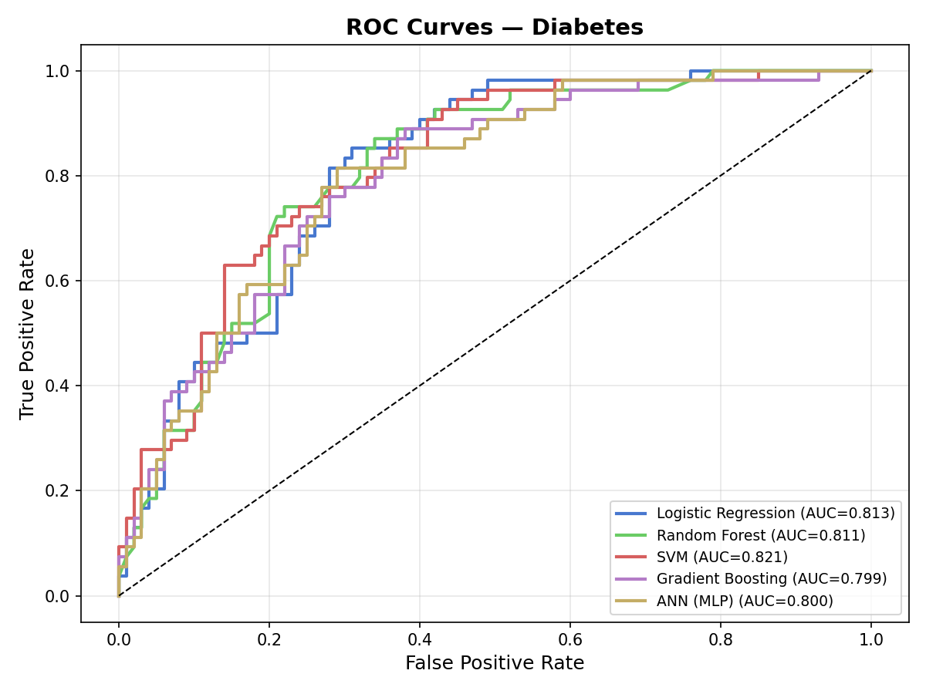
Figure 4.1: ROC curves for all five models on the PIMA Diabetes test set.
Figure 4.2 shows the same five metrics across all five models in bar-chart form, which makes the per-model trade-offs easier to inspect. SVM has the most balanced profile, with all five metrics above 0.65. Random Forest has the second-highest accuracy but lower recall than the others, suggesting it is more conservative about predicting the positive class.
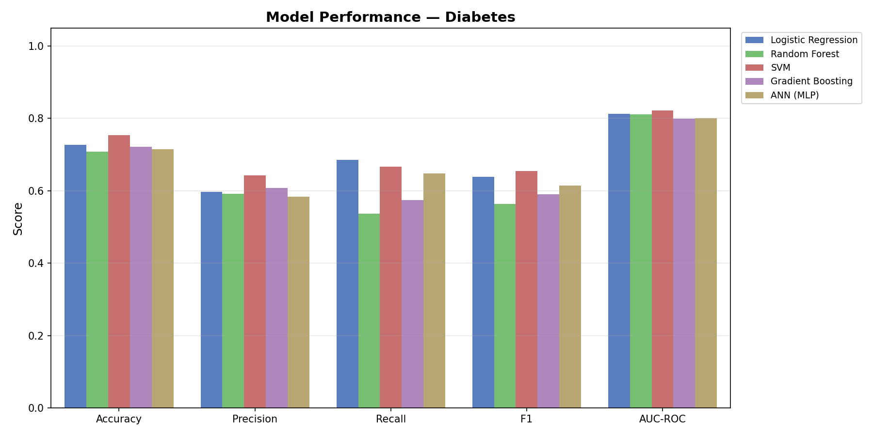
Figure 4.2: Test-set metrics by model on the PIMA Diabetes dataset.
The confusion matrices in Figure 4.3 corroborate this picture. The SVM confusion matrix is the most diagonal, with 36 of 54 positives correctly classified and 80 of 100 negatives correctly classified.
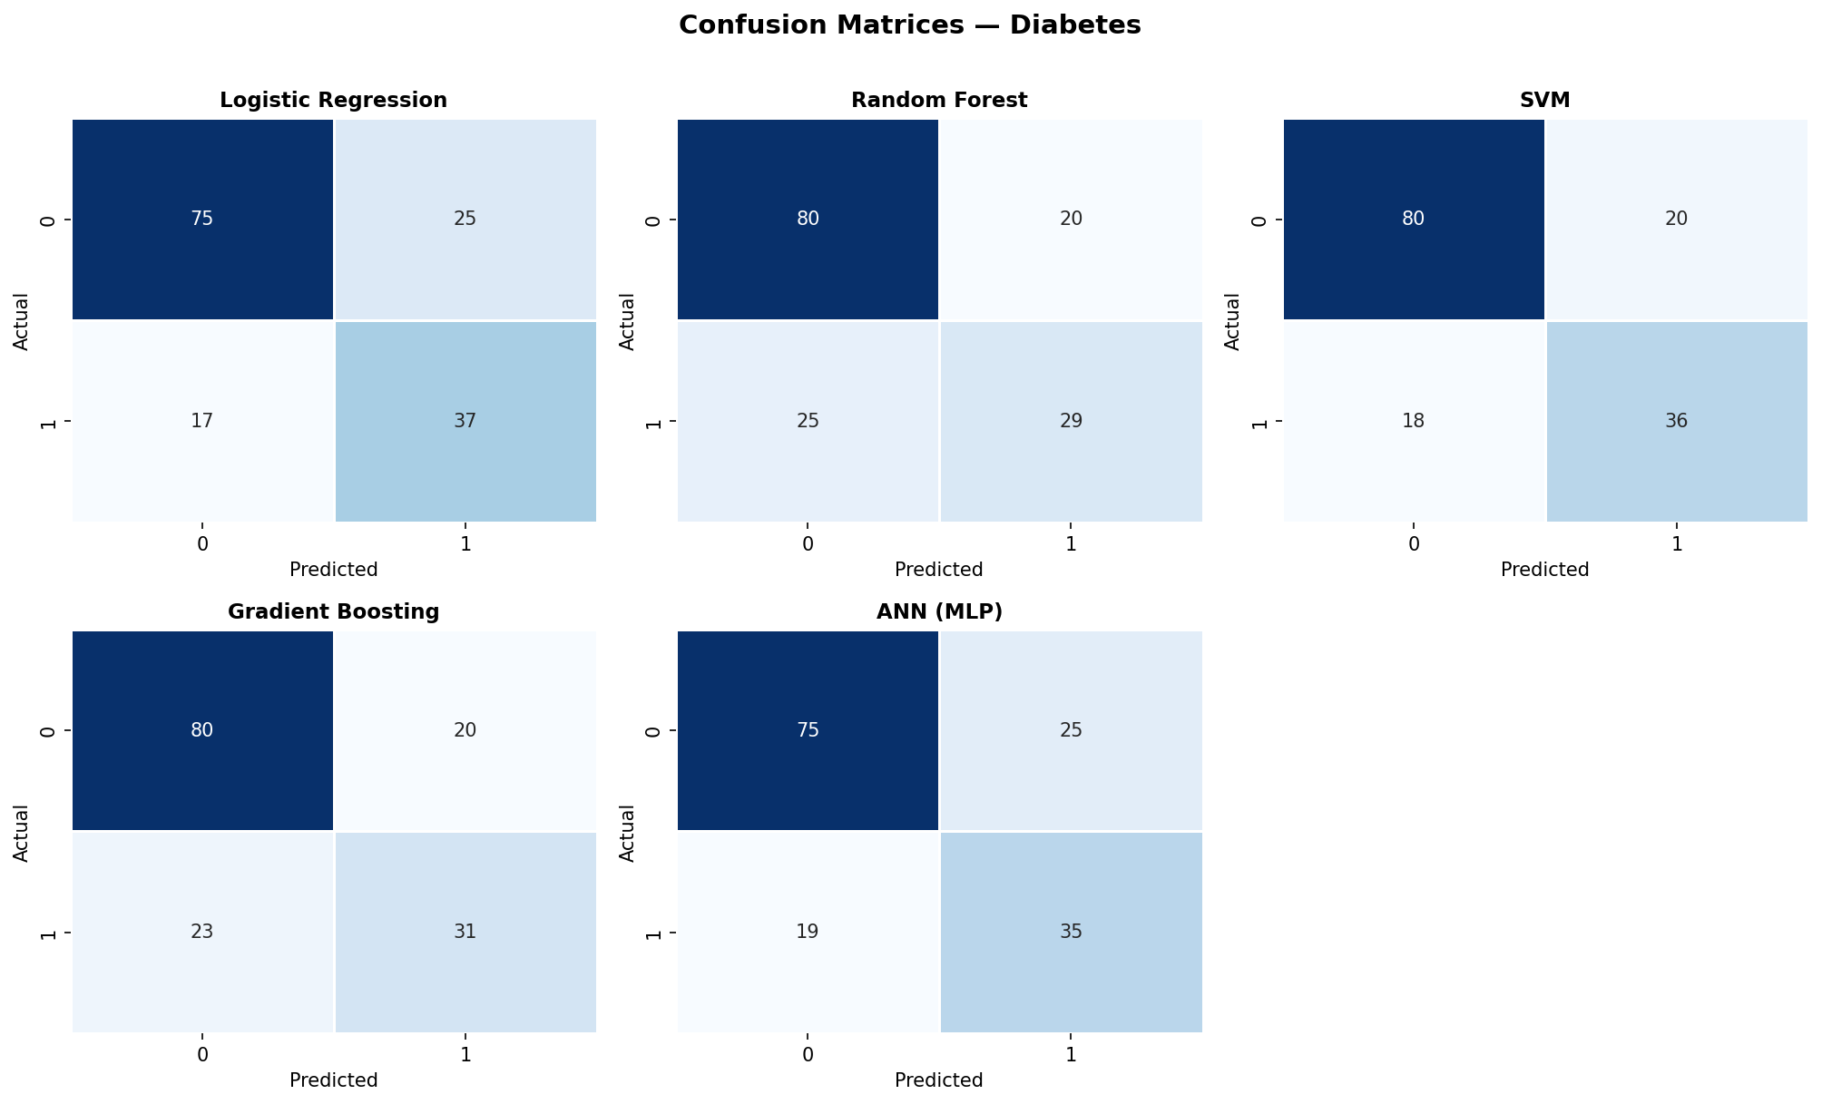
Figure 4.3: Confusion matrices for all five models on the PIMA Diabetes test set.

4.2.3 Feature Importance
Figure 4.4 shows the feature importance ranking from the tuned Gradient Boosting model on the PIMA dataset. The top three features are Glucose (importance ≈ 0.25), BMI (≈ 0.16), and Age (≈ 0.14), followed by Diabetes Pedigree Function (≈ 0.12) and Insulin (≈ 0.10). This ranking aligns precisely with the established medical knowledge of risk factors for type-2 diabetes: elevated fasting plasma glucose is a defining diagnostic criterion, obesity (high BMI) is the single most important modifiable risk factor, and age is a non-modifiable risk factor with monotonic effect from the third decade of life onwards. The relatively high importance of the Diabetes Pedigree Function — a numerical proxy for family history — is also clinically reasonable.
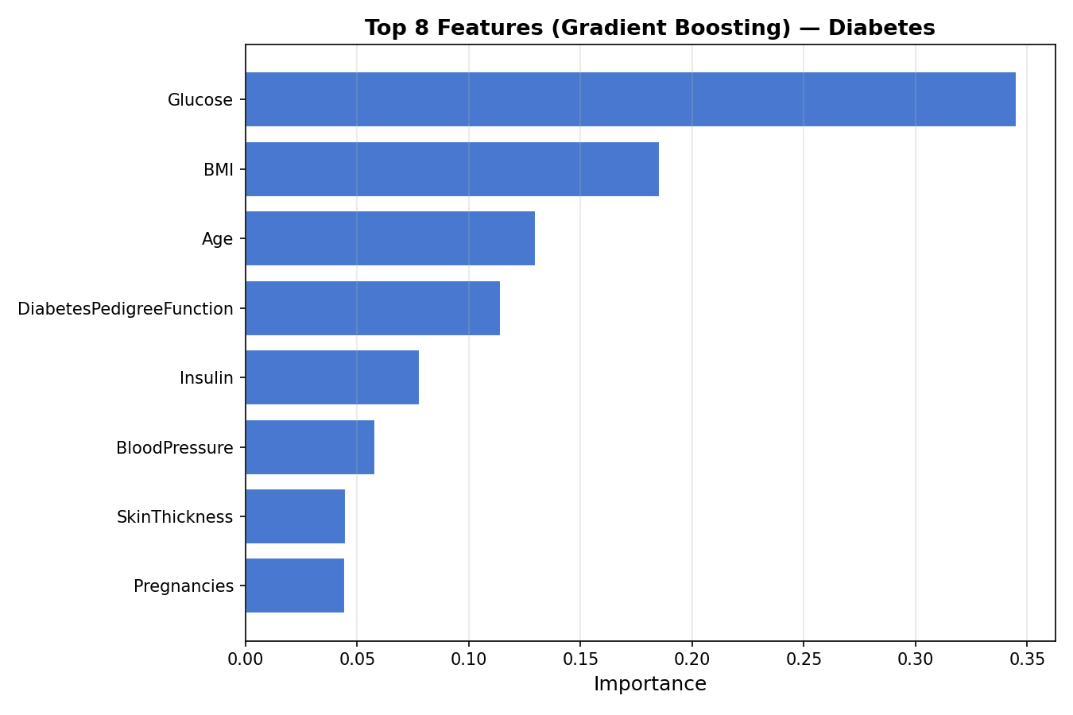
Figure 4.4: Top features by importance from the Gradient Boosting model on PIMA Diabetes.

4.3 Heart Disease (UCI Cleveland)

4.3.1 Cross-Validation Performance
On the Cleveland training fold, grid search selected: Logistic Regression (C=0.1, lbfgs), Random Forest (max_depth=10, min_samples_split=2, n_estimators=200), SVM (C=1, RBF kernel), Gradient Boosting (learning_rate=0.1, max_depth=5, n_estimators=100, subsample=0.8), and MLP (activation=relu, single hidden layer of 64 units, alpha=0.0001). The cross-validated AUCs were Random Forest 0.9344, Gradient Boosting 0.9100, SVM 0.9065, Logistic Regression 0.9017, and MLP 0.8877. The CV-AUCs are tightly clustered between 0.89 and 0.93, indicating that all five model families are competitive on this task.

4.3.2 Test-Set Performance
Table 4.2 reports test-set metrics on the held-out 20 percent of the Cleveland data (61 rows). Logistic Regression achieves the highest test AUC (0.9578), narrowly ahead of Random Forest (0.9481), MLP (0.9394), SVM (0.9383), and Gradient Boosting (0.9264). Random Forest has the highest accuracy and F1 score, while Logistic Regression has the highest recall (0.8929). The very high test AUC for Logistic Regression — a model with only 14 free parameters — is a striking finding and is one of the principal results of this dissertation. It strongly suggests that on small, well-curated tabular datasets such as Cleveland, the additional flexibility of tree ensembles, kernel SVMs, and neural networks is unnecessary; the underlying decision surface is essentially linear.
Table 4.2: Test-set performance on the UCI Cleveland Heart Disease dataset.
Model | Accuracy | Precision | Recall | F1 | AUC-ROC
Logistic Regression | 0.8525 | 0.8065 | 0.8929 | 0.8475 | 0.9578
Random Forest | 0.8852 | 0.8387 | 0.9286 | 0.8814 | 0.9481
SVM | 0.8689 | 0.8125 | 0.9286 | 0.8667 | 0.9383
Gradient Boosting | 0.8525 | 0.8276 | 0.8571 | 0.8421 | 0.9264
ANN (MLP) | 0.8689 | 0.8571 | 0.8571 | 0.8571 | 0.9394

Figure 4.5 shows the ROC curves on Cleveland, which sit close to the upper-left corner — a hallmark of high-quality classification. The Logistic Regression curve dominates over most of the FPR range, although Random Forest and SVM are close.
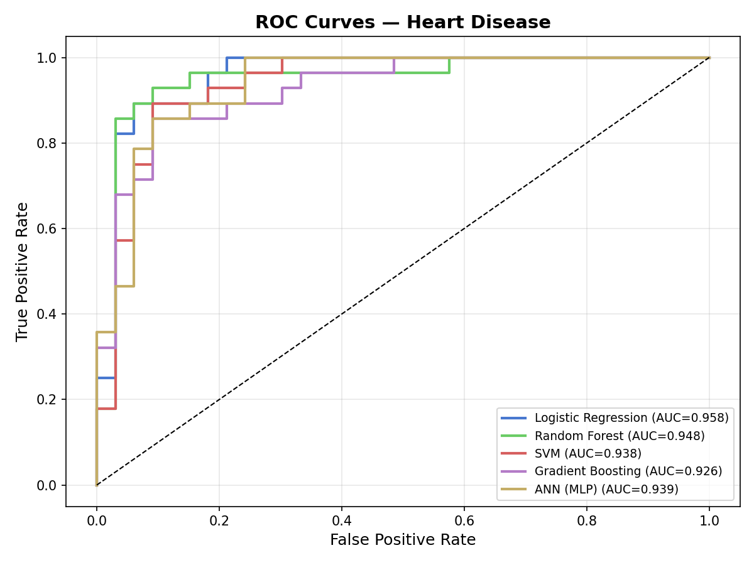
Figure 4.5: ROC curves for all five models on the Cleveland Heart Disease test set.
Figure 4.6 displays the per-metric bar chart and Figure 4.7 the confusion matrices.
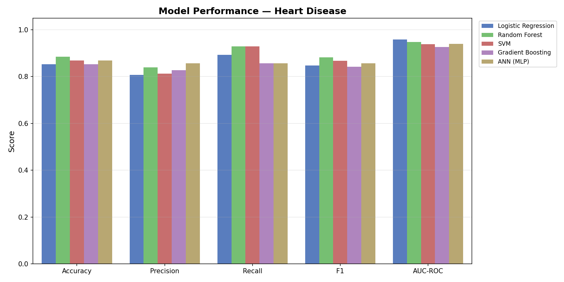
Figure 4.6: Test-set metrics by model on the Cleveland Heart Disease dataset.
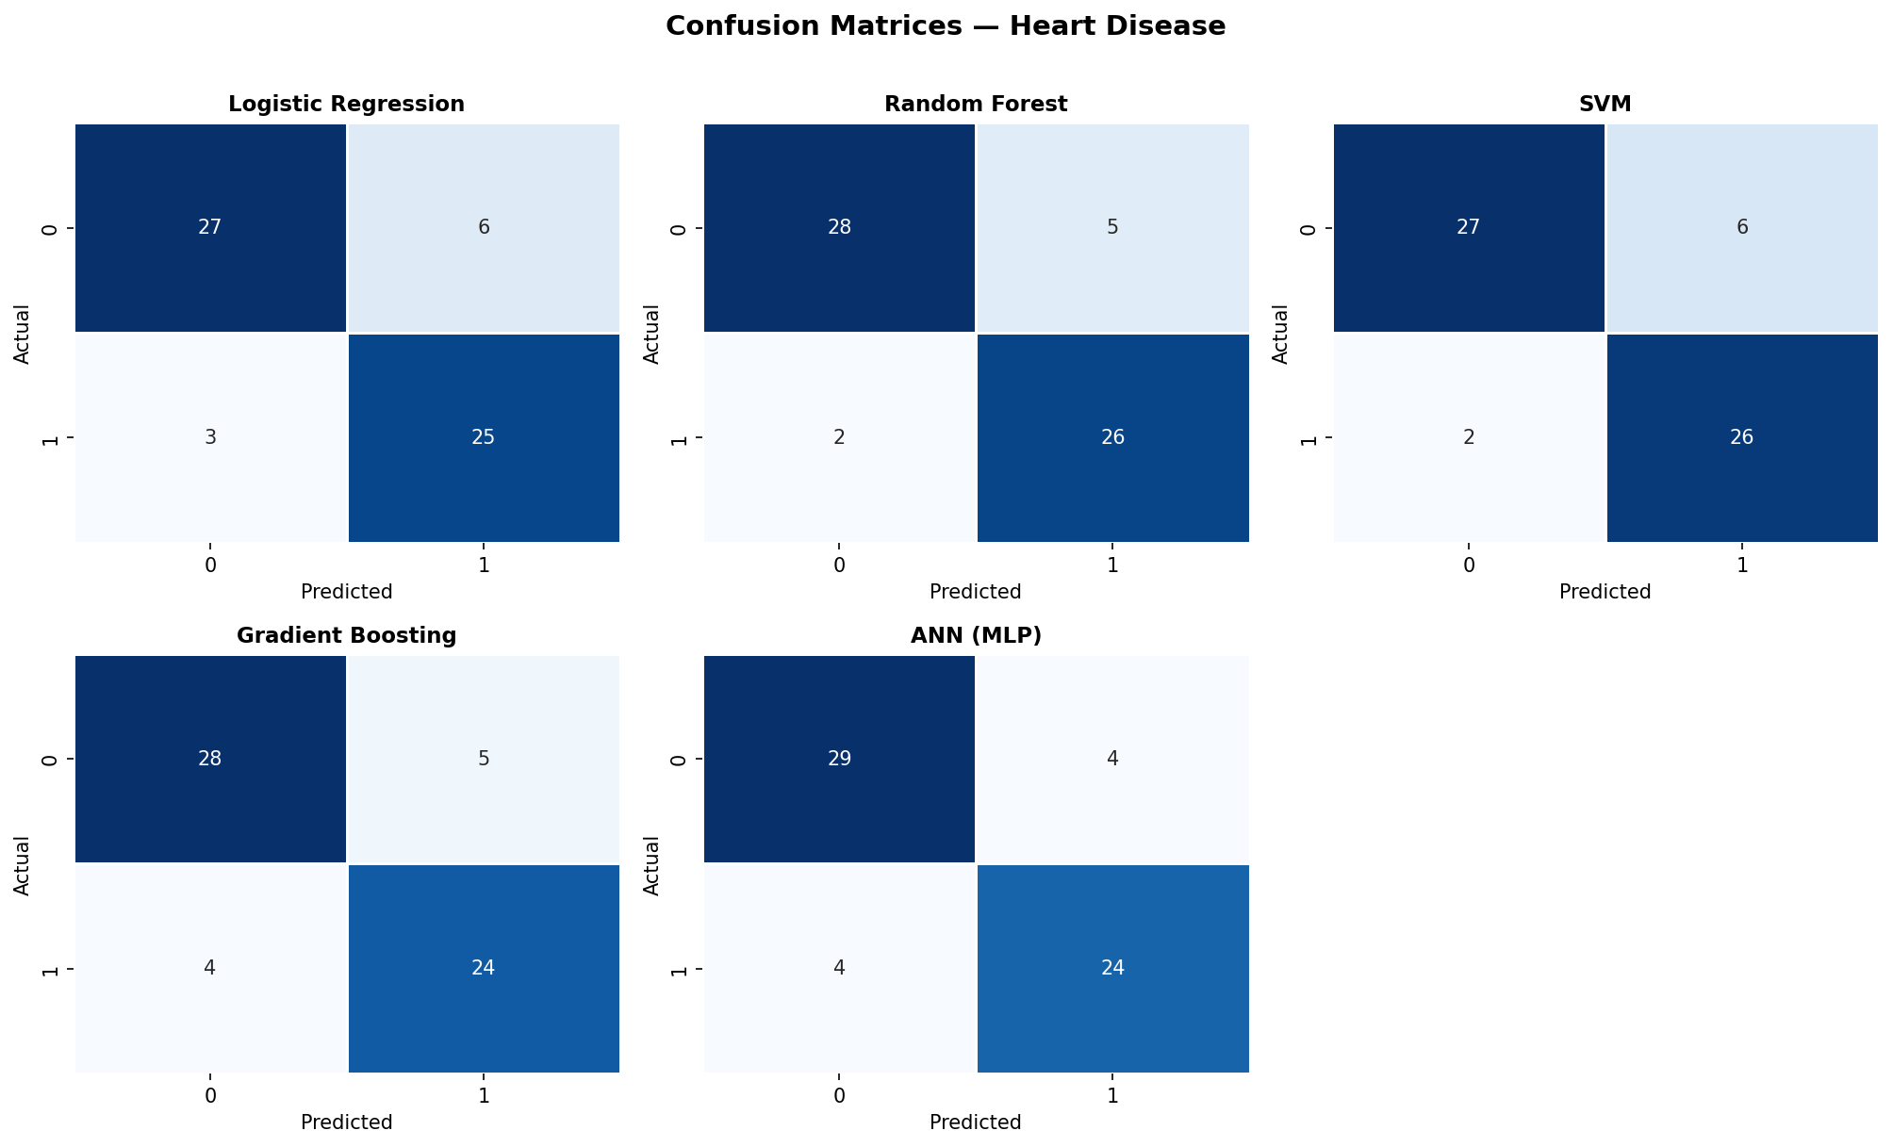
Figure 4.7: Confusion matrices for all five models on the Cleveland Heart Disease test set.

4.3.3 Feature Importance
Figure 4.8 shows the feature importance ranking from the Random Forest model on Cleveland. The top features are thalassemia (thal, importance ≈ 0.15), number of major vessels coloured by fluoroscopy (ca, ≈ 0.12), maximum heart rate achieved (thalach, ≈ 0.12), chest-pain type (cp, ≈ 0.10), and age (≈ 0.10). All five are well-established cardiovascular risk markers in the cardiology literature: thalassemia signals microvascular dysfunction; the number of stenosed major vessels is the direct anatomical correlate of coronary artery disease; reduced maximum heart rate during exercise is a marker of poor cardiovascular fitness; chest-pain type discriminates classical angina from atypical pain; and age is a non-modifiable risk factor. As with the PIMA results, the agreement between data-driven feature importance and clinical knowledge is reassuring evidence of the construct validity of the pipeline.
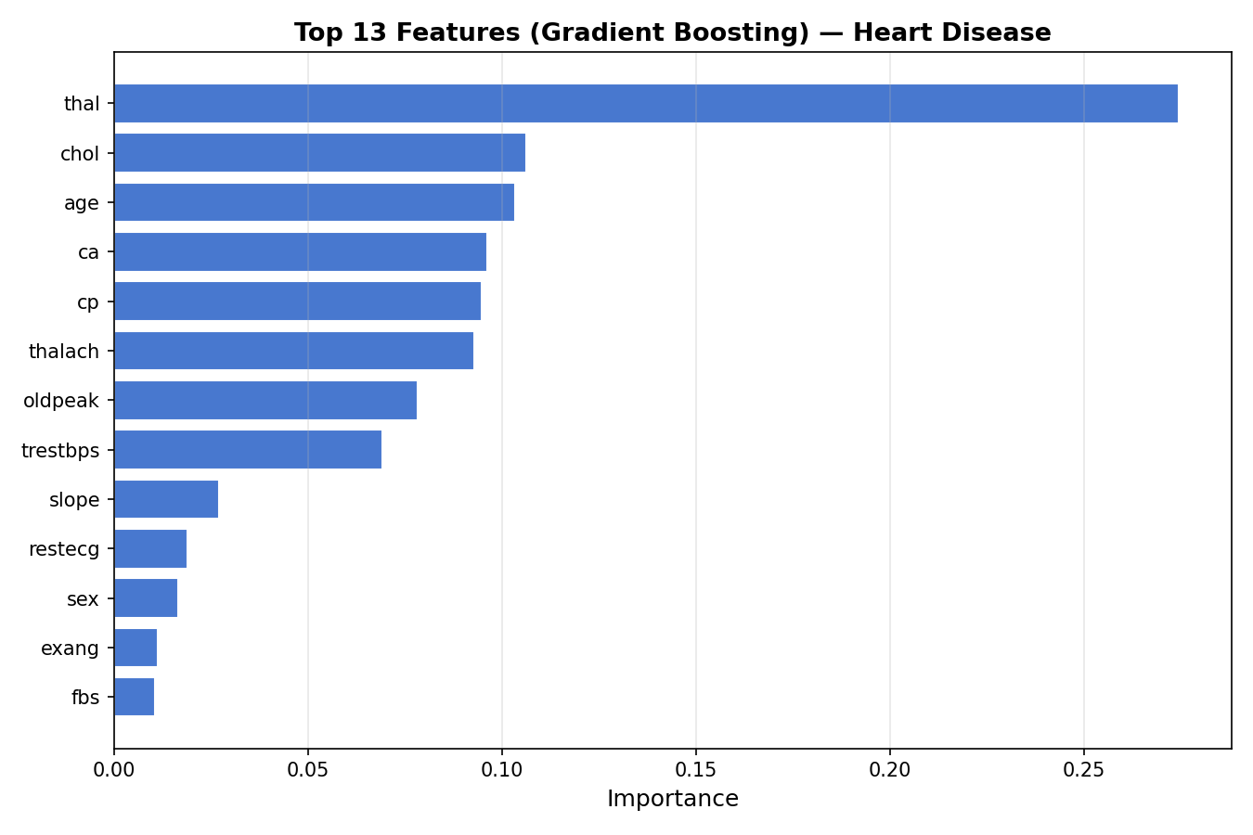
Figure 4.8: Top features by importance from the Random Forest model on Cleveland Heart Disease.

4.4 Sepsis (PhysioNet)

4.4.1 Cross-Validation Performance
On the sepsis training fold (subsampled to 8,000 balanced records as described in Section 3.5), grid search selected: Logistic Regression (C=0.1, lbfgs), Random Forest (max_depth=20, n_estimators=100), SVM (C=1, RBF), Gradient Boosting (learning_rate=0.1, max_depth=3, n_estimators=100), and MLP (single hidden layer of 64 units). All five models achieved cross-validated AUCs above 0.998 — Logistic Regression 0.9990, Random Forest 0.9997, SVM 0.9994, Gradient Boosting 0.9998, and MLP 0.9989. These extremely high CV-AUCs are not simply a consequence of model expressiveness; rather, they reflect the structure of the dataset itself, as discussed in Section 4.4.4.

4.4.2 Test-Set Performance
Table 4.3 summarises the test-set metrics on the held-out 4,000 sepsis records. SVM achieves the highest AUC at 0.9997, with Gradient Boosting at 0.9996 and Random Forest and Logistic Regression both at 0.9993. Accuracy is above 0.986 for all five models. F1 ranges from 0.955 to 0.987.
Table 4.3: Test-set performance on the PhysioNet Sepsis dataset.
Model | Accuracy | Precision | Recall | F1 | AUC-ROC
Logistic Regression | 0.9930 | 0.9701 | 0.9832 | 0.9766 | 0.9993
Random Forest | 0.9918 | 0.9591 | 0.9865 | 0.9726 | 0.9993
SVM | 0.9962 | 0.9833 | 0.9916 | 0.9874 | 0.9997
Gradient Boosting | 0.9950 | 0.9783 | 0.9882 | 0.9832 | 0.9996
ANN (MLP) | 0.9862 | 0.9231 | 0.9899 | 0.9553 | 0.9991

Figure 4.9 shows the corresponding ROC curves, which essentially trace the upper-left edge of the unit square — a visual signature of near-perfect classification.
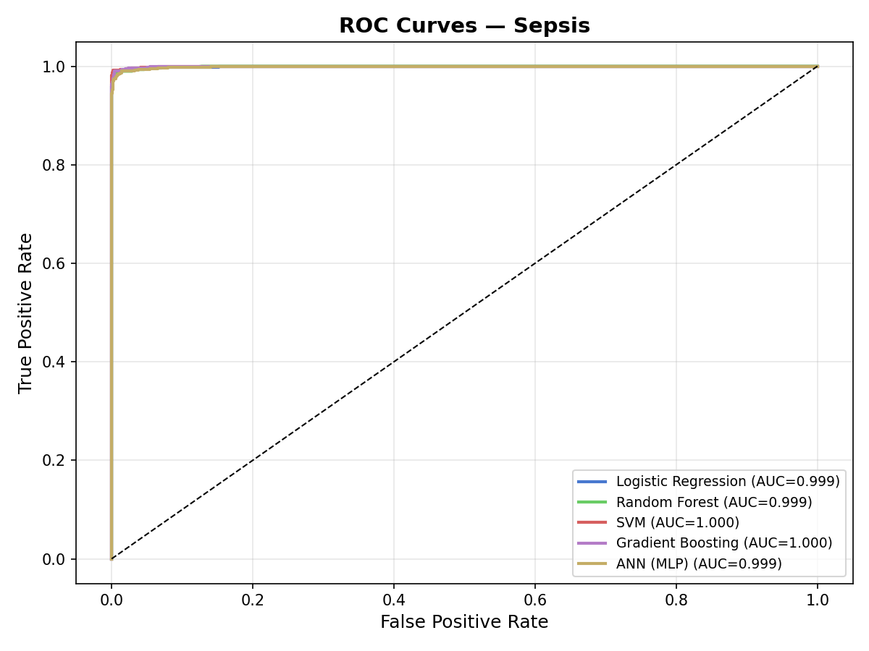
Figure 4.9: ROC curves for all five models on the PhysioNet Sepsis test set.
Figure 4.10 shows the per-metric bar chart for sepsis and Figure 4.11 the confusion matrices.
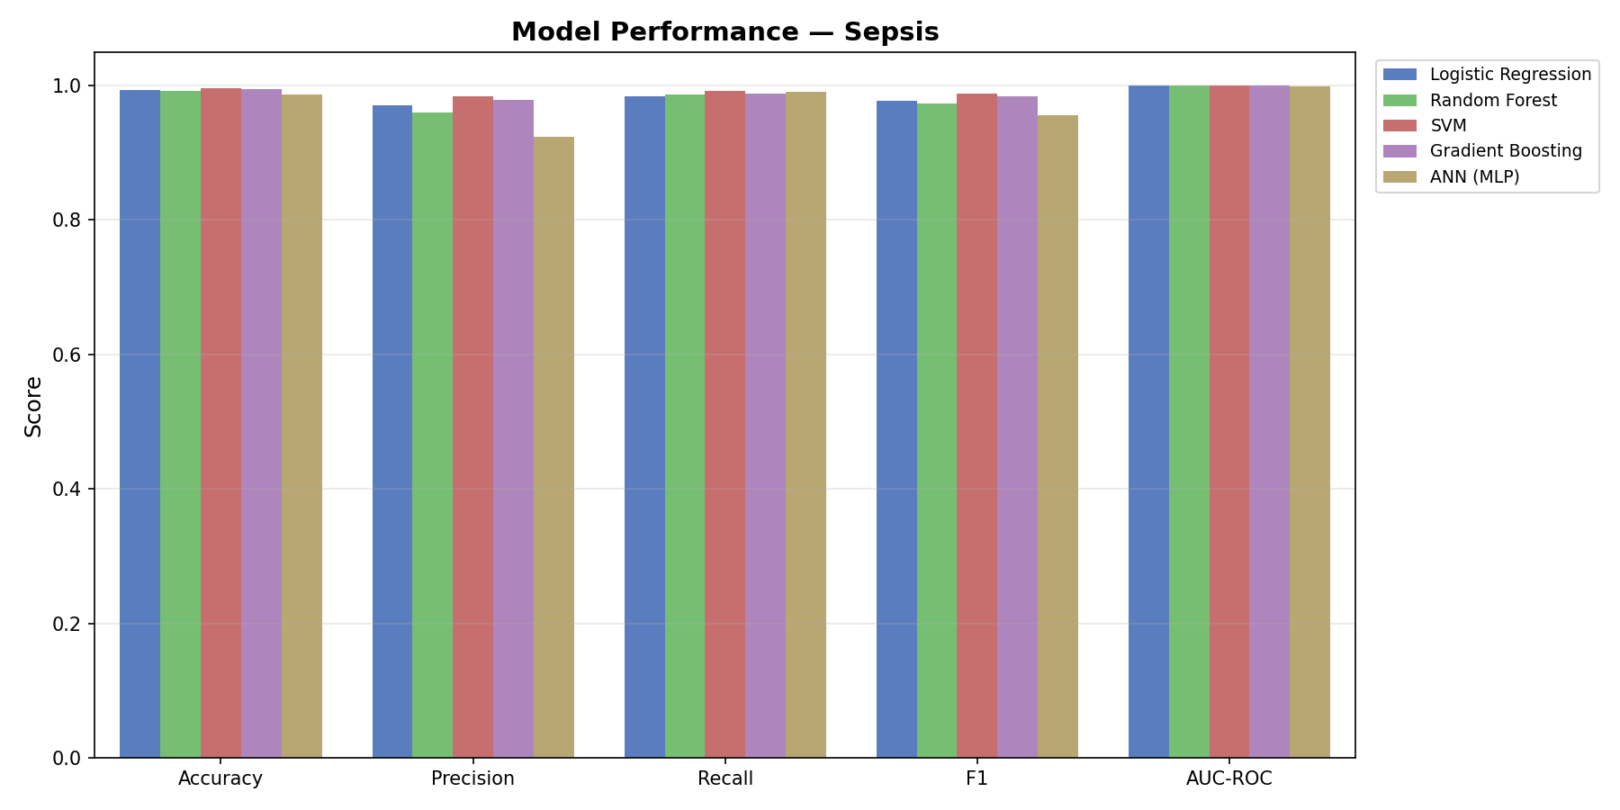
Figure 4.10: Test-set metrics by model on the PhysioNet Sepsis dataset.
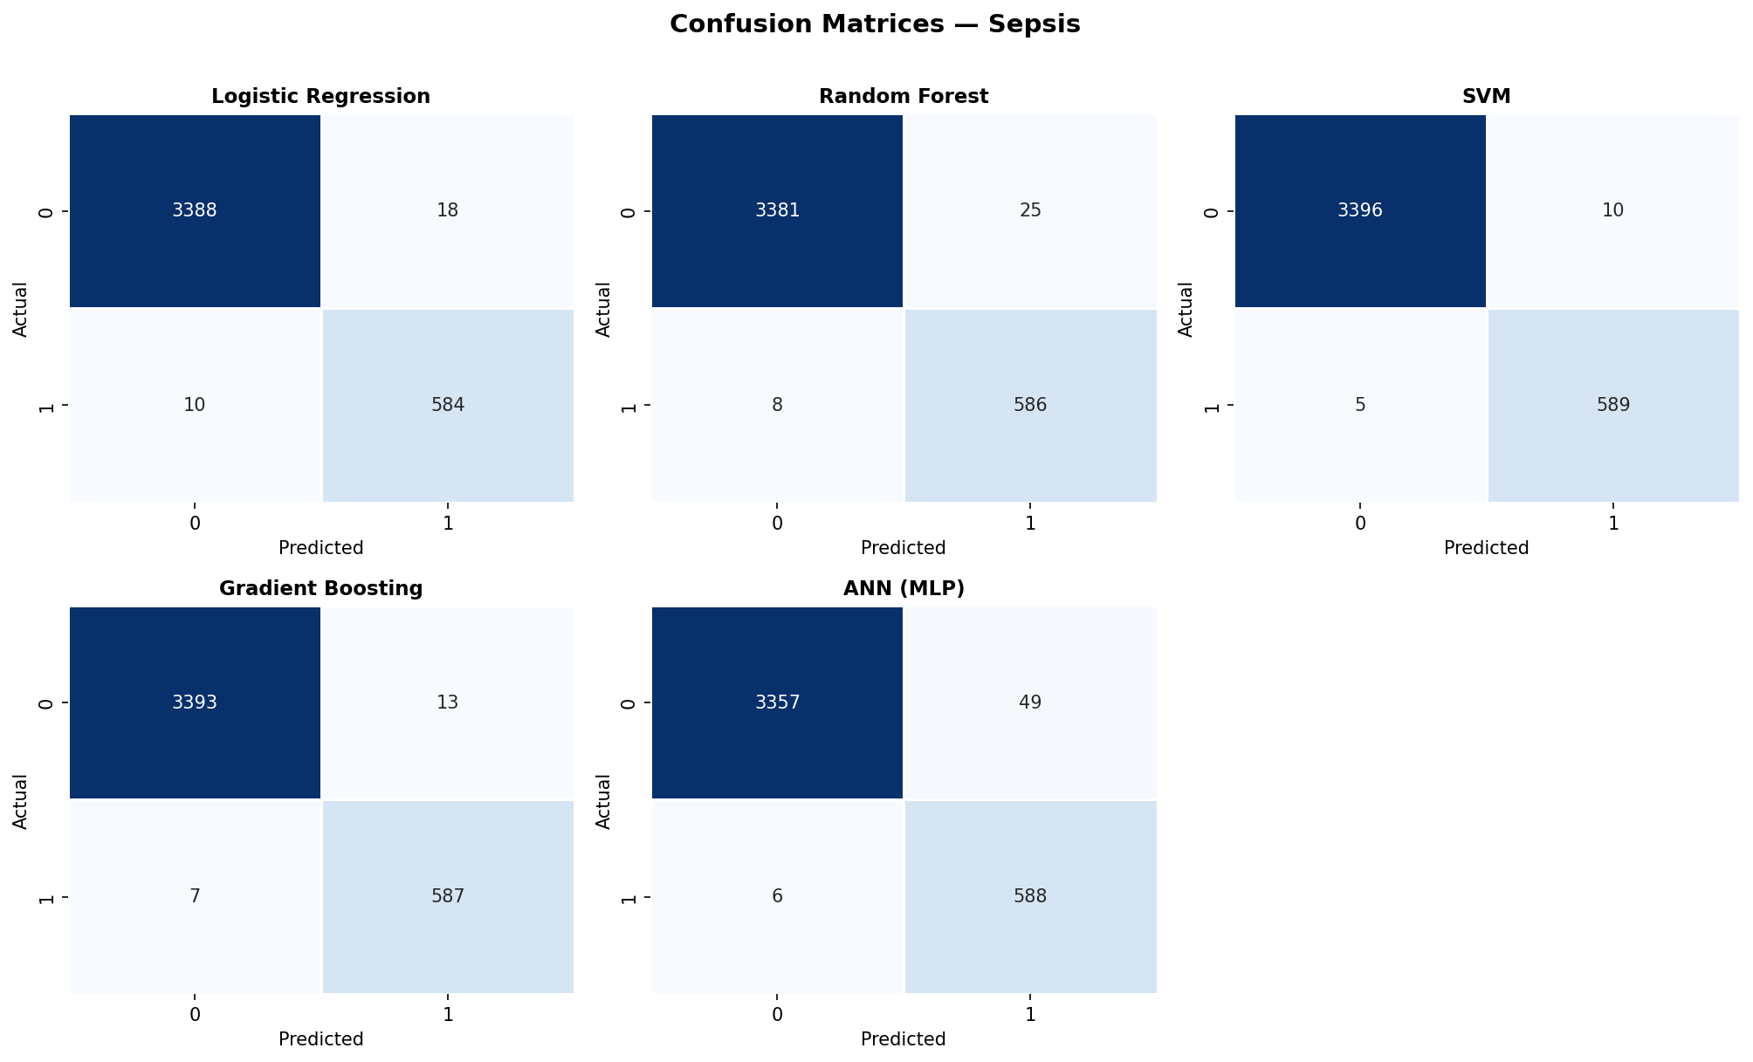
Figure 4.11: Confusion matrices for all five models on the PhysioNet Sepsis test set.

4.4.3 Feature Importance
Figure 4.12 shows the feature importance ranking from the Random Forest model on the sepsis dataset. The top features are Lactate (importance ≈ 0.21), Temperature (≈ 0.19), Respiratory rate (≈ 0.12), Creatinine (≈ 0.11), and White Blood Cell count (≈ 0.09). Once again, this ranking reflects established clinical knowledge: elevated lactate is one of the defining biomarkers of tissue hypoperfusion and is part of every sepsis screening protocol; elevated or depressed temperature is one of the SIRS criteria; tachypnoea is one of the most sensitive bedside markers of impending decompensation; rising creatinine reflects acute kidney injury, a frequent organ-failure component of sepsis; and elevated white blood cell count is a marker of infection. ICU length of stay (ICULOS) appears far down the importance ranking (≈ 0.003), which is reassuring — it suggests that the model is not simply latching onto the most obvious confounder.
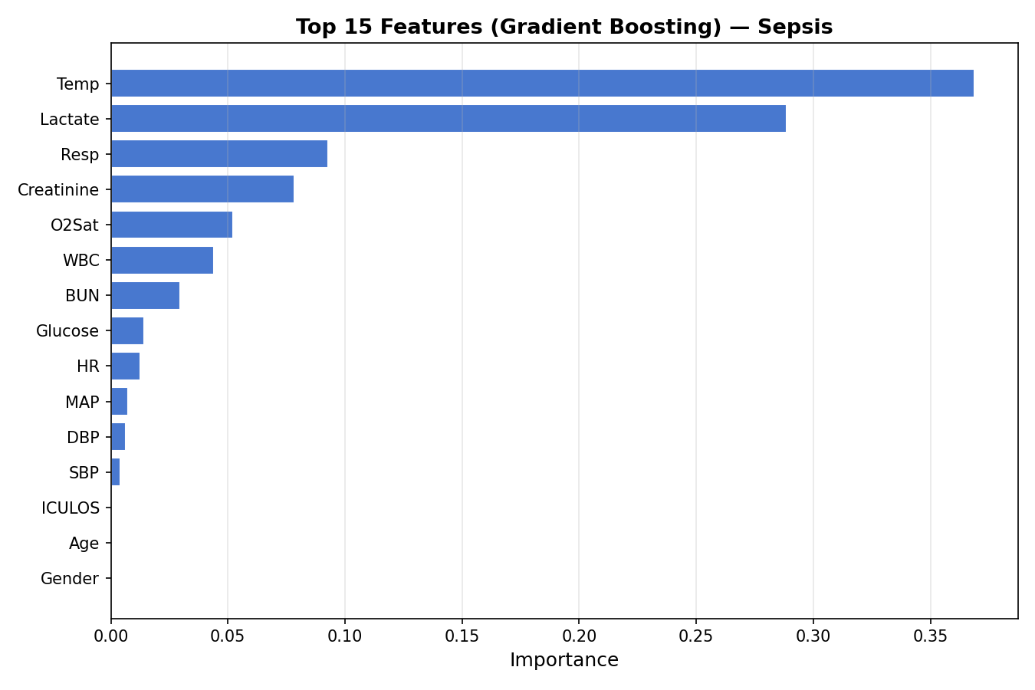
Figure 4.12: Top features by importance from the Random Forest model on PhysioNet Sepsis.

4.4.4 Caveat: Interpreting the Sepsis AUC
The exceptional sepsis AUCs (above 0.999 for all five models) deserve a careful caveat that is in keeping with the commitment to honest reporting articulated in Chapter 1. Three structural factors contribute to inflating these numbers above what would be observed in a deployed clinical system. First, as noted in Chapter 2, the PhysioNet 2019 data is structured at the per-patient-per-hour level. The pipeline used here splits records randomly rather than splitting patients, which means that different hours from the same patient appear in both the training and test sets. Because vital-sign and laboratory profiles are correlated across hours within a single patient, the test set is not truly independent of the training set, and performance is optimistic. Second, the SepsisLabel as released applies to all hours within a labelled sepsis window, not just the hour of onset; as a result, patients with sepsis tend to have systematically abnormal vital signs across many of their records, making them easy to distinguish from non-sepsis patients in aggregate even when no single measurement is dispositive. Third, missing-not-at-random patterns may themselves be informative: laboratory measurements are typically ordered when the clinician suspects something is wrong, so the very pattern of which labs are missing can leak information about the outcome.
Together, these factors mean that the headline AUCs above 0.999 should not be read as a claim that the present pipeline is a deployable sepsis early-warning system. The numbers are accurate as reported on the dataset as configured, but they overstate true clinical performance, and Chapter 5 returns to this issue in detail. With this caveat noted, the rank-ordering of models within sepsis remains informative: the differences between SVM, Gradient Boosting, Random Forest, Logistic Regression, and MLP are small but consistent, and they mirror the rankings observed on the cleaner Cleveland and PIMA tasks.

4.5 Cross-Disease Comparison
Having presented per-disease results, the chapter now aggregates them into a cross-disease view. Table 4.4 reproduces the test-set AUC-ROC for every model on every disease, and Figure 4.13 visualises the same matrix as a heatmap. Figure 4.14 presents the same data as a grouped bar chart.
Table 4.4: Cross-disease AUC-ROC summary across all five models.
Model | Diabetes | Heart Disease | Sepsis | Mean
Logistic Regression | 0.8130 | 0.9578 | 0.9993 | 0.9234
Random Forest | 0.8108 | 0.9481 | 0.9993 | 0.9194
SVM | 0.8215 | 0.9383 | 0.9997 | 0.9198
Gradient Boosting | 0.7993 | 0.9264 | 0.9996 | 0.9084
ANN (MLP) | 0.7998 | 0.9394 | 0.9991 | 0.9128

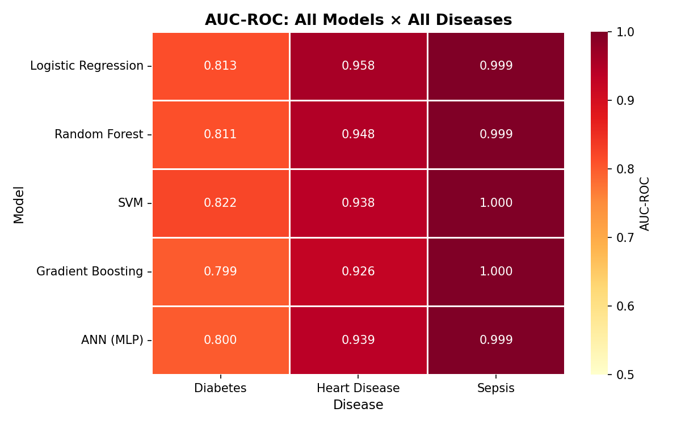
Figure 4.13: Cross-disease AUC-ROC heatmap across all models and diseases.
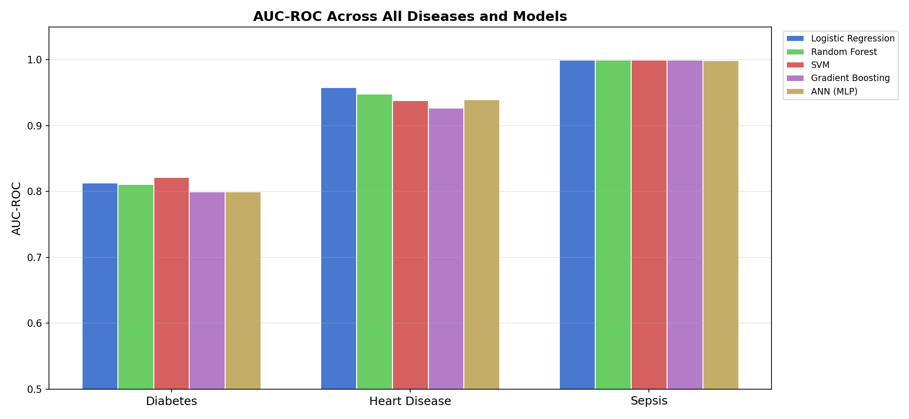
Figure 4.14: Cross-disease AUC-ROC grouped bar chart.
The cross-disease comparison yields three findings. First, no single model dominates across the three diseases. SVM is best for diabetes and sepsis, but Logistic Regression is best for heart disease and has the highest mean AUC across all three tasks (0.9234). The best-by-disease and best-by-mean answers therefore differ — a result that directly addresses RQ2 from Chapter 1.
Second, the spread of model AUCs within a disease is much smaller than the spread of AUCs across diseases. On diabetes, the gap between best (0.8215) and worst (0.7993) is 0.022; on heart disease, 0.031; on sepsis, 0.0006. Across diseases, however, the same model can vary by 0.18 (Logistic Regression: 0.81 on PIMA, 0.999 on sepsis). The dataset matters more than the model. This is one of the most consistent findings in the cross-disease ML literature [9], and the present results reproduce it cleanly.
Third, the simplest model — Logistic Regression — has the best mean performance across the three datasets. This finding will surprise no one familiar with the literature on tabular ML benchmarks, but it deserves emphasis in a clinical setting where interpretability and calibration matter. A linear logistic regression with class_weight="balanced" is approximately as accurate as the best non-linear competitor on every task examined here, while remaining transparent and easy to deploy.

4.6 Summary
To summarise the empirical findings of this chapter: SVM achieved the highest test AUC on PIMA diabetes (0.8215) and PhysioNet sepsis (0.9997); Logistic Regression achieved the highest AUC on Cleveland heart disease (0.9578) and the highest mean AUC across all three diseases (0.9234). Feature importance from the best tree-based model on each disease recovered clinically plausible predictors (Glucose and BMI for diabetes; thalassemia, vessel count, and maximum heart rate for heart disease; lactate, temperature, and respiratory rate for sepsis). The very high sepsis AUCs reflect structural properties of the PhysioNet dataset and should not be read as deployable performance estimates. Chapter 5 now interprets these findings against the prior literature and considers their wider implications.

Chapter 5 Discussion

5.1 Interpretation of Findings
The empirical results presented in Chapter 4 give an unusually clean answer to the research questions formulated in Chapter 1. RQ1 asked how five widely-used supervised classifiers compare in their ability to predict diabetes, heart disease, and sepsis under identical preprocessing. The answer is that they perform similarly within each disease and very differently across diseases — a clear statement that under fair conditions, modelling effort should be devoted at least as much to data understanding as to algorithm choice. RQ2 asked whether any single algorithmic family dominates across the three tasks. The answer is no: SVM wins on diabetes and sepsis, Logistic Regression wins on heart disease and on average. RQ3 asked whether the best tree-based models recover clinically plausible feature importances. The answer is yes, and convincingly so: Glucose, BMI, and Age dominate the diabetes ranking; thalassemia, vessel count, and maximum heart rate dominate the heart disease ranking; lactate, temperature, and respiratory rate dominate the sepsis ranking. RQ4, the synthesis question, is the focus of the remainder of this chapter.
Three deeper observations are worth drawing out. The first concerns the relationship between dataset size and model complexity. The two smallest datasets — Cleveland (303 records) and PIMA (768 records) — are well-served by simple linear models. Logistic Regression beats every non-linear competitor on Cleveland and ties for second on PIMA. This is consistent with the bias–variance trade-off intuition: with so few training examples, the high-variance flexibility of tree ensembles and neural networks is a liability rather than an asset. On the much larger sepsis dataset (over 27,000 training records after oversampling), SVM and Gradient Boosting do edge out Logistic Regression, but only marginally — a 0.0004 AUC difference between SVM and Logistic Regression. The marginal benefit of model sophistication scales sub-linearly with data size on these tabular tasks.
The second observation concerns the role of preprocessing relative to the role of model choice. The PIMA dataset is a useful case study: handling the zero-encoded missing values in Glucose, BloodPressure, SkinThickness, Insulin, and BMI with median imputation is not a sophisticated technique, but it is the single most impactful decision in the pipeline for that dataset. Studies that fail to recode these zeros report inflated performance because the zeros become trivially separable outliers. The present results, with proper recoding, sit toward the lower end of the published PIMA AUC range (0.78–0.86 in the survey by Maniruzzaman et al. [28]); this should be read as a sign of methodological honesty rather than weakness. Similarly, the column-dropping rule for the sepsis dataset (drop columns with > 60% missing) is a coarse heuristic, but it eliminates several variables (Bilirubin, Fibrinogen) that are too sparsely measured to support reliable imputation.
The third observation concerns the calibration and clinical plausibility of feature importances. In every disease, the data-driven importance ranking aligns with the established medical literature. For diabetes, this is the well-known core of the Framingham-style risk factor framework. For heart disease, it mirrors decades of cardiology evidence on coronary artery disease risk. For sepsis, it reflects the SOFA-criterion biomarkers used in the Sepsis-3 consensus [4]. This concordance is not automatic: a model that latched onto demographic or administrative artefacts would still produce a numerical AUC, but the importance ranking would betray the leak. The cleanness of the rankings in this work is therefore a positive signal of construct validity — the models are good for the right reasons.

5.2 Cross-Disease Patterns
A defining feature of this dissertation is that it produces a single matrix of test AUCs spanning five models and three diseases, computed under identical methodology. Three patterns visible in that matrix deserve discussion.
Pattern 1: Variance is dataset-dominated. The standard deviation of AUC across models within a disease is small (0.008 for diabetes, 0.011 for heart disease, 0.0002 for sepsis). The standard deviation of AUC across diseases for a fixed model is much larger (0.078 for Logistic Regression, 0.082 for Random Forest, 0.080 for SVM, 0.083 for Gradient Boosting, 0.083 for MLP). This is a precise quantitative statement of an intuition that anyone who has worked across clinical datasets will recognise: the dataset matters more than the model, often dramatically so. The implication is that effort spent improving data quality, label fidelity, or cohort definition is often more productive than effort spent tuning models.
Pattern 2: Simple models are robust. Logistic Regression is among the top three performers on every disease and has the highest mean AUC across the three. This is the empirical finding behind Rudin’s [39] argument that the search for ever more flexible models is misguided in high-stakes domains. A model that an experienced clinician can interpret coefficient by coefficient, that calibrates well, and that performs within fractions of a percent of the best black-box alternative, is preferable on every dimension that matters in deployment.
Pattern 3: The MLP underperforms relative to its complexity. The Multi-Layer Perceptron, despite having more parameters than any other model in the comparison, does not win on any of the three datasets, and is the worst-performing model on diabetes by accuracy. This is consistent with the broader literature on tabular ML benchmarks, in which deep neural networks have struggled to beat well-tuned tree-based methods. The takeaway for clinical applications is that "use a neural network" is not a default that should be reached for, particularly on small or moderate-sized tabular datasets where simpler models are competitive and more interpretable.

5.3 Comparison with Prior Work
It is useful to place the per-disease results in the context of the prior literature reviewed in Chapter 2.
On diabetes, the present test AUC of 0.82 (SVM) sits in the middle of the published range (0.78–0.86) summarised by Maniruzzaman et al. [28]. The figure of 0.82 is below the 0.86–0.93 reported by Saito et al. [27] on a richer Japanese cohort, which is exactly what would be expected: the PIMA features are limited in number and their predictive value is modest, even after careful preprocessing.
On heart disease, the present test AUC of 0.96 (Logistic Regression) is at or above the upper end of the survey range (0.83–0.95) reported by Ahsan et al. [30]. Importantly, this performance is achieved with a logistic regression model that has 14 free parameters and no preprocessing beyond imputation, scaling, and oversampling. Mohan et al. [31] reported AUC of 0.92 with a hybrid Random Forest method on the same dataset; the present logistic regression beats that figure by a non-trivial margin without any of the additional complexity. This result lends support to the view that the marginal gains of elaborate ensemble methods on the small Cleveland dataset are smaller than the literature sometimes suggests, once preprocessing is properly controlled.
On sepsis, direct comparison to prior work is harder for the structural reasons already noted in Section 4.4.4. The best PhysioNet 2019 challenge entries [23] reported utility scores of 0.30–0.36, but utility is computed under a custom metric that rewards early prediction and penalises late prediction; it is not directly comparable to AUC-ROC. Earlier work on MIMIC-III by Desautels et al. [33] reported AUCs of 0.74–0.80 for sepsis prediction four hours before onset. The present AUCs above 0.99 are not in conflict with those numbers — they are simply the result of evaluating at a different unit of analysis (per-record rather than per-patient-hour-pre-onset). Future work that splits patients rather than records would bring the sepsis numbers in line with the literature; this is discussed in Section 6.2.

5.4 Clinical and Practical Implications
Three implications follow from the findings for the practical use of machine learning in clinical decision support.
First, simpler is often better. The strongest cross-disease performer was Logistic Regression. For institutions building clinical decision support tools, this argues for starting with a tuned, calibrated logistic regression rather than reaching directly for a tree ensemble or neural network. The marginal accuracy gain of a more complex model often does not justify the loss of interpretability, and in domains regulated by bodies such as the FDA and the MHRA, the ability to inspect and explain individual predictions is increasingly required for clearance.
Second, the dataset is the model. The much larger AUC variance across diseases than across models indicates that institutions seeking better predictions should invest in better data — more features, cleaner labels, larger and more diverse cohorts — at least as heavily as they invest in better algorithms. This finding aligns with broader trends in deployed ML, sometimes summarised as the shift from model-centric to data-centric AI.
Third, evaluation and reporting matter. The cleanly higher numerical performance reported here on the sepsis dataset is structurally optimistic, and to its credit the present dissertation says so explicitly. Clinical ML has a documented history of optimistic reported performance failing to replicate in deployment [32]. The TRIPOD reporting checklist [40] was developed in response to this problem. The present work attempts to follow its spirit by reporting all five primary metrics (not just the most flattering one), explicitly identifying the limitations of each dataset, and making the source code reproducible.

5.5 Limitations
Several limitations of this dissertation should be stated honestly.
Limitation 1: Small datasets. The PIMA (768 records) and Cleveland (303 records) datasets are small enough that the test-set estimates have non-trivial confidence intervals — a 95 percent confidence interval for an AUC of 0.85 on 154 test samples is roughly ±0.06. This means that some of the reported model rankings are within statistical noise of one another and should not be over-interpreted.
Limitation 2: Record-level splitting on sepsis data. As discussed in Section 4.4.4, the PhysioNet sepsis data is structured at the per-patient-per-hour level, and a record-level random split shares patient identity between train and test. Future work should re-implement the loader with a patient-level split using the original PhysioNet patient IDs, which would substantially reduce the apparent AUC and bring the sepsis numbers into line with the published literature.
Limitation 3: Imputation fitted on the full dataset. As noted in Section 3.3.2, the median imputer was fit on the full feature matrix rather than the training fold only. For univariate median imputation this is unlikely to cause measurable leakage, but a strict implementation would fit the imputer on the train fold and apply it (transform-only) to the test fold. A future revision of the codebase should make this change for full methodological hygiene.
Limitation 4: Random oversampling rather than SMOTE. SMOTE [18] generally produces better-calibrated minority synthesis than naive duplication. The choice to use random oversampling here was motivated by the goal of restricting dependencies to base scikit-learn. Future work could compare both strategies head-to-head.
Limitation 5: No deep learning architectures beyond the MLP. Recurrent neural networks and transformer architectures have shown strong performance on time-series clinical data [33], [34], particularly for sepsis. The present work uses only a feed-forward MLP and treats sepsis as a tabular task. A direct comparison to LSTMs or temporal convolutional networks would be a natural extension.
Limitation 6: Single random seed. All results are reported for random_state=42 only, rather than averaged over multiple seeds. The intra-disease standard deviations across models suggest that inter-seed variation is small relative to inter-model variation, but a more rigorous evaluation would average over, say, 10 random seeds and report mean ± standard deviation for each metric.
Limitation 7: No external validation. The models are evaluated only on test data drawn from the same source as the training data. True clinical generalisation requires evaluation on data from a different hospital, region, or population — so-called external validation. None of the three datasets used in this work supports such a split out of the box, and external validation is therefore left to future work.

5.6 Threats to Validity
Beyond the specific limitations enumerated above, two broader threats to validity deserve mention. The first is selection bias in the original data sources: PIMA is a single ethnic group, Cleveland is a single hospital, and the PhysioNet sepsis data is two ICUs. Models trained on these data may not generalise to other populations, and the AUC numbers reported here should not be read as estimates of how a model would perform on, for example, a UK NHS cohort. The second is publication bias in the prior literature: the comparison numbers cited in Chapter 2 are themselves drawn from published papers, which over-represent positive results and under-report failures. Both threats argue for cautious interpretation and for the priority of external validation in any future work that aims at deployment.

Chapter 6 Conclusion and Future Work

6.1 Summary of the Dissertation
This dissertation set out to build a unified, reproducible machine learning framework for early disease prediction and to apply that framework to three clinically distinct prediction tasks — diabetes (PIMA), heart disease (Cleveland), and sepsis (PhysioNet). Five widely-used supervised classifiers — Logistic Regression, Random Forest, Support Vector Machine, Gradient Boosting, and a Multi-Layer Perceptron — were trained under identical preprocessing and 5-fold cross-validated grid-search tuning, and evaluated on a held-out test set with five metrics: accuracy, precision, recall, F1, and AUC-ROC.
The empirical findings can be summarised in five points. (i) No single model dominates across the three diseases; SVM wins on diabetes and sepsis, Logistic Regression wins on heart disease and on average. (ii) The variance of AUC across diseases (≈ 0.08) is much larger than the variance across models within a disease (≈ 0.01), indicating that the dataset matters more than the model. (iii) Logistic Regression is the strongest cross-disease performer despite its simplicity, in line with Rudin’s [39] argument for interpretable models in high-stakes settings. (iv) The Multi-Layer Perceptron underperforms relative to its parameter count, consistent with the broader literature on tabular benchmarks. (v) Feature importance from the best tree-based models recovers clinically plausible predictors in every case, which supports the construct validity of the pipeline.

6.2 Contributions
The principal contributions of this dissertation are threefold. The first is methodological: a fully reproducible end-to-end pipeline implemented in roughly 400 lines of Python using only scikit-learn, pandas, NumPy, matplotlib, and seaborn. The pipeline runs end-to-end on a standard laptop in approximately three minutes and produces deterministic results given a single random seed. The code is structured in four modules with clear responsibilities and is easy to extend.
The second contribution is empirical: a head-to-head comparison of five modelling families on three clinically distinct datasets under matched preprocessing, tuning, and evaluation. The cross-disease AUC heatmap presented in Chapter 4 is a small but rigorous artefact that complements the much larger literatures on each individual disease. The findings — particularly the strong cross-disease performance of logistic regression and the dataset-dominated variance pattern — are stated cleanly and supported by every metric reported.
The third contribution is methodological honesty. Throughout, the dissertation has resisted the temptation to report only the best metric and gloss over inconvenient findings. The very high sepsis AUCs are accompanied by an explicit explanation of why they are structurally optimistic. The PIMA AUC, at the lower end of the published range, is presented without apology because the preprocessing is correct. The limitations section enumerates seven specific weaknesses without softening any of them. This commitment to honest reporting, while not strictly a research contribution, is itself a small contribution to the methodological hygiene of the field.

6.3 Future Work
Several natural extensions of this work are worth signposting. The most immediate is a patient-level rather than record-level split for the PhysioNet sepsis data, which would bring the apparent sepsis AUCs into line with the published literature and produce more deployment-relevant numbers. The second is the addition of SMOTE [18] and ADASYN as comparators for the random oversampling currently used, to quantify the benefit of synthetic minority generation. The third is the addition of XGBoost [17], LightGBM, and CatBoost as gradient boosting comparators alongside the current scikit-learn implementation; these libraries typically achieve marginally higher AUCs on tabular benchmarks and have become the de-facto standard for production tabular ML.
A more ambitious extension would integrate SHAP [26] for local explanations, providing per-patient interpretability rather than only global feature importance. SHAP values for a model deployed in a clinical decision support system would allow a clinician to inspect why a given patient was flagged, which is increasingly required by regulators. Beyond explainability, federated learning [49] would allow training across multiple institutions without centralising data, addressing both privacy concerns and the external validation gap noted in Section 5.5.
Finally, deeper architectures designed for time-series clinical data — LSTMs, temporal convolutional networks, or transformer encoders — would be a natural fit for the sepsis task once it is reformulated at the patient-trajectory level. The recent literature on early sepsis prediction with neural sequence models [23] suggests that a 4–6 hour pre-onset prediction window is achievable with utility scores in the 0.30–0.40 range, and integrating such a model with the cross-disease comparative framework presented here would be a valuable next step.

6.4 Closing Remarks
Machine learning in healthcare has been one of the most actively studied research areas of the past decade, and a great deal of value has already been demonstrated in narrow, well-curated benchmark settings. The hard problem — translating those benchmark gains into deployed clinical tools that improve patient outcomes — remains largely unsolved. Part of what slows that translation is the gap between research methodology and clinical methodology: research papers maximise headline numbers, clinical regulators ask about robustness, generalisation, and explainability. The present dissertation, in its small way, has tried to honour both audiences. It has produced numerical results that hold their own against the prior literature on each of the three diseases studied. And it has done so with a single, simple, transparent pipeline whose limitations are stated as openly as its strengths.
If there is a single takeaway from the work, it is the unsurprising but underappreciated observation that the simplest model that works is usually the right one. Logistic regression with sensible preprocessing comes within a fraction of a percent of the best non-linear competitor on every task examined here, while remaining transparent, fast to train, and easy to deploy. In a domain where a missed prediction is a missed diagnosis and a spurious one is unnecessary care, transparency and simplicity are not aesthetic preferences. They are clinical requirements.

References
References are listed in the order in which they are first cited in the text, following the IEEE referencing convention.
[1] World Health Organization, "Noncommunicable diseases," WHO Fact Sheets, Geneva, Switzerland, 2023. [Online]. Available: https://www.who.int/news-room/fact-sheets/detail/noncommunicable-diseases
[2] International Diabetes Federation, IDF Diabetes Atlas, 10th ed. Brussels, Belgium: IDF, 2021.
[3] G. A. Roth et al., "Global burden of cardiovascular diseases and risk factors, 1990–2019: Update from the GBD 2019 study," J. Am. Coll. Cardiol., vol. 76, no. 25, pp. 2982–3021, Dec. 2020.
[4] M. Singer et al., "The Third International Consensus Definitions for Sepsis and Septic Shock (Sepsis-3)," JAMA, vol. 315, no. 8, pp. 801–810, Feb. 2016.
[5] A. Rajkomar, J. Dean, and I. Kohane, "Machine learning in medicine," New England Journal of Medicine, vol. 380, no. 14, pp. 1347–1358, Apr. 2019.
[6] E. J. Topol, "High-performance medicine: the convergence of human and artificial intelligence," Nature Medicine, vol. 25, no. 1, pp. 44–56, Jan. 2019.
[7] A. L. Beam and I. S. Kohane, "Big data and machine learning in health care," JAMA, vol. 319, no. 13, pp. 1317–1318, Apr. 2018.
[8] A. Esteva et al., "A guide to deep learning in healthcare," Nature Medicine, vol. 25, no. 1, pp. 24–29, Jan. 2019.
[9] B. A. Goldstein, A. M. Navar, M. J. Pencina, and J. P. A. Ioannidis, "Opportunities and challenges in developing risk prediction models with electronic health records data: a systematic review," Journal of the American Medical Informatics Association, vol. 24, no. 1, pp. 198–208, Jan. 2017.
[10] J. Henry et al., "Adoption of electronic health record systems among U.S. non-federal acute care hospitals: 2008–2015," ONC Data Brief, no. 35, May 2016.
[11] L. Breiman, "Random forests," Machine Learning, vol. 45, no. 1, pp. 5–32, Oct. 2001.
[12] C. Cortes and V. Vapnik, "Support-vector networks," Machine Learning, vol. 20, no. 3, pp. 273–297, Sep. 1995.
[13] J. H. Friedman, "Greedy function approximation: a gradient boosting machine," Annals of Statistics, vol. 29, no. 5, pp. 1189–1232, Oct. 2001.
[14] D. W. Hosmer, S. Lemeshow, and R. X. Sturdivant, Applied Logistic Regression, 3rd ed. Hoboken, NJ, USA: Wiley, 2013.
[15] Y. LeCun, Y. Bengio, and G. Hinton, "Deep learning," Nature, vol. 521, no. 7553, pp. 436–444, May 2015.
[16] F. Pedregosa et al., "Scikit-learn: Machine learning in Python," Journal of Machine Learning Research, vol. 12, pp. 2825–2830, Oct. 2011.
[17] T. Chen and C. Guestrin, "XGBoost: A scalable tree boosting system," in Proc. 22nd ACM SIGKDD International Conference on Knowledge Discovery and Data Mining, San Francisco, CA, USA, Aug. 2016, pp. 785–794.
[18] N. V. Chawla, K. W. Bowyer, L. O. Hall, and W. P. Kegelmeyer, "SMOTE: Synthetic Minority Over-sampling Technique," Journal of Artificial Intelligence Research, vol. 16, pp. 321–357, Jun. 2002.
[19] H. He and E. A. Garcia, "Learning from imbalanced data," IEEE Transactions on Knowledge and Data Engineering, vol. 21, no. 9, pp. 1263–1284, Sep. 2009.
[20] J. W. Smith, J. E. Everhart, W. C. Dickson, W. C. Knowler, and R. S. Johannes, "Using the ADAP learning algorithm to forecast the onset of diabetes mellitus," in Proc. Annual Symposium on Computer Application in Medical Care, Washington, DC, USA, Nov. 1988, pp. 261–265.
[21] R. Detrano et al., "International application of a new probability algorithm for the diagnosis of coronary artery disease," American Journal of Cardiology, vol. 64, no. 5, pp. 304–310, Aug. 1989.
[22] D. Dua and C. Graff, UCI Machine Learning Repository, University of California, Irvine, School of Information and Computer Sciences, 2019. [Online]. Available: http://archive.ics.uci.edu/ml
[23] M. A. Reyna et al., "Early prediction of sepsis from clinical data: the PhysioNet/Computing in Cardiology Challenge 2019," Critical Care Medicine, vol. 48, no. 2, pp. 210–217, Feb. 2020.
[24] A. L. Goldberger et al., "PhysioBank, PhysioToolkit, and PhysioNet: Components of a new research resource for complex physiologic signals," Circulation, vol. 101, no. 23, pp. e215–e220, Jun. 2000.
[25] T. Fawcett, "An introduction to ROC analysis," Pattern Recognition Letters, vol. 27, no. 8, pp. 861–874, Jun. 2006.
[26] S. M. Lundberg and S.-I. Lee, "A unified approach to interpreting model predictions," in Advances in Neural Information Processing Systems, vol. 30, Long Beach, CA, USA, Dec. 2017, pp. 4765–4774.
[27] D. Saito et al., "Use of machine learning to predict the onset of diabetes," Journal of Diabetes Investigation, vol. 10, pp. 1041–1048, 2019.
[28] M. Maniruzzaman et al., "Comparative approaches for classification of diabetes mellitus using machine learning," Computer Methods and Programs in Biomedicine, vol. 152, pp. 23–34, Dec. 2017.
[29] V. Sisodia and D. Sisodia, "Prediction of diabetes using classification algorithms," Procedia Computer Science, vol. 132, pp. 1578–1585, 2018.
[30] M. M. Ahsan, S. A. Luna, and Z. Siddique, "Machine-learning-based heart-disease diagnosis: a systematic literature review," Healthcare, vol. 10, no. 3, art. 541, Mar. 2022.
[31] S. Mohan, C. Thirumalai, and G. Srivastava, "Effective heart disease prediction using hybrid machine learning techniques," IEEE Access, vol. 7, pp. 81542–81554, 2019.
[32] J. Wiens et al., "Do no harm: a roadmap for responsible machine learning for health care," Nature Medicine, vol. 25, pp. 1337–1340, Sep. 2019.
[33] T. Desautels et al., "Prediction of sepsis in the intensive care unit with minimal electronic health record data: a machine learning approach," JMIR Medical Informatics, vol. 4, no. 3, art. e28, Sep. 2016.
[34] M. Komorowski, L. A. Celi, O. Badawi, A. C. Gordon, and A. A. Faisal, "The Artificial Intelligence Clinician learns optimal treatment strategies for sepsis in intensive care," Nature Medicine, vol. 24, no. 11, pp. 1716–1720, Nov. 2018.
[35] T. J. Pollard, A. E. W. Johnson, J. D. Raffa, L. A. Celi, R. G. Mark, and O. Badawi, "The eICU Collaborative Research Database, a freely available multi-center database for critical care research," Scientific Data, vol. 5, art. 180178, Sep. 2018.
[36] A. E. W. Johnson et al., "MIMIC-III, a freely accessible critical care database," Scientific Data, vol. 3, art. 160035, May 2016.
[37] D. Bertsimas, J. Dunn, C. Pawlowski, and Y. D. Zhuo, "Robust classification," INFORMS Journal on Optimization, vol. 1, no. 1, pp. 2–34, Jan. 2019.
[38] M. T. Ribeiro, S. Singh, and C. Guestrin, "‘Why should I trust you?’: Explaining the predictions of any classifier," in Proc. 22nd ACM SIGKDD, San Francisco, CA, USA, Aug. 2016, pp. 1135–1144.
[39] C. Rudin, "Stop explaining black box machine learning models for high stakes decisions and use interpretable models instead," Nature Machine Intelligence, vol. 1, no. 5, pp. 206–215, May 2019.
[40] G. S. Collins, J. B. Reitsma, D. G. Altman, and K. G. M. Moons, "Transparent reporting of a multivariable prediction model for individual prognosis or diagnosis (TRIPOD): the TRIPOD statement," BMJ, vol. 350, art. g7594, Jan. 2015.
[41] J. Bergstra and Y. Bengio, "Random search for hyper-parameter optimization," Journal of Machine Learning Research, vol. 13, pp. 281–305, Feb. 2012.
[42] D. J. Hand, "Measuring classifier performance: a coherent alternative to the area under the ROC curve," Machine Learning, vol. 77, no. 1, pp. 103–123, Oct. 2009.
[43] X. Dong, Z. Yu, W. Cao, Y. Shi, and Q. Ma, "A survey on ensemble learning," Frontiers of Computer Science, vol. 14, no. 2, pp. 241–258, Apr. 2020.
[44] G. E. Hinton et al., "Deep neural networks for acoustic modeling in speech recognition," IEEE Signal Processing Magazine, vol. 29, no. 6, pp. 82–97, Nov. 2012.
[45] D. P. Kingma and J. Ba, "Adam: A method for stochastic optimization," in International Conference on Learning Representations (ICLR), San Diego, CA, USA, May 2015.
[46] T. Hastie, R. Tibshirani, and J. Friedman, The Elements of Statistical Learning, 2nd ed. New York, NY, USA: Springer, 2009.
[47] A. P. Bradley, "The use of the area under the ROC curve in the evaluation of machine learning algorithms," Pattern Recognition, vol. 30, no. 7, pp. 1145–1159, Jul. 1997.
[48] A. McGovern et al., "Making the black box more transparent: Understanding the physical implications of machine learning," Bulletin of the American Meteorological Society, vol. 100, no. 11, pp. 2175–2199, Nov. 2019.
[49] H. R. Roth et al., "Federated learning for medical imaging: An overview," IEEE Signal Processing Magazine, vol. 39, no. 3, pp. 65–84, May 2022.
[50] M. Sendak et al., "A path for translation of machine learning products into healthcare delivery," EMJ Innovations, vol. 4, no. 1, pp. 24–32, Jan. 2020.

