
MASTER OF BUSINESS ADMINISTRATION

EVALUATION OF THE EFFECTIVENESS OF CHATBOTS IN DIGITAL MARKETING AND CUSTOMER SERVICE INTERACTIONS
(LCMB7035)

STUDENT NAME: DIXIT PIPALIYA

STUDENT ID: 2427130

SUPERVISED BY: ADEYEMI THOMOS KAYODE

WORD COUNT: 16206



Master’s Degrees by Examination and Dissertation
Declaration Form.

I, Dixit Pipaliya, declare that this dissertation has been composed by myself, that the work contained herein is entirely my own except where explicitly stated otherwise in the text, and that this work has not been submitted for any other degree or qualification, in whole or in part, except as specified.

Signature: dixit
Date: 1st Febreary 2026

Abstract
The rapid development of digital technologies has altered the manner in which organisations interact with their customers with chatbots being increasingly integrated into the digital marketing (DM) and customer service environments. This dissertation examines how chatbots can improve customer satisfaction, customer loyalty, and the general service experience in the context of e-commerce. The research will evaluate the functional role of chatbots, their influence on customer attitude and behavioural intentions, essential operation and technological issues to address, and give suggestions on how to best optimise the implementation of chatbots.
The mixed-methods research method was used. A structured consumer survey was conducted to help in the collection of quantitative data to determine the patterns of using chatbots, their level of satisfaction, trust, and whether participants would make a purchase again. Semi-structured interviews with marketing and customer service managers were used to gather qualitative data on how the managers discussed the introduction of chatbots, their performance, and limitations. The findings indicate that chatbots are quite efficient when it comes to routine, high-volume, and transactional interactions like product recommendations, questions frequently asked, and order tracking. These functions will add to the efficiency of operation and increased reaction time.
Nevertheless, the outcomes show the conditional influence on customer satisfaction and loyalty, as well. Although efficiency and convenience provide better short-term satisfaction, constraints in emotional intelligence, situation appreciation and ability to work on complex queries leads to less trust and long-term loyalty. Another factor that affects the effectiveness of chatbots is technological limitations, issues with system integration, and data privacy.
The researchers determine that the key to the full realisation of chatbot value lies in the hybrid chatbot-human service models, the intensified system of personalisation with the assistance of CRM, the unceasing AI training, and open communication. The dissertation is a contribution to the theory combining UTAUT, Self-Determination Theory, and Social Presence Theory and provides practitioners with practical advice on how organisations can strategically implement chatbots in digital marketing and customer support settings.
Keywords:
Chatbots, Digital Marketing, Customer Service, Customer Satisfaction, Customer Loyalty, Artificial Intelligence, E-commerce, Hybrid Service Models

Acknowledgement
I would like to thank to the people without whom I would not be able to complete this project.
First, I would like to give thanks to my friends and family who supported well throughout my studies. Special thanks and gratitude to my supervisor who guided me and resolve all my problems.
Other than that, I am thankful to the respondents as well.
Yours thankful

Table of Contents
Chapter 1: Introduction 9
1.1 Introduction 9
1.2 Background to the study 9
1.3 Research Problem 10
1.4 Research Aim and Objectives 10
1.4.1 Research Aim 10
1.4.2 Research Objectives 10
1.5 Research Questions 11
1.6 Rationale 11
1.7 Significance of the Study 13
1.8 Research Methodology 13
1.9 Research Structure 13
1.10 Summary 14
Chapter 2: Literature review 15
2.1 Introduction 15
2.2 Conceptual review 15
2.2.1 Concept of chatbots 15
2.2.2 Concept of DM 15
2.2.3 Concept of customer service interactions 16
2.3 Thematic review 16
2.3.1 Function of chatbots in DM and customer service interactions 16
2.3.2 Impacts of chatbot usage in DM on client satisfaction and loyalty 17
2.3.3 Issues linked with chatbot applications in DM and client service interactions 18
2.3.4 Strategies to overcome issues and boost the chatbot’s usefulness 20
2.3.5 Challenges in Assessing Chatbot Effectiveness 21
2.4 Empirical review 22
2.5 Literature gap 23
2.6 Theoretical underpinning 23
2.6.1 UTAUT (Unified Theory of Acceptance and Use of Technology) 23
2.6.2 SDT (Self-Determination Theory) 24
2.6.3 Social Presence Theory 25
2.7 Summary 26
Chapter 3: Methodology 27
3.1 Introduction 27
3.2 Research onion 27
3.3 Research Philosophy 28
3.4 Research Approach 28
3.5 Research Strategy 29
3.6 Research Design 30
3.7 Data Collection Methods 30
3.8 Sample Size and Sampling Technique 31
3.9 Data Analysis Techniques 31
3.10 Reliability and Validity 32
3.11 Ethical Considerations 32
3.12 Limitations 33
3.13 Summary 33
Chapter 4: Findings, Analysis and Discussion 34
4.1 Introduction 34
4.2 Quantitative Findings 34
4.2.1 Demographic Profile of Respondents 35
4.2.2 Chatbot Interactions in Direct Messages and Customer Support 36
4.2.3 Impact on Customer Loyalty and Satisfaction 40
4.2.4 Problems with Chatbot Implementation 43
4.2.5 Recommendations for Improving Chatbot Utility 45
4.3. Descriptive Statistics 46
4.4 Qualitative Findings: Interview Analysis 52
Theme 1: Chatbots as Enablers of Operational Efficiency and Scalable Engagement 52
Theme 2 : Conditional Influence of Chatbots on Customer Satisfaction and Loyalty 53
Theme 3: Technological and Managerial Constraints Limiting Chatbot Performance 54
Theme 4 — Strategic Enhancement through Hybrid Service Design and Personalisation 55
Chapter 5: Integrated Discussion 56
5.1 Practical Implications 59
5.2 Significance of the Findings 60
5.3 Summary 60
Chapter 6: Conclusion and Recommendations 62
6.1 Introduction 62
6.2 Summary of Key Findings 62
6.3 Conclusion 63
6.4 Recommendations 64
6.5 Limitations 65
6.6 Future Research Directions 65
Appendices 77
Appendix 1: Survey questionnaire 77
Appendix 2: Interview questionnaire 81

Chapter 1: Introduction

1.1 Introduction
The following chapter significantly refers to introducing the research topic, which is extensively focused on the evaluation of the effectiveness of chatbots in digital marketing (DM) and customer service interaction. Through the consideration of this section, an adequate background to the study, along with referring to research problems, aims, and objectives, and significance, will be critically understood while referring to methodological aspects and overall research structure. Besides, this section will prominently offer a brief introduction to the research context while offering a guideline that will be followed further in the adjoining research sections.

1.2 Background to the study
Today's DM is very different from earlier conventional marketing methods. In the digital age, marketing is data-driven, automated, and intelligent. For evidence, big data analytics, artificial intelligence (AI), advances in storage of data technologies, faster microprocessors, and other major information technology developments are altering marketing processes and practices, much as in other sectors (Huseynov, 2023). These advancements are all helping businesses create new technological solutions that will drastically change the way they interact with their customers. Nazhifa et al. (2024) suggested that these innovations are causing the company-customer relationship to shift from being focused on individuals to being technology-oriented. One of the most recent developments that significantly changes customer service processes and how customers experience is through chatbots in DM.
Without requiring the employees to be present all the time, chatbots may offer customer assistance around the clock, seven days a week (Huseynov, 2023). This guarantees that consumers may receive support at any time, which may result in increased client satisfaction. Apart from that, chatbots also serve a company's clients or customers, often doing assistance tasks including answering questions about products or services, facilitating orders, and resolving technical issues. Additionally, Khatri et al. (2022) justified that chatbots can automate routine functions like responding to frequently asked questions, updating order status, and managing returns and exchanges. This can enhance overall customer service by freeing up human agents to deal with more complicated questions and activities.
Chatbots are increasingly being utilised in many different ways to support a wide variety of business processes, particularly in customer service and sales. The level of client service has a significant impact on customer satisfaction and loyalty in every company. A growing number of businesses are heavily utilising chatbots to interact with clients on their web pages, social media profiles, and messaging applications in the cutthroat business world of today (Huseynov, 2023). Connecting to that, chatbots are an excellent choice for businesses looking to improve their sales and customer service activities since they allow tailored interactions with users, offer easily accessible service, and manage costs.

1.3 Research Problem
In the first growing digital marketplace, businesses have been identified to be increasingly deploying chatbots in order to manage marketing and customer service interaction (Huseynov, 2023). However, it is noted that it remains unclear regarding how effective these automated agents are in achieving real customer satisfaction, loyalty, and service quality. Besides this, chatbots have been identified to be cost-saving and efficient; however, they have limited conversational quality, poor handling of complex queries, and a lack of human touch that can undermine user trust (Zhang et al. 2024). In this regard, the problem statement of this research is to focus on rigorously evaluating whether and under what conditions chatbot-based interactions can significantly deliver promising benefits.

1.4 Research Aim and Objectives

1.4.1 Research Aim
The study aims to assess the potency of chatbots in DM and client service interactions.

1.4.2 Research Objectives
- To analyse the function of chatbots in DM and customer service interactions
- To evaluate the impacts of chatbot usage in DM on client satisfaction and loyalty
- To recognise the issues linked with chatbot applications in DM and client service interactions
- To offer advice for overcoming issues related to the chatbot application and boost its usefulness

1.5 Research Questions
- How do chatbots work in direct messages and customer support interactions?
- How does using chatbots in direct messages affect customer loyalty and satisfaction?
- What are the problems associated with chatbot implementations in direct messages and customer support exchanges?
- How to resolve problems with the chatbot application and increase its utility?

1.6 Rationale
Using apps, websites, smartphones, social networks, search engines, and other digital tools to market and sell goods and services is referred to as digital marketing. E-commerce businesses utilise DM strategies, including social media, content, email, influencer, and others to increase traffic, increase sales, and foster online customer loyalty (Semenda et al. 2024). These strategies focus on boosting awareness, engagement, and conversions on various digital channels. Connecting to that, by the year 2030, the UK's internet-based advertising sector is anticipated to generate $95,727.8 million in revenue, with a growth rate of 15.4% (Grandview Research, 2025).
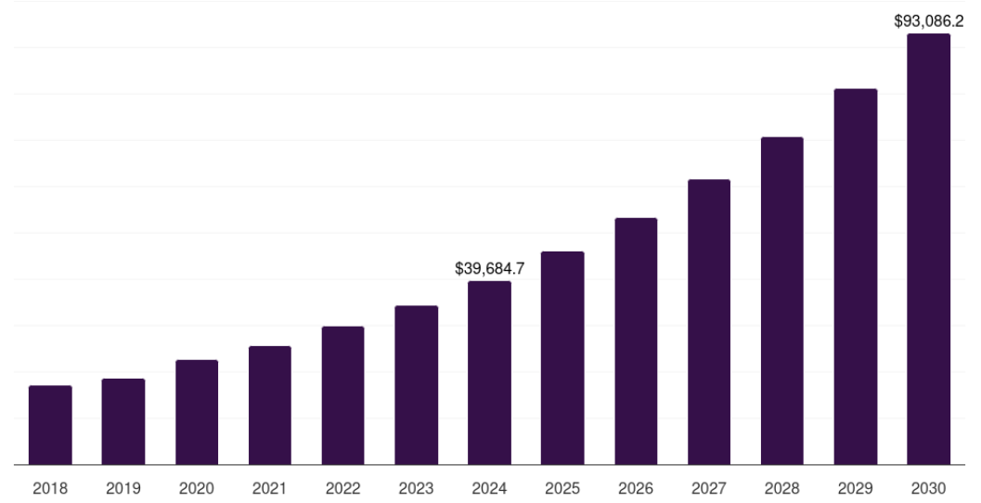
Figure 1.1: The UK’s DM market growth
(Source: Grandview Research, 2025)
As evidence, H&M has implemented AI-powered solutions to give its customers more individualised, effective, and interesting experiences. H&M is not only keeping pace with the modern era but also setting the standard for the way AI may transform the shopping experience with its smart virtual assistants and chatbots (H&M, 2025). Similar to this, the massive online retailer ASOS has added Nibble AI to its discount website, so that consumers may bargain over costs (Ross, 2024). This is their experimental AI bartering chatbot, which has enabled users to bargain between themselves with the bot. Along with that, some customers have used the increasingly popular technology to obtain discounts of up to 40% on ASOS items (Ross, 2024). The utilisation of chatbots is expanding globally at a rate of 23.3% between 2025 and 2030, which has greatly supported this (Grandview Research, 2025).
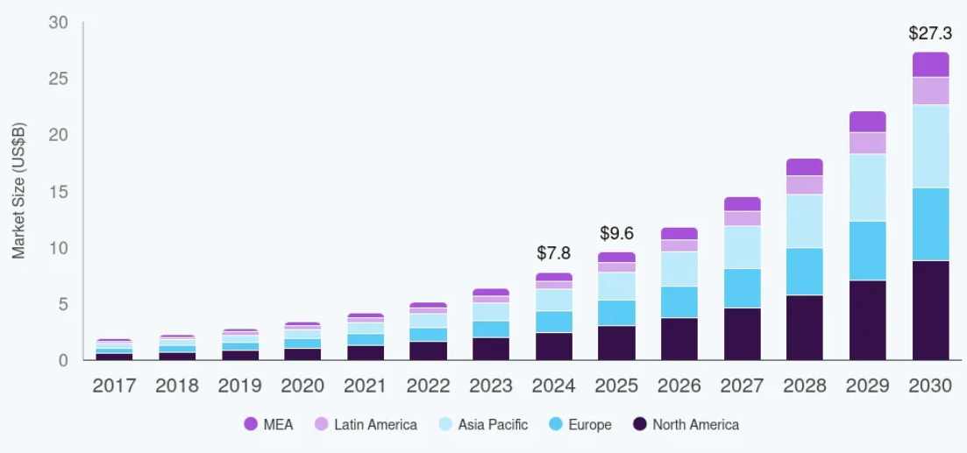
Figure 1.2: Growth of chatbots in the marketplace
(Source: Grandview Research, 2025)
On the contrary, there are significant challenges with chatbots, such as empathy gaps, ambiguous queries, domain knowledge limitations, cultural sensitivity, integration complexities, and significant others, which can lead to creating problems for businesses in terms of dealing with complex problems and decisions that require human judgment (Dilmegani, 2025). Connecting to that, it is extensively essential to understand the context of chatbots in terms of offering promising results to the organisations to maintain customer service interactions and effectiveness regarding satisfaction and loyalty.

1.7 Significance of the Study
The study has been acknowledged to be significant, as it prominently evaluates the way chatbots are influencing DM and customer service effectiveness, which is a growing and under-researched area. It significantly fills the gap in terms of understanding whether chatbot interactions are truly enhancing customer satisfaction, service quality, and loyalty. Moreover, the findings of this research will prominently allow e-commerce businesses to adopt refined chatbot strategies while informing marketers and customer service professionals about the benefits and limitations of automated communication.

1.8 Research Methodology
The research methodology of the study is extensively focused on undertaking a mixed method of data collection in which both primary qualitative and quantitative methods would be used. Connecting to this, in terms of a qualitative method, a semi-structured interview would be considered to generate responses from managers that can significantly lead to addressing research objectives and questions. Furthermore, a survey-based questionnaire would be structured while focusing on the quantitative sources in order to generate findings, while understanding the perspective of consumers regarding chatbots. All of the collected information will be further analysed through the consideration of percentage and thematic analysis, while presenting the empirical information as well as first-hand data.

1.9 Research Structure
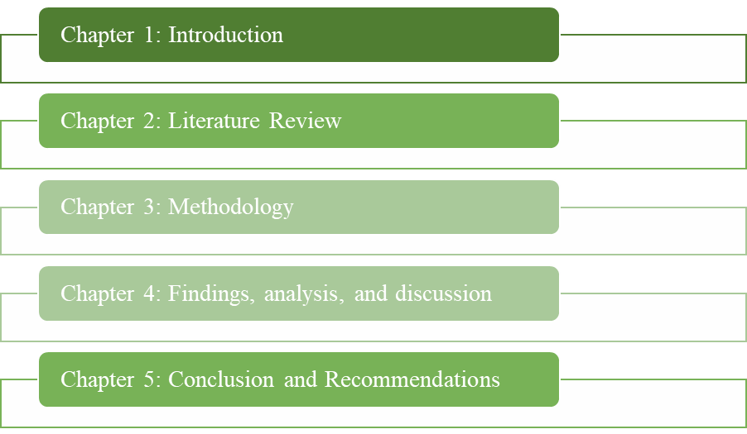
Figure 1.3: Research structure
(Source: Self-created)
The following research structure refers to five significant chapters, in which the first chapter introduces the research topic, along with stating the problem, aims and objectives, along with giving an overview of the research. Furthermore, the second chapter refers to reducing existing theories and empirical studies regarding DM, chatbots, and customer service while identifying gaps and explaining the key theoretical context. Furthermore, the third chapter explains research designs, sampling and data collection methods while focusing on ethical considerations by the researcher. Besides this, the fourth chapter presents the collected data while analysing the results and interpreting the findings, while discussing the literature. In the end, the last chapter presents the results, stating a conclusion, along with discussing practical recommendations for future research.

1.10 Summary
While analysing the research context, it has been noted that the utilisation of chatbots has significantly grown among businesses. This prominently allows in terms of maintaining efficiency in terms of customer service and satisfaction. However, significant challenges have been identified, which need to be undertaken carefully during the implementation and integration of chatbots. Apart from this, an approach towards understanding the significance of the study has been referred to while reflecting on the research methodological context and structure. Besides, a brief consideration regarding the topic has been undertaken in this section, which will be further descriptively and critically analysed in the adjacent chapter with empirical findings and theoretical backgrounds.

Chapter 2: Literature review

2.1 Introduction
The following section focuses on critically examining the body of research on assessing chatbots' use in customer service and DM (Digital Marketing). The function of chatbots in improving customer service interaction and DM, as well as their effect on customer happiness and loyalty, will be examined in light of the research objectives. Aside from that, the difficulties associated with using chatbots for DM and customer support will also be examined. Additionally, methods for resolving problems with chatbot applications and increasing their utility will be covered. The use of chatbots and their impacts will be understood through the use of theoretical viewpoints.

2.2 Conceptual review

2.2.1 Concept of chatbots
Chatbots are noted to be the AI-driven software program that stimulates human conversation using NLP (Natural Language Processing). As analysed by Huseynov et al. (2023), the chatbot prominently operates 24/7 while handling consumer queries, automating the task by providing a personalised assistant. This also reduces workload and human agents while managing repetitive enquiries, along with offering time to the staff to focus on complex issues. Chatbots also gather consumer data, such as in terms of feedback, behaviour, and preferences, which is used in terms of structuring and marketing strategies that can improve user experience (Hsieh et al. 2025). In this regard, it can be stated that chatbots are cost-effective with a scalable touchpoint that enhances engagement and streamlines services.

2.2.2 Concept of DM
As suggested by Pires et al. (2022), DM refers to using online and electronic channels, such as in terms of social media, websites, email, search engines, and mobile devices, to promote products, brands, and services. It is different from traditional marketing with highly measurable and interactive aspects that enable real-time tracking for consumer behaviour. Besides this, DM has been identified to be using a variety of tactics in terms of SEO, email content, and social media to reach audiences on data-driven personalisation, cost efficiency, flexibility in communication, as well as making a central pillar for modern business strategy (Vidani, 2024).

2.2.3 Concept of customer service interactions
As referred to, the analysis of Krishnan et al. (2022) demonstrated that customer service interactions are the point of communication between business and consumer across their journey from enquiry to post-purchase support. This interaction can take place over several channels, such as in terms of chat, phone, email, social media, and other ways. Yun and Park (2022) justified that this interaction is referred to as an opportunity in terms of building trust, gathering feedback, and delivering value. In this regard, quality and responsiveness in these interactions are identified to be strongly influencing customer satisfaction while impacting brand advocacy and loyalty.

2.3 Thematic review

2.3.1 Function of chatbots in DM and customer service interactions
Huseynov et al. (2023) demonstrated in the analysis that AI-based chatbots are one of the cutting-edge technologies that drastically alter customer service procedures and the customer experience. Talkbots, chatterbots, bots, instant messaging bots, participatory agents, conversational agents, digital assistants, and Artificial Conversational Entities are some other names for this intelligent software (Huseynov et al. 2023). Besides this, chatbots are computer programs that can simulate human speech or text and serve as online clients' virtual assistants. On the other hand, a positive aspect of chatbots has been noted, as it delivers 24/7 availability with instant responses and simultaneous handling of multiple queries.
In terms of DM chatbot, conversational AI is a practical lead produced by collecting user preferences, initiating discussion, along supervising visitors to the acquisition voyage (Bhagyalakshmi and Begam, 2023). This proposes incorporation with e-commerce watercourses, personalising the communications based on user material, which can provocatively reinforce their worth. On the supplementary side, Cai et al. (2024) advanced that there are distinguished concerns, such as the thoughtlessness of proclamation, which remains unpredictable. For instance, customers find chatbots vacillating, disconnected, or unproductive due to AI-based empathy. This recommends that mechanisation might not substitute nuanced hominoid interactions, predominantly in terms of multi-layered and expressive circumstances.
A dissimilar standpoint can be added to conclude the findings of Hsieh et al. (2025), in which it is said that the chatbots are efficient in terms of repeatable queries and handling standard queries, which are less related in context, requiring empathy. However, Horbenko (2025) argues that data privacy system integration and maintenance might pose a non-trivial burden. Moreover, chatbots might link back to a system to deliver meaningful responses. From this perspective, Horbenko (2025) suggested that chatbots can collect conversation and user data required for businesses to navigate transparency, consent, and regulatory complaints.
From a DM perspective, chatbots significantly offer a competitive labour in terms of reducing cost per contact, scaling support efficiency, along with a free human agent for higher value. In this regard, organisations are required to recognise that technology is not a human substitute. However, Bhagyalakshmi and Begam (2023) stated that successful deployment depends on user experience design, escalation pathways, and continuous learning. For evidence, the advances in AI make chatbots smarter, such as through intent-recognition and NLP (Natural Language Processing), which requires opting in to get a better alignment with customer service. To demonstrate, Huseynov et al. (2023) analyses that the digital music streaming giant Spotify has incorporated a Facebook Messenger bot within its platform, giving users an easy method to browse, listen to, and share music. Additionally, the chatbot provides customized playlist suggestions based on the user's activity, mood, or preferred musical genres.
In this regard, chatbots are prominent in transforming marketing engagement and customer service delivery. However, the real value lies in terms of executing integration, not in the automation (Bhagyalakshmi and Begam, 2023). Therefore, businesses are required to adopt chatbots while prioritising the user experience and ensuring they are seamless and effective so that they can treat customer interaction effectively.

2.3.2 Impacts of chatbot usage in DM on client satisfaction and loyalty
The adoption of chatbots within the DM plans has had a massive influence on customer happiness and customer loyalty by changing the customer experience and redefining the interactions with the brand. According to Kaushal and Yadav (2021), immediacy and customisation are the primary advantages of chatbots, as they improve the customer experience. However, customers appreciate timeliness and contextuality of their engagements; hence, such a level of customisation improves the apparent quality of service, in addition to convenience. Moreover, the prospect of chatbots to provide support 24/7 allows building a continuous customer experience, thereby reducing the response time, and increasing customer delight of the experience. Besides, Shumanov and Johnson (2021) argued that personalisation is another very important element of effective chatbot communication is happiness and trust. Nonetheless, the great indicators of customer happiness in the context of AI application to communication are consistency, precision, and a certain level of empathy. On top of that, transparent communication can establish trust and decrease a sense of deception.
As per Ribino (2023), a human-like approach to communication, which includes the use of polite language and emotional appeals, reduces long-term client loyalty and confidence in the service also contributes to enhancing the relational connection between companies and users. However, good chatbot interactions are essential in influencing emotional attachment between consumers and companies from a brand loyalty and engagement perspective. As mentioned by Yun and Park (2022), the experience of a chatbot that is designed well will increase user engagement, and this will create more word-of-mouth advertising and repurchase intent. Nonetheless, chatbots can maintain the relationships after interaction of a transactional nature; the relationship is maintained through the provision of constant and relevant interaction; this makes companies customer-centric and sensitive. Further, the interactive component of chatbots encourages a continuous feedback mechanism that assists companies in knowing and predicting customer needs more. Nevertheless, Paramonova et al. (2024) argued that among the anthropomorphic design features presented to make chatbots more user-friendly and user-involved, they are giving chatbots human names and friendly avatars or making their conversation sound natural.
Context-specific design is also demonstrated to be a vital factor in global digital marketing plans; however, the fact is that user preferences towards chatbot features differ based on culture, including tone, gender, or formality levels. Moreover, Daoud et al. (2023) counterargued that constraints remain as the empirical evidence of various industries demonstrates the calculable enhancement of customer retention, conversion rates and engagement rates, hence confirming the connection between chatbot usage and customer happiness. As a result, this can disappoint consumers and ensure that they are not as happy despite the fact that most chatbots still cannot comprehend complicated questions, emotions, and subtle language. Hence, the eventual achievement in digital marketing mainly relies on enhancing emotional intelligence as well as situational responsiveness to the changing client needs, despite the fact that the chatbots have already demonstrated their value in boosting efficiency in the services and shaping client loyalty.

2.3.3 Issues linked with chatbot applications in DM and client service interactions
The findings of Zhang et al. (2024) indicated that while the use of chatbots in interacting with customers and DM offers opportunities related to the elevation of clients' experience and happiness, it may familiarise a range of problems relating to data management and optimistic provision. In particular, the deprived emotional acumen of a chatbot can be a motive for clients' displeasure.
This is because human emotions like prevention, annoyance, and sarcasm are problematic for chatbots to comprehend. Therefore, customers might feel unnoticed and not properly appreciated when they act in response to fragile complaints in a shared, computerised way. This can further unpromisingly sway purchasers' experience, which can lead to shortened contentment and trust, which can additionally cause reputational harm and diminished sales.
Zhang et al. (2024) point in the direction that chatbots commonly accumulate and stock up economic and individual facts. Similarly, individuality theft and fiscal deception may come from unauthorised access and data breaches caused by inadequate safety measures or weaknesses in the chatbot system. Similarly, Hasal et al. (2021) shed light on the actions of receptive factors of clients; this knowledge can increase worry connected to theft and misappropriation of evidence. This, in turn, can result in risk related to legislative compliance for organisations, which not only causes a decline in customer trust but also can result in financial losses. For instance, Hasal et al. (2021) indicated that misuse of clientele facts could be the reason for contravention of information defence acts like GDPR (General Data Protection Regulation).
In addition, Huseynov (2023) notes that it might also be a source of moral issues, as it is incompetent in making moral decisions, when it gets contradictory facts from diverse users. Adding to this, Zhang et al. (2024) pointed out that there can be a fondness among customers to interact with human agents rather than chatbots for emotionally charged complaints. This indicates that customers' resistance to interacting with chatbots can be highlighted as a complexity for organisations while emphasising DM. This can cause negative perception among customers regarding businesses, as they may not feel comfortable interacting with chatbots, leading to customer dissatisfaction. However, Huseynov (2023) indicated that with the advancement of AI, there is a potential for this technology to be capable of integrating human emotion and showing empathy, in the future, in offering personalised services. Despite that, it is evident that this technology introduces various complexities for businesses, which may cause customer dissatisfaction, reputational damage, and financial loss.

2.3.4 Strategies to overcome issues and boost the chatbot’s usefulness
The alignment of technical capacity to user expectations is pegged on the growing consensus among the scholarly discourse about the optimisation of chatbots. The first of these methods focuses on conversational design. According to Al-Shafei (2025), chatbots will be more effective when they are guided by the provisions of clarity, coherence, and contextual responsiveness. In this respect, usefulness is constructed in collaboration with interactive cues that reduce cognitive load and uncertainty among the consumers and not merely a reflection of system intelligence. Nevertheless, Liao et al. (2023) insisted that it is essential to prevent stereotypes that often obstruct communication, and this is possible through establishing specific intention recognition channels.
However, Ait Baha et al. (2023) state that to remain relevant during the conversation, chatbots have to be flexible enough to accommodate multiple linguistic patterns, communicative preferences, and situational needs. Besides, Zhang et al. (2024) found that the failures observed by many are often due to irrational expectations of the cognitive capabilities of the chatbot, and not due to technological failures. However, Reese (2023) states that definite boundaries, targeted solicitation, and examples promote the creation of real interaction frames. Apart from that, Thyme-Gobbel and Jankowski (2021) indicated that powerful fallback strategies, such as rephrasing questions, providing alternatives to elucidation, or referring the visitors to another line of conversation, will be used to encourage interaction even when the communication is not effective. These techniques will assist the chatbot in being perceived as a reliable friend because they will maintain the interaction pleasant instead of considering failure as such.
Trust is another essential element of which numerous researchers have taken a closer glance. Applying the same patterns in speech, decision-making reasoning being more transparent, and the chatbot stating explicitly that it is not a human actor are generally discussed as trust-enhancing strategies. On the other hand, Wanner et al. (2022) postulate that transparency enhances psychological well-being, which in the long term allows the user to trust the system. User acceptance is based on trust, especially in sensitive or personal activities. Lastly, the study emphasises that it needs continuous learning strategies to ensure they remain relevant in the long term. This is in line with adaptive system theories, which, according to Emadi (2023), posit that technologies have to improve in parallel to the needs of the users to stay effective. Contextual awareness through feedback-based adaptation is a key success factor in ensuring user engagement.

2.3.5 Challenges in Assessing Chatbot Effectiveness
Even though chat bots are becoming quite common in digital marketing to interact with customers it is quite challenging to measure the effectiveness of these services. This is mostly because user satisfaction ratings that are used by organizations to analyse the effectiveness of chatbots are not able to measure the essential emotional responses they generate. This very aspect makes chatbots appear to be more robotic than human when communicating with consumers (Rangert, 2024). Apart from that, chatbots also struggle to answer ambiguous questions asked by customers which makes the assessment of their performance quite inconsistent across different customer interactions scenarios. Moreover, the contextual understanding of chatbots that are currently employed by various retail firms are quite limited compared to human customer representatives which reduces their overall accuracy and addressing queries of customers does complicate the overall objective of measuring their conversational effectiveness. Furthermore, in terms of customer service representatives often encounter frustrated customers and since chatbots often generate repetitive automated replies, this can further frustrate customers which not only reduces the satisfaction rate of consumers but also impacts an organisations capability to measure their effectiveness (Ifelebuegu, 2023).
Chatbots are not designed to measure or reveal behavioural or attitudinal changes in consumers therefore it becomes difficult to measure the long-term trust consumers have over chatbot interactions. In addition to that these systems are programmed and based on algorithms that are designed specification for different organisations which makes this assistance less replicable in order to achieve the highest degree of effectiveness. However, if applicable models are utilised then it is highly likely that the responsiveness generated by these chats would become quite generic (Goodman et al. 2023). This further complicates the matter where organisations are not able to understand to what extent these bots are actually addressing the queries of consumers through generic responses.
The quality of data that is used for training advanced chat bots extensively depends upon data collected by organisations where actual representatives resolve consumer queries; therefore, performances of these birds can become quite unpredictable and lead to varied outcomes when it comes to the practical evaluation process. The integration of these machines with legacy systems is another issue that organisations face as advanced AI chat boats require extensive advanced infrastructure to effectively achieve the given objectives (Mohelska and Sokolova, 2021). This not only requires a significant level of investment in infrastructure development but also requires time for training a chatbot model.
Another major challenge in majoring the effectiveness of these systems is the lack of an industry wide evaluation standard. This means that different organisations use different metrics and evaluation systems which essentially leads to an unstandardised evaluation process. As a result, organisations might not be able to make meaningful comparisons of their chat about models with that of their competitors thus affecting the overall objective of measuring effectiveness (Hsu et al. 2023). Moreover, multilingual support offered by these chats significantly affects the accuracy of their responses which complicates the evaluation of these machines in a cross-market evaluation process.

2.4 Empirical review
The empirical research investigating the application of chatbots in customer service and digital marketing has been conducted on the basis of varying methodological choices to analyse the perceptions of users, the performance of the system, and the outcomes of the interaction. The most common type of quantitative study is a survey-based one, especially those examining trust, personalisation, and satisfaction. A case in point was Kaushal and Yadav (2021), who employed structured questionnaires to determine how immediacy and personalisation affect consumer happiness. However, the study has been conducted via a secondary method, and as shown in their study, customised messages and timely feedback affect perceived service quality. Nonetheless, focusing on the primary method and based on a sample of over 57,000 chatbot interactions, Shumanov and Johnson (2021) analysed empathy signals in chatbot interaction with a quantitative approach, including the results that trust is facilitated by a conversational style. Nonetheless, Yun and Park (2022) conducted an online survey for 2 weeks as of May 2021, while 380 responses were gathered via structural equation modelling to test the hypothesis, and it is more likely to rely on self-reported scales and to underestimate the situational heterogeneity and overestimate such intentions. Besides, Paramonova et al. (2024) conducted semi-structured interviews with 31 participants over two iterations, which in turn applied controlled scenario testing to analyse such human-like design peculiarities as natural language, tone, and personality.
Their results proved that despite the positive impact of human-like features on engagement, they may also increase the expectations that chatbots cannot fully meet. Besides, the findings of Ribino (2023) through the evaluation of scientific works indicate the importance of the gap between what is perceived and the system’s capability. Besides this, Zhang et al. (2024) provided empirical evidence through a qualitative research method that the low level of emotional intelligence can be the main cause of user annoyance, especially in a situation when chatbots are employed to respond to emotionally evocative questions. The qualitative study will also help us get a better insight into the user experience. Hsieh et al. (2025) utilised semi-structured interviews to explore the aspects of chatbots that they can be trusted with, and in this case, they examined how well chatbots respond to simple and repetitive queries. Conversely, Horbenko (2025), based on case-based qualitative data, discovered that there were organisational issues in the areas of privacy, complexity of the system, and regulatory compliance. Altogether, the existing empirical evidence suggests that chatbots are limited in terms of privacy management, contextual comprehension, and emotional reaction, even though chatbots are more productive and provide scalable support in customer service.

2.5 Literature gap
Although there is much information on the adoption of chatbots based on the existing studies, a number of questions remain open. The majority of the content focuses on technical performance and attitudes of the users, but does not sufficiently address the emotional, ethical and contextual factors that determine the acceptance of the user. Moreover, the research available is often specific to a particular feature of design and not the manner in which the issues of conversational quality, trust, and privacy interact to influence the behaviour of users. The evolving demands of the human-AI interaction and long-term user interaction are also not examined properly.

2.6 Theoretical underpinning

2.6.1 UTAUT (Unified Theory of Acceptance and Use of Technology)
The UTAUT framework refers to a model that prominently explains the factors that influence the willingness of a person to use a new technology (Kaluarachchi and Nagalingam, 2024). Connecting to the research, the theory explains the way users prominently adopt chatbots in DM and customer service.
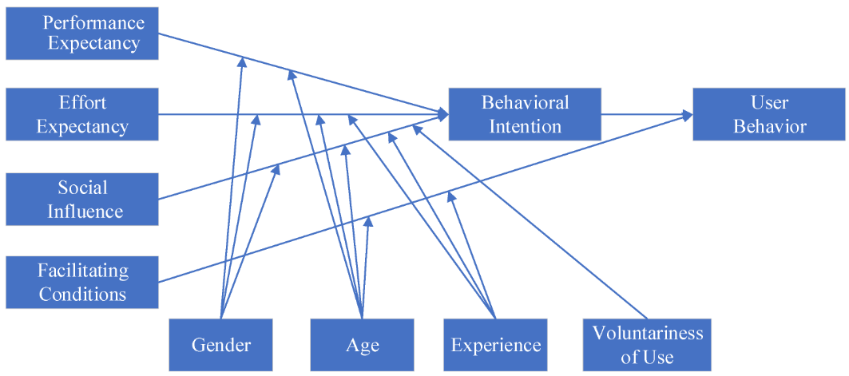
Figure 2.1: UTAUT model
(Source: Kaluarachchi and Nagalingam, 2024)
While referring to the theory, it constructs their performance expectancy, effort expectancy, facilitating condition, and social influence refer to the overall research objective. For instance, performance expectancy aligns with the way users perceive chatbot functional value in marketing (Dawar et al. 2022). On the other hand, effort expectancy and facilitating conditions influence the way users find chatbots to be an infrastructure support for smooth interaction that turns loyalty and satisfaction. Besides this, social influence prominently refers to the way peers or organisations pressure, which prominently drives adoption while highlighting the adoption where the users face trust or capability issues, shedding light on the problem.

2.6.2 SDT (Self-Determination Theory)
Gagné et al. (2022) demonstrated that SDT theory refers to a motivational framework that prominently explains the way human behaviour focuses on the needs for control, mastery, and connection. SDT theory refers to a powerful lens for understanding the motivation behind using chatbots, especially in terms of customer service satisfaction and loyalty, which depends on the utility of the user's psychological existence. According to the theory, people are more engaged when there is a need for competence, autonomy, and relatedness to be met (Gagné et al. 2022).
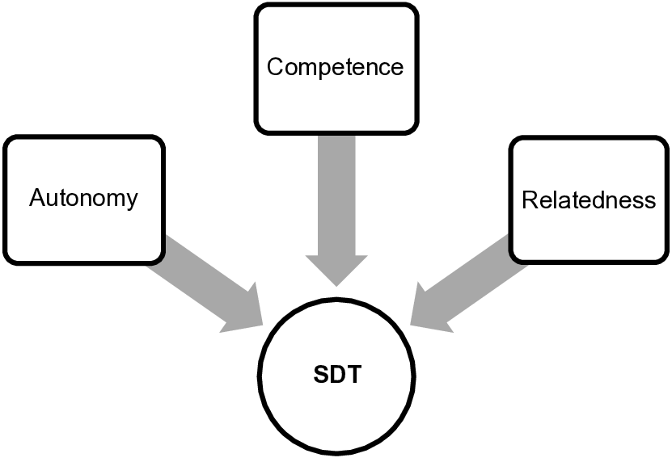
Figure 2.2: SDT
(Source: Self-created)
In the context of chatbots, autonomy can mean offering users the flexibility over the conversation path, and competence in satisfying when chatbots offer reliable answers while solving the problem. If a chatbot senses too unyielding, its comebacks would be motorised, which can be detrimental to low capability, or it would feel objective, which can impact appointment, foremost to churn (Al-Shafei, 2025). To report this, it is obligatory to project the chatbot to be supplementary relaxed while leveraging interpersonal characteristics with personalisation, sympathy, and follow-up, which can supplement chatbot provision brilliance and buyer loyalty.

2.6.3 Social Presence Theory
Social presence theory conspicuously explains the way broadcasting meaningfully fluctuates in transmitting the consciousness of psychological features that other personalities are actually contemporary (Kreijns et al. 2022). In this context, when a chatbot transports communal attention via informal style with receptiveness, users might feel that they are collaborating with a physical communal representative rather than a device. Concerning that, it can be quantified that progressive social presence in chatbots progresses initial trust, which, in the short term, along with affecting overall brand gratification and friendliness. On the contrary, this theory blatantly highlights the problem that highly human-like chatbots can principal to a reduction in trust (Hasal et al. 2021). In order to advance effectiveness, it is indispensable to equilibrium social cues with dependable performance that can be entrenched with empathy, temperance, and informal planning.
Moreover, chatbots are also obligatory to make available precise and contextually applicable responses while calculating an emergency instrument and preserving trust (Ribino, 2023). Connecting to that, definite chatbot disposition is noteworthy to balance common company with functional resoluteness that can guarantee high competence, along with support when mistakes happen. This theoretical background is deeply brought into line with the learning objectives, referring to optimising social appearance along with perpetuation of high performance.

2.7 Summary
In conclusion, the present analysis deals with evaluating the usage of chatbots within customer care alongside digital marketing instances including theories and empirical insights. It also covered the critical issues, like the privacy aspect, building trust, emotional constraints, the quality of interaction, and challenges with the design. The evaluation highlighted academic approaches to making chatbots more useful, including adaptive learning and better naturalness in conversations and transparency. Empirical studies also indicated the current flaws and efficiencies of the current chatbot systems. The identified gaps in the literature, in particular, the insufficient role of emotional, contextual, and behavioural factors, suggest a need to deepen and further research the subject and gain a more profound understanding of the interaction between people and chatbots, how people respond to them, and how they eventually use them.

Chapter 3: Methodology

3.1 Introduction
In research, methodological incorporation is always seen as a requisite aspect to ensure proper accumulation of facts and their interpretation to derive conclusions. The following chapter has been dedicated to declaring the methodological techniques that are incorporated in completing the research on analysing the outcomes of using chatbots in customer service interaction and digital marketing. Utilised methods for completing the study will be thoroughly described in this chapter, alongside giving reasons behind their usage. Explicitly, the philosophical view, reasoning method, strategic choice, and methods for accumulating information and analysing it will be revealed in this chapter. Ethical standards that are regarded in this research will also be discussed in this chapter.

3.2 Research onion
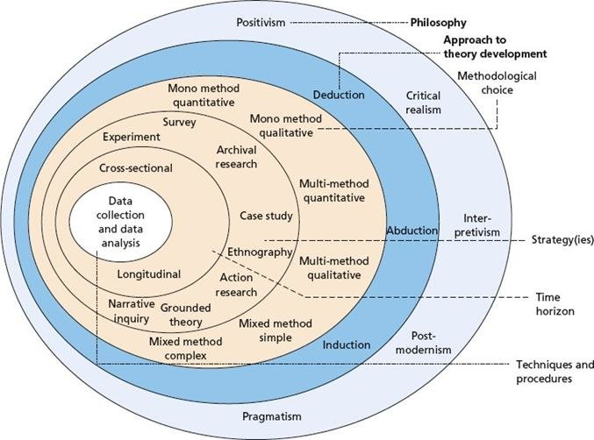
Figure 3.1: Onion model
(Source: Saunders, 2023)
Research onion is a supportive tool for successfully obtaining methodological choices by using the six stages, as illustrated in Figure 3.1 (Saunders, 2023). Most importantly, as the selection of methods is requisite for research and it is a complex process, this tool works as a guiding element for methods step-by-step, which includes philosophy, reasoning method, strategy, methodological choice, time horizon, and techniques for obtaining and analysing data. For making justifiable methodological choices for this research, this tool has been leveraged. The following sections of this chapter will reveal the methodological techniques chosen, using the onion’s idea, which are incorporated for completing this research.

3.3 Research Philosophy
The onion model pointed out that researchers can leverage a variety of philosophical ideas, including “interpretivism”, “critical realism”, “postmodernism”, “positivism”, and “pragmatism”. Among these philosophical views, when positivism is regarded to be favourable for quantitative studies, interpretivism drives favourable results in qualitative studies (Mphale et al. 2024). Furthermore, pragmatism is regarded to be a philosophical standpoint that supports mixed-method research, which incorporates both qualitative and quantitative findings, which is selected for this study. This is because, while the interpretivist philosophy, with a subjective focus, limits generalizability, and positivism with an objective focus struggle to understand subjective experience, pragmatism overcomes both limitations as it allows flexibility to adopt a mixed method (Mphale et al. 2024; Gillespie et al. 2024).
Pragmatism is regarded as a philosophical viewpoint that strongly emphasises real-world experience and practical consequences, as the foundation of meaning, action, and truth. As it strongly suggests that the truth or usefulness of ideas is usually determined by their practical results, it is noteworthy in problem-solving (Mphale et al. 2024). Likewise, this philosophical standpoint has positively assisted in solving the research issue by drawing clear and comprehensive ideas regarding the functionalities of chatbots in customer service interactions and DM. In addition, this philosophy is more focused on deriving the usefulness of findings (Gillespie et al. 2024). This trait of the pragmatist philosophy has successfully assisted in understanding the practical implications of chatbots in customer service and DM, and its impacts on customer satisfaction. In addition to that, this philosophy also assists in understanding issues linked with this aspect and offers useful suggestions regarding chatbots applications and enhancing their usefulness, which supports the attainment of objectives.

3.4 Research Approach
The onion model indicated that a reasoning method must be incorporated following the selection of a philosophical standpoint. Researchers can leverage “inductive”, “abductive”, or “deductive” reasoning methods, in this regard, as per their study requirements (Saunders, 2023). Explicitly, while emphasising the appropriateness of reasoning methods, deductive reasoning is regarded to be beneficial for positivist studies, inductive reasoning is favourable for interpretivist studies, and abductive reasoning is beneficial for pragmatic studies. Likewise, for successfully carrying out the study on the usefulness of chatbots in DM and interactions in customer service, the abductive reasoning method has been leveraged. Behind this, the main reason is that while inductive reasoning has a limitation in offering general conclusions and deductive reasoning has a limitation in leveraging and analysing theoretical ideas, abductive reasoning is a balanced method for overcoming the limitations of both (Conaty, 2021).
The abduction, as a reasoning method, can be regarded as a type of reasoning that involves developing the most likely explanation from a set of observations or incomplete facts. This method of reasoning benefits studies by allowing flexibility in leveraging theory and data, which makes it a well-fitted method for understanding complex phenomena (Conaty, 2021). Consequently, the complex phenomena of chatbot usage interaction with customers and DM, and both positive as well as negative outcomes of its use have been thoroughly interpreted with the use of the abduction method. Additionally, as this method facilitates the use of both quantitative and qualitative insights, it is well-suited for bridging the gap between methodological techniques and offering more comprehensive ideas (Abdelhakim, 2021). Likewise, by using this method, the functions of chatbots in DM and customer service and their impacts on customer satisfaction as well as loyalty, as well as issues linked with this aspect, are successfully observed, which ensures the development of sufficient knowledge for achieving objectives.

3.5 Research Strategy
Researchers use qualitative, quantitative, or mixed method strategies, as per requirements (Saunders, 2023). The qualitative strategy allows observation and deep comprehension of research issues with non-numeric information, whereas the quantitative strategy is supportive of understanding broad patterns and studying issues by successfully using statistical information. Furthermore, the mixed method strategy allows a combined use of both qualitative observations and numerical insights to comprehend complex issues (Taherdoost, 2022).
A mixed-method strategy has been incorporated for successfully carrying out the study on analysing the outcomes of using chatbots in customer service interactions and DM. This is because the limitations of both methods regarding sole dependents on qualitative or quantitative data are addressed while the mixed method strategy is leveraged (Taherdoost, 2022). By using the mixed methods strategy, this research incorporates qualitative information obtained through interviews with the managers of e-commerce companies, and quantitative information is obtained through a survey of online shoppers in the UK. This strategy has ensured the successful use of statistical and non-numerical observations to uncover functionalities of chatbots in customer service, as well as DM. By comparing qualitative and quantitative findings to understand the impacts of chatbot usage on customer satisfaction as well as loyalty.

3.6 Research Design
Research design refers to the overall strategy in the blueprint of a research project in terms of conducting a study, along with outlining a plan in terms of data collection and addressing research questions adequately (Muzari et al. 2022). As the following research has been considered based on a mixed-method approach to descriptive design, it has been taken to be an appropriate design because it refers to systematically mapping and describing the current state of chatbot use and customer satisfaction, along with referring to the issues within DM and service interaction.
However, exploratory, and explanatory designs have not been considered, as the study does not aim to establish causal relationships; instead, it aims to describe patterns and correlations as they naturally occur. In this regard, descriptive research design has been undertaken to be beneficial, as it is a cost-effective method with a comprehensive approach for understanding a topic with flexibility while providing a baseline for future comparison (Muzari et al. 2022). By leveraging this method, the understanding developed regarding the outcomes of using chatbots in DM and interactions in customer service has been thoroughly described in this study. Successful description of findings and observations of the study, with the help of this method, has ensured successful attainment of objectives and answered study questions, which in turn, contributed to the study quality.

3.7 Data Collection Methods
Data collection is a process of systematically gathering information regarding the research context in order to answer the research objective and questions, along with evaluating the outcomes (Taherdoost, 2021). The study has significantly relied on primary data collection using a mixed-method approach combining qualitative and quantitative aspects. Regarding this, the following research has combined a structured survey of consumers and semi-structured interviews of managers. Primary data is appropriate as it prominently allows the collection of updated information regarding the research objective, which has allowed the researcher to access the chatbots’ influence on customer satisfaction, service quality, and loyalty, along with understanding the managerial perspective of chatbot deployment.
Primary data has significant enable and control over the sampling, along with ensuring data directly reflects the research context (Taherdoost, 2021). For the quantitative component, the survey has been done by undertaking a sufficiently large sample of customers who have interacted with chatbots in DM or a customer service context. For the survey, the researcher has selected relevant social media platforms, such as Facebook and Instagram, along with posting and sharing the survey link to relevant consumer groups who are engaged in online shopping, while collecting responses over the defined time period of 2 to 4 weeks.
In terms of qualitative components, semi-structured interviews have been conducted with managers of decision-makers in the e-commerce firms using chatbots. These interviews have explored their motivations for adopting chatbots, along with perceived challenges and benefits and perception of customer reaction. Connecting to that, significant potential managers have been identified by sending them a personalised connection request on LinkedIn while briefly explaining the study purpose, along with ensuring confidentiality. After that, the scheduled interview was conducted via LinkedIn messaging.
In this regard, while using both methods, the researcher has significantly captured a broader user-level trend along with detailed viewpoints, offering a comprehensive and balanced perspective regarding the research context.

3.8 Sample Size and Sampling Technique
For this research, purposive sampling has been selected, in which a researcher purposefully chooses participants according to their particular traits or areas of expertise in order to achieve the study's objectives. In contrast to random sampling, this approach depends on the researcher's judgment to select participants who are most likely to offer detailed, rich information pertinent to the study issue (Andrade, 2021). Connecting to that, the following study has significantly selected 55 customers via a social media survey, and 3 marketing managers via LinkedIn interview. The sample size is justified, as the study adopts an exploratory mixed-methods approach, where 55 customer responses provide sufficient breadth for identifying patterns in social media perceptions, while interviews with three marketing managers offer in-depth expert insights to contextualise and triangulate the findings.
Purposive sampling has been identified to be appropriate because it significantly targets specific groups, such as customers who have experience with chatbot interactions and managers who were responsible for chatbot deployment. The sample size significantly reflects practical aspects, as the responses provide enough insight regarding the research.

3.9 Data Analysis Techniques
Data analysis technique refers to the categorisation of quantitative and qualitative methods while extracting insights and patterns that can lead to answering research questions (Perera, 2023). In this context, for the following research aspect, the data collection has been referred to a mixed method of qualitative and quantitative perspectives, which has been supported with a combination of analyses that include descriptive percentage analysis and thematic analysis. Percentage analysis allows summarising information and reflecting distribution or characteristics in data, which is beneficial for uncovering patterns (Kotronoulas et al. 2023). Likewise, for analysing quantitative information, descriptive percentage analysis was conducted, which has helped in uncovering patterns of using chatbots in DM and interactions in customer service.
Additionally, while conducting the thematic analysis, Braun and Clarke's tool of coding has been utilised. This tool of coding has six stages, which are “familiarisation”, “generating codes”, “searching for themes”, “reviewing themes”, “defining & naming themes” and “producing the report” (Chen et al. 2021). By using these stages, themes have been developed for conducting thematic analysis using initial codes such as DM, customer service interaction, chatbots, customer satisfaction, loyalty, and others. From raw data, themes have been developed using these codes and further named; the obtained qualitative information has been analysed based on those themes. Proactive focus on analysing both qualitative and quantitative information has contributed to the study outcomes by making findings more comprehensive.

3.10 Reliability and Validity
In order to complete the study effectively, the researcher has significantly focused on maintaining the reliability and validity of the research. Connecting to that, to ensure reliability, the researcher has focused on standardising the survey aspect with a consistent questionnaire with Likert scale options, so that the responses remain stable. Apart from this, in terms of validity, the questionnaire and interview guide have been significantly designed based on the existing literature and theory to ensure items truly measure constructs like loyalty, customer satisfaction, and perceived usefulness of chatbots. Apart from this, content validity and construct validity significantly aligned with the research context. Furthermore, using a mixed-method has significantly enhanced construct validity while cross-verifying findings.

3.11 Ethical Considerations
Ethical standards must be respected while completing studies in order to deliver responsible results without failure to avoid misconduct like plagiarism, misuse of data, or harming participants' rights (Nii Laryeafio and Ogbewe, 2023). Likewise, while carrying out this research, remarkable focus has been kept on ethical standards, including responsibility, transparency, safeguarding information, and participants' rights. Explicitly, informed consent has been ensured using the participant information sheet; respondents are allowed to participate voluntarily and withdraw before the research completion.
In particular, to give this study a wide berth to copyright-centred concerns, a focus has been kept on following the guidelines of the CDPA (Copyright, Designs and Patents Act) 1988 (GOV, 2025). Respecting this, sources of information are highlighted in the list of references and in-text citations. Collected information has been using the guidelines of GDPR (General Data Protection Regulation) and DPA (Data Protection Act) 2018 (GDPR, 2025; GOV, 2025). Collected information has been securely kept in the University drive and is intended to be completely erased after the research completion to avoid further misuse.

3.12 Limitations
Even though the researcher has significantly focused on maintaining accuracy in collecting data and analysing, it has significant limitations that have been acknowledged, such as reliance on a small and non-random sample, such as 55 customers and 3 managers can significantly limit generalisability to the broader population. Moreover, the findings may not reflect the views of all chatbot users or firms. Furthermore, using online social media surveys may risk self-selection and response bias, because respondents may have distinct traits. Apart from that, qualitative interviews with a few participants might suffer from subjectivity and research bias that can limit replicability and validity.

3.13 Summary
Reflecting on the overall chapter, the research onion has significantly supported the researcher in terms of understanding the adequate process of selecting methodological aspects to complete a study. In this regard, pragmatist philosophy, abductive approach, mixed-method research strategy, along with descriptive research design, have been undertaken by the research in order to understand the research context while collecting adequate sources and information for addressing the research aim. Furthermore, the researcher has focused on collecting a mixed method of data collection with qualitative and quantitative research aspects. Most importantly, to successfully analyse qualitative and quantitative information, the thematic analysis method and descriptive percentage analysis method have been utilised, respectively. Positive focus on analysing both types of data has enhanced the study outcomes by giving findings in depth regarding the impacts of using chatbots in DM as well as interactions during service on customer satisfaction and loyalty. Additionally, a strong focus has been kept on ethical standards, which makes the study outcomes more dependable.

Chapter 4: Findings, Analysis and Discussion

4.1 Introduction
The chapter provides the results, discussion and analysis of a study on the effectiveness of chatbot in the area of digital marketing (DM) and customer service communication. The objectives of this research are to investigate the effects of chatbot use on customer satisfaction, customer loyalty, and customer experience of the service carried out by both consumers and managers. To fulfill this, the chapter synchronizes quantitative data gathered by consumer surveys with qualitative information that will be obtained via semi-structured interviews with marketing managers. The findings are critically discussed and explained in the form of the well-known theoretical framework, such as the Unified Theory of Acceptance and Use of Technology (UTAUT), Self-Determination Theory (SDT), and Social Presence Theory. The chapter is structurally divided into four parts, including quantitative findings, qualitative findings, an integrated discussion of the results and existing literature, and a final conclusion that outlines the main insights and implications.

4.2 Quantitative Findings
The present section displays the quantitative result of the consumer survey. The descriptive percentage analysis is applied to evaluate the demographic profiles of respondents, the chatbot usage patterns, their level of satisfaction, trust factors, and behavioural intentions contributing to understanding the efficiency of chatbots in digital-based marketing and customer interaction through customer services.

4.2.1 Demographic Profile of Respondents
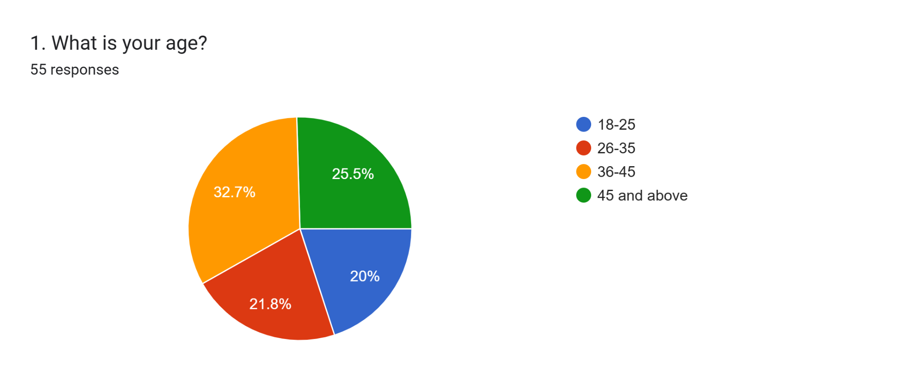
Finding
The age distribution demonstrates a heterogeneous sample, as the highest percentage is among the respondents age 36-45 (32.7%) and the next percentage is among the respondents age 45 and over (25.5%). The young age groups of 26-35 (21.8%) and 18-25 (20%) were also represented well.
Analysis
This age distribution shows that the chatbot interactions are not only enjoyed by young and tech-savvy users but are common based on the age bracket. The high proportion of customers that fall in the middle age category implies that chatbots are assuming a dominant status as a service tool. This upholds the performance expectancy concept of UTAUT where individuals of all ages interact with chatbots when they feel there is functional value, convenience, and efficiency in the digital marketing and customer service interactions.
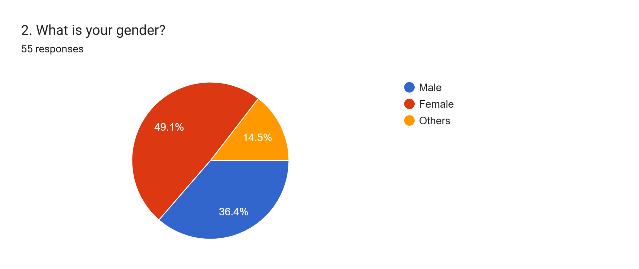
Finding
The largest percentage of the respondents was constituted of female respondents (49.1%), a smaller percentage was made up of male respondents (36.4%) and other genders (14.5%). It implies a comparatively equal gender distribution amongst users who socialise with chatbots in the context of online shopping.
Analysis
The gender distribution indicates that the usage of chatbots is widely agreed upon irrespective of the gender representations. The fact that the women are slightly increased might point to increased use of online shopping and online customer care mediums. In social presence, to facilitate accordability, chatbot design must be inclusive and neutral, and this gender-neutrality is critical. The results also suggest that effectiveness of a chatbot cannot be based on gender-related assumptions but on expected and general usability with the accompaniment of trust-building abilities.

4.2.2 Chatbot Interactions in Direct Messages and Customer Support
Research Question 1: How do chatbots work in direct messages and customer support interactions?
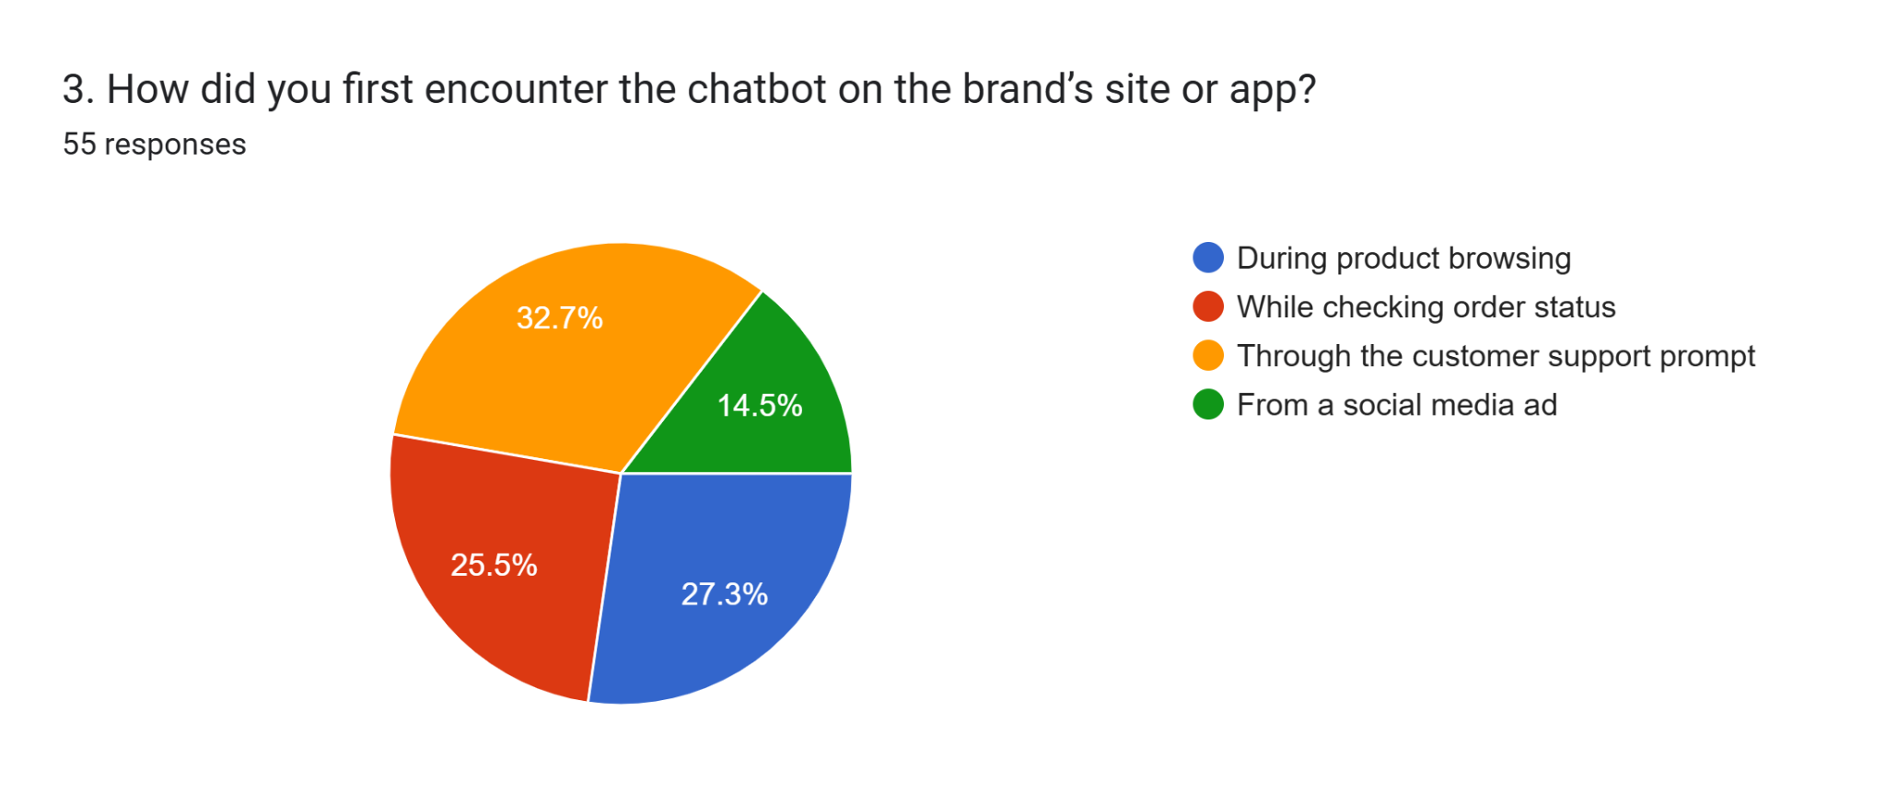
Finding
A majority of the respondents came across chatbots as prompts (32.7%) in the customer support section, then product browsing (27.3%) and order status checking (25.5%). The less extended proportion initially communicated with chatbots through social media advertisements (14.5%).
Analysis
These results demonstrate that chatbots are mainly implemented when there is an element of problem solving or assistance as opposed to an aspect of pure promotion. This brings to the fore their high level of customer service in lieu of early customer appeal in marketing. In terms of digital marketing, chatbots are reactive and support-oriented technologies. This confirms the literature, indicating that chatbots are most applicable when contextually integrated into the customer experience as opposed to standalone marketing capabilities.
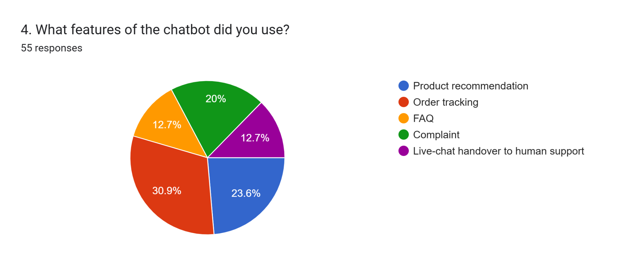
Finding
The most utilized chatbot functions were order tracking a feature (30.9%), product suggestions (23.6%), and complaint management (20%). The least used were responses to the FAQs, and handover in the live-chat to the human support with 12.7% respectively.
Analysis
The prevalence of order tracking shows the functionality of the application of chatbots where the customers focus on efficiency and immediacy. Reduced implementations in live-chat handover indicate reduced access to human care or frustration over human support among users. These results do not conflict with the competence needed of SDT because users appreciate the matter of chatbots that can complete their tasks successfully. Nevertheless, autonomy is potentially limited by the availability of limited handover choices and adversely impacts satisfaction in complex interactions.
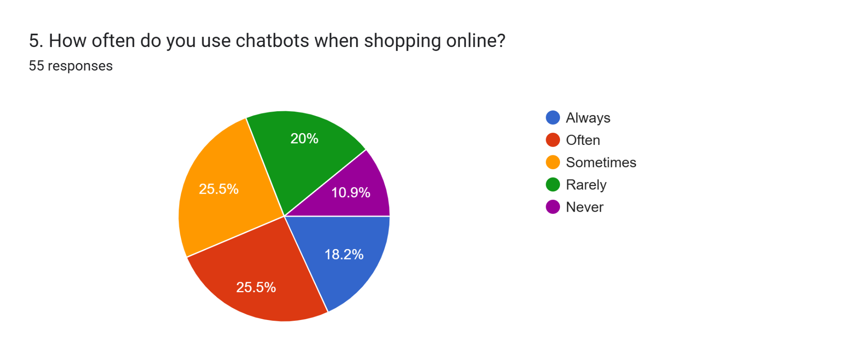
Finding
Most interviewees said that they actively use chatbots as 25.5% used them frequently, and there were some who used them on a regular basis. Meanwhile, 18.2% of those constantly use chatbots, and 20% of them rarely use chatbot services and 10.9% never use chatbot services.
Analysis
The discrepancy in usage frequency shows that the technology of chatbots is not unanimously accepted. Although a large percentage of users use chatbots, there is a significant number of individuals who do not use them, which can indicate the lack of trust or performance-related issues. This agrees with the effort expectancy component of UTAUT, in which adoption is dependent on ease of use. Unstable performance or perceived lack of efficiency can cause discouragement in the habitual use, and better reliability and user-friendly chatbot design should be implemented.
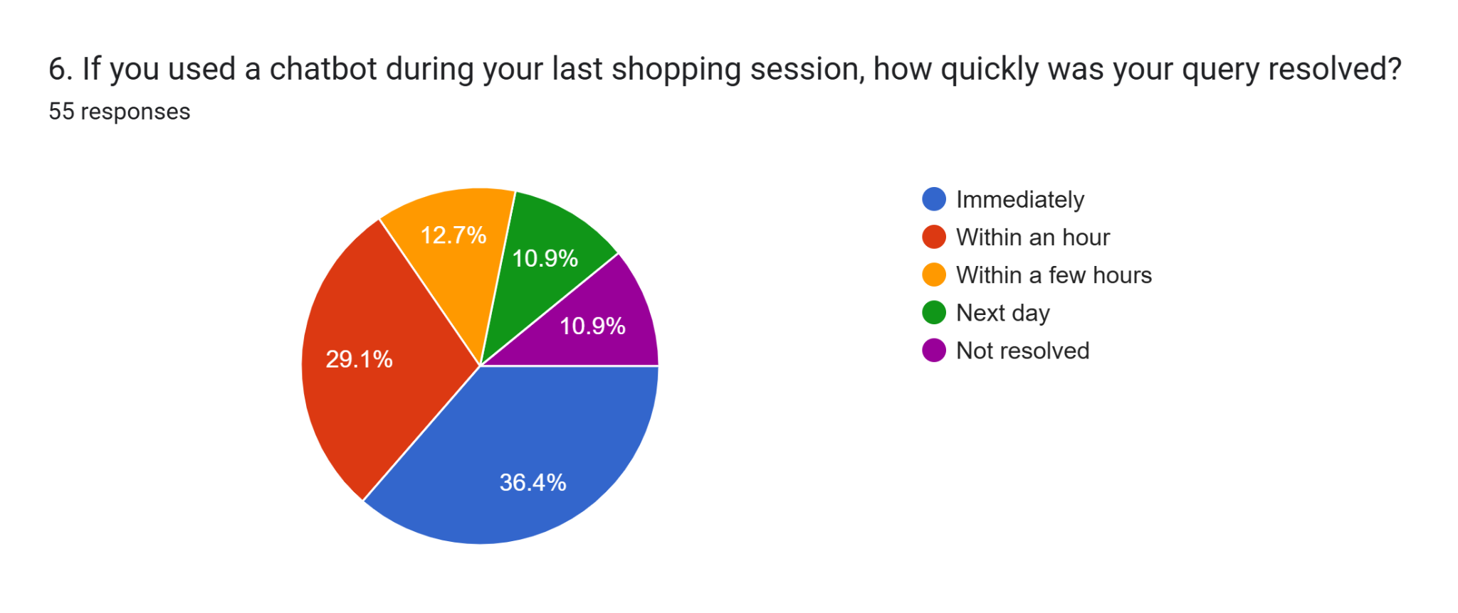
Finding
More than a quarter of the responders (36.4%) stated that their queries were solved immediately, and 29.1% that their queries were resolved within an hour. Nevertheless, 23.6% had to handle unresolved issues or delayed issues such as non-response the next day, or not responded to at all.
Analysis
Quick response rates help to support one of the core strengths of chatbots, i.e., immediacy. Nevertheless, non-resolved cases reveal a shortcoming regarding the need to manage complex cases. These findings correspond to the literature that chatbots are more efficient in tasks that can be performed in a routine than in complex queries. In the view of performance expectancy, failure or postponements might lessen trust and gratification, which underscores the significant role of effective escalation to human agents.

4.2.3 Impact on Customer Loyalty and Satisfaction
Research Question 2: How does using chatbots in direct messages affect customer loyalty and satisfaction?

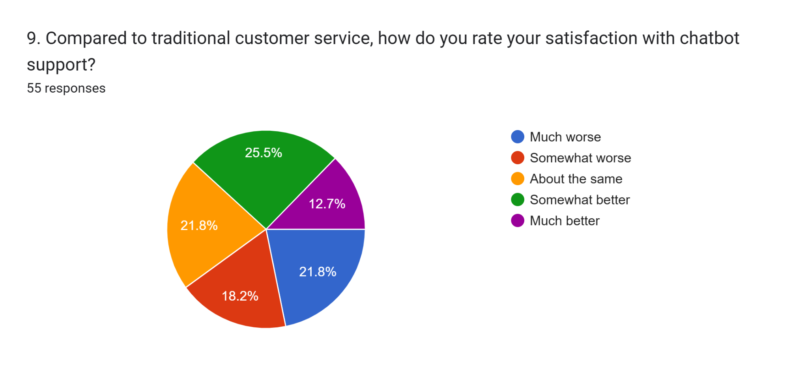
Finding
About 38.2 percent of the respondents rated chatbot service as superior to that of traditional support, and 40 have viewed it as inferior. Satisfaction by another 21.8% stated that they were equally satisfied using chatbot and human-assisted service.
Analysis
The split level of satisfaction reveals that chatbots can be more effective or less effective depending on the expectations of users and the conditions of the service. Whereas efficiency appeals to some of the users, the need to feel emotions by humans is favored by some of the users. This is consistent with SDT and Social Presence Theory that chatbots can address the competence needs, but frequently not with relatedness needs, especially in situations of emotional sensitivity with services.
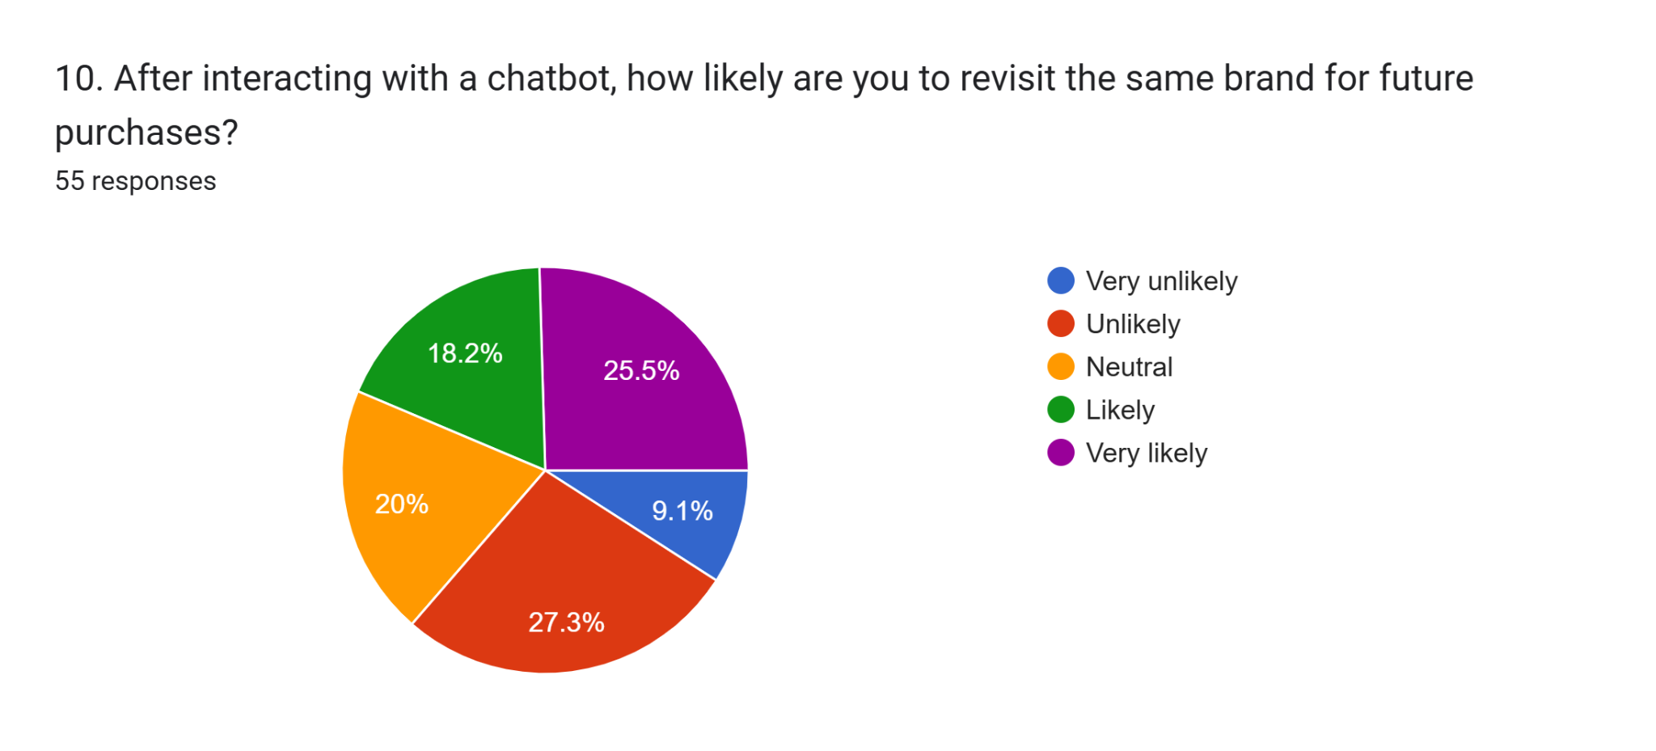
Finding
The proportion of people who said that they would probably or most probably go back to the brand after interacting with the chatbot was 43.7 percent, and those who said they would not be 36.4 percent. The rest 20 percent were just neutral.
Analysis
The results indicate that the interactions with chatbots can have an impact on the intention to repurchase, but not always. Good experiences make customers loyal, and poor experiences discourage repeat business. This shows how conditional chatbots are to be used to create loyalty as it supports a set of literature that highlights the importance of experience quality as a mediator between the use of technology and long-term customer relationships.
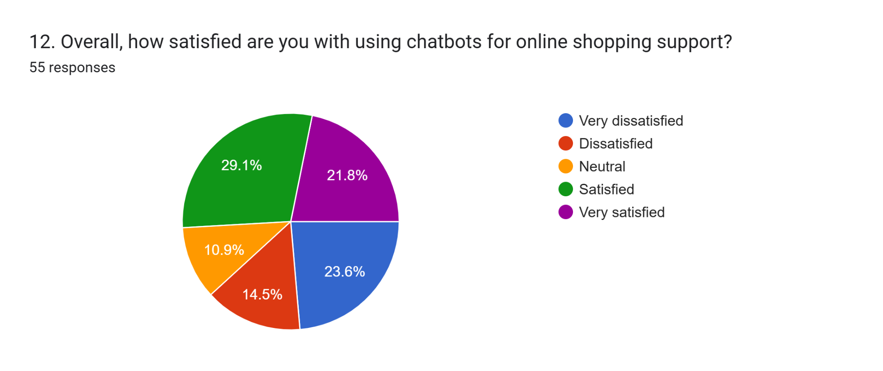
Finding
The overall satisfaction content was ambivalent, with 50.9 percent of the respondent’s indicating satisfaction or high satisfaction. Nevertheless, 38.1% said that they were satisfied, and 10.9% were neutral, which reveals different experiences with the chatbot-assisted online purchasing.
Analysis
The ambivalent satisfaction rates prove that chatbots are not always that useful. Although efficiency and convenience are positive, lack of issues analyzed and lack of personal response to concerns amounts to less satisfaction. Such results are in line with the current literature implying that the success of chatbots should be determined by the balance of automation and human-like interaction, openness, and proper mechanisms of escalation.

4.2.4 Problems with Chatbot Implementation
Research Question 3: What are the problems associated with chatbot implementations in direct messages and customer support exchanges?

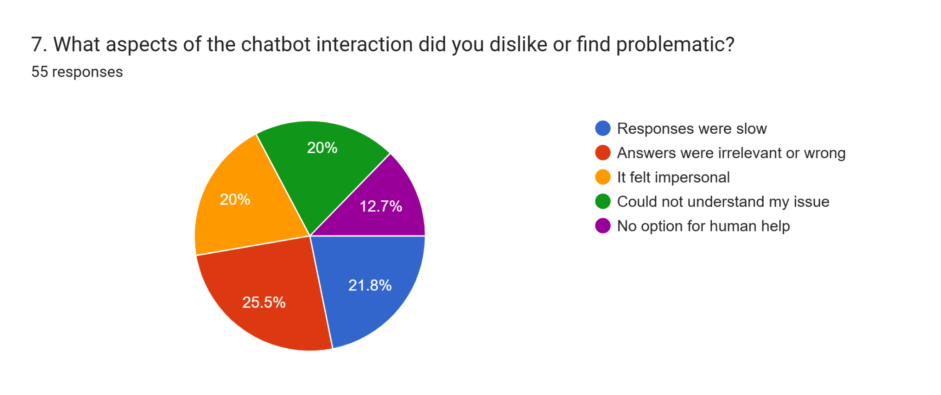
Finding
Irrelevant or wrong responses were regarded as the most frequent causes of dissatisfaction (25.5%), and then there came the slowness of responses (21.8%). Impersonal interactions and poor understanding of the issue was the same (20%), and lack of human support was mentioned (12.7%).
Analysis
The issues are representative of fundamental problems reported in the literature on chatbots, especially lack of contextual awareness and emotional intelligence. The understanding of depersonalized contact is consistent with the Social Presence Theory, in which decreased human stimuli decrease interaction. Wrong answers are harmful to trust and credibility of the system. Such results indicate that enhancing accuracy in conversations and emotional responsiveness is one of the most essential elements of improving chatbot performance and acceptance by users.
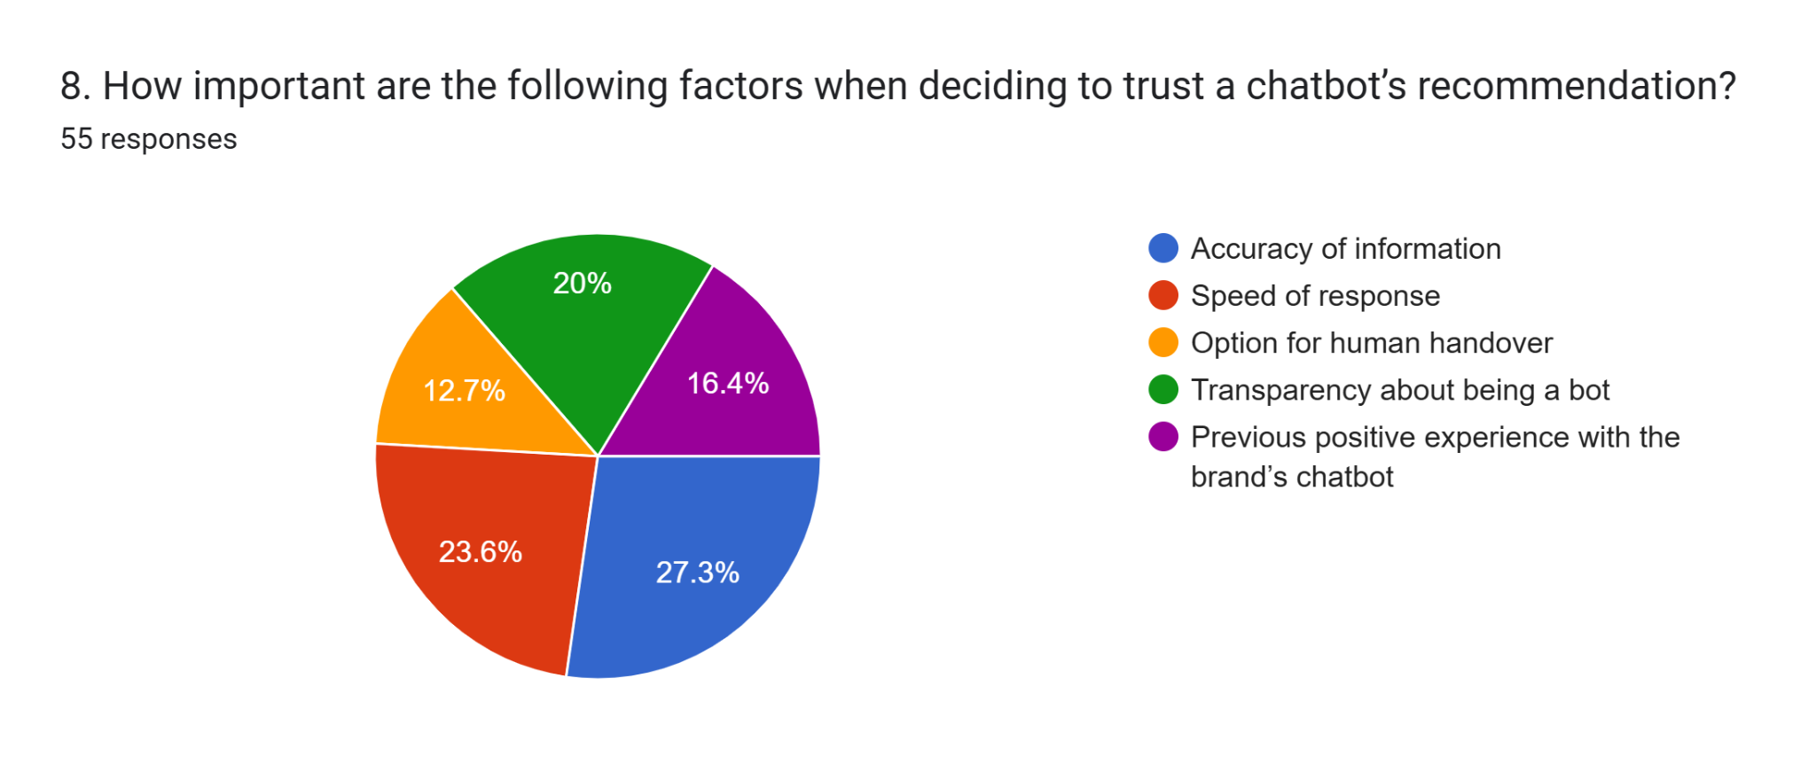
Finding
The most significant factors that affected trust were accuracy of information (27.3%), followed by speed of response (23.6%), and disclosure over being a bot (20%). Previous experiences and human handover preferences were deemed to be not so influential.
Analysis
The main reason behind trust in chatbots is utility reliability and not emotions. This contributes to the performance expectancy dimension of UTAUT, in which the perceived usefulness increases the adoption. An important role is also made by transparency, which supports the ethical and trust-based design. Although human handover was not prioritised as much, it is still important in case of complex interaction to ensure that the user has confidence in it.

4.2.5 Recommendations for Improving Chatbot Utility
Research Question 4: How to resolve problems with the chatbot application and increase its utility?

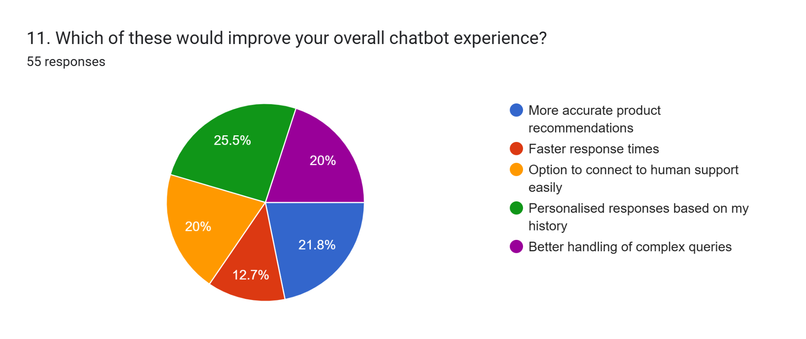
Finding
Personalised response was given the third priority by the respondents in consideration of the interaction history (25.5%), and then there was an accurate product recommendation (21.8%). Enhanced management of complicated queries and simplified access to human assistance were considered as well at 20% each.
Analysis
The tendency towards personalisation can be seen as an increasing demand for intelligent and adaptive chatbot systems. This corresponds to SDT needs of autonomy and competence, where users have a need to feel relevant and in control. The further improvement in handling more complicated queries is another sign that people are not satisfied with current restrictions of chatbots, and hybrid human-AI service models are necessary to exist.

4.3. Descriptive Statistics
Age Distribution of Respondents (N = 55)
Age Group | Frequency | Percentage (%)
18–25 years | 11 | 20.0
26–35 years | 12 | 21.8
36–45 years | 18 | 32.7
45 years and above | 14 | 25.5
Total | 55 | 100
Interpretation
The table shows a heterogeneous age distribution. The largest proportion of respondents belongs to the 36–45 age group, indicating that chatbot usage is common among middle-aged consumers and not limited to younger users. The distribution of age of the respondents gives a representative sample of various ages. The highest percentage of the respondents is in the 36-45 years age group (32.7%), then there are those aged 45 years and above (25.5%). The adequate representation of younger respondents (21.8) aged 26-35 years and (20.0) aged 18-25 years is also sufficient. The distribution shows that chatbot use online shopping does not target younger or more technologically literate users but rather is also common among middle-aged and older customers. Having representatives of all age categories indicates the extensive adoption of chatbots as a means of communication with customers.
Table 4.2
Gender Distribution of Respondents (N = 55)
Gender | Frequency | Percentage (%)
Female | 27 | 49.1
Male | 20 | 36.4
Other | 8 | 14.5
Total | 55 | 100
Interpretation
The results indicate a relatively balanced gender distribution, suggesting that chatbot usage in online shopping is not gender specific. The gender distribution of respondents shows fairly even participation. The female respondents represent the majority (49.1%), then male respondents (36.4) with 14.5% identifying themselves as other genders. This even distribution indicates that gender does not play any key role in the use of chatbots in online shopping. The results suggest that chatbots are equally attractive to representatives of various gender groups and may be regarded as a gender-neutral technology in the case of digital marketing and customer care.
Table 4.3
Areas Where Chatbots Are Encountered During Online Shopping (N = 55)
Area of Interaction | Frequency | Percentage (%)
Customer support prompts | 18 | 32.7
Product browsing | 15 | 27.3
Order status checking | 14 | 25.5
Social media advertisements | 8 | 14.5
Total | 55 | 100
Interpretation
Most respondents encountered chatbots in customer support and order-related activities, highlighting the service-oriented role of chatbots rather than purely promotional use. As the table indicates, the most frequent usage of chatbots among the respondents was on customer support prompts (32.7%), product browsing (27.3%), and order status checking (25.5%). Less percentage actually came across chatbots in social media adverts (14.5%). The results underscore the fact that chatbots are mostly utilized in service-based operations but not in promoting the business. This implies that the primary purposes of online shopping chatbots are to help customers when they are at problem-solving and transactional levels.
Table 4.4
Frequency of Chatbot Use During Online Shopping (N = 55)
Variable / Statement | Mean | Standard Deviation | N
Frequency of chatbot use during online shopping | 3.20 | 1.268 | 55

Interpretation
The mean value of 3.20 indicates a moderate level of chatbot usage among respondents. The standard deviation shows variability in usage frequency across users. The average of 3.20 means that the usage of chatbot by respondents during online shopping is moderate. The standard deviation of 1.268 indicates the variation in the usage frequency, i.e. some respondents may use the chatbots regularly, whereas others may use it occasionally or infrequently. This difference is observed because of the differences in the likes of the users, experience with technology, and perceived value of chatbots.
Table 4.5
Speed of Query Resolution Using Chatbots (N = 55)
Response Time | Frequency | Percentage (%)
Immediately | 20 | 36.4
Within one hour | 16 | 29.1
Delayed / unresolved | 19 | 34.5
Total | 55 | 100
Interpretation
While most respondents received quick responses, a considerable proportion experienced delays, indicating limitations in chatbot efficiency for complex issues. It can be seen that 36.4 percent of the respondents had their questions answered instantly and 29.1 percent of the respondents had their questions answered within one hour. Nonetheless, 34.5% had a delayed or unresolved query. Despite the ability of chatbots to respond promptly, it can be seen that the number of cases that are delayed or not resolved is very high, which points to the inability to resolve sophisticated problems of customers. The results of this finding imply that there should be more efficient chatbots and more effective escalation mechanisms.
Table 4.6
Satisfaction with Chatbot Support Compared to Traditional Customer Service (N = 55)
Satisfaction Level | Frequency | Percentage (%)
More satisfied | 21 | 38.2
Less satisfied | 22 | 40.0
Equally satisfied | 12 | 21.8
Total | 55 | 100
Interpretation
The results show mixed satisfaction levels, suggesting that chatbot effectiveness varies depending on user expectations and service context. As shown in the table, there is a mixed level of satisfaction. Although 38.2 percent of the respondents indicated that they are more satisfied with chatbot support, 40.0 percent indicated that they are less satisfied, and 21.8 percent indicated that they are satisfied equally. These findings also show that the performance of chatbots can be different according to personal expectations and service experiences. There are those users who are conscious of speed and convenience as opposed to human contact.
Table 4.7
Overall Satisfaction with Chatbot-Assisted Online Shopping (N = 55)
Satisfaction Level | Frequency | Percentage (%)
Satisfied / Highly satisfied | 28 | 50.9
Dissatisfied | 21 | 38.1
Neutral | 6 | 10.9
Total | 55 | 100
Interpretation
Although more than half of the respondents expressed satisfaction, a significant proportion reported dissatisfaction, indicating inconsistency in chatbot performance.
Table 4.8
Likelihood of Revisiting the Same Brand After Chatbot Interaction (N = 55)
Variable / Statement | Mean | Standard Deviation | N
Likelihood of revisiting the same brand after chatbot interaction | 3.24 | 1.347 | 55
Interpretation
The mean score reflects a moderate intention to repurchase, indicating that chatbot interactions can influence loyalty but are not a decisive factor for all users. Over fifty percent of the interviewed (50.95) indicated that they were satisfied or highly satisfied with chatbot-assisted online shopping. Nevertheless, there was a high level of dissatisfaction (38.1%), which was neutral (10.9%). This means that there is no consistency in chatbot performance, therefore, it can be concluded that although chatbots are useful to some customers, they do not always perform satisfactorily to all customers.
Table 4.9
Problems Faced While Using Chatbots (N = 55)
Problem Area | Frequency | Percentage (%)
Incorrect or irrelevant responses | 14 | 25.5
Slow response time | 12 | 21.8
Impersonal interaction | 11 | 20.0
Poor issue understanding | 11 | 20.0
Lack of human support | 7 | 12.7
Total | 55 | 100
Interpretation
Incorrect responses and slow speed are the most common issues, which negatively affect trust and satisfaction with chatbot systems. The average score of 3.24 displays an average desire to repeat the experience with a chatbot of the same brand. The standard deviation of 1.347 means that there are variations in customer experience. This is an indication that chatbot communications can be used to affect customer loyalty in a way, but it is not the only factor influencing repeat purchases.
Table 4.10
Factors Influencing Trust in Chatbots (N = 55)
Trust Factor | Frequency | Percentage (%)
Accuracy of information | 15 | 27.3
Speed of response | 13 | 23.6
Transparency about being a bot | 11 | 20.0
Previous experience | 9 | 16.4
Human handover option | 7 | 12.7
Total | 55 | 100
Interpretation
Accuracy and speed are the strongest determinants of trust, indicating that functional reliability is more important than emotional factors. The greatest reported issue was wrong or irrelevant answers (25.5%), then low response time (21.8). The question of impersonal interaction and lack of understanding of customer problems was mentioned by 20.0 percent of the respondents each. Such results indicate the main flaws of chatbot systems, specifically, in accuracy and personalisation, which adversely influence user trust and satisfaction.
Table 4.11
Pearson Correlation Between Chatbot Usage and Revisit Intention (N = 55)
Variables | 1 | 2
1. Frequency of chatbot use during online shopping | 1 | −0.202
2. Likelihood of revisiting the same brand after chatbot interaction | −0.202 | 1

The correlation test was performed to analyse the correlation between the number of times the chatbot was used during online shopping and the probability of using the same brand in future. The findings reveal that the two variables have a weak and negative correlation and the Pearson correlation coefficient is = -0.202. This value implies a slight, but not very strong tendency of decreasing revisit intention with the increase in the frequency of chatbot use; moreover, the strength of this association is rather low. In further examination of the statistical significance, it is indicated that the p-value is 0.140, exceeding the standard understanding of the level of statistical significance of 0.05. This shows that the relationship observed is not statistically significant. Thus, the negative relationship found in the correlation test cannot be discussed as reliable and extrapolative outside of the sample. That is, the data is not sufficient to make a conclusion that the frequency of use of chatbots has significance to the intention of customers to revisit the same brand. These results indicate that the use of chatbots is not a powerful predictor of customer loyalty. Although chatbots can facilitate customer communication by allowing them to respond quickly and give some basic support, their presence or common use does not necessarily lead to repeat purchase intentions. Customer loyalty is a multifaceted phenomenon that is determined by a variety of factors and not a technological feature.
Issues like service quality, information accuracy, customer faith in the system and general customer experience are likely to influence revisit intentions in a more important way. In cases where chatbots are not effective in solving problems, or are not personalised and understanding of emotions, their effect on long-term customer relationships can be minimal. As such, organisations must consider chatbots as a supplementary feature in a larger service approach instead of a separate solution to improving customer loyalty.

4.4 Qualitative Findings: Interview Analysis
The thematic analysis of the interview data followed the six stages depicted by Braun and Clarke (2007): (1) familiarisation of the data, (2) creation of initial codes, (3) theme searching, (4) theme review, (5) theme definition and naming, and (6) creation of the report. Primary coding generated narrow codes that were grouped into four broad themes that are consistent with research goals and interview data. During analysis, there is a coding table which summarises theme and representative codes.
Coding table
Theme No. | Theme name | Key codes
1 | Operational efficiency & scalable engagement | order tracking, FAQs, lead capture, 24/7 availability, response speed, cost-per-contact
2 | Conditional effects on satisfaction & loyalty | immediacy, task complexity, emotional needs, repeat purchase intent, trust, escalation
3 | Technological & managerial constraints | NLP limits, legacy integration, data privacy, AI training, multilingual support, monitoring
4 | Hybrid design & personalization strategies | human handover, CRM integration, personalised replies, transparency, continuous learning, fallback flows

Theme 1: Chatbots as Enablers of Operational Efficiency and Scalable Engagement
Chatbots were always put forward by managers as frontline tools that cut down on routine workload and scaled. The description of this operational position was presented by one of the managers in the following way: chatbots receive the FAQs, order tracking, and product recommendations... insta-support around the standardised number of queries. This is a pragmatically based treatment with high-volume, low-complexity work being meted out by bots in this approach. There is empirical support that chatbots provide faster replies and lower the cost-per-contact, particularly with transactional processes like order tracking and solving questions frequently asked (Misischia et al., 2022).
More crucially, the wastage reduction depends on the nature of the work and the level of integration. The efficiency of chatbots is not service quality: when chatbots handle transactional questions effectively, it leaves the staff to work on value-adding tasks, ensuring that human agents are not bound to simple or low-value interactions. However, when bots are isolated or not effectively connected to the CRM and fulfillment systems, the gains are overstated since the friction caused by escalation acts against efficiency. This reflects the results that organizational returns to chatbot benefits are only achieved by balancing organizational processes (routing, knowledge-bases, analytics) with automation (Zhang et al., 2023).
To the point, chatbots can be considered an efficiency multiplier in e-commerce provided that they are developed as a component of an integrated service architecture, or perceived benefits will be superficial. The accounts of managers reveal that the scalability of operations is not a fiction, yet the sustainability of values needs to be observed in order to maintain a systemic orientation of the system with the marketing and service processes at large (Lin et al., 2024).

Theme 2 : Conditional Influence of Chatbots on Customer Satisfaction and Loyalty
Chatbot effects on customer satisfaction and customer loyalty according to interviewees were subtle: “Chatbots enhance satisfaction when we have simple queries... but when the problems are more complex, we need human input in order to retain the trust and guarantee long-term loyalty”. This conditionality is consistent with the studies that found out that short-term satisfaction is motivated by immediacy and task-success, and long-term loyalty is motivated by relationship-related aspects (Sidlauskiene et al., 2023).
Importantly, the data suggest that there are two paths, (a) positive transactional path: rapid, precise responses to straightforward tasks amplifying perceived usefulness and able to elevate repurchase intent, and (b) negative relational path: impersonal or erroneous response when engaging in queries comprehensive of emotional affect or ambiguity diminishes trust and is repelling of repurchase. The statements used by managers like “emotional connection and loyalty development cannot be achieved without personalised human experiences”show that they realise that chatbots fulfil the competence needs, but tend to miss relatedness needs outlined in SDT (Chandrakumar, 2024).
It has an implication of sensitivity to measurement: surface KPIs (response time, resolved tickets) can improve when the Net Promoter Scores or retention rates remain unchanged over a long term. Thus, companies are to track short-term performance indicators and downstream loyalty ones. It is indicated in the literature that a mixed-metrics approach i.e. a task success measurement alongside attitudinal measurement alongside a behavioural measure would be used to measure the conditional influence of chatbots on satisfaction and loyalty (Vebrianti et al., 2025).

Theme 3: Technological and Managerial Constraints Limiting Chatbot Performance
Managers predicted constraints: NLP constraints, having to integrate with legacy systems, upholding data security, and updating content to present correct, context-specific reactions are some of the challenges it has. These remarks correspond to a rather large evidence base of NLP fragility, data governance risks, and organisational readiness gaps (Alawida et al., 2023).
More importantly, two constraint clusters which are closely connected emerged. First, technical: NLP is yet to tackle the problem of ambiguity, sarcasm, and domain specifics, and provides irrelevant or wrong responses thus eroding credibility. Multilingual assistance and continuous model re-training is costly to the operations. Second, managerial: change management, content governance and monitoring regimes are needed to achieve successful deployment, otherwise bots bring up inconsistent experiences. The fact that managers focus on the idea of constant AI training, performance monitoring and compliance emphasizes that these are the issues that cannot be resolved solely by means of technologies, processes and roles will have to evolve (Zhang et al., 2023).
Additionally, there is the issue of privacy and compliance stresses (e.g., GDPR), which present further limitations: one cannot just gather conversational data to enhance it, as it is legally and ethically questionable. Consequently, it brings about trade-offs between personalization and privacy of organisations. In the literature, an incremental and risk-related rollout with a strong logging, human control, and explicit data policies are suggested to solve these limitations (Laymouna et al., 2024). Also, the training of employees and teamwork across the different functional domains should be considered to make chatbots operate efficiently in extended service ecosystems, which once again accentuates the role of technology and the preparedness of managers.

Theme 4 — Strategic Enhancement through Hybrid Service Design and Personalisation
The importance of hybrid service design and personalisation in enhancing chatbot effectiveness continued to be stressed consistently by managers. According to one manager, the situation required the improvement of personalization, the introduction of a smooth human handover, and the constant improvement of the AI based on the improvement of the contextual and emotional understanding. This hybrid vision is supported by research demonstrating that the addition of chatbots and customer relationship management (CRM) systems improves service quality and user satisfaction where customer data is used to personalize interactions and increase relevance of responses, and human agents are free to handle complex cases (Sadhu et al., 2024).
Smooth transition to the human support is of crucial importance in particular, as hybrid systems that facilitate the coordination of AI with the human agents have been demonstrated to enhance the levels of satisfaction and decrease feelings of frustration among users in case the query cannot be addressed only by the bot (Chakraborti et al., 2025). Contextualised responses based on interaction history and CRM data are examples of data -driven personalisation that intensify engagement and perceived competence, which conform to results on human-AI interactions in service settings to set realistic expectations and create trust (Jothy, 2025).Transparent UX design, where users have awareness of both the capabilities and limits of a bot, is likewise in line with best-practice recommendations on human-AI interactions in services to create realistic expectations and develop trust (Jothy, 2025). The pillars reflect the practical suggestions made by the managers, who recommend “investing in the advanced NLP, regularly check the level of satisfaction, and provide some clarity on the capabilities of the bots”.
Collectively, these hybrid approaches assist in bringing chatbots farther as efficiency aids, into the form of long-term customer engagement and retention drivers, to that of automation and human compassion and context-centric personalisation.

Chapter 5: Integrated Discussion
This section integrates quantitative survey results and qualitative interview results to present a multi-faceted examination of how well chatbots perform in digital marketing (DM) and communication with customers in customer services. The contextualisation of the discussion is that the objectives of the research in the study are to examine the functionality of chatbots, determine the impact of chatbots on customer satisfaction and customer loyalty, the operational challenges, and to provide strategic recommendations that can be made to ensure that chatbots can maximally optimise their use. A synthesis of empirical and conceptual knowledge, that is the adoption and effectiveness of the chatbots within the e-commerce setting, allows a conceptual illustration of a conditional, as opposed to a universal, nature of the latter. More importantly, this part will place the empirically derived results of the study squarely against the previous empirically derived studies to establish whether the results are merely confirmatory, reach farther or contradict the information already known.
These results demonstrated that consumers are largely interested in chatbots to follow orders (30.9%), receive product suggestions (23.6%), and get frequently asked questions (FAQs) (12.7%). These findings have been supported by interesting qualitative interview findings, wherein managers remarked, “Our chatbots answer common questions, monitor orders, and provide products recommendation. They provide real-time replies to frequently asked questions. Such a trend is highly consistent with previous empirical literature, which also reports that chatbots are mostly applied to routine, transactional, and low-complexity tasks, and not relationship-oriented interactions (Misischia et al., 2022; Zhang et al., 2023). The presented evidence, when combined with the literature, indicates that the chatbots are the most useful in settings that are collectively hazardous with respect to volume and repetitive service provision through the decrease in the response time and the cost of the operation.
This finding is further confirmed by quantitative results that indicate that 36.4% of the respondents got their query resolved immediately and 29.1% got their query resolved within one hour. Similar enhancements of the response times have been reported in previous research by Huseynov (2023), where speed and availability were found to be the key factors of perceived usefulness of chatbots. Hence, the current research proves its empirical arguments with the previous statements that efficiency has been the leading functional benefit of chatbot implementation in customer service and DM.
Theoretically, one would expect such results because the performance expectancy construct of UTAUT considers that experienced users perceive the apparent value of easing daily routine and performing its functions effectively and correctly by chatbots. Similarly, the competence need in SDT is met since chatbots help lessen mental exertion and also make communication mechanisms simpler (Gagné et al., 2022). Nonetheless, similar to other previous empirical studies, this paper shows that efficiency is not a sufficient factor in guaranteeing satisfaction. Relevancy in the responses (25.5%), slow response (21.8%), and impersonal interaction were some of the problems reported by the respondents of the survey (20%). These results are similar to previous empirical studies that Chen et al. (2021) reached, concluding that the quality of conversations and the absence of contextual awareness of the message are not overcome by functional accuracy.
The results of the interaction complexity and perceived relational quality were conditional results of customer satisfaction and customer loyalty. The managers noticed, “Chatbots were more appropriate to address simple questions. Yet complex cases require human intervention to gain trust and sustained customer loyalty. This observation is supported by survey results: 43.7% of surveyed thematic that they were likely to revisit a brand after interacting with a chatbot, 36.4% were unlikely, and 20% were indifferent. This distribution is quite similar to the mixed loyalty results by Sidlauskiene et al. (2023) who concluded that satisfaction mediated by chatbots does not always result into repeat purchase intentions. Compared to studies that show a consistent positive impact of loyalty, the study is important because it empirically supports the argument that the effect of chatbot on loyalty depends on context instead of taking place automatically.
The combined results demonstrate significant technological and managerial limitations as well. The issues that were outlined by managers include NLP and system integration, multilingual support, and data privacy compliance, saying, Continuous training of AI, monitoring of its performance, and maintaining it within regulatory data privacy requirements are essential operational and technical challenges. These operational problems are empirically represented by survey dissatisfaction with irrelevant responses (25.5%), and being unable to answer complex queries (20%). These results support the previous research conducted who claimed that existing NLP models are not capable of handling ambiguity, sarcasm, and domain-specific vocabulary resulting in poor interaction quality and trust. Also, the poor CRM integration has been demonstrated to cause disruptions to the continuity of service and canceled efficiency improvements (Zhang et al., 2023).
The issues of privacy and ethics make chatbot implementation even more difficult. Conversational data is personalised; however, to comply with the requirements under the GDPR, it requires well-developed governance structures (Laymouna et al., 2024). This research supports previous claims on the relevance of organisational readiness and governance maturity in chatbot success with its empirical basis.
The need to have hybrid service models is a key strategic understanding that came out of the qualitative interviews. The suggestions that managers made included enhancing personalisation, facilitating human handover, and enhancing contextual perception. This is supported by the survey results as 25.5% of the respondents considered interaction-history-based responses as the most important and 21.8% of the respondents believed in the importance of accurate product recommendations. These results are in line with Sadhu et al. (2024), who empirically proved that chatbots applied in CRM contribute to perceived relevance and competence to a significant extent. Additionally, it has been demonstrated that smooth human escalation mechanisms are found to save trust and frustration in complicated service scenarios (Chakraborti et al., 2025).
The hybrid approach balances between efficiency and relational engagement, role of chatbots as tactical mechanisms, as opposed to long term management of relationships with customers. The current research builds on the established studies by using empirical evidence, surveys and interviews, to show that hybrid architectures perform better than fully automated systems in terms of balance of satisfaction and loyalty results.
On the whole, the evidence that is synthesized makes a strong correlation with UTAUT, SDT, and Social Presence Theory. UTAUT describes the initial adoption by usefulness and ease of use, SDT why satisfaction requires the satisfaction of competence, autonomy and relatedness needs and the Social Presence Theory explains inconsistent levels of loyalty because of less emotional involvement. This study will enhance the relevance of these theories to modern AI-based settings of service by empirically confirming them in an actual e-commerce setup.
Overall, quantitative data show that chatbots have been largely accepted and are functional, but have limited satisfaction and loyalty. Qualitative interviews offer a level of explanation, which demonstrates efficiency in routine activities, and emotional and relationship constraints inhibit engagement. In comparison to the previous research, the study confirms the established efficiency benefits and extends the literature by means of the empirical demonstration of the conditional and context-specificity of chatbot effectiveness. The chatbot competence is thus localised, situational and best achieved in hybrid, user centric service architectures.

5.1 Practical Implications
The research can provide a number of practical lessons to managers in the field of chatbot implementation in the sphere of digital marketing and customer service. The chatbots must first be responsible mainly with routine and high-volume activities like frequently asked questions, order status, and product suggestions, and delicate, unclear, or emotionally charged questions must be handled with ease by human operators. This hybrid strategy is efficient and maintains a balance between efficiency and relations, which guarantees both business scalability and reliability in the eyes of the customers (Chakraborti et al., 2025).
Second, chatbot personalization entails integrating chatbots into Customer Relationship Management (CRM) systems, which will subsequently allow delivering individually targeted responses tailored to specific contexts and history information. This personalisation makes the perceived competence, relevance, and engagement more powerful and favors long-term loyalty (Sadhu et al., 2024).
Third, to ensure reliability, control the expectations of users and avoid frustration, it is necessary to organize the ongoing training of AI, track its performance in real time, and communicate with the users in a transparent manner. Building trust and developing adoption require managers to clearly outline chatbot capabilities, restrictions and pathways of escalations (Jothy, 2025).
Lastly, companies should also consider using hybrid performance measures in which operational KPIs (e.g., response times, query resolution rates, and cost per contact) should be integrated with the relational ones (e.g., user satisfaction, loyalty and purchase intention repeat). Such a thorough analysis will make sure that short term efficiencies, as well as longer term engagement results can also be rated thereby making sure that they can be continually improved and offer a strategic orientation towards long-term marketing and service goals.

5.2 Significance of the Findings
The results of this article have important implications on theory and practice of digital marketing and customer service. To begin with, they emphasize the fact that chatbots are not just cost-efficiency automation systems but rather tactical tools that may help to improve the efficiency, scalability and customer interaction of operational processes. The paper supports the implication that hybrid service models are chicken soup in modern e-commerce by showing that chatbots were efficient at handling high volumes and routine queries and releases human agents to engage in advanced interactions (Chakraborti et al., 2025).
Second, the study clarifies the contingent effect of chatbots on client satisfaction and commitment. Although a quick fix helps customer satisfaction in the short-term, customer loyalty in the long-term is tied to relationship-based determinants including personalization, empathy, and human handover normalcy. This observation promotes theoretical knowledge as it provides the combination of UTAUT, SDT, and Social Presence Theory as such, demonstrating how competence, autonomy, and social presence affect technology acceptance and engagement.
Thirdly, the paper highlights the operational and managerial limitations in the implementation of chatbots, such as limitations in natural language processing, privacy and the fact that constant monitoring is necessary. The awareness of these obstacles is a guide that will offer organisations guidance on how to adopt risk-conscious, dynamic and situational chatbot strategies.
All in all, the results confirm that, with a carefully developed hybrid systems, which are aligned with CRM and data-driven personalization, chatbots are indeed capable of becoming a viable instrument of tactical efficiency but sustained customer satisfaction, customer loyalty, and the bottom right of a business, providing practical and theoretical value to the subject.

5.3 Summary
This chapter provided a detailed study of the efficiency of chatbots in digital marketing and customer service, combining both quantitative survey and qualitative managerial interview results. The findings indicate that chatbots are popular among all age groups and genders, and they are mainly utilized in such common tasks as tracking shipments, frequently asked questions, and product suggestions, which evidences their role as the efficiency accelerators of operations and scalable stimuli attracting tools. Nevertheless, the survey findings suggest an ambivalent happiness and loyalty levels, which emphasize that efficiency is not the only aspect to ensure people have positive experiences.
The qualitative data should add a layer of understanding that chatbots are easy to use when it comes to transactional models, yet when it comes to relational requirements, including emotional response, confidence, and addressing intricate problems, they do not always deliver. Technological and managerial constraints, such as NLP limitations, integrating systems, and compliance with data privacy were noted by managers to limit the performance and adoption. The important strategies that were discovered included: hybrid service designs and customized interactions, with seamless human handover, CRM-integrated context-specific responses, and transparent communication that are required to establish trust, engagement, and long-term loyalty.
All these findings prove that the effectiveness of chatbots rests on a multi-dimensional basis, and it is dependent on the destabilization between automation and human empathy, operational efficiency and relationship sensitivity, as well as technical functionality and constant changes. The knowledge obtained here lays a solid base on Chapter 5 which will make a conclusion and forward actionable suggestions on improving the deployment of chatbot and maximization of value in digital marketing and customer service.

Chapter 6: Conclusion and Recommendations

6.1 Introduction
The chapter provides the final stage of the study reporting the main findings and how they relate to the research aims. It also provides real-life suggestions to organisations that are applying chatbots to digital marketing and customer service situations. The chapter also discusses the study limitations, and suggests future research directions.

6.2 Summary of Key Findings
This section critically connects the research objective with empirical findings of the research. The systematic approach to every goal permits the discussion to show how both the quantitative and the qualitative findings can be used to assess the effectiveness of chatbots in digital marketing and customer service interactions.
Objective 1: To analyse the function of chatbots in DM and customer service interactions
The findings indicate that chatbots play a primary role of a transactional and informational tool in the DM and customer services settings. The data of surveys proved that customers often used chat bots to track orders, frequently asked questions, or product recommendation, which was supported by managerial interviews. This establishes that chatbots are operationally efficient in providing real-time responses and backlogs to service, and facilitating marketing conversion processes with real-time engagement.
Objective 2: To evaluate the impacts of chatbot usage in DM on customer satisfaction and loyalty
The research found a subtle correlation between the usage of chatbot, satisfaction and loyalty. Although a great number of respondents said that chatbots are fast and convenient, the results achieved in loyalty were rather ambiguous. The quantitative findings indicated that a significant percentage of users had no intention or were uninterested in returning to a brand after engaging with a chatbot. Qualitative data elucidated the fact that contentment is rather task orientation and loyalty is more relationship and it is based on the emotional interaction, trust and perceived human presence.
Objective 3: To recognise issues linked with chatbot applications in DM and customer service interactions
Some challenges were discovered, such as natural language processing constraints, the inability to support complicated queries, impersonal interaction, and integration complications with the CRM system, as well as the data privacy matter. These problems cut down on the perceived quality of service and give importance to the dangers of excessive automation.
Objective 4: To offer advice for overcoming issues and boosting chatbot usefulness
The findings suggest implementing hybrid chatbots and human service models, increasing personalisation, making it easy to escalate to human agents, and continuous training of AI. These are strategies that enable efficiency in automation and emotional intelligence to enhance the service quality, customer satisfaction, and the long-term engagement outcomes.

6.3 Conclusion
The aim of this study was to assess the usefulness of chatbots in digital marketing (DM) and customer support communications with a specific focus on customer satisfaction, loyalty, and business issues in the context of e-commerce. Referring to a mixed-method study design, the results indicate that chatbots are an important and more and more strategic part of digital interactions with customers. The empirical research indicates that chatbots work exceptionally well with routine, high-frequency, and low-complexity tasks, including tracking the orders, frequently asked questions, and simple product suggestions, which is accompanied by significant advantages in terms of response time and operational efficiency.
Nevertheless, the results also show that the effectiveness of chatbots is not universal, but conditional. Although efficiency and availability have a positive impact on short-term satisfaction, they do not necessarily lead to long term customer loyalty. Weaknesses associated with the depth of conversation, emotional intelligence and contextual understanding are a limitation to user trust especially in moments of complex or emotionally charged interactions. Therefore, deploying chatbot systems fully automated would jeopardize relational engagements in the event that a solution is not provided.
In sum, the research comes to the conclusion that chatbots can be most useful as a supplement to hybrid service models. They are effective not just because of their technological complexity but also due to their strategic integration, user-oriented design and organisational preparedness. Balancing automation and human interaction mean that the firms will be able to maximise the results of the operational performance and customer experience.

6.4 Recommendations
Several practice recommendations can be given based on the findings of the study regarding organisations introducing chatbots to the context of digital marketing and customer service.
First, organisations need to pursue hybrid service models where they become strategic in integrating chatbot efficiency with human empathy. Chatbots are to be implemented in the context of routine tasks, having a high volume, and low complexity like tracking orders, frequently asked questions and recommending products. Alternatively, emotionally sensitive, high-risk or complex queries should be smoothly transferred to human trained agents. Well defined and obviously noticeable escalation routes lessen user frustration, improve the feeling of service reliability, and contribute to retaining customer trust and loyalty.
Second, the personalisation and being aware of the context should be prioritised by the firms by combining the chatbots with Customer Relationship Management (CRM). The chatbots will be able to provide more appropriate, consistent and personal answers with the access to customer profile, the history of interactions, and the data on their behaviour. This enhances perceived relevance and competency of the chatbot communication, which consolidates customer satisfaction and interaction.
Third, the successful chatbot operation requires ongoing training of AIs and performance evaluation. It is recommended that organisations should frequently refresh their knowledge base, optimise natural language processing models and scan chatbot conversations to detect common problems or those that have no solution. Continuous optimization minimises inaccurate/relevant feedback and improves discussion accuracy with time.
Fourth, organisations need to be ethically compliant and sound governance of data, especially concerning the data privacy laws like the GDPR. Open dialogue on data collection, use and storage fosters customer trust and minimizes perceived privacy threats on automated interaction.
Lastly, the companies are encouraged to exercise high customer expectation management by expressing the chatbot capabilities and weaknesses. Open design and communication allow users to form achievable expectations, and this allows greater satisfaction, trust and usage.
Collectively, these recommendations will foster a proactive, user-friendly attitude to the implementation of chatbots, allowing organisations to gain the maximum operational effectiveness and establish sustainable and trust-based relationships with customers.

6.5 Limitations
Nevertheless, this research has a number of limitations that one would take note of. First, the study made use of a rather insufficient and non-random sample, which encompassed 55 consumers and three marketing managers. Although this is adequate to carry out mixed-method analysis in an exploratory way, it restricts the transfer of results to wider populations, businesses and geographical environments. The consumer perception that is obtained with the help of social media surveys can be not entirely representative of less digitally active customers and those who have scheduled less chatbot exposure.
Second, the data used in the study was self-reported, thus allowing a possibility of a response bias such as exaggeration, social desirability bias, or selective recall. The perceptions of satisfaction and loyalty expressed by the participants might not necessarily be associated with the actual buying or engagement behaviour of the participants.
Third, based on a few interviews with the managers, qualitative observations were made. These gave useful strategic insights, but it is possible that the results are not general trends, but instead practice in the organisation or the industry.
Lastly, the study used cross-sectional design, which obtained the perception at one time. Since the technologies of chatbots are developing quickly, there are chances that user attitudes and the effectiveness outcomes will vary, which constrains the time validity of the obtained results. These constraints suggest that the findings can be used with caution and within the framework of the study design.

6.6 Future Research Directions
This research can be expanded in various significant ways in future research. First, future research, based on probability sampling and monitoring various industries and countries, would contribute to the overall accountability of the research findings and to the comparative analysis of the chatbot acceptance and effect across cultures. Such a study would be informative given that there are cultural variations in the communication and faith in automation.
Second, longitudinal research designs may be used in the study to investigate the changes in customer satisfaction and loyalty that may occur through the years as people become more accustomed to the use of chatbot technologies. This would assist in knowing whether repeated exposure enhances trust and relationship engagement and positively influences dissatisfaction.
Third, to expand on self-report measures of satisfaction and customer loyalty, future research may include behavioural measures (including repeat purchases or customer lifetime value). This would enhance the validity of inferences about business outcomes in terms of performance results.
Also, comparative analyses of AI-only, human-only, and hybrid service models would be beneficial in providing more profound information about the best service settings. Lastly, it is possible that future work will look into more sophisticated capabilities of chatbots such as affective AI, voice chatbots, and generative models to determine how empathy and contextual comprehension alleviate the resulting limitations.

References
Abdelhakim, A.S., (2021). Adopted Research Designs by Tourism and Hospitality Postgraduates in The Light‎ of Research Onion. International Journal of Tourism and Hospitality Management, 4(2), pp.98-124. https://ijthm.journals.ekb.eg/article_206774_39a512b92a6470df762792c8d0c60a12.pdf
Ait Baha, T., El Hajji, M., Es-Saady, Y. and Fadili, H., (2023). The power of personalization: A systematic review of personality-adaptive chatbots. SN Computer Science, 4(5), p.661. https://link.springer.com/article/10.1007/s42979-023-02092-6
Alawida, M., Mejri, S., Mehmood, A., Chikhaoui, B. and Isaac Abiodun, O., (2023). A comprehensive study of ChatGPT: Advancements, limitations, and ethical considerations in natural language processing and cybersecurity. Information, 14(8), p.462. https://doi.org/10.3390/info14080462
Al-Shafei, M., (2025). Navigating human-chatbot interactions: an investigation into factors influencing user satisfaction and engagement. International Journal of Human–Computer Interaction, 41(1), pp.411-428. https://www.tandfonline.com/doi/abs/10.1080/10447318.2023.2301252
Andrade, C., (2021). The inconvenient truth about convenience and purposive samples. Indian Journal, 43(1), pp.86-88. https://journals.sagepub.com/doi/abs/10.1177/0253717620977000
Bhagyalakshmi, R. and Begam, G.S., (2023). Exploring the effects of conversational marketing and artificial intelligence on customer engagement—A comprehensive literature review. Tuijin Jishu/Journal of Propulsion Technology, 44(4), pp.4509-4517. https://www.researchgate.net/profile/R-Bhagyalakshmi-Ramadas/publication/375632301_Exploring_The_Effects_of_Conversational_Marketing_and_Artificial_Intelligence_on_Customer_Engagement_-A_Comprehensive_Literature_Review/links/65538509b86a1d521be2989d/Exploring-The-Effects-of-Conversational-Marketing-and-Artificial-Intelligence-on-Customer-Engagement-A-Comprehensive-Literature-Review.pdf
Cai, N., Gao, S. and Yan, J., (2024). How the communication style of chatbots influences consumers’ satisfaction, trust, and engagement in the context of service failure. Humanities and Social Sciences Communications, 11(1), pp.1-11. https://www.nature.com/articles/s41599-024-03212-0
Chakraborti, S., Alapati, S., and Paul, D. (2025). The impact of AI-powered customer service tools (chatbots) on consumer satisfaction and brand loyalty in e-commerce. International Journal of Innovative Research and Technology (IJIRT), 12(2).https://ijirt.org/publishedpaper/IJIRT182383_PAPER.pdf
Chandrakumar, H., (2024). The Use of AI-Driven Personalization for Enhancing the Customer Experience for Gen-Z. Open Journal of Business and Management, 12(6), pp.4472-4481.https://www.scirp.org/pdf/ojbm2024126_391534127.pdf
Chen, S., Liu, X., Yan, J., Hu, G. and Shi, Y., (2021). Processes, benefits, and challenges for adoption of blockchain technologies in food supply chains: a thematic analysis. Information Systems and e-Business Management, 19, pp.909-935.https://im.nju.edu.cn/_upload/article/files/45/43/dad9ab6d48b1bb78344fc8d813d8/1023c156-7c45-4537-88ae-1db13cdaae44.pdf
Conaty, F., (2021). Abduction as a methodological approach to case study research in management accounting—an illustrative case. Accounting, Finance & Governance Review, 27. https://afgr.scholasticahq.com/article/22171.pdf
Daoud, M.K., Al-Qeed, M., Ahmad, A.Y.B. and Al-Gasawneh, J.A., (2023). Mobile marketing: Exploring the efficacy of user-centric strategies for enhanced consumer engagement and conversion rates. International Journal of Membrane Science and Technology, 10(2), pp.1252-1262. https://www.researchgate.net/profile/Marzouq-Al-Qeed-2/publication/371868476_Mobile_Marketing_Exploring_the_Efficacy_of_User-Centric_Strategies_for_Enhanced_Consumer_Engagement_and_Conversion_Rates/links/649f63fcc41fb852dd42ad70/Mobile-Marketing-Exploring-the-Efficacy-of-User-Centric-Strategies-for-Enhanced-Consumer-Engagement-and-Conversion-Rates.pdf
Dawar, S., Panwar, S., Dhaka, S. and Kudal, P., (2022). Antecedents and role of trust in chatbot use intentions: An Indian perspective. Marketing i menedžment innovacij, 13(4), pp.198-206. https://savearchive.zbw.eu/bitstream/11159/15930/1/1844109763_0.pdf
Dilmegani, C., (2025). Top 10 Conversational AI and Chatbot Challenges. [Online]. Available at: https://research.aimultiple.com/conversational-ai-challenges/ [Accessed on 02 December 2025]
Emadi, J., (2023). The Development of a Design Theory for Web Based Information Systems. Journal of Robotics Spectrum, 1, pp.013-023. https://anapub.co.ke/journals/jrs/jrs_pdf/2023/jrs_volume01/JRS202301002.pdf
Gagné, M., Parker, S.K., Griffin, M.A., Dunlop, P.D., Knight, C., Klonek, F.E. and Parent-Rocheleau, X., (2022). Understanding and shaping the future of work with self-determination theory. Nature Reviews Psychology, 1(7), pp.378-392. https://www.nature.com/articles/s44159-022-00056-w
Gagné, M., Parker, S.K., Griffin, M.A., Dunlop, P.D., Knight, C., Klonek, F.E. and Parent-Rocheleau, X., (2022). Understanding and shaping the future of work with self-determination theory. Nature Reviews Psychology, 1(7), pp.378-392. https://www.nature.com/articles/s44159-022-00056-w
GDPR, (2025). General Data Protection Regulation. [Online]. Available at: https://gdpr-info.eu/ [Accessed on 06 December 2025]
Gillespie, A., Glăveanu, V. and de Saint Laurent, C., (2024). Pragmatism and methodology: Doing research that matters with mixed methods. Cambridge University Press. https://eprints.lse.ac.uk/121579/1/Gillespie_pragmatism_and_methodology_published.pdf
Goodman, R. S., Patrinely, J. R., Stone, C. A., Zimmerman, E., Donald, R. R., Chang, S. S., ... and Johnson, D. B. (2023). Accuracy and reliability of chatbot responses to physician questions. JAMA network open, 6(10), e2336483-e2336483. https://jamanetwork.com/journals/jamanetworkopen/articlepdf/2809975/goodman_2023_oi_231053_1695240536.8461.pdf
GOV, (2025). Copyright, Designs and Patents Act 1988. [Online]. Available at: https://www.legislation.gov.uk/ukpga/1988/48/contents [Accessed on 06 December 2025]
GOV, (2025). Data Protection Act 2018. [Online]. Available at: https://www.legislation.gov.uk/ukpga/2018/12/contents/enacted [Accessed on 06 December 2025]
Grandview Research, (2025). Chatbot Market. [Online]. Available at: https://www.grandviewresearch.com/industry-analysis/chatbot-market [Accessed on 02 December 2025]
Grandview Research, (2025). UK digital advertising market, 2018-2030. [Online]. Available at: https://www.grandviewresearch.com/horizon/outlook/digital-advertising-market/uk#:~:text=The%20digital%20advertising%20market%20in,South%20Africa [Accessed on 02 December 2025]
H&M, (2025). H&M continues its exploration of creativity with AI. [Online]. Available at: https://hmgroup.com/news/hm-continues-its-exploration-of-creativity-with-ai/ [Accessed on 02 December 2025]
Horbenko, Y., (2025). Confidential Computing in Front-End: Enhancing Data Security with Secure Enclaves and Homomorphic Encryption. International Journal of Advanced Multidisciplinary Research and Studies, 5(3), pp.308-321. https://www.multiresearchjournal.com/admin/uploads/archives/archive-1747130538.pdf
Hsieh, L.H., Liu, E.Y., Lin, C.M. and Liu, C.J., (2025). Developing chatbots as virtual clients for empathy training in counselor education: Examining feasibility from users’ perspectives. Bulletin of Educational Psychology, 56(3), pp.539-570. https://toaj.stpi.niar.org.tw/file/article/download/4b1141f9961ac13801961e97fa1601ac
Hsu, P. F., Nguyen, T., Wang, C. Y., and Huang, P. J. (2023). Chatbot commerce—How contextual factors affect Chatbot effectiveness. Electronic Markets, 33(1), 14. https://repository.mdx.ac.uk/download/95904b87c9e7c94d969a91a9baefec6ad8f3e4fd28a5e0210b575500d0b97e07/1818773/ELMA-D-22-00367_R4.pdf
Huseynov, F., (2023). Chatbots in digital marketing: Enhanced customer experience and reduced customer service costs. In Contemporary approaches of digital marketing and the role of machine intelligence (pp. 46-72). IGI Global. https://www.igi-global.com/chapter/chatbots-in-digital-marketing/327550
Ifelebuegu, A. O. (2023). Rethinking online assessment strategies: Authenticity versus AI chatbot intervention. Journal of Applied Learning and Teaching, 6(2), 385-392. https://jalt.journals.publicknowledgeproject.org/index.php/jalt/article/download/875/601
Jothy, K. P. (2025). A study on the role of AI and chatbots in social media marketing: Enhancing customer engagement and experience. International Journal of Latest Technology in Engineering, Management & Applied Science (IJLTEMAS), 14(6).https://www.ijltemas.in/submission/online/article/view/2316/2163
Kaluarachchi, S. and Nagalingam, N., (2024). Triangulating the moderate impact of performance expectancy, effort expectancy, and social influence in social media marketing: A study of business performance in Sri Lanka's cashew industry. Quality & Quantity, 58(5), pp.4407-4431. https://link.springer.com/article/10.1007/s11135-024-01862-5
Kaluarachchi, S. and Nagalingam, N., (2024). Triangulating the moderate impact of performance expectancy, effort expectancy, and social influence in social media marketing: A study of business performance in Sri Lanka's cashew industry. Quality & Quantity, 58(5), pp.4407-4431. https://link.springer.com/article/10.1007/s11135-024-01862-5
Kaushal, V. and Yadav, R., (2021). Delivering superior customer experience through new-age technologies. In Industry 4.0 technologies for business excellence (pp. 47-60). CRC Press. https://www.taylorfrancis.com/chapters/edit/10.1201/9781003140474-3/delivering-superior-customer-experience-new-age-technologies-vaishali-kaushal-rajan-yadav
Khatri, D.K., Aggarwal, A. and Goel, P., (2022). AI chatbots in SAP FICO: Simplifying transactions. Innovative Research Thoughts, 8(3). https://www.researchgate.net/profile/Digneshkumar-Khatri-2/publication/383510198_AI_Chatbots_in_SAP_FICO_Simplifying_Transactions/links/678024417934b95644aea129/AI-Chatbots-in-SAP-FICO-Simplifying-Transactions.pdf
Kotronoulas, G., Miguel, S., Dowling, M., Fernández-Ortega, P., Colomer-Lahiguera, S., Bağçivan, G., Pape, E., Drury, A., Semple, C., Dieperink, K.B. and Papadopoulou, C., (2023), April. An overview of the fundamentals of data management, analysis, and interpretation in quantitative research. In Seminars in oncology nursing (Vol. 39, No. 2, p. 151398). WB Saunders. https://www.sciencedirect.com/science/article/pii/S0749208123000293
Kreijns, K., Xu, K. and Weidlich, J., (2022). Social presence: Conceptualization and measurement. Educational psychology review, 34(1), pp.139-170. https://link.springer.com/article/10.1007/S10648-021-09623-8
Kreijns, K., Xu, K. and Weidlich, J., (2022). Social presence: Conceptualization and measurement. Educational psychology review, 34(1), pp.139-170. https://link.springer.com/article/10.1007/S10648-021-09623-8
Krishnan, C., Gupta, A., Gupta, A. and Singh, G., (2022). Impact of artificial intelligence-based chatbots on customer engagement and business growth. In Deep learning for social media data analytics (pp. 195-210). Cham: Springer International Publishing. https://link.springer.com/chapter/10.1007/978-3-031-10869-3_11
Laymouna, M., Ma, Y., Lessard, D., Schuster, T., Engler, K. and Lebouché, B., (2024). Roles, users, benefits, and limitations of chatbots in health care: rapid review. Journal of medical Internet research, 26, p.e56930.https://www.jmir.org/2024/1/e56930/
Liao, Q.V., Subramonyam, H., Wang, J. and Wortman Vaughan, J., (2023, April). Designerly understanding: Information needs for model transparency to support design ideation for AI-powered user experience. In Proceedings of the 2023 CHI conference on human factors in computing systems (pp. 1-21). https://arxiv.org/pdf/2302.10395
Lin, X., Wang, X., Shao, B. and Taylor, J., (2024). How chatbots augment human intelligence in customer services: A mixed-methods study. Journal of management information systems, 41(4), pp.1016-1041.https://doi.org/10.1080/07421222.2024.2415773
Misischia, C.V., Poecze, F. and Strauss, C., (2022). Chatbots in customer service: Their relevance and impact on service quality. Procedia Computer Science, 201, pp.421-428.https://doi.org/10.1016/j.procs.2022.03.055
Mohelska, H., and Sokolova, M. (2021). Measuring chatbot effectiveness. https://digilib.uhk.cz/bitstream/handle/20.500.12603/536/MOHELSKA_Hana_Marcela_SOKOLOVA.pdf?sequence=1
Mphale, O., Gorejena, K.N. and Nojila, O.H., (2024). Understanding IoT Adoption in Botswana’s SMEs: A Research Onion Approach. Journal of Information Systems and Informatics, 6(4), pp.2374-2396. https://www.journal-isi.org/index.php/isi/article/download/880/448
Muzari, T., Shava, G.N. and Shonhiwa, S., (2022). Qualitative research paradigm, a key research design for educational researchers, processes and procedures: A theoretical overview. Indiana Journal of Humanities and Social Sciences, 3(1), pp.14-20. https://indianapublications.com/articles/IJHSS_3(1)_14-20_61f38990115064.95135470.pdf
Nazhifa, N., Malini, H., Afifah, N., Ramadania, R. and Karsim, K., (2024). Influence of user experience, product innovation, and customer relationship management on word of mouth with the customer satisfaction as a mediating role in by. U digital provider. Journal of Management Science (JMAS), 7(1), pp.223-231. http://exsys.iocspublisher.org/index.php/JMAS/article/view/389
Nii Laryeafio, M. and Ogbewe, O.C., (2023). Ethical consideration dilemma: systematic review of ethics in qualitative data collection through interviews. Journal of Ethics in Entrepreneurship and Technology, 3(2), pp.94-110. https://www.emerald.com/insight/content/doi/10.1108/jeet-09-2022-0014/full/pdf
Paramonova, I., Lamas, D. and Sousa, S., (2024, January). Socio-Technical Trustworthiness (SoTechTrust): A Framework to Ensure the Trustworthiness of Socio-Technical Systems. In World Conference on Qualitative Research (pp. 375-401). Cham: Springer Nature Switzerland. https://www.researchgate.net/profile/Iuliia-Paramonova-2/publication/384544080_Socio-Technical_Trustworthiness_SoTechTrust_A_Framework_to_Ensure_the_Trustworthiness_of_Socio-Technical_Systems/links/685277437869fe75c55a1409/Socio-Technical-Trustworthiness-SoTechTrust-A-Framework-to-Ensure-the-Trustworthiness-of-Socio-Technical-Systems.pdf
Perera, K.D.R.L.J., (2023). Applying thematic analysis to analyse qualitative data: A researcher’s experience. International Journal of Research and Innovation in Social Science (Ijriss), 7(2), pp.1334-1340. https://edu.cmb.ac.lk/wp-content/uploads/2022/04/Proceedings-IRS-2021.pdf#page=294
Pires, P.B., Santos, J.D., Brito, P.Q.D. and Marques, D.N., (2022). Connecting digital channels to consumers’ purchase decision-making process in online stores. Sustainability, 14(21), p.14392. https://www.mdpi.com/2071-1050/14/21/14392
Rangert, E. (2024). CHALLENGES IN IMPLEMENTING AND USING CHATBOT TECHNOLOGY FOR CUSTOMER SERVICE IN LARGE RETAIL COMPANIES. https://www.diva-portal.org/smash/get/diva2:1898869/FULLTEXT01.pdf
Reese, S.D., (2023). Writing the conceptual article: A practical guide. Digital Journalism, 11(7), pp.1195-1210. https://www.researchgate.net/profile/Stephen-Reese/publication/358108621_Writing_the_Conceptual_Article_A_Practical_Guide/links/620310dac83d2b75dffc4318/Writing-the-Conceptual-Article-A-Practical-Guide.pdf
Ribino, P., (2023). The role of politeness in human–machine interactions: a systematic literature review and future perspectives. Artificial Intelligence Review, 56(Suppl 1), pp.445-482. https://link.springer.com/content/pdf/10.1007/s10462-023-10540-1.pdf
Ross, K., (2024). ASOS pilots AI bartering chatbot Nibble. [Online]. Available at: https://www.theindustry.fashion/asos-pilots-ai-bartering-chatbot-nibble/ [Accessed on 02 December 2025]
Sadhu, A.K.R., Parfenov, M., Saripov, D., Muravev, M. and Sadhu, A.K.R., (2024). Enhancing customer service automation and user satisfaction: An exploration of ai-powered chatbot implementation within customer relationship management systems. Journal of Computational Intelligence and Robotics, 4(1), pp.103-123.https://thesciencebrigade.org/jcir/article/view/249
Saunders, M.N., (2023). Helping your students find what questions are answered by qualitative designs. Ensuring Quality Research Through Supervision. https://www.academia.edu/download/98910397/1c_Helping_your_students_find_what_questions_re_answered_using_qualitative_designs.pdf
Semenda, O., Sokolova, Y., Korovina, O., Bratko, O. and Polishchuk, I., (2024). Using social media analysis to improve E-commerce marketing strategies. International Review of Management and Marketing, 14(4), pp.61-71. https://www.academia.edu/download/116715360/07_IRMM_16196_semenda_okey.pdf
Shumanov, M. and Johnson, L., (2021). Making conversations with chatbots more personalized. Computers in human behavior, 117, p.106627. https://www.sciencedirect.com/science/article/pii/S0747563220303745
Sidlauskiene, J., Joye, Y. and Auruskeviciene, V., (2023). AI-based chatbots in conversational commerce and their effects on product and price perceptions. Electronic Markets, 33(1), p.24.https://pmc.ncbi.nlm.nih.gov/articles/PMC10206356/pdf/12525_2023_Article_633.pdf
Taherdoost, H., (2021). Data collection methods and tools for research; a step-by-step guide to choose data collection technique for academic and business research projects. International Journal of Academic Research in Management (IJARM), 10(1), pp.10-38. https://hal.science/Hal-03741847/
Taherdoost, H., (2022). What are different research approaches? Comprehensive review of qualitative, quantitative, and mixed method research, their applications, types, and limitations. Journal of Management Science & Engineering Research, 5(1), pp.53-63. https://hal.science/hal-03741840/document
Thymé-Gobbel, A. and Jankowski, C., (2021). Choosing Strategies to Recover from Miscommunication. In Mastering Voice Interfaces: Creating Great Voice Apps for Real Users (pp. 469-493). Berkeley, CA: Apress. https://link.springer.com/chapter/10.1007/978-1-4842-7005-9_13
Vebrianti, R., Aras, M., Putri, M.S.S. and Swandewi, I.A., (2025). AI Chatbots in E-Commerce: Enhancing Customer Engagement, Satisfaction and Loyalty. PaperASIA, 41(2b), pp.248-260.https://www.researchgate.net/publication/391410087_AI_Chatbots_in_E-Commerce_Enhancing_Customer_Engagement_Satisfaction_and_Loyalty
Vidani, J., (2024). Digital Marketing: A Boon for the Current Business Era. Available at SSRN 4848059. https://papers.ssrn.com/sol3/papers.cfm?abstract_id=4848059
Wanner, J., Herm, L.V., Heinrich, K. and Janiesch, C., (2022). The effect of transparency and trust on intelligent system acceptance: Evidence from a user-based study. Electronic Markets, 32(4), pp.2079-2102. https://link.springer.com/content/pdf/10.1007/s12525-022-00593-5.pdf
Yun, J. and Park, J., (2022). The effects of chatbot service recovery with emotion words on customer satisfaction, repurchase intention, and positive word-of-mouth. Frontiers in psychology, 13, p.922503. https://www.frontiersin.org/journals/psychology/articles/10.3389/fpsyg.2022.922503/pdf
Zhang, J.J., Følstad, A. and Bjørkli, C.A., (2023). Organizational factors affecting successful implementation of chatbots for customer service. Journal of internet commerce, 22(1), pp.122-156.https://doi.org/10.1080/15332861.2021.1966723
Zhang, R.W., Liang, X. and Wu, S.H., (2024). When chatbots fail: exploring user coping following a chatbots-induced service failure. Information technology & people, 37(8), pp.175-195. https://www.emerald.com/insight/content/doi/10.1108/ITP-08-2023-0745/full/pdf

Appendices

Appendix 1: Survey questionnaire
What is your age?
- 18-25
- 26-35
- 36-45
- 45 and above
2. What is your gender?
- Male
- Female
- Others
3. How did you first encounter the chatbot on the brand’s site or app?
- During product browsing
- While checking order status
- Through the customer support prompt
- From a social media ad
4. What features of the chatbot did you use?
- Product recommendation
- Order tracking
- FAQ
- Complaint
- Live-chat handover to human support
5. How often do you use chatbots when shopping online?
- Always
- Often
- Sometimes
- Rarely
- Never
6. If you used a chatbot during your last shopping session, how quickly was your query resolved?
- Immediately
- Within an hour
- Within a few hours
- Next day
- Not resolved
7. What aspects of the chatbot interaction did you dislike or find problematic?
- Responses were slow
- Answers were irrelevant or wrong
- It felt impersonal
- Could not understand my issue
- No option for human help
8. How important are the following factors when deciding to trust a chatbot’s recommendation?
- Accuracy of information
- Speed of response
- Option for human handover
- Transparency about being a bot
- Previous positive experience with the brand’s chatbot
9. Compared to traditional customer service, how do you rate your satisfaction with chatbot support?
- Much worse
- Somewhat worse
- About the same
- Somewhat better
- Much better
10. After interacting with a chatbot, how likely are you to revisit the same brand for future purchases?
- Very unlikely
- Unlikely
- Neutral
- Likely
- Very likely
11. Which of these would improve your overall chatbot experience?
- More accurate product recommendations
- Faster response times
- Option to connect to human support easily
- Personalised responses based on my history
- Better handling of complex queries
12. Overall, how satisfied are you with using chatbots for online shopping support?
- Very dissatisfied
- Dissatisfied
- Neutral
- Satisfied
- Very satisfied

Appendix 2: Interview questionnaire
- Could you describe how your company currently uses chatbots in marketing and customer-service interactions?
- What motivated your company to adopt chatbots, and what problems were you trying to solve before their implementation?
- In your experience, how has the use of chatbots affected customer satisfaction, engagement or loyalty?
- What operational or technical challenges have you encountered in deploying or managing chatbots?
- How do you measure the effectiveness of your chatbots?
- How has chatbot implementation changed the role or workload of human customer service or support staff?
- Based on your experience, what improvements or changes would you recommend to maximise the usefulness and acceptance of chatbots in marketing and customer service?

Notes
Output Created |  | 18-DEC-2025 19:27:44
Comments
Input | Active Dataset | DataSet1
Input | Filter | <none>
Input | Weight | <none>
Input | Split File | <none>
Input | N of Rows in Working Data File | 55
Missing Value Handling | Definition of Missing | User-defined missing values are treated as missing.
Missing Value Handling | Cases Used | Statistics for each pair of variables are based on all the cases with valid data for that pair.
Syntax |  | CORRELATIONS  /VARIABLES=@5.How4doyouusechatbotswhenshoppingonline @10.Afterinteractingwithachatbothow4areyoutorevisitthesamebrandf  /PRINT=TWOTAIL NOSIG  /STATISTICS DESCRIPTIVES  /MISSING=PAIRWISE.
Resources | Processor Time | 00:00:00.02
Resources | Elapsed Time | 00:00:00.03

Correlations
 |  | 5. How 4 do you use chatbots when shopping online? | 10. After interacting with a chatbot, how 4 are you to revisit the same brand for future purchases?
5. How 4 do you use chatbots when shopping online? | Pearson Correlation | 1 | -.202
5. How 4 do you use chatbots when shopping online? | Sig. (2-tailed) |  | .140
5. How 4 do you use chatbots when shopping online? | N | 55 | 55
10. After interacting with a chatbot, how 4 are you to revisit the same brand for future purchases? | Pearson Correlation | -.202 | 1
 | Sig. (2-tailed) | .140
 | N | 55 | 55

Regression
Notes
Output Created |  | 18-DEC-2025 19:29:38
Comments
Input | Active Dataset | DataSet1
Input | Filter | <none>
Input | Weight | <none>
Input | Split File | <none>
Input | N of Rows in Working Data File | 55
Missing Value Handling | Definition of Missing | User-defined missing values are treated as missing.
Missing Value Handling | Cases Used | Statistics are based on cases with no missing values for any variable used.
Syntax |  | REGRESSION  /MISSING LISTWISE  /STATISTICS COEFF OUTS R ANOVA CHANGE  /CRITERIA=PIN(.05) POUT(.10)  /NOORIGIN  /DEPENDENT @6.Ifyouusedachatbotduringyourlastshoppingsessionhowquicklywasyo  /METHOD=ENTER @5.How4doyouusechatbotswhenshoppingonline @9.Comparedtotraditionalcustomerservicehowdoyourateyoursatisfact @12.Overallhow1areyouwithusingchatbotsforonlineshoppingsupport  /RESIDUALS DURBIN HISTOGRAM(ZRESID) NORMPROB(ZRESID).
Resources | Processor Time | 00:00:00.98
Resources | Elapsed Time | 00:00:01.14
Resources | Memory Required | 2596 bytes

