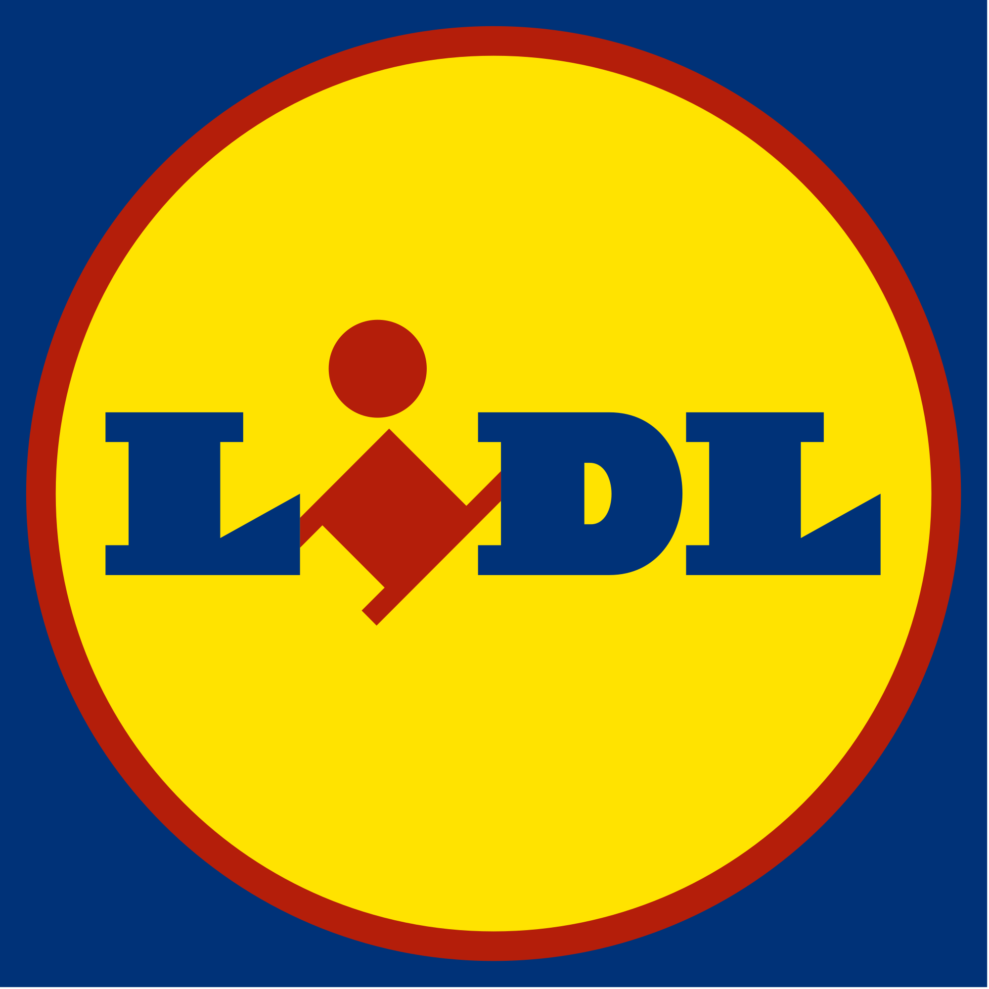
Charlotte Koochekzadeh-Yazdi (1903136)

Lidl – the german discounter gaining marketshare
STRATEGIC MANAGEMENT AND SUSTAINABILITY: M3X9111

1.0 EXECUTIVE SUMMARY
The purpose of this report is to critically analyse Lidl. Highlighting the strategic approach that Lidl have employed, through thorough investigation into the ways in which they achieve this approach. Lidl is a German supermarket that first entered the UK industry in 1994. Lidl delivers a slightly more unorthodox shopping experience in comparison to the UK bread supermarkets like Tesco and Sainsburys. The popularity of Lidl has grown more in recent years, instigators of which could be put down to the economic uncertainty that the UK has faced instilling a savvier spending mentality into UK shoppers. This report sees Porter’s Generic Strategies underpinned throughout from which it is clear that Lidl primarily employs a cost leadership strategy. This strategy has been implemented through a variety of techniques; for example, economies of scale, supplier relationships, location-based strategies, labour savings and more sustainable approaches in their stores. Each approach has generated savings for Lidl thereby resulting in a low-cost organisation all round. The cost leadership strategy certainly promotes advantages and disadvantages, which Lidl have benefited from. For example, barriers to entry in the supermarket industry which were already quite substantial however, now seem insurmountable. Additionally, the low-cost approach has seen Lidl outperform rivals, seeing their marketing share increase. However, the disadvantages cultivated from adopting a cost leadership strategy could arguably make it the more dangerous of strategies to take on. What with the potential of price wars, lack of customer loyalty and low-quality perception that it fosters Lidl have done well to mitigate these as much as possible. After careful consideration of Lidl’s impressive performance in the UK supermarket industry, some recommendations regarding consumer loyalty cards, marketing and an online shopping experience have been suggested. Though these perhaps stray away from the stricter cost leadership strategy and suggest more differentiated services, it seems impractical to continue without them, given the supporting evidence.

2.0 INTRODUCTION
The German low-cost supermarket giant Lidl first entered the UK market in 1994. Offering fewer product lines at lower prices in comparison to the bigger players in the UK market, Tesco and Sainsburys (BBC, 2019).

2.1 REPORT REMIT
This report aims to investigate Lidl (Lidl UK GmbH) within the UK market identifying the competitive strategy they have employed to gain their market share. It will critically analyse the competitive strategy through the use of academic literature. Furthermore, recommendations will be suggested based upon findings that the organisation could utilise in order to move forward.

2.2 BACKGROUND OF THE ORGANISATION
“To enhance the lives of our customers, by providing quality products at market leading value, whilst ensuring that customer satisfaction is at the heart of everything we do.” (Lidl, 2019).
Lidl is a supermarket, that provides ‘high quality products at the lowest possible prices’ (Lidl, 2019) offering a range of products from groceries, fresh and frozen, to lifestyle products and electronic goods (MarketLine, 2019). Lidl works closely with their suppliers in order to ensure that the products they stack their shelves with are market leading value and in doing so Lidl have amounted a ‘5.8% share of the UK grocery spending’ (BBC, 2019).
Lidl UK GmbH is a subsidiary of Lidl Dienstlegistung GmbH & Co KG. The German supermarket opened its first UK store in 1994, there are now ‘760 stores and thirteen regional distribution centres’ employing more than 22,000 people (Lidl, 2019). Since Lidl entered the UK market it has been ‘a roaring success’, ‘the company and its fellow discounter Aldi are shaking up the grocery market’ (Statista, 2019). In 2018, Lidl amounted a 474.5 million British pound turnover, as represented in figure 2.0. Lidl UK has increased its annual turnover year on year since 2012 (Statista, 2019).
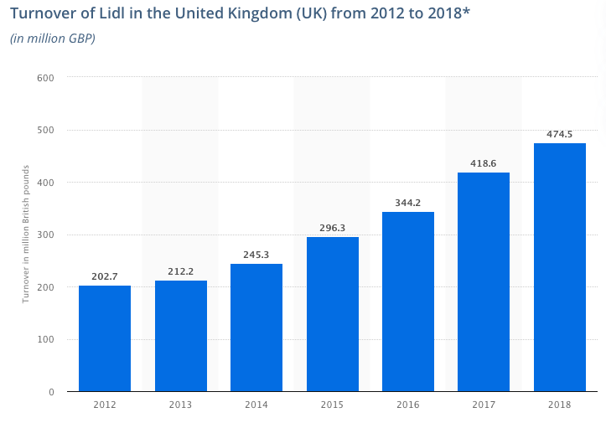
Figure 2.1 Lidl Turnover (Statista, 2019)
Recently Lidl has been in the news for investing £15bn into the farming industry. Pledging to ‘increase sales of British-sourced fresh meat, poultry and fresh produce by over 10%’ (MarketLine, 2019) ‘following on from their commitment to source 100% fresh poultry from UK farms’ (MarketLine, 2019). Investing this substantial amount of money into their suppliers just highlights one of the ways that Lidl is able to achieve leading market value.

2.3 DEFINITIONS OF MAJOR CONCEPTS
Porter’s Generic Strategies, developed by Professor Michael Porter in the 1980’s, is the key academic literature underpinned throughout this report. This strategy has four facets: cost leadership, differentiation, focus cost leadership, focus differentiation ‘the notion underlying the concept of generic strategies is that competitive advantage is at the heart’ (Porter, 2004, p.12). Porter argues that ‘to attain a competitive advantage, it must make a choice’ (Porter, 2004, p.12) therefore elucidating that ‘being “all things to all people” is a recipe for strategic mediocrity and below-average performance’ (Porter, 2004, p.12) otherwise referred to as the strategic wilderness. The purpose of a competitive strategy like Porter’s is to take ‘offensive and defensive actions […] to cope with the five competitive forces in the industry’ (Tanwar, 2013, p.11).
Competitive Advantage
Uniqueness perceived by Customer
Low Cost Position
Competitive Scope
Industry Wide
Segment Only
Figure 2.2 Porter’s Generic Strategies. (authors own)
Differentiation, how ‘the firm is seeking to differentiate itself from its competitors’ (Graham et al, 2011, p.308) seeking uniqueness within the industry, ‘along some dimensions that are widely valued by buyers’ (Porter, 2004, p.14). Graham et al (2011), interpret the uniqueness drivers as seen in figure 2.3 as the different routes to differentiation. To be successful, ‘differentiation should be pursed on multiple fronts’ (Graham et al, 2011, p.318). Although differentiation creates competitive advantage, it presents the possibility of higher costs (Porter, 2004). Though this uniqueness offered through differentiation can also result in a premium price (IFM, 2019, Porter, 2004).
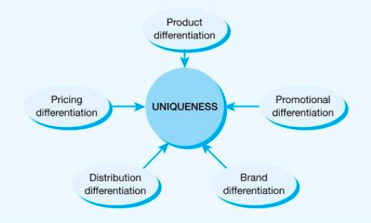
Figure 2.3. Uniqueness Drivers. (Graham et al, 2011)
Cost leadership, in short it pertains to the minimisation of costs to the organisation of producing a product or service (Porter, 2004). Porter (1985) coined the term ‘cost drivers’ which are the factors that affect organisational cost, presented in figure 2.4. As depicted there are several ways that an organisation can seek to reduce their costs. Though, it is important to bear in mind that there can only be one cost leader in an industry and that this position once obtained will be under attack from competitors, making cost leadership among the most challenging to sustain and maintain (Graham et al, 2011).
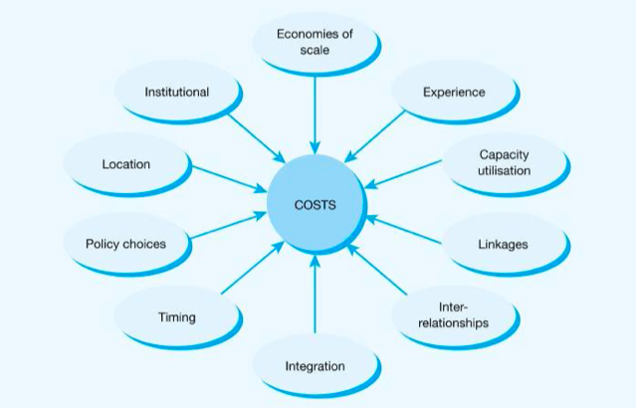
Figure 2.4. Cost Drivers. (Graham et al, 2011)
A focus strategy occurs when an organisation concentrates on a particular segment of a market making it quite different from the other strategic approaches (Porter, 2004). It selects a segment within an industry and then tailors a strategy in order to meet the needs of this particular group, to the exclusion of others (Porter, 2004). Porter presents two different focus strategies; focus differentiation and focus cost leadership.
A short falling of this particular model is the stuck in the middle or strategic wilderness, in which porter predicts companies would be unsuccessful. Stuck in the middle occurs when an organisation ‘engages in each generic strategy but fails to achieve any of them’ (Porter, 2004, p.16). Porter is suggestive that being stuck in this strategic wilderness would lead to organisational failure as it will possess no competitive advantage, they will be competing at a disadvantage to those organisations that have better positioning (Porter, 2004). Often being stuck in the middle is the ‘manifestation of a firm’s unwillingness to make choices about how to compete’ (Porter, 2004, p.17). It can be argued that Porter is wrong to say that this strategic wilderness will ensue failure, ‘research indicates that differentiation and cost leadership can co-exist’ (Datta, 2010, p.37). This ‘hybrid strategy’ (Stonehouse et al, 2004) can cultivate success where it has been made as a conscious decision, whereas unconsciously adopting more than one strategy is usually a recipe for disaster (Stonehouse et al, 2004).

3.0 MAIN BODY
Lidl, one of ‘the world’s biggest “deep discount” grocers’ (The Economist, 2015) penetrated the UK supermarket industry through the adoption of a cost leadership strategy. Lidl have taken on more than one of the cost drivers approach in order to attain this cost leadership position and gain market share.
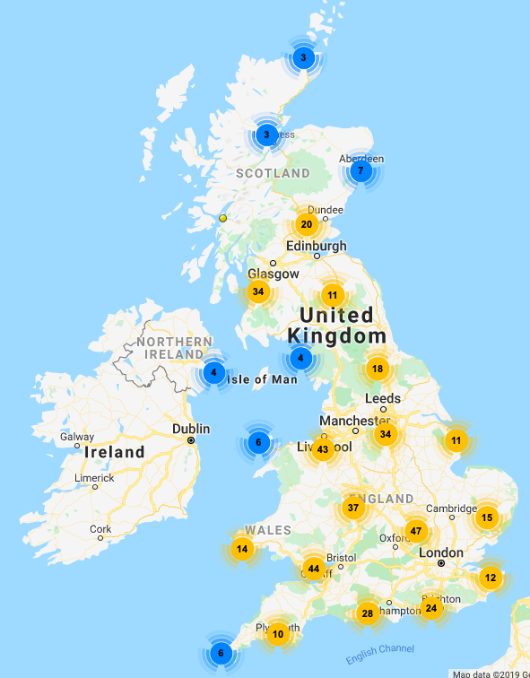
One of Lidl’s approaches to cost leadership is by taking advantage of economies of scale described by Porter as, the volume of purchasing with a given supplier cultivating greater bargaining power (Porter, 2004). As portrayed in figure 3.1 Lidl has amassed a vast plethora of stores across the UK, elucidating to the fact that they are a large organisation that can take advantage of economies of scale due to their size. Furthermore, their ’13 regional distribution centres’ (Lidl, 2019) allow for stock to be ordered in bulk and stored prior to delivery to their 760 stores (Lidl, 2019). This presents a competitive advantage as financially it leads to a reduced cost per unit of stock. However, the adoption of this cost driver is not nearly enough to gain cost leadership as economies of scale is undertaken by all the large supermarkets in the UK like; Tesco and Sainsburys.
Figure 3.1. Map of Lidl Locations UK. (Saturday Walkers Club, 2019)
Linkages, ‘coordinating with suppliers on specifications, delivery, and other activities can lower total costs’ (Porter, 2004, p.92). This is perhaps one of Lidl’s deadliest weapons against the UK supermarket Giants. Lidl is renowned for having few brands within their stores around 90% of which are private-label brands specifically for Lidl (Hanbury, 2017). By engaging in this sort of exclusive deal where a supplier manufactures for them and them alone it gives Lidl a degree of bargaining power and therefore, they are able to take advantage of lower costs. Additionally, by only having a few brands from few suppliers it gives Lidl more buying power (Hanbury, 2017) as they are ordering from them solely in huge quantities to stock their 760 stores across the UK once again contributing to their lower production costs.
Though Lidl is a German Supermarket brand they are strategic in that, the produce they stack their UK shelves with is mostly British as seen in figure 3.2. This ‘affects the cost of inputs through the cost of transportation and the ease of communication’ (Porter, 2004, p.92).
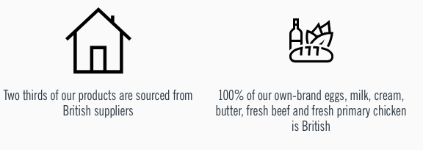
Figure 3.2 British Produce (Lidl, 2019)
Not only does this mean lower costs in terms of transportation but it also means that Lidl is cementing relationships within the UK. Which is beneficial to their continual growth within the market. Lidl develop long term contracts with suppliers, ‘enabling local businesses to grow’ (Lidl, 2019) and constantly develop their British sourcing (Lidl, 2019). Lidl has notably invested considerable amounts of money into the British farming industry, by doing so they build invaluable relationships with their suppliers who are committed to working alongside Lidl and promoting their success.
Another cost strategy that Lidl is perhaps quite well known for is that they keep labour costs low, this is done through a number of ways. The most prominent is the way in which they stock their stores, ‘it displays products in the boxes they were shipped in’ (Hanbury, 2017). This is perhaps a more effective method as it not only reduces the number of employees that are necessary to stock the shelves, it also means that it is carried out considerably faster (Hanbury, 2017).
Technologically speaking Lidl ensure that they are more cost efficient as well as environmentally friendly. In 2018, Lidl fitted a substantial amount of its stores with LED lighting as a result it saw a reduction of 63.4% in energy consumption (Lidl, 2019). This sort of saving is considerable and helps Lidl to seek this cost leadership position.

3.1 IMPLEMENTATION OF THE STRATEGY
It is fair to say that Lidl successfully implements this cost leadership strategy through the varied approaches that it takes though, it should be noted that they are not the total cost leader of the UK market. Lidl has amounted a share of 5.9% of the UK market (Makortoff, 2019) whilst fellow discount supermarket Aldi, who also adopt the cost leadership strategy has a market share of 6.2% (Makortoff, 2019). Porter (2004) implies that several firms have failed when more than one fights for the position of cost leader, as the strategic logic is that only one firm be the total cost leader. Though in the long term this may be true, realistically speaking it is clear that both German supermarkets Aldi and Lidl are operating to achieve and sustain cost leadership and are doing so profitability and sustainably as shown in the continued market growth they are both generating. Figure 3.3 depicts the percentage of increase in Lidl’s sales. Though it can be interpreted that the percentage growth of sales has decreased Lidl are still experiencing growth which can be put down to their continued investment in this cost leadership strategy.
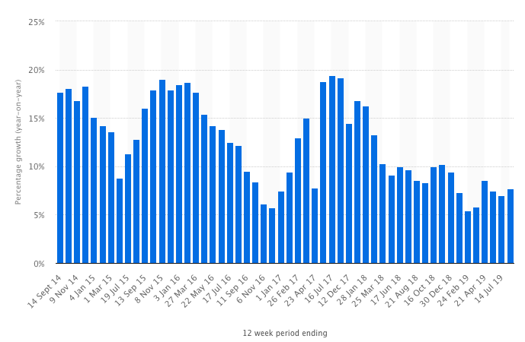
Figure 3.3 Lidl Sales Percentage Increase. (Statista, 2019)
This notion is reinforced through Lidl’s substantial profit progression as depicted in figure 3.4. This once again underlines the effectiveness of Lidl’s cost leadership strategy. It is now important that Lidl continue doing what they do well, so to ensure that they can sustain this growth within the UK market and compete with Aldi to achieve the total cost leadership position.
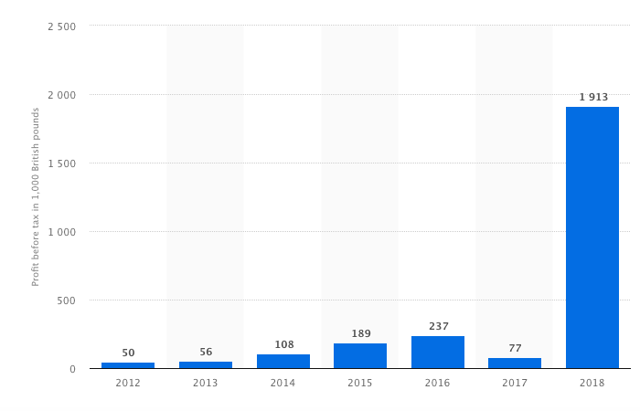
Figure 3.4 Lidl Profit (Statista, 2019)
The UK supermarket industry is changing dynamically, it is still an oligopoly market that is controlled by the likes of Tesco, Sainsburys and Asda. Nevertheless, Lidl is gradually stealing market share (Statista, 2019). This is presented in figure 3.5 one factor that greatly supported this growth initially was the recession that hit where the cheaper alternatives were much more favourable, however; as of recent Brexit and the uncertainty surrounding it has had a significant impact on consumer behaviour to spend more savvy (Statista, 2019). As a result, Lidl and its fellow discount provider Aldi have instigated price wars creating a more volatile grocery retail market (Statista, 2019).
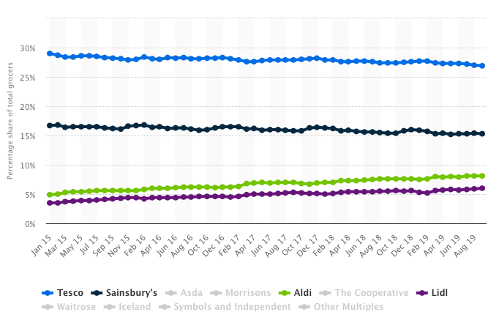
Figure 3.5 Grocery Market Share in Great Britain (Statista, 2019)
Although it is obvious that Lidl have employed this cost leadership strategy it would be daft to say it is the only strategy that they have taken on. To a consumer Lidl is the big blue and yellow sign that promises low prices, Porter (2004) agrees that a cost leader cannot ignore differentiation to a certain degree as consumers must still perceive their products as comparable or substitutes to those offered by the larger supermarket chains. Nonetheless it can be argued that Lidl have taken differentiation further than this, whilst still not employing a direct differentiation strategy. For example, their bakery implemented in 2011 has become well renowned amongst shoppers but it does not particularly stand with the original no frills shopping experience. That is not to say that this has not been successful, which contradicts what Porter (2004) upholds in that any firm tempted to blur generic strategy will surely fail.

3.2 ADVANTAGE AND DISADVANTAGES OF THE STRATEGY
This cost leadership strategy brings about both advantages and disadvantages to Lidl, a notable advantage is the erecting of barriers to entry of the market. The UK supermarket is already considered a difficult market to penetrate due to the big players in it. Lidl’s cost leadership strategy has further blocked the entry into the market as any new player hoping to gain entry by offering lower priced products and adopting a cost leadership strategy which ‘is often used as a strategy for entering a new market’ (Stonehouse et al, 2004, p. 176) making it near on impossible against the established powerhouse that is Lidl.
Furthermore, another advantage is that the implementation of this strategy enabled Lidl to outperform their rivals overtaking the likes of Waitrose by 1% (Statista, 2019). As shown in figure 3.5 the larger players in the market are losing share percentage due to Lidl stealing consumers. Their low prices, efficient stores and simple shopping style is outdoing the traditional British shopping experience, for a much more European approach which is become a fan favourite. Butler (2019) highlighted that two thirds of shoppers frequented the likes of Tesco and Sainsburys and instead chose to go Lidl and Aldi for Christmas. This statistic just shows the degree to which Lidl is outperforming its competitors and seeking its way into the hearts of UK shoppers.
Cost leadership brings about its disadvantages, the biggest of such is the lower consumer loyalty that it cultivates. Consumers are shopping there because it costs them less, therefore; following this logic we arrive at the perception that if another supermarket were to drop their prices substantially Lidl would lose sales. Since Lidl is making its mark the larger supermarkets are beginning to engage in price wars as such this could see sales drawn from Lidl back to the big four supermarkets. Take Tesco as an example, they offer differentiated products and differentiated services like their Tesco Clubcard that yields loyalty. So, if they were to reduce their prices consumers would be quick to jump ship as nothing is keeping them tied to Lidl.
Often the low price that comes hand in hand with an organisation adopting a cost leadership strategy can be construed for low quality which is certainly a perception that affected Lidl for a while. However, Lidl has continually tried to mitigate this to emphasise the high quality of their suppliers and the products that they offer through the means of marketing and advertisement. As reinforced by Bryan Roberts a TCC Global analyst ‘the food is high quality and its simple to shop. You don’t have to choose between 15 types of ketchup; you choose between 2’ (Wood, 2018). Lidl have proved time again that their products are more than just cheap prices.

4.0 CONCLUSION
Lidl deserve a round of applause; they penetrated a market run by traditional household names that engaged in collusion in order to set the price for consumers. They have improved year on year and through the continued implementation of their cost leadership strategy they are likely to continue to do so. Lidl have found means to ensure continual cost reductions, whether this be through the procurement of goods, by means of labour or sustainable practices. Their greatest success could perhaps be placed upon their suppliers and the relationships that they have forged with them. These relationships are unprecedented giving Lidl a substantial competitive edge helping them to succeed in the UK market. It has meant that they can offer fewer brands thereby reducing unnecessary consumer choice at the lowest possible price to both them and the consumer. Lidl continues to strengthen these relationships through investment ensuring a loyal and reliable bond between organisation and supplier, by doing so it enables Lidl to deliver high quality products to consumers for a margin of the price found at the bigger retailers. Their simple shopping experience and unpacked boxes on shelves though unorthodox have seen them generate savings, by supplying British produce its saved costs in transportation whilst also generating support and sales from British consumers.

4.1 RECOMMENDATIONS
One way to mitigate the disadvantage that Lidl faces in regard to consumer loyalty, is through the implementation of a loyalty card. This way Lidl can grow their consumer base by means of more than just their cheap prices. The loyalty scheme would be beneficial if a price war were to break out as it would help to stop customers frequenting Lidl for other supermarkets.
It should be noted that Lidl have experienced ‘much better ROI from press, radio and TV advertising’ (Hobbs, 2017). Therefore, one way to continue their growth within the market is for Lidl to invest more into their marketing and advertisement supported by Stonehouse et al (2004) who state cost leadership depends on activities like advertising to generate more sales. Particularly to mitigate consumer doubt that surrounds their brands, which unlike the brands stocked in Tesco are unknown and not well established. Lidl need to build that blind trust that consumers experience when going into Tesco and picking up a product. So, to Remedy this marking will increase the awareness around the brands that they are stocking.
Though an online shopping experience is more of a differentiated service, ‘online grocery shopping in the UK is the fastest growing purchase channel’ (Statista, 2019). Therefore, to continue to disregard its prominence for UK shoppers puts Lidl at a disadvantage. It is forecasted that by 2021 the online grocery retail market will grow to 17.9 billion in GBP (Statista, 2016). As a result, it seems imperative that Lidl develop an online shopping experience. Building upon their convenient and low-cost shopping capability.

REFERENCES
BBC News. (2019). Lidl expansion ramps up supermarket battle. [online] Available at: https://www.bbc.co.uk/news/business-48606304 [Accessed 30 Oct. 2019].
Butler, S (2019) Two-Thirds of UK shoppers visited Aldi or Lidl over Christmas. [online] theguardian.com https://www.theguardian.com/business/2019/jan/08/uk-aldi-lidl-christmas-supermarkets-brexit [Accessed 13 Nov. 2019]
Datta, Y. (2010) A Critique of Porter’s cost leadership and differentiation strategies. Chinese Business Review., 09(04).
Graham, H., Nicoulaud, B. and Piercy, N. (2011). Marketing strategy and competitive positioning. México: Pearson Educación.
Hanbury, M. (2017). A German grocery chain that's coming to America is already dominating Walmart on prices — here's why it's so cheap. [online] Business Insider. Available at: https://www.businessinsider.com/how-lidl-keeps-its-prices-down-2017-6?r=US&IR=T#1-most-of-its-products-are-private-label-brands-1 [Accessed 13 Nov. 2019].
Hobbs, T. (2017) Lidl: Programmatic is new, shiny and overvalued. [online] MarketingWeek. Available at: https://www.marketingweek.com/lidl-says-unproven-programmatic-is-overvalued/ [Accessed 20 Nov. 2019]
IFM. (2019). Porter's Generic Competitive Strategies (ways of competing). [online] Available at: https://www.ifm.eng.cam.ac.uk/research/dstools/porters-generic-competitive-strategies/ [Accessed 9 Nov. 2019].
Lidl (2019). About us. [online] Available at: https://www.lidl.co.uk/about-us [Accessed 30 Oct. 2019].
Lidl (2019). Environment - Lidl. [online] Available at: https://www.abettertomorrow-lidl-ni.co.uk/environment/#energy-efficiencies [Accessed 13 Nov. 2019].
Lidl (2019). Supplier Relationships - Lidl Great Britain. [online] Available at: https://corporate.lidl.co.uk/sustainability/supplier-relationships [Accessed 13 Nov. 2019].
Lidl (2019). Vision and Mission Statement. [online] Available at: https://www.lidl.co.uk/about-us/vision-and-mission-statement [Accessed 30 Oct. 2019].
Makortoff, K. (2019). Lidl attains its biggest UK grocery market share at 5.9%. [online] the Guardian. Available at: https://www.theguardian.com/business/2019/aug/20/lidl-attains-biggest-uk-market-share [Accessed 13 Nov. 2019].
MarketLine (2019). Lidl invests £15bn into the British farming industry. [online] MarketLine. Available at: https://advantage-marketline-com/News/lidl-invests-15bn-into-the-british-farming-industry_27188 [Accessed 30 Oct. 2019].
MarketLine. (2019). Lidl UK GmbH. [online] Available at: https://advantage-marketline-com/Company/Summary/lidl-uk-ltd [Accessed 30 Oct. 2019].
Porter, M. (1985) Competitive Advantage. The Free Press. New York.
Porter, M. (2004). Competitive advantage Creating and Sustaining Superior Performance. New York: Free Press.
Saturday Walkers Club. (2019). UK Supermarkets Map - SWC. [online] Available at: https://www.walkingclub.org.uk/shops/ [Accessed 13 Nov. 2019].
Statista (2016) Grocery retail forecast value growth in the United Kingdom from 2016 to 2021, by distribution channel. [online] Statista.com. Available at: https://www.statista.com/statistics/566462/grocery-retail-forecast-value-growth-united-kingdom-uk/ [Accessed 20 Nov.2019]
Statista (2019) Online grocery shopping in the United Kingdom – Statistics and Facts. [online] Statista.com. Available at: https://www.statista.com/topics/3144/online-grocery-shopping-in-the-united-kingdom/ [Accessed 20 Nov. 2019]
Statista (2019). Lidl sales growth year-on-year in Great Britain 2014-2019. [online] Statista.com. Available at: https://www-statista-com/statistics/386773/lidl-sales-percentage-change-great-britain-uk/ [Accessed 13 Nov. 2019].
Statista (2019). Market Share of grocery stores in Great Britain from January 2015 to September 2019. [online] Statisa.com. Available at: https://www.statista.com/statistics/280208/grocery-market-share-in-the-united-kingdom-uk/ [Accessed 13 Nv. 2019]
Statista (2019). Profit before tax of Lidl in the United Kingdom. [online] Statista.com. Available at: https://www-statista-com /statistics/1050237/lidl-profit-before-tax-in-the-united-kingdom/ [Accessed 13 Nov. 2019].
Statista (2019). Turnover of Lidl in the United Kingdom (UK) 2012-2018. [online] Statista. Available at: https://www-statista-com/statistics/919806/lidl-turnover-in-the-united-kingdom/ [Accessed 30 Oct. 2019].
Stonehouse, G., Campbell, D., Hamill, J., Purdie, T. (2004) Global and Transitional Business: Strategy and Management. Sussex: England, Wiley
Tanwar, R. (2013). Porter’s Generic Competitive Strategies. IOSR Journal of Business and Management, 15(1), pp.11-17.
The Economist. (2015) Aldi and Lidl: Tomorrow not quite the world. [online] Available at: https://www.economist.com/business/2015/03/12/tomorrow-not-quite-the-world [Accessed 9 Nov. 2019].
Wood, Z. (2018) Low prices and no frills. Can Tesco’s secret plan defeat Lidl and Aldi?. [online] TheGuardian. Available at: https://www.theguardian.com/business/2018/sep/15/low-prices-no-frills-can-tesco-defeat-lidl-and-aldi [Accessed 20 Nov.2019]

