Fundamentals of Construction Technology
Assignment 2

Thomas Poole

Context page

The ground floor –

Construction, detailing and junctions with external walls………………………………3

The first floor

Construction, detailing, junctions with external walls and restraints………………….3-4

Openings

Solutions for lintels, sills and jambs………………………………………………………4-5

Eaves detailing and roof covering

Indicating appropriate weathering, fixing and laps……………………………………..6

The main roof structure

Construction, detailing and fixing…………………………………………………………7

Sketches

Ground floor ……………………………………………………………………………….8

First flush ………………………………………………………………………………….9

Opening for door …………………………………………………………………………10

Flush reveal ……………………………………………………………………………….11

Jambs ……………………………………………………………………………………..12

Eave covering……………………………………………………………………………..13

Steel straps………………………………………………………………………………..14

Pitched roof ………………………………………………………………………………15

1)

Ground Floor

Foundations

To begin construction of the structure we must firstly remove the 450mm of topsoil. We will need to dig out the strip foundations until we find solid clay. The depth of strip foundations will need to be approved from the local building inspector. When depth has been established, we can proceed to pour the concrete footings. The thickness of concrete will be typically 250 mm thick and will be high strength concrete as it will be the foundations of this building.
The next step is to build up to a height with standard 100mm blocks where we can start the slab construction that can be seen in Ground Floor sketch. Before we can start pouring the concrete slab, we must lay a hardcore subbase with a DPM membrane laid on top. The hardcore subbase allows a compact layer between soil and the concrete slab. As a requirement of the building regulations show we must protect the structure from the growth of weeds and other plant life. DPM membrane is used for this purpose and is also to provide a moisture resistant barrier underneath the concrete slab. The typical thickness of the DPM is 1200 gauge. The concrete slab is the poured over the DPM membrane and the typical thickness of this concrete is 100mm.

Detailing

As our foundations have been complete, we can now start the suspended floor construction. The timber ground floor joists are to be fixed on galvanized hangers mounted to inner leaf block wall. The timber floor joists will be sized on the span of the room. Thicker, deeper joists are used to span greater distance from wall to wall. The timber joists are to be mounted a minimum of 150mm from the finished concrete slab. Reason from this is to provide a ventilation void that allows air flow from one side of the building to other. This allows any moisture under to be dissipated into atmosphere. This can be achieved by fitting air vents to the specification shown on Ground Floor sketch 1. The Joists also lay on honeycombed sleeper walls that are used to support the load of the timber wooden joists.

DPC is fitted 150mm off ground floor and between the joist and wall. DPC is used as a moisture barrier through the structure to prevent rising moisture by capillary action known as rising damp, this is the effect of water rising from the ground into a building.

2)

First floor Timber joists

After the construction of the ground floor as been complete. We will now build up to a height of typical 2400mm for the first floor. We will build up to this height with 100mm standard blocks. We will be constructing a traditional solid timber with tongue and groove softwood flooring.

The size of the timber joists will depend on the span of each room. The timber joists will sit in the blockwork on inner leaf wall of the structure, with a 100mm bearing. The timber joists will require lateral support to the walls. This will be constructed as in First Floor Sketch.

When constructing floors, we must consider that they provide lateral support to walls. When we come to joists and floors being ‘built in’ we should take the following into account:
Shrinkage within the joists- joists must be fixed to prevent twisting
The Joists need to be protected from moisture- away protecting joists is to dip them a preservative solution. This will protect the joists from rot and shrinkage.
Any gaps formed during construction in the wall from the joists must be sealed with a compressible filler to ensure air tightness.
Bearings of joists, floors and roof members can be no less than 90mm onto a load bearing wall.

Lateral restrain straps

When constructing floors and roofs, walls must require lateral restraint by using tension straps. This is shown from the provision BS EN 1996-2:2006 and building regulations.

Lateral restraint straps are needed for rafter and floor or flat roof member levels. When building a pitched roof, you will need to use straps at ceiling joist levels. Provision will be necessary if wall height exceed recommended values. This is found in BS EN 1995-1-1:2004 and building regulations.

We must ensure that all restraint straps are fitted tightly against the masonry face within the structures’ cavity.

Blocking in gaps between the rafter / joist and the parallel wall at all lateral restrain strap positions, is required.

We must not fit all lateral restraint straps at roof or floor level by plug and screwing the strap to the masonry.

Restrain straps must be tight up against the face of the wall and must turn down the cavity with by a minimum of 100mm.

The tone and groove flooring will be constructed and fitted at an angle of 90 degrees to the timber floor joist. The tone and groove flooring can be nailed or screwed securely to the timber floor joists.

3)

Openings

Building openings give light, ventilation and climate control for rooms. A building opening is also a boundary between inside and out. It allows for the exchange of energy (heat, solar radiation, air and light). This happens primarily through openings as they control other interface functions such as access. Shown on Opening for door sketch.

Solutions for Lintels

Reinforced Concrete Lintels

Reinforced concrete lintels are provide an excellent solution to support over window and door openings. Lintels in buildings are used to support the load bearing from the structure above. The lintel spreads and transfers the weight down the wall.

To install the reinforced concrete lintel, we must first build up to the height of the opening. The blocks will be used as load bearings. It is mandatory to not bear the lintels on cut blocks.
Secondly, when constructing the external lintel a flexible damp proof course or cavity tray must be installed. DPC is a barrier to prevent moisture and dampness from spreading through the internal skin of a wall.

Steel Lintels
Similar to the installation of the reinforced concrete lintel we must build up to the height of the opening. We must use a padstone block for the steel lintel to rest on as it is much stronger as it is more compact rather than a standard block. We would use steel lintel beams for spans greater. All damp proof courses, wall ties and weep vents must agree with the up to date building regulations.
Sills
Sills are used in windows and doors. Window sill is the bottom part of the window. The sill protects where the window secures to the wall. The sill prevents moisture and drafts from entering into the structure. The door sill takes away any unwanted rainwater that may cause damage to the door frame. It is absolutely necessary by building contract that window sills must be installed.
Window sills are installed by firstly building up to selected window height with 100mm blocks. Before we apply the window frame, we must lay a damp proof course shown on sketch DPC. DPC prevents moisture and raising damp. After this has been laid we can now fit the window frame and sill. The sill secures the window solid. Last step to the installation of the window sill we must apply a mastic sealant to prevent any drafts from passing through. Shown on flush reveal sketch.

Door Jambs
Door jambs are used to take the weight off the door, it also keeps the door frame stable and square. Door jambs prevent drafts from flowing through the building. Drafts reduce the heat of the structure.
To install a door jamb, we must first measure the width and length of the door and cut out jambs with those measurement. Next step is to install the door frame into the opening and secure with nails. Our last step is to check if the middle of the jambs is level before nailing into the door frame with a nail gun.
Shown on Jambs sketch.

4)
Eave covering
The eaves detail shown on sketch Eaves detailing, shows where the coverings and roof members meet the wall. The structures cavity will be closed with a proprietary cavity closer. The wall plate will be secured to the internal wall and is separated by a length of DPC. The wall plate is also then used to secure the rafter.
The other purpose of eaves is to keep rainwater away from the walls. This will prevent the ingress of water into the junction of the wall and roof.
Shown on Eave covering sketch.

Roof covering
Felt
Roof felt are large sheets of membrane. Felt prevents water ingress within the home. Vapour permeable breathable felt is water resistance but allows air movement through the membrane. It is installed by laying the first membrane sheet at the bottom of the rafter then laying the other sheet above. The membrane will be stapled into the rafter. This will prevent water from entering the roof as the membrane is over lapping.

Batten

Batten will be used to provide the fixing point for slates and tiles. Batten will be installed by nailing lengths horizontally onto the rafters. The batten will be treated to prevent rot. Batten must be a minimum size of 50x25. The batten is graded by BS5534

Dry verge

Dry verge will be clipped over the edge of the slates. Dry verge is used to protect the slates by keeping them secured. It is also used to prevent rain or pests from entering the roof.

Slates
Roof coverings protects against sunlight, rain, wind and extreme temperatures.
Slate and tile roofing are used because they are both fire resistant and mould resistant. Slate also has a low water absorption. This suggests that it is resistant to frost damage.

Slate roofing is installed by nailing them into onto the batten. We must nail from the bottom of the roof and start overlapping the slates. This will prevent any rain from entering the roof.

5)

Roof structure

Due to the second floor having bedrooms I have decided to have the roof designed by a roof truss manufacture. They will design timber roof trusses by using wind, loading factors and pitch. With us already knowing the roof being a pitch of 40⁰ we must deliver this information to the manufactures of the truss. Roof structure consists of rafters and trusses. They are both beams that shape the framework of the roof. They also support the sheathing. Rafters are ready made wooden frames. Rafters are used to support the load of the structure, especially the roof area. The manufactures will calculate the appropriate timber size of the trust. The manufactures will provide designed structural calculations that British standards. The calculation will then be sent off to the building inspector for his approval.

Our first step before installing the trusses is to fix a timber wall plate by using concrete screws into the inner leaf block wall. A wall plate is a load-bearing structural member. Wall plate timber lengths must be a minimum of 3m long. Steel straps are used to ensure that the roof structure remains secure. Shown on Steel straps sketch.

We then must lift the trusses up to the roof using a crane. When the trusses have been lifted and dropped into position, we must secure them to the wall plate by using metal joist hangers fixed by 40mm twist nails. Our next step is to secure the timber roof to the inner block leaf block by using galvanised steel straps to BS EN 1346:2009 they are also designed in accordance with building regulations BS5268 part 3. Shown on sketch steel straps.
Timber structural is then used to also secure the trusses together

We must install 100mm Kingspan insulation into the attic bedroom walls. We will then fit 120mm solid insulation between the rafters of the pitched attic roof. Our last step to the roof structure installation we will fix 25mm insulated plasterboard to the underside of the rafter. This will avoid thermal bridging. Details in accordance with section 8 of BS 5250:2002.

Shown on Pitched roof sketch

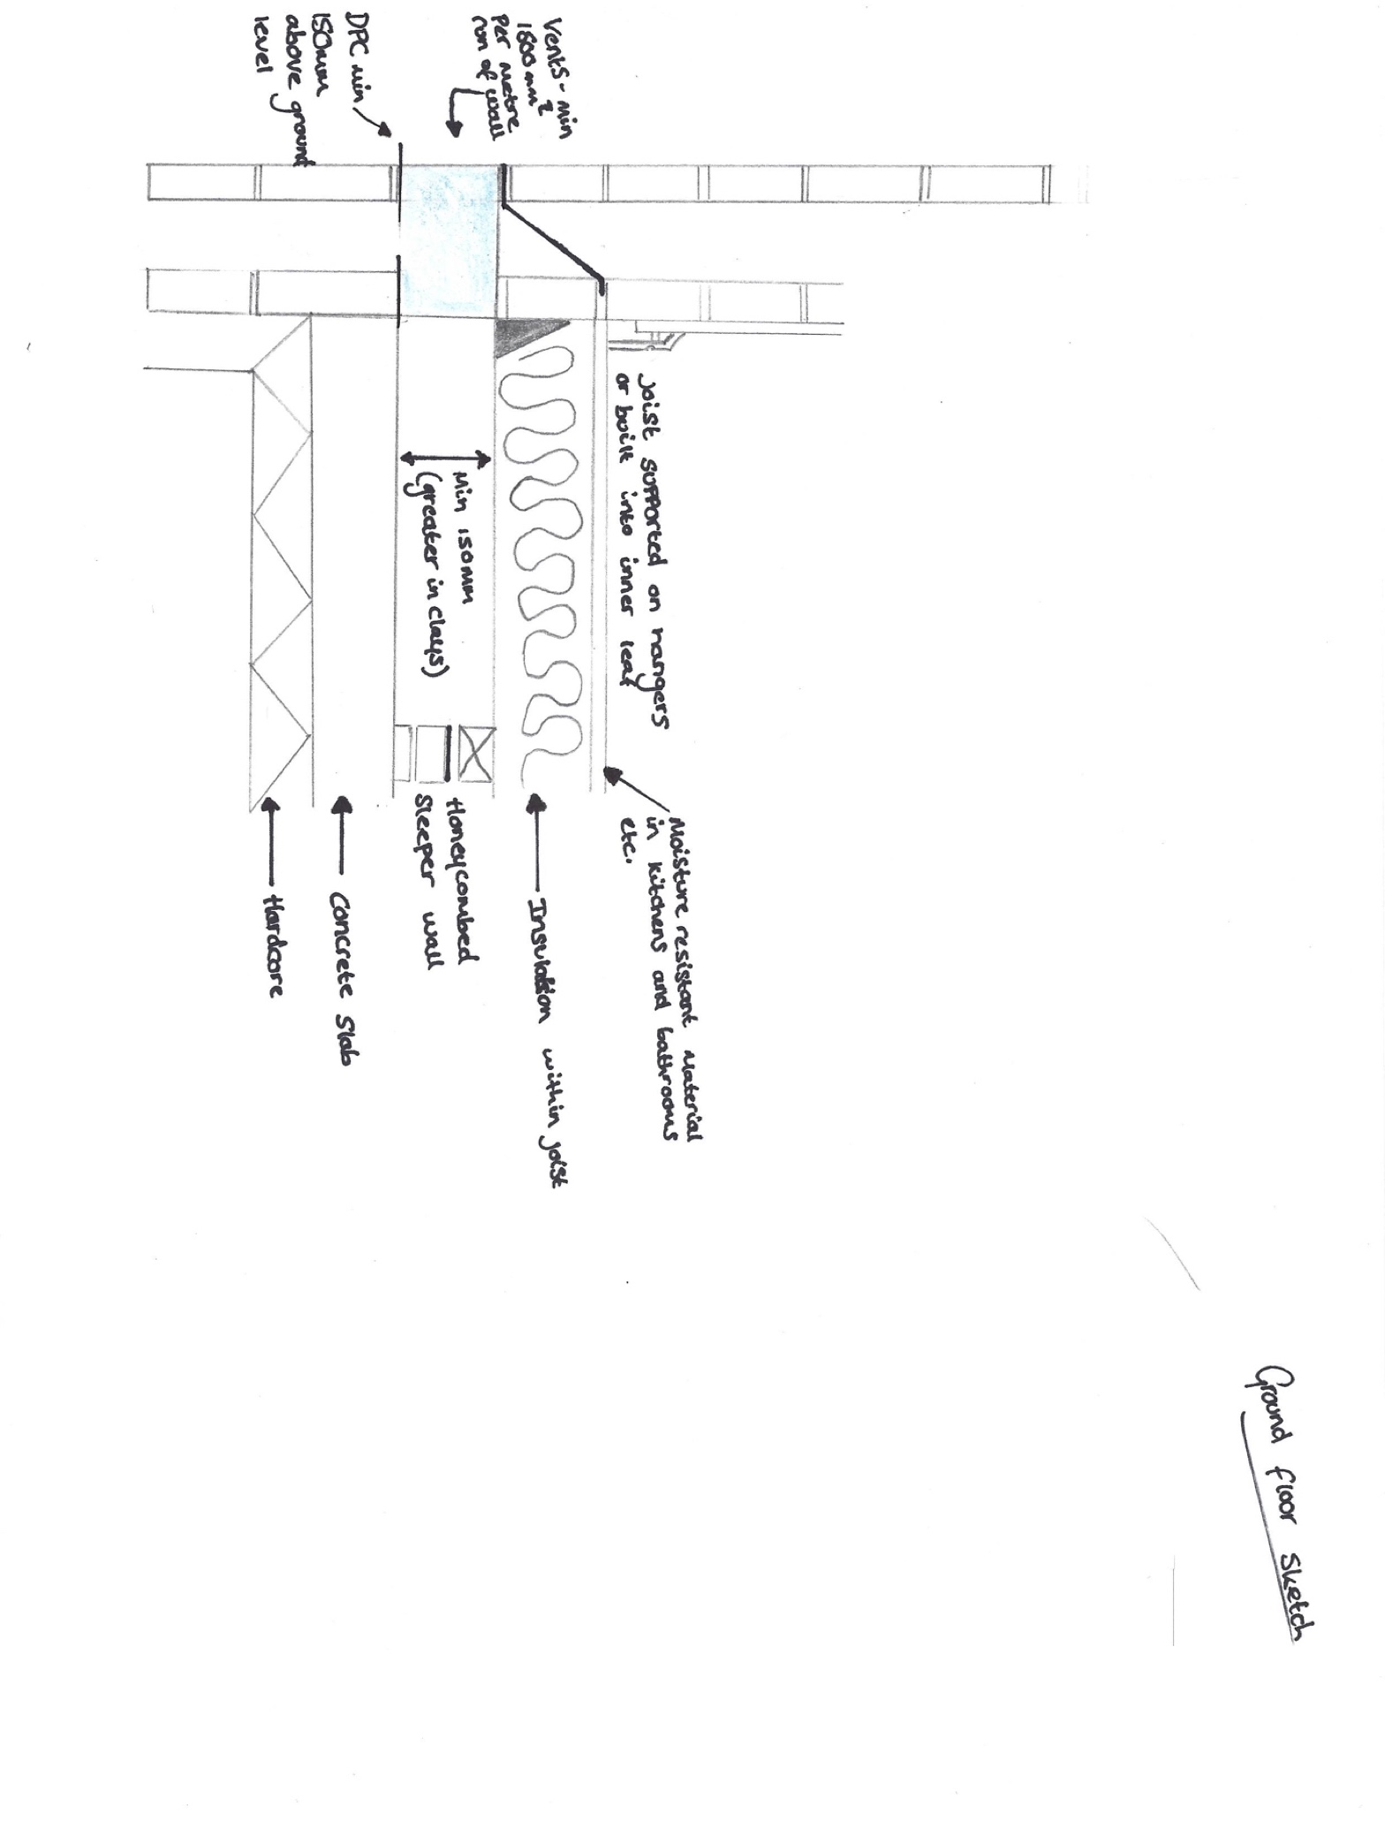
Sketches


