This document doesn't have any headings. To add headings to your Table of Contents, go to Home > Styles



MODULE | Enterprise and Entrepreneurial
Student | MIRABELA BARBU
Certificate | IN HIGHER EDUCATION BUSINESS SKILLS IN WORPLACE
LECTURER NAME | BOHDAN KOVALOV
BUSINESS PLAN | BEAUTY SALON
BUSINESS CODE | LCLM4006
SRUDENT ID | 2433190

Executive Summary;
BLUSH ROYALE is a prop used business aiming to attract new customers and people who loves a new look. The business seeks to meet the needs of its customs by offering high-quality products/services, competitive pricing, and excellent customer service. This business plan outlines the business objectives, target market, marketing strategies, operational plans, and financial goals to support its growth and long-term success.

P - Political factors include financial policies. The business will need to keep up to date with relevant profitable budget.

E –Economic factors- THE PRODUCT I WANT TO SELL IS ELEGANT AND THATS WHAT IT MAKES IT STAND OUT. Rosing the costs of beauty products, equipment, rent, and electricity may also affect profits
Impact on the business- Higher business costs could reduce profits.
Impact on the business- Customers may book fewer treatments, reducing revenue.
Action Plan- Offer treatment packages, loyalty rewards and a range of services at different price points while monitoring profit margins.

S-Social factors- I am Supportive towards my customers who purchase from me. The salon can attract customers by offering popular treatments , providing excellent customer service and creating a welcoming environment. Understanding customer needs will help the business build a loyal customer base.
Impact on the business- A salon that does not adapt may lose customers to competitors.
Action plan- Research local preferences, gather feedback and update the treatment menu to reflect demand.

T-Technological factors include new equipment, online services and digital marketing

L-LEGAL factors include laws and regulations that a business must follow.

E-ENVIRONMENTAL factors include sustainability, waste and the impact a business has on the environment.

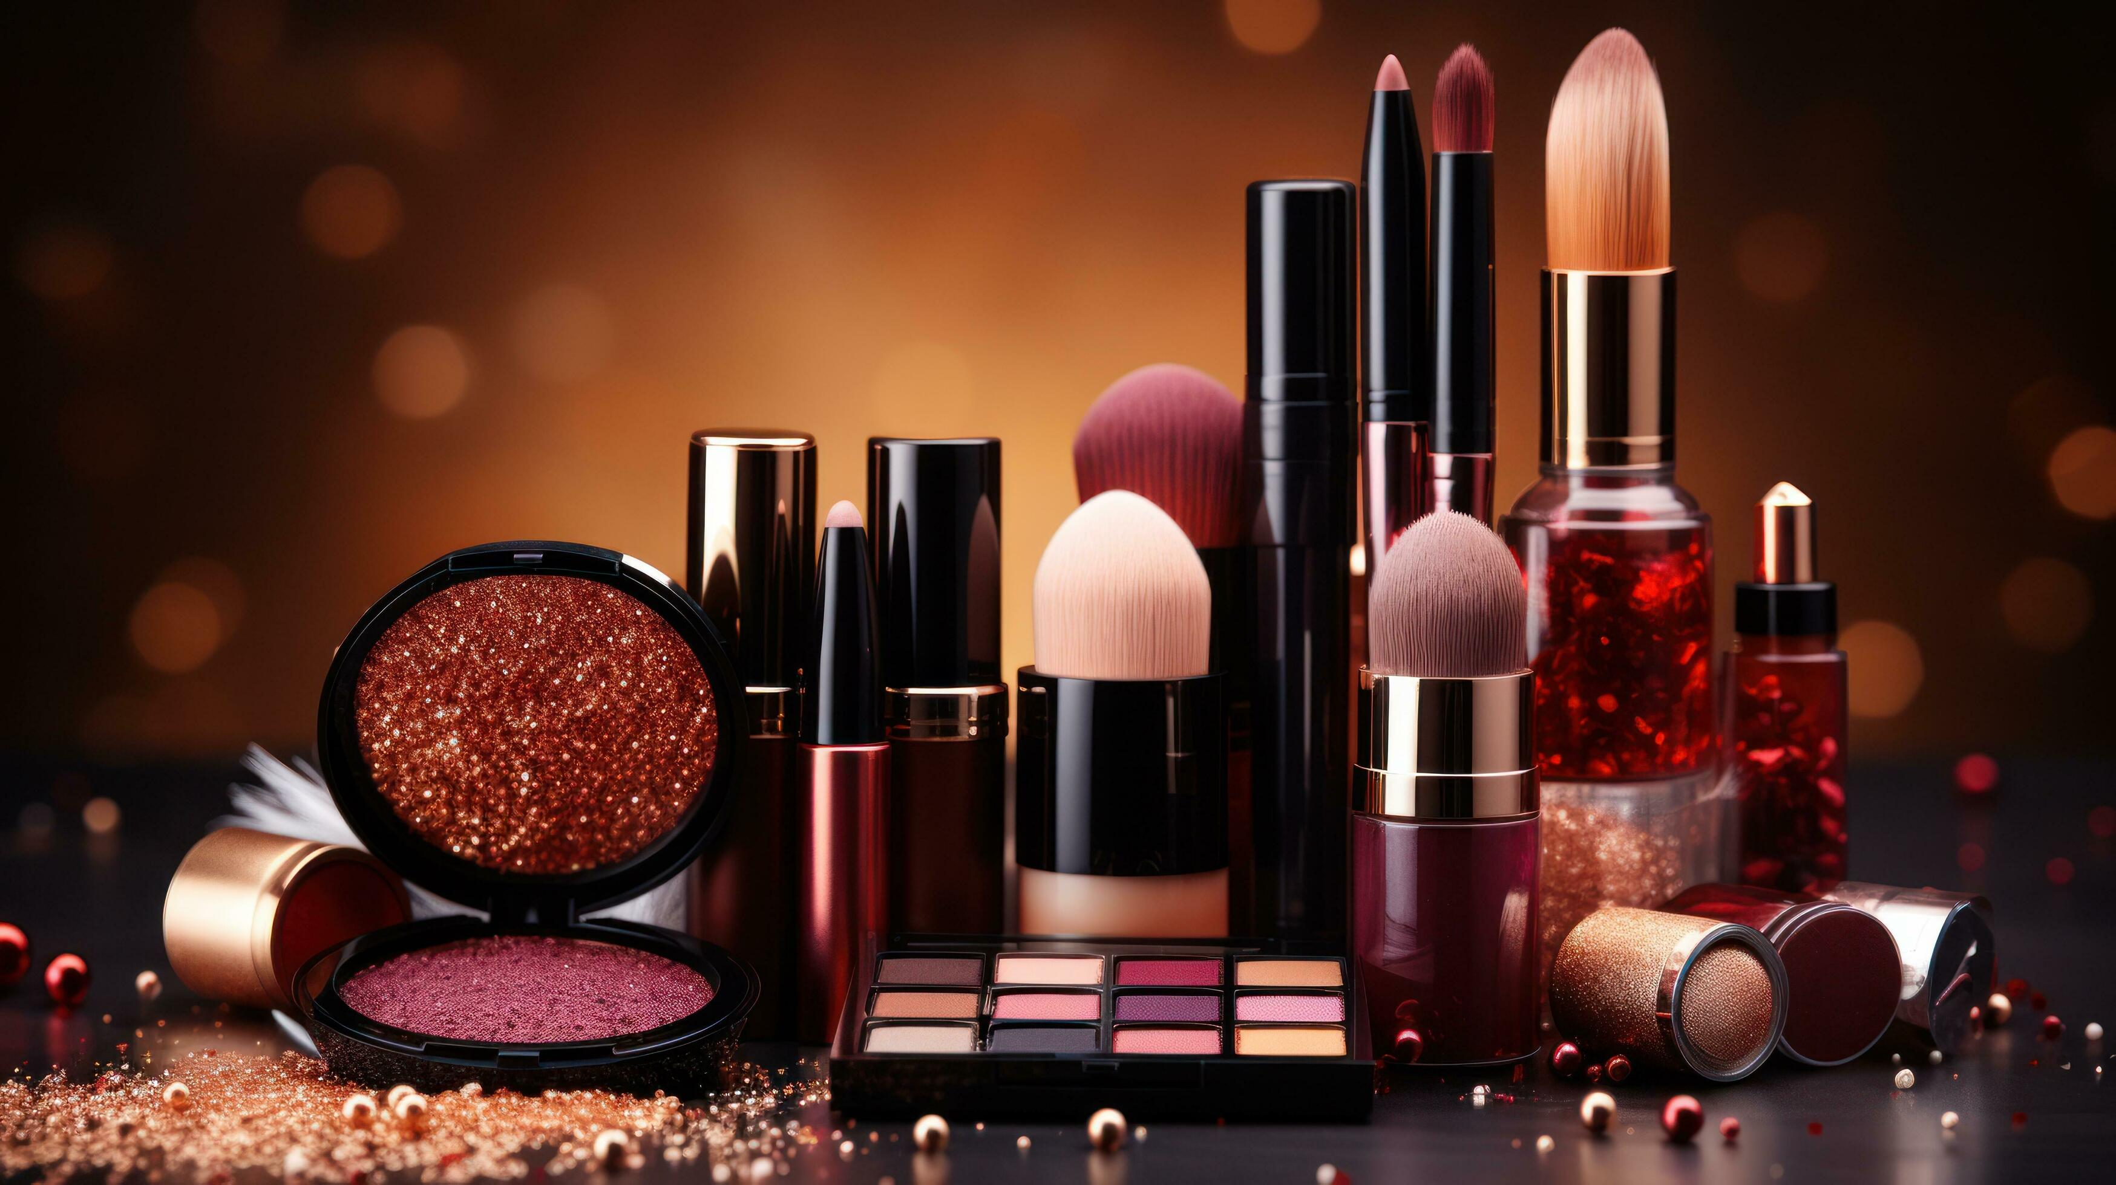

BEAUTY PRODUCT | DESCRIBTION | PRICE
Golden Radience [glow oil]  Nivea  Rare beauty Lipstick  Glowy Foundation  Diamond Dust  Golden Satin  Pure Seduction  Crystal clear | For face serum  Hand and face moisturizing cream  Smooths lips with a fruity fragrance  Flawless and long lasting  Shiny&Beautifulhighlighter  Body oil  Perfect perfume for any event with sweet&fruity fragrance with long lasting smell.  Face cleanser with amazing results | £25  £15  £30  £30  £25  £20  £10  £15
MONTH | EXPECTED PROFIT | EXPECTED SALES
1 | £1.000 | 180
2 | £1,200 | 200
3  4  5  6  7  8  9  10  11  12 | £1,250  £1,300  £1,400  £1.450  £1,500  £1.6001  £1.800  £1.750  £1,900  £2.450  This document doesn't have any headings. To add headings to your Table of Contents, go to Home > Styles | 250  300  400  450  500  600  700  850  970  1800

MARKET RESEARCH AND CUSTOMERS

;TARGET CUSTOMERS

;AGE- 18 – 30

-LOCATION-BIRMINGHAM

-INTERESTS-MAKE-U- MUSIC-FASHION-SOCIAL MEDIA

HOW WILL THE BUSINESS OPERATE

.ONLINE STORE [WEBSITE AND SOCIAL MEDIA]
.E-COMMERCE PLATFORM
.CUSTOMER SERVICE VIA EMAIL OR SOCIAL MEDIA
.PACK AND SHIP ORDERS QUICKLY

KEY POINTS;

-ONLINE STORE AND SOCIAL MEDIA SALES

- TARGET MARKET- 18-30 YEAR OLDS

-AMAZING SELLING POINT AFFORDBLE AND GOOD

-SHORT TERM GOAL REACH £7,000 IN SALES IN THE FIRST YEAR

LONG TERM GOAL- REACH INTERNATIONALLY

OUR TEAM

WE'RE LOOKING FOR PEOPLE WHO KNOWS HOW TO WORK IN THE INDUSTRY OF SALES AND MARKETING.
IT WOULD BE BENEFICIAL FOR US TO HIRE PEOPLE WHO FINISHED ALL THEIR EDUCATION LEVELS AS TO THAT WOULD BE PREFERED.

WE WILL ALSO BE POSTING ON ALL PLATFORMS SO THAT IT WILL BE EASIER FOR PEOPLE TO SEE THAT WE NEED STAFF.

THEY WOULD ALSO BE NEEDING TO HAVE AT LEAST 2 DIPLOMAS.

IF ANYONE WHO DOES NOT REQUIRE ANY OF THE FOLLOWING THINGS OF THE LIST WILL NOT BE HIRED.
WHAT WE PROMIE TO OFFER TO OUR CUSTOMERS

. LOYALTY
. DISCOUNTS
FREE GIVE-AWAY GIFTS
.GIFT CARDS
.SALES
.NEW PRODUCTS
.........AND MANY MORE

RESOURCES NEEDED;

STOCK AND SUPPLIES

WEBSITE AND E-COMMERCE PLATFORM

MARKETING BUDGET

SOFTWARE

SMALL TEAM [AT FIRST]

GOALS AND TIMELINE


0-3 EMONTHS;
SET UP WEBSITE AND BRANDING
ORDER INITIAL STOCK
LAUNCH SOCIAL MEDIA CHANNELS

3-6 MONTHS

START ONLINE SALES
GROW SOCIAL MEDIA FOLLOWING
COLLECT CUSTOMER FEEDBACK

6-12 MONTHS

INCREASE SALES AS MUCH AS POSSIBLE
EXPLORE NEW EVENTS
IMPROVE PRODUCTS

YEAR 2

OPEN PHYSICAL STORE
EXPAND TO INTERNATIONAL MARKETS
BUILD A TEAM AND SCALE OPERATIONS

OPENING TIME WILL BE VERY SOON AND WE CANT WAIT TO PLEASE YOU WITH OUR AMAZING OF VARIETY PRODUCTS.

ADDITIONAL INFORMATION

.MARKET RESEARCH DATA
. SUPPLIER STOCK
.SOCIAL MEDIA CONTENT
.WEBSITE UPDATES
.PRODUCTS NEW EVERY NOW AND THEN

CONCLUSION

BEAUTY ROYALE IS A FANCY AND A ELEGANT BRAND. DESIGNED ESPECIALLY FOR ALL THE LADIES THAT LOVE MAKEUP AND THOSE WHO WOULD LOVE AN ABSOULBTY NEW LOOK. WE PROMISE TO MEET YOUR EXPECTENTIONS AND GIVE YOU THE BEST MAKEUP LOOK OVER YOU EVER HAD. IT'S NOT JUST ABOUT OUR PRODUCTS THAT MAKE IT STAND OUT BUT ALSO THE PRICES. IN THIS ECONOMY WE KNOW THAT EVERYTHING HAS GONE UP THE BUDGET AS IT SHOULD BE SO THAT'S WHY WE CAME UP WITH THIS BRAND BECAUSE IT'S ALSO CHEAP. THIS WAY EVERYONE CAN AFFORD IT. WE INCOURAGE YOU TO BELIEVE IN YOURSELFS AND BE THE WAY YOU ALL WANT TO BE . WE WILL TRY TO BRING AS MANY MORE PRODUCTS AND EVERYTHING YOU NEED AND WANT.

IT'S MORE THAN A VISION, MORE LIKE A STYLISH,ELEGANT AND SUSTAINABLE FUTURE.
I TRUELY BELIEVE THAT WITH THE RIGHT STRATEGY, RESOURCES AND DEDICATION THIS BUSINESS CAN AND WILL GROW INTO A SUCESSFUL AND LASTING BRAND.

WE ARE LOOKING FORWARD TO SEE YOU ALL AT THE GRAND OPENING VERY SOON. I WILL NOT DISSAPOINT NEITHER OF YOU AND THANK YOU ALL FOR YOUR LOVE AND SUPPORT

MARKETING AND SALES PLAN

HOW WILL WE ATTRACT CUSTOMERS

.SOCIAL MEDIA [INSTAGRAM,TIK TOK, FACEBOOK]

.WEBSITE WITH ONLINE STORE

.EMAIL MARKETING [DISCOUNTS AND NEW COLLECTION]

.INFLUENCER COLLABORATIONS

.CUSTOMER REVIEWS AND WORD OF MOUTH
SALES STRATEGY
. LAUNCH WITH A BIG COMPANY OR BRAND
. OFFER SPECIAL DISSCOUNTS FOR FIRST TIME BUYERS
. BUILD AN EMAIL FOR FUTURE PROMOTIONS
. USE ANALYTICS TO TRACK WHAT PRODOCTS PERFORM BEST

FINANCIAL PLAN
START UP COSTS

ITEM | COST £
INITIAL STOCK | 850
WEBSITE AND BRANDING  MARKETING  PACKAGING AND OTHER COSTS  TOTAL COST | 600  200  300  £1,950

MONTHLY COSTS | COSTS£
STOCK REPLACEMENT | 650
WEBSITE & HOSTING  MARKETING  UTILITIES  TOTAL MONTHLY COST | 40  150  60  900

