BMIH6007
International Meetings Management for the Hotel Industry
Assignment 1: Feasibility Plan for an International Meeting
PowerPoint Presentation
Student Name: Roxana Roman
Student ID: 2129008
Tutor Name: Jemma Smith

Innovation on restaurant menus
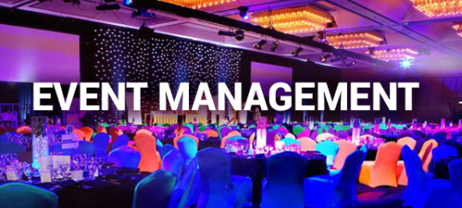
- An event can be a success only when a feasibility test has been conducted and proper research has been conducted to check if the event is possible.
- Feasibility hosting plan to encourage members of the hotel industry to take part in the event to gain and provide insight into the use and management of technology in the hospitality industry for restaurant menus.
- The presentation will focus on understanding the target market, demand patterns, skills requirements and other such factors.
- Other focus will be on restaurant owners, hotel chains and customers.
- The financial cost predictions along with the funding sources will be elaborated to understand how the resources will be collected.
- The Innovation restaurant menu event will be held on 15 May 2024

Fundings
Advertisements | £20,000
Registration Fees | £18000
Participation Fees | £20000
Sponsors | £50,000
Total | £108,000
Expenditure
Particulars | Cost
Decorators | £3,000
Caterers | £10,000
Transport Facilities | £1,000
Technical Support /Wi-Fi | £2,000
Beverage | £4000
Venue | £7,300
Electric Cost | £2,000
Parking | £800
Marketing | £3500
Staff cost | £12,000
Total | £45,600
Total Profit | £62,400

Predicted Revenues and Funding Sources
Funding Sources
- Registration Charge: The event will charge per head of £40 for all the participants who participate in the event.
- Advertisements: The brand will engage with different national brands and provide space for advertisements (forbes, 2023).

Predicted Revenues
- Sponsorship: The event will seek sponsorship from Coca-Cola and the Cadbury company which will allow the brand to raise funds for the event (PHILLIPS, 2022).

- Participation Charge from the businesses: The businesses who will participate in the business to present their business model will have to pay a charge of £5000.
- Local Government: The event manager will collaborate with the local government to engage with the event with the goal of promoting entrepreneurial guidance to businesses in the economy.

Choosing the Venue
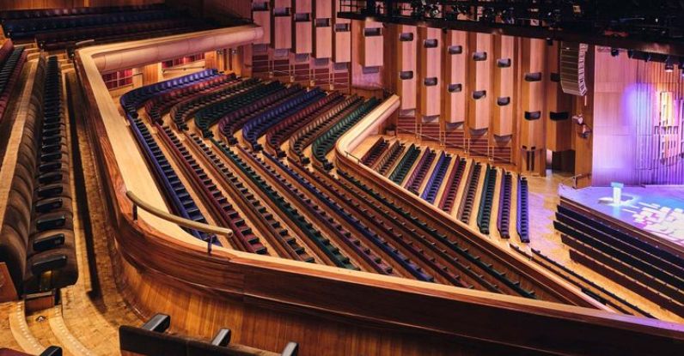
- Event will be held on 15th May 2024, starting 10:00 at Barbican Hall which is located within the main Barbican building, Barbican Centre, Silk Street, London, EC2Y 8DS
- Easily accessible by bus, tube, train and by foot or bicycle

Inviting the audience
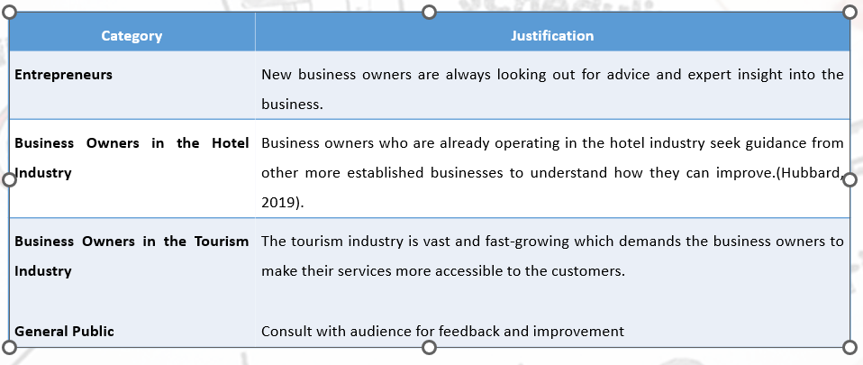

Designing the program content (Agenda)
10:00 Welcome speech and introductions
Event schedule and house keeping
11:00 Menu innovation
13:00 Break
14:00 Innovation techniques and resources
16:00 Questions and a chance for the guests to meet and discuss

Competition
- There are many brands that work with other businesses to provide guidance on similar events.
- Events companies like these could pose a threat to the ‘Restaurant Menus Innovation’ since they might fail to gain the trust of the business owners.
- PCMA is one of the most reputable brands that provides business event strategies (pcma, 2024).

Choosing the event team
- 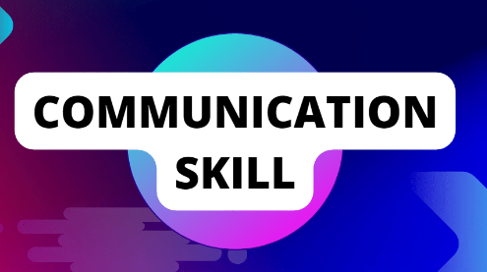 Communication Skills are essential for the event manager to ensure that the manager can share the event vision and other deliverables with the team (forbes, 2022).
- Coordination Skills are essential to ensure that they can work cooperatively towards achieving the milestones and delivering quality work (forbes, 2022).
- 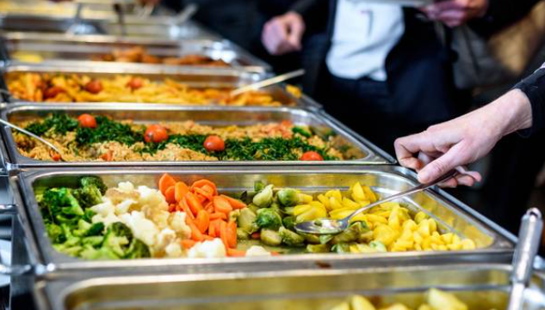 Decorators will be necessary for the seating arrangements and the decorations of the event hall to ensure that the event decorum can be built (forbes , 2023).
- Caterers will be needed for the preparation of the lunch, snacks and drinks for the participants at the event.
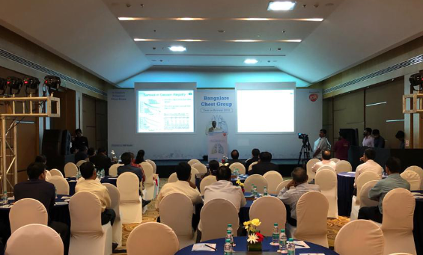
Stakeholders: Environmental MGO and Green Companies
- Renewable materials
- Energy-efficient systems
- Natural light
- Managing waste

Conclusion

- The presentation has provided an insight into the understanding of how the event will source its funding and where the event will be conducted.
- This has further assisted in understanding how the different skills and resources that the event manager and the team will need to maintain their operations and deliver the task.

References
eventflare, (2024). Breathtaking Venue With Multiple Spaces. [Online] Available at: https://eventflare.io/spaces/london/breathtaking-venue-with-multiple-spaces [Accessed 18 April 2024].
forbes , (2023). How To Create An Effective Stakeholder Communication Plan. [Online] Available at: https://www.forbes.com/sites/forbesagencycouncil/2023/10/27/how-to-create-an-effective-stakeholder-communication-plan/?sh=3f52de6347ed [Accessed 20 April 2024].
forbes, (2022). Cognitive Communication: Communicating To Maximize Excellence And Business Results. [Online] Available at: https://www.forbes.com/sites/forbescoachescouncil/2022/01/05/cognitive-communication-communicating-to-maximize-excellence-and-business-results/?sh=7b1cf30413a1 [Accessed 20 April 2024].
forbes, (2022). Group Project Syndrome: How Great Teams Should Balance Creativity & Coordination. [Online] Available at: https://www.forbes.com/sites/shanesnow/2022/08/23/group-project-syndrome-how-great-teams-should-balance-creativity--coordination/?sh=422f1bb432fb [Accessed 20 April 2024].
forbes, (2023). The Power Of Advertising: Prioritizing Value Over Profits. [Online] Available at: https://www.forbes.com/sites/forbesagencycouncil/2023/05/24/the-power-of-advertising-prioritizing-value-over-profits/?sh=66f32bb211ea [Accessed 21 April 2024].
Houston, M., (2023). How Time Management Increases Efficiency And Saves You Money. [Online] Available at: https://www.forbes.com/sites/melissahouston/2023/06/15/how-time-management-increases-efficiency-and-saves-you-money/?sh=771dea053021 [Accessed 20 April 2024].
Hubbard, L., (2019). Why Is Identifying the Target Market so Important to a Company?. [Online] Available at: https://smallbusiness.chron.com/identifying-target-market-important-company-76792.html [Accessed 21 April 2024].
pcma, (2024). Our History our Future. [Online]
Available at: https://www.pcma.org/about/ [Accessed 21 April 2024].
PHILLIPS, K., (2022). Why Sponsors Bring Major Value to Your Event. [Online] Available at: https://info.6connex.com/blog/how-your-event-can-benefit-from-sponsorships [Accessed 21 April 2024].
statista, (2023). Hotel industry in the United Kingdom - statistics & facts. [Online] Available at: https://www.statista.com/topics/3146/hotel-industry-in-the-united-kingdom-uk/#topicOverview [Accessed 21 April 2024].

