STUDENT NAME: RIFNA BEGUM

STUDENT ID: 1713342

LECTURE NAME: MUMTAZ GOOLAM

ASSIGNMENT TITLE: INTRODUCTION TO PHYSIOLOGY BMHP5003

Female Reproductive System

Fallopian tube its function is to collect the eggs after ovulation.
Through funnel the oviducts receives the ova.

Anatomy & Physiology of Female Reproductive System
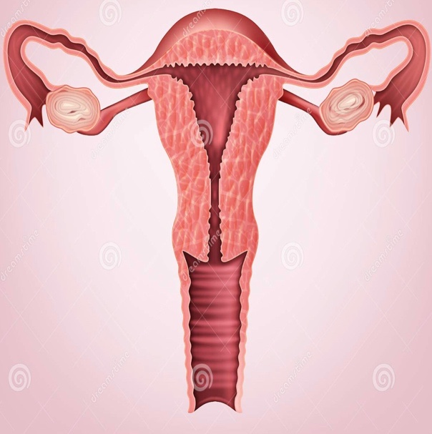
Vagina conducts protective function of muscles and muscular tubes that are mainly folded by vulva.
Cervix is the entrance into the uterus facilitating mucus for sperm entrance.
Ovarian ligament circulated between uterus and ovary.
Vulva is the external genital organ. It acts as the gate for the uterus or womb by opening & closing. In consists of the labia majora ( outer lips) & labia minora ( inner lips).
Ovary is the place of having ovulation and formation of fertilisation.
Uterus protects embryo with thick cells and blood & linings are protective layers called Endometrium maintains patency of uterus cavity wall.

Figure 1: Female reproductive system and it’s functions.
( Source: dreams time, 2020)

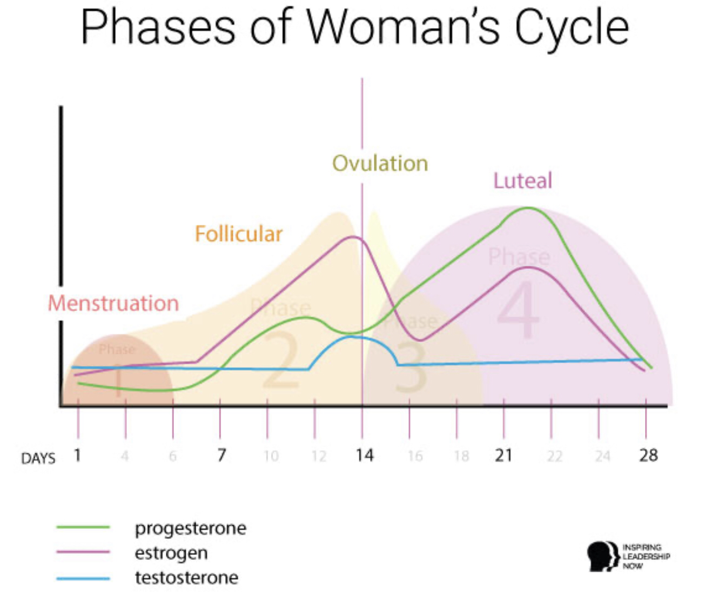
This diagram shows a woman’s normal reproductive system that is controlled under a chronological pattern of biological changes within a woman. It consists of fallopian tube, it’s function is to collect eggs after ovulation here ( Koyama et al,, 2019). The ovarian ligament is another major part that has a critical function in this system, where it serves as a circulation between uterus and ovary ( Agostinis et al, 2019); besides, the function Cilia and Peristalsis is to carry out the eggs along with the tubes. Following the procedure here, the uterus plays significant function in thickening the cells and blood every month and at the same time, it provides nourishment to the embryo as well ( Staff et al, 2020). And the vaginal muscles act as a protective muscular tube folded by the vulva. Further, in the overall process of reproductive functions, the uterus lining that is known as Endometrium here has its basic function is to prevent the walls that are opposing mainly myometrium and maintaining patency of uterine cavity as well.

(Source: Inspiring Leading Now, 2019).

In the normal cycle of a woman, it goes natural before menopause that starts from the stage of Oogenesis and the cycle of sexual reproduction (O’Conner et al, 2020). The Oocyte is produced at every 28 days cycle as well within a woman. In the next stage, it goes along with degeneration process named atresia. In the third stage it’s known mainly meiosis and then turning down into eggs along with the large amount of cytoplasm. Hormones are generated during the age of puberty period- estrogens, progesterone, inhibin and some amount of androgen ( Woman’s Health Concern, 2020).

Moreover, the normal cycle of female reproduction is also consists of three particular stages of ovarian cycle that involves follicular phase, ovulation as well as luteal phase as well. Further, the changes that take place within the uterus at the time of menstrual cycle are menstruation, the stage of proliferation and phase of secretion (Woman’s Health Concern, 2020). This stage starts from day 1. Till day 5 when the sex hormones lie below lower levels. In the second stage of proliferation from day 6 to day 14 there is a stage of stimulation for progesterone development.

Post this stage, the Uterine tube becomes oedematous as well as fimbriae gets developed and finally in the stage of secretion, spiral arteries elaborates and the cervical mucus gets viscous layer formations round the cervical plug and stops sperm entrance.

Stopping of menstrual cycle: the stopping of the cycle happens during the time of menopause when a female is at 45-55 years old (Woman’s Health Concern, 2020). The reason behind is the reducing level or complete secretion of estrogen hormones
that may starts dysfunction at older age normally.

The primary system which is the Fallopian tubes which starts shrinking along with the ovaries.

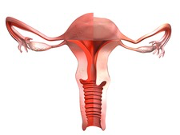
Physiology during menopause
Ovary ligaments are non-effective post menopause, where it’s not able to release hormones are so of useful & beneficial for the ovary and uterus.

This results into ovaries starts secreting hormones in replacement of estrogen & produces testosterone as well as androstenedione. At the same time, bleeding stops & the endometrial stops preventing the uterine cavity as well.
The uterus and the cervix becomes smaller, including the vaginal mucosa that gets pale and dry in nature.

Figure 2: During & Post Menopause
(Source: Science Photo Library, 2020).

Moreover, the vaginal moisturiser gets affected during the time of menopause again, where the tissues get thinner and dry and similarly, progesterone also stops secreting as well that makes irregular periodic cycle and finally stops (Publishing, 2020). Hence, in this entire process of menopause the stated reproductive system affected individually that is connected with each other for different kinds of hormonal secretions and biological reactions.

What happens post menopause: The post menopausal syndrome takes through hot flushes that starts after immediate effect in a woman (Publishing, 2020). At the same time, in a woman post menopause, it happened to be growing possibility of vasomotor symptoms as well as cognitive and mood swing as well ( Woman’s Health Concerns, 2020). On the other hand, urogenital atrophy may also take place and later sexual problems comes front. This makes a woman start facing osteoporosis as well along with the other symptoms of cardiovascular diseases as well as making genital configuration.

Diagnosis: The diagnosis of this kind of post menopausal problem can be treated and diagnosed through systematic astrogen therapy that can be effective in term of providing good sleep to the woman (Woman Health Concerns, 2020). At the same time, Progestin therapy where the use of megestrol acetate can also be crucial along with selective serotonin inhibitors for controlling hot flushes that happens due to the changes in the oestrogen levels (Publishing, 2020). In fact, there is a higher level of follicle-stimulating hormone during menopause stage that is often diagnosed during test at the stage.

References
Agostinis, C., Mangogna, A., Bossi, F., Ricci, G., Kishore, U., & Bulla, R. (2019). Uterine immunity and microbiota: A shifting paradigm. Frontiers in Immunology, 10, 2387. (Online) Available from:. https://www.frontiersin.org/articles/10.3389/fimmu.2019.02387/full
(Accessed: 06/10/2020).

Casanova. Liv. ( 2019). A Guide To Every Phase Of The Menstrual Cycle. (Online) Available from:
https://yourdaye.com/vitals/womens-health/menstrual-cycle-phases
(Accessed: 05/11/2020).

Dreamstimes. (2020). Reproductive System Illustrations & Vectors. (Online) Available at:
https://www.dreamstime.com/illustration/reproductive-system.html
(Accessed: 28/10/2020).

Inspiring Leadership Now.(2019). Women in Leadership Series. How To Be More Productive (Not Less) By Harnessing The Power Of Your Menstrual Cycle. (Online) Available at:
https://www.inspiringleadershipnow.com/women-in-leadership-menstrual-cycle-productivity/
(Accessed: 31st/10/2020).

Koyama, H., Shi, D., & Fujimori, T. (2019). Biophysics in oviduct: Planar cell polarity, cilia, epithelial fold and tube morphogenesis, egg dynamics. Biophysics and physicobiology, 16, 89-107. (Online) Available from:. https://www.jstage.jst.go.jp/article/biophysico/16/0/16_89/_article/-char/ja/
(Accessed: 07/10/2020).

nhs.uk. (2020). Retrieved 22 October 2020, from https://www.nhs.uk/conditions/contraception/contraceptive-injection/

O’Connor, B. B., Pope, B. D., Peters, M. M., Ris-Stalpers, C., & Parker, K. K. (2020). The role of extracellular matrix in normal and pathological pregnancy: Future applications of microphysiological systems in reproductive medicine. Experimental Biology and Medicine, 245(13), 1163-1174. (Online) Available from: . https://journals.sagepub.com/doi/full/10.1177/1535370220938741
( Accessed: 15/10/2020).

Publishing, H. (2020). Menopause And Perimenopause - Harvard Health. Retrieved 23 October 2020, from https://www.health.harvard.edu/a_to_z/menopause-and-perimenopause-a-to-z
(Accessed: 06/10/2020).

SCIENCEphotoLIBRARY. (2020). Menopause vaginal effects illustrations. ( Online) Available from:
https://www.sciencephoto.com/media/911474/view/menopause-vaginal-effects-illustration
(Accessed: 31st/10/2020).

Staff, A. C., Fjeldstad, H. E., Fosheim, I. K., Moe, K., Turowski, G., Johnsen, G. M., ... & Sugulle, M. (2020). Failure of physiological transformation and spiral artery atherosis: their roles in preeclampsia. American Journal of Obstetrics and Gynecology. (Online) Available from: https://www.sciencedirect.com/science/article/pii/S0002937820311169
(Accessed: 13/10/2020).

Wang, Y., Mishra, A., & Brinton, R. D. (2020). Transitions in metabolic and immune systems from pre-menopause to post-menopause: implications for age-associated neurodegenerative diseases. F1000Research, 9. (Online) Available from: https://www.ncbi.nlm.nih.gov/pmc/articles/PMC6993821/
(Accessed: 15/10/2020).

Women's Health Concern. (2020). Retrieved 22 October 2020, from https://www.womens-health-concern.org/help-and-advice/factsheets/menopause/
(Accessed: 15/10/2020).

Yates. Margaret. (2020). Is the menopause responsible for your divorce?. (Online) Available from:
https://www.beingeve.net/relationships/menopause-responsible-divorce
(Accessed: 03/11/2020).

