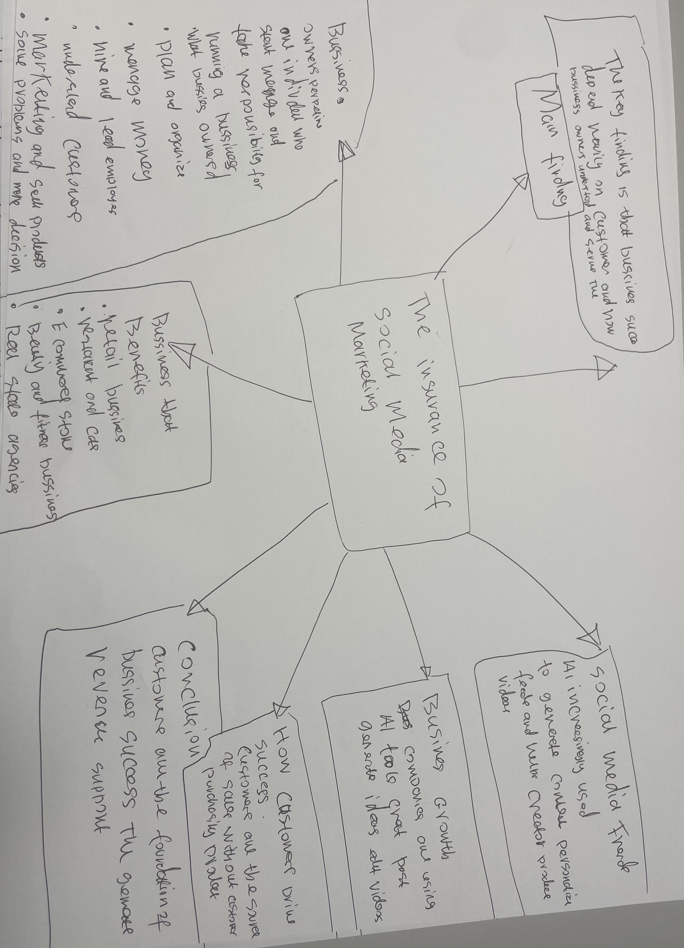


Task 1 – Reading Task Template
Upload your photo of your A3 in-class notes here:

1. Answer these questions using the sentence starters below
a. What is the main idea of the text?
The main idea is that Text messages are a quick and convenient way for people to communicate and share information electronically.

b. What are two key points?
One key point is They allow fast communication
Another key point isThey are used to share information
c. What part of the text did you find most important? Why?
The most important part is the part that I got instant message
d. Was anything unclear or difficult to understand?
I was not sure about but it all became easy at the end
e. How did your group help you understand the text better?
My group helped me by explaining to me a to a
3. One sentence reflection
Question: What did you find challenging about this task?
The hardest part was you have to think about what your going to say

