
Module: Living with Care: The Older Person

Assessment 1 Written assignment (Report)

Module code: BMHP6009

Student name: Catalina Dragoi
Student number:2022850
Lecturer: Dr Laila Surani

Table of Contents
Introduction 3
Meaning of elderly people in UK and another country 4
Aging population of elderly people 5
Relevant theories of loneliness and isolation 8
Impact of loneliness and isolation on elderly people 10
Current legislation and policies to reduce loneliness of elderly people 11
Critical evaluation of local, national and global provision of services 14
Future perspective on the care of elderly people 15
Usage of technology for care provision 16
Recommendation 17
Conclusion 18
Reference 19

Introduction
Elderly people are recognised by their age and physical appearance. However, age is the primary factor to include a person in the group of elderly people. Loneliness and social isolation are two major problems for elderly people. These two issues can create a number of health problems along with mental stress. Central government of the United Kingdom has taken a number of initiatives and developed different laws for ensuring the wellbeing of elderly people of this country. This report is going to focus on statistics on elderly people and rules and regulations developed for them in the United Kingdom and China. China has been selected as another country to compare the statistics of elderly people with the United Kingdom. Different theories of loneliness and isolation will also be demonstrated in this study. Apart from that, the impact of loneliness and social isolation on elderly people will also be properly demonstrated in this report.

Meaning of elderly people in UK and another country
Elderly people can be recognised as per their age. Generally, people aged over 60 or 65 can be included in the group of elderly people. Health conditions and physical appearance can also be considered to identify elderly people. According to the United Nations, a person who is over 60 years of age can be defined as an older person. However, communities and families can use other socio-cultural referents to define age. These socio-cultural referents can include age-related health conditions, family status and physical appearance. According to the National Health Sector of the United Kingdom, people over the age of 65 years can be considered older persons. It is not easy to apply a strict definition because a person aged 75 may be stronger than another person aged 60 (Coşar et.al., 2020). On the other hand, the Republic of China defines a person aged 60 or above 60 as older. As a result, elderly people are generally identified based on their age. However, different types of services are provided to elderly people based on their age and health conditions. In this aspect, some older people do not need any kind of services because of good health conditions and financial power. As per the definition and introduction of elderly people in the United Kingdom and China, both these countries identify elderly people based on their age and health conditions.

Aging population of elderly people
According to National Statistics of the United Kingdom, the number of people aged over 65 in this country was around 11 million. As per the recent census of this country, around 18.6% people of in this country are included in the group of elderly people. According to the 2011 census of the United Kingdom, the number of people aged over 65 years was around 9.2 million. Around 1.8 million increases in the population of elderly people has been seen. The proportion of elderly people rose from 16.4% to 18.6% (Day et.al., 2020). The percentage of people aged over 70 is around 13.6% in the United Kingdom. This percentage is not the same in different regions. Different regions of this country have different proportions.
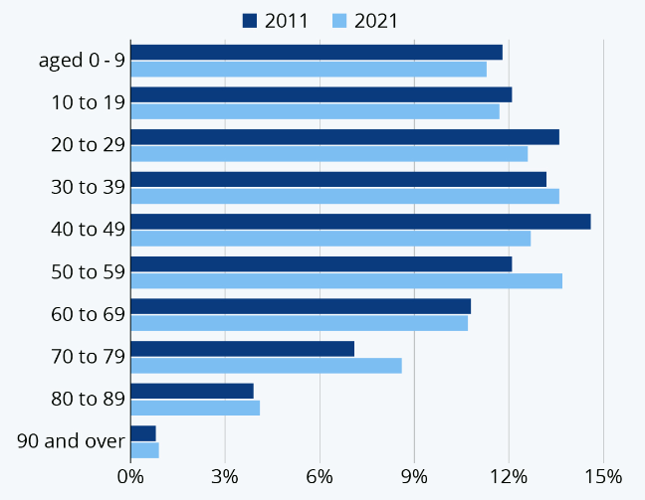
Figure 1: Population of elderly people of the United Kingdom
(Source: Zhang et.al., 2020)
The aforementioned figure shows the population of people from different age groups. As per the above figure, a notable increase in the population of people aged over 70 has been seen.
China is the country with the largest population of elderly people all over the world.
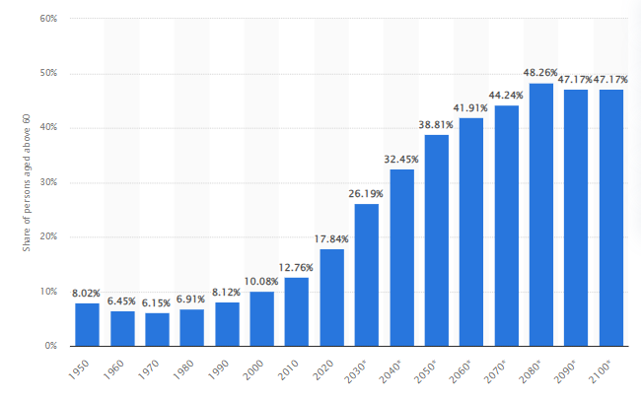
Figure 2: Population of elderly people in China with forecast for upcoming years
(Source: Statista, 2023)
The aforementioned figure shows the percentage of elderly people in China. As per the above figure, in 2020 the population of elderly people in this country was around 17.84%. As per the 2010 census, the percentage of the population of elderly people in this country was around 12.7% (Shareef et.al., 2021). The population of elderly people in this country was around 254 million in 2019. As per the forecast, the population of elderly people in this country is going to be over 400 million by 2040. This year, around 28% of the population will be included in the group of elderly people. As a result, a gradual increase in the margin of elderly people has been seen in this country. As per a report, in 2022 around 13.72% people of in this country were aged over 65. However, a slight decrease in the margin of people aged over 70 has been seen in 2020. Percentage of people over 70 was around 5.74% in 1972 (Wong, 2020). This percentage has decreased to 5.45% in 2020. Gradual increase in the population of elderly people in both the United Kingdom and China represents the application of adequate rules and conveniences for them.

Relevant theories of loneliness and isolation
Loneliness occurs when people feel insecure attachment patterns and behave in such a way that can result in rejection by their relatives. Rejection from close relatives can create mental stress along with loneliness. As a result, people often choose isolation. Different theories and models can be used to evaluate loneliness and isolation of elderly people.
Weiss theory of loneliness
According to the principles of this theory, six different social needs are required to mitigate loneliness of a person. These six different needs are social integration, attachment, a sense of reliable alliance, nurturance, reassurance of worth and guidance in stressful situations. Attachment with close relatives or friends is required to avoid loneliness. Social integration is also required to share our own perspectives about different things. Lack of social integration can also be responsible for mental stress and loneliness (Loeffler and Bovaird, 2019). Elderly people should also be guided in stressful situations. Loneliness of elderly people can be increased further due to a lack of guidance and co-operate. Nurturance is another important aspect to help elderly people to avoid loneliness. In this aspect, health-related services should be available for them.
Cognitive dissonance theory
As per the principles of this theory, two different beliefs of people can be inconsistent and this can create cognitive conflict or dissonance. Elderly people want to communicate with other people but they cannot communicate with other people due to the lack of presence of close relatives at home. Loneliness and isolation at home are two major reasons behind this dissonance.
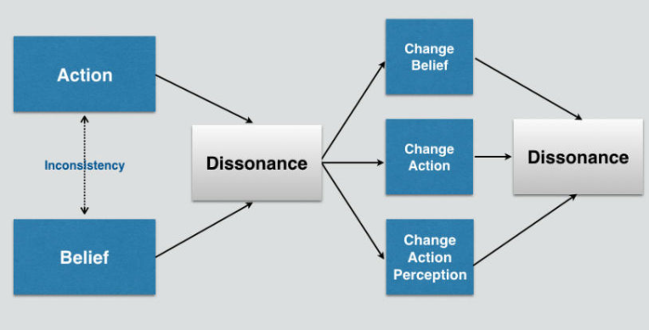
Figure 3: Cognitive dissonance theory
(Source: Lättman et.al., 2019)
As per the aforementioned discussion, elderly people need support from their close relatives to avoid issues related to isolation and loneliness. Health-related services to them should also be continued to mitigate mental stress. Different reasons are there behind social isolation and loneliness. Limited finances, divorce, impaired mobility, lack of access and inequality due to rural living are some of the major reasons behind loneliness and social isolation.

Impact of loneliness and isolation on elderly people
Elderly people often feel lonely who live in a care setting. Different mental problems can be faced by elderly people due to isolation and loneliness. According to research, several physical and mental conditions can be enhanced due to social isolation and loneliness. Heart disease, high blood pressure, anxiety, a weakened immune system and cognitive decline are some of the physical and mental problems that can be faced by elderly people due to social isolation and loneliness (Yu et.al., 2022). Lack of social relationships can be responsible for cardiovascular disease in elderly people. Elderly people can also increase their suicidal thoughts due to loneliness and social isolation.
Mental stress can be a major negative outcome of loneliness and social isolation. Elderly people often find the touch of close relatives or friends. They cannot fulfill their needs and requirements without taking help from others. As a result, close relatives including sons or daughters can be most effective group of people who can fulfill their mental needs. Social isolation can create mental stress for them and they can think that their relatives do not have interest in giving some time for them (Li et.al., 2021). As a result, different health issues can also be increased due to loneliness. Services from healthcare service providers cannot fulfill their mental needs. Heart disease among elderly people who are in a care setting is a major outcome of loneliness and social isolation.

Current legislation and policies to reduce loneliness of elderly people
Different rules and regulations have been developed in China and the United Kingdom to protect the group of elderly people. The Care Act 2014 is the law developed by the government of the United Kingdom to ensure safety concerns for elderly people. This act replaced the old system of this country (Handleylaw, 2023). The principles of this law force local authorities to promote the well-being of elderly people. Principles of this law also include physical and emotional well-being of people including the group of elderly people. Apart from that, this law has set out a new legal framework for the provision of care as well as support services for disabled and older people. The government of this country has also taken different initiatives for elderly people. Care for elderly people is divided into two different categories including residential and home care. The National Grant Scheme is a scheme that encourages elderly people of this country to participate in different sports and physical activities. Different other services including foot care, care and restaurants, training courses and day centers are also provided by the government of the United Kingdom for elderly people. Age UK is known as a leading charity that helps elderly people in this country by providing different types of services.
The government of China is also not far behind in terms of different initiatives for elderly people. The government of this country passed an unprecedented law named "The Protection of the Rights and Interest of Elderly People" in 2013 (Miura et.al., 2022). This law is also known as Filial Piety Law. According to the principles of this law, adult children have to provide culturally expected support to their parents who are above 60 years old. Article 49 of this act states that children who are adult have the duty to take care of and support their parents who are aged 60 or above 60. Different initiatives have also been taken by the government of this country for the well-being of elderly people. The central government of this country has allocated around 5 billion Yuan to encourage new pilot programs of home-based elderly care services that are started in around 203 different cities of this country. The elderly people of this country generally prefer home-based services. As a result, a number of government-funded charities provide community services to elderly people in this country. The "Big Health Industry" of this country includes medical and healthcare stores. The market size of elderly care sector is around 33% of total market size. A range of services are provided by this sector to elderly people of this country. Around 90% of elderly people in this country are cared for by their families. On the other hand, around 7% of elderly people in this country are cared for by different community service providers. Around 3% of elderly people in this country are living in nursing homes. The development of the aforementioned law has helped to increase the percentage of elderly people taking caring services from their children. This country is also known for a number of welfare institutions for elderly people.
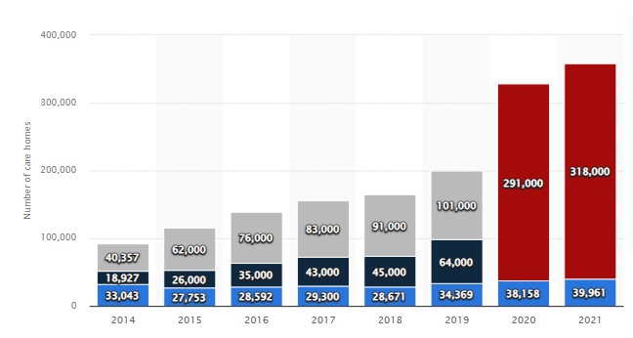
Figure 4: Number of nursing homes and social welfare institutions for elderly people in China
(Source: Statista, 2023)
The above figure represents the number of social welfare institutions for elderly people in this country. According to the aforementioned figure, there were around 358000 welfare institutions for aged people including around 40000 nursing homes in 2021 in this country. Number of nursing homes and social welfare institutions for aged people in this country was around 38k and 318k respectively in 2020 (Gale et.al., 2019). As a result, a notable margin of increase in the number of these two different types of elderly people care service institutions has been seen in this country. The graph shows a gradual increase in the number of nursing homes and social welfare institutions for aged people.

Critical evaluation of local, national and global provision of services
Local policies for elderly people include providing food services for elderly people. Local charities in both the United Kingdom and China take care of elderly people by providing them with shelter and food services. National services for elderly people include a certain amount of investment for elderly people (Elliott et.al., 2021). The development of different rules and regulations for elderly people is a major service for elderly people. For example, China has developed Filial Piety Law to ensure protection of elderly people from their family members. As a result, there is a slight difference between local and national services for elderly people. Local authorities and charities can provide food, shelter and health services for elderly people and those services can be included in local provision of services. On the other hand, the central government of a country can develop rules and regulations and a huge amount of investment for elderly people (Wang, 2019). As per United Nations, elderly people should be able to live in security and with full dignity and be free of physical and mental abuse. Apart from that, elderly people should also have access to water, food, shelter and healthcare through the provision of community support and family.

Future perspective on the care of elderly people
Different initiatives can be taken by the governments of the United Kingdom and China in the future for elderly people. The arrangement of social awareness programs can be an effective initiative for aged people. The governments of these countries can arrange different institutions for the physical activities of elderly people (Miles et.al., 2021). These steps can help remove mental stress and social isolation of elderly people. Surveys can be arranged to collect information from elderly people regarding their choices and requirements. The collection of data can help to take further steps to ensure the well-being of elderly people. Central government can also build some homes for elderly people to provide smart services to them.

Usage of technology for care provision
Different technological aspects can be used for the care of elderly people. Medical alert systems can be an effective technological aspect to enhance the safety concerns for elderly people (Sun et.al., 2020). This technical system can alert service providers or family members when any kind of service would be needed for an old person in the home. A major part of elderly people face hearing issues. These issues can be mitigated with the help of using wearable technology. Different other technologies can also be implemented to help elderly people overcome mental health issues including loneliness, depression and enhance emotional well-being. Digital interactive education can be an effective technology to educate elderly people. As a result, this technology can help old people to enhance their personal skills. The arrangement of therapeutic programs can also help to mitigate different physical and mental issues. Challenging virtual puzzles can help elderly people to spend some time gaming and to be self-sufficient. The usage of robots can also be helpful for providing different types of services to elderly people at home.

Recommendation
It can be recommended that the government of the country should ensure safety concerns for elderly people. In this aspect, arrangements for sufficient social awareness programs should be made to ensure health and safety of old people. Social campaigns can help to educate people about the importance of health and other services for elderly people. The development of adequate rules and regulations can be an effective step to ensure the well-being of elderly people. Apart from that, charities that provide health and other services for elderly people should be funded. Different health schemes for elderly people can also be provided. The Governments of both aforementioned countries should ensure food and shelter for elderly people who are facing issues related to the services of their families. Regular counseling of elderly people is also required to help them overcome loneliness and social isolation. Educational services will be an effective service to help old people to enhance their personal skills. Different steps should also be followed by family members to ensure health and safety concerns for their elderly members. They should communicate regularly with elderly family members. Apart from that, elderly family members should also be asked about their needs. Attachment will be the best policy to help elderly people. Communication with them on a regular basis can also help to avoid mental stress and loneliness.

Conclusion
It can be concluded that elderly persons can be identified based on their age. People over the age of 60 or 65 are often considered to be elderly. The health issues and physical appearance of the elderly can also be used to identify them. The gradual increase in the senior population in both the United Kingdom and China signifies the implementation of appropriate policies and conveniences for them. To avoid feelings of isolation and loneliness, elderly individuals require the assistance of close family. To alleviate mental stress, they should continue to receive health-related services. There are various reasons for social isolation and loneliness. Loneliness is caused by a variety of factors, including limited income, divorce, reduced mobility, a lack of access, and inequalities related to rural life. The Care Act 2014 is a law enacted by the United Kingdom government to address elderly people's safety concerns. This statute superseded the country's previous system. The organisation of social awareness programmes might be a beneficial endeavour for the elderly. The governments of these countries can set up various institutes for the physical activity of the elderly.

Reference
Coşar, S., Fernandez-Carmona, M., Agrigoroaie, R., Pages, J., Ferland, F., Zhao, F., Yue, S., Bellotto, N. and Tapus, A., 2020. ENRICHME: Perception and Interaction of an Assistive Robot for the Elderly at Home. International Journal of Social Robotics, 12, pp.779-805.
Day, P., Gould, J. and Hazelby, G., 2020. A public health approach to social isolation in the elderly. Journal of Community Nursing, 34(3).
Elliott, A., Taub, N., Banerjee, J., Aijaz, F., Jones, W., Teece, L., van Oppen, J. and Conroy, S., 2021. Does the clinical frailty scale at triage predict outcomes from emergency care for older people?. Annals of emergency medicine, 77(6), pp.620-627.
Gale, R.P., Mahmood, S., Devonport, H., Patel, P.J., Ross, A.H., Walters, G., Downey, L., El-Sherbiny, S., Freeman, M., Berry, S. and Jain, N., 2019. Action on neovascular age-related macular degeneration (nAMD): recommendations for management and service provision in the UK hospital eye service. Eye, 33(Suppl 1), pp.1-21.
Handleylaw.co.uk, 2023 [Online] Available at:https://handleylaw.co.uk/care-act-2014/#:~:text=The%20Care%20Act%202014%20Protecting%20the%20Elderly&text=This%20wide%2Dranging%20term%20incorporates,the%20setting%20of%20suitable%20accommodation. [Accessed on 26.08.2023]
Lättman, K., Olsson, L.E., Friman, M. and Fujii, S., 2019. Perceived accessibility, satisfaction with daily travel, and life satisfaction among the elderly. International journal of environmental research and public health, 16(22), p.4498.
Li, W., Yigitcanlar, T., Erol, I. and Liu, A., 2021. Motivations, barriers and risks of smart home adoption: From systematic literature review to conceptual framework. Energy Research & Social Science, 80, p.102211.
Loeffler, E. and Bovaird, T., 2019. Co-commissioning of public services and outcomes in the UK: Bringing co-production into the strategic commissioning cycle. Public Money & Management, 39(4), pp.241-252.
Miles, D.K., Stedman, M. and Heald, A.H., 2021. “Stay at Home, Protect the National Health Service, Save Lives”: A cost benefit analysis of the lockdown in the United Kingdom. International Journal of Clinical Practice, 75(3), p.e13674.
Miura, C., Chen, S., Saiki, S., Nakamura, M. and Yasuda, K., 2022. Assisting personalized healthcare of elderly people: Developing a rule-based virtual caregiver system using mobile chatbot. Sensors, 22(10), p.3829.
Shareef, M.A., Kumar, V., Dwivedi, Y.K., Kumar, U., Akram, M.S. and Raman, R., 2021. A new health care system enabled by machine intelligence: Elderly people's trust or losing self control. Technological Forecasting and Social Change, 162, p.120334.
Statista.com, 2023 [Online] Available at: https://www.statista.com/chart/27697/census-shows-population-of-england-and-wales/ [Accessed on 26.08.2023]
Statista.com, 2023 [Online] Available at: https://www.statista.com/statistics/251529/share-of-persons-aged-60-and-older-in-the-chinese-population/#:~:text=Share%20of%20population%20aged%2060%20and%20older%20in%20China%201950%2D2100&text=In%202020%2C%20about%2017.8%20percent,nearly%2040%20percent%20by%202050. [Accessed on 26.08.2023]
Sun, X., Yan, W., Zhou, H., Wang, Z., Zhang, X., Huang, S. and Li, L., 2020. Internet use and need for digital health technology among the elderly: a cross-sectional survey in China. BMC public health, 20, pp.1-8.
Wang, X.B., 2019, July. Research on Community Elderly Care Service in China. In 5th Annual International Conference on Management, Economics and Social Development (ICMESD 2019) (pp. 443-447). Atlantis Press.
Wong, F.M., 2020. Factors associated with knowledge, attitudes, and practices related to oral care among the elderly in Hong Kong community. International journal of environmental research and public health, 17(21), p.8088.
Yu, T., Tian, L. and Jian, S., 2022. Explore the Rehabilitation Landscape Design under the Home-Based Elderly Care Mode. International Journal of Frontiers in Sociology, 4(3).
Zhang, Q., Li, M. and Wu, Y., 2020. Smart home for elderly care: development and challenges in China. BMC geriatrics, 20(1), pp.1-8.

