Name | Susan Okwera
Student Number | 1806775
Module Title | Developing Workplace Critical Thinking
Module Number | BMSW 5101- LON
Lecturer | Mr Ze Zook

Contents

Introduction 3-4
Workplace Scenario 4
Organizational Structure 6
Critical Thinking 7
Six Hat Theory 8-9
Beliefs, Values and Attitudes 10-11
Management Theories 12-18
Conclusion 18
References 19- 21

Developing Workplace Critical Thinking and Management Theories.

Introduction.

This report is based on a specific organisation of which evaluation and critical thinking will be applied in the context of beliefs, attitudes, value systems and management theories, demonstrating appropriate workplace levels of critical thinking. The organisation that I will be evaluating is a charity based organisation that provides residential care homes to the local community called Leonard Cheshire disability. This organisation has a lot of care homes under its umbrella with different house names, but I will only focus on the residential care home that I work in called Athol House. Although the organisation implements the government legislations and carries the same policies and procedures this effects all round their many residential care homes as the organisation is all alike and functions the same whether large or small residential homes. This residential care home is part of a large charity organisation that provides a service and caters after 30,000 individuals with different disabilities. The charity organisation was founded by Leonard Cheshire a retired RAF pilot in 1948. The reason why Leonard Cheshire established this charity organisation was because he rescued and took who was homeless and sick into his house a man who was dying and nursed him back to health. This organisation provides a service for the individuals with disabilities in community and has been doing so since its foundation the disabilities range from individuals with MS to individuals who have suffered a stroke. The reason for the organisation, was to assist servicemen who were wounded, needing help and had nowhere to go.
Literature Review.
(Chatfield, 2018) suggests that when humans are critically thinking, individuals would seriously operate by seeking to comprehend what is the situation through the channels of thinking carefully, reasoning, and evaluating evidence leading from reasonable and reliable sources. (Chatfield, 2018) goes on to suggest that skepticism and objectivity
(Maund, p40, 2018) defines organizational behavior as a personal examination of behavior and how their behavior affects individuals in the workplace. It is believed that science applies to an individual’s behavior in the workplace through psychology, sociology, and cultural anthropology of which organizational behavior is drawn from therefore social psychologists’ study suggests that through the specialty of psychology leaders manage to influence individuals and their organizational behavior.
(Maund, p40, 2018), management practices have been in place since the revolution of 1900s and most scholars agree however management practices did not start from the scientific theory of Fredrick Taylor, but from the Hawthorne Theory 1927 and 1932 of Elton Mayo.

Scenarios at work place.
Managing conflict of two team leaders who have been having issues and just did not get along but one day both team leaders had a disagreement and erupted to a full verbal war at the workplace. Both the team leaders are from different backgrounds of which can have an impact on their values, beliefs and attitudes.
Another scenario was a female support worker claimed to have been sexually assaulted by a resident by touching her bottom. The resident a Mr. P, is blind and cannot see since he was a child also is deaf and can only hear in one ear through un hearing aid.
Another scenario is what is happening around the world. Globally corona virus has become pandemic affecting the rich, the poor, the young and the old. This virus does not discriminate and has had a huge impact on all types of businesses whether service or product business. At Leonard Cheshire residential home Athol House, the corona virus has had a huge effect as residents are vulnerable and can get sick easily and staff have had to go into isolation therefore causing a shortage of staff on duty. There have also been some residents that has been admitted to hospital and are now affected with the corona virus or corvid 19.
As the media and courts continue to focus on a case that has caused change to policies and legislation #METOO. The #MeToo era, has continued to expose those that have taken advantage of women as well as men in the workplace that has been mainly expressed in the entertainment industry. surges of women have joined the movement to implement the workplace policies against discrimination that have governed the organisation so women and men who have been abused by those in power or authority are now speaking with one voice.
Sexual harassment is a behavior that is unwanted from an individual or individuals in a sexual orientation in the example;
- Violating ones’ dignity
- Making one feel intimidated, degraded, or humiliated.
- Creating an intimidating, hostile, degrading, humiliating or offensive environment.
- Make sexual comments or jokes
- Physical behavior, including unwelcome sexual advances, touching and various forms of sexual assault.
- Displaying pictures, photos, drawings of a sexual nature.
- Sending emails with sexual content.

The Sex Discrimination Act 1975 (amended 2003).
The Employability Equality (sexual orientation regulations 2003).
Article 3 of the Human Rights Act of 1988.

The process that has been put in place as a cause of action to take when there is a behavior change or incident would be to inform your line manager and fill out a behavior incident form. The manager will review the information submitted and interview the individual privately.

Structure:
Every organisation whether small, medium or large has to have a structure of chain of command because an organizational structure is an order of networks that follows a process to how business tasks are to be achieved through management and delegation of tasks in order to achieve goals. This is significant to the chain of command and defines the roles of each employee and employer. This structure also controls the flow of information separating different levels inside the organization to stop chaos and organize the tasks accordingly. According to Maduenyi, S and Oke, O and Fadeyi, O and Ajagbe, A. (2015) the research suggests that if organisations want to accomplish their set goals then they should aspire to a structure that is well defined. Sainsbury’s and Lidl use a hierarchy organisational structure as there are levels above and each level manages the level below. There are two kinds of organisational structures, tall and flat structures. Leonard Cheshire organisational structure is a flat structure with employees at the bottom, next stage up are team leaders and then managers. This is an advantage because flat structures are cost effective, communication is good as it makes the flow of information easy, not much of bureaucracy.
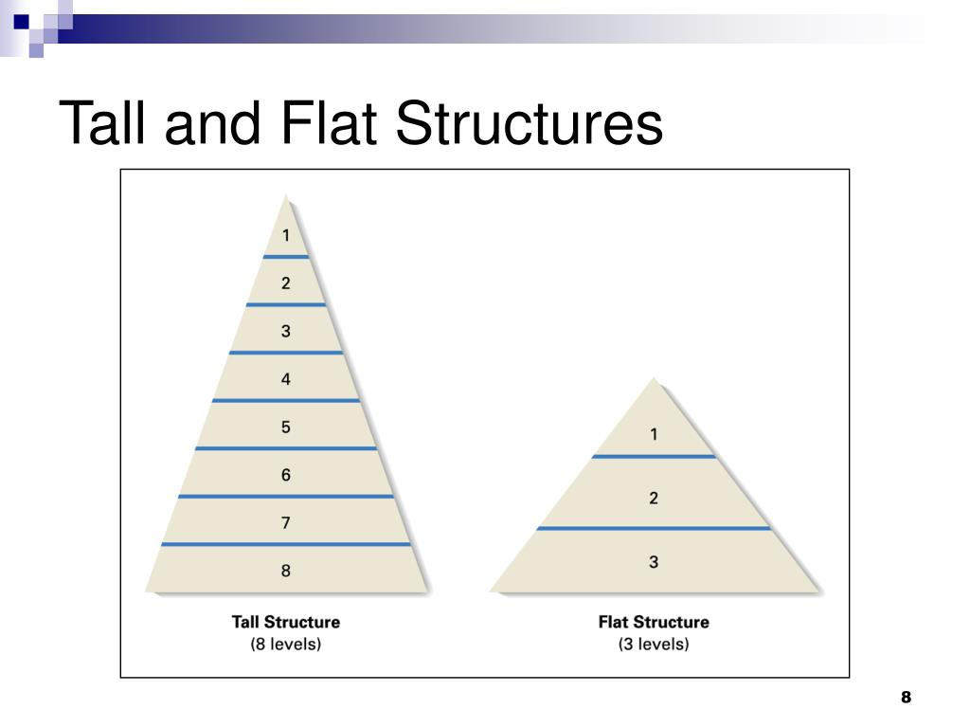
Source: Bing.com
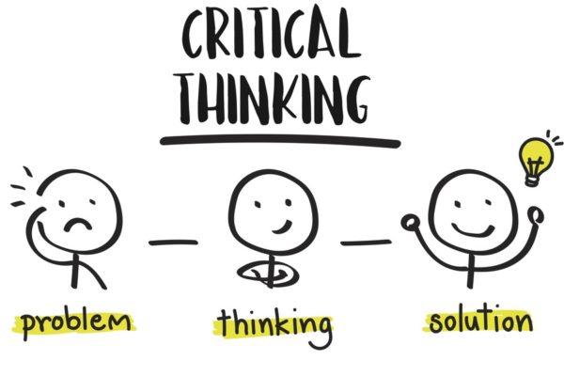
Critical Thinking.
8

8

Source: Bing.com
According to (Moodle 2020) Critical thinking is a set of skills that are intellectual and habits of psychology, which makes it effortless to solve problems correctly, communicate with clarity and unearth truths.
When Critical thinking is taking place in workplace, thinkers would use their skills and habits by elevating vital questions with precisely and clear construct, collecting and evaluating applicable information and effectively interpreting ideas as well as arriving at logical solutions and conclusions.
When one thinks of Critical and thinking together, it is assumed to be of a negative effect when in actual sense this is not the case. The word critical is associated with danger as in critical illness and critical situation, but when it comes critical thinking in the workplace this would endeavor us to think outside the box and find solutions to a problem. Critical thinking is sensitive and as well as perceptive. This depends on the individuals’ positive or negative experiences and understanding of behavior, ideas and value. In a working relationship questioning what is appropriate is ideal to the situation.

The Six Hat Theory

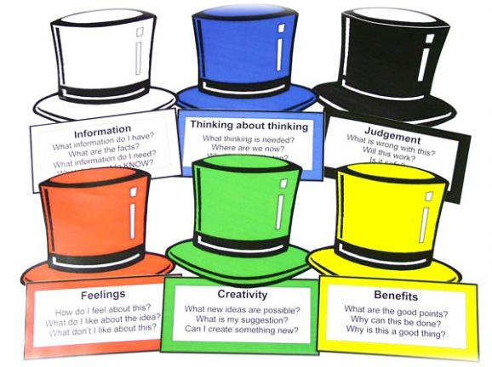
Source: Bing.com
The Six hat theory was created by Edward De Bono, (De Bono 2017) describes his method as robust, effective and simple, divided into six different colours to represent different competence. De Bono goes on to say that in thinking the difficulty is confusion as individuals do too much at the same time. Hence the separation of the process that allows simple thinking to take place. The separation between logic and emotions, information and creativity and so on, so that individual thinkers put on one hat at a time.
According to Learning-mind.com, the six hat theory divides thinking and defines six roles of which thinkers can work out favorable solutions to the problem.
The link between beliefs, attitude and values is culture. All three relationships are learned behavior of which one can dismiss and take on a new way of thinking. (Potter 2012) ( Albarracin, Zana, Johnson and Kumkale 2005) suggest that attitudes and beliefs are interlinked to either one and each individuals needs mental constructions. All possess different elements of the behaviors and find that when we are in a workplace or relationship we are attached to those that have similar beliefs, attitude and values and ourselves which makes the workplace environment tranquil and peaceful making the life at work easy and also the process of work effective and on the other hand because beliefs, attitude and values are learned behavior this will equally make an individual to fit into the mix or adapt to the work environment easily and be inbound in the organization. Allport 1935) claims that idea of attitudes is quintessence to all of social psychology.
However, if the tables are turned and the individual is not able to understand the values, attitude, or beliefs this can lead to dismissal and stress related illness. Although not everyone will have all three components of beliefs, attitude and values, individuals would perhaps have only beliefs and attitude or values and attitude this can be positive or negative that leads to the functioning of a team as a whole. Best practice of the workplace would be that all employees are different and have different skills to carry out tasks but adhere to the same organizational beliefs, attitude and values that the company operates under. This is the core organizational objective and mission that would initially build the organization to where it is now. Although overtime the organization would have to change according to its environment and political time.
Iceberg what is seen externally cannot be seen internally. Conscious or unconscious.
Emotions: (Clay-Warner & Robinson, 2008) suggests that emotions are intense and relatively short lived feelings. I disagree with this definition because not all disagreements of are emotionally challenging, intense or short lived. This depends on an individual’s’ mindset and emotional wellbeing as on a negative emotion can has a detrimental effect on an individual and lead to self-destructive behavior.
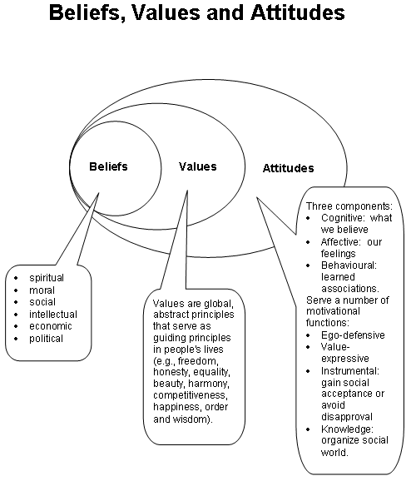
sourced: owlcation.com 9th march 2020.
Beliefs: are opinions that an individual hold to be true. The most common attitudes towards belief are Religion and Aliens of which questions are asking if God does exist and also if aliens do exist. But those with belief do believe that God does indeed exist although having never seen God but the belief and having faith removes the question to existence of God. This also applies to the believers of aliens there are claims to those who believe to have experienced the existence of aliens and therefore believe so.

Attitudes: an attitude is a positive; negative or mixed evaluation of an object that is expressed at some level of intensity. It is an expression of a favorable or unfavorable evaluation of a person, place, thing or event. (Anderson & De Silva, 2009), describes an attitude as the way a person expresses or applies their beliefs and values, and is expressed through words and behavior. Eg I get upset when I hear about cruelty to children and animals, or I hate school. I agree with this definition because ones’ words or behavior comes from the mindset or viewpoint of an individual towards situations, people or things and contributes to the way it affects the individual’s behavior emotionally and can negatively lead to dislikes or a positive outcome of likes and happy with self-belief.
Having a positive attitude at work would improve communication and multiply in efficiency to create a better workplace whilst negative attitudes in an organization can affect employees and create misunderstandings causing chaos and distraction which is damaging to the business.
I believe that having a positive attitude at a workplace is of great paramount to the organisation because this helps in engaging with colleagues to create an effective communication of information flow and as well as a positive environment to work in.

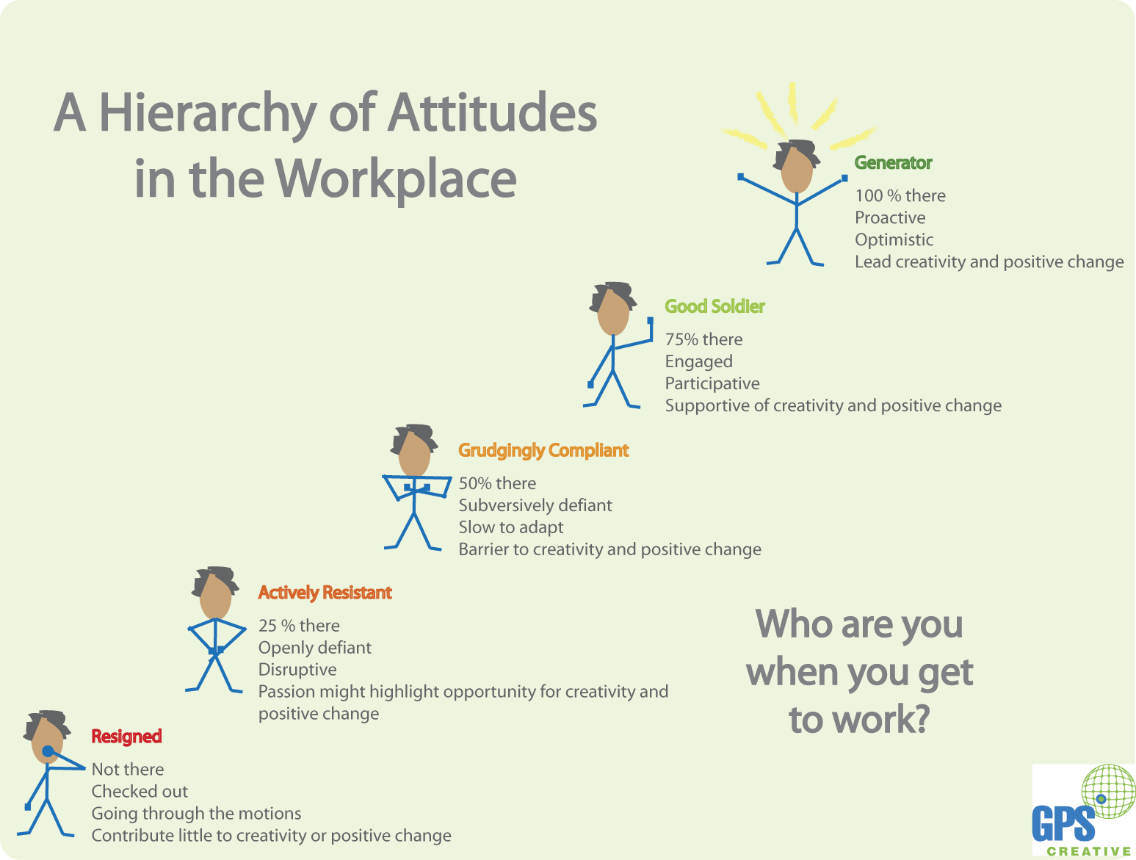
Values: are laid down foundations of an individual that contributes to a system of beliefs and behavior leading to a pattern of reasoning. (Anderson & De Silva, 2009) suggests that “value is a measure of the worth or importance a person attaches to something; our values are often reflected in the way we live our lives” e.g. I value freedom of speech or I value my family, morals. I agree with this definition because having values is having beliefs of morals and this is important in ones’ life, values gives the individual a sense of balance and measure to be able to evaluate situations and being aware to make right life decisions that reflect with a purpose and values are usually passed down through the family line. However, in business values has a different view in the workplace.

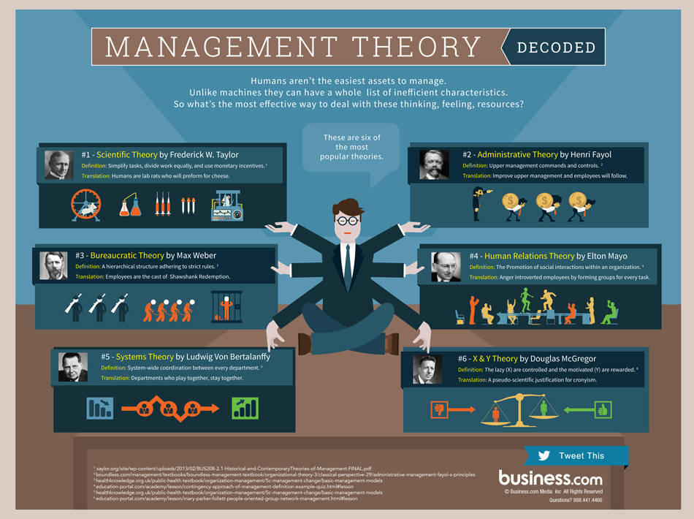
Sourced: Business.com 20th march 2020.
Organizational management theories.
Since the industrial revolution mangers have been an essential component to the accomplishments of an organisation. Managers are crucial to a business and being an effective manager takes time and experience to be able to manage a team without micro managing which can have a negative effect, but not all managers are likely to succeed and achieve with their style of management. According to ( Rosenzweig 2010) (McNamara) with managers of every generation battles with questioning the purpose it’s about as over the years 1950s to1960s, to be a competent manager there was four activities done well: Control, plan, direct and organize.
Effective managers can be able to withstand crisis and deal with complex matters calmly without causing panic among the team and take steps to ensure a positive outcome. Management theories have an impact on the organisation to be able to improve efficiency. Effective leaders or managers can implement the strategies to be able to apply the theories motivation and team building, conflict resolution, effective communication making decisions and critical thinking or negotiating deals and allocating resources is outstanding. multiply production and service standards. However, individuals manage differently and with the ever changing times, new business trends are blossoming new theories. although old theories are still relevant and used effectively.

The study of management theories conducted by Hawthorne 1927-1932, steered to a focus of an individual’s behavior in an organization. This theory is a psychological experiment. Over the time since the revolution era, the management definition has produced different modified approaches according to theories with many versions and interpretations of management that has been researched but yet the most cogent theory and effective remains that of Henri Fayol.
Fayol 2013 Reprint of 1949 Edition) urgues that in order for management to be effective, there are activities that are key elements whether complex or simple activities to be undertaken in management and defines them as follows; to Plan, to forecast to command, to organize, to control and to coordinate. Fayol went on to explain what each element would entail, therefore suggesting that managers would have to anticipate and analyse weighing up options to prepare and have a future plan of action.

The scientific Management Theory by Fredrick Taylor in the1900s is a classic one. Taylor was a professional engineer, who explored different ways that can be more effective and efficient to work and achieve targets. Taylor’s approach to the scientific management theory produces some interesting queries and researched heavily into what could workers do to improve the efficiency of producing more and faster effectively. Taylor introduced the theory of organisations to work together with their employees that they would achieve success and grow their business of which would benefit both company and staff. (Sheldrake 20203) states that Taylor believed that being mutually interested Taylor’s maximum prosperity to both company and individual employee would be beneficial to both
The scientific theory contributed a great deal to making the efficiency of working. The Scientific Theory made changes and improved efficiency making the following;
- The reduction of hours worked per day
- Matching staff by skills
- Payment incentives.
- Mutual interests.
(Sheldrake 2003) states that there was some form of resistance to the Taylorism from labourers and managers threatened by the new methods.
However, this theory had some crucial weaknesses which was unfortunate for the scientific theory.
Taylor’s four essential theories that was generated to the scientific management theory are as follows;
- Firstly, individual tasks should be examined to conclude the best possible way of achievement of tasks. This method disorganizes the process of working tradition.
- Secondly, positions should be suited to the employees’ capabilities and motivation.
- Thirdly, closely monitoring employees would be effective to the best working practices.
- Fourthly, managers should be preparing for the future commitments and allocate time to staff training.
Taylors’ theory has some pragmatic theories to his studies in the instance of employees being suited to each task according to their capabilities and motivation this allows efficiency and would be effective for employee to work accordingly. Whereas on the other hand the flaws of the scientific theory negatively impact the working dynamics as the theory allows the practice of micromanagement which would be ineffective in today’s working society. The scientific management theory does not highlight the importance of team work and focuses on tasks given according to capabilities which would abolish the practice of creative problem solving in a team.
The Administrative Management Theory by Henri Fayol was a French man and a mining engineer who developed the administrative theory also known as the Fayolism. Henri Fayol modernised and expanded the management theories in cooperating it with the principles of the scientific theory by Fredrick Taylor.
When Fayol made further improvements to the administrative Management theory, six more concepts of management theories were added to which most are still practiced in today’s workplace and they are as follows;
- Planning
- Forecasting
- Commanding
- Controlling
- Organising
- Coordinating.
The Bureaucratic Management Theory by Max Weber, a Sociologist German, constructed the well-known Weber’s Theory of Bureaucracy in 1947. Weber’s main basis of The Bureaucratic Management Theory was mainly the structure of the organisation. According to Bashir, Mahmood and Muhammad (2012) Weber concentrated more on splitting up the organisation into hierarchy and demonstrating the chain of command showing control and authority and therefore suggesting that businesses should establish an inclusive and complete standard of plan of action to the tasks. It is of the opinion (Warwick, 1975; McNamra, 2010) that Weber’s theory should be followed with utmost respect though the chain of command, therefore, managers are to dictate to workers and direct tasks using the managerial rules and regulations. In addition Ihlen and Fredriksson (2018) Weber described managers as being in a positon of “actors” to justify Weber argued that the foundation of a system’s validity differs, and depends on the variety of beliefs that approve it with the suggestion of charismatic personalities into organisation
Principles of Bureaucratic Management Theory
- Written rules and regulations.
- Show hierarchy with chain of command
- Special training for Managers and workers.
- Staff selection according to tasks.
- Clear roles

The world is a nation of systems because humankind has a culture or civilization to carrying out our daily life of which a system is used, starting from when we are going to work till when we return home. The system starts from the time of waking up, we then take a shower, however if the shower is not working then the system has failed or broken this disrupts the system causing delays and chaos.
The system theory is defined as how an organisation is managed or coordinated through a collection of components that are involved to achieve more or less objectives or goals.
According to (Chikere, Cornell C.1 and Nwoka, Jude2, September 2015). An organisation is regarded as a system comprising combined parts that should be organized for effectiveness and efficiency. As a result of their study, it was found and recommended that present-day companies must adjust to systems strategy in order to increase the company profitability and growth.
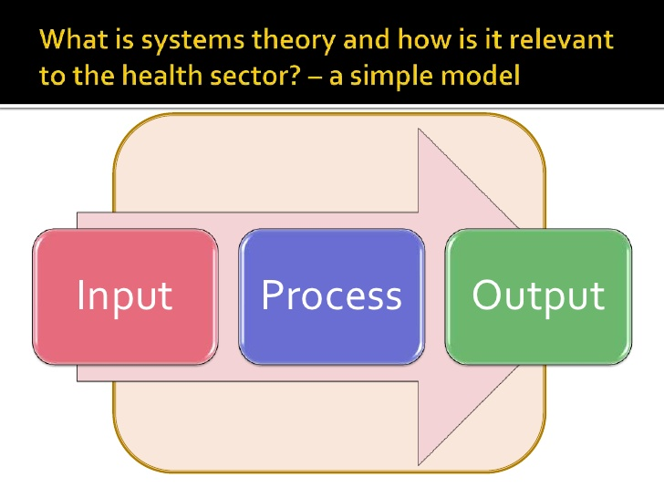
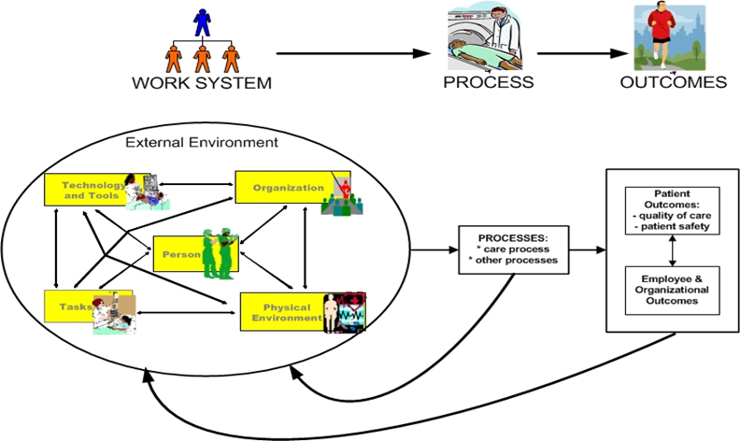
Source: Bing.com
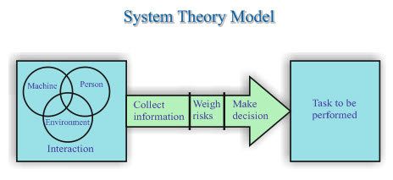
Source: www.bing.com/images
Ludwig von Bertalanffy (1968) argues that the “general system theory is a general science of wholeness”. However, there are open and closed systems within the system that affects the environment and they are called open and closed systems and subsystem. An open system is where the surrounding can be exchange or a swap of both energy and matter and a closed system is one that the surrounding is unable to exchange with the matter. ( Madhusha, 2017 ) for instance; the surrounding is the space around the earth, and the system is the earth. The matter and energy is the sunlight and rockets as the matter of sunlight reaches the earth’s surface and rockets are energy that is sent to space, respectively. The human body is a sub system which is a larger system that is combined by different elements to make the body function.
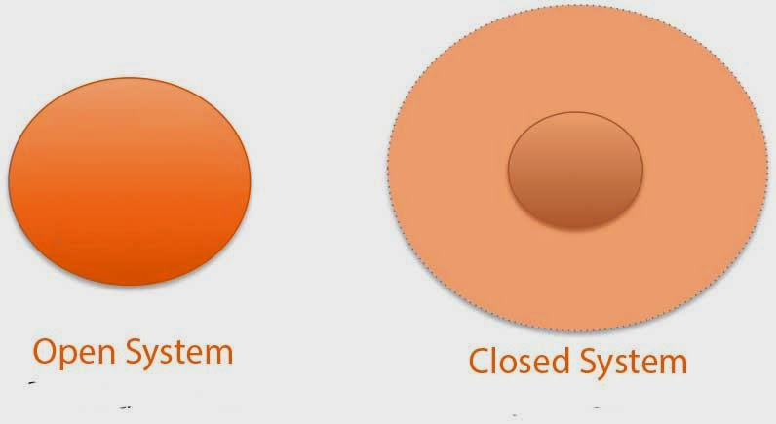
The Behavioral Management Theory: Elton Mayo (Hawthorne effect): This study also saw Mayo keen to increase efficiency in production in the manufacturing industry. Mayo examined the reaction production line employees had when lights were high or lowered. Although production improved in both in both research lighting scenarios of high or dimmed. Mayo puzzled with the results interviewed the production line employees and attained information that concluded production line workers cherished the attention from the research team and felt significant. However, production did reduce when the researchers had gone from the factory. (Macefield 2007) As a result: advocates of the Hawthorne results say that individuals who are selected for whichever research possibly increase their behavior or performance. It is not of any particular situation being examined, but just a simply attention being received. (Rice, 1982, p. 1).
Conclusion.
To conclude the workplace works better with positive attitudes and the beliefs and values of individuals contribute to the team to bring insights to the organisations and adaptation. Most organisations depending on their structure and business have taken on points of each theory to make the organisation successful and manageable. With effect to the bureaucratic management theory of Weber the setting of clear guide lines and rules in a workplace gives some so of security to both employers and employees.

REFERENCES

Ajagbe, A. Fadeyi, O. Maduenyi, S and Oke, O (2015) Impact of Organisational Structure on Organisational Performance. Available at: eprints.covenantuniversity.edu.ng/5296/#.Xr25u_ZFzIU

Basharat, M. Bashir, Z and Mahmood, Z (2012) ‘Review of Classical Management Theories’ Volume: 2 Issue: 1 ISSN: 2223-4934
International Journal of Social Sciences and Education https://www.ijsse.com/sites/default/files/issues/2012/volume%202%20issue%201%20Jan%202012/paper%2039/paper-39.pdf
Bertalanffy, L (1968) ‘Passages from General System Theory’ https://www.panarchy.org/vonbertalanffy/systems.1968.html
Bing Images: Available at: https://www.bing.com/images/search
Bono, E. (2017) Six Thinking Hats, United Kingdom: Penguin
https://www.bing.com/images/search?q=6+hat+thinking+theory&FORM=HDRSC2
https://books.google.co.uk/books?hl=en&lr=&id=Q1grDwAAQBAJ&oi=fnd&pg=PT6&dq=edward+de+bono+six+thinking+hats&ots=Wh9NfFJBfE&sig=l3CEBuu3_TKi1nGQPr_ETjNwe5A#v=onepage&q=edward%20de%20bono%20six%20thinking%20hats&f=false
Chatfield. T, (2018) Critical Thinking. London: SAGE.
Chikere, C and Nwoka, J. (2015) ‘The Systems theory of management in modern day organisations’, A study of Aldgate congress resort limited, Volume 5, Issue 9, 1 ISSN 2250-3153: Accessed 19th April 2020.
Ihlen, O and , Fredriksson, M. (2018) Public Relations and Social Theory: Key Figures, Concepts and Developments. 2nd Ed: Routledge. Available at https://orion2020.org/archivo/TO/h_hawthorne-effect.pdf (Accessed: 12th May 2020).

Six hat theory and how to apply it to problem solving, Available at: https://www.learning-mind.com/six-thinking-hats-theory/ (Accessed:13th May 2020).
Macefield, R. (2007) ‘Usability Studies and the Hawthorne Effect’ Vol. 2, Issue 3 pp. 145-154.

Madhusha. (2017) Difference Between Open and Closed System. Available at: https://pediaa.com/difference-between-open-and-closed-system/ (Accessed: 13th May 2020).

Maund. A, (2018), BA in Leadership and Management: Skills for the Workplace Student Yearbook, 1st Year. London: Sage.
Potter, W. (2012) Media Effects. Illustrated: Sage
ISBN | 1412964695, 9781412964692
Rosenzweig, P. (2010) Robert S. McNamara and the Evolution of Modern Management. Available at: https://hbr.org/2010/12/robert-s-mcnamara-and-the-evolution-of-modern-management

Sheldrake, J. (2003) Management Theory revised Ed. London Cengage Learning EMEA

