APPENDICES

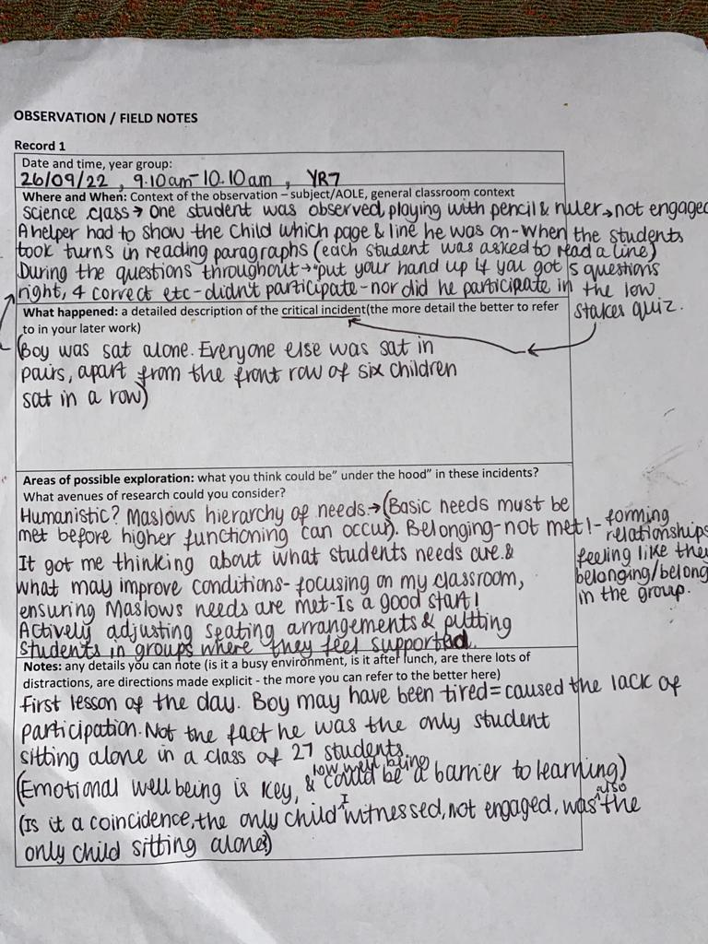
Appendix A- Observation/Field Notes (Record 1)- (The Critical Incident discussed in this Literature Review)
Appendix B- Observation/Field Notes (Record 2)

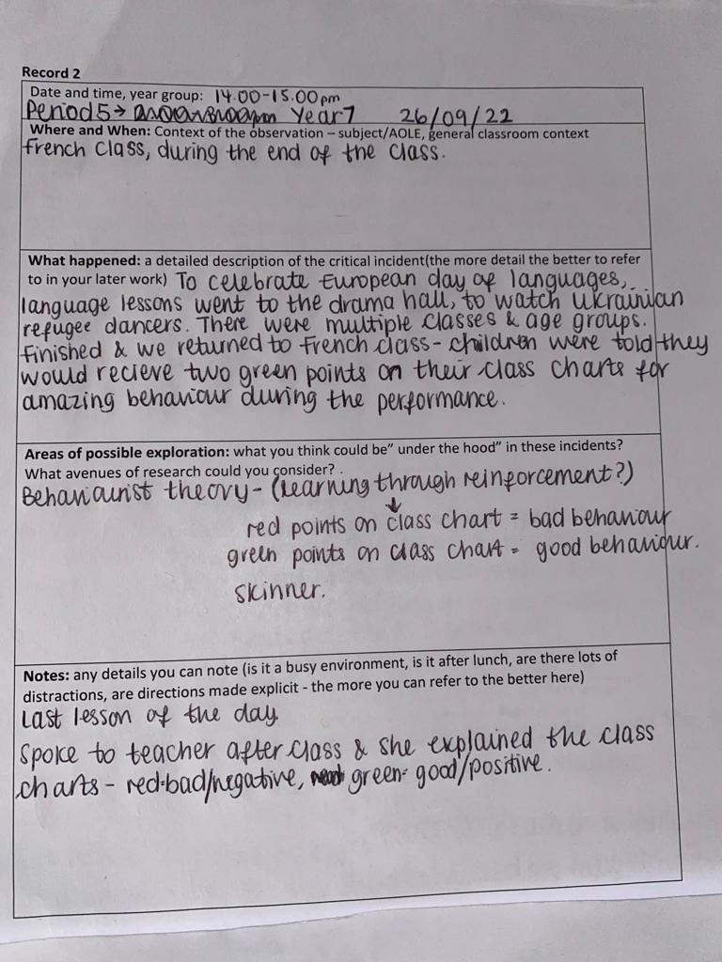

Appendix C- Observation/Field Notes (Record 3)

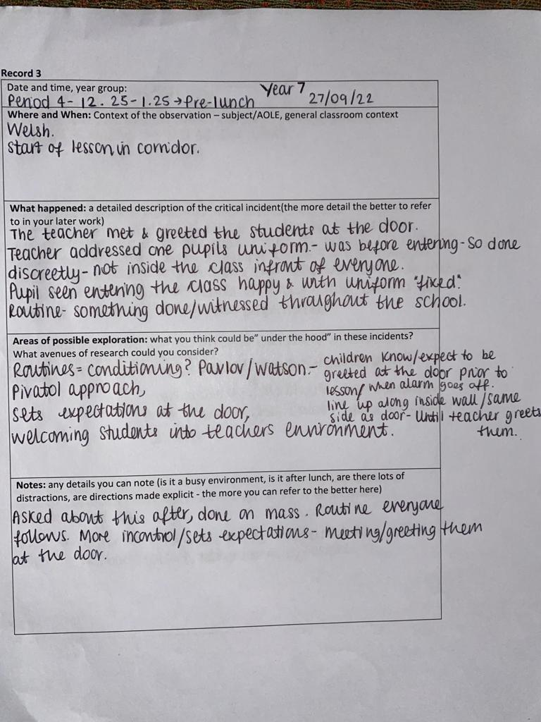

Appendix D- Layout of the classroom seating plan
Where I sat
Represents where students were seated
Represents where Student A sat
Empty seat
Tables

This table was empty/no students sat here, but another observer and I, sat here.
This table was empty/no students sat here, but 2 fellow observers sat here.

