Impact of E-Business Solutions within Motorsport

Introduction
In this report there will be discussion of some E-business solutions and how it effects different aspects of motorsport. E-business is anything in a work place that uses internet. However, E-business has different duties depending on who is using it and what its being used for, e business from a company’s perspective is simply a tool to keep online work processes flowing, for example online booking. Another perspective from an e-commerce in a business is simply the exchange of selling and buying products or a service.

What impact has e-business had on the Motorsport Industry
E Commerce has been growing 23% year after year according to EKM’s website 2002-2018 (Online) available at https://www.ekm.com/blog/what-is-ecommerce/ and is on track to be accountable for $6.7Trillion by 2020. To put it in the perspective of how this impacts Motorsport, is to look at how the industry its self is viewed. For example, Formula 1 has 5 online options on how it can be viewed internationally, one is the ‘ESPN App’ and another is the ‘SKY Go App’ two of which you can view from your smart phone, laptop and your Smart TV essentially any device that can connect to the internet. By creating this need for the consumers to want, by having the Formula 1 App it accesses the consumer to exclusive content and reminders of up and coming events, to then charge them an amount to download the app. However, e-business has gotten to the point where the majority of the Television depending on what package or company you go with, is now only accessible through the internet. This has got a huge advantage for the industry as it is a profitable way to raise revenue.
Motorsport is an entertaining sport to watch, it gets a lot of views when it gets broadcasted on SKY TV or BT SPORT, they generate revenue from viewers with these online Formula 1 packages whether its streamed online or with one of the tv packages. They generate a revenue percentage depending on how many views they get on a certain broadcasted event whether it be a race or a conference for the drivers. They also generate money from the consumers who sign up and subscribe to there online packages for example a season pass to view it online or through the TV.
By broadcasting the event through these online tv packages it generates revenue for the ‘middle men’ also known as the wholesaler in this case its BT and SKY. They have the access to motorsport and charge consumers to watch it from home. By doing so it does generate money for both sides it allows sponsors to get there brand out there which creates brand awareness. Formula 1 is not the only sport in the industry that have several ways of accessing their content ‘WRC’ (World Rally Championship) have their own app as well as ‘Red Bull TV’. Motorsport over a period of 10 years has had to evolve with current trends and needs for the consumer. For example, 10 years ago, there wasn’t a Red bull or WRC app that fans could access to see current news and events within the sport. It’s since 2008 onwards where apps for mobiles and computers have revolutionised how consumers view the sport. To put in perspective how much apps have evolved is from this article by Single Grain website [online] website available https://www.singlegrain.com/blog-posts/mobile/how-mobile-apps-are-reshaping-the-e-commerce-industry/. As quoted on their website they stated that in 2008 Apple Store said there was only 800 available apps to download. In 2017 there’s 2,200,000 available to download, its an industry that is growing profusely, however its an industry that every other industry is getting Involved with, almost all the major companies have apps or online websites that are accessible through consumer phones or computers.
However, charging consumers to watch basic motorsport has got its downfalls because in some sports there has been a severe decrease in viewings. According to Statista’s website (31/10/2018) [online] available at https://www.statista.com/aboutus/ The annual views for MotoGP in 2012 were 6,523,000 this is when it was shown on Freeview TV for free, where there was no charge to the consumer other than a tv licence. However, the following year in 2013 BT won the rights to air MotoGP according to F1 Broadcastingblog 2012-2018 (Online) available at https://f1broadcasting.co/2017/08/29/bt-sport-likely-to-retain-uk-tv-rights-for-motogp/, and the views dropped by almost 2 million down to around 4.5million, this would have had a monumental effect on what sponsors would have remained sponsoring the teams within the sport. The reasoning behind this is down to two factors, one: consumers refuse to pay for a service they once got free, two: the consumers don’t have access to the internet to get BT or they are already in a binded contract with SKY. Charging consumers to watch the sport to raise revenue for the industry isn’t always an efficient way of doing business it has had the opposite effect in this case.
E Commerce is an aspect of E-business solutions and its used frequently throughout the motorsport industry when it comes to buying equipment for the teams and parts for the vehicles. Although it’s often a fast-efficient way for a consumer to buy a product, it does come with its risks. For example, within the motorsport industry especially during race season there’s only so much time between venues and races, to make sure parts arrive at the right place at the right time, the seller has the responsibility of making sure they send it with a reliable courier to ensure the consumers purchase arrives not damaged and on time. Because, if an item bought online doesn’t arrive or if it arrives damaged, then the seller has to take action and resolve the issue according to the Which’s website (2018) [online] www.which/consumerrights.co.uk, this is because the contract is between the seller and the courier company not the consumer.
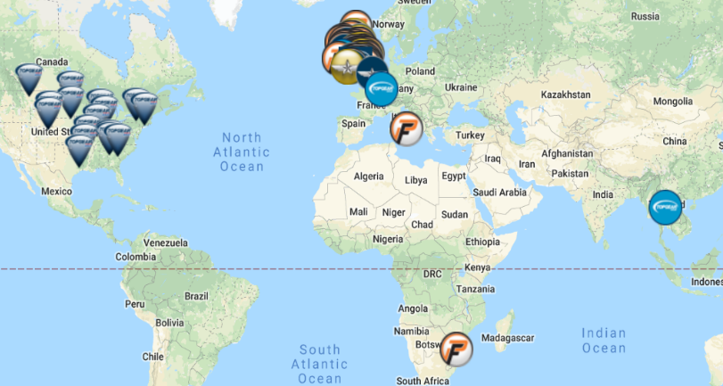
Another aspect of E-commerce is being able to interact with business partners that could be national or international. E commerce has widened the field of communication between businesses enabling small businesses to sell internationally. For example, Topgear created Powerflow Exhausts which are manufactured in a small warehouse in Bridport Dorset and are sold nationally and internationally as far the US and Thailand. Here’s a visual representation. [Which was also taken from the website listed below]
Without Ecommerce the operating dealers who they distribute their performance exhausts and other performance accessories too would not be able to function as efficiently without it, because browsing and purchasing of the products are all online. Topgear’s [online] website available here https://www.topgear.co.uk/dealer.Also, a key aspect of e business solutions is Intranet. Intranet is used in almost every operating company worldwide, Intranet is a privatised network used internally within a business, a form of this is staff email. This applies to any industry especially in motorsport between the sponsors and the team management and generally between team mates.
E-Business within motorsport especially in Formula 1 has used it in a practical form, enabling their race cars to have WiFi which allows them to alter and tweak the performance without having to bring the car in to the pits. This has a positive effect on the outcome of the racer essentially allowing it to flow and not be interrupted by mechanical issues. It also allows the race to be continuous to allow for more ‘action’ for the consumers keeping it exciting.
Another aspect of E-business solutions is the autonomous side of the businesses. Pay role in most industries is an automated process supervised by a member of HR, in motorsport this would apply to the sponsors who pay the team. The sponsorship money would be for advertisement, to have their brand imprinted over the performing car. The payment would not be cash it would be done on an online banking service, to ensure that the money Is taxable. This also applies to the staffing of the teams in formula 1 it would have a similar process of online payment to their employees.

Conclusion
E-business has completely revolutionised how businesses operate whether there large or small or if there national or international, it’s widened the opportunities for all businesses and allowed a free-flowing business network. It’s also ruled out a large amount of human error, making most business processes extremely accurate. Within the motorsport industry e-business has generated a different way of how the sport can be promoted and viewed, it’s also allowed different ways of how the sponsors of the sport can get advertised. Alike most areas of the motorsport industry it created efficiency within the work place and simplified other aspects, saving time and money for the industry. Overall e-business has had a big impact on any business or industry revolutionising and now completely dominating most business.

Reference Page

F1 Broadcastingblog 2012-2018 (Online) available at https://f1broadcasting.co/2017/08/29/bt-sport-likely-to-retain-uk-tv-rights-for-motogp/

EKM’s website 2002-2018 (Online) available at https://www.ekm.com/blog/what-is-ecommerce/

Statista’s website (31/10/2018) [online] available at https://www.statista.com/aboutus/
(please note with the statista website you can only view the info when you first click the page, if you click off the page it will restrict the info and try and charge.)

Topgear website 2018 [online] Page editor Dylan Ross https://www.topgear.co.uk/dealer

Which’s website (2018) [online] www.which/consumerrights.co.uk

