LCMB7034
International Business Concepts

Assessment component 1: Individual report

Topic: boAt Lifestyle's Expansion into the United Kingdom: An International Business Strategy Analysis

Student Id : 2519666
Student Name : Godhani Hevin Ashvinbhai

Word Count : 5248

Table of Contents
SECTION 1: boAt Lifestyle's Entry into the UK Market 3
1. Introduction 3
2. Organizational Classification and Global Strategy 4
2.1 Strategic Categorization 4
2.2 Global Configuration 5
3. Macro-Environmental Appraisal and Market Attractiveness 7
3.1 Host Country (UK) Analysis 7
3.2 Market Entry: The Eclectic Paradigm (OLI Framework) 11
4. Entry Mode Strategy and Strategic Synthesis 13
4.1 Historical Pattern Recognition 13
4.2 Strategic Fit and Justification 15
4.3 Conclusion and Recommendations 17
SECTION 2: Reflective Account 20
Reference List 24

SECTION 1: boAt Lifestyle's Entry into the UK Market

1. Introduction
boAt Lifestyle (Imagine Marketing Limited) is an Indian direct-to-consumer (D2C) audio and wearables company that was founded in 2016 by Aman Gupta and Sameer Mehta and was originally focused on selling durable charging cables, before branching out to headphones and true wireless stereo (TWS) earbuds, to smartwatches and gaming peripherals (Core77, 2024). The company is now India's biggest audio-wearable brand with revenue of about ₹3,089.6 crore in FY25 and is back in profit after two years of losses, and is seeing the light of initial public offerings (IPO) (m.Stock, 2025; INDmoney, 2026). In the past, boAt has focused its business, manufacturing and distribution efforts on the Indian market, and the latest interest into Southeast Asia is Bosnia, where the brand just recently arrived on the market in Malaysia, and is stated in boAt Lifestyle LinkedIn (2026) to be 'the initial move'. Most importantly, boAt does not have any subsidiary, production plant, joint ventures or official distribution deal in U.K. as of 2026 as of now; any sale in U.K. does not happen directly, but is done indirectly through the marketplace listings and re-exports. This meets the assessment's criterion for selecting the host country – where the firm has little or no operational presence.
For three reasons, the United Kingdom chosen as target market. First, it is a well-developed, English-medium, digitally advanced market for wearable technology, currently valued at USD 5.89 billion to USD 5.92 billion which is projected to more than double between 2030 and 2034 (Mordor Intelligence, 2025; Market Data Forecast, 2026a). Second, the recently signed Comprehensive Economic and Trade Agreements (CETA) between India and the UK was inaugurated on 15 July 2026, which significantly lowered the tariff and administrative hurdles for the Indian consumer-electronics exporters to invest in the UK market (Mohamed, 2026; Singh, 2026). Thirdly, boAt's affordable positioning – a positioning that is digitally native – fits a niche segment in the UK audio market which is otherwise dominated by higher-end brands like Sony, JBL and Apple (mStock, 2025). This report categorizes boAt's international strategy according to the Bartlett and Ghoshal's (1989) typology, it analyzes the macro-environment of the UK and evaluates the market attractiveness using PECL analysis and eclectic paradigm proposed by Dunning (1988) and it also analyzes the boAt's market entry modes in the past and recommends a market entry strategy for the UK.

2. Organizational Classification and Global Strategy

2.1 Strategic Categorization
Multinational enterprises (MNEs) are seen by Bartlett and Ghoshal (1989) as being able to be grouped on two dimensions: pressure for global integration (efficiency, standardisation, cost); and pressure for local responsiveness (adaptation of host-market tastes, regulation and culture). Four archetypes emerge: multi-domestic (high responsiveness, low integration), global (high level of integration, low responsiveness), international (low level of responsiveness and integration, reliance on the competencies of home company) and transnational (high responsiveness, high integration, an integrated network) (Bartlett and Ghoshal, 1989; Blind, Jastram and Müller, 2024). These are not distinct categories, but a continuum, and in practice not all firms reach the "pure transnational" end of the continuum, as capabilities and pressures change over time (Macro and Ott, 2024).

Figure: boAt Logo
Source: (boAt Lifestyle, 2026)
Applying the typology, it can be said that BoAt is following an international strategy and their emerging transnational strategy. The company has a low level of local responsiveness, as its evolving products, branding, marketing with celebrity influencers, and marketing through "boAtheads"/community-building are designed centrally in India by its own research and design team, boAt Labs, which has 101 engineers on its rolls as of June 2026 (INDmoney, 2026; boAt Lifestyle LinkedIn, 2026). Even as this happens, the pressure due to integration is moderate, and not high, as boAt doesn't have a globally coordinated manufacturing or logistics network like what is meant by a "global" strategy; it simply uses its advantages in ownership of the products and their design as well as 'low cost' source and boosts the brand equity as assets and then sends them outwards the opposite way (hands and legs are not necessary going outwards). The firm, however, does exhibit some signs of transnational tendencies, such as customising select elements whereby the sitespecificities of the partnerships and marketing language for each new geography is adapted, signaling a possibly ongoing transition towards a more networked, contextually responsive model as internationalisation progresses (Macro and Ott, 2024).
Table 1: Bartlett and Ghoshal (1989) Classification Applied to boAt Lifestyle
Criterion | Evidence for boAt | Implication
Local responsiveness | Low – centralised design via boAt Labs; marketing template reused across UAE, Nepal, Malaysia | Limited adaptation increases risk of cultural misalignment in new markets such as the UK
Global integration | Moderate – some integration of R&D and sourcing (Dixon Technologies, Califonix JV) but not a coordinated global value chain | Cost advantages are exportable but operational integration is still India-centred
Predominant type | International, with early transnational signals | Strategy is transferable to UK but will need selective local adaptation

2.2 Global Configuration
The current geographical presence of boAt is still largely India-centric, as the majority of the company's revenue, manufacturing and retail relationships are in India with 75.83% of units manufactured there as of the mid-2025 period (INDmoney, 2026; Precize, 2026). The distribution includes over 12,000 offline retailers across 25 states supported by 112 distributors along with e-commerce platforms such as Amazon, Flipkart and Myntra and boAt's website (INDmoney) (2026). The configuration forms the backbone of boAt's key edge, a fast and cheap product-development cycle, backed by its ability to release products regularly and the software ecosystem named "Crest+", coming on the back of a superior brand recall among the Indian youth; Industry estimates talk about 50–60% aided awareness among the youth in India (Business Model Canvas, 2026).
This arrangement is not completely translatable to the more mature western market like the UK. Certain advantages such as cost-leadership and digital-marketing that have helped boAt gain access in the Indian market are in theory ‘geography-agnostic' and can be leveraged in other markets also with little marginal cost. But an extensive retail presence with hyper-local social-media/influencer marketing geared towards Indian youth culture is also crucial to boAt's value creation, and these elements cannot simply be replicated in the UK's more concentrated retail setup (which comprises big brands and Amazon UK) and its different influencers set-up. However, Pfeiffer's analysis confirms that BoAt's competitive edge is somewhat "portable," in terms of it having a cost and agility advantage in entering the UK market that can simply be replicated in other markets but that's a lesson the firm must learn, by selectively building-up its distribution and marketing network in the UK.
However, boAt's asset-light setup is worth reading against the broader circumstances of marketplace entry in the UK. The data also show that UK-focused brands, whether they are localising the content in their catalogue to the local market using relevant wording, adopting a more UK-centric keyword strategy or tailoring the product imagery and expectations behind their ads, for example, are more likely to see uptake, well above those that don't localise at all, carrying catalogue content straight from India or another Amazon market unchanged (Toucan Ecommerce, 2026). The brands that have been successfully localised on Amazon UK and on other European marketplaces have seen between 15% – 25% increase in incremental revenue after 6 – 12 months of launching, whereas the kinds of brands that have copied and pasted from existing listings have seen flows of initially much lower revenue–around 5% (Ecombrainly, 2026). This validates that whilst boAt's products are geographically mobile, if it is to gain sales in the UK, then the app will definitely need to be invested in for a UK strategy in terms of the cost and design.

3. Macro-Environmental Appraisal and Market Attractiveness

3.1 Host Country (UK) Analysis
Instead of enumerating descriptively all the PECL dimensions, this section focuses on the ones most relevant to the affordable audio/wearable electronics, digitally distributed DNA of boAt's business and its strategy, which is asset-light and brand/design-heavy.
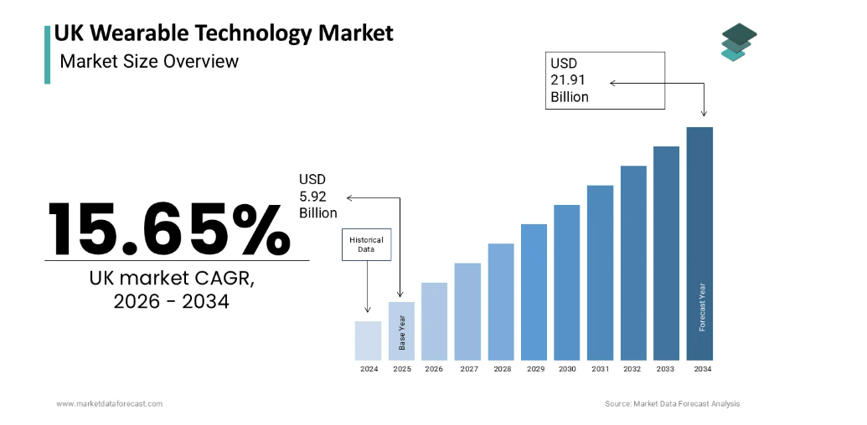
Figure: UK Wearable Technology Market Size
Source: (Market Data Forecast, 2026)
Political: Since 2021, the relations between the UK and India have improved significantly with the formation of the UK-India Enhanced Trade Partnership and the Vision 2035 India-UK roadmap, culminating the Comprehensive Economic and Trade Agreement (CETA) signed by Commerce and Industry Minister Piyush Goyal and UK Secretary of State Jonathan Reynolds on 24 July 2025, which came into force on 15 July 2026 (Deccan Herald, 2026; Lexology, 2026). Officially, CETA represents the UK's most important bilateral business agreement since it exited the European Union and India has the most comprehensive FTA with a country from the G7 bloc (Lexology, 2026). With respect to the politics, it marks a more stable bilateral trading relationship with increased political encouragement that Indian companies will enter the UK, minimised by the Double Contribution Convention on social security, and in parallel, the commitment on professional mobility (Lexology, 2026).
Economic: Mordor Intelligence estimates the value of the UK wearable-technology market at approximately USD 5.89–5.92 billion for 2025, with the value expected to increase at a compound annual growth rate of around 15.6–15.7% through 2030–2034, driven by the addition of hearables, health-tracking features, and 5G connectivity. In this, UK headphones alone remained valued at USD 570.95 million in 2025 and are expected to hit USD 801.46 million by 2034 (Market Data Forecast, 2026b) while wireless/TWS earbuds in the UK when seen as a whole is already a mature, high-penetration sub-segment with >70% of adults already adopting these devices, with value growth now fuelled mostly by premiumisation and away from new adoption (Research and Markets, 2026; Grand View Research, 2025). With the maturity, boAt is likely to have a that it is no longer targeting first-time devices but those in the market to buy more, at affordable prices, that are being ignored by premium brands like Sony, JBL and Apple, who enjoy a greater market share because of scale and brand.Stock, 2025; Decisions Advisors, 2026). This economic context is also supported by boAt's broader experience in the direct-to-consumer (D2C) retail landscape: The global D2C marketplace is expected to cross USD 571.34 billion by 2031 and his market is growing at an estimated rate of 14.3% per year, as internet penetration, and consumers' desire for another set of brands to handle their own customer experience over third-party retailers are propelling it forward (Markets and Data, 2024). The changing trajectory to direct, digitally mediated retail and relationships globally reduces the traditional costs and time required to go into an unexplored market with a bricks and mortar retail outlet, and complements boAt's current operational model of retailing directly.
The other economic twist relates to the emerging "hearables" market segment, which includes health-tracking and voice-control capabilities which are increasingly bridging the gap between audio peripheral and health device. Sony's higher priced noise cancelling devices have regained momentum, while JBL and BoAt have emerged as serious competitors to Apple in the ‘lifestyle' category that BoAt would be most likely to compete in (Sourceready, 2026), Apple, Sony, JBL and BoAt were the brands with the most influential search and retail visibility on the UK market. Up to USD 68.56 billion, the hearable market is projected to increase at a compound annual growth rate (CAGR) of 14.7% from USD 34.76 billion in 2026 to USD 59.88 billion by 2031, with AI-powered personalised audio content and embedded health-monitoring features as major contributors (Research and Markets, 2026). This also implies that the gap between the budget and premium audio markets in the UK is not a permanent one; with budget product squeezes coming from the premium side and premium product pricing going towards the budget side, it will also be about the timing of entry and positioning in the product line.
Legal: The regulatory climate for consumer electronics has been a lot more predictable since 2024. The Product Safety and Metrology etc. (Amendment) Regulations 2024 also introduced the UK's change of stance on the CE marking of consumer goods, placing all the majority of consumer product categories for electronics under voluntary rather than mandatory UK Conformity Assessed (UKCA) marking (Calvin, 2026; GetReady Compliance, 2026) This will significantly reduce the compliance burden and cost of market entry for an exporter like boAt, which complies to CE standards already for other markets, while maintaining compliance to the specific requirements (e.g., radio equipment regulations, electrical safety and the data-protection obligations as per the UK GDPR for a connected/Bluetooth device) remains the same and must be verified by the product type. (Gronkvist, 2025) The legal landscape is now much more conducive than it was even two years ago, in conjunction with CETA's obligations on mutual recognition of conformity-assessment bodies (CAB) in electronics and the single-window customs clearance system (Lexology, 2026; IBEF, 2025).
UK's tighter Extended Producer Responsibility (EPR) regime for Waste Electrical and Electronic Equipment (WEEE): Yet another legal case is the pending proposal of the UK's Expanded Producer Responsibility (EPR) regime to manage the disposal of Waste Electrical and Electronic Equipment (WEEE). According to electronic goods' EPR Compliance, the overseas sellers of these devices, like BoAt's earbuds and speakers, can now be categorized as producers and be held legally liable for end-of-life issues on the online marketplaces on which they sell, like Amazon. Although this also puts some of the compliance burden on the market place, whilst boAt continues to sell through re-exports and third parties, any decision to sell through a dedicated Amazon UK store front on a D2C website or through a distribution partnership would result in boAt becoming the "producer" and hence liable for WEEE registration, reporting and battery take-back costs, a cost that should be allocated and planned for as soon as the modified entry strategy proposed in Section 4 is adopted.
Cultural: Based on Hofstede's (2010) cultural-dimensions framework, India has a high score of Power Distance (77) and a comparatively low score on Individualism (48), while the UK has a low score on Power Distance (35) and a very high score on Individualism (89) (Zheng et al., 2025). This split has clear marketing implications for boAt: their marketing for India is rooted in collective branding (boAtheads), hierarchical celebrity recommendation and promotion of price as added value, while the UK consumers with their high degree of individualism are generally more attuned to personalised value propositions, design/signalling status and autonomous decision making rather than communal branding (Greene, 2024). A total of the boAt's brand-ambassador initiative may be transferrable in design but will need to adapt the appearance and messaging to communicate the brand's important point of difference to UK customers: personal style and product function, rather than communal identity.
This individualism also influences the attitude of the consumers towards influencer marketing, a key aspect of the boAt's current brand strategy. While the endorsement style of Ebongo (Ebongsounds.com) is highly suited to Indian audiences, consumer research carried out in the UK suggests that Gen Z look only favorably on partnerships between brands and influencers when they are authentic, proportionate and clearly marked as such. This implies a direct transplant of boAt's "boAtheads" community-marketing model would not sit well with the UK crowd who are increasingly shopping for lower budget content with “bigger little heads,” as they say, rather than “big guys” flying their flags in the name of a brand's marketing and commerce rig.
Table 2: Host-Country Factors Most Relevant to boAt's UK Entry
Dimension | Key finding | Relevance to boAt
Political | CETA in force since 15 July 2026; strong bilateral trade backing | Reduces political/trade-policy risk of exporting to the UK
Economic | UK wearables market ~USD 5.9bn (2025), 15%+ CAGR; TWS segment mature and premiumising | Opportunity in value/replacement segment; must avoid head-on competition with premium incumbents
Legal | CE marking indefinitely recognised since 2024; UKCA voluntary for most electronics | Materially lowers compliance cost versus pre-2024 assumptions
Cultural | UK high individualism (89) and low power distance (35) vs India (48; 77) | Requires adapted, individual-centred marketing rather than direct replication of Indian messaging

3.2 Market Entry: The Eclectic Paradigm (OLI Framework)
The paradigm espoused by Dunning is eclectic in nature, in which a firm enters into international production or entry into the target market if it has an Ownership-specific advantage, the market has Location-specific advantages and Internalisation advantages lead the firm to believe that it can better organise the transaction itself than arm's length market institutions could. (Dunning, 1988; Chen, 2026). In most of the recent scholarship on the matter, the framework is seen as a long-lasting and flexible one on which to build a current analysis of the theories of foreign direct investment (FDI) pertinent to the analysis of foreign direct investment (FDI) viewed from a context-specific perspective (Douraid and Laradi, 2026), with other recent additions warning against equating brand and design advantages simply with analogous internalisation advantages (Hymer, 2006; Oner and Cetin, 2003).
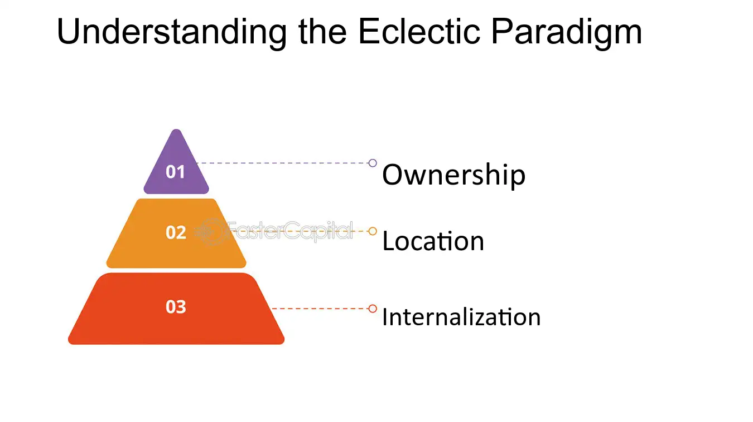
Figure: The Eclectic Paradigm (OLI Framework)
Source: (FasterCapital, 2025)
Ownership advantages: boAt does not have transferable patents: Any successful patents that would be of value to boAt, would belong to the respective technology partner (Dixon Technologies, Qualcomm); Manufacturing is not very expensive for the company because boAt has a joint venture at Califonix, and has contract manufacturing alliances with other companies such as Taylor Dixon (boAt Labs, Technology Product Canvas, 2026; INDmoney, 2026).
Location advantages: The UK has attracted a massive and expanding addressable market, a digital environment in the English language, much of which complements the online-first approach boAt is taking and crucially the trade and regulatory environment has considerably improved since the entry into force of CETA, with tariffs doing away on the vast majority of Indian tariff lines, while both governments have committed themselves to mutual recognition of electronics conformity-assessment procedures (Maritime Gateway, 2026; Lexology, 2026) Gap in value sector of UK audio market is still relatively under serviced compared to the premium sector of Sony, JBL and Apple (m.Stock, 2025).
Internalisation advantages: The brand and design is BoAt's primary asset and it can be affected by the introduction of low-quality intermediaries, which make some amount of control over price, product presentation and after-sales service necessary even in the early stages of high resource commitment. While the potential benefits of full internalisation (being owned internally; through the UK subsidiary) may exist, it is not right to assume that it would be the most appropriate channel of internationalisation by backstading boAt in developed market countries when the company has built up limited experience of operating in other countries. According to Donor's available literature on born global ventures, Ems have been found to bear more risk and more psychic distance in internationalising than Dms in early stages and have been observed bearing this risk through different mediums of communication such as digital and marketplace channels rather than face-to-face initiation.
The internalisation issue is also influenced by the likely reactions of the UK consumers to the country where boAt is based. Consumer ethnocentrism has been shown to interact with mode of entry: Low control modes (e.g., unbranded marketplace listing) may strengthen a negative valuation of an entrant from a foreign country, while high control modes (e.g., curtsey marketing/friendly customer service) can alleviate it. For a brand like boAt, the term internalisation not only refers to safeguarding design and brand value from intermediaries' eyes but relates to the perception of a price conscious brand from an origin country, India, where consumers already have several premium brands on offer.
The UK is an appealing, however not indegree market segment, as the ownership benefit exists, but the location advantage might have improved to a substantial degree since CETA, while there is reasons to include the brand in the marketplace (where the brand control is managed to its utmost) but not via a full-fledged subsidiary at this point of time where the internalisation logic already exists.

4. Entry Mode Strategy and Strategic Synthesis

4.1 Historical Pattern Recognition
The international plan for boAt so far has been a steady process with hardly any investment. Internally, the company started from selling products exclusively on Amazon in India and later expanded to an Omnichannel (two channel) business model (Jain and Jain, 2024). Over the years, its operations have expanded abroad in Malaysia, Nepal, and — praise be to the digital era — the UAE, following the same trends of being ‘asset-light and digitally led' as in India, with the latter's launch being combatted in the public eye simply as an exploratory step and not a commitment to full-scale operations (boAt Lifestyle LinkedIn, 2026; Affluense, 2025). This aligns with the broader findings on exporting and e-commerce-based entry compared to equity investments in foreign countries, as noted in prior studies of emerging-market "born-global" brands and digitally native brands, which indicated that product prototypes sometimes require testing to gauge customer response before committing capital (Manohar et al., 2024; Zonex, 2024).
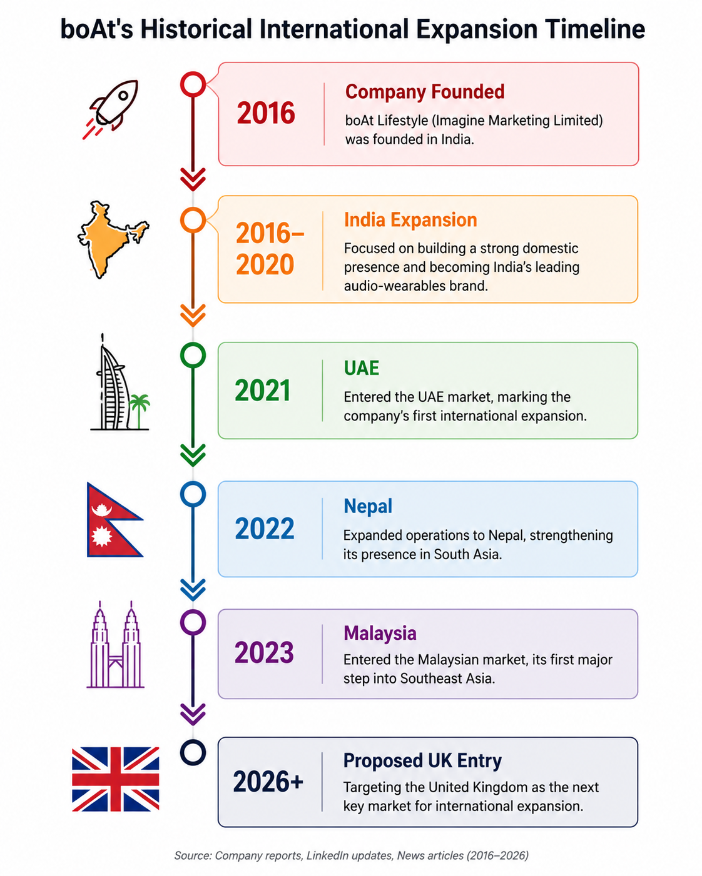
Figure: boAt's Historical International Expansion Timeline
Source: Created by Author

4.2 Strategic Fit and Justification
This is a mode that, broadly speaking, is well suited to the UK context and one associated with little commitment, but with the proviso that this is more or less qualified. One significant advantage of it is that it minimises financial and operational risk, especially in a market where there is no brand recognition for the company boAt yet, and helps the company test the demand, pricing, and product-market fit before commitment in terms of capital and resources (Zonex, 2024; Reinhardt, 2025). It's also bolstered by the legal and tariff system enhancement brought by CETA and the 2024 UKCA reforms, which diminish the compliance expenses typically related to merely low-burden exporting (Calvin, 2026; Lexology, 2026).
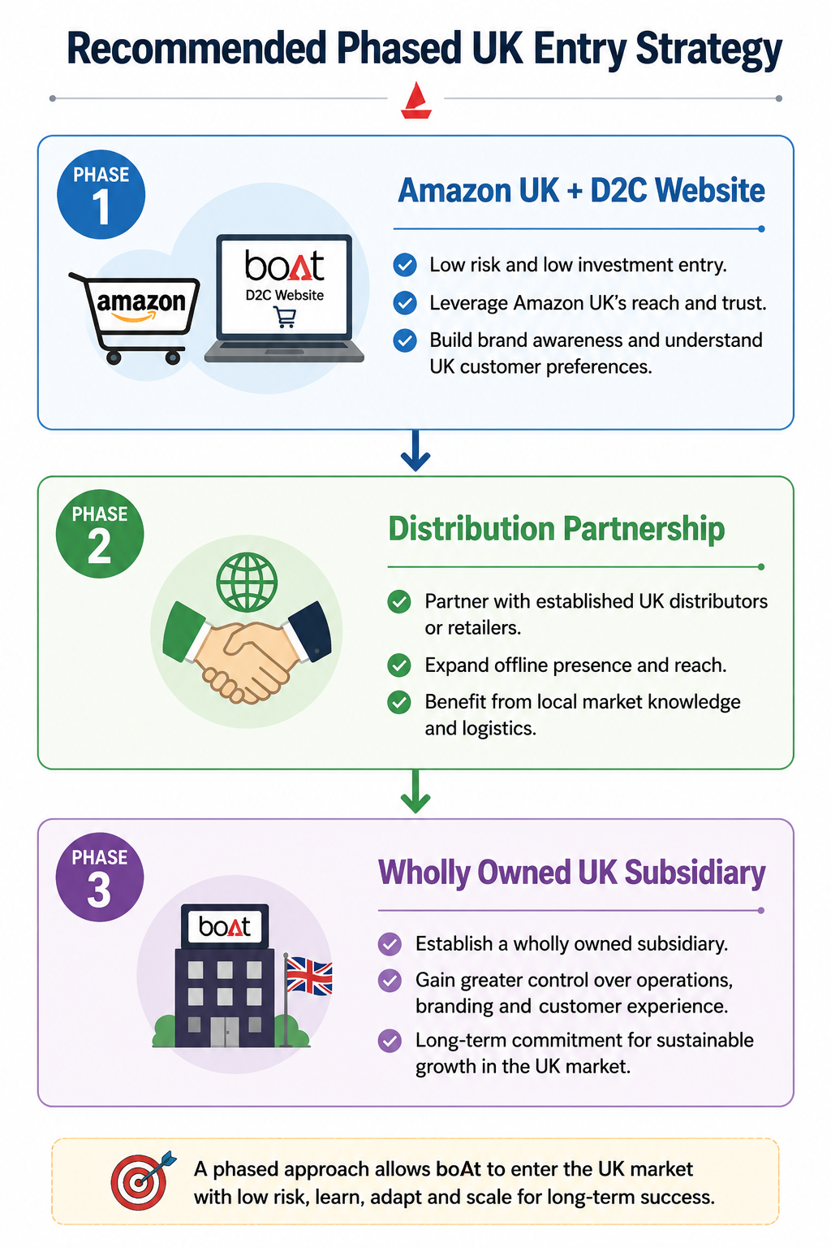
Figure: Recommended Phased UK Entry Strategy
Source: Created by Author
An unmodified exporting/marketplace-only option, however, comes with strategic drawbacks in the UK market, which is so competitive and premiumising that exporters are typically restricted from launching new products or markets due to the lack of a support regime. Without any control over brand presentation, customer experience and after-sales support – which were recognised as the brand's core ownership advantage as recounted above – pure marketplace listing could also lead to branding being viewed as an undifferentiated budget import and not a considered brand choice, especially given the UK consumer culture's individual-spirited and design-obsessed nature (Greene, 2024). Another drawback of the pure exporting model is the lack of offline retail ties, which is integral to boAt's value creation in India and is a gap the company aims to fill with these models (INDmoney, 2026).
A modified strategy is warranted: existing e-commerce/marketplace channels (highly through a dedicated boAt UK storefront on Amazon.co.uk as well as a D2C brand website) are to be continued as the main distribution method in the near term with, but not entirely, with a supplementary distribution/licensing partnership with an established UK electronics retailer/distributor to provide a limited (non-committed) offline channel presence, brand curation and after-sales support (which warrants a low-risk approach and low resource commitment but higher degrees of control and strategic fit, due to the market's projected growth of 15%+). The result conforms with the view of entry-mode literature which recommended matching mode to the risk control resource relationship instead of falling into either extremes (Reinhardt, 2025; Zonex, 2024).

4.3 Conclusion and Recommendations
In the international strategy typologisation by Bartlett and Ghoshal (1989), boAt Lifestyle is considered to be following an international strategy, and only with marginal varying level of local response. odnosno boAt Lifestyle can be classified with respect to Bartlett and Ghoshal typology (1989) of strategy in international business as an International Strategy since it is using the ownership advantage created from brand equity, design capability, and cost-effective sourcing centrally while having only a small scope of local response. The UK market is a high-growth, high English-language market whose appeal will significantly increase after entry into force for CETA in July 2026 and with the new introduction of the UKCA in 2024, the market is still more mature, premium and domestically individualistic than India. Under revised Dunning's 1988 eclectic paradigm, boAt is equipped with existing advantages in terms of ownership and location which should give them the justification to enter the market, but in terms of internalisation logic, a company's equity commitment is more beneficial when it occurs in stages.
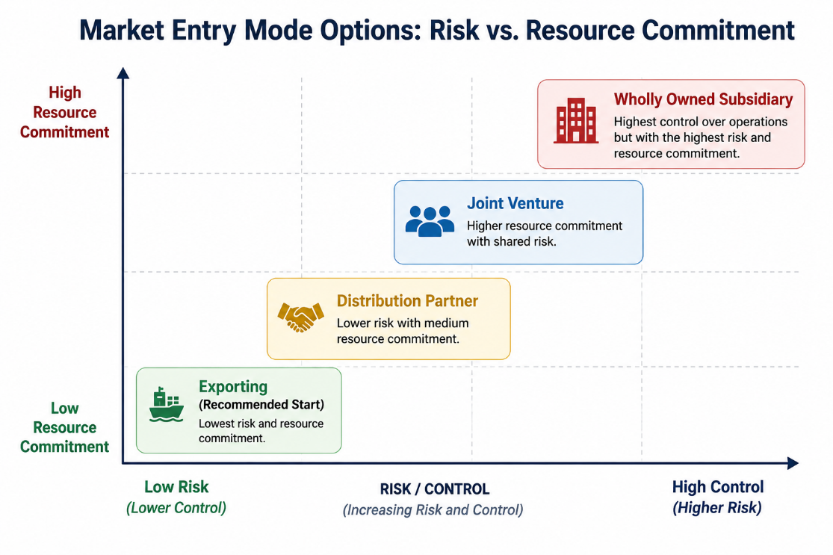
Figure: Risk vs Resource Commitment Matrix
Source: Created by Author
The recommended phase-in approach is therefore a gradual entry; as the first phase is an initial low commitment approach which utilizes boAt's existing e-commerce implementation (the Amazon UK site and boAt's site) to test demand and begin to build initial brand awareness; while the second phase is a medium-term position of establishing a selective distribution or licensing agreement with the UK electronics retailer to gain controlled access to the offline channel, and higher brand control; and the third phase is the longer term offering of establishing a wholly owned UK entity to provide more control and brand equity, which will have a greater resource commitment and lead to a higher sales volume. The gradual shift reflects an approach that is more in line with BoAt's track-record of moving forward through asset-light internationalisation, while at the same time catering to the more competitive and culturally-focused needs of the UK where the brand needs more playing with string than can be achieved via pure exporting.

SECTION 2: Reflective Account
Using Gibbs' (1988) Reflective Cycle; Description, Feelings, Evaluation, Analysis, Conclusion, Action Plan.
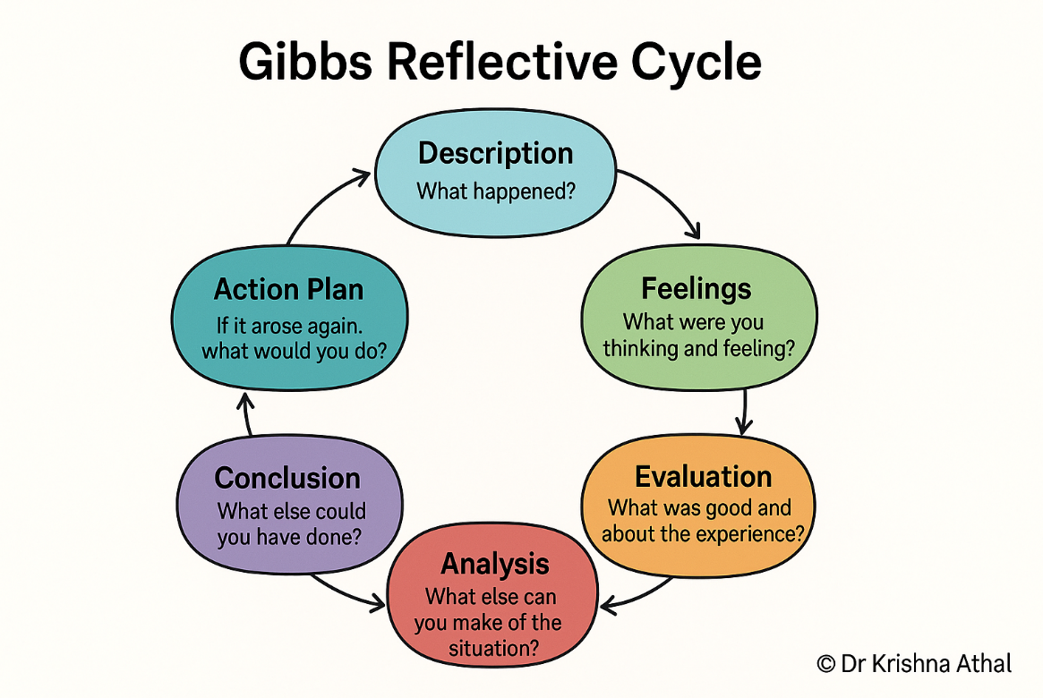
Figure: Gibbs Reflective Cycle
Source: (Athal, 2025)
Description: The problem involved choosing a foreign company with no obvious operations in a selected target country and analyzing its entry decision using a number of principles of international business. As per market reports and news coverage that had been provided in relation to boAt, the company had no subsidiary, production facility or formal sales partnerships in the United Kingdom, apart from countries like UAE and Malaysia it has taken its first nursery into, prior to this verification via disclosures from the company. I then divided my research into three questions: First, how would boAt's current strategy for the international market fit within the dimensions of the strategy; next, what host-country conditions would affect a boAt entry into the UK; and third, what entry mode would be appropriate for boAt's history of expansion and the characteristics of the UK market. This included navigating the company's financial disclosures, IPO disclosures and documents, reviewing wearables and audio devices industry market-research reports, recent analysis of trade-policy showcases India – UK Comprehensive Economic and Trade Agreement, and academic literature pertaining to Bartlett and Ghoshal typology, Dunning's eclectic paradigm and entry-mode choice.
Feelings: The aspect that caught my attention the most with the brief was its combination of interest and uncertainty. I felt venture-driven, since boAt is a familiar and quickly rising model, and an actual, unsolved examination of its international expansion system was being explored, versus a hypothetical game. boAt has clearly spoken out about plans for extending its international footprint, and the questions I raised were real, instead of hypothetical. I was also not certain how to put my tried and tested academic models, which have always been based on large, externally owned multi-national corporations with a significant public record, into practice for a fledgling, privately-owned digitally-oriented firm which has no extensive internal support for including in an open document. Additionally, I was aware that the India–UK trade agreement was a relatively new and evolving frontier and had to be careful not to use old thinking on UK–India trade relations, but to provide accurate and up-to-date information.
Evaluation: There are some things that I did well in my researching approach. Using multiple sources of industry report data values for UK market-size data (not a single source of data) enabled me to provide a defensible range for the data instead of only a single, possibly inaccurate, estimate and cross-referencing the claims regarding UKCA marking by regulators and data with multiple independent sources of information (advisory compliance) helped me avoid assuming that the CE marking was phased out, which is an outdated assumption given that other sources are asserting UKCA marking as an approved data source. Other issues presented some difficulties. However, detailed information regarding boAt's international strategy was available only from documents disclosed to the public by the company and other documents disclosed to investors, and these led at times to value judgements about exactly what sort of Bartlett or Ghoshal was boAt, and so on; there was thus a definite element of informed judgement in these arguments involving an IPO of a company which was not public, and hence did not publish a great deal of detail. I also struggled to write this without being purely descriptive in a PESTLE style, making sure that each political, economic, legal and cultural factor is specifically linked to boAt's own industry and asset-light model as opposed to written in more of a generic manner.
Analysis: I found it difficult to classify how boAt's strategy fits in because Bartlett and Ghoshal's (1989) typology was created to describe large, already multinational, industrial firms with established overseas subsidiaries, boAt is on an early and low commitment phase of internationalisation making the typology useful but forced me to think of where this emerging, digitally native brand fits in on a continuum rather than in a fixed category as per more recent scholarly thought about the transnational ideal not being always realised in practice. By exploring Dunning's eclectic paradigm, I gained insights into the fact that the advantages of ownership a firm found itself based on validation, does not necessarily correlate to a firm being ready for market internalisation, yet resulted in the staged entry mode recommendation. I found learning about the trade-offs between risk, control and resource commitments when comparing export and foreign direct investment for the module very useful as I progressed from mere description of these two modes to assessing whether they were suitable for boAt's specific circumstances, and the specific market conditions in the UK. Here, I also learnt that born-global companies, digital natives, are not necessarily the same as the Uppsala school model which we had been educated under where firms involve themselves in the marketplace slowly and steadily. In the case of boAt, I realised that I had to come to terms with emerging-market multinational firms, which frequently operate outside these traditional fashion.
Conclusion: In conclusion, I found my conclusions to be that the assignment clarified my understanding of the need to interpret important theoretical frameworks in a critical and contextually, rather than mechanically, intelligent manner. Points where I could make better can be embedded even at the beginning to understand which evidence would be required for each framework before I start penning, especially for my initial attempts that had to be refined after realising that there were more details required in terms of descriptive PESTLE content that needed a reframing in line with the strategy that BoAt employs. Also, I would look for a broader raft of primary company resources, for example investor presentations, annual reports as well, earlier rather than later in the process upon which based on secondary industry commentary.
Action Plan: When conducting international research tasks in the future, I will start every task by explicitly stating what kind of questions the international framework is supposed to answer, before doing the research, to prevent exploratory research from the beginning. I will also continue to cross-check market-data and regulatory statements from multiple sources, especially for rapidly moving policy areas like post-Brexit trade regulation, and will set more time aside to re-read and re-think early parts of pieces in order to provide them with sufficient depth once the analysis is complete, rather than assuming too early that they are close to final.

Reference List
Affluense (2025) Boat Lifestyle Financials 2025. Available at: https://www.affluense.ai/company/boat-lifestyle-financials-cfafb1 [Accessed 31 July 2026].
Athal, K. (2025). Gibbs Reflective Cycle Explained: A Framework for Structured Self-Reflection - Dr Krishna Athal. [online] Dr Krishna Athal - Life & Executive Coach. Available at: https://drkrishnaathal.com/blog/gibbs-reflective-cycle-explained-a-framework-for-structured-self-reflection/ [Accessed 31 July 2026].
Bartlett, C.A. and Ghoshal, S. (1989) Managing Across Borders: The Transnational Solution. Boston: Harvard Business School Press.
Blind, K., Jastram, S.M. and Müller, J.-A. (2024). Subsidiary Strategy and Importance of Standards: An Institutional Development of the Integration-Responsiveness Framework. European Management Journal. [online] Available at: https://www.sciencedirect.com/science/article/pii/S0263237324001282.
boAt Lifestyle (2026) LinkedIn company page. Available at: https://in.linkedin.com/company/boat-lifestyle [Accessed 31 July 2026].
Bose, T.K., Chew, T.C., Purohit, S. and Moser, R. (2024) 'International business entry modes and consumer ethnocentrism: A multi country perspective', Thunderbird International Business Review, 66(3), pp. 233–249. Available at: https://doi.org/10.1002/tie.22376 [Accessed 31 July 2026].
Business Model Canvas (2026) What is Growth Strategy and Future Prospects of boAt Company? Available at: https://businessmodelcanvastemplate.com/blogs/growth-strategy/boat-growth-strategy [Accessed 31 July 2026].
Calvin, S. (2026). Do you actually need UKCA marking to sell in the UK? The real 2026 rule (it’s not what most guides say). [online] CMGM | China Manufacturing & Global Marketing. Available at: https://www.cmgm.net/ukca-marking-required-uk-2026-real-rule/ [Accessed 31 July 2026].
Chen, J. (2026). Eclectic paradigm: Definition, Example, Advantages. [online] Investopedia. Available at: https://www.investopedia.com/terms/e/eclecticparadigm.asp [Accessed 31 July 2026].
Chishty, S.K., Sayari, S., Mohamed, A.H., Inkesar, A., Mallick, M.F. and Khan, N. (2025) 'Determinants of SME internationalisation: An empirical assessment of born global firms', Journal of Risk and Financial Management, 18(4), p. 199. Available at: https://doi.org/10.3390/jrfm18040199 [Accessed 31 July 2026].
Core77 (2024) A Look at How boAt Lifestyle Dominates India's Audio Tech Industry. Available at: https://www.core77.com/posts/133475/A-Look-at-How-boAt-Lifestyle-Dominates-Indias-Audio-Tech-Industry [Accessed 31 July 2026].
Deccan Herald (2026) FTA and the ties beyond trade. Available at: https://www.deccanherald.com/opinion/editorial/fta-and-the-ties-beyond-trade-3649238 [Accessed 31 July 2026].
Decisions Advisors (2026). United Kingdom Wireless Audio Devices Market. [online] Decisions Advisors. Available at: https://www.decisionsadvisors.com/insights/united-kingdom-wireless-audio-devices-market [Accessed 31 July 2026].
Douraid, A. and Laradi, M. (2026). The Evolution of the Eclectic Paradigm: A Review of the OLI Framework in International Business Research. [online] ISSN: 3085–4873(15), pp.616–633. Available at: https://www.researchgate.net/publication/403450750_The_Evolution_of_the_Eclectic_Paradigm_A_Review_of_the_OLI_Framework_in_International_Business_Research [Accessed 31 July 2026].
Dunning, J.H. (1988) 'The eclectic paradigm of international production: A restatement and some possible extensions', Journal of International Business Studies, 19(1), pp. 1–31.
Ebongo, L. (2026). Gen Z consumer behaviour in 2026: Value, trust and community are reshaping spend. [online] dentsu. Available at: https://www.dentsu.com/uk/en/blog/gen-z-consumer-behaviour-in-2026 [Accessed 31 July 2026].
Ecombrainly (2026) Amazon Seller Statistics 2025–2026: 200+ Statistics. Available at: https://ecombrainly.com/amazon-seller-statistics/ [Accessed 31 July 2026].
EPR Compliance (2026) WEEE Compliance UK 2026: Registration, Schemes and Obligations. Available at: https://eprcompliance.co.uk/blog/weee-compliance-uk-guide/ [Accessed 31 July 2026].
FasterCapital (2025). Cracking the Code: Demystifying the OLI Framework in the eclectic paradigm. [online] FasterCapital. Available at: https://fastercapital.com/content/Cracking-the-Code--Demystifying-the-OLI-Framework-in-the-Eclectic-Paradigm.html [Accessed 31 July 2026].
GetReady Compliance (2026) UKCA Marking in 2026: Still Required, Still Relevant. Available at: https://getreadycompliance.eu/ukca-marking-still-required/ [Accessed 31 July 2026].
Gibbs, G. (1988) Learning by Doing: A Guide to Teaching and Learning Methods. Oxford: Further Education Unit, Oxford Polytechnic.
Grand View Research (2025). UK Bluetooth Headphones Market Size & Outlook, 2030. [online] Grandviewresearch.com. Available at: https://www.grandviewresearch.com/horizon/outlook/bluetooth-headphones-market/uk [Accessed 31 July 2026].
Greene, J. (2024). Hofstede’s Cultural Dimensions Theory | EBSCO. [online] Available at: https://www.ebsco.com/research-starters/business-and-management/hofstedes-cultural-dimensions-theory [Accessed 31 July 2026].
Gronkvist, F. (2025). Electronics labelling requirements in the United Kingdom. [online] Compliance Gate. Available at: https://www.compliancegate.com/electronics-labelling-requirements-united-kingdom/ [Accessed 31 July 2026].
Hofstede, G., Hofstede, G.J. and Minkov, M. (2010) Cultures and Organizations: Software of the Mind, 3rd edn. New York: McGraw-Hill.
IBEF (2025) India–UK Free Trade Agreement | FTA Overview & Key Provisions. Available at: https://www.ibef.org/economy/india-uk-comprehensive-economic-and-trade-agreement-ceta [Accessed 31 July 2026].
INDmoney (2026) boAt IPO 2026: Price Band, Dates & How to Apply. Available at: https://www.indmoney.com/ipo/boat-ipo [Accessed 31 July 2026].
Jain, A. and Jain, P. (2024). Metamorphosis of India’s electronic consumer device landscape: Case study of Asia’s most successful brand – boAt. Journal of Information Technology Teaching Cases. [online] Available at: https://doi.org/10.1177/20438869241227565. [Accessed 31 July 2026].
Lexology (2026) A New Chapter in Bilateral Trade: India-UK Free Trade Agreement Effective July 15, 2026. Available at: https://www.lexology.com/library/detail.aspx?g=27752615-3d30-449a-83bd-d9550edaa6a8 [Accessed 31 July 2026].
m.Stock (2025) boAt IPO 2025: Issue Size, Dates & Key Details. Available at: https://www.mstock.com/articles/boat-ipo-everything-you-need-to-know [Accessed 31 July 2026].
Macro, S. and Ott, U.F. (2024). The Evolution of the Ability to Effectively Innovate in a Transnational Organization – A Configurational Analysis. Journal of International Management, [online] 30(6), pp.101200–101200. Available at: https://www.sciencedirect.com/science/article/pii/S1075425324000814. [Accessed 31 July 2026].
Manohar, A., Lioliou, E., Prevezer, M. and Saridakis, G. (2024). Explaining differences in internationalization between emerging and developed economy born global firms: A systematic literature review and the way forward. International Journal of Management Reviews. [online] Available at: https://doi.org/10.1111/ijmr.12378. [Accessed 31 July 2026].
Maritime Gateway (2026) India–UK CETA Comes into Force. Available at: https://www.maritimegateway.com/india-uk-ceta/ [Accessed 31 July 2026].
Market Data Forecast (2026). UK Wearable Technology Market Report. [online] Market Data Forecast. Available at: https://www.marketdataforecast.com/market-reports/united-kingdom-wearable-technology-market [Accessed 31 July 2026].
Market Data Forecast (2026a) UK Wearable Technology Market Size, Share, & Growth. Available at: https://www.marketdataforecast.com/market-reports/united-kingdom-wearable-technology-market [Accessed 31 July 2026].
Market Data Forecast (2026b) UK Headphones Market Size, Share, Trends and Analysis. Available at: https://www.marketdataforecast.com/market-reports/united-kingdom-headphones-market [Accessed 31 July 2026].
Markets and Data (2024) Direct-to-Consumer (D2C) Market: Trends, Strategies, and Insights 2031. Available at: https://www.marketsandata.com/industry-reports/direct-to-consumer-d2c-market [Accessed 31 July 2026].
Mohamed, E. (2026). India-UK trade deal comes into effect: What’s cheaper in each country now? [online] Al Jazeera. Available at: https://www.aljazeera.com/news/2026/7/15/india-uk-trade-deal-comes-into-effect-whats-cheaper-in-each-country-now [Accessed 31 July 2026].
Mordor Intelligence (2025) UK Wearable Technology Market – Size, Share & Industry Analysis. Available at: https://www.mordorintelligence.com/industry-reports/united-kingdom-wearable-technology-market [Accessed 31 July 2026].
Precize (2026) boAt IPO: Key Dates, FY25–FY26 Timeline. Available at: https://www.precize.in/blogs/boat-ipo-key-details [Accessed 31 July 2026].
Reinhardt, L. (2025) 'International Market Entry Modes and Their Strategic Implications for Global Business Expansion', JRIBM, 12: 051. Available at: https://www.interesjournals.org/articles/international-market-entry-modes-and-their-strategic-implications-for-global-business-expansion.pdf [Accessed 31 July 2026].
Research and Markets (2026). Hearable Market Analysis Report 2026: $68.56 Bn Opportunities, Trends, Competitive Landscape, Strategies, and Forecasts, 2020-2025, 2025-2030F, 2035F. [online] Yahoo Finance. Yahoo Finance UK. Available at: https://uk.finance.yahoo.com/news/hearable-market-analysis-report-2026-091200654.html [Accessed 31 July 2026].
Research and Markets (2026). True Wireless Stereo Earbuds Market Size, Share & Industry Trends Analysis Report By Price Band (USD 100-199, Below USD 100 and Over USD 200), By Sales Channel (Offline and Online), By Regional Outlook and Forecast, 2022 - 2028. [online] researchmarkets. Available at: https://www.researchandmarkets.com/reports/5658873/true-wireless-stereo-earbuds-market-size-share?srsltid=AfmBOopJX-0lm6YiF-bfskmAPekBT4oe7oL4TWgfUVVmtONQcwzwt9vn [Accessed 31 July 2026].
Singh, R. (2026). India-UK CETA: What changes for exporters and workers from July 15? [online] bsindia. Available at: https://www.business-standard.com/economy/news/india-uk-ceta-comprehensive-economic-and-trade-agreement-import-duty-tariffs-cut-july-15-exports-126071300485_1.html [Accessed 31 July 2026].
Sourceready (2026) UK Audio Devices Market Report 2026: Trends & Forecasts. Available at: https://www.sourceready.com/report/detail/uk-audio-devices-market-report-2026 [Accessed 31 July 2026].
Toucan Ecommerce (2026) Amazon UK Strategy Guide for Brands: Advertising, SEO & Growth. Available at: https://toucanecommerce.com/blogs/news/amazon-uk-strategy-guide-how-brands-can-grow-and-scale [Accessed 31 July 2026].
Zheng, F., Zhao, C., Yasmin, F. and Sokolova, M. (2025). Hofstede’s cultural dimensions and proactive behavior as the antecedents of entrepreneurial innovativeness. Acta Psychologica, [online] 256, pp.1–12. Available at: https://www.sciencedirect.com/science/article/pii/S0001691825002616 [Accessed 31 July 2026].
Zonex, Q. (2024) 'International market entry strategies and risk management', Business Studies Journal, 16(6), pp. 1–2. Available at: https://www.abacademies.org/articles/international-market-entry-strategies-and-risk-management.pdf [Accessed 31 July 2026].

