Problem
Analysis and Solution
Development

Module Name: Analysing and Solving Problems
Module Code: ACCA 4019
Student Name: Eduard Fabian Pasare
Student ID: 2518439
Group:2
Lecturer’s Name: Adam Philpot

Table of Contents
Table of Contents 0
1. Introduction 0
2. Deconstruct the Problem 0
2.1 MoSCoW Technique Requirement 0
2.2 Variables Identification 0
3. Proposed Solution 0
3.1 Flowchart 0
3.2 Flowchart Explanation 0
4. Reflection and Justification 0
4.1 Abstract thinking 0
4.2 Sub-dividing 0
4.3 Justification of solution 0
4.4 Limitation 0
4.5 Assumption 0
5. Conclusion 0
References 0

1. Introduction

College computing students work in groups of students, and meetings with group members are managed poorly by many of these students. In order to allow enough time to complete all of the required tasks for a project with a deadline, these students need to hold a number of meetings before the project’s overall deadline. The necessary number of meetings can be organized by using a structured approach to find the best set of meeting times and to minimize conflicts on each member’s timetable. The meetings can then be ordered so that each meeting occurs before the project’s overall deadline. This small scheduling problem can be formulated as a constraint-based problem. For this problem all relevant information is represented by means of variables. The constraints (requirements) and preferences of the problem are clearly separated from each other. All candidate meeting slots for the scheduled meeting are tested for suitability until the best feasible solution has been found. [1], [3]

2. Deconstruct the Problem

Deconstruct the Problem Stage 1 - Input for availability of each student. Stage 2 - Constraints for each student. Stage 3 - Candidate meeting times for each student. Stage 4 - Evaluation of candidate meeting times for each student to choose the best meeting time for the group. Stage 5 - Holding of meeting with all members at chosen time. The system compares the time slots available for the members’ schedules. There can be a number of common time slots available, therefore softer criteria are used to compare these. These are based on how convenient it would be to hold a meeting at a particular time, any optional conflicts with other meetings/schedule items, and the amount of time available to complete any work or preparation required for a project milestone before a deadline. Timetabling therefore involves considering both the mandatory constraints for a schedule and other criteria which can improve the quality of the resulting ‘timetable’ [1], [2].

2.1 MoSCoW Technique Requirement

MoSCoW Technique Requirement MoSCoW Prioritisation: The MoSCoW Prioritisation technique was used to classify each requirement as a Must Have, Should Have, Could Have or Won't Have this time [4]. This ensured that the Must Have requirements were protected from being excluded in favor of the convenience features of the Could Have requirements. • Must Have: All required members are available for the meeting. The meeting has a set duration. The meeting occurs prior to the relevant deadline. The selected time is communicated to all members. • Should Have – be able to minimize conflicts with timetables, avoid work/teaching commitments (where known), allow sufficient time for preparation. • Could Have – preferred meeting times, recurring patterns, calendar invitations and online/offline meeting preferences. • Won't Have this time – advanced workload prediction, long-term behaviour analysis and complex travel-time optimisation, because these are unnecessary for the basic solution. The resulting solution will be of suitable size and complexity to deal with the simple availability requirements of the problem. A complex system to deal with a simple problem would be of no use.

2.2 Variables Identification
The main variables required by the scheduling process are shown below.
Variable | Description
Member availability | Time intervals when each student can attend.
Meeting duration | Length of the meeting, for example 60 minutes.
Project deadline | Latest date/time by which the relevant work must be completed.
Meeting frequency | How often the group needs to meet.
Candidate slot | A possible date and time generated from shared availability.
Hard conflict | A condition that makes a slot unacceptable.
Soft preference | A desirable condition used to rank feasible slots.
Slot score | A value representing the quality of a feasible slot.
Selected meeting | The final slot satisfying hard constraints with the best score.
For a simple implementation, availability can be represented using values such as Available/Unavailable or 1/0 in a spreadsheet. This is similar to scheduling models that use decision variables to represent assignments to slots [5].

3. Proposed Solution

We will implement an interactive constraint-based meeting scheduler with a scoring stage. First, the group of stakeholders enters the information of the members such as availability, meeting duration, frequency of meetings and project deadlines in the scoring stage. Candidate slots are created within a planning period. These slots can be rejected immediately by the system, for example, if they are too early in the morning, or if there are too many meetings on one day for one of the required members, and so on, if they for example violate a Must Have requirement of one of the required members.

Next to the hard constraints, the group member can enter a number of soft preferences. This can be scored (e.g. Score = convenience points – conflict points), i.e. all times are given a number of positive points (e.g. preparation time in advance of a milestone). A number of weights will have to be agreed upon by all group members, in order to rank their preferences. The scores are only used to pick the “best” time between all feasible times.

Once the best time for each of the required meetings has been found, the system should accommodate all the required meetings. The hard constraints or soft preferences of the next project milestone should be taken into account for each of the required meetings in turn. If, for any of the required meetings, no feasible times are found, the system should report this problem to the group members. They can then update their information or try to negotiate with the other members about their lower-priority preferences, for example, about their preferred times for online meetings.

Here is an outline for an algorithm to schedule meetings. The main points are: 1) For each candidate time for a meeting of the group, check if all required members can attend. If not, then the candidate time’s feasibility is set to zero. The time is then removed from consideration. 2) All of the remaining candidate times for meetings are then scored for their convenience and for the lack of conflict with other goals or obligations of the members of the group. 3) The slot with the highest score is then chosen for the meeting. If there are several slots with the same highest score, then a secondary rule is used to choose the slot that is the best meeting time for the group.

Shared spreadsheets can be used to solve simple college groups with members in rows and times in columns. In such cases, a count of available members for each time can be used to find the most common slots. Scores can then be assigned to the remaining feasible slots. Constraint programming can be used to solve larger groups, by means of a similar approach, by using decision variables and hard/soft constraints.

By decomposing the problem into parts, each member of the group will be able to see how each part was used to choose a time for a meeting. In that sense, the proposed solution is very explicit. Hence, all informal decisions will be avoided. All members who are required for a meeting will be dealt with in the same manner. Thus, it will also be fair.

3.1 Flowchart
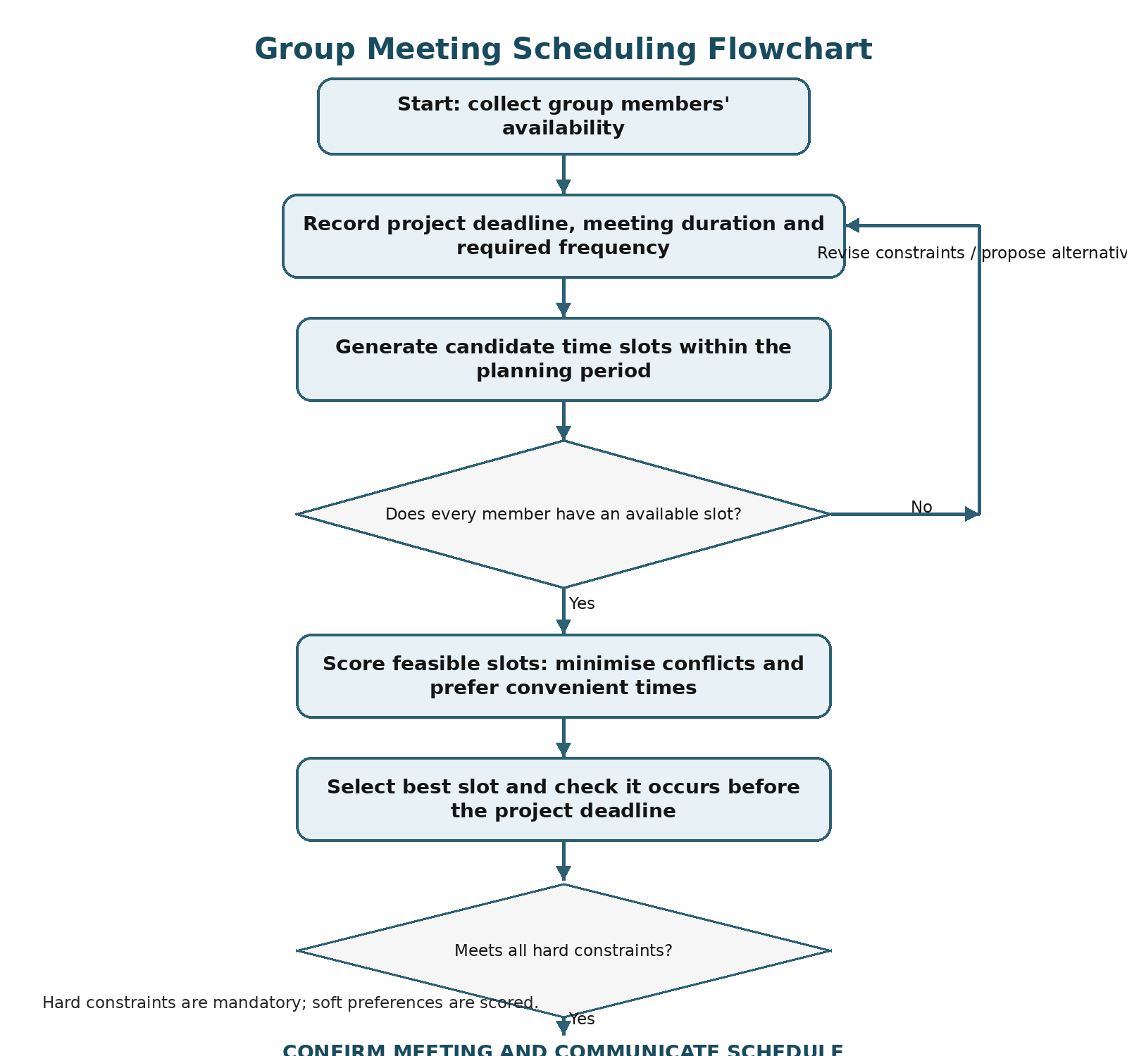
Figure 1: Proposed group meeting scheduling process.

3.2 Flowchart Explanation
Flowchart Explanation The flowchart above records availability for the meeting duration, frequency and project deadline. Candidate times are generated from the planning period. The flowchart checks each slot for the availability of all required members for the meeting. If any member is unavailable for a slot then that slot is rejected. The remaining slots are ranked using scores for convenience and optional conflicts for the meeting. Once a candidate has been scored he or she is checked against the Must Have constraints for the project and the project’s deadline. If all of these have been satisfied then the meeting can be confirmed and a time for the meeting scheduled. If not, consideration can be given to another candidate. In the worst case scenario for a group of people trying to schedule a meeting all candidates may turn out to be unsuitable. In such cases the group could try to change a lower-priority preference or a constraint in order to schedule a meeting(s). [1], [2].

4. Reflection and Justification

Reflection and Justification As each meeting is to be planned for the group of students for the project, the same sequence of steps will be followed for each meeting. Thus this is a repeatable process. This can be used for any group of students for any project. It is not a single solution to a particular problem in a timetable for a particular project.

4.1 Abstract thinking
Abstract thinking In order to store only the information which affects the scheduling, abstraction has been used. This means that for every interval where a student is unavailable, only the reason for their absence needs to be stored. Since the reason for a student’s absence for a meeting is based on the project’s deadlines, the group’s members’ availability and the group’s meeting requirements, the project topic does not need to be stored. Thus the above simplified representation can be used for other groups and for other projects. [3].

4.2 Sub-dividing

Sub-dividing For the problem of scheduling group project meetings a simple flowchart can be made. First a flowchart is made for the data collection, then the constraint checking, then the candidate generation, the scoring and last of all the confirmation. Every stage has its own purpose and can be tested separately.

4.3 Justification of solution

Justification of solution This solution meets the 3 goals of scheduling. In scheduling group meetings of a project, the solution considers the availability of group members before scheduling a meeting for them. It also rejects hard conflicts and ranks softer conflicts between preferred times for meetings. Lastly, the solution checks the project deadlines before confirming a meeting for the members of a group for a project. It creates a simple scheduling tool for a spreadsheet that is also compatible with more advanced constraint programming. In the solution, the hard constraints of the meetings of the Must Have functions are kept separate from the preferences of the meetings. So the preferred times for the meetings are only ranked and not accepted against the will of the members of the group or of the project.

4.4 Limitation

Limitation This simple method does not provide for all personal preferences of its users. The simple scores assigned by this method can not be all adequate for its users. Agreement of members of a group on the weights to be assigned to their preferences is required. As the number of group members, meetings and constraints between them increases, the use of a spreadsheet to implement this method becomes less practical.

4.5 Assumption

Assumption Assumptions. The simple scheduling solution presented for scheduling group project meetings relies on several key assumptions: (1) availability information for each group member for their scheduled meetings is always current and provided by the group member, (2) each group member providing the availability for their scheduled meetings knows the meeting duration as well as the project’s hard constraints and meeting deadline, (3) when no feasible slots are found for a group of people to hold a meeting (i.e., no meeting slots that satisfy all of the required members’ constraints), they will work to change a lower-priority preference rather than break a Must Have meeting requirement, (4) there is one person or even a shared digital system used by the group to record the confirmed meetings for the group.

5. Conclusion

Conclusion The aim of this report was to provide a structured solution to the problem of scheduling group project meetings. The solution provided in this report has been developed by breaking down the problem and then developing a flowchart to solve the problem of scheduling group project meetings. The solution provided in this report for scheduling group project meetings forms a repeatable process that first removes all the impossible times from consideration. All the remaining possible times for the group’s meeting are then ranked. Finally all the project’s hard constraints and deadlines are checked before the meeting is confirmed.

References
[1] E. K. Burke and S. Petrovic, “Recent research directions in automated timetabling,” European Journal of Operational Research, vol. 140, no. 2, pp. 266–280, 2002, doi: 10.1016/S0377-2217(02)00069-3.
[2] T. Müller and R. Barták, “Interactive timetabling,” arXiv preprint cs/0109022, 2001.
[3] J. M. Wing, “Computational thinking,” Communications of the ACM, vol. 49, no. 3, pp. 33–35, 2006, doi: 10.1145/1118178.1118215.
[4] Agile Business Consortium, “What is MoSCoW prioritization?,” Agile Business Consortium, 2026. [Online]. Available: https://www.agilebusiness.org/resource/what-is-moscow-prioritization/
[5] S. Chitnis, M. Yennamani, and G. Gupta, “ExSched: Solving constraint satisfaction problems with the spreadsheet paradigm,” arXiv preprint cs/0701109, 2007.
[6] Google for Developers, “Employee scheduling,” OR-Tools documentation, 2024. [Online]. Available: https://developers.google.com/optimization/scheduling/employee_scheduling

