  Component One:  What are the key skills required when working in the housekeeping team? 750 words (+/- 10%)  Contribution to Overall Module Assessment: 25% | Student No: | 2118032
 | Module Title: | Operating Hotel Facilites
 | Module Code: | BMIH4006
 | Lecturer: | Muhammad Cassamo
Student Journal: Key Skills Required in the Housekeeping Team
Throughout my professional career, I have gained experience in various hospitality industry sectors, including housekeeping department positions. Acquiring essential competencies for household management has constituted a pivotal aspect of my personal development thus far. Through my experience in this particular field, I have gained a comprehensive understanding of the significance of precise and efficient collaboration within a team and the completion of tasks in a timely manner. The objective of my research is to ascertain and comprehend the fundamental capabilities essential for achieving success in this particular domain while working in a team. The essay will also cover how theoretical knowledge is used in the field and how vital these abilities are to the hospitality sector.
Key Skills
Communication Skills
For the housekeeping team to effectively collaborate with other departments and teams, excellent communication abilities are required to enhance the collaboration. Clear and succinct communication helps to reduce the likelihood of misunderstandings and increases the likelihood that activities will be completed correctly (Pai et al., 2020, 4345). For instance, efficient communication between the front desk and cleaning staff is necessary in order to coordinate the availability of rooms and the demands made by guests.
Attention to detail
Exhibiting attention to detail is a crucial competency while operating within the housekeeping team. This entails ensuring that the room or area is consistently maintained following the established standards of the organization. It is essential for housekeepers to diligently execute every task, regardless of its magnitude, to guarantee a flawless outcome consistently (Pai et al., 2020, 4346). During my tenure as a housekeeper in a motel, I ensured comprehensive cleaning of the room by vacuuming the entire area, wiping down all surfaces, dusting all corners, and replacing the bed linens with fresh ones. The minor details were considered, resulting in a spotlessly clean and welcoming environment for the visitors.
Time Management
Effective time management capabilities are crucial for individuals working in the housekeeping profession. Efficient organizing and prioritization are crucial when faced with the task of cleaning an enormous amount of rooms within a restricted time frame. The efficient management of time by members of the housekeeping team can guarantee the timely completion of tasks while maintaining high standards of quality (Rinekasari et al., 2019, np). Housekeepers must schedule their day around guest needs and duties. In a hotel, I estimated the duration it would take me to finish my responsibilities and planned accordingly. This would allow me to balance my work with the guests' needs and give exceptional service.
Teamwork
Teamwork is a crucial competency in the field of the housekeeping team. The ability to engage in teamwork and cooperation to guarantee guest contentment is of utmost importance in the housekeeping field. Collaborating efficiently within a team, extending assistance, and aiding individuals in need are crucial aspects of upholding a superior standard of service (Guo, 2019, np). During my tenure in the housekeeping department, I was willing to assist my colleagues whenever necessary to optimize guest satisfaction. Consequently, all of the assignments were accomplished promptly and efficiently.
Steady and energetic performance
Consistent and vigorous execution is a crucial competency in the field of housekeeping. Employment in the housekeeping department typically entails strenuous physical activity, frequently necessitating prolonged periods of standing. Consequently, housekeeping staff must exhibit optimal performance by upholding vigilance and attentiveness to undertake requisite measures to optimize the client's experience (Tra, 2020, np). Furthermore, maintaining a consistent pace and sustaining motivation are crucial factors for enhancing productivity.
Application of Theoretical Knowledge
Academic knowledge can be used in hospitality practice. For instance, learning about different cleaning agents and their proper use can help you choose the best products for specific cleaning chores. Understanding ergonomics can help cleaning personnel adopt optimal body mechanics and reduce work-related accidents (Davras & Caber, 2019, 85). Additionally, theoretical knowledge of customer service and communication can improve guest interactions. Addressing visitor requests and inquiries efficiently requires learning practical communication skills. Understanding the benefits of a happy mindset can also help guests feel welcome.
Significance of Key Skills in the Hospitality Industry
The hospitality business values housekeeping abilities. Hotel cleanliness and maintenance significantly affect customer satisfaction and loyalty. Detail-oriented service fosters guest satisfaction through excellent service delivery. Time management also helps the hotel arrange guest rooms quickly. Effective housekeeping team and department communication promote teamwork and collaboration. Collaboration ensures smooth operations, improves visitor experiences, and resolves issues quickly.
Conclusion
Communication, detail, time management, energy, and teamwork are essential for housekeeping. These abilities help housekeepers serve visitors swiftly and well in the hotel sector. The industry's prosperity depends on guests' satisfaction.

Reference List
Davras, Ö. and Caber, M., 2019. Analysis of hotel services by their symmetric and asymmetric effects on overall customer satisfaction: A comparison of market segments. International Journal of Hospitality Management, 81, pp.83-93.
Guo, X., Cheng, A. and Pavlou, P., 2019. Skill-biased technical change again? Estimating the effect of TaskRabbit on local employment in the housekeeping industry.
Pai, A., Manjunath, M., Kowshik, C.S., Ayedee, N., Malarout, N. and Naik, N., 2020. SOFT SKILLS AS A KEY COMPETENCY FOR THE FUTURE LEADERS OF THE HOSPITALITY INDUSTRY. PalArch's Journal of Archaeology of Egypt/Egyptology, 17(9), pp.4341-4355.
Rinekasari, N.R., Jubaedah, Y. and Sobariah, S.N., 2019. Standard Operating Procedure of Housekeeping Adaptation: The Development of Assessment Tools in Cleaning Bathroom Practices at Vocational High School. KnE Social Sciences, pp.150-161.
Tra, T., 2020. Action plan for training new Housekeeping Employee: case: Hotel Indigo Helsinki.

Word Count | 770

Component Two:
Contribution to Overall Module Assessment: 25%
In this scenario – You have just been promoted to team leader for a floor within the hotel. A guest complains that on their arrival, their room had not been properly cleaned. Create an action plan and answer the following questions.

Problem | Why did it happen? | What are you going to do? | How will you prevent this from happening in the future? | What measures would you introduce to improve team effectiveness?
Based on the guest's complaint that their room had not been properly cleaned upon arrival, the problem identified was that the housekeeping team did not meet the expected cleanliness standards for the guest's room. | - Time Constraints  - Staffing Issues  - Lack of Training  - Communication Breakdown  - Human Error | - Acknowledge the Complaint  - Gather Information  - Assess the Situation  - Engage the Housekeeping Team  - Investigate the Root Cause  - Implement Corrective Measures  - Follow-up with the Guest  - Learn from the Incident  - Communicate and Train | - Reinforce Training  - Quality Control Checks  - Standardized Cleaning Procedures  - Clear Communication Channels  - Adequate Staffing Levels  - Continuous Feedback and Improvement  - Learn from Mistakes  - Continuous Training and Development | - Clear Roles and Responsibilities  - Teamwork and Collaboration  - Regular Team Meetings  - Training and Development  - Performance Evaluation and Feedback  - Efficient Workflow and Task Management  - Recognition and Rewards  - Leadership and Support

Component Three:
Contribution to Overall Module Assessment: 50%
Your task is to create and prepare a presentation following the detailed scenario provided below.

As the floor housekeeping manager and given the recent guest complaints you need to put together a basic training presentation for your colleagues within the housekeeping team to get the best out of them, ensure that brand standard is being achieved and that Health and Safety procedures are also being followed.



Training Notes:
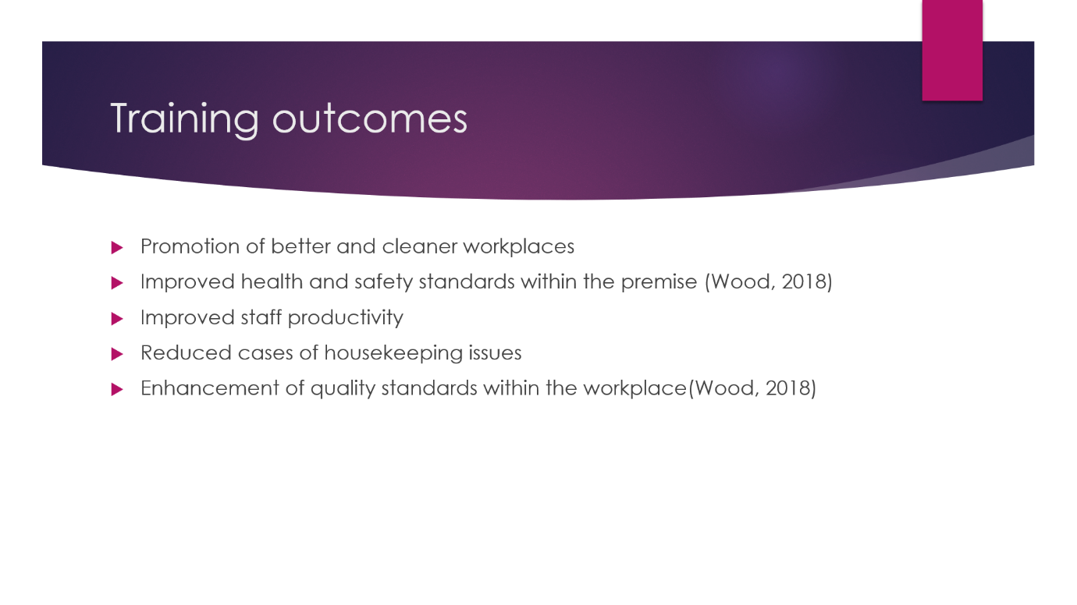

Training Notes: hotel housekeeping training has a significant impact on the overall guest experience and the success of a hotel. It enhances the skills and knowledge of staff members, leading to improved cleanliness, attention to detail, guest interaction, safety, and productivity. By investing in effective training programs, hotels can ensure that their housekeeping team operates at the highest standards, resulting in guest satisfaction, positive reviews, and repeat business.
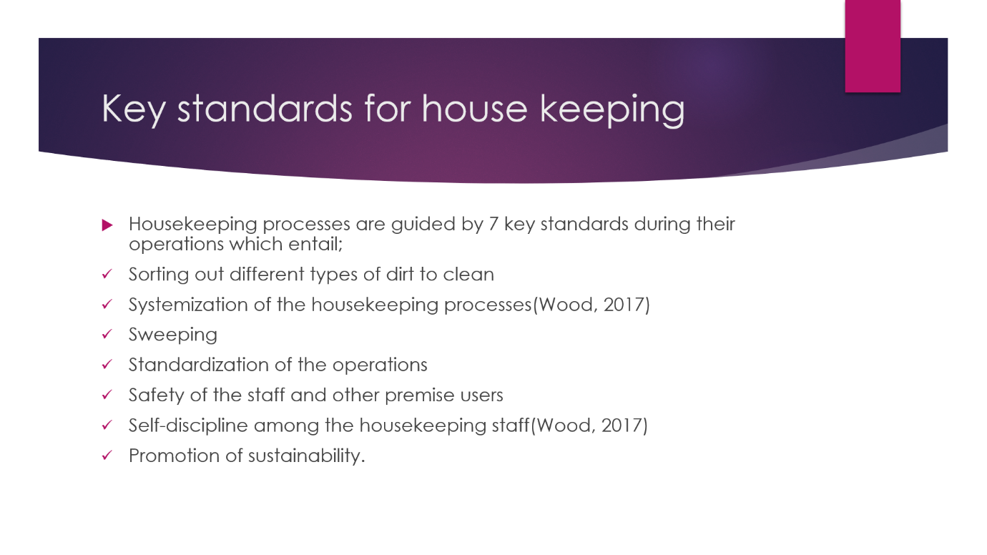

Training Notes: These key standards provide a framework for hotel housekeeping operations, ensuring that cleanliness, hygiene, and guest satisfaction are consistently upheld. By following these standards, hotels can create a comfortable and pleasant environment for guests, maintain a positive reputation, and strive for excellence in their housekeeping services.
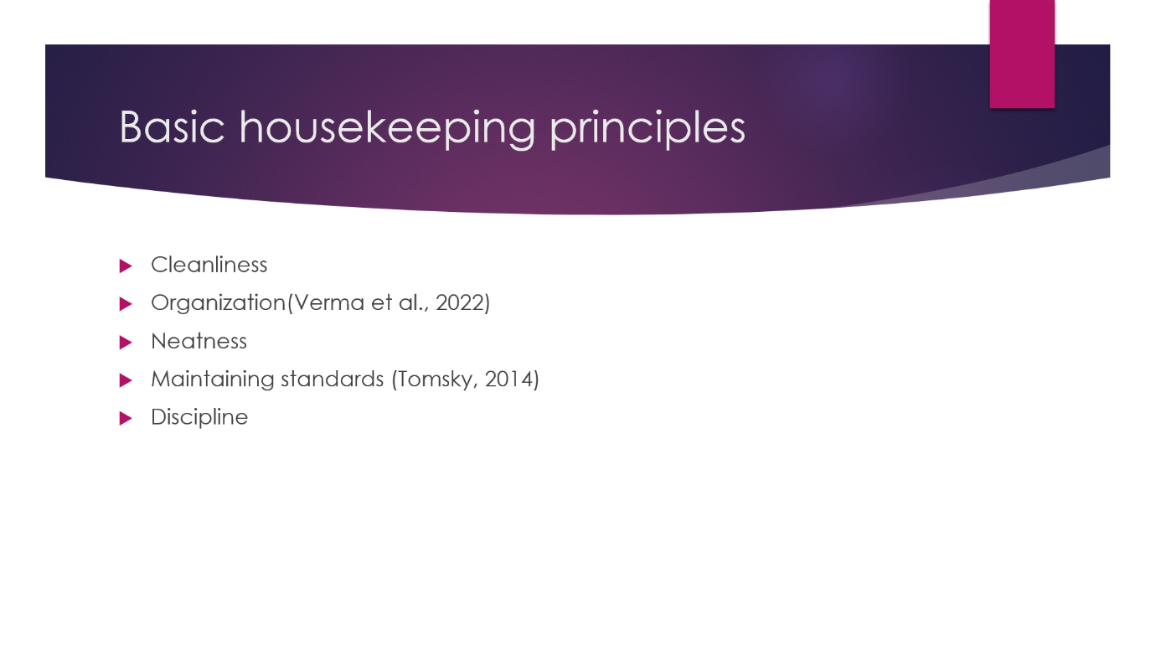

Training Notes: These principles serve as guiding values for hotel housekeeping operations, ensuring that cleanliness, organization, guest satisfaction, and safety remain at the forefront of all activities. By adhering to these principles, hotel housekeeping departments can maintain a high standard of service, create a positive guest experience, and contribute to the overall success and reputation of the hotel.
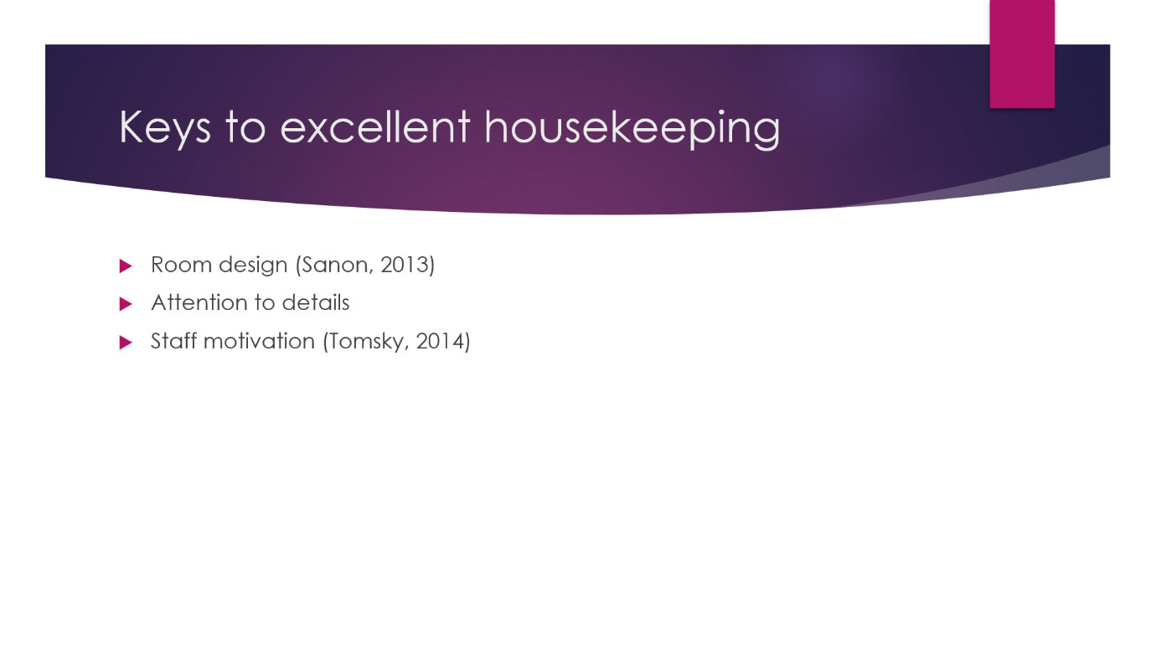

Training Notes: By following these keys to excellent hotel housekeeping, properties can create a clean, comfortable, and enjoyable environment for guests, thereby enhancing their overall experience and fostering a positive reputation for the hotel.

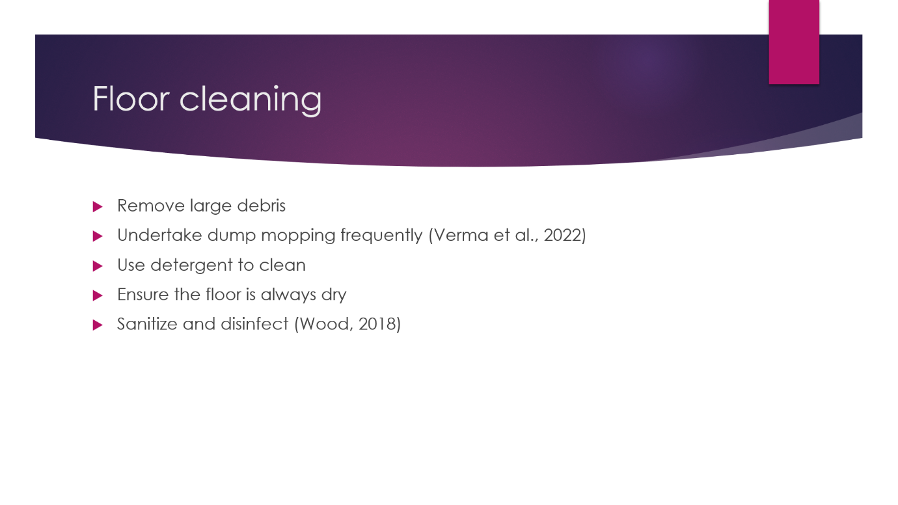

Training Notes: By following these practices, hotel housekeeping staff can effectively clean and maintain various types of floors within the property. This contributes to a clean, safe, and visually appealing environment for guests, enhancing their overall experience and satisfaction.
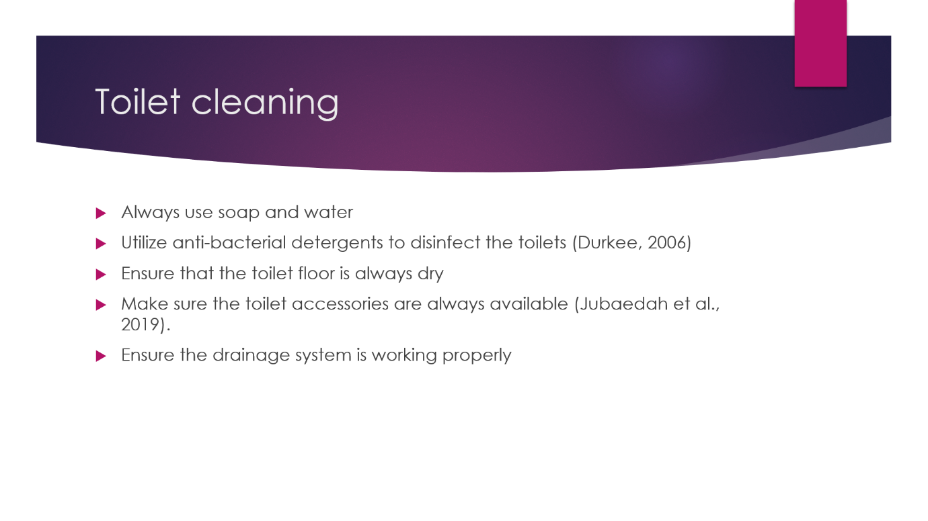

Training Notes: Following these practices for hotel housekeeping toilet cleaning helps maintain a clean, hygienic, and pleasant restroom environment for guests. It demonstrates the commitment to cleanliness and contributes to a positive guest experience and the overall reputation of the hotel.
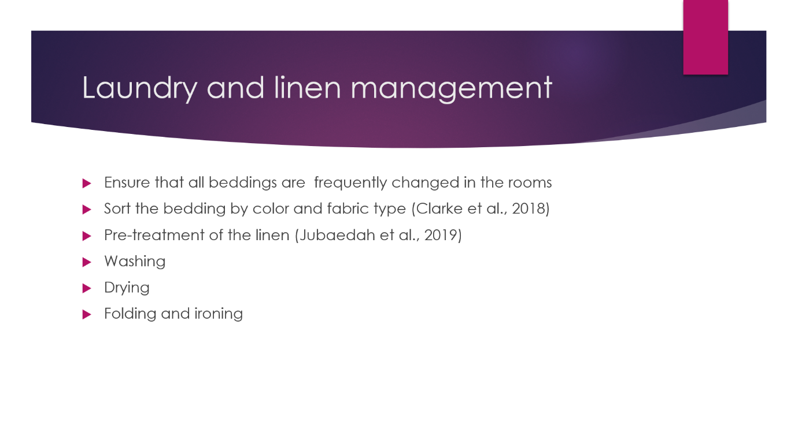

Training Notes: Efficient management of hotel housekeeping laundry and linen ensures that guests are provided with clean, fresh, and well-maintained linens, contributing to a positive guest experience and the overall reputation of the hotel. Proper handling, cleaning, and storage of linens help maintain cleanliness, hygiene, and the desired level of guest comfort.
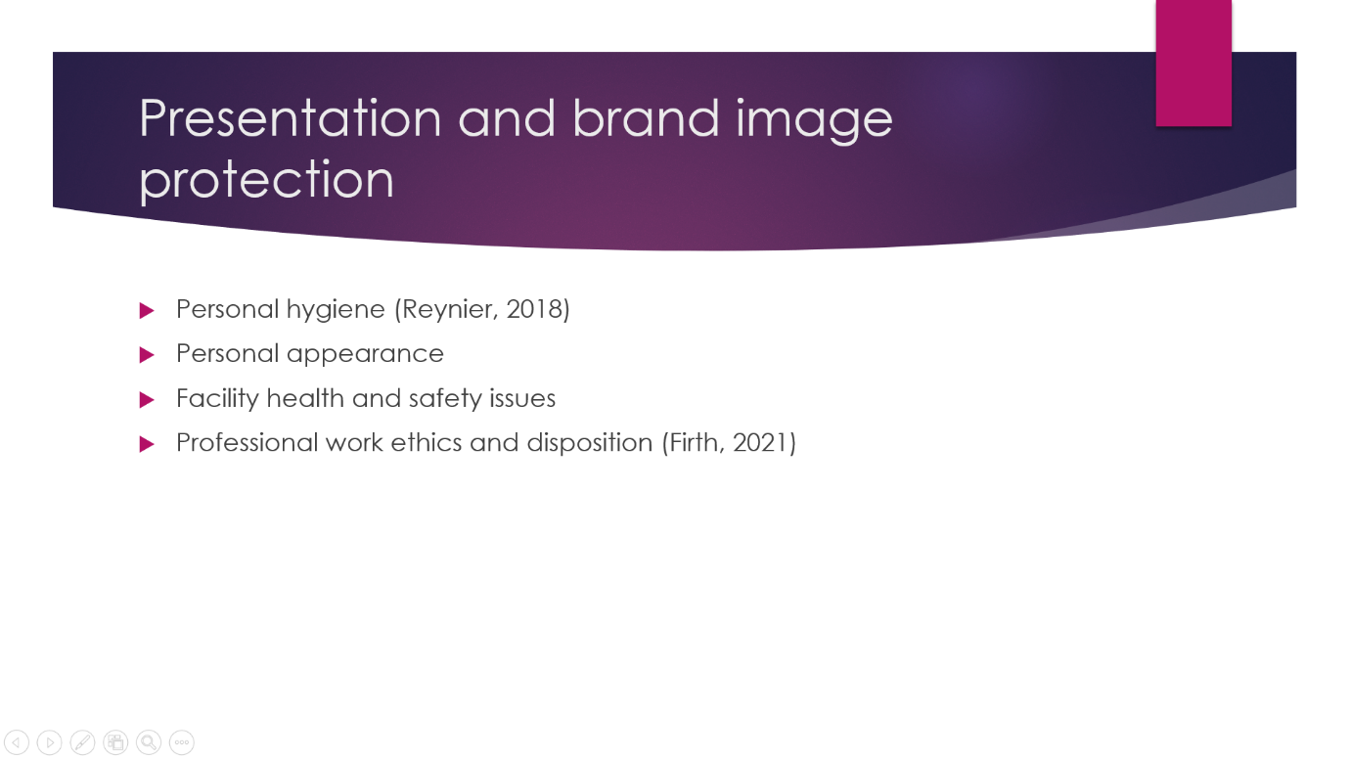

Training Notes: By prioritizing presentation and brand image protection in hotel housekeeping, properties can create a memorable and positive guest experience. Consistent cleanliness, attention to detail, professionalism, and alignment with the brand values all contribute to a strong brand.
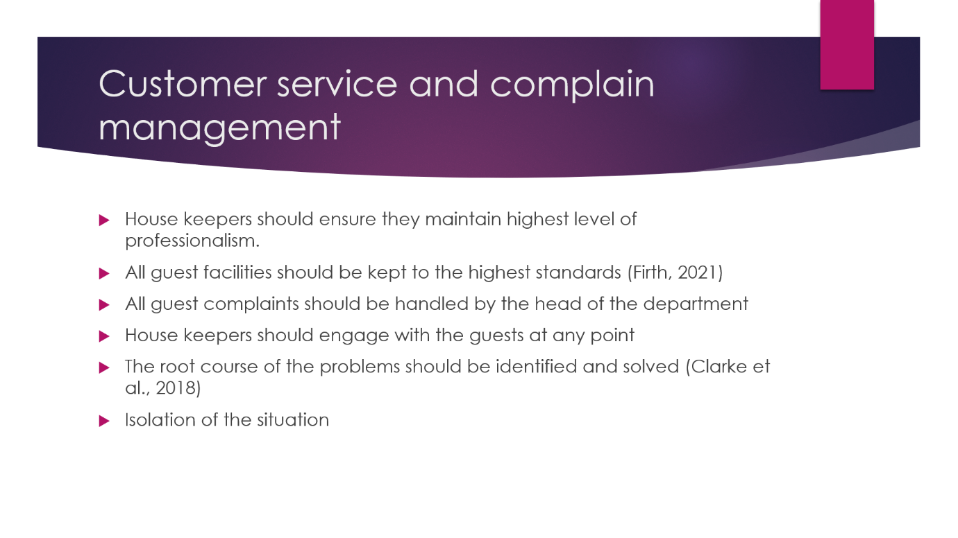

Training Notes: By prioritizing customer service and effective complaint management in hotel housekeeping, properties can enhance the guest experience, build guest loyalty, and safeguard their reputation. A customer-centric approach, effective communication, and a commitment to continuous improvement contribute to a positive customer service and management.

References

- Clarke, J., Robinson, O. and Mayo, C. (2018) Trouble in Hotel Paradise Housekeeping Department: A case study [Preprint]. doi:10.4135/9781529720662.
- Durkee, J.B. (2006) Management of industrial cleaning technology and Processes. Elsevier.
- Firth, R. (2021) ‘Conditions of housekeeping’, Housekeeping among Malay Peasants, pp. 1–16. doi:10.4324/9781003135364-1.
- Jubaedah, Y., Rinekasari, N.R. and Rohaeni, N. (2019) ‘Job performance apprenticeship in housekeeping department: An implementation of competency-based assessment model’, Proceedings of the 1st Vocational Education International Conference (VEIC 2019) [Preprint]. doi:10.2991/assehr.k.191217.040.
- Reynier, C. (2018) ‘The good housekeeping essays at the Crossroads’, Virginia Woolf’s Good Housekeeping Essays, pp. 136–158. doi:10.4324/9780429452932-10.
- Sanon, M.-A. (2013) ‘Hotel Housekeeping work influences on Hypertension Management’, American Journal of Industrial Medicine, 56(12), pp. 1402–1413. doi:10.1002/ajim.22209.
- Tomsky, J. (2014) Heads in beds: A reckless memoir of hotels, hustles, and so-called hospitality. Thorndike Press, a part of Gale, Cengage Learning.
- Verma, P., Singh, Dr.M. and Aggarwal, Dr.N. (2022) ‘Examination of hotel management aspirants’ perspectives towards a career in the technologically inclined hospitality sector—special reference to the housekeeping industry’, Webology, 19(1), pp. 2279–2293. doi:10.14704/web/v19i1/web19155.
- Wood, A. (2018) ‘Housekeeping, citizenship, and nationhood in good housekeeping and modern home’, Women’s Periodicals and Print Culture in Britain, 1918-1939 [Preprint]. doi:10.3366/edinburgh/9781474412537.003.0017.
- Wood, R.C. (2017) ‘Housekeeping and related accommodation services’, Hotel Accommodation Management, pp. 70–82. doi:10.4324/9781315169965-6.

