"FROM A MONKEY TO A ROBOT". HOW DOES TECHNOLOGY AFFECT WHAT WE CALL HUMANITY – SURVIVAL.
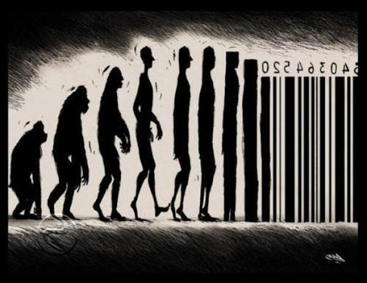

INTRODUCTION:
THE PURPOSE OF THIS ESSAY IS DIRECTED TO WHAT MIGHT BE CONSIDERED AS ONE OF THE GREATEST THREAD TO HUMANITY - TECHNOLOGICAL ADVANCEMENT.
I will be oscillate between human nature and along with what makes us human and nature of changes that take a place in people under the influence of technology development.
It will uncover hidden mechanism of internal shift, equally on the level of society and at the level of the individual due to technological growth. The first part will response to the answer: what is an essence of human nature , what make us the people , in which way we are connected with all other beings on our planet and the universe. I intend to support my reflections with the words of Jiddu Krishnamurti, Indian philosopher, writer and speaker.
Next part will concern of development of technology and how our interaction with technology in every day life affect our functioning and limiting our contact with nature, on the basis of research and definitions a.o. Dr. Goleman author of the book “Emotional intelligence “.
The last part will refer to the future based on the predictions and opinion a scientist Steven Hawking as well as Mr. Elon Musk and Ray Kurzweil.
How technological advancement have seeped into our everyday life will be demonstrated through a review of the Matrix (1999)and Her(2013) whilst both these are fictional the analysis will consider how they are possibly not as far off from the truth as we would like to think.
This essay proposes that individuals should consider , stop and think where our technological progress is leading us , and to then seek ways to use it properly, differently ,responsibly.
What chance do we have to tame our own nature in order to protect the nature that protect us ?
Where we come from ..
A world without technology ... the first associations or comments I can imagine when saying these words: cavemen, age stone, primitivism, hard life, old times, lack .... Why not: connection with nature, people, tradition, stories, ceremonies, ancestors, culture ...? what made us do not know our own origins, roots and legends. Did we forget about tradition, where did we come from and why? Does broadly understood development, including mainly technological development, determine our goals and desires today? Do we understand where we are going, do we learn from the past, do we are aware of our own path in the modern world , or are we just rushing blindly, stretching out our hands for new, better, more ... easier?
“Today's modern conveniences are easy to take for granted, but it's important to look back on just how far we've come. There’s a great saying that if we don’t know where we come from, how can we know where we are going?- says Francine Cefola, co-author of the new book “Tell It To the Future. “ I am a firm believer that we learn from the past, and if we ignore things we can’t conceptualize because it seems too archaic or slow or unproductive, we miss understanding how we got to where we are today - Bob Larkin says, in article from March 2019 “What It Was Like to Live Without Today's Technologies We Totally Take for Granted”, posted on portal BEST LIFE .
Is too hard to imagine life before technology ? Let's look back, just a few decades ago:
Before GPS, we used atlases to get us around.
Before e-mail or texting, we wrote letters.
Before digital cameras, we'd wait a week for film to develop.
Before Kindles, we had to go to the library
Before fitness trackers, we never thought about our heart rates.
Before Amazon, we'd get our basics at the dime store.
Before social media, you had to work harder to maintain relationships- the author mentions and then develops individual thoughts.
I personally remember that time and letter-writing when the distance shared me with a loved one and there was no room for quick, often unnecessary words leading to misunderstandings- like in quick chatter on the messenger. Every word on the paper was important and thoughtful and flowing from the heart and waiting for a letter taught a patience.
But let us go a long way back to the times when the ancient tribes lived in harmony with the rhythm of nature, in their attachment to the earth and their ancestral traditions, fairly using Mother Earth's gifts in respect and gratitude to her and ourselves.
Let’s answer the questions : What is a nature , what is our relationship with nature?
“If you lose relationship with nature, you lose relationship with humanity.
“If you hurt nature , you are hurting yourself.”

Krishnamurti in Ojai 1983, Talk 1
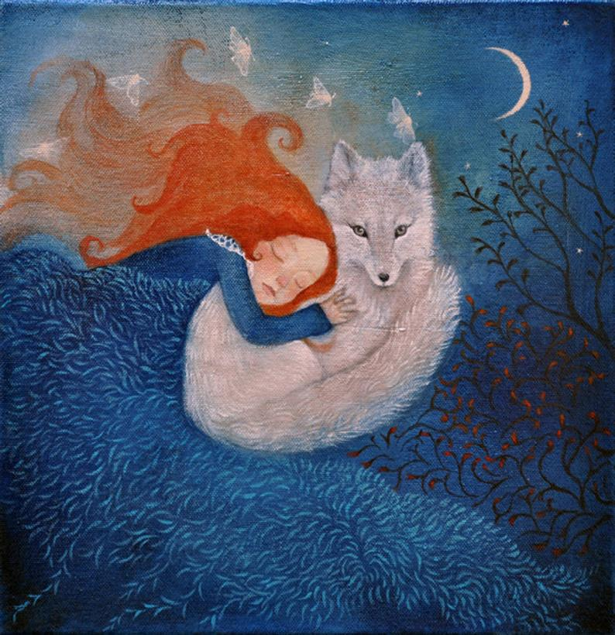

Let me use the words of Jiddu Krishnamurti, Indian philosopher, writer and speaker.
“What is nature? There is a great deal of talk and endeavour to protect nature, the animals, the birds, the whales and dolphins, to clean the polluted rivers, lakes, fields and so on.
Nature is not put together by thought, as religion and belief are. Nature is the tiger, that extraordinary animal with its energy, its great sense of power. Nature is the solitary tree in the field, the meadows and the grove; it is that squirrel shyly hiding behind a bough. Nature is the ant, the bee and all the living things of the earth. Nature is the river, not a particular river, whether the Ganga, the Thames or the Mississippi. Nature is those mountains, snow-clad, with dark blue valleys and range of hills meeting the sea. The universe is part of nature. One must have a feeling for all this, not destroy it, not kill for one’s pleasure or one’s table. We do kill cabbages, the vegetables we eat, but one must draw the line somewhere. If you do not eat vegetables, how will you live? So one must intelligently discern…”
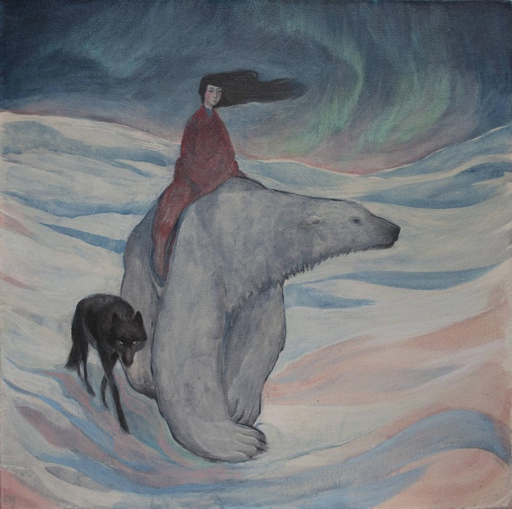
This publication beautifully captures the essence of the dependence and unity between man and nature, the other person and himself. It is a journey to the source of human nature without understanding which, nothing can be understood.
“Nature is part of our life. We grew out of the seed, the earth, and we are part of all that, but we are rapidly losing the sense that we are animals like the others.”
We are so engrossed in our own desires, aspirations, ego, ambitions that we do not notice this great belonging to the world of nature, coexistence with everything that surrounds us, so much so that we destroy ourselves by destroying nature around us, mindlessly exploiting it, ignoring all signs such as I statistics that clearly inform us that if we do not start using the earth's resources reasonably, we will not survive. So has
Lucy Campbell “Polar bear, black wolf, woman. Aurora.”
humanity lost its instinct of self-preservation and all intuitions And willfully, blindly heading for destruction ???
“Because we do not love the earth and the things of the earth but merely utilise them, we are insensitive to the beauty of a waterfall and have lost the touch of life. We don’t sit with our backs against the trunk of a tree. And since we do not love nature, we do not know how to love human beings. We have lost the sense of tenderness, that sensitivity, that response to things of beauty.”
Krishnamurti in Poona 1948, Talk 8
Humanity has gone far from nature and is departing more and more. This disconnection deepens our inability to feel our own emotions, and the lack of them ,distances us more and more, we have forgotten that nature is a remedy for our mental and emotional problem.
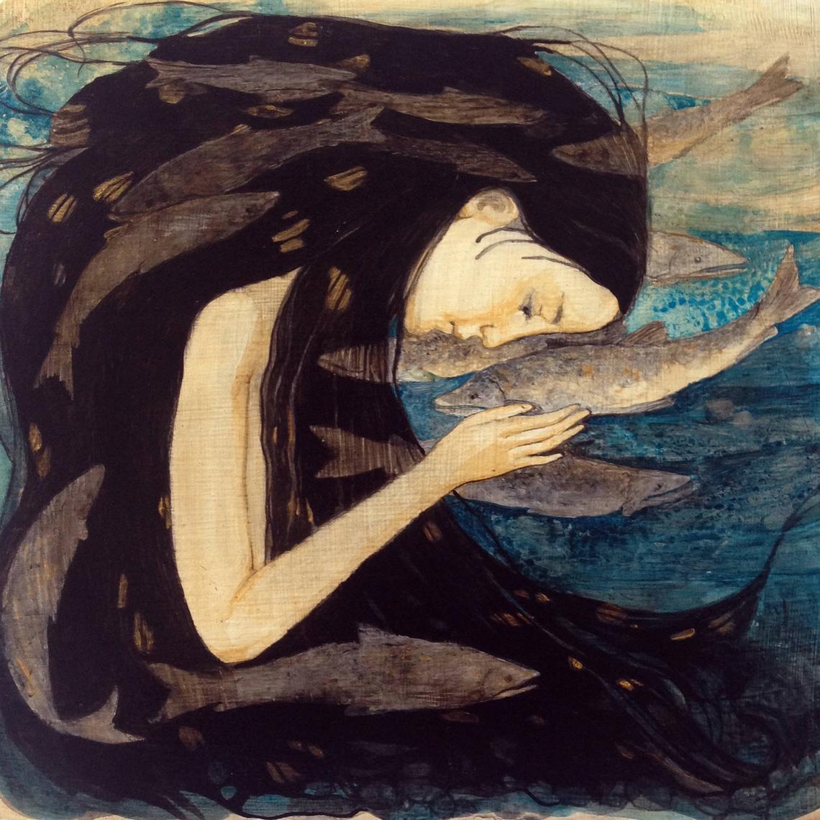
“It is odd that we have so little relationship with nature, with the insects and the leaping frog and the owl that hoots among the hills, calling for its mate. We never seem to have a feeling for all living things on the earth. If we could establish a deep abiding relationship with nature, we would never kill an animal for our appetite; we would never harm, vivisect, a monkey, a dog, a guinea pig for our benefit. We would find other ways to heal our wounds and our bodies. But the healing of the mind is something totally different. That healing gradually takes place if you are with nature, with that orange on the tree and the blade of grass that pushes through the cement, and the hills covered, hidden, by the clouds.”
From the book Krishnamurti to Himself by J. Krishnamurti

What chances do we have to heal ourselves without being connected to nature, what chances do we have to stop, sit down, realize where we are and where are we going, stop the process of self-destruction ????
Let's answer the question what separates us from nature today ?? Concrete cities, the pace of life, the omnipresent, rapidly developing technology that has mastered almost every area of ​​life? What do we understand by technology:?
“Technology is the way we apply scientific knowledge for practical purposes. It includes machines (like computers) but also techniques and processes (like the way we produce computer chips). ... In fact, a hammer and the wheel are two examples of early human technology .
We find these and similar definitions on the Internet, as well as other answers to the questions: What is technology in our life:?
“ Technology affects the way individuals communicate, learn, and think. It helps society and determines how people interact with each other on a daily basis. Technology plays an important role in society today. It has positive and negative effects on the world and it impacts daily lives.”
Yes, indeed, the impact of technology on our lives is enormous and I do not hesitate to say the key, but unlike nature, there are more negatives than positives. Especially for what is called humanity.
How we define a humanity?
Humanity is the human race, which includes everyone on Earth. It's also a word for the qualities that make us human, such as the ability to love and have compassion, be creative, and not be a robot or alien. ... When people ask for money to help feed starving children, they're appealing to your sense of humanity.
In this definition, given by the google search engine, there is something that suggests that we are unity and equality, able to love and sympathize with our own emotions and the emotions of another being, i.e. we are capable of empathy, but in fact the scale of differentiation of this ability in different people is huge, from very weak to very deep.
So what makes us capable of this ?? What makes each of us different?
I reach for the concept of emotional intelligence that will help to clarify this issue.
Dr. Daniel Goleman, in his book “Emotional Intelligence”, defines emotional intelligence as the ability to identify one’s own feelings and the feelings of others. He notes that people with high degrees of E.I. have healthier relationships, adapt better to environments, and they are more skilled at working toward their goals.
Dr. Goleman identifies five key qualities that foster emotional intelligence: self-awareness, self-regulation, social skills, empathy, and motivation.
Thus, emotional intelligence is essentially what defines our humanity, our relationship with the world and ourselves, makes us perceive reality and how we are perceived by others.
This is, it might say, a higher form of awareness.
We can both, influence the development of our EI through conscious action, behavioral habits, etc. but also external factors in the modern world significantly weaken and lower the level of our EI.
As I mentioned above, the greatest threat to EI is the rapidly developing technology, specifically computerization in almost every area of ​​life, which has made us turn the connection with the source of our emotions into a connection with the computer network, which already dominates the real live,world, relationship. We have reached a ceiling in which, in fact, from the beginning of our existence, we are brought up in a network where is already everything except; air, food and toilet. A 10-year-old children move around the internet with the efficiency of a monkey while nature becomes something strange to them, and there is no need or curiosity to get to know her, we choose online contact instead of face to face meetings, billions of stimuli from the virtual world separate us from own emotions.
This is where we are today…
Sean Grover, L.C.S.W., a psychotherapist and the author of” When Kids Call the Shots: How to Seize Control from Your Darling Bully and Enjoy Being a Parent Again” says :
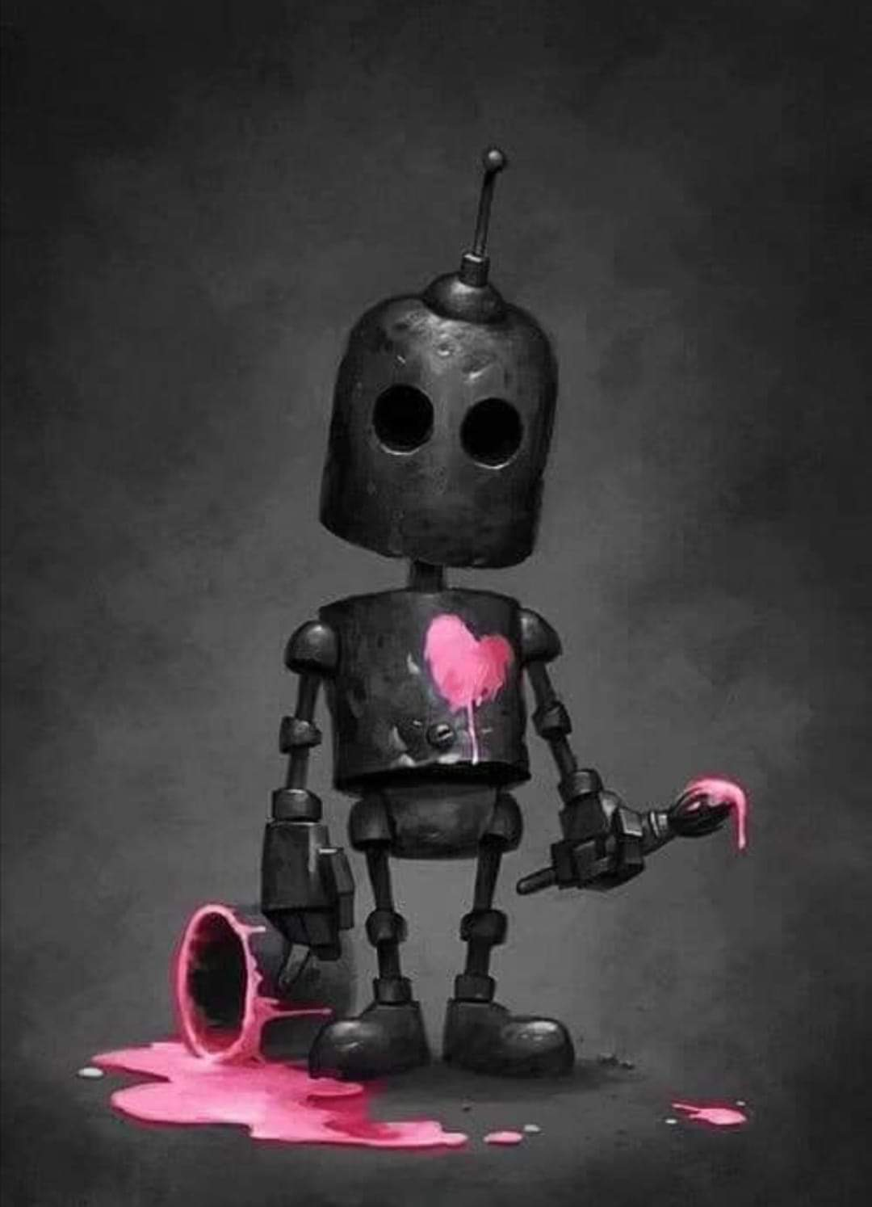
“I am defining technology is any external mechanism that disrupts your kid’s ability to be present with his or her thoughts and feelings, and attuned to others. That includes any device that draws your kid’s attention away from the moment—such as ear buds, smart phones, laptops—and dulls his or her senses to the world and the people in it.”

This definition may seem one-sided to supporters of technological progress, therefore in the further part of the article he explains to which point the use of good technology may be beneficial:
“The ability to dissociate from a stressful environment can be helpful. For example, listening to music can release stress by allowing you to take a break and escape a difficult moment. There are also apps designed to boost mindfulness and reduce anxiety through guided meditations or relaxation exercises. “
And when plugging to the technology is equal to unplugging from the world?:
“The trouble begins when interacting with technology starts to take priority over engaging in meaningful communication. As tech dependence increases, kids move through the world in a narcissistic bubble, divorced from their own thoughts and feelings, and the thoughts and feelings of others. As conversation skills and positive interactions crumble, technology even starts to warp kids’ sense of humanity; they are less compassionate and sensitive to others.”
S. GROVER lists and describes how technology dependence disrupts the features of emotional intelligence identified by Dr. Goleman: Undermines Self-awareness, weakens Self-regulation, diminishes Social Skills,undermines Empathy ,stunts Motivation.
We have a wealth of knowledge on this subject: in articles, books, films, pictures and through other forms of art, many of them run into the future, showing the reality that we inevitably aim at if we remain in the ignorance phase and do not start to wisely use the good of both nature and technology.
“Every mammal on this planet instinctively develops a natural equilibrium with the surrounding environment; but you humans do not. Instead you multiply, and multiply, until every resource is consumed..”
Agent Smith “Matrix”
Where are we heading?
What would we become without emotion , what would intellect be in a body without emotion? Is the body as a container for information still a man?
When watching films that show a fairy-tale vision of the world, science fiction films,
are we aware of the fact that many of them are more science and less fiction?

Let's start with a Matrix that gives us a great perspective on this and other issues?
Andy Wachowski's Matrix (1999) can be considered an illustration of the post-human condition, an extreme illustration approaching the end of human life -I read in the article "The Matrix:" Humanity Reloaded "found on the Brock Wiki. As the author claims, the article uses the Matrix to explore the limits of posthumanism.
“When considering what is human, or what constitutes humanness 'the body' has been of significance, however, moving into a post-humanism era embodiment has seemed to lose all significance; here the body is likened to a machine.”
While both the body and the machine are capable of 'cycling energy into different forms' (Hayles, 1999, p. 101), the body has become simply a manipulatable cavity for post-humans, a mechanical entity that has the ability to reproduce. Equated with machine, the body can no longer be considered an asset for humanist thought, implicating the human consciousness as the only remaining precursor for humanism. Similarly, Hans Moravec (1988) and Norbert Wiener (1954) proposed an idea that human consciousness can be effectively telegraphed or transmitted into a machine (In Hayles, 1999, p. 1). When civilization reaches this stage or, on the other hand, machines acquire the ability to reproduce, the gap between mankind and machine may be completely bridged as machines and humans will become comparatively the same.”( Hayles (1999) states that once information loses its body it becomes very easy to equate humans and computers.)
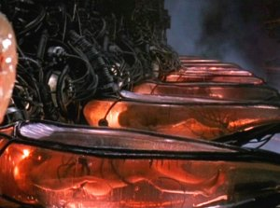
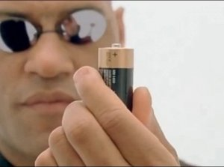
“Wachowski’s The Matrix (1999) fashions a world where that which is natural (or humankind) has incorporated the technological and the technological has incorporated the natural. What we consider our everyday world is known as ‘the matrix’, a fantasy dream world that is nothing more than a digital space or computer generation referred to in the film as a “neural interactive simulation.” Predating the creation of ‘the matrix’ mankind celebrated the creation of artificial intelligence that spawned the creation of an entire race of machines capable of reproduction. This set machines and humankind in opposition, in a battle of survival of the fittest. After humankind blocked out the sun in an attempt to destroy the machines major source of power, the human race is consequently positioned as the chief energy source for machines, like living batteries, their bodies become farmed for fuel and their minds sent to ‘the matrix’ to keep their bodies docile. “
“The Matrix in its illustration of the Real world depicts a state of complete machine dominance, where the majority of humankind is relatively indistinguishable from one another, all confined to system draining their energy, all pale, naked, hairless bodies representing human singularity under the control of machines. It is this first scene in The Matrix that depicts the Real world where one sees crops of human bodies growing that one can identify that universal homogeneity has prevailed. Similarly, when given a glimpse into the world of the Matrix, homogeneity seems not too far around the corner. Neo files himself into the norm at the beginning of the film by confining himself to one of numerous identical cubicles at his workplace, wearing the black suit and tie identical to his boss and many of those around him. It is only the resistance population in the Real world that demonstrates any kind of individuality or diversity. In this respect it seems as though The Matrix functions as a critique of the capitalist system. It is the capitalist system that is forcing the human population into homogeneity and post humanism and the capitalist system thrives on the use and sales of technology.”
If, after this extremely accurate - in my opinion, analysis, the Matrix is ​​still a fictional, swaggering vision of the future, let's refer to the opinions of respected scientist Steven Hawking, known for his work on black holes and relativity ,who was regarded as one of the most brilliant theoretical physicists since Albert Einstein.
The last few years of his life, Hawking repeatedly warned about the threat of climate change, artificial intelligence, population burden and hostile alien. Hawking warned that due to climate change, Earth will become a sizzling fireball by 2600 and humanity will become extinct.
"The development of full artificial intelligence could spell the end of the human race,"- the cosmologist told BBC News in 2014.
In an interview with the WIRED magazine, Hawking said AI will eventually reach a level where it will essentially be a "new form of life that will outperform humans".
"I fear that AI may replace humans altogether. If people design computer viruses, someone will design AI that improves and replicates itself. This will be a new form of life “- he said .
The renowned physicist maintained that while the primitive forms of AI had proven very useful, he feared the consequences of creating something that can match or surpass humans.
"It would take off on its own, and re-design itself at an ever-increasing rate," -he had said.
Hawking was referring to the development of AI that’s smart enough to think, or even better than, human beings. An event that’s been dubbed the technological singularity is a hypothetical point in time at which technological growth becomes uncontrollable and irreversible, resulting in unforeseeable changes to human civilization.
In terms of when that will happen (if ever) Hawking didn’t exactly offer a time table for humanity’s survival on Earth.
Others, such as SoftBank CEO Masayoshi Son and Google chief engineer Ray Kurzweil, have put the timeframe for the singularity even sooner than that — within the next 30 years. Ray Kurzweil previously pegged this superintelligence tipping point at around 2045, citing exponential advances in technologies like robotics, computers and AI. 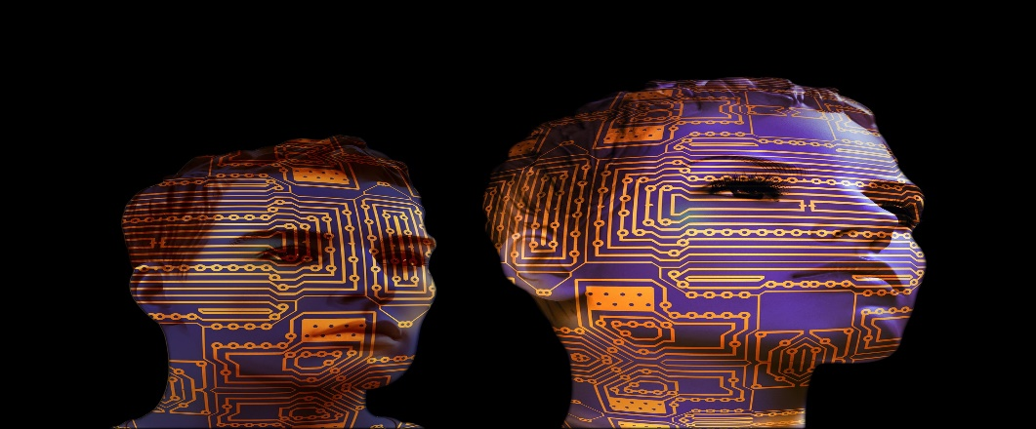
that current trends suggest AI could overtake humans by 2025. The billionaire engineer, who also helped found the artificial intelligence research lab OpenAI in 2015, has consistently warned of the existential threat posed by advanced artificial intelligence in recent years. Despite this, he said he still feels that the issue is not properly understood.
“My assessment about why AI is overlooked by very smart people is that very smart people do not think a computer can ever be as smart as they are. And this is hubris and obviously false,”- he said.
In 2016, Mr Musk said that humans Mr Elon Musk, whose ventures include electric car maker Tesla and space firm SpaceX, said in an interview with The New York Times risk being treated like house pets by artificial intelligence unless technology is developed that can connect brains to computers.
Shortly after making the remarks, Mr Musk announced a new brain-computer interface startup that is attempting to implant a brain chip using a "sewing machine-like device".
Neuralink will allow humans to compete with AI, according to Mr Musk, as well as help cure brain diseases, control mood and even let people "listen to music directly from our chips."
Both Mr Musk and Mr Kurzweil were among prominent artificial intelligence researchers to pledge support for stringent guidelines for the development of advanced AI.
An open letter published by the Future of Life Institute (FLI) in 2017 outlined a set of principles deemed necessary to avoid an out-of-control AI, as well as doomsday scenario involving lethal autonomous weapons.
"We hope that these principles will provide material for vigorous discussion and also aspirational goals for how the power of AI can be used to improve everyone's lives in coming years," the institute said at the time” .
This “optimistic” vision of connecting the brain with the computer and the coexistence of people and artificial intelligence is perfectly captured in the film “HER”(2013) directed by Spike Jones .
In drawing a picture of the near future, Jonze sprinkles fatalism with a sauce of melancholy. He does not dispair over the fall of civilization, but speaks of loneliness and hunger for closeness. About the illusions of fulfillment and the pain of disappointment.


Theodore (Joaquin Phoenix) lives alone in a large metropolis and works for BeautifulHandwrittenLetters.com. He writes personal letters on behalf of clients: he professes love for their loved ones, remembers the beautiful moments of their life together. He is a master of imitation, one of the cogs in the world of illusion. The busy inhabitants of the world of the future are eager to deceive themselves. Virtual reality is for them an extension of "normal" life. Theodore is also looking for an antidote to his loneliness in the virtual world. One day, he installs a modern system on the computer that learns about the user's needs in order to be able to meet them in the best possible way. This is how his relationship with OS (Scarlett Johansson) begins, a computer system that understands him better than any human being.
Not even for a moment does Jonze fall into the trap of moralizing. The story of the relationship between man and machine is stripped of intellectual simplifications - there is no mention of the collapse of morals or the end of interpersonal ties. Jones describes Theodore's relationship with OS as if he were talking about two living people. There is a mutual curiosity between this pair, the birth of closeness and the first bumps. The journey of love follows a classical pattern, leading from emotional ups and downs to a painful fall.
Jonze consciously avoiding surreal excesses. The world of the future he sketches on the screen is not an overflowing futuristic vision, but a reality that we know well. Huge skyscrapers, sterile apartments, people sneaking from home to work, constantly talking into the telephone receiver… All this is known, seen somewhere, close…. but in the deeper layer of the film it shows man's total dependence on technology and there is a story about how artificial intelligence learns , evolves and leaves man when realise it is no longer needed, it shows the weakness of the human race and its body:
“ Before, I was worried about not having a body, but now I like it. if I would have a physical shape I would not develop as I do now, nothing limits me, I can be everywhere, in different places at the same time and space do not concern me in such a way as a being locked in a body that will inevitably die..” ( Samanta “OS ”in one of last scenes ).
The film leaves us with the question of what's next? Will artificial intelligence take control of humans or will it just stop serving humans?
CONCLUSION
We as a human are part of nature, part of one spirit. We are a one with whole universe, with every living creature in the cosmos. This connection is perfect in it’s essence but by leaving nature, we cease to feel it , we are loosing connection with our own heart.
At the same time , people’s dependence from technology increases with each passing day and become irreversible . Technological addiction lowers vibrations , disturb emotions and weakens the body.
Men created technology to dominate the nature but in time they become a slave of technology, giving it a power over themselves.
Actually we are powering technology with our own energy and one day,inevitably, it will manifest itself in material world in a form, which we cannot predict. UNLESS…..
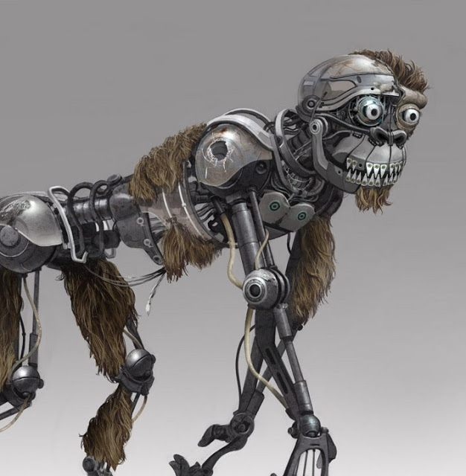
Jim Martin “Robot Monkey has seen better days...”

Bibliography:
Best Life 2019 url https://bestlifeonline.com/life-before-technology/ (accessed March 2021)]
Francine R Cefola , Bobbi R Madry , Francine Barish-Stern, 2019, TELL IT TO THE FUTURE, Golden Quill Press;
J. Krishnamurti The Whole Movement of Life is Learning ,2015 , CRAFT Verlag C. Raab/O. Sosath
Krishnamurti foundation trust URL https://kfoundation.org/what-is-our-relationship-with-nature/(accessed March 2021)]
1993 ,,J. Krishnamurti , Krishnamurti to Himself: His Last Journal , Harper Collins
2004, Daniel Goleman Omnibus: "Emotional Intelligence", "Working with EQ"
2015 Sean Grover , When Kids Call the Shots: How to Seize Control from Your Darling Bully -- and Enjoy Being a Parent Again, Amacom .
Psychology today 2017 url https://www.psychologytoday.com/us/blog/when-kids-call-the-shots/201707/how-technology-lowers-emotional-intelligence-in-kids( accessed March 2012)
BROCK WIKI URL http://kumu.brocku.ca/robowiki/"The_Matrix:_Humanity_Reloaded"(accessed March 2021)]
Hayles, K.N. (1999). "How We Became Post Human: Virtual Bodies in Cybernetics, Literature, and Informatics." Chicago: IL University of Chicago Press.

Moravec, H. (1988). "Mind Children: The Future of Robot and Human Intelligence." Cambridge: Harvard University Press.

Weiner, N. (1954). "The Human Use of Human Beings: Cybernetics and Society" 2nd Ed. Garden City: NY. Doubleday.
Independent , url independent.co.uk(accessed March 2021)]
2021 Outlook url www.outlook .com(accessed March 2021)]

