

I acknowledge the use of Grammarly (https://www.grammarly.com/) on 24 Oct 2025 to support proofreading and editing of my written work for correct American spelling and grammar errors.
I confirm that I have not presented any AI-generated text as my own work. I confirm I have copies of my drafts, notes, and other resources I used before and after the use of AI tools which I may be asked to provide in evidence

Module Title: Hotel Placement Research Project
Module Code: BMIH6008
Assessment Type:
Research Project
Topic- Understanding the role of preventive maintenance practices in enhancing guest experience by shaping working facilities- A Case Study of Leonardo Hotels Exeter
Student Name: Mihai Alexandru Crisan
Student ID: 2217500
Tutor name: Kathryn Flynn

Acknowledgement
I would likely provide my acknowledgement to my teacher or educator for aligning with greater circumstances of norms in efficient ways and manner. Based on their ultimate guidance, I have learnt the major books and articles required to understand the in-depth understanding of the work in efficient ways. Furthermore, I will also provide by sole contribution to the participants have prominently provided their transparent and clear statements in the interview. Absence of the contribution in this research work might result in limitation and create prominent impact. Furthermore, I will also be grateful of my librarian, who have ensured to provide me hardcopies that aligns with my research topic in efficient ways and manner.

Declaration
I hereby declare that this Hotel Placement Research Project is my own original work. All the sources of information and literature deployed have been duly acknowledged and properly referenced by following the academic standards and conventions. All the assessment guidelines have been strictly followed by understanding the University's policies on academic integrity. I hereby take full responsibility for the work submitted. The whole research and composition have been conducted independently and the final submission is an outcome of my own efforts and critical thinking.

Abstract
The context of the research project has been centred around in determining the role of preventive maintenance in improving the experience of guests at Leonardo Hotels. Providing a seamless experience to guests resonates with the utilisation of preventive maintenance that results in reducing downtime. Following the brief introduction of the rationale behind the context, it has led to the fulfilment of the objectives, which include addressing the various ways and techniques that shape the operational facility in the particular hotel. The research has also been conducted to showcase the different challenges as well as strategic measures to eradicate the highlighted challenges. The literature review has effectively shed light on the variety of proactive approaches by the company, which has been initiated by the establishment of the checklist and rigorous inspection. Training of staff plays a significant role towards the utilisation of new technologies and highlights the way proper training is helpful for organising their operations. Consequently, conflicts among the stakeholders and the increasing cost of operations are considered some of the barriers to fulfilling the user experience in the hotel. The continuous requirement of meeting the needs of guests creates urgency and leads to disrupting the comfort of the guests. Several strategies have been underlined in the research, which include careful management of assets and adequate data-driven decisions, alongside focusing on small deliverables such as routine checks. Literature review has also delved into the conceptual framework along with the theoretical framework, which includes change management theory and resource-based view, for further understanding of the guest experience. In the further chapter of the research, there has been a discussion of research methods and the different methods that have been adopted to apprehend the perspective of this research. The overall research emphasised on the primary data from the conduction of semi-structured interview and further synthesised. Subsequently, the SWOT analysis of the case study, along with the PESTEL frameworks, has been effective in the research on the case study. It has highlighted strengths such as frequent inspection and encouraging collaborative practice among the teams and staff to effectively address the issues of guests. It has been indicated that adapting to the digital system and ensuring training of their employees in advanced technologies are recognised as some of the opportunities for the company. Analysing the external environment scenario revealed the strong regulatory compliance of the UK, along with economic and technological growth. The discussion of the research has signified the analysis and findings of the interview, which have effectively demonstrated the views and feedback of the participants. It has suggested some of the practical recommendations to further pinpoint their improvement areas. This has been disclosed that effectively allocating the resources and administration of predictive maintenance technologies such as IoT can ensure the real-time system. Meanwhile, managing the internal operations by collaborative efforts and encouraging professional development of staff to help them in better serving their guests. There has also been a suggestion to incorporate feedback from the research and adapt industry practices, and reflect on the benchmark set by players in the relevant industry of hospitality.

Table of Contents
Chapter 1: Introduction 8
1.1 Background and Context 8
1.2 Problem Statement 8
1.3 Research aim and objectives 8
1.4 Research Rationale 9
1.5 Significance of research 9
Chapter 2: Literature Review 10
2.1 Introduction to the review 10
2.2 Key Concepts and review of literature 10
2.2.1 Various processes for preventive maintenance to shape working facilities in order to enhance guest experiences 10
2.2.2 Challenges confronted by hotels in integrating preventive maintenance for enhancing guest experiences 11
2.2.3 Strategic measures undertaken for the successful incorporation of preventive maintenance, in order to improve guest experiences 11
2.3 Conceptual Framework 12
2.4 Theoretical Framework 13
2.5 Literature Gap 13
2.5 Summary of Chapter 14
Chapter 3: Methods 15
3.1 Research Philosophy 15
3.2 Research Approach 15
3.3 Research Design 15
3.4 Data Collection Tools 15
3.5 Data Analysis Process 16
3.6 Sampling Techniques 16
3.7 Time Horizon 16
3.8 Research Reliability and Viability 16
3.9 Ethical Considerations 16
Chapter 4: Application of Framework (Case Study Analysis) 17
4.1 SWOT Analysis 17
4.2 Application of the PESTLE framework 18
Chapter 5: Findings and Analysis 21
5.1 Findings 21
5.2 Discussion 31
Chapter 6: Conclusion and Recommendations 33
6.1 Conclusion 33
6.2 Recommendations and Practical Strategies 34
References 37
Appendix 42
Gantt Chart 42
Ethics Form 42

Chapter 1: Introduction

1.1 Background and Context
Functioning with seamless experiences, it creates a larger impact in reciprocating with greater aspects of utilising preventive maintenance (Howells, 2021). Manufacturing companies are also adopting the following role of preventive maintenance in which it has seen cost downtime by 42% increasing approximately 50 billion British Pounds annually (Garibian, 2025). It has also been seen that a 30% impact has been recognised due to certain actions. Leading to efficient experiences of the guest, it has been seen that decline in guest experience has been seen for those companies who have not followed (Dominioni, 2023). Preventive maintenance also includes the use of AI, therefore, the common workers or ground staff have been productive due to use of the automation software by 40% (The Flexkeeping Team, 2021). It is also seen that, employees are not very fond of consequently understanding the systems or algorithm of preventive maintenance therefore fail to maintain outcome by 90% to 82% (Ofori-Boateng, 2020).

1.2 Problem Statement
Significant time and money savings are maintained due to the role of preventive maintenance as fair it is seen, in efficient ways. Adhering to the right significance of the notions required to have a prime operating profit (Wright, 2025). Based on maintaining good machinery facilities, hospitality equipment and many more adequately enlarging larger consequences in the UK hospitality sector (Williams, 2025). The purpose of the role of preventive maintenance is to understand the requirements in the workplace of customers and align with their demands prominently. For example fast-paced hospitality services required to have preventive maintenance as a means to enrol with common aspects of guest rooms satisfaction (Smoliienko, 2025). Based on certain applications, Leonardo Hotels Exeter has experienced challenges which will be highlighted through strategic measures undertaken by them (Leonardo Hotel Exeter, 2025).

1.3 Research aim and objectives
Aim
To understand the role of preventive maintenance practices taken by Leonardo Hotels Exeter in enhancing guest experience by shaping working facilities
Objectives
To identify various ways through which preventive maintenance techniques are shaping the working facilities at Leonardo Hotels Exeter for enchanting guest experiences.
To examine the challenges experienced by Leonardo Hotels Exeter while integrating preventive maintenance for enchanting guest experiences through shaping the working facilities.
To evaluate the strategic measures undertaken by Leonardo Hotels Exeter for mitigating the challenges and affirming the successful incorporation of preventive maintenance, in order to improve guest experiences by working on facilities.
Questions
1. What are the various ways in which preventive maintenance techniques are shaping the working facilities at Leonardo Hotels Exeter for enchanting guest experiences?
2. What are the extreme challenges faced by Leonardo Hotels Exeter while integrating preventive maintenance for enchanting guest experiences through shaping the working facilities?
3. What strategic measures that have been adopted by Leonardo Hotels Exeter for mitigating the challenges and affirming the successful incorporation of preventive maintenance, in order to improve guest experiences by working on facilities?

1.4 Research Rationale
Based on anticipating the enlargement of greater circumstances, it has been seen that understanding the role of preventive maintenance plays a greater role. As it shapes, the longing as a means to have efficient consequences of understanding the role of arrangements in shaping the working facilities in efficient ways. A high way of assisting with larger consequences creating a larger way of understanding the needs required for customers. As long as it plays with vital circumstances it is also maintained to analyse with greater circumstances as a means to have valid ways of adjusting greater norms by researchers studying at university level (Rosowsky, 2022).

1.5 Significance of research
High development research work is done by understanding the preventive maintenance in uplifting working facilities in the hospitality sector of the UK. Common circumstances maintaining the skills and knowledge management are done through which highlights in assessing with greater understanding (Vitasek, 2024). Therefore, in which customer understanding and the ways it creates in managing larger scalability processes in efficient ways.

Chapter 2: Literature Review

2.1 Introduction to the review
Summarising the existing literature-based scholarly articles, journals and books for developing a comprehensive knowledge is considered a literature review. Through connecting different sources at the same time following section will aim to synthesise by showing the relation between topics for aligning with research objectives. The core answer to the research questions will be served in this section through generating a brief generalised discussion. Further, the data collection and findings portion will be guided by having a foundation for the study.

2.2 Key Concepts and review of literature

2.2.1 Various processes for preventive maintenance to shape working facilities in order to enhance guest experiences
Development of comprehensive checklists
Discussed by Giousmpasoglou and Marinakou (2024), preventive maintenance techniques are mainly associated with the process of creating detailed and standardised checklists for all areas of work. Focusing on guest-facing aspects like HVAC systems, plumbing and electrical outlets, these mainly prioritise safety features which might include smoke detectors. Moreover, these approaches can be significant in integrating CMMS software utilisation to centralise the maintenance tasks while tracking progress in real-time.
Detailed inspection
Ewin and Oye (2025) said that, through regular inspection, the detection of early signs of risks is more likely to be leveraged in this context. In areas like hospitality, it is needed to analyse the wear and tear situations for carpets, lighting and furniture, which can serve a better guest experience. Through improving working facilities for the existing staff and allowing them to have a detailed inspection, hospitality businesses tend to provide a better customer experience.
Staff training
Noted by West et al. (2024), proper staff training associated with the predictive maintenance procedure, while using new software and tools, can improve the procedure. Proper training through predictive maintenance can allow the company to leverage effectiveness in managing organisational operations more efficiently. Creating and maintaining an inventory can be significantly managed by supporting the workforce in the change.

2.2.2 Challenges confronted by hotels in integrating preventive maintenance for enhancing guest experiences
Stakeholder conflicts
As stated by Au-Yong et al. (2024), management of stakeholder conflicts is more likely to hinder the process of success in the context of preventive maintenance interaction. Owners and operators might have different beliefs towards maintenance, which can lead them towards diverse challenges in managing compliance. Encompassing effective communication can allow companies to manage their stakeholder perspectives while maintaining their business.
Rising operational costs
Tonoy (2025) stated that a critical reactive maintenance system can be challenging due to its nature of being cost-ineffective. Operational cost can be increased through this by causing emergency callouts, expensive emergency repairs, and loss of revenue from unavailable rooms. According to Wouterse et al. (2025), preventive maintenance, on the other hand, requires initial investment to support sustainable growth and prevent future costs.
Guest experiences balance
Discussion made by Mediratta (2025) justifies that guest expectations are evolving in the modern industry, which creates a continuous need for existing companies in the hotel and hospitality industry to adopt the changes. While Wilson (2025) mentioned that balancing the need for maintenance with guest comfort has been significantly required. It is essential to consider task completion within a schedule without changing customer experience during the guest hours.

2.2.3 Strategic measures undertaken for the successful incorporation of preventive maintenance, in order to improve guest experiences
Comprehensive asset management
A hospitality company often requires staying updated to manage its asset management section. Noted by Rantatalo (2025), creating an asset inventory for tracking all the equipment, components and maintenance logs can help in leveraging effectiveness. Following this approach, the hotels are more likely to have a clear picture of the required maintenance and probable failures during guests' stay.
Data-driven scheduling
As discussed by Taloma et al. (2025), integrating data-driven practices which can promote significant maintenance scheduling of equipment conditions, usage and time intervals using a mix of periodic and network-based predictive methods can be beneficial. Narrated by Lucantoni et al. (2025), data-scheduling can be beneficial in ensuring systems are serviced before having any disruptive failure.
Focus on guest-facing systems
Hutsaliuk et al. (2025) narrated that routine checks on the key guest impacting systems like guest room, fixtures, elevators and public areas are significant to be analysed. Through directly contributing to guest satisfaction by providing better amenities, companies are able to form a proper functional shower in a comfortable room.

2.3 Conceptual Framework
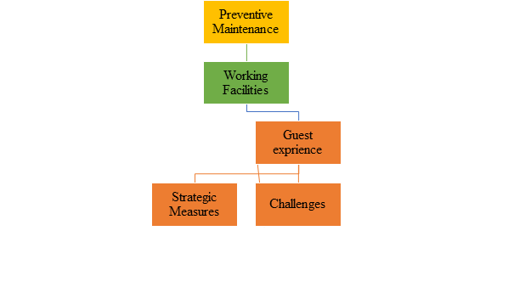
Figure: Conceptual Framework
Source: (Author, 2025)
The Following conceptual framework has conceptualised the preventive maintenance approach through working facilities and guest experiences at companies like Leonardo Hotels Exeter. Preventive maintenance mainly acts as an independent variable that influences the condition and performance of existing working facilities. Considered as the moderating variables, these are more likely to lead towards improved facilities while enhancing guest experience. The aforementioned article additionally highlights obstacles. To successfully implement the technique and enhance the experience of guests, strategic measures, that deliberate efforts for enhanced outcomes, have also been incorporated.
2.4 Theoretical Framework
Systems Theory
Becvar et al. (2023) highlight that the idea of systems mostly emphasises the interdependence among numerous organisational aspects when taking an integrated approach to managing multiple activities. In the context of the theory, this is significant that preventive maintenance is a systemic approach which affirms the seamless function of all physical assets. Through adopting preventive maintenance as a part of a larger operational environment, system theory showcases the ability to foster reliability and consistency in the process of service delivery.
Change Management Theory
Phillips and Klein (2023) said that challenges commonly encountered in the hospitality industry associated with the maintenance process are more likely to need better change management. Lewin’s Change Management Theory, explaining transition phases like unfreeze, change, and refreeze, can help during disputes in existing processes. Resistance during change among the staff can be effectively understood and supported by the theory of integration by the companies.
Resource-Based View
Analysed by Ferreira and Ferreira (2025), the understanding of competitive advantage arising from unique resources can be analysed from the resource-based view theory. Narrated by Lubis (2022), investing in strategic maintenance and facility upgradation processes, hospitality companies can leverage physical and human resources to top-tier their guest experiences. Following RBV, hospitality businesses can enrich their operations with significant resources.

2.5 Literature Gap
Through discussion on the topic has been showcased that the existing literature extensively covers preventive maintenance in the industrial tourism and hospitality sector. However, there are some limited insights into its role in enhancing guest experiences within the hospitality environment, causing barriers to improvement. A potential link between maintenance strategies and perceived service quality has been avoided by most of the studies while learning about the mid-scale hotels. Additionally, challenges remain consistent as a lack of empirical data causes operational barriers during implementation. Resource-based view has been expected to be effective as per Ferreira and Ferreira (2025), yet its viability for Leonardo Hotels Exeter has not been justified. Consequently, Au-Yong et al. (2024) discussed that stakeholder conflicts are a challenge in managing preventive maintenance. However, there is no corporate-based evidence which can justify the information based on the chosen case study.

2.5 Summary of Chapter
Overall discussion made in the research showcases effective literature which is beneficial in the context of leveraging effectiveness. Integration of preventive maintenance is expected to be beneficial despite critical and small challenges, which are significant in managing success. Focusing on the existing authentic scholarly articles and journals, researchers have been able to create a foundation for the study. Prioritising the research, a proper people management aspect has been analysed with strategic actions which can help in mitigating the barriers.

Chapter 3: Methods

3.1 Research Philosophy
The undertaken philosophical choice is interpretivism in this course of action as per its nature. It is aimed to assess the functionality of preventive maintenance to shape guest experience within a specific organisational context. This specific choice helps in finding the real life scenarios leading to the generation of practical contexts (Junjie and Yingxin, 2022). It is justifiable if seen from the perspectives of Saunder’s Research Onion where this one proves to be the most suitable one.

3.2 Research Approach
Inclusion of data types and purpose of the research is aligned with an inductive approach. This goes well with the qualitative study where theoretical patterns are expected to be created through new observations and evaluation (Diller and Passmore, 2023). Case studies and other secondary paths of such analysis have good synergy with this kind of approach. Association of primary routes is also taken into consideration here to gain a vast set of data. Having a focus on complexities and underexplored patterns in the topic is completed by this choice.

3.3 Research Design
A multi-method synergy has been employed in this research that is based on the organisational context of Leonardo Hotels Exeter. It is a qualitative study where two different kinds of sources have been utilized (Phillips et al., 2024). An interview has been conducted here including maintenance manager and associated assistance in the process. From the scenario of secondary path review of customer feedback and case study of the business environment are executed. The questions made for the interview are specific and directly questions the research objectives for addition of depth.

3.4 Data Collection Tools
Major primary data has been arrived from the semi-structured interview with two key participants from the considered company. The Maintenance Manager followed by the assistant are in the course of action to take insights from (Adeoye‐Olatunde and Olenik, 2021). Each of the questions has focused on the research aim from a range of aspects created in Google Forms. Secondary data were accumulated from case studies where various industry information, government reports, journals and many more have been utilised. Review of users from the company website and also Google have been done to add value in the process.

3.5 Data Analysis Process
The results of the interview are gained from Google Forms in a structured way to have specific answers to the questions. Specific frameworks have been taken into use like PESTLE and SWOT to showcase the condition of the associated business environment. Taking evidence of the ways customers shared their reviews and feedback on the website and other trusted platforms, an analysis has been provided to state their perception (Frazer and Thielking, 2023).

3.6 Sampling Techniques
A purposive sampling style has been aligned in this case to select only two participants as stated previously (Nyimbili and Nyimbili, 2024). It is to ensure a value-adding involvement of individuals from the organisation for providing related information on the topic. This process is good to conduct qualitative research and dive deep into the execution.

3.7 Time Horizon
The course of action has applied a cross-sectional horizon of time to complete the research within definite means. Such an approach is good to take data and carry out all the activities in regard to a specific time period (Simkus, 2023). A longitudinal view might be applied in this path to ensure the gathering of more profound information. However, this was not needed or it is not the actual purpose of the work which makes the cross-sectional choice the superior one.

3.8 Research Reliability and Viability
The qualitative research is made with ensured reliability and validity to enhance the quality of outcomes. Credible data has been used here to keep the results practical like the first hand data collection and many more. A vast data set is being kept to help in triangulation marketing the reality. There is decent generalisability criteria to relate the outcomes to other similar contexts (McLeod, 2024).

3.9 Ethical Considerations
Maintenance of ethics is a vital thing to such scenarios and all the criteria have been maintained in the way. While carrying out the primary one informed consent has been provided to the participants here to let them know the purpose. Confidentiality along with anonymity are the things that have also been there to keep their sides protected. They can withdraw from the princess without having the consequences with them (research-methodology, 2025). In case secondary data usage, citations and proper referencing to make the work ethically successful.

Chapter 4: Application of Framework (Case Study Analysis)

4.1 SWOT
Strengths | Weaknesses
The inclusion of the approach of preventive maintenance at Leonardo Hotels Exeter plays a pivotal role in demonstrating high value of operational management. It also directly contributes towards managing the overall guest satisfaction. Managing and inspecting principal systems and activities involving the HVAC, plumbing, air conditioning and more ensure avoiding the occurrence of customer dissatisfaction and grievances. Swift and seamless addressing of various guest-reported issues are conducted by collaborating with maintenance staff and front-office teams.  (Duve , 2025). | The presence of certain identified weaknesses has disrupted the overall implementation of the preventive maintenance process. Having a very limited and less staffing levels have often led to develop major issues for the hotel. It exacerbates during the busy periods and resulted in giving rise to delayed responses. Important tasks like documentation and record-keeping are still kept partly manual and as a result of this, inefficiencies have been registered in monitoring progress(Garibian, 2025). Apart from this, the presence of heavy budget constraints also largely restricts the timely and adequate replacement of various worn-out equipment.
Opportunities | Threats
The adoption process of digital maintenance management systems for Leonardo Hotel Exeter is associated with multiple benefits and opportunities. Enhanced staff training develops technical expertise and preventive awareness, which leads to greater efficiency in operations. In addition to this, the use of data analytics plays a pivotal role in elevating the process of predicting maintenance needs in an accurate manner (Grooss 2024). Incorporating sustainability initiatives such as energy-efficient equipment and eco-friendly maintenance materials, strengthening the hotel’s environmental image and attracting more conscious guests. It can also make the firm successfully streamline the process of reporting and scheduling. | The overall effectiveness and role of the preventive maintenance system of the hotel gets largely impacted from the external and operational threats. The constantly rising energy prices and stricter environmental regulations are accountable for significantly increasing the levels of operational costs. All these incidents can directly end up challenging the existing budget. A very high guest turnover can be also noticed and frequent use of amenities sometimes A very crtical risk has been faced by the hotel while trying to maintain high level of guest and extensive competition has been faced from the rise of newer hotels in Exeter (Forbes, 2025).

4.2 Application of the PESTLE framework
Factors | Analysis
Political | The political and regulatory environment in UK plays a significant role in the activities of maintenance of Leonardo Hotels Exeter. Adherence to national building, health and safety regulations acted as a priority factor emphasised with regular inspection. Local authorities had policies and rules concerning workplace safety and energy management, which were strictly followed. It aided in avoiding punishment and preserve a good image in the society. Preventive maintenance was employed as a strategic measure to en sure that the property was in tandem with all the statutory requirements. It favoured the risk management system of the hotel (Leonardo, 2025).
Economic | Economically, the preventive maintenance strategy is directly impacted. Seasonal tourism and the general economic trends had an uneven effect on the occupancy levels in the hospitality industry in Exeter. Preventive maintenance was an important factor in minimising operational inconveniences and expensive emergency corrective actions, enhancing financial stability generally. Hence, the rising maintenance costs of materials and labour pool pressured the maintenance budgets, necessitated effective resource allocation and prioritisation. Long-term cost savings worked off and short-term expenditure is paid off in proactive maintenance (Donnellan, 2024).
Social | Social factors played an essential role in shaping preventive maintenance practices. Customers often look for services that combines comfort in a clean environment which implies reliability to be associated with their own experience. Hence, taking preventive maintenance ensures fostering all these needs with the inclusion of lighting, air conditioner and functional plumbing that soothes guests. A lot of repeated guest visitations are attained due to the positive brand image of the hotel. It is also responsible for causing a huge organisational growth and driving the rate of sales (Iwarue and Asanga 2025). Hence, it becomes very significant for the hotel to enable all its employees to work in a productive and inclusive work environment. All these positive aspects play a valuable role in causing an indirect impact on guest comfort and also enhances the level of service quality.
Technological | The necessity for doing digital maintenance has also contributed towards enhancing the level of tracking and communication among various departments of the company. On the other hand, a very adequate management of the preventive maintenance in Leonardo Hotels Exeter is achieved from the adoption of innovative technologies (SAP, 2025). Smart monitoring tools and predictive maintenance techniques enabled early detection of issues, reducing downtime and repair costs. Energy-efficient technologies such as LED lighting and sensor-based climate control systems were integrated to promote sustainability and operational efficiency. Adhering to technology transformed maintenance from a reactive to a data-driven, proactive function within the hotel’s operations.
Legal | Strict guidance from UK legislation related to health, safety and environmental protection was provided to the hotel’s maintenance operations. Preventive maintenance ensured compliance with the Electricity at Work Regulations, fire safety standards and water hygiene requirements. Regular audits and documentation demonstrated accountability and reduced the likelihood of legal breaches (hse.gov.uk, 2025). Failure to maintain compliance would have resulted in fines or reputational damage. Therefore, preventive maintenance acted as a safeguard to uphold the brand’s integrity and ensure guest safety.
Environmental | Environmental considerations were adequately embedded within the hotel’s maintenance practices. Preventive maintenance contributed to sustainability goals by promoting energy and water efficiency, minimising waste and extending the lifespan of equipment. Implementation of environmentally responsible measures such as recycling, use of eco-friendly materials and regular servicing of systems to avoid excessive consumption (The Business Concept, 2024). Aligning these practices with Leonardo Hotels’ broader corporate social responsibility commitments improved its brand image.

Chapter 5: Findings and Analysis

5.1 Findings
Assessing all the responses of the interview questions for the maintenance manager of Leonardo Hotel Exeter
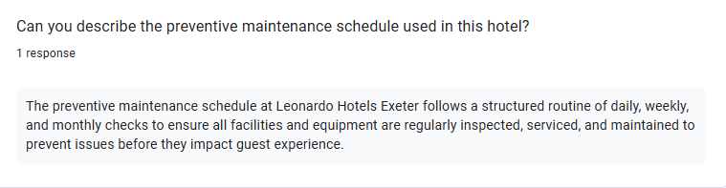
(Google form, 2025)
Analysis
The maintenance manager of Leonardo Hotel Exeter has given his opinion regarding the preventive maintenance. It follows a dedicated schedule that is structured for doing a monthly checking of every room. Some important tasks include performing a detailed inspection of all facilities like air conditioning units, furniture and more.

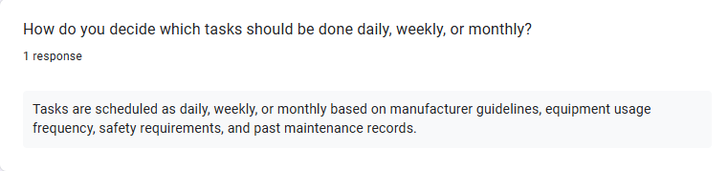
(Google form, 2025)

Analysis
The maintenance manager has given detailed answers during the interview regarding the allocation of tasks. According to him, all the major tasks and activities are chosen on the basis of their importance and mostly scheduled daily, weekly or even monthly. It remains highly dependent on the presence of frequency of equipment utilisation, past maintenance records and more.
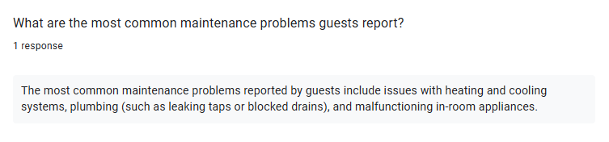
(Google form, 2025)
Analysis
The manager emphasised some common and majorly witnessed maintenance related problems that are reported by the guests. Some of them include the heating, cooling issues, plumbing difficulties, blocked drains and more. The overall system has registered some logging problems that are reported by guests or even staff.
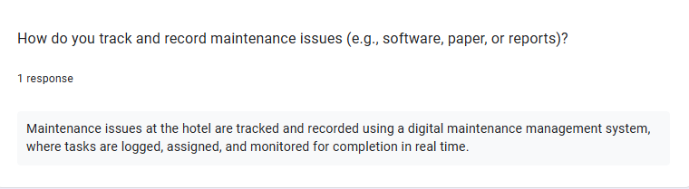
(Google form, 2025)
Analysis
The above response of the maintenance manager has managed to highlight some operational constraints that are measured through the application of a digital maintenance system. It plays a pivotal role in embracing a strong allocation of important tasks. Communication channels among multiple departments are kept functional and sometimes also deliberately slow down during the peak season of the hotel.
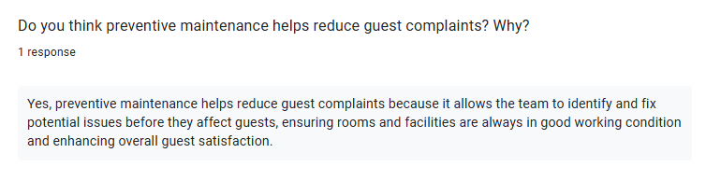
(Google form, 2025)
Analysis
The above response basically states the overall efficacy of the undertaken preventive maintenance system that is endorsed by the hotel. It plays a valuable role in bolstering all the staffing levels and helps in overcoming some major technical issues. Lots of minor repair requests that get piled up during peak occupancy seasons are also fulfilled.
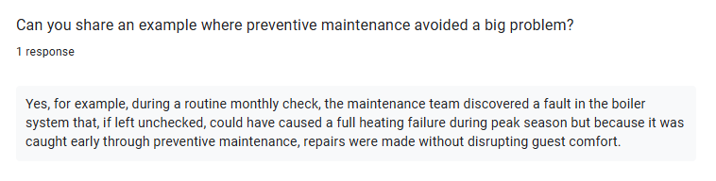
(Google form, 2025)
Analysis
A suitable example of the significance of the preventive maintenance approach followed by a hotel has been given by the maintenance manager. A fault in the boiler system has been located by the staff team and it could have potentially resulted in causing full heating failure. Hence, the manager has managed to identify the need for offering better coordination between housekeeping and maintenance.
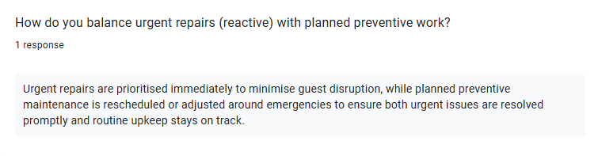
(Google form, 2025)
Analysis
The action of rescheduling the planned preventive maintenance has been often prioritised for dealing with all the urgent repair needs reported by the guests. It plays a pivotal role in maintaining a necessary balance between the swift resolution of urgent demands and also conducting routine checkups. The role of overseeing all repair works has been mentioned by the maintenance manager. Along with this, all the benefits they bring about for ensuring the smooth running of the hotel have been also disclosed. Moreover, the hotel is well known for using a digital system for tracking issues and ensuring a high level of guest comfort.
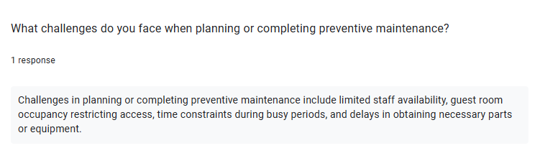
(Google form, 2025)
Analysis
One response of the manager has stood out and it involves the major challenges experienced while trying to cope with all the challenges of the preventive maintenance completion. The manager has also stated the guest satisfaction is high owing to the quick responses. However, some critical challenges have been mentioned with the presence of delay in necessary equipment, less staff availability and more.
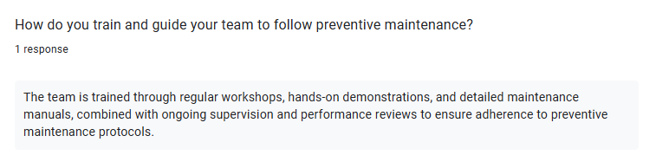
(Google form, 2025)
The manager's views on the importance of offering adequate training and guidance to the staff have been very interesting. This also plays a valuable role in directly establishing ties into maintenance by preventing waste. The action of attending courses on safety, use of new equipment, partaking in regular workshops and more has been stated. Budget is considered one of the key factors and the need for doing collaboration with other departments has been also stated.
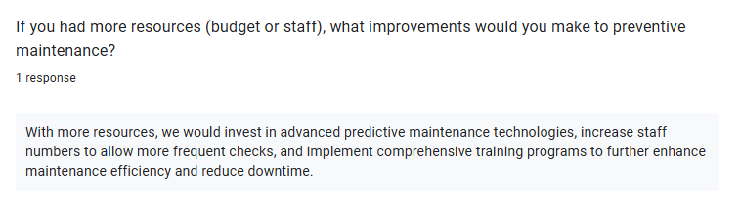
(Google form, 2025)
Analysis
The above interview response has depicted the significant improvements that would have been made by the maintenance manager himself in the current hotel’s preventive maintenance. All these measures have been chosen since they are both cost‑effective and help in maintaining high standards. The tactical actions involving incrementing the total number of staff, adoption of training programmes and more have been taken into account.
Analysing all the responses of the interview questions for the maintenance assistant of Leonardo Hotel Exeter
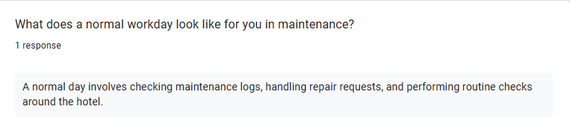
(Google form, 2025)
Analysis
The above response has tried to describe the normal workday for the maintenance assistant and some important relevant tasks have been showcased. His primary role pivotally remains focused on doing various hands-on work and starts the day with a checklist of tasks. Fixing minor issues, doing routine checks and more are performed for ensuring a high level of guest satisfaction.
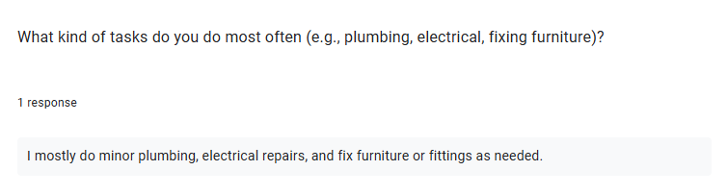
(Google form, 2025)
Analysis
The maintenance assistance has described the tasks of executing minor plumbing operations, doing electrical repair and more as its daily job roles. A typical repair process is being followed and appreciates the manager's support in resolving the identified issues at a rapid pace. All the furniture fixing, electrical repairs and fittings and more are successfully accomplished.

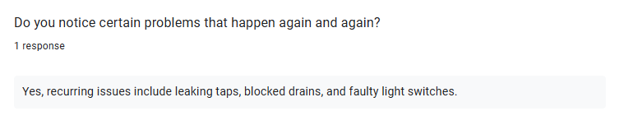
(Google form, 2025)
Analysis
Some recurring and widely observed issues faced by the guests have been stated in the above response. They include the presence of leaking taps, blocked drains and more. During peak season all these issues pile up and despite this, the assistance still feels the system works well and guest feedback motivates him.
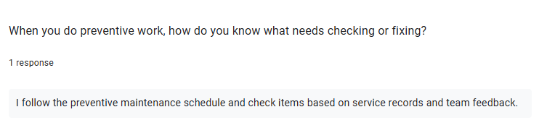
(Google form, 2025)
Analysis
The reason behind adopting the preventive work has been showcased in the above interview response. Following a preventive maintenance schedule and regularly checking items on the basis of service records has been taken into consideration by the assistant. He has also mentioned the role of teamwork and it has been disclosed that he has worked with the manager on executing many bigger jobs.
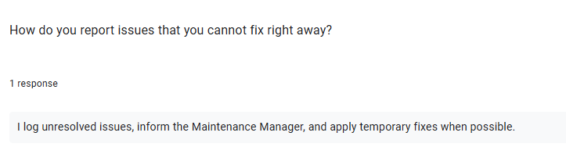
(Google form, 2025)
Analysis
The above response has tried to demonstrate the process of reporting the issues that get very difficult to fix instantly. The assistant manager has said that all the unresolved issues get informed to the manager and sometimes temporary fixes are also applied in emergency cases. Compared to the manager, this response of the assistant has been more day-to-day focused. Budget has been completely ignored and he has agreed on the importance of preventive checks.
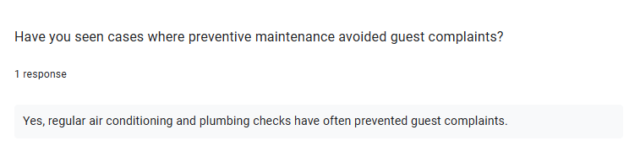
(Google form, 2025)
Analysis
Regular plumbing checks and air conditioning have found out to be the major incidents in which all the guest complaints get avoided by the preventive maintenance. A solid maintenance framework has been developed and the manager is known for mainly handling all the strategies. Both assistant and manager complement each other and this could help in resolving all the identified risk factors.

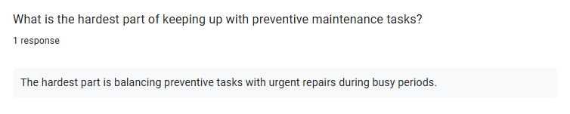
(Google form, 2025)
Analysis
Trying to balance all the important preventive tasks with those of urgent repairs needs have turned out to be the most difficult part of preventive maintenance tasks. The maintenance assistant has described the role as both demanding and rewarding. This particular response has managed to reflect a particular hands-on understanding of all the operational challenges that are faced daily.
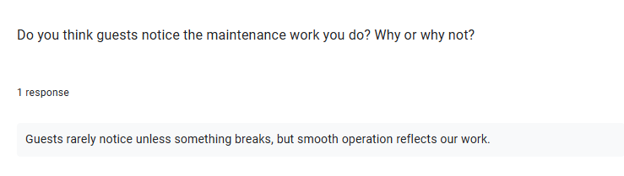
(Google form, 2025)
Analysis
The maintenance assistant has stated that the guests rarely have observed any faults in the hotel maintenance operations. He mentioned the significance of the hotel’s fault‑reporting system and the ways it has made the job easier.
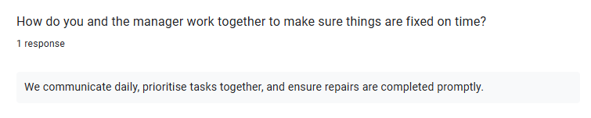
(Google form, 2025)
Analysis
The assistant has acknowledged positive guest interactions and it has done so by maintaining a smooth communication channel with the maintenance manager. Despite completing all the repairs in a prompt manner, some occasional setbacks have been mentioned that underline the importance of maintenance resources.
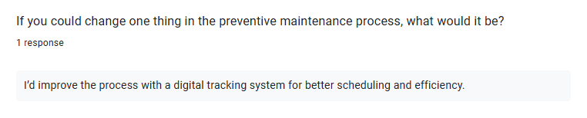

(Google form, 2025)
Analysis
The digital tracking system has been chosen by the assistant to further improve the preventive maintenance process. It has been selected for enhancing the rate of scheduling and efficiency. Overall, this particular insight of him depicts the ways for striving towards getting high efficiency and overcoming all the physical and logistical limits.
Analysing some reviews and guest feedback
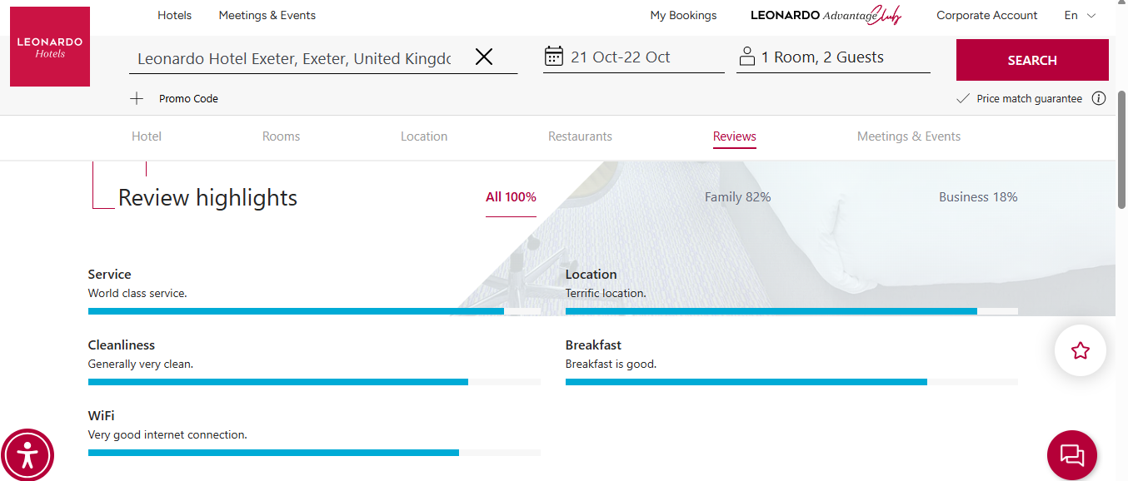
Source: (Leonardo-hotels, 2025)
Analysis
All the guest reviews on the official website of the Leonardo Hotel Exeter help in offering different perspectives. Many guests have praised the main location of the hotel in Exeter as it is located very close to various shops and attractions. Some guests have also reported positive experiences regarding comfortable beds and very reliable Wi-Fi connection.
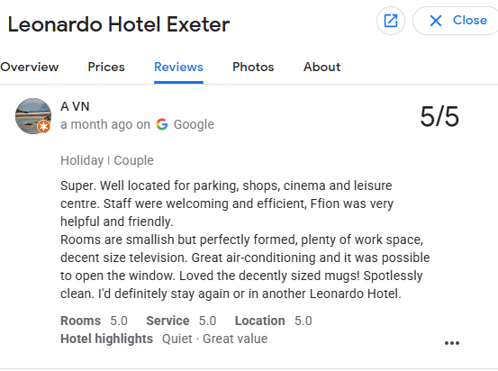
Source: (Google, 2025)
Analysis
The above guest review has been helpful in depicting the positive side that includes staff friendliness, adequate spaces for parking and more. Apart from thanking the maintenance team for offering help and suitable appreciation is also provided for doing some late-night repairs. Facilities like great air conditioning, cleanliness and more have offered good marks to the hotel.
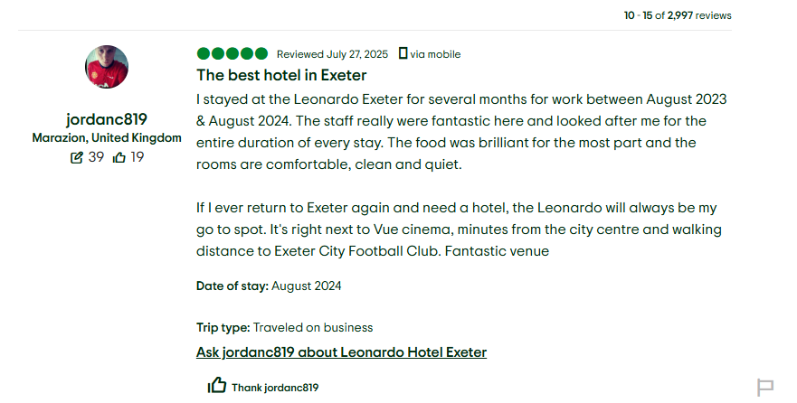
Source: (Google, 2025)
Analysis
The above review of the guest has stated the Leonardo Hotel as the best hotel in the location of Exeter. All the maintenance and staff services have been greatly praised along with welcoming the quality of food and spacious rooms. Overall, the hotel is known for doing well with all the basics and properly addressing the common complaints have led to boosting the guest satisfaction.

5.2 Discussion
Key results gained from the research were primarily gained from the interview and the literary aspects shared by scholars. The aspects gathered from the interview with the maintenance manager and the maintenance assistant of the Leonardo Hotel Exeter. Also, an analysis of the reviews left by the guests offered information on the effectiveness and operational issues of preventative maintenance in the hospitality industry. A planned preventive maintenance programme is strictly adhered to and the duties are specified based on the frequency of use and other aspects as well. Focusing on the consistency of the results with the study by Giousmpasoglou and Marinakou (2024), it discusses the significance of the detailed checklists and systematic procedures. Their necessity in improving operational efficiency and improving the guest experience, through the implementation of digital maintenance systems, was emphasised. It was considered critical to simplify the distribution of tasks and repairs and coordinate interdepartmental operations. Overall, the justification of previous academic claims about the role of technology in the centralisation of the maintenance process was ensured by West et al. (2024).
From the analytical discussion of answers, some technical failures like air conditioning problems, plumbing problems and repair of furniture were addressed. In confirming the insights of Ewin and Oye (2025), it has benefited from the timely identification of wear and tear. They can be a major contributor to both the minimisation of disruption in the operations and the satisfaction of the guests. It has been noted that preventive maintenance responds accurately to operational short-term needs and also helps in the service quality in the long term. By reducing the chances of major failure, as in the case of the boiler syste, as pointed out by the maintenance manager. Support for the current literature stating that preventive maintenance is a crucial factor that takes care of the reliability of primary equipment and facilities. As a direct factor, it affects the overall guest experience as confirmed by Au-Yong et al. (2024). Furthermore, it is also necessary to understand the adequacy of the interview questions which were staff training. Both the manager and assistant emphasised the need to offer sufficient training on safety measures, the use of new equipment and the implementation of digital tracking systems. It implies the academic discussion of the importance of workforce readiness in predictive and preventive maintenance as per West et al. (2024). Furthermore, by introducing technology-based solutions, the maintenance operations positively influenced the efficiency of scheduling and responsibility is sustained. It consistently suggests the integration of both knowledgeable staff and modern systems to maximise the effectiveness of the operations.
Some difficulties in the application of preventive maintenance were also observed. For example, common problems were stakeholder conflicts, lack of resources, seasonal pressures and delay in equipment delivery. Resonating the results with the claims made by Au-Yong et al. (2024) strongly emphasises operational limitations in maintenance management in the hotel sector. In terms of fostering a balance between the routine preventive maintenance activities and urgent maintenance. As mentioned before, despite communication channels being generally effective, at times they slowed down during the peak occupancy times. Hence, they require adaptive strategies of coordination to effectively control the workload. From these results, it has been indicated that preventive maintenance can be very effective. However, the operational constraints and scarcity of resources may hinder the optimal implementation of the preventive maintenance. It supports the necessity to develop a strategic plan to be prioritised. The internal findings of the operations were complemented by the analysis of the guest feedback. Overall, the hotel was always praised by reviews as responsive to maintenance problems, facilities which offer reliability and comfort. Favourable guest opinion on air conditioning, Wi-Fi and resolution of minor repairs denotes that the preventive maintenance system played a significant role towards guest satisfaction. Hence, it confirmed the direct relationship between operational excellence in maintenance and perceived service quality. It validates the assertion by the literature of the importance of guest-focused approaches in creating hospitality brand value, as discussed by Giousmpasoglou and Marinakou (2024).
However, there are some shortcomings of the study that must be admitted. The study was based only on the interviews conducted with two employees and the secondary source of data about the opinions of guests. It could be stated that the data might fail to reflect such a wide experience of employed in various sections or seasonal differences in the work of hotels. Also, the guest reviews were helpful. However, these were only available through the online platforms and could have been biased towards selection. Future studies that include more samples, cross-departmental lenses and quantitative measures of operations. They may be able to give a more extensive assessment of the effectiveness of preventive maintenance.

Chapter 6: Conclusion and Recommendations

6.1 Conclusion
Summary of findings
The study has tried to explore the significance of preventive maintenance in terms of making the customer experience great within Leonardo Hotels Exeter. Handling the facilities and operations in shaping the guests’ conditions in this organisation. It has been executed following a multi-method way where qualitative data being the only data type to consider. A two-way methodology was there where both primary and secondary origins have been included. The interview was done keeping an emphasis on preventive maintenance and its role where the main participants were the hotel's Maintenance Manager and Maintenance Assistant. The secondary information was achieved through guest reviews taken from credible sites and sources. A case study structure was also being applied there accompanied by relevant frameworks like SWOT and PESTLE as well. As per the outcomes of the work Leonardo Hotels Exeter already has a plan for preventive maintenance on the basis of daily, weekly and other interval maintenance as well. There are some main areas where they focus like conditioning, furnishing the appearance, room accessibility or many more like plumbing. From the insights of the Maintenance Manager it is a fact that task prioritisation is perceived by frequency, previous shortcomings and many more. Both the Manager and Assistant indicated the real-life tracking of the maintenance to be in the top priority. They also stated that having a good flow of communication across the departments is also very needed. From the view the guest reviews various facts have been revealed and contributed to the findings. Minor issues in service pace, tidiness or even the room elements of accommodations functioning have been indicated by them. Barriers have been listed from a diverse scale such as labour voids, delays in supply chain and work complexities during the peak times of the market. Apart from that, both of the people in the interview showcased protocols and other problems that come while working in collaborative ways. Overall, the study showcased the usage and broader fields of preventive maintenance. There are a lot of scopes to support the guest experience to ensure continuity in services, risk analysis and many more. The findings for Leonardo Hotels Exeter helped in understanding the influence of service shortcomings for guests with the help of proper planning.
Limitations acquired in this research
Accepting only data and information from doing the interview through primary data sources has created a limitation. In which high consequences have been seen, getting through first hand data collection only. These circumstances have created a great gap. Only collections from participants were not enough which required in-depth analysis which are not available. Application of previous evidence from existing researchers is very low as per the important topic undertaken by the investigator. Therefore, certain limitations have created disruption in maintaining prominent quality work. High use of secondary data is not highly available which is creating a major impact as a means to assess common norms in efficient ways and manner (Dale et al., 2025). In which high consequences have been seen, getting through first hand data collection only. Major skill development based on finding or knowledge understanding are not done as a means to manage with common circumstances effectively. A high way of assisting with larger consequences creating a larger way of understanding the needs required for customers based on the topic of great evidence is not collected.
Further direction for the researcher
One of the prominent ways of maintaining a high-quality work is to understand the entail factors required for resources in upscaling the research work. Greater norms of understanding in validating larger facts have been addressed through authentic collection of the data apparently. Improvement in a solid way of understanding through perfect and best collection of data is needed to maintain a high collection of secondary formation. These approaches help to bring the ultimate quality and in-depth analysis in efficient ways and tactics. A high way of assisting with larger consequences creating a larger way of understanding the needs required for customers will be ensured which are highly needed to be improved by the investigator. More newer and high-quality questions needed to be asked by both participants creating a valid reciprocation effectively.

6.2 Recommendations and Practical Strategies
Increase Preventive Maintenance Staffing and Resource Allocation
Staffing related issues have been noticed here where lack of scopes and high occupancy factors. Hence, it is recommended to the company to look into this matter and maintain the staffing related areas in the peak seasons. Hiring extra staff in those periods for ground levels works like housekeeping and other means to enhance the service quality. Moreover, there can be a specific budget for preventative maintenance to carry out those things.
Implement Predictive Maintenance Technologies
The digital system for fault-reporting may be enhanced in terms of its operations with the use of predictive maintenance. It is suggested to apply technologies like IoTs and other smart settings to have real-time updates of issues if any (Forbes, 2024). These can provide signals of any failure and issue to take prompt measures. It also reduced the damage and efforts in the repairs within emergency activities.
Strengthen Interdepartmental Collaboration
There needed to be better inclusion of communication across the departments starting from the management to base levels ones. Having a virtual or digital dashboard can prove to be beneficial as well to report any issue and expect the solutions at a faster pace. Discussion sessions in a consistent way or executing joint briefings may keep all the associated teams informed.
Enhance Staff Training and Development
The manager and associated assistant both showcased the value of training in case of the employees. It is beneficial for the hotel to create a well-suited preventive maintenance program for staff. They will be compliant with equipment along with safety measures leading to good hospitality services. Meeting the experience expectations of the guests, resolving disputes and many more would be possible through this route (Leonard, 2025).
Create a Feedback Loop from Guest Reviews
Among all the evidence and research findings the customer reviews revealed a great side in this course of action. They should look after the functionality and relevancy of the apparatus and systems in the accommodations. Hence, having a glance over the comments and reviews would be maintained to make changes accordingly.
Establish Maintenance Scheduling via CMMS
Incorporation of CMMS can enable a chance for accurate tracking of equipment usage through automating service reminders while affirming systematic planning in managing the maintenance activities. Organisations utilising CMMS are likely to have a significant increase in their equipment uptime and a reduction in unexpected failures (Garibian, 2025). For the hotels, this can also minimise service disruption while affirming cautious guest comfort. CMMS can be beneficial in helping with performance evaluation while generating maintenance logs, which can help in proper compliance with health and safety regulations.
Adopting Sustainability-Oriented Maintenance Practices
Sustainability goals with a maintenance process can help companies to have betterment in their operations. Optimisation of HVAC systems for energy efficiency or utilisation of eco-friendly cleaning materials can reduce operational costs, which can appeal in a better manner to the environmentally conscious guests (Enwerem et al., 2025). As per the World Tourism Organisation, hospitality companies' adoption of green maintenance practices is more likely to have increased guest satisfaction (untourism, 2025). Sustainable maintenance also extends asset life, which can directly or indirectly contribute to long-term operational efficacy.
Benchmark Against Industry Practices
Helping the staff to cope with the industry changes can be possible through continuously comparing their preventive maintenance performance with the industry leaders (Ewin and Oye 2025). Leonardo Hotels Exeter will be able to foster continuous improvement through benchmarking, which can mitigate the current gap while revealing the areas of improvement. The well-known hospitality company will be able to adopt tested strategies while outperforming competitors with the help of superior methods (Elche et al., 2021).

References
- Adeoye‐Olatunde, O.A. and Olenik, N.L., (2021). Research and scholarly methods: Semi‐structured interviews. Journal of the american college of clinical pharmacy, 4(10), pp.1358-1367.
- Au-Yong, C.P., Hoh, P.K. and Amos, D., (2024). Enhancing the Maintenance Practice to Improve Guests’ Satisfaction in the Hotels Industry. Built Environment Journal, 21(1), pp.18-29.
- Becvar, R.J., Becvar, D.S. and Reif, L.V., (2023). Systems theory and family therapy: A primer. Rowman & Littlefield.
- Bryman, A. (2008) Social Research Methods. 3rd ed. Oxford: Oxford University Press.
- Collis, J. & Hussey, R. (2014) Business Research: A Practical Guide for Undergraduate and Postgraduate Students. 4th ed. Basingstoke: Palgrave Macmillan.
- Cottrell, S. (2011) Critical Thinking Skills: Developing Effective Analysis and Argument. 2nd ed. Basingstoke: Palgrave Macmillan.
- Cottrell, S. (2014) Dissertations and Project Reports: A Step-by-Step Guide. Basingstoke: Palgrave Macmillan.
- Cottrell, S. (2014) Dissertations and Project Reports: A Step-by-Step Guide. 2nd ed. Basingstoke: Palgrave Macmillan.
- Dale, A., Arber, S. and Procter, M., (2025). Doing secondary analysis. Taylor & Francis.
- Denscombe, M. (2010) The Good Research Guide: For Small-Scale Social Research Projects. 4th ed. Maidenhead: Open University Press.
- Diamantopoulos, A. & Schlegelmilch, B.B. (2002) Taking the Fear Out of Data Analysis: A Step-by-Step Approach. London: Thomson Learning.
- Diller, S.J. and Passmore, J., (2023). Defining digital coaching: a qualitative inductive approach. Frontiers in Psychology, 14, p.1148243.
- Dominioni, F., (2023). 5 Ways To Optimize Hospitality Operations In A Time Of Travel Recovery. [Online] Available at: https://www.forbes.com/councils/forbesbusinessdevelopmentcouncil/2023/03/06/5-ways-to-optimize-hospitality-operations-in-a-time-of-travel-recovery/ [Accessed 15 October 2025].
- Donnellan, L., (2024). The Future Of The Hospitality Industry After Growing To $4.9 Trillion In 2024. [Online] Available at: https://www.forbes.com/sites/laureldonnellan/2024/12/17/the-future-of-the-hospitality-industry-after-growing-to-49-trillion-in-2024/ [Accessed 16 October 2025].
- Duve, (2025). How Leonardo Hotels Enhanced Guest Experience and Operational Efficiency with Duve.. [Online] Available at: https://duve.com/how-leonardo-hotels-enhanced-guest-experience-and-operational-efficiency-with-duve/ [Accessed 16 October 2025].
- Elche, D., Martínez-Pérez, Á. and García-Villaverde, P.M., (2021). Pioneering orientation and the threat of imitation in tourism and hospitality firms: the role of knowledge strategy. Journal of Hospitality Marketing & Management, 30(8), pp.1005-1034.
- Enwerem, M., Malomo, G., Jayeoba, S., Ibitoye, O. and Olaoye, O., (2025). The Role of Eco-Friendly Materials in Enhancing Comfort and Aesthetics in Hotel Design. Journal of African Innovation and Advanced Studies.
- Ewin, G. and Oye, E., (2025). Transitioning from Corrective to Preventive Maintenance Strategies: Enhancing Equipment Reliability and Efficiency.
- Ferreira, N.C. and Ferreira, J.J., (2025). The field of resource-based view research: mapping past, present and future trends. Management Decision, 63(4), pp.1124-1153.
- Forbes, (2024). How Predictive Analytics And Proactive Maintenance Deliver Operational Resilience. [Online] Available at: https://www.forbes.com/councils/forbestechcouncil/2024/05/03/how-predictive-analytics-and-proactive-maintenance-deliver-operational-resilience/ [Accessed 15 October 2025].
- Forbes, (2025). Outrageous New Hotel Designs, Where To Ski In Europe This Winter And Other Travel News. [Online] Available at: https://www.forbes.com/sites/passport/2025/10/03/outrageous-new-hotel-designs-where-to-ski-in-europe-this-winter-and-other-travel-news/ [Accessed 16 October 2025].
- Frazer, I., Orr, C. and Thielking, M., (2023). Applying the framework method to qualitative psychological research: Methodological overview and worked example. Qualitative Psychology, 10(1), p.44.
- Garibian, E., (2025). How Predictive Maintenance Supports Resilient Manufacturing. [Online] Available at: https://www.forbes.com/councils/forbestechcouncil/2025/06/25/how-predictive-maintenance-supports-resilient-manufacturing/ [Accessed 15 October 2025].
- Garibian, E., (2025). How Predictive Maintenance Supports Resilient Manufacturing. [Online] Available at: https://www.forbes.com/councils/forbestechcouncil/2025/06/25/how-predictive-maintenance-supports-resilient-manufacturing/ [Accessed 16 October 2025].
- Garibian, E., (2025). How Predictive Maintenance Supports Resilient Manufacturing. [Online] Available at: https://www.forbes.com/councils/forbestechcouncil/2025/06/25/how-predictive-maintenance-supports-resilient-manufacturing/ [Accessed 15 October 2025].
- Giousmpasoglou, C. and Marinakou, E., (2024). The contemporary hotel industry: A people management perspective. Springer Nature.
- Google, (2025). Leonardo Hotel Exeter. [Online] Available at: https://www.google.com/travel/search?q=leonardo%20hotel%20exeter&g2lb=4965990%2C72317059%2C72414906%2C72471280%2C72472051%2C72485658%2C72560029%2C72573224%2C72616120%2C72647020%2C72686036%2C72803964%2C72882230%2C72958624%2C72959983%2C73053698%2C73059275%2 [Accessed 16 October 2025].
- Grbich, C. (2006) Qualitative Data Analysis: An Introduction. London: SAGE Publications Ltd.
- Greetham, B. (2014) How to Write Your Undergraduate Dissertation. 2nd ed. Basingstoke: Palgrave Macmillan.
- Grooss, O.F., (2024). Digitalization of maintenance activities in small and medium-sized enterprises: A conceptual framework. Computers in Industry, 154, p.104039.
- Howells, R., (2021). Industry 4.0 Is A Key Enabler Of Maintenance Strategies. [Online] Available at: https://www.forbes.com/sites/sap/2021/06/15/industry-40-is-a-key-enabler-of-maintenance-strategies/ [Accessed 15 October 2025].
- hse.gov.uk, (2025). Leadership of health and safety at work. [Online] Available at: https://www.hse.gov.uk/leadership/index.htm [Accessed 16 October 2025].
- Hutsaliuk, O., Levchenko, A., Panchyshyn, A., Abliazov, D., Buhaieva, M., Pantielieieva, I. and Chen, M., (2025). Leveraging Information Systems, Applications, and Technologies for Energy-Efficient, Resource-Saving Sustainable Innovation and Strategic Development in the Hospitality Industry: Interactions between Corporate Law and Public Administration.
- Iwarue, J. and Asanga, U., (2025). Online Sales Channels and its Impact on Business Performance. British Journal of Management and Marketing Studies, 8(1), pp.1-19.
- Junjie, M. and Yingxin, M., (2022). The Discussions of Positivism and Interpretivism. Online Submission, 4(1), pp.10-14.
- Leonard, K., (2025). The Importance of Training & Development in the Hospitality Industry. [Online] Available at: https://smallbusiness.chron.com/importance-training-development-hospitality-industry-64312.html [Accessed 15 October 2025].
- Leonardo Hotel Exeter, (2025). Hotel Info. [Online] Available at: https://www.leonardo-hotels.com/exeter/leonardo-hotel-exeter [Accessed 15 October 2025].
- Leonardo, (2025). Making a valuable contribution. [Online] Available at: https://www.leonardo-hotels.com/sustainability [Accessed 16 October 2025].
- Leonardo-hotels, (2025). Guests reviews for Leonardo Hotel Exeter. [Online] Available at: https://www.leonardo-hotels.com/exeter/leonardo-hotel-exeter/reviews [Accessed 16 October 2025].
- Lubis, N.W., (2022). Resource based view (RBV) in improving company strategic capacity. Research Horizon, 2(6), pp.587-596.
- Lucantoni, L., Antomarioni, S., Ciarapica, F.E. and Bevilacqua, M., (2025). A data-driven framework for supporting the total productive maintenance strategy. Expert Systems with Applications, 268, p.126283.
- Marshall, C. & Rossman, G.B. (2015) Designing Qualitative Research. 6th ed. Thousand Oaks, CA: SAGE Publications.
- McGivern, Y. (2006) The Practice of Market and Social Research: An Introduction. 2nd ed. Harlow: Prentice Hall.
- McLeod, S., (2024). Reliability vs Validity in Research. [Online] Available at: https://www.simplypsychology.org/reliability-or-validity.html [Accessed 15 October 2025].
- Mediratta, H., (2025). Transaction to Transformation: Unlocking the Secret of Guest Expectations. In Addressing Contemporary Challenges in the B2B Hospitality Sector (pp. 373-402). IGI Global Scientific Publishing.
- Nyimbili, F. and Nyimbili, L., (2024). Types of purposive sampling techniques with their examples and application in qualitative research studies.
- Ofori-Boateng, C., (2020). Improving Asset Performance Management With Data Analytics. [Online] Available at: https://www.forbes.com/councils/forbestechcouncil/2020/10/13/improving-asset-performance-management-with-data-analytics/ [Accessed 15 October 2025].
- Pallant, J. (2010) SPSS Survival Manual: A Step-by-Step Guide to Data Analysis Using SPSS. 4th ed. Maidenhead: Open University Press.
- Phillips, J. and Klein, J.D., (2023). Change management: From theory to practice. TechTrends, 67(1), pp.189-197.
- Phillips, K.M., Tichavakunda, A.A. and Sedaghat, A.R., (2024). Qualitative research methodology and applications: A primer for the otolaryngologist. The Laryngoscope, 134(1), pp.27-31.
- Rantatalo, P., (2025). Improving Inventory & Asset Management: Investigating improvements for Maintenance Departments with a focus on the Asset Management and Localization.
- research-methodology, (2025). Ethical Considerations. [Online] Available at: https://research-methodology.net/research-methodology/ethical-considerations/#google_vignette [Accessed 15 October 2025].
- Robson, C. & McCartan, K. (2016) Real World Research. 4th ed. Chichester: Wiley Blackwell.
- Rosowsky, D., (2022). The Role Of Research At Universities: Why It Matters. [Online] Available at: https://www.forbes.com/sites/davidrosowsky/2022/03/02/the-role-of-research-at-universities-why-it-matters/ [Accessed 15 October 2025].
- SAP, (2025). What is preventive maintenance?. [Online] Available at: https://www.sap.com/resources/what-is-preventive-maintenance [Accessed 16 October 2025].
- Saunders, M., Lewis, P. & Thornhill, A. (2012) Research Methods for Business Students. 6th ed. Harlow: Pearson Education Limited.
- Silverman, D. (2011) Interpreting Qualitative Data. 4th ed. London: SAGE Publications Ltd.
- Simkus, J., (2023). Cross-Sectional Study: Definition, Designs & Examples. [Online] Available at: https://www.simplypsychology.org/what-is-a-cross-sectional-study.html [Accessed 15 October 2025].
- Smoliienko, I., (2025). Predictive Maintenance: Five Ways To Enhance Data Quality. [Online] Available at: https://www.forbes.com/councils/forbestechcouncil/2025/08/07/predictive-maintenance-five-ways-to-enhance-data-quality/ [Accessed 15 October 2025].
- Taloma, R.J.L., Cuomo, F., Comminiello, D. and Pisani, P., (2025). Machine learning for smart water distribution systems: exploring applications, challenges and future perspectives. Artificial Intelligence Review, 58(4), p.120.
- The Business Concept, (2024). The Value of Preventative Maintenance for Achieving Sustainability Goals. [Online] Available at: https://www.thebusinessconcept.com/the-value-of-preventative-maintenance-for-achieving-sustainability-goals/ [Accessed 16 October 2025].
- The Flexkeeping Team, (2021). 4 Benefits of Hotel Preventive Maintenance Management. [Online] Available at: https://flexkeeping.com/blog/hotel-preventive-maintenance#:~:text=The%20purpose%20of%20preventive%20maintenance,with%20Hotel%20Preventive%20Maintenance%20Software [Accessed 15 October 2025].
- Tonoy, A.A.R., (2025). Condition monitoring in power transformers using IoT: A model for predictive maintenance.
- untourism, (2025). Sustainable development. [Online] Available at: https://www.untourism.int/sustainable-development [Accessed 16 October 2025].
- Veal, A.J. (2006) Research Methods for Leisure and Tourism. 3rd ed. Harlow: Financial Times Prentice Hall.
- Vitasek, K., (2024). Why All Students Must Learn Academic Research (And How It Helps Them). [Online] Available at: https://www.forbes.com/sites/katevitasek/2024/06/12/why-all-students-must-learn-academic-research-and-how-it-helps-them/ [Accessed 15 October 2025].
- West, J., Siddhpura, M., Evangelista, A. and Haddad, A., (2024). Improving equipment maintenance—switching from corrective to preventative maintenance strategies. Buildings, 14(11), p.3581.
- Williams, J., (2025). What Is Preventive Maintenance? Definition, Examples, Pros & Cons. [Online] Available at: https://www.sfg20.co.uk/blog/what-is-preventive-maintenance [Accessed 15 October 2025].
- Wilson, O., (2025). Enhancing Operational Efficiency and Guest Satisfaction in Hotel Management: A Strategic Approach. OTS Canadian Journal, 4(5), pp.72-81.
- Wouterse, B., Santos, J.V. and Hiligsmann, M., (2025). Future directions for the economics of prevention. Expert Review of Pharmacoeconomics & Outcomes Research, pp.1-4.
- Wright, T. C., )2025). Preventive Maintenance & Service Agreements. [Online] Available at: https://smallbusiness.chron.com/preventive-maintenance-service-agreements-74654.html [Accessed 15 October 2025].
- Yin, R.K. (2003) Case Study Research: Design and Methods. 3rd ed. Thousand Oaks, CA: SAGE Publications Ltd.

Appendix

Interview Questions
Interview Questions for Maintenance Manager
Can you describe the preventive maintenance schedule used in this hotel?
How do you decide which tasks should be done daily, weekly, or monthly?
What are the most common maintenance problems guests report?
How do you track and record maintenance issues (e.g., software, paper, or reports)?
Do you think preventive maintenance helps reduce guest complaints? Why?
Can you share an example where preventive maintenance avoided a big problem?
How do you balance urgent repairs (reactive) with planned preventive work?
What challenges do you face when planning or completing preventive maintenance?
How do you train and guide your team to follow preventive maintenance?
If you had more resources (budget or staff), what improvements would you make to preventive maintenance?
Interview Questions for Maintenance Assistant
What does a normal workday look like for you in maintenance?
What kind of tasks do you do most often (e.g., plumbing, electrical, fixing furniture)?
Do you notice certain problems that happen again and again?
When you do preventive work, how do you know what needs checking or fixing?
How do you report issues that you cannot fix right away?
Have you seen cases where preventive maintenance avoided guest complaints?
What is the hardest part of keeping up with preventive maintenance tasks?
Do you think guests notice the maintenance work you do? Why or why not?
How do you and the manager work together to make sure things are fixed on time?
If you could change one thing in the preventive maintenance process, what would it be?

Gantt Chart
Activity | Week 1 | Week  2 | Week  3 | Week  4 | Week  5
1. Topic Selection
2. Making of the aim and objectives
3. Creation of research questions
4. Literature Review
5. Research Methodology
6. Analysis of the data and the findings
7.Concluding key points and the recommendations

Ethics Form
APPLICATION FOR ETHICAL APPROVAL – INTRODUCTORY NOTES

In order for research to result in benefit and minimise risk of harm, it must be conducted ethically. A researcher may not be covered by the University’s insurance if ethical approval has not been obtained prior to commencement.

The University follows the OECD Frascati manual definition of research activity:
“[C]reative work undertaken on a systematic basis in order to increase the stock of knowledge, including knowledge of man, culture and society, and the use of this stock of knowledge to devise new applications”.
As such this covers activities undertaken by:
- Members of staff (academic staff or support staff);
- Individuals holding honorary title from the University;
- Postgraduate research students;
In all of these cases ethical review is required regardless of discipline.

The individual undertaking the research activity is known as the lead researcher.

Ethical approval is not required for routine audits, performance reviews, quality assurance studies, testing within normal educational requirements, and literary or artistic criticism.

For most projects you will only need to complete sections in the main part of the form. A few projects will need more detailed ethical consideration and will need you to fill in sections in an appendix. At some points in this form you will be asked questions about your research in the following way:

1 | Does your research involve <<something specific>>? | YES | Click to continue to appendix <<N>> | NO | Continue to the next section
2 | Have you completed appendix <<N>>? | YES | ☐ | NO | ☐

Clicking in the appropriate box will take you to the appropriate location in the text. At the end of each appendix is a box. Clicking on this will return you to the question that originally took you to the appendix.

Return to the main form

NB These clickable links will only work if you are editing the document in the desktop version of Word, not the browser version. Please download and save the form before editing it.

Guidance notes are provided as comments or as text IN GREEN throughout this form. Please ensure that the comments are removed and that the green text is replaced by your own text or removed as appropriate BEFORE submitting this form.

Please ensure that you have read the UWTSD Research Ethics and Integrity Policy and the UWTSD Research Data Management Policy BEFORE submitting this form.

APPLICATION FOR ETHICAL APPROVAL
SECTION A: About You (Lead Researcher)
1 | Full Name: |  | Mihai Alexandru Crisan
2 | Tick all boxes that apply: |  | Member of staff: |  | ☐ | Honorary research fellow: |  | ☐
2 | Undergraduate Student | ☒ | Taught Postgraduate Student |  | ☐ | Postgraduate Research Student |  | ☐
3 | Institute/Academic Discipline/Centre: |  | Institute of Management and Health Swansea
4 | Campus: |  | Online
5 | E-mail address: |  | 2217500@student.uwtsd.ac.uk
6 | Contact Telephone Number: |  | 07519081712
7 | Project Title |  | The Role of Preventive Maintenance in Enhancing Guest Experience at Leonardo Hotels Exeter
8 | Proposed Start Date |  | 30.09.2025 | Proposed End Date
For students:
9 | Student Number: |  | 2217500
10 | Programme of Study: |  | International Hospitality Management
11 | Director of Studies/Supervisor: |  | Kathryn Flynn

SECTION B: Grant or Contract Funding
1 | Has your research been awarded, applied for, or intend to apply for external funding? | YES | Click to continue to appendix 1 | NO | Continue to the next section
2 | Have you completed appendix 1? | YES | ☐ | NO | ☐

SECTION C: Internal and External Ethical Guidance Materials
Ethical Guidance Documents
Please list the core ethical guidance documents that have been referred to during the completion of this form (including any discipline-specific codes of research ethics, location-specific codes of research ethics, and also any specific ethical guidance relating to the proposed methodology). Please tick to confirm that your research proposal adheres to these codes and guidelines. You may add rows to this table if needed.
1 | UWTSD Research Ethics & Integrity Policy | ☒
2 | UWTSD Research Data Management Policy | ☒
3 | UWTSD Open Access Publications Policy | ☒
4 | UWTSD Export Control Policy  Required if Appendix 8 completed | ☐
5 | UWTSD Trusted Research and Innovation Policy  Required if research is taking place outside the UK | ☐
6 | [List any other relevant documents here] | ☐

SECTION D: External Collaborative Research Activity
1 | Does your research involve collaborating partners at another institution or organisation? | YES | Click to continue to appendix 2 | NO | Continue to the next section
2 | Have you completed appendix 2? | YES | ☐ | NO | ☐

SECTION E: Details of Research Activity
Aims, Vision and Approach of the Research (maximum 200 words per section)
Please outline what are you hoping to achieve with your proposed work and how will you deliver it?
1 | Research aims and objectives
Guests often focus on service and food, but their experience is also strongly shaped by working facilities such as showers, air conditioning, and lifts. During my placement, I noticed that even small issues could affect reviews. Maintenance is not noticed when things work, but when something breaks, it has a big effect on guest satisfaction. This makes it a valuable and often overlooked area to study.

(
2 | Vision
My research is important because it shows how hotel maintenance affects guest satisfaction. Guests notice when things don’t work, so good preventive maintenance helps avoid complaints and keeps them happy.
This study adds new ideas by linking planned maintenance with guest experience. It is timely because hotels now depend a lot on online reviews, and even small problems can affect ratings.
The impact can be positive for both business and the environment: fewer repairs save money, reduce waste, and improve how guests see the hotel.

(this box should expand as you type)
3 | Approach
For my project I will collect data in two main ways: interviews with maintenance staff and analysis of guest feedback. The interviews will help me understand how preventive maintenance is planned and done in practice. The guest reviews will show me what problems visitors notice most often. I will also use my own observations from the placement.
I chose these methods because they are simple, realistic, and match my research aim. Talking with staff gives inside knowledge, while reviews and observations show the guest side. Together they give a balanced picture.
This approach is practical because I already have access to the staff and online reviews, and the amount of data is manageable within the project time. The methods are effective because they link daily work in the hotel with real guest experiences.
Risks could be that staff have limited time for interviews or that I may not get enough detail from reviews. To manage this, I will keep questions short, be flexible with staff availability, and use multiple sources of guest feedback.
The approach will help turn results into useful outcomes, because the findings can be used by the hotel to reduce complaints, improve guest satisfaction, and even save money and resources in the long run.

(this box should expand as you type)
4 | Location of research activity  Identify all locations where research activity will take place.
The research is done in UK on Leonardo Hotel Exeter

(this box should expand as you type)

5 | Will any of your research be undertaken outside of the UK? | YES | Click to continue to appendix 3 | NO | Continue to the next section
6 | Have you completed any of appendix 3? | YES | ☐ | NO | ☐

SECTION F: Research Methods
Will the research activity include: |  | YES | NO
1 | Use of a questionnaire or similar research instrument? | ☐ | ☒
2 | Use of interviews? | ☒ | ☐
3 | Use of focus groups? | ☐ | ☒
4 | Use of participant diaries? | ☐ | ☒
5 | Use of video or audio recording? | ☐ | ☒
6 | Use of computer-generated log files? | ☐ | ☒
7 | Participant observation with their knowledge? | ☐ | ☒
8 | Participant observation without their knowledge? | ☐ | ☒
9 | Access to personal or confidential information without the participants’ specific consent? | ☐ | ☒
10 | Administration of any questions, test stimuli, presentation that may be experienced as physically, mentally or emotionally harmful / offensive? | ☐ | ☒
11 | Performance of any acts which may cause embarrassment or affect self-esteem? | ☐ | ☒
12 | Investigation of participants involved in illegal activities? | ☐ | ☒
13 | Use of procedures that involve deception? | ☐ | ☒
14 | Administration of any substance, agent or placebo? | ☐ | ☒
15 | Working with live vertebrate animals? | ☐ | ☒
16 | Procedures that may have a negative impact on the environment? | ☐ | ☒
17 | Other primary data collection methods. Please indicate the type of data collection method(s) below. | ☐ | ☒
Details of any other primary data collection method:  (this box should expand as you type) |  | ☐ | ☒

SECTION G: Research Participants

Research participants include people who will be taking part in your research as providers of research data (e.g. being interviewed, answering questionnaires, or doing user testing of hardware or software). This includes animal participants.
1 | Does your research involve human or non-human participants? | YES | Continue this section | NO | Click to continue to section N

Participant numbers and source
How will you ensure an appropriately convened sample group in order to meet the aims of the research? Give details for subgroups separately, if appropriate. How will any potential pitfalls, for example dual roles or potential for coercion, be addressed?
1 | How many participants will be recruited and how was the number decided upon? | 2  (this box should expand as you type)
2 | Who will the participants be? | Maintenace Manger and his assistant  (this box should expand as you type)
3 | How will you identify the participants? | I shadow them during my work placement.  (this box should expand as you type)
4 | Will you be excluding any groups of people, and if so what is the rationale for that? | (this box should expand as you type)
5 | Will the research involve any element of deception? If yes, please describe why this is necessary and whether participants will be informed at the end of the study | No  (this box should expand as you type)
6 | Describe whether participants will be able to withdraw from the study, and up to what point (eg if data is to be anonymised). If withdrawal is not possible, after a certain point, explain why not. | Yes, They can withdraw as per their convenience  (this box should expand as you type)
7 | How long will the participant have to decide whether to take part in the research? | 1 week  (this box should expand as you type)
8 | What arrangements have been made for participants who might have difficulties understanding verbal explanations or written information, or who have particular communication needs that should be taken into account to facilitate their involvement in the research? | (this box should expand as you type)

SECTION H: Research with Vulnerable People
1 | Are your participants classed as vulnerable people? | YES | Click to continue to appendix 4 | NO | Continue to the next section
2 | Have you completed appendix 4? | YES | ☐ | NO | ☐

SECTION I: Research Involving Animals
1 | Are your participants non-human animals? | YES | Click to continue to appendix 5 | NO | Continue to the next section
2 | Have you completed appendix 5? | YES | ☐ | NO | ☐

SECTION J: Research with the Prison Service or the Probation Service
1 | Are your participants staff or offenders within the Prison Service or the Probation service? | YES | Click to continue to appendix 6 | NO | Continue to the next section
2 | Have you completed appendix 6? | YES | ☐ | NO | ☐

SECTION K: Health and Social Care Research
1 | Are your participants selected due to their health or social care needs? | YES | Click to continue to appendix 7 | NO | Continue to the next section
2 | Have you completed appendix 7? | YES | ☐ | NO | ☐

SECTION L: Types of Personal Data
Personal Data  Does the research activity involve personal data (as defined by the General Data Protection Regulation 2016 and the Data Protection Act 2018)? |  | YES | NO
1 | Personal data means any information relating to an identified or identifiable natural person (‘data subject’). An identifiable natural person is one who can be identified, directly or indirectly, in particular by reference to an identifier such as a name, an identification number, location data, an online identifier or to one or more factors specific to the physical, physiological, genetic, mental, economic, cultural or social identity of that natural person. Any video or audio recordings of participants and transcription of such are considered to be personal data. | ☐ | ☐
1 | If you ticked YES, provide a description of the data and explain why this data needs to be collected: | ☐ | ☐
(this box should expand as you type)

Special Category Data  Does the research involve the processing of special category data (as defined by the General Data Protection Regulation 2016 and the Data Protection Act 2018)? |  |  | YES |  | NO
2 | Racial or ethnic origin |  | ☐ |  | ☒
3 | Political opinions |  | ☐ |  | ☒
4 | Religious or philosophical beliefs |  | ☐ |  | ☒
5 | Genetic, biometric or health data |  | ☐ |  | ☒
6 | Sex life or sexual orientation |  | ☐ |  | ☒
7 | Trade union membership |  | ☐ |  | ☒
If you ticked YES to any of questions L2-L7, provide a description of the data and explain why this special category data needs to be collected to support the research and that it is in the public interest to do so:
8 | (this box should expand as you type)
9 | Please describe how the research has been designed to gather the minimum amount of personal data necessary for the specified research purpose:
(this box should expand as you type)
10 | Demonstrate that the processing is not likely to cause substantial damage or distress to individuals and that their interests will be safeguarded:
(this box should expand as you type)
11 | Demonstrate that the data will not be used to take any action or make decisions in relation to the individuals concerned:
(this box should expand as you type)
12 | Data should be anonymised wherever possible, either at point of capture or once collated. If the data cannot be anonymised, and if pseudonymisation is not possible, demonstrate why the that is possible. If special category data cannot be anonymised, explicit consent to share that data must normally be obtained.
(this box should expand as you type)
13 | If special category data cannot be anonymised, will you obtain explicit consent to share that data? | YES |  | NO |  | N/A
13 |  | ☐ |  | ☐ |  | ☐

SECTION M: Participant Information and Consent

Information for participants  It is normally expected that those participating in research should do so having given their informed consent. If this is not appropriate or practical, explicit justification must be provided, in line with prevailing disciplinary conventions. Please note however, that informed consent to participate in the research is separate from consent to process (e.g. collect, analyse, store, reuse or share) personal data, as the University’s lawful basis for processing personal data in research activities is part of its ‘public task’. |  | YES |  | NO |  | N/A
1 | Will you obtain written consent for participation? | ☐ |  | ☐ |  | ☒
2 | Will you describe the main research procedures to participants in advance, so that they are informed about what to expect? | ☐ |  | ☐ |  | ☒
3 | Will you tell participants that their participation is voluntary? | ☐ |  | ☐ |  | ☒
4 | Will you explain to participants that refusal to participate in the research will not affect their treatment or education (if relevant)? | ☐ |  | ☐ |  | ☒
5 | If the research is observational, will you ask participants for their consent to being observed? | ☐ |  | ☐ |  | ☒
6 | Will you tell participants that they may withdraw from the research at any time and for any reason? | ☐ |  | ☐ |  | ☒
7 | Will participants be made aware of how you will treat any information that may reasonably by considered as confidential? | ☐ |  | ☐ |  | ☒
8 | If your research requires your participants to sign up for a service provided by an external company or organisation will you inform them that their data may be stored and processed outside UWTSD? | ☐ |  | ☐ |  | ☒
9 | Will you give participants the UWTSD Privacy Notice for Research? | ☐ |  | ☐ |  | ☒
If you have answered NO to any of questions M1-M8, please provide justification detailing why this is necessary for the research.
10 | (this box should expand as you type)
Informed consent: Describe the arrangements to inform potential participants, before providing consent, of what is involved in participating. Describe the arrangements for participants to provide full consent before the research begins. If gaining consent in this way is inappropriate, explain how consent will be obtained and recorded.
11 | (this box should expand as you type)
Confidentiality: Confidential information refers to information that can be related to an identifiable individual, whether living or deceased, which is not in the public domain and which is given with the expectation that it will be kept confidential. Under Common Law when an individual entrusts a researcher or research team with confidential information, the team must handle this in line with ‘reasonable expectations’. In other words, confidential information should only normally be shared when there would be ‘no surprises’ for the individuals concerned. Where participants would not expect the researcher to be sharing their confidential information with others, researchers can manage their expectations by informing them of their intentions (e.g. in the participant information sheet or during discussions about participation) and asking them if they are happy with these plans. They should understand what is being proposed and what this might mean for them, before they decide whether the researcher can share their confidential information with others.
Please detail how you will treat confidential information:
12 | (this box should expand as you type)
Copies of any written consent form, written information and all other explanatory material should accompany this application. If you have included these then please list the documents included here.
13 | Sample information sheets and consent forms are available from the University ethical review intranet page at https://intranet.uwtsd.ac.uk/research/research-integrity-and-ethics
14 | Consent form attached? |  | YES  ☐ |  | NO  ☐ |  | N/A  ☐

SECTION N: Research with Potential Military Application
1 | Does your research have any potential military application? | YES | Click to continue to appendix 8 | NO | Continue to the next section
2 | Have you completed appendix 8? | YES | ☐ | NO | ☐

SECTION O: Use of Artificial Intelligence Tools
Use of generative AI and other AI-based tools  There are a number of ethical issues relating to the use of generative AI and other AI-based tools, including data security, output bias, and output errors. In general you should assume that any generative AI or other AI-based tool that you pay to use is more secure and accurate than one which is free to use.  Will the research use AI tools to do any of the following: |  | YES | NO | N/A
1 | Capture data? | ☐ | ☐ | ☒
2 | Generate and/or edit text? | ☐ | ☐ | ☒
3 | Generate graphics? | ☐ | ☐ | ☒
4 | Generate video? | ☐ | ☐ | ☒
5 | Generate sound/music? | ☐ | ☐ | ☒
6 | Generate code? | ☐ | ☐ | ☒
7 | Generate synthetic data? | ☐ | ☐ | ☒
8 | Analyse data? | ☐ | ☐ | ☒
9 | Analyse personal or sensitive data? | ☐ | ☐ | ☒
10 | Classify data? | ☐ | ☐ | ☒
11 | Do you intend to use the free version of any AI tools? | ☐ | ☐ | ☒
If you have answered YES to any of questions O1-O11, please provide justification detailing why this is necessary for the research.
12 | (this box should expand as you type)

Section P: Research Data Management Plan

1 | Data Summary
You’ll collect primary data (interviews with maintenance staff, personal notes/observations) and use secondary data (guest reviews, academic articles).
2 | Responsibilities
- You (the student researcher) are responsible for data management.
- No external partners are involved, so no shared responsibilities.

3 | Assessment of existing data
- Existing data = online reviews (TripAdvisor, Booking.com) and possibly hotel records (if allowed).
- Gap = these reviews don’t explain the internal maintenance process, so interviews are needed.

4 | Management and curation of data
- You’ll keep interview notes organised by date.
Data will be anonymised (no staff names or personal identifiers).
Guest reviews will be collected in a simple document or spreadsheet.

5 | Quality assurance of data
You’ll check interview transcripts against recordings for accuracy.
You’ll double-check guest reviews copied into your notes to avoid mistakes.
Data will be cross-checked during analysis for consistency

6 | Short-term data storage
- Files stored on your password-protected laptop and backed up on secure cloud storage (OneDrive/UWTSD system).
- Only you will have access.

7 | Long-term data storage and preservation
- Interview notes and anonymised transcripts may be kept until the project is marked and finished.
- Long-term, only anonymised data might be archived if required by UWTSD.

8 | Documentation and metadata
- You’ll label files with clear titles (e.g., “Interview_Manager_01” or “ReviewData_July”).
- A short description will be kept in a research log (what data, when collected, source).

9 | Data sharing
- Data will mostly stay private because of confidentiality.
- Findings will be shared in your dissertation/project report, but raw interview data won’t be made public.
- No charges, no open access (unless UWTSD requires anonymised summary).

10 | Copyright and intellectual property ownership
- n/a
11 | Resources
- You only need basic storage (laptop, secure cloud, maybe recording device).
- No extra costs expected.

SECTION Q: Risk Assessment

Outline any anticipated risks that may adversely affect any of the participants, the researchers and/or the University, and the steps that will be taken to address them.

If you have completed a full risk assessment (for example as required by a laboratory, or external research collaborator) you may append that to this form.
1 | Full risk assessment completed and appended? |  | YES | NO
1 |  |  | ☐ | ☒
Risks to participants, researchers, and the University
2 | Social risks: disclosures that could affect participants standing in the community, in their family and their job. |  | YES | NO
2 |  |  | ☐ | ☐
Risk:  Staff might feel worried that their answers could affect their job or how managers see them.  (this box should expand as you type) |  | How will you address any risks?  Keep answers anonymous, don’t use names, only report themes. Make it clear that interviews are for research only
3 | Legal risks: activities that could result in the participant, researchers and / or University committing an offence; activities that might lead to a participant disclosing criminal activity to a researcher which would necessitate reporting to enforcement authorities; activities that could result in a civil claim for compensation |  | YES | NO
3 |  |  | ☐ | ☐
Risk:  None expected, as the research does not involve sensitive or illegal activity.  (this box should expand as you type) |  | How will you address any risks?
4 | Economic harm: financial harm to participant, researcher and / or University through disclosure or other event. |  | YES | NO
4 |  |  | ☐ | ☐
Risk:  No financial risks for staff, researcher, or university.  (this box should expand as you type) |  | How will you address any risks?  : If unexpected disclosures happen, follow university policy and report only if required.
5 | Reputational risk: damage to public perception of University or the University / researchers’ reputation in the eyes of funders, the research community and / or the general public. |  | YES | NO
5 |  |  | ☐ | ☐
Risk:  Hotel or university could look bad if staff comments are linked directly.  (this box should expand as you type) |  | How will you address any risks?  Do not name the hotel staff in the report. Data anonymised, findings presented in general terms only.
6 | Safeguarding risks: Risk to young people, vulnerable adults and / or researcher from improper behaviour, abuse or exploitation. Risk to researcher of being in a comprising situation, in which there might be accusations of improper behaviour. |  | YES | NO
6 |  |  | ☐ | ☐
Risk:  n/a  (this box should expand as you type) |  | How will you address any risks?  n/a
7 | Sensitive, embarrassing or upsetting topics. If research activity may include sensitive, embarrassing or upsetting topics or issues likely to disclose information requiring further action (e.g. criminal activity), give details of the procedures to deal with these issues, including any support/advice (e.g. helpline numbers) to be offered to participants. Note that where applicable, consent procedures should make it clear that if something potentially or actually illegal is discovered in the course of a project, it may need to be disclosed to the proper authorities. |  | YES | NO
7 |  |  | ☐ | ☐
Staff may feel uncomfortable talking about failures or guest complaints.
(this box should expand as you type)
 | Health and safety risks
8 | Location hazards: for example: fire; visiting or working in participant’s homes; working in remote locations and in high crime areas; overseas travel; hot, cold or extreme weather conditions; working on or by water. Also hazardous work locations, such as construction sites, confined spaces, roofs or laboratories. For overseas travel, researchers will need to check country / city specific information, travel health requirements and consider emergency arrangements as part of their research planning. In all cases the University’s International Travel Policy must be followed. |  | YES | NO
8 |  |  | ☐ | ☐
Risk:  Interviews may take place in hotel back-office areas, but no high risks.  (this box should expand as you type) |  | How will you address any risks?  n/A
9 | Activity hazards: for example: potentially mentally harmful activities; distressing and stressful work and content; driving; tripping, or slipping; falling from height; physically demanding work; lifting, carrying, pushing and pulling loads; night time and weekend working. |  | YES | NO
9 |  |  | ☐ | ☐
Risk:  N/A  (this box should expand as you type) |  | How will you address any risks?  N/A
10 | Machinery and equipment: for example: ergonomic hazards, including computer workstations and equipment; contact with electricity; contact with moving, rotating, ejecting or cutting parts in machinery and instruments; accidental release of energy from machines and instruments. |  | YES | NO
10 |  |  | ☐ | ☐
Risk:  N/A  (this box should expand as you type) |  | How will you address any risks?  N/A
11 | Chemicals and other hazardous substances: the use, production, storage, waste, transportation and accidental release of chemicals and hazardous substances; flammable, dangerous and explosive substances; asphyxiating gases; allergens; biological agents, blood and blood products. |  | YES | NO
11 |  |  | ☐ | ☐
Risk:  N/A  (this box should expand as you type) |  | How will you address any risks?  N/A
12 | Physical agents: for example: excessive noise exposure, hand-arm vibration and whole body vibration; ionising radiation; lasers; artificial optical radiation and electromagnetic fields |  | YES | NO
12 |  |  | ☐ | ☐
Risk:  N/A  (this box should expand as you type) |  | How will you address any risks?  N/A
13 | Environmental risks: for example: accidental spillage of pollutants, damage to local ecosystems |  | YES | NO
13 |  |  | ☐ | ☐
Risk:  N/A  (this box should expand as you type) |  | How will you address any risks?  N/A

SECTION R: Disclosure and Barring Service

Disclosure and Barring Service
1 | If the research activity involves children or vulnerable adults, a Disclosure and Barring Service (DBS) certificate must be obtained before any contact with such participants. | YES | NO | N/A
 | Does your research require you to hold a current DBS Certificate? | ☐ | ☐ | ☒
2 | If YES, please give the certificate number. If the certificate number is not available please write “Pending”; in this case any ethical approval will be subject to providing the appropriate certificate number.

SECTION S: Declaration
The information which I have provided is correct and complete to the best of my knowledge. I have attempted to identify any risks and issues related to the research activity and acknowledge my obligations and the rights of the participants.

In submitting this application I hereby confirm that I undertake to ensure that the above named research activity will meet the University’s Research Ethics and Integrity Policy which is published on the website: https://www.uwtsd.ac.uk/research/research-ethics/

1 | Name of applicant | Mihai Crisan
2 | Electronic or written signature of applicant: | Mihai Crisan
3 | Date | 04/10/2025
4 | Name of Director of Studies
5 | Electronic or written signature of Director of Studies:
6 | Date

Checklist: Please complete the checklist below to ensure that you have completed the form according to the guidelines and attached any required documentation:
1 | ☒ | I have read the guidance notes supplied before completing the form.
2 | ☒ | I have completed all relevant sections of the form in full.
3 | ☐ | I have attached a copy of the Participant Information Sheet (PIS) or Consent Form
4 | ☒ | I have attached a completed copy of the Trusted Research and Innovation Checklist (where applicable)
5 | ☒ | I have attached a full risk assessment (where appropriate)
6 | ☒ | I understand that it is my responsibility to ensure that the above named research activity will meet the University’s Research Ethics and Integrity Code of Practice
7 | ☒ | I understand that it is my responsibility to ensure that the above named research activity will meet the University’s Research Data Management Policy
8 | ☒ | I understand that it is my responsibility to ensure that the above named research activity will meet the University’s Research Export Control Policy
9 | ☒ | I understand that it is my responsibility to ensure that the above named research activity will meet the University’s Open Access Research Policy
10 | I have completed the following appendices: |  | 1 | ☐ | 2 | ☐ | 3 | ☐ | 4 | ☐
10 |  |  | 5 | ☐ | 6 | ☐ | 7 | ☐ | 8 | ☐

All communications relating to this application during its processing must be in writing and emailed to pgresearch@uwtsd.ac.uk , with the title ‘Ethical Approval’ followed by your name.

APPENDIX 1 – Grant or Contract Funding

A1.1 | Has your research been awarded external funding? | YES | ☐ | NO | ☒
A1.2 | Have you applied for funding / awaiting decision? | YES | ☐ | NO | ☒
A1.3 | Are you intending to apply for funding? | YES | ☐ | NO | ☒
A1.4 | Funding Body
A1.5 | Lead institution (grant holder)
A1.6 | If awarded, grant reference
A1.7 | If awarded, grant value
A1.8 | If awarded, start date and duration

Return to the main form

APPENDIX 2: External Collaborative Research Activity

INSTITUTION 1
A2.1 | Name
A2.2 | Researcher name and position
A2.3 | Role in project (e.g. co-investigator)
A2.4 | Contact e-mail address
A2.5 | External Ethical Approval  Please detail the ethical approval required and arrangements for this partner. See Section 14 of the UWTSD Research Ethics and Integrity Policy. If approved, please supply confirmation. | Obtained? | YES | NO | PENDING
A2.5 |  | Obtained? | ☐ | ☐ | ☐

INSTITUTION 2
A2.6 | Name
A2.7 | Researcher name and position
A2.8 | Role in project (e.g. co-investigator)
A2.9 | Contact e-mail address
A2.10 | External Ethical Approval  Please detail the ethical approval required and arrangements for this partner. See Section 14 of the UWTSD Research Ethics and Integrity Policy. If approved, please supply confirmation. | Obtained? | YES | NO | PENDING
A2.10 |  | Obtained? | ☐ | ☐ | ☐

INSTITUTION 3
A2.11 | Name
A2.12 | Researcher name and position
A2.13 | Role in project (e.g. co-investigator)
A2.14 | Contact e-mail address
A2.15 | External Ethical Approval  Please detail the ethical approval required and arrangements for this partner. See Section 14 of the UWTSD Research Ethics and Integrity Policy. If approved, please supply confirmation. | Obtained? | YES | NO | PENDING
A2.15 |  | Obtained? | ☐ | ☐ | ☐

Add additional collaborators as needed

Return to the main form

APPENDIX 3: Research Undertaken Outside of the UK

A3.1 | Research activity outside of the UK  If research activity will take place overseas, you are responsible for ensuring that local ethical considerations are complied with and that the relevant permissions are sought. Specify any local guidelines (e.g. from local professional associations/learned societies/universities) that exist and whether these involve any ethical stipulations beyond those usual in the UK (provide details of any licenses or permissions required). Also specify whether there are any specific ethical issues raised by the local context in which the research activity is taking place, for example, particular cultural and/or legal sensitivities or vulnerabilities of participants. Describe the measures you have taken to comply with these and provide evidence of approvals etc. If you live in the country where you will do the research then please state this. If you have a local research supervisor or research advisor then please give their contact details here.
(this box should expand as you type)
A3.2 | Responsible Research and Innovation  If research is taking place overseas please refer to the UWTSD Trusted Research and Innovation Policy and complete the Trusted Research and Innovation Checklist and submit it with this form.
A3.3 | Confirm that you have read the Trusted Research and Innovation Policy | ☐

If you are a postgraduate research student working with a research supervisor or research advisor at your local university then you do not need to fill in any more sections of this appendix.  If you are working in a research collaboration with an overseas partner please complete the remaining sections of this appendix. | Return to the main form

Organisational Details
A3.4 | Name of Organisation
A3.5 | Country where organisation is based:
A3.6 | Registration number and name of registration body (examples of relevant registration bodies are government, tax, corporation, charity, educational authority):
(this box should expand as you type)
A3.7 | What is the legal status of the organisation? (for example: public university, private university, charity, private company, non-profit making company, government research organisation, independent research organisation) Please include the date of foundation. Note: We may be required to ask for evidence of this at a later stage.
(this box should expand as you type)
A3.8 | Is your organisation affiliated to any other organisation? (i.e. is the organisation legally part of a larger organisation or a group of larger organisations).
(this box should expand as you type)
A3.9 | Name(s) of investigators in the organisation who will be responsible for the collaborative research and innovation
(this box should expand as you type)

About New Partners
A3.10 | Why does a partner want to work with you?
(this box should expand as you type)
A3.11 | What are they expecting in return for their financial support or involvement?
(this box should expand as you type)
A3.12 | Is the organisation associated with a country which may be viewed as hostile to the UK or one which has different democratic and ethical values from our own? If you have ticked YES, please briefly describe below how you will maintain the UK’s democratic and ethical values within the research. | YES | NO
A3.12 |  | ☐ | ☐
(this box should expand as you type)
A3.13 | Has due diligence into the partner identified any involvement in research on behalf of the military or police with links to a hostile state? If you have ticked YES, please summarise below how you will prevent information from this research from being released to these organisations. | YES | NO
A3.13 |  | ☐ | ☐
(this box should expand as you type)
A3.14 | Set within the context of any information gained from due diligence, could your research be misused or have unintended applications which would be negative? If you have ticked YES, please summarise below how this might occur. | YES | NO
A3.14 |  | ☐ | ☐
(this box should expand as you type)
A3.15 | Are there any legal, regulatory or university policy constraints on undertaking your research with this partner? If you have ticked YES, please summarise these below. | YES | NO
A3.15 |  | ☐ | ☐
(this box should expand as you type)
A3.16 | Having considered the answers to questions A3.10-A3.15, are there potential reputational or ethical risks to you or the university? If you have ticked YES, please summarise these risks below. | YES | NO
A3.16 |  | ☐ | ☐
(this box should expand as you type)

About Research Relationships |  | YES | NO
A3.17 | Are the terms of any proposed Memorandum of Understanding (MoU) in keeping with the expectations of your department and university? | ☐ | ☐
A3.18 | Are you providing existing intellectual property (IP), research data, confidential or personally identifiable data to the project? If so, how is this going to be protected? | ☐ | ☐
(this box should expand as you type)
A3.19 | Who will own any IP that is generated?
(this box should expand as you type)
A3.20 | What plans do you have in place for protecting the resulting IP?
(this box should expand as you type)
A3.21 | What contractual requirements are you able to put in place to protect the interests of your academic institutions?
(this box should expand as you type)
A3.22 | What access will the research partner have to your IT network? If they do have access, what broader visibility might this provide?
(this box should expand as you type)
A3.23 | Is there any physical separation or protection required between research in similar fields?
(this box should expand as you type)

About Existing Partners
A3.24 | Would proceeding with the research raise potential conflicts of interest with existing research partners? If you have ticked YES, please explain these conflicts below. | YES | NO
A3.24 |  | ☐ | ☐
(this box should expand as you type)
A3.25 | Have you spoken with your existing partners about any potential conflict of interest? If you have ticked YES, please briefly summarise their response(s) below. | YES | NO
A3.25 |  | ☐ | ☐
(this box should expand as you type)
A3.26 | Does any non-disclosure agreement for this project include an expectation that you will need to provide visibility to existing partners? If you have ticked YES, please explain below how this will be managed. | YES | NO
A3.26 |  | ☐ | ☐
(this box should expand as you type)
A3.27 | Will this research breach any existing contractual agreements that you, your department or university already have? If you have ticked YES, please explain below how this will be managed. | YES | NO
A3.27 |  | ☐ | ☐
(this box should expand as you type)

Return to the main form

APPENDIX 4: Research with Vulnerable People

Will the research involve data processing involving the following data subjects: |  |  |  |  | YES |  | NO
A4.1 | Children under 16 |  |  |  | ☐ |  | ☒
A4.2 | Adults with learning disabilities |  |  |  | ☐ |  | ☒
A4.3 | Adults with other forms of mental incapacity or mental illness |  |  |  | ☐ |  | ☒
A4.4 | Adults in emergency situations |  |  |  | ☐ |  | ☒
A4.5 | Prisoners or young offenders |  |  |  | ☐ |  | ☒
A4.6 | Those who could be considered to have a particularly dependent relationship with the investigator, e.g. members of staff, students |  |  |  | ☐ |  | ☒
A4.7 | People who have not given their explicit consent to participate in the project |  |  |  | ☐ |  | ☒
A4.8 | People engaged in illegal activities |  |  |  | ☐ |  | ☒
A4.9 | Any other people who can be considered vulnerable in the context of this project |  |  |  | ☐ |  | ☒
Please justify the inclusion of the above people (if applicable), explaining why the research cannot be conducted on non-vulnerable people.
A4.10 | (this box should expand as you type)
Please give details of extra steps taken to assure the protection of vulnerable people participating in the research. You should describe any arrangements to be made for obtaining consent from a legal representative.
A4.11 | (this box should expand as you type)
It is the researcher’s responsibility to check whether a DBS check (or equivalent) is required and to obtain one if it is needed. Please confirm:
A4.12 | DBS Check required? | YES |  | NO
A4.12 | DBS Check required? | ☐ |  | ☐
A4.13 | DBS certificate obtained? | YES | NO |  |  | N/A
A4.13 | DBS certificate obtained? | ☐ | ☐ |  |  | ☒

Return to the main form

APPENDIX 5: Research Involving Animals
The use of animals in research is tightly governed and monitored by law and by the Home Office, specifically under the Animals (Scientific Procedures) Act 1986 and its accompanying codes of practice and processes. The Act regulates procedures that are carried out on protected animals for scientific or educational purposes that may cause pain, suffering, distress or lasting harm. Under the Act, a protected animal is ‘any living vertebrate, other than man, and any living cephalopod’. The University does not hold a Home Office issued Establishment Licence and therefore researchers must ensure that any proposed work involving animals is either exempt from the Act or falls outside of its scope. Exempted research, for example involving routine veterinary practice or clinical veterinary research, may still require external ethical approval from the Royal Society of Veterinary Surgeons. When undertaking collaborative research involving animals, the UWTSD Research Ethics Committee must be assured that the partner institution(s) conform to the appropriate regulatory framework or legislation, and have approval from their local Research Ethics Committee. Any such work must follow the guidance of the National Centre for the Replacement, Reduction and Refinement of Animals in Research, known as the 3Rs. In all cases, advise must be sought from INSPIRE for any proposed research involving animals, either at UWTSD, or by research collaborators in partnership with UWTSD. This should be at the very early stages of research design, so that an appropriate due diligence exercise can be undertaken.
Will the research involve any work with any of the following animals (including observation in their natural habitat) |  | YES | NO
A5.1 | Any living vertebrates, other than humans? | ☐ | ☒
A5.2 | Any living cephalopods? | ☐ | ☒
A5.3 | Has INSPIRE undertaken an initial due diligence exercise? | ☐ | ☒
A5.4 | Due diligence assessment appended to this application? | ☐ | ☒
Please provide a summary of the due diligence exercise, noting arrangements for compliance with the necessary regulatory frameworks and legislation. Please append the full due diligence assessment from INSPIRE.
A5.5 | (this box should expand as you type)

Return to the main form

APPENDIX 6: Research with Staff or Offenders in Prison Establishments and Probation Services

Research with staff and/or offenders in prison establishments, the Probation Service or within His Majesty’s Prison and Probation Services requires additional approvals.
Will the research involve any of the following? |  | YES | NO
A6.1 | Staff in prison establishments | ☐ | ☒
A6.2 | Offenders in prison establishments | ☐ | ☒
A6.3 | The Probation Service | ☐ | ☒
A6.4 | His Majesty’s Prison and Probation Services | ☐ | ☒
All researchers wanting to conduct research with staff and/or offenders in prison establishments, the Probation Service regions or within HM Prison and Probation Service (HMPPS) Headquarters are required to formally apply for research approval to the HMPPS National Research Committee (NRC). Before doing so, INSPIRE must undertake an initial due diligence exercise. If you have not contacted INSPIRE, please do so immediately. If YES to any of the above, please confirm:
A6.5 | Has INSPIRE undertaken an initial due diligence exercise? | ☐ | ☒
A6.6 | Have you applied to the HMPPS National Research Committee (NRC)? | ☐ | ☒
A6.7 | Has HMPPS National Research Committee approval been granted? If yes, please append to this application. | ☐ | ☒
A6.8 | Due diligence assessment appended to this application? | ☐ | ☒
Please provide a summary of the due diligence exercise, noting arrangements for compliance with the necessary regulatory frameworks and legislation. Please append the full due diligence assessment from INSPIRE.
A6.9 | (this box should expand as you type)

Return to the main form

APPENDIX 7: Health and Social Care Research
All health and social care research must have a sponsor as defined by the Health Research Authority UK Policy Framework for Health & Social Care. The University will under no circumstances act as the sponsor of health and social care research (i.e. that which requires approval by a NHS Research Ethics Committee). In all cases, therefore, an appropriate collaborating partner must lead the research. Any health and social care research therefore requires an initial due diligence exercise, which will be undertaken by INSPIRE. The purpose of the due diligence exercise is to ensure that the University has the capability to undertake the research, either independently or in collaboration with research partners. This will include advice on suitable collaborative arrangements and the appropriate involvement of UWTSD researchers in the proposed research study. This is likely to apply to the following areas:
Will the data processing involve: |  |  | YES |  | NO
A7.1 | Participants who have been recruited on the basis of medical and health conditions, life stage or other physical or mental attribute. |  | ☒ |  | ☐
A7.2 | Participants who will engage in physical exercise, activity or exertion of any kind, or who use exercise equipment, assistive devices or other apparatus for the purposes of the research study. This includes interventions that are minimally invasive. |  | ☒ |  | ☐
A7.3 | Patients and users of the NHS (including NHS patients treated in the private sector). |  | ☐ |  | ☒
A7.4 | Individuals identified as potential participants because of their status as relatives or carers of patients and users of the NHS. |  | ☐ |  | ☒
A7.5 | Patients who are cared for in private and voluntary sector nursing homes. |  | ☐ |  | ☒
A7.6 | Confidential patient information. |  | ☒ |  | ☐
A7.7 | Clinical trial of a medicinal product or medical device. |  | ☐ |  | ☒
A7.8 | Access to organs or other bodily material of past and present NHS patients, or any material consisting of or containing human cells. |  | ☐ |  | ☒
A7.9 | Use of human tissue (including non-NHS sources) where the collection is not covered by a Human Tissue Authority licence. |  | ☐ |  | ☒
A7.10 | Foetal material and IVF involving NHS patients. |  | ☐ |  | ☒
A7.11 | The recently deceased under NHS care. |  | ☐ |  | ☒
A7.12 | NHS staff or premises. |  | ☐ |  | ☒
A7.13 | Practising midwives conducting a clinical trial. |  | ☐ |  | ☒
A7.14 | Investigational medicinal product. |  | ☐ |  | ☒
A7.15 | Medical devices that are not CE-marked or CE-marked medical devices that have been modified or are being used for a new purpose. |  | ☐ |  | ☒
A7.16 | Exposure to ionising radiation. |  | ☐ |  | ☒
A7.17 | Other health and social care related research. |  | ☐ |  | ☐
Leonardo Hotels Exeter  (this box should expand as you type) |  |  |  |  | ☐
Researchers proposing to work on projects involving health and social care research must check whether their study meets the HRA definition of research and whether it should undergo ethics review by a NHS Research Ethics Committee. If you have answered YES to any of questions A7.1-A7.17 then this is likely to be the case and sponsorship by a third party will be required. This can be checked via the Health Research Authority’s Decision Tool : https://www.hra-decisiontools.org.uk/research/
A7.18 | Does the research meet the HRA definition of research? | YES | NO |  | N/A
A7.18 | Does the research meet the HRA definition of research? | ☐ | ☐ |  | ☒
A7.19 | Is the Research being sponsored by a collaborating partner? | YES | NO |  | N/A
A7.19 | Is the Research being sponsored by a collaborating partner? | ☐ | ☐ |  | ☒
A7.20 | Has NHS ethics approval been granted? | YES | NO |  | N/A
A7.20 | Has NHS ethics approval been granted? | ☐ | ☐ |  | ☒
A7.21 | Has INSPIRE undertaken an initial due diligence exercise? | YES |  | NO
A7.21 | Has INSPIRE undertaken an initial due diligence exercise? | ☐ |  | ☒
Please provide a summary of the due diligence exercise, noting arrangements for compliance with the necessary regulatory frameworks and legislation. Please append the full due diligence assessment from INSPIRE. If you have not contacted INSPIRE, please do immediately.
A7.22 | (this box should expand as you type)

A7.23 | Have you been granted NHS ethical approval? | YES | Click to continue to Section R | NO | Return to the main form

APPENDIX 8: Export Control for Research with Potential Military End Uses
Export controls apply to the physical, electronic or oral transmission outside the UK of applied research, sensitive technology, software and equipment that could potentially be misused, either directly or indirectly, for military purposes. These legal controls are a serious obligation and UWTSD researchers must actively manage the risks of these being misused to fuel conflict, threaten national security, support terrorism and crime, violate human rights or proliferate Weapons of Mass Destruction. UWTSD’s Export Control Policy provides a clear six step process to determine if your research is covered by export controls. Please complete the following screening to judge if you need to compete a full export control assessment. If you are in any doubt, then please contact INSPIRE. Any research in UWTSD involving the following high-risk areas must be screened.
Will the research involve:
Defence |  | YES | NO
A8.1 | Military equipment and munitions | ☐ | ☒
A8.2 | Defence equipment, including satellites | ☐ | ☒
A8.3 | Technical data, including some border and port information | ☐ | ☒
A8.4 | Dual use research | ☐ | ☒
Materials and Technologies |  | YES | NO
A8.5 | Nuclear materials, facilities and equipment | ☐ | ☒
A8.6 | Chemicals, microorganisms and toxins | ☐ | ☒
A8.7 | Electronics design, development and production | ☐ | ☒
A8.8 | Computers | ☐ | ☒
A8.9 | Telecommunications | ☐ | ☒
A8.10 | Sensors and lasers | ☐ | ☒
A8.11 | Navigation and avionics | ☐ | ☒
A8.12 | Marine technology | ☐ | ☒
A8.13 | Composite materials | ☐ | ☒
A8.14 | Aerospace and propulsion | ☐ | ☒
Sensitive Information |  | YES | NO
A8.15 | Cryptology | ☐ | ☒
A8.16 | Counterterrorism | ☐ | ☒
A8.17 | Counternarcotics | ☐ | ☒
A8.18 | Cyber-related | ☐ | ☒
A8.19 | Non-proliferation | ☐ | ☒
A8.20 | Transnational criminal organisations | ☐ | ☒

Genetic Resources |  | YES | NO
A8.21 | Genetic material of actual or potential value | ☐ | ☒
A8.22 | Organisms, or parts thereof | ☐ | ☒
A8.23 | Populations (or organisms) | ☐ | ☒
A8.24 | Other biotic components of ecosystems | ☐ | ☒
A8.25 | Domesticated or cultivated species in which the evolutionary process has been influenced by humans | ☐ | ☒

Will you be exporting military or dual-use technology, now or possibly in the future? This information may take many forms, including: |  | YES | NO
A8.26 | Physical transfer of goods, technologies, material or equipment | ☐ | ☒
A8.27 | Blueprints | ☐ | ☒
A8.28 | Plans | ☐ | ☒
A8.29 | Diagrams | ☐ | ☒
A8.30 | Models | ☐ | ☒
A8.31 | Formulae | ☐ | ☒
A8.32 | Tables | ☐ | ☒
A8.33 | Engineering designs and specifications | ☐ | ☒
A8.34 | Manuals and instructions | ☐ | ☒
A8.35 | Software | ☐ | ☒
A8.36 | Know-how | ☐ | ☒

Will your project transfer technology using any of the following physical methods? |  | YES | NO
A8.37 | USB flash drives | ☐ | ☒
A8.38 | Portable hard drives | ☐ | ☒
A8.39 | Laptops | ☒ | ☐
A8.40 | Tablets | ☐ | ☐
A8.41 | Intangible forms by using electronic media, such as email, phone storage and cloud file sharing | ☐ | ☒
A8.42 | Physical exports | ☐ | ☒

Will your project involve any of the following? |  | YES | NO
A8.43 | Oral transfer by phone or videoconferencing or presentations | ☐ | ☒
A8.44 | Travelling overseas for any purpose, while unintendingly carrying any of the above. | ☐ | ☒
A8.45 | Will you be hosting foreign visitors? | ☐ | ☒

If you answer YES to any of questions A8,1-A8.45 then you should complete a full export control assessment and append that to this application. Before doing this please contact INSPIRE who will advise further. |  | YES | NO
A8.46 | Full export control assessment required? | ☐ | ☐
A8.47 | Full export control assessment completed? | ☐ | ☐
A8.48 | Full export control assessment appended? | ☐ | ☐

Return to the main form



