

Planning and Delivering an International Event Idea for the Year of Croeso
The module title: International Meetings Management BMIH6007
Lecturer name: Kathryn Flynn
Student name: Elena Boboc
Student number: 2206217

Declaration
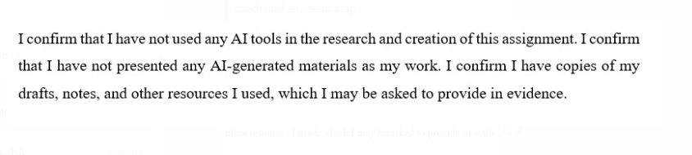

Table of Contents
1 Introduction 3
2 The Event Cycle 4
2 Event Concept 5
3 Aim and Objectives 7
4 Event Management Considerations 7
5.1 Operational Needs 7
5.2 Planning Activities 7
5.3 Marketing Activities 8
5.4 Skills Needed 8
6 Event Budget 8
7 Industry Trends / Issues / Impacts 9
8 Situational and Cultural Considerations 10
8.2 PESTEL Analysis 10
8.2.1 Political 10
8.2.2 Economic 11
8.2.3 Social 12
8.2.4 Technological 12
8.2.5 Environmental 12
8.2.6 Legal 13
8.3 SWOT Analysis 13
8.3 SOAR Analysis 14
9 EMBOK Model 15
10 Conclusion 16
11 References 17

Introduction
The planned event is a family-friendly, guided cycling tour that follows the Welsh National Coastal Path. It is generally designed for international tourists and families with young children (Walescoastpath.gov.uk, 2020). The things that make the experience unique are how it balances outdoor adventure with cultural exploration. Participants will enjoy overnight camping in tents, sit around campfires, and roast marshmallows, activities that help to make a fun and memorable trip. The tour travels from North to South Wales, giving people the chance to stop at historical landmarks, try traditional Welsh dishes, and take in the breathtaking coastal views. This event was chosen as part of the Year of Croeso celebrations, which aim to welcome visitors and share the richness of Welsh heritage (Walescoastpath.gov.uk, 2020). Moreover, by including cultural attractions and family-friendly fun along the route, the event goes beyond just local tourism. It helps people from around the world expressively connect with Wales.
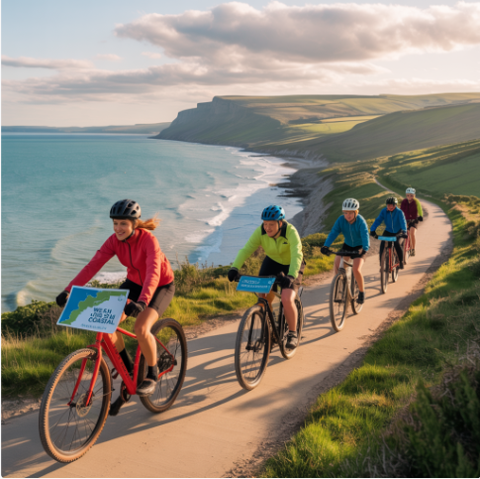
Figure 1: Cycling Tour
Source: (Author)

The Event Cycle
The Event Cycle includes all the phases involved in planning and managing events (Smith, 2012). It usually follows six important phases that are initiation, planning, implementation, the event itself, closure, and evaluation (O’Toole, 2011). These stages work together to certify the event is safe, organised, and successful. In the initiation phase, the idea for a family-friendly cycling tour along the Welsh National Coastal Path was proposed. The aim was to promote Welsh culture to foreign visitors and families by combining outdoor adventure with cultural education. This brings into line with the aims of the Year of Croeso celebrations and has received interest from local tourism boards and communities.
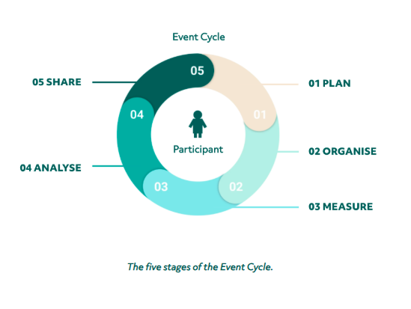
Figure 2: The Event Cycle
Source: (Aleksi Kaunisto, 2021)
In the planning phase, the organisers worked on setting the route, identifying suitable camping areas, and applying for permits. The event also planned a timeline, booked local guides and cultural performers, arranged food vendors offering traditional Welsh cuisine, and developed a marketing strategy using social media and travel platforms (Meredith, 2022). Risk assessments and safety procedures were also designed, especially for families with children. Throughout the implementation phase, logistics like setting up campsites, confirming bookings, preparing signage, and coordinating staff were completed. Training sessions for volunteers and guides were held to certify smooth operations.
The event itself covers over more than a few days as families cycle from North to South Wales, stopping at historic and scenic sites. Evening activities like campfires and storytelling sessions help to involve children and present the cultural insights. In the closure phase, the event team will undo temporary setups, clean the campsites, and thank all participants and volunteers (Williams et al., 2019).
Finally, in the evaluation phase, feedback will be collected from participants over surveys and interviews. This data will be used to calculate the event’s success and reported to all stakeholders for review and improvement in future editions. Furthermore, by following the Event Cycle, the organisers can confirm that the cycling tour is well-planned, culturally meaningful, and enjoyable for all participants.

Event Concept
The theme for this event is “Croeso i Gymru” which means “Welcome to Wales.” The tour highlights Welsh hospitality, culture, nature, and family bonding through an immersive and adventurous experience (Evans and Williams, 2024). Delegates and guests, including international visitors and families, will enjoy a well-rounded mix of cycling, cultural activities, local cuisine, and nature exploration. Activities are designed to be inclusive, safe, and interactive, certifying participants of all ages are engaged and welcomed.
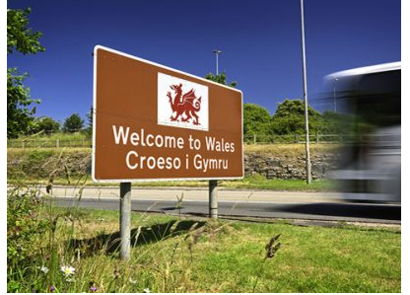
Figure 3: Welcome to Wales Sign (Croeso i Gymru) road sign
Source: ((Song, 2018)

Table 1: Event Concept
Time | Activity
8:00 AM | Welcome briefing and safety instructions at the starting point
9:00 AM | Guided cycling begins – scenic route through coastal landscapes
11:00 AM | Stop at a historical site for a short tour and photo opportunity
12:30 PM | Picnic lunch featuring local Welsh foods and refreshments
2:00 PM | Cultural activity: Welsh folk music and language introduction session
3:30 PM | Continue cycling to the campsite area
5:00 PM | Tent setup and family rest time
6:30 PM | Campfire session with storytelling about Welsh myths and legends
7:30 PM | Marshmallow roasting and a light acoustic performance by a local musician
8:30 PM | Wind down and night briefing for the next day's route
Source: (Author)
Each day of the tour will feature different cultural stops, scenic routes, and interactive activities, ensuring the journey remains fresh, engaging, and educational for all participants. The tour is arranged in South Wales. Where families can join a final celebration and obtain participation certificates as souvenirs of their cultural adventure through Wales.

Aim and Objectives
Aim
To celebrate and encourage Welsh culture through a fun, family-friendly cycling tour for international and local visitors.
SMART Objectives
- To have at least 150 people take part in the full cycling tour, including at least 50 international guests who want to learn more about Wales.
- To receive 90% positive feedback from participants through feedback forms, especially about the cultural experiences and family-friendly activities.
- To involve a minimum of 10 local food vendors and 5 cultural performers or storytellers during the tour to showcase real Welsh hospitality and support local talent.

Event Management Considerations
Planning this cycling tour along the Welsh National Coastal Path will need a lot of teamwork, good organisation, and clear communication (Evans and Williams, 2024). Since it is a moving event with different stops, we have to concentrate on operations, planning, and marketing to make sure everything runs smoothly.

5.1 Operational Needs
The event needs to organise bikes, helmets, and safety gear for all the families joining the tour (Mogaji, 2022). Campsites must be booked ahead of time, with tents, toilets, and cooking spaces ready at each location (Coates and Tapsell, 2019). A support van will carry luggage, support anyone who needs a break, and provide basic first aid. At each stop, also arrange for some local food and cultural activities, and there must be enough trained guides to lead the group safely and keep everyone together.

Planning Activities
The planning activities can work closely with local councils and tourism boards to get the right permissions and make sure that the volunteers are following the rules (Chilufya et al., 2019). A detailed route plan will include scenic stops, cultural spots, and safe cycle paths. The event also plans for things like weather changes, medical emergencies, and how to handle large groups on the road. Volunteers will help with camp setup, guest support, and guiding families during the ride. Everyone helping out will get training before the tour begins.

Marketing Activities
To promote the event, run social media campaigns using a fun hashtag like #CycleCroeso. Posts will show the beauty of the Welsh coast, the family-friendly vibe, and highlights like campfires and local food (Frandsen et al., 2022). The volunteers will share flyers in popular tourist spots, work with bloggers, and maybe even partner with travel agencies or Welsh tourism pages to get more attention.

Skills Needed
The skills that are needed to organise an event are to bring it all together, plus logistics staff to handle travel and campsites. Tour guides should know the local areas and be good with people. Marketing people will focus on getting the word out and answering questions online (Evans and Williams, 2024). Volunteers need to be friendly and helpful, especially with kids and families. Everyone involved should have strong communication skills, a helpful attitude, and an understanding of Welsh culture and hospitality.

Event Budget
Income Sources | Amount (£)
Visit Wales Grant | 5,000
Sponsorship from Local Businesses | 3,000
Vendor Stall Fees | 1,500
Voluntary Donations via Tickets | 1,000
Total Income | 10,500
Expenditure Costs | Amount (£)
Venue Hire | 2,000
Marketing and Promotion | 1,500
Performer Fees | 2,000
Staff and Volunteer Expenses | 1,000
Infrastructure (toilets, tents, signs) | 2,000
Health and Safety / Insurance | 1,000
Total Expenditure | 9,500
The total income of £10,500 covers all event costs. Most funding comes from Visit Wales and local business sponsors. Vendor fees and ticket donations add extra income for the event. Expenditure includes venue hire, marketing, and performer payments. Staff and volunteer expenses confirm smooth event operation. Infrastructure covers tents, toilets, and signs for guests. Health and safety costs cover insurance and safety measures (Mustard and Yanar, 2023). A contingency fund of £1,000 will cover unexpected costs. The event aims to stay within budget and deliver value.

Industry Trends / Issues / Impacts
The meetings and events industry is changing quickly with new trends. Sustainability is one of the biggest focuses for event organisers today. Visitors now prefer events that protect the environment and reduce waste (Masuda et al., 2022). Our event will avoid single-use plastics to help reduce pollution. Recycling bins will be placed around the venue for convenience. All food vendors must use local ingredients and eco-friendly packaging (Hagen, 2021). This method supports local farmers and decreases the event’s carbon footprint. Many visitors appreciate these green efforts when choosing which events to attend.
One more important trend is authenticity, which the People want real and unique experiences that show local culture. The event will highlight the Welsh heritage through many activities (Whitfield et al., 2022). It will invite local artists and craftsmen to display their talents. Involving community groups creates a welcoming atmosphere that visitors love. Small local businesses will be encouraged to sell traditional Welsh products. This keeps the event genuine and helps boost the local economy. Authenticity makes the event more memorable and enjoyable for guests.
Digital tools are changing how events connect with audiences today. Many events now use online platforms to encourage and share live moments (Estanyol, 2022). There will be live streams of important performances, allowing people worldwide to join in. Social media will be used to share photos, videos, and updates before and during the event. Using hashtags like #Croeso2025 helps attract more attention online (Frandsen et al., 2022). Digital marketing helps us reach younger audiences who spend time on the internet. It also supports collecting feedback through online surveys after the event. Technology makes events more interactive and accessible than ever before.
Health and safety are still very important, especially after the COVID-19 pandemic (Gold et al., 2021). People want to feel safe when attending public events. Outdoor venues like Cardiff Castle provide fresh air and natural space to reduce risks. It will have clear signage about hygiene and social distancing where needed (da Silva and Amaral, 2019). Hand sanitising stations will be available at all entrances and main points.
The events industry also faces some challenges that affect planning. The weather can be unpredictable for outdoor events, so backup plans are needed. Rising costs of materials and services mean budgets must be carefully managed. Securing permits and following legal rules requires time and effort from organisers (Connon and Hall, 2021). Volunteer recruitment can be difficult, but volunteers are essential for smooth operations. Competition with other events means marketing needs to be creative and targeted. Despite these challenges, careful planning helps overcome problems and deliver successful events.
Moreover, our event is strongly influenced by these main industry trends. Sustainability shapes how we organise waste and vendor rules. Authenticity guides our choice of activities and community involvement. Digital tools help us promote and share the event beyond Cardiff. Health and safety measures that can ensure all visitors feel comfortable and secure (da Silva and Amaral, 2019). Understanding these trends lets us create a meaningful and enjoyable experience. This method also supports the long-term success of Welsh cultural events.

Situational and Cultural Considerations

PESTEL Analysis

Political
The Welsh Government supports tourism and culture through event management initiatives. Government funding can help support event management teams and local promotion (Masuda et al., 2022). Political stability allows event management to plan without major disruptions or risks. Local councils assist event management with permits, security, and traffic control. The following figure analyses Europe’s dominance in the MICE industry, with a 41% market share in 2022, which reflects strong political stability, favorable government policies, and international cooperation (Market, 2023). The success in hosting international association conferences is supported by efficient visa policies. Political backing builds trust among sponsors, partners, and community stakeholders.
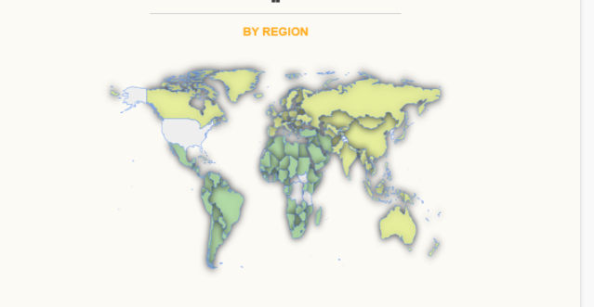
Figure 4: Global Regional Distribution of the MICE Industry
Source: ((Market, 2023)

Economic
Event management plays a vital role in boosting the local economy. Events attract tourists who spend money on transport, food, and hotels. The following graph is analysing MICE industry trends by event type and region (Market, 2023). The graph shows strong future growth in Meetings and Conventions. Europe, holding 41% market share in 2022, leads globally, especially the UK and Germany. Growth is driven by international conferences and rising online booking trends, supporting Europe’s continued dominance (Barna and Semak, 2020). Opportunities arise through temporary roles in event setup and support. Economic growth from events improves long-term community development and branding.
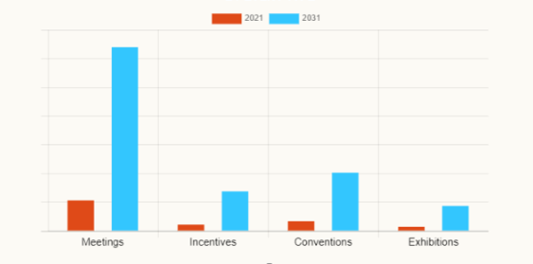
Figure 5 Projected MICE Market Growth by Event Type (2021 vs 2031)
Source: (Market, 2023)

Social
Social trends influence how event management plans for audience experiences. People now seek events that connect them with culture and community (Frost and Frost, 2020). Event management must include activities that reflect Welsh traditions and values. Events bring people together, promoting unity and social well-being (Parker, 2022). Diverse age groups enjoy well-managed events with inclusive experiences. Event management encourages local pride through showcasing heritage and identity.

Technological
Technology is very important in modern event planning and management. QR codes make it easy for visitors to access event information quickly. Online systems are used for ticketing and smooth registration processes. Social media helps events reach younger and larger groups of people. Event managers use feedback tools to know what guests liked or disliked. Live streaming allows people worldwide to watch the event from home (Hernando and Macías, 2023). Mobile apps help visitors navigate events and get real-time updates. Virtual events reduce the need for travel, lowering carbon emissions. Using digital tools reduces the use of paper and plastic materials.

Environmental
Sustainability is now important in planning and managing any successful event. Event managers try to decrease waste and protect the natural environment. Using fewer single-use plastics helps keep the event clean and green. Recycling stations at events help manage waste in the right way.
Vendors must follow the green rules given by the event management team (Liu and Lei, 2021). Eco-friendly events attract visitors who care about the environment and nature. Using local food and products reduces pollution from long transport journeys. Many events now use digital tickets to save paper and trees. Solar power and LED lights are used to save electricity (Yusoff et al., 2022). Reusable decorations are better than items thrown away after one event. Eco-awareness training is given to staff and volunteers at big events.

Legal
Event management must comply with all health, safety, and legal regulations. Insurance is required to protect visitors, staff, and the venue (Tansel et al., 2021). Event management follows noise control rules to respect local communities. Risk assessments are done to ensure the event is safe for all. Good legal practice makes event management more trusted and professional (Yusoff et al., 2022). Considering each factor ensures events are safe, inclusive, and culturally meaningful. This approach strengthens Welsh tourism and supports long-term event management success.

SWOT Analysis
Table 2: SWOT Analysis
Strengths | Weaknesses
Strong cultural identity attracts many visitors. | The event depends on good weather for outdoor activities.
Support from local stakeholders helps with resources. | Limited indoor space reduces options in bad weather.
Unique Welsh traditions create memorable experiences (Ramely et al., 2022). | Some parts of the community may not fully engage.
An experienced event team ensures a smooth organisation. | Marketing reach might be limited initially (Ramely et al., 2022).
Opportunities | Threats
Tourism is recovering well after the pandemic. | Unexpected event cancellations can hurt a reputation.
New partnerships with sponsors can bring more funding. | Risk of overspending on event activities and promotions.
Growing interest in cultural and heritage tourism. | Competition from other regional events during the same period (Teixeira et al., 2019).
Use of technology can improve the visitor experience. | Possible travel restrictions or safety concerns for visitors.
Source: (Author)
Figure 6: SWOT Analysis
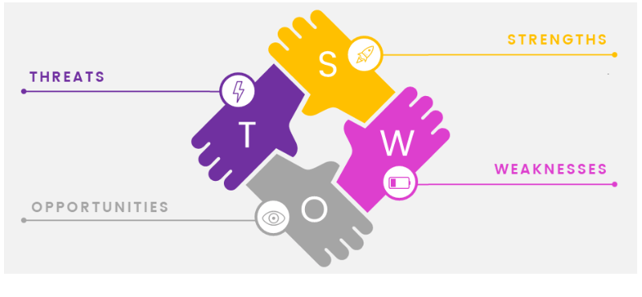
Source: (Admin, 2018)

8.3 SOAR Analysis
Table 3 SOAR Analysis
SOAR Element | Details
Strengths | Strong focus on Welsh culture, language, food, and music.  The iconic venue (Cardiff Castle) adds historical value.  Support from local government and tourism boards.  An experienced team ensures smooth event coordination  Use of social media and tech for wider outreach and feedback.
Opportunities | Rising interest in heritage and cultural tourism post-COVID (Gómez, 2021).  Potential partnerships with local businesses and schools.  Media exposure and long-term branding through Visit Wales (Evans and Williams, 2024).  Chance to promote green, eco-friendly event practices.  Engagement with young people and families.
Aspirations | Establish the event as an annual cultural celebration.  Promote local pride while attracting international visitors.  Be a role model for inclusive and sustainable event planning.  Inspire youth to engage with and preserve Welsh traditions (Teixeira et al., 2019).
Results | Over 1,000 attendees are expected during the day.  90 %+ visitor satisfaction rate targeted.  15% rise in local tourist attraction visits post-event.  Boost to local businesses and cultural awareness in the region.

Source: (Author)

EMBOK Model
The EMBOK Model helps the Year of Croeso event team plan and run the festival smoothly. It has five important parts: Administration, Design, Marketing, Operations, and Risk.
- Administration
means managing the budget carefully, hiring staff, and signing contracts with suppliers. All permits and paperwork must be kept organised and updated to avoid problems.
- Design
Focuses on creating an authentic Welsh experience (van Antwerpen, 2023). This includes planning traditional food and decorations that celebrate Welsh culture.
- Marketing
promotes the event through websites, local tourism boards, posters, and social media (Thomas and Stephens, 2022). Working with journalists and influencers helps spread the word to more people.
- Operations
Handle the event setup, security, equipment, and technical needs (Struniawski, 2024). It also makes sure public transport runs well and the crowd is controlled safely.
- Risk
Planning prepares for challenges like rain or accidents. Volunteers are trained on emergency plans and first-aid locations to keep visitors safe (Vainio et al., 2024). Using the EMBOK Model will help Year of Croeso be a successful, well-organised event that celebrates Welsh culture while keeping everyone safe and happy.
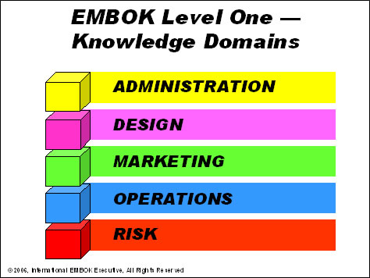
Table 4 EMBOK Model
Source: (Super User, 2025)

Conclusion
The “Celebrating Welsh Heritage” event at Cardiff Castle is a special way to share and enjoy Welsh culture. Through following careful planning steps and using strong teamwork, the event will be safe, fun, and welcoming for everyone. It will benefit visitors to learn about Welsh traditions through food and stories while supporting local businesses and tourism. With attention to health, safety, and the environment, this event shows respect for the community and nature. Moreover, it will create a memorable experience and help grow Welsh cultural tourism in the future.

References
Connon, I. L., and Hall, E. (2021). ‘It’s not about having a back-up plan; it’s always being in back-up mode’: Rethinking the relationship between disability and vulnerability to extreme weather. Geoforum, 126, 277-289. https://doi.org/10.1016/j.geoforum.2021.08.008
Da Silva, S. L. C., and Amaral, F. G. (2019). Critical factors of success and barriers to the implementation of occupational health and safety management systems: A systematic review of literature. Safety science, 117, 123-132. https://doi.org/10.1016/j.ssci.2019.03.026
Estanyol, E. (2022). Traditional festivals and COVID-19: Event management and digitalisation in times of physical distancing. Event Management, 26(3), 647-659. 10.3727/152599521X16288665119305
Evans, N., and Williams, C. (2024). Globalising Welsh Studies: Decolonising history, heritage, society and culture (p. 336). University of Wales Press.
Frandsen, K., Jerslev, A., and Mortensen, M. (2022). Media events in the age of global, digital media: Centring, scale, and participatory liveness. Nordic Journal of Media Studies, 4(1), 1-18. DOI: https://doi.org/10.2478/njms-2022-0001
Frost, W., and Frost, J. (2020). Events and tourism. In The Routledge handbook of events (pp. 76-92). Routledge.
Gold, D., Hughes, S., and Thomas, D. (2021). Perceptions, experiences and opportunities for occupational safety and health professionals arising out of the COVID-19 Pandemic. Humanities and Social Sciences Communications, 8(1), 1-14. | https://doi.org/10.1057/s41599-021-00955-y
Hagen, D. (2021). Sustainable event management: new perspectives for the meeting industry through innovation and digitalisation?. Innovations and traditions for sustainable development, 259-275. DOI:10.1007/978-3-030-78825-4_16
Hernando, R., and Macías, J. A. (2023). Development of usable applications featuring QR codes for enhancing interaction and acceptance: a case study. Behaviour and Information Technology, 42(4), 360-378. https://doi.org/10.1080/0144929X.2021.2022209
Liu, Y. Q., and Lei, W. S. C. (2021). Towards sustainable practice in the event industry: Insights from practitioners. Event Management, 25(3), 213-226. https://doi.org/10.3727/152599519X15506259856462
Mustard, C. A., and Yanar, B. (2023). Estimating the financial benefits of employers’ occupational health and safety expenditures. Safety science, 159, 106008. https://doi.org/10.1016/j.ssci.2022.106008
O’Toole, W. (2011) Events feasibility and development: from strategy to operations. Elsevier: Oxford https://doi.org/10.4324/9780080940595
Parker, J. (2022). Politics, Systems thinking and building the wellbeing economy: The example of Wales. In Transformation Literacy: Pathways to Regenerative Civilizations (pp. 203-218). Cham: Springer International Publishing. https://doi.org/10.1007/978-3-030-93254-1_14
Super User (2025). EMBOK - Event Management Body of Knowledge - Domains. [online] Embok.org. Available at: https://www.embok.org/index.php/domains-page [Accessed 29 May 2025].
Ramely, A., Talib, M. F. A., Radha, J. Z. R. R. R., and Mokhtar, M. F. (2022). Green event practices: Understanding the adaptation of event organisers through a systematic review. Malaysian Journal of Sustainable Environment, 9(1), 119-140.doi: 10.24191/myse.v9i1.17295
Rogers, T. Wynn-Moylan, P (2022) Conferences and conventions: a global industry. 4th Edition. Routledge: Oxford
Smith, A. (2012) Events and urban regeneration: the strategic use of events to revitalise cities. Routledge: Oxford
Tansel, T., Yeshenkulova, G., and Nurmanova, U. (2021). Analysing waste management and recycling practices for the hotel industry. Journal of Environmental Management and Tourism, 12(2), 382-391. https://doi.org/10.14505//jemt.v12.2(50).07
Teixeira, S. J., Ferreira, J. J., Almeida, A., and Parra-Lopez, E. (2019). Tourist events and satisfaction: a product of regional tourism competitiveness. Tourism Review, 74(4), 943-977. https://doi.org/10.1108/TR-12-2018-0181
Thomas, K., and Stephens, S. (2022). Understanding the Management Theory in Event Management: A Conceptual Framework. Available at SSRN 4051469.
Walescoastpath.gov.uk. (2020). Wales Coast Path / Cycling. [online] Available at: https://www.walescoastpath.gov.uk/things-to-do/cycling/?lang=en [Accessed 29 May 2025].van Antwerpen, S. (2023). A proposed integration of the event and project management body of knowledge. International Journal of Applied Sciences in Tourism and Events, 7(2), 107-119.
Whitfield, J., Svobodova, P., and Webber, D. J. (2022). How Can We Reduce Conference Venues''Use of Single-use Plastics?. Event Management, 26(7), 1577-1590. DOI: https://doi.org/10.3727/152599522X16419948391140
Williams, T., Vo, H., Samset, K., and Edkins, A. (2019). The front-end of projects: a systematic literature review and structuring. Production Planning and Control, 30(14), 1137-1169. https://doi.org/10.1080/09537287.2019.1594429
Yusoff, M. S., Kamaruddin, M. A., Hanif, M. H. M., Norashiddin, F. A., Shadi, A. M. H., Wang, L. K., and Wang, M. H. S. (2022). Solid Waste Management in the Tourism Industry. In Solid Waste Engineering and Management: Volume 3 (pp. 1-54). Cham: Springer International Publishing. DOI:10.1007/978-3-030-96989-9_1
Market, A. (2023). MICE Industry Size, Share, Trends & Industry Growth, 2032. [online] Allied Market Research. Available at: https://www.alliedmarketresearch.com/MICE-industry-market [Accessed 3 Jun. 2025].
Barna, M., & Semak, B. (2020). Main trends of marketing innovations development of international tour operating. Baltic Journal of Economic Studies, 6(5), 33-41.https://doi.org/10.30525/2256-0742/2020-6-5-33-41
Gómez, L. A. E. (2021). Cultural tourism in cities post-COVID-19: a perspective and proposals for an alternative model. Boletín de la Asociación de Geógrafos Españoles, (91), 7.
https://orcid.org/0000-0002-7954-4064
Admin (2018). We learn from mistakes – how to use the SWOT analysis to assess the event and improve our offer (pt. 1) - Online event registration software | Konfeo. [online] Online event registration software | Konfeo. Available at: https://www.konfeo.com/en/blog/we-learn-from-mistakes-how-to-use-the-swot-analysis-to-assess-the-event-and-improve-our-offer-pt-1/ [Accessed 3 Jun. 2025].
Aleksi Kaunisto (2021). Introducing the Event Cycle – The core of Event Success Management. [online] Lyyti.com. Available at: https://www.lyyti.com/en/blog/introducing-the-event-cycle-the-core-of-event-success-management [Accessed 3 Jun. 2025].
Song, L. (2018). Talk to Welsh speakers: Welsh language opens another door to me - InterCardiff. [online] InterCardiff. Available at: https://cardiffjournalism.co.uk/intercardiff/business-culture/follow-taith-laith-explore-welsh-language [Accessed 3 Jun. 2025].
Mogaji, E. (2022). Cycling in Lagos: The challenges, opportunities, and prospects. Transportation research interdisciplinary perspectives, 14, 100608. https://doi.org/10.1016/j.trip.2022.100608
Coates, T., & Tapsell, S. (2019). Planning for an uncertain future: the challenges of a locally based collaborative approach to coastal development decisions. Environmental Science & Policy, 101, 24-31. https://doi.org/10.1016/j.envsci.2019.07.005

