

RESULT

BACHELORS DEGREE ASSIGNMENT SPECIFICATION

Student name: | Ben Rowland-Jones | Student P number: | 2213554
Programme: | Full time manufacturing programs
Module: | Materials and introduction to processing | Module Level (4, 5, 6): | 4
Module code: | ACMA4000 | Contribution to Overall  Module Assessment (%): | 50
Lecturer: | Chris Wyatt | Internal Verifier: | Kelvin Lake
Assignment Title: | Rubber properties | Assignment No (x of x): | 1
10 | 12/10/22 | Submission deadline: | 14/11/2022
Referencing: | In the main body of your submission you must give credit to authors on whose research your work is based. Append to your submission a reference list that indicates the books, articles, etc. that you have read or quoted in order to complete this assignment (e.g. for books: surname of author and initials, year of publication, title of book, edition, publisher: place of publication).
Disclosure: | I declare that this assignment is all my own work and that I have acknowledged all materials used from the published or unpublished works of other people. All references have been duly cited.
Student’s Signature: | Assignments will not be accepted without a signature here  B. Rowland-Jones | Date: | 14/11/2022
Turnitin: Lecturer to tick to indicate if an electronic version of the assignment must be submitted to Turnitin. Note: the Turnitin version is the primary submission and acts as a receipt for the student. Both electronic and paper versions MUST be submitted by the same deadline. No marks will be released until both submissions are received. Late submission of the electronic version will result in a late penalty mark. Penalties for late submission: Up to one week late, maximum mark of 40%. Over one week late, Refer. | YES | x
 | NO

Learning Outcomes tested  (from module syllabus) | Assessment Criteria To achieve each outcome a student must demonstrate the ability to:
an understanding of the structure and properties of metals and polymers | - Design simple experiments in material science  - Understand key material properties such as UTS, young’s modulus, fatigue limit, toughness  - Understand the underlying science, stress, strain, energy  - A basic understanding of how chemistry and structure affects material properties  - An understanding of elastomers – their behaviour and chemistry
- Please submit the assignment parts via moodle
- This form (ALL PAGES) MUST be at the front of the paper submission. Assignments will not be accepted without this form as it is a requirement that you sign the disclosure regarding referencing convention.
- DO NOT put this form into Turnitin or it will match many similarities with other students’ submissions.
TASK DESCRIPTION

(Lecturer – please insert task(s) / questions / what the student must do, here)

You are tasked with finding the stress strain curve for a rubber material used to create a rubber band of your choice. Ideally you should also look at rubber phenomena such as creep, hysteresis and fatigue fractures.

For this task you will not be given a “packaged” practical session – rather you will have to design the experiment(s) yourself using materials you have at hand – or can purchase cheaply. Part of the assignment is to critically evaluate your own experiment but you will not gain marks by spending lots of money!

Research Required:
Using the internet and the library research and understand the following.

Rubber

1) Key Properties of Rubber materials
2)Underlying chemistry which creates these properties
3)Stress strain curves
4)Youngs Modulus
5) Ultimate tensile stress
8)Creep in materials
7) Mechanical energy absorption in materials.
8) Hysteresis
9) Material property variation.
10) Visco elastic behaviour
10) Historical development of nature rubber and synthetics.

You do not need to write up or sumarise research – rather it should be evident that you understand these things based on how you design, conduct, introduce and report your experiment (s)

Design of experiments

Ingredients:

A method to measure the cross sectional area of a rubber band.
A method to stretch a rubber band using a known force
A method to measure the length of the unstretched and stretched band

Minimum Work Required.

- Obtain a Force/Stretch data for a rubber band of your choice. Take the curve to the point the band snaps
- Convert the data into an engineering stress/engineering strain curve for the material.
- Covert the curve into a true stress / true strain curve for the material
- Find young’s modulus at the initial stretch point and the ultimate tensile strength of the material based on the true stress and trues strain curve
- Observe how the chemistry of rubber materials dictates how the curve works
- Analyse your experimental accuracy. What are the sources of variation in the result? How could the sample (the band) be better prepared? If you had more money and time how could you make the experiment more accurate and more repeatable?
- Analyse the cost of the experiment in terms of time and money. Reflect on the trade off between quality and cost
Additional marks can also be given for additional work :
- Analyse the variations in result for a sample of supposedly identical bands. Ie repeat the test number of times . Get the mean and standard deviation of the result
- Conduct fatigue testing on a sample of bands – this requires you to stretch the band with a known force repeatedly until it breaks – counting the number of cycles until the break occurs. The known force should start at 0.3 * breaking force – then repeat the whole experiment at 0.4* breaking force etc
- Try to understand the effect of temperature on the properties. If you have a walk-in fridge or a sauna – you could use that. Alternatively, you could repeat the test at different times in the day to get varying temperature. It is important that the temperature is held constant throughout the experiment and the measurement reflects the temperature of the band. Hair dryers do not work.
The most important instruction : Have fun and learn something! . And more seriously think about safety and damage – especially if you are using liquids! Bands will snap!

Write up :

You are required to write a report in English (Max 2500 words) .

It us suggested that you use the following titles.

Introduction : State the problem to be solved. Discuss the theory of elastomer behaviour (with references) and how it relates to your experiment(s)

Experimental method : Describe your method (with pictures as well as words).

Results: Clearly lay out your experimental results. Use tables where necessary. Make sure units are clear to the reader throughout

Analysis of results : If you use a spreadsheet make sure you write up all the equations properly (use the equation editor in word and make sure the reader understandfs exactly what any variable names refer to. Quote the units

Analysis of experimental inaccuracy and cost/quality trade-off. How could your experiment be improved? How can you reduce variation caused by the experiment rather than the natural variation on the sample.

Discussion: How do your results reflect the established theory? What would you like to do if you had more time/money.

Conclusion: Don’t bring in anything new – just summarise the results, analysis and discussion

Acknowledgements: Did you work with each other – Say so and how and acknowledge it. Did your mum allow you to use the kitchen? Say so!

References. Formal reference section – don’t forget to put the references in your main text as well [1] !

References :
[1] UWTSD , UWTSD Referencing handbook , https://uwtsd.ac.uk/media/uwtsd-website/content-assets/documents/library-and-learning-resources/infoskills/IEEE-eng_v.1.2.pdf

Supplementary Rules:

Please feel free to work in groups to share research findings and exchange ideas. YOU MUST ACKNOWLEDGE OTHER STUDENTS WHO YOU HAVE WORKED WITH!

GUIDANCE FOR Students IN THE COMPLETION OF TASKS

Follow the class video carefully to understand some of the analysis techniques

marking criteria and Student FEEDBACK

This section details the assessment criteria. The extent to which these are demonstrated by you determines your mark. The marks available for each criterion are shown. Lecturers will use the space provided to comment on the achievement of the task(s), including those areas in which you have performed well and areas that would benefit from development/improvement.

Common Assessment Criteria Applied | Marks available | Marks  awarded
1. Research-informed Literature
Extent of research and/or own reading, selection of credible sources, application of appropriate referencing conventions.
Ability to find credible information Research items | 10
2. Knowledge and Understanding of Subject
Extent of knowledge and understanding of concepts and underlying principles associated with the discipline.
Demonstrate that you understand  Rubber possibly relevant research topics  1) Key Properties of Rubber materials  2)Underlying chemistry  3)Stress strain curves  4)Youngs Modulus  5) Ultimate tensile stress  8)Creep in materials  7) Mechanical energy absorption in materials.  8) Hysteresis  9) Material property variation.  10) Poisson’s ratio  And that you have started to become aware of the issues around Design of experiments.  Do not include material in your report if you do not think it is relevant. | 15
3. Analysis
Analysis, evaluation and synthesis; logic, argument and judgement; analytical reflection; organisation of ideas and evidence
Demonstrate that you can convert force/stretch data to Stress/strain data  Demonstrate you are beginning to understand the issues around sampling. Be able to compute a mean and standard deviation from a sample  Show that you have begun to be able to analyse repeatability in experiments.  Show that you understand engineering units in a practical environment | 25
4. Practical Application and Deployment
Deployment of methods, materials, tools and techniques; application of concepts; formulation of innovative and creative solutions to solve problems.
Show creativity in your solution to measurement and experimental procedure | 35
5. Skills for Professional Practice
Attributes in professional practice: individual and collaborative working; deployment of appropriate media; presentation and organisation.
Presentation  Referencing, Structure, diagrams and pictures | 15

Assignment Mark (Assessment marks are subject to ratification at the Exam Board. These comments and marks are to give feedback on module work and are for guidance only until they are confirmed. ) | Late Submission Penalties (tick if appropriate) |  | %
 | Up to one-week late | 40 | %
 | Over one week late | 0 | %

COMMON ASSESSMENT AND MARKING CRITERIA

 | OUTRIGHT FAIL | UNSATISFACTORY | SATISFACTORY | GOOD | VERY GOOD | EXCELLENT | EXCEPTIONAL
Assessment Criteria | 0-29% | 30-39%* | 40-49% | 50-59% | 60-69% | 70-79% | 80-100%
1. Research-informed Literature  Extent of research and/or own reading, selection of credible sources, application of appropriate referencing conventions | Little or no evidence of reading.  Views and findings unsupported and non-authoritative.  Referencing conventions largely ignored. | Poor evidence of reading and/or of reliance on inappropriate sources, and/or indiscriminate use of sources.  Referencing conventions used inconsistently. | References to a limited range of mostly relevant sources. Some omissions and minor errors.  Referencing conventions evident though not always applied consistently. | Inclusion of a range of research-informed literature, including sources retrieved independently. Referencing conventions mostly consistently applied. | Inclusion of a wide range of research-informed literature, including sources retrieved independently.  Selection of relevant and credible sources. Very good use of referencing conventions, consistently applied. | A comprehensive range of research informed literature embedded in the work. Excellent selection of relevant and credible sources. High-level referencing skills, consistently applied. | Outstanding knowledge of research-informed literature embedded in the work. Outstanding selection of relevant and credible sources. High-level referencing skills consistently and professionally applied.
2. Knowledge and Understanding of Subject  Extent of knowledge and understanding of concepts and underlying principles associated with the discipline. | Major gaps in knowledge and understanding of material at this level. Substantial inaccuracies. | Gaps in knowledge, with only superficial understanding. Some significant inaccuracies. | Evidence of basic knowledge and understanding of the relevant concepts and underlying principles. | Knowledge is accurate with a good understanding of the field of study. | Knowledge is extensive. Exhibits understanding of the breadth and depth of established views. | Excellent knowledge and understanding of the main concepts and key theories. Clear awareness of challenges to established views and the limitations of the knowledge base. | Highly detailed knowledge and understanding of the main theories/concepts, and a critical awareness of the ambiguities and limitations of knowledge.
3. Analysis  Analysis, evaluation and synthesis; logic, argument and judgement; analytical reflection; organisation of ideas and evidence | Unsubstantiated generalisations, made without use of any credible evidence. Lack of logic, leading to unsupportable/ missing conclusions. Lack of any attempt to analyse, synthesise or evaluate. | Some evidence of analytical intellectual skills, but for the most part descriptive. Ideas/findings sometimes illogical and contradictory. Generalised statements made with scant evidence. Conclusions lack relevance. | Evidence of some logical, analytical thinking and some attempts to synthesise, albeit with some weaknesses.  Some evidence to support findings/ views, but evidence not consistently interpreted.  Some relevant conclusions and recommendations, where relevant | Evidence of some logical, analytical thinking and synthesis. Can analyse new and/or abstract data and situations without guidance.  An emerging awareness of different stances and ability to use evidence to support the argument.  Valid conclusions and recommendations, where relevant | Sound, logical, analytical thinking; synthesis and evaluation. Ability to devise and sustain persuasive arguments, and to review the reliability, validity & significance of evidence. Ability to communicate ideas and evidence accurately and convincingly.  Sound, convincing conclusions / recommendations. | Thoroughly logical work, supported by evaluated evidence. High quality analysis, developed independently or through effective collaboration.  Ability to investigate contradictory information and identify reasons for contradictions.  Strong, persuasive, conclusions, justifiable recommendations. | Exceptional work; judiciously selected and evaluated evidence. Very high quality analysis, developed independently or through effective collaboration.  Ability to investigate contradictory information and identify reasons for contradictions.  Highly persuasive conclusions
4. Practical Application and Deployment  Effective deployment of appropriate methods, materials, tools and techniques; extent of skill demonstrated in the application of concepts to a variety of processes and/or contexts; formulation of innovative and creative solutions to solve problems. | Limited or no use of methods, materials, tools and/or techniques.  Little or no appreciation of the context of the application. | Rudimentary application of methods, materials, tools and/or techniques but without consideration and competence. Flawed appreciation of the context of the application. | An adequate awareness and mostly appropriate application of well established methods, materials, tools and/or techniques.  Basic appreciation of the context of the application. | A good and appropriate application of standard methods, materials, tools and/or techniques.  Good appreciation of the context of the application, with some use of examples, where relevant. | A very good application of a range of methods, materials, tools and/or techniques.  Very good consideration of the context of the application, with perceptive use of examples, where relevant.  Evidence of some innovation and creativity. | An advanced application of a range of methods, materials, tools and/or techniques.  The context of the application is well considered, with extensive use of relevant examples.  Application and deployment extend beyond established conventions. Innovation and creativity evident throughout. | Outstanding levels of application and deployment skills. Assimilation and development of cutting edge processes and techniques.
5. Skills for Professional Practice  Demonstrates attributes expected in professional practice including: individual initiative and collaborative working; deployment of appropriate media to communicate (including written and oral); clarity and effectiveness in presentation and organisation. | Communication media is inappropriate or misapplied.  Little or no evidence of autonomy in the completion of tasks.  Work is poorly structured and/or largely incoherent. | Media is poorly designed and/or not suitable for the audience.  Poor independent or collaborative initiative.  Work lacks structure, organisation, and/or coherence | Can communicate in a suitable format but with some room for improvement.  Can work as part of a team, but with limited involvement in group activities.  Work lacks coherence in places and could be better structured. | Can communicate effectively in a suitable format, but may have minor errors.  Can work effectively as part of a team, with clear contribution to group activities.  Mostly coherent work and is in a suitable structure. | Can communicate well, confidently and consistently in a suitable format.  Can work very well as part of a team, with very good contribution to group activities.  Work is coherent and fluent and is well structured and organised. | Can communicate professionally and, confidently in a suitable format.  Can work professionally within a team, showing leadership skills as appropriate, managing conflict and meeting obligations.  Work is coherent, very fluent and is presented professionally. | Can communicate with an exceptionally high level of professionalism.  Can work exceptionally well and professionally within a team, showing advanced leadership skills.  Work is exceptionally coherent, very fluent and is presented professionally.

Student Self Evaluation Form
Student name: |  | Student P number:
Programme: |  | Year of programme
Assignment Title:

This section repeats in brief the common assessment criteria detailed on previous pages. The extent to which these are demonstrated by you determines your mark. Using these criteria, tick the box that best indicates the level of achievement you feel you have achieved with regard to each of them.

Common Assessment Criteria Applied | Level of Achievement
Common Assessment Criteria Applied | REFER |  |  | 3rd |  | 2:2 |  | 2:1 | 1st | 1st
 | OUTRIGHT FAIL | UNSATISFACTORY | SATISFACTORY |  | GOOD |  | VERY GOOD |  | EXCELLENT | EXCEPTIONAL
1. Research-informed Literature | 0-29% | 30-39% | 40-49% |  | 50-59% |  | 60-69% |  | 70-79% | 80-100%
1. Research-informed Literature | □ | □ | □ |  | □ |  | □ |  | □ | □
2. Knowledge and Understanding of Subject | 0-29% | 30-39% | 40-49% |  | 50-59% |  | 60-69% |  | 70-79% | 80-100%
2. Knowledge and Understanding of Subject | □ | □ | □ |  | □ |  | □ |  | □ | □
3. Analysis | 0-29% | 30-39% | 40-49% |  | 50-59% |  | 60-69% |  | 70-79% | 80-100%
3. Analysis | □ | □ | □ |  | □ |  | □ |  | □ | □
4. Practical Application and Deployment N/A | 0-29% | 30-39% | 40-49% |  | 50-59% |  | 60-69% |  | 70-79% | 80-100%
4. Practical Application and Deployment N/A | □ | □ | □ |  | □ |  | □ |  | □ | □
5. Skills for Professional Practice N/A | 0-29% | 30-39% | 40-49% |  | 50-59% |  | 60-69% |  | 70-79% | 80-100%
5. Skills for Professional Practice N/A | □ | □ | □ |  | □ |  | □ |  | □ | □

PLEASE COMMENT ON AREAS IN WHICH YOU FEEL THAT YOU HAVE PERFORMED WELL | PLEASE COMMENT ON AREAS you feel that you need TO DEVELOP

Student’s Name | Ben Rowland-Jones | Date | 14/11/2022
Student’s Signature | B. Rowland-Jones

Rubber band experiment

A report detailing the results of an experiment carried out on an elastomer.
  - Ben Rowland-Jones

Contents
Introduction 2
Experimental Method 4
Experiment Results 6
Analysis of Results 10
Fatigue Testing 14
Creep Testing 15
Analysis of Experimental Inaccuracies and Cost/Quality Trade-off 16
Discussion 17
Conclusion 18
Acknowledgements 19
Bibliography 20

Introduction
Rubber bands are mostly made of natural rubber, which is an elastomer. An elastomer, which is from “elastic polymer”, is a polymer that has both elasticity and viscosity. Meaning it has the capacity to be stretched quite a lot and still be able to return to its original size and shape.
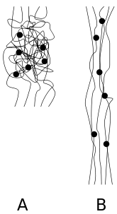
The monomers that form the polymers in an elastomer are typically made up of silicon, oxygen, carbon and hydrogen. Elastomer molecules are randomly packed, as shown below (A), until you apply a force and stretch it. Then, the molecules will straighten and follow the direction of the force (B). Once the force has been taken away, the molecules will return to a randomly packed shape of its own accord.

(Wikipedia, 2022)

Further on in this report, there are two stress/strain curves. Due to the curvature of these curves, it is possible to see one of the properties of elastomers. That property is hardness, the rubber band hardens as you add a load to it. Elastomers also have a high tensile strength and, as previously mentioned, has very high elasticity. These properties will govern and be shown in the experiment results.

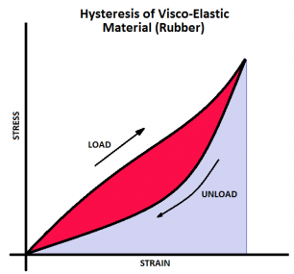
Hysteresis in elastomers is the absorption of energy in to the elastomer itself. Using a rubber band as an example, when a force is applied to the band, the band will absorb some of the energy used. Below is a graph detailing this energy absorption:

(Bulldog Casters, 2016)

The “Load” curve is the stress/strain curve of the rubber band when the load is applied, whereas the “Unload” curve is the stress/strain curve when the load is removed. The red area of the graph is the energy absorbed by the rubber band. This is the hysteresis.
The above graph is also a visual representation of a viscoelastic material. This is a display of the viscous behaviour of the elastomer. You would not see hysteresis or a loss of energy in a purely elastic material. But a viscoelastic material will absorb and lose energy in a cyclical load experiment.
The blue section of the graph shows the energy that was not absorbed by the rubber band. This blue area, along with the hysteresis, add up to the same amount of energy used as the load applied to the rubber band.
Over the years, the use of rubber has become more ubiquitous. Originally found hundreds of years ago in rubber trees/plants, naturally occurring rubber was used by old, central American cultures. It eventually made its way to Britain in the 1700’s when it was first used to erase pencil marks from paper, which was when the name “rubber” was coined.
In the 1900’s, synthetic rubber was produced from petroleum and used in a wide range of applications including car tyres and gaskets. (Wikipedia, 2022)

Experimental Method
This experiment required the stretching of a rubber band with known force increments to the point of destruction. This meant there needed to be an accurate way of measuring out a known substance, in this case water, and adding that force to the rubber band. The following pieces of equipment were used:
- Rubber bands
- Stepladder
- Metal hook
- Bucket
- Luggage weighing scales
- Weighing scales (for the water)
- Knife
As you can see in the Fig 1 below, the luggage weighing scales are suspended from the stepladder with a knife that is going through the handle, on top of the ladder:
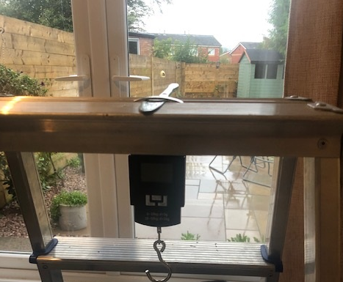

Fig 1

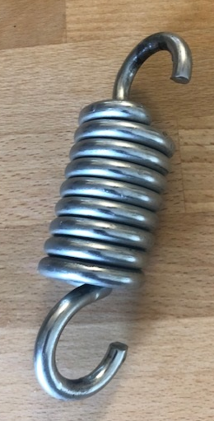

The rubber band was then hooked on to the hook of the luggage weighing scales. The metal hook shown in Fig 2 below, was then hooked on to the rubber band and the weight was recorded, which was 320g.

Fig 2

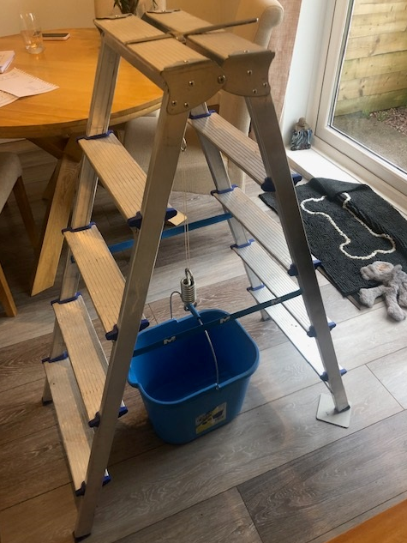
After the weight of the hook was recorded, the bucket was then placed on the other side of the hook, which weighed in at 575g, total of 895g, as shown in Fig 3 below:

Fig 3

Once the bucket was loaded on to the hook, the known force increments could be added in the form of water added at 200g increments. Below, in Figure 4, is the weighing scales I used to measure the water weights:
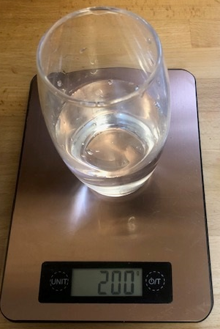

Fig 4

Experiment Results
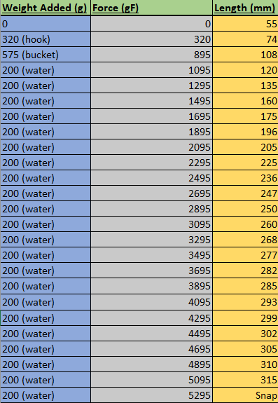
200g of water was added 22 times before the rubber band snapped, bringing the total force applied to the rubber band to 5295gF. The new length of the rubber band was measured with a measuring tape. You can see in Figure 5, all of the force increments along with the new lengths that were achieved:

Fig 5

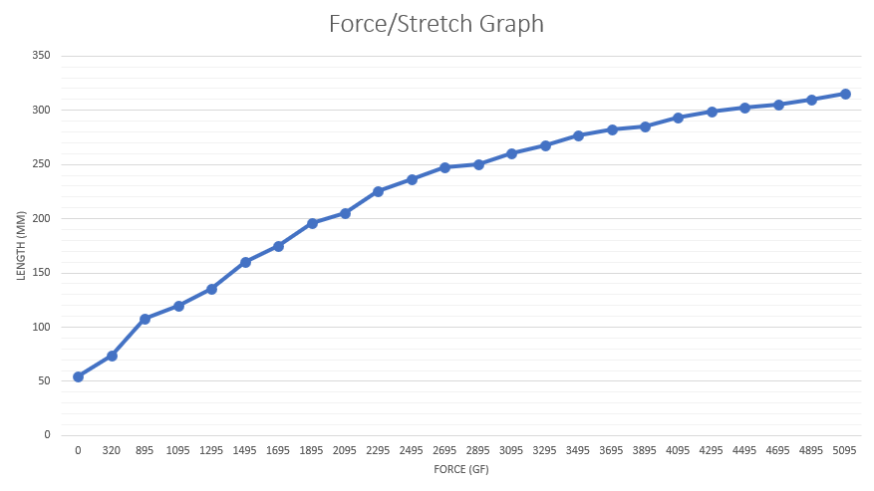
After compiling this data in Microsoft Excel, a graph was created using the length and force data, as shown in Figure 6, below:

Fig 6

This graph shows the length of the band increasing quite rapidly at the start of the experiment. It then starts to plateau at the end before eventually snapping.
From the data gathered in the experiment, the engineering strain could be worked out by using the following formula:
$$Engineering Strain= \frac{∆L}{L}$$
Where $∆$L is the change in length which is divided by the original length. This formula was inputted into Excel by using the following in Figure 7, where C5 is the new length and C4 is the original length:
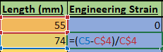

Fig 7
The drag function within Excel was used to calculate the other engineering strain values. The True Strain was also calculated using the data from the experiment. Using the formula below in Figure 8:
$$True Strain= Σ \frac{ΔL}{L}$$
Where $Σ$ means the sum of and the rest of the equation is as above. This formula was inputted into Excel by using the following in Figure 8, where LN is natural log, C5 is the new length and C4 is the original length:


Fig 8
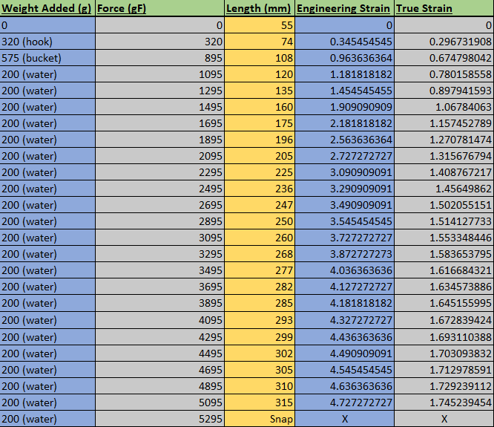
The drag function within Excel was used to calculate the other true strain values. As you can see below in Figure 9, there are now columns for engineering strain and true strain values gathered from the original data collected from the experiment.

Fig 9

The width and depth of the rubber band was measured before the experiment using a digital calliper. Below are the results, along with the area and the cross-sectional area:
- Width – 3.16mm
- Depth – 1.76mm
- Area – 5.5616mm^2
- Cross-sectional area – 11.1232mm^2
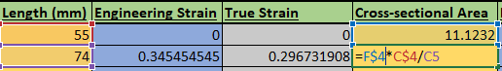
The cross-sectional area of the new length of the rubber band was then calculated in Excel using the following formula in Figure 10, where F4 is the original cross-sectional area, C4 is the original length and C5 is the new length:

Fig 10
The drag function was then used to calculate the cross-sectional area of the other rubber band lengths. The force applied in Newtons was then calculated using the following formula:
$$F=mg$$
Where F is force, m is mass and g is acceleration due to gravity, which is about 9.81. This was then inputted into Excel by using the following in Figure 11, where B5 was the first weight added, multiplied by 9.81 then divded by 1000, because the unit of measurement from the experiment was in grams.
Fig 11
The drag function was then used to calculate the rest of the force values in Newtons. There are now columns for the cross-sectional area and force in Newtons, as can be seen in Figure 12 below:
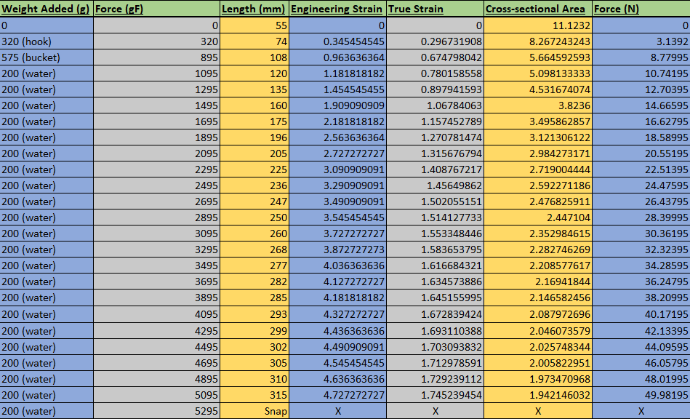

Fig 12

From this new data, the engineering stress can be calculated using the following formula:
$$Engineering Stress= \frac{Force}{Original Area}$$
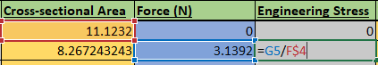
This formula was inputted into Excel by using the following in Figure 13, where G5 is the force in Newtons and F4 is the original cross-sectional area:

Fig 13
The drag function was then used to calculate the rest of the engineering stress values. It is now possible to achieve the True Stress value from the data by using the following formula:
$$True Stress= \frac{Force}{Actual Area}$$
This formula was inputted into Excel by using the following in Figure 14, where G5 is the force and F5 is the actual area:

Fig 14
The drag function was then used to calculate the rest of the true strain values. There are now columns for engineering stress and true stress, as can be seen in Figure 15:
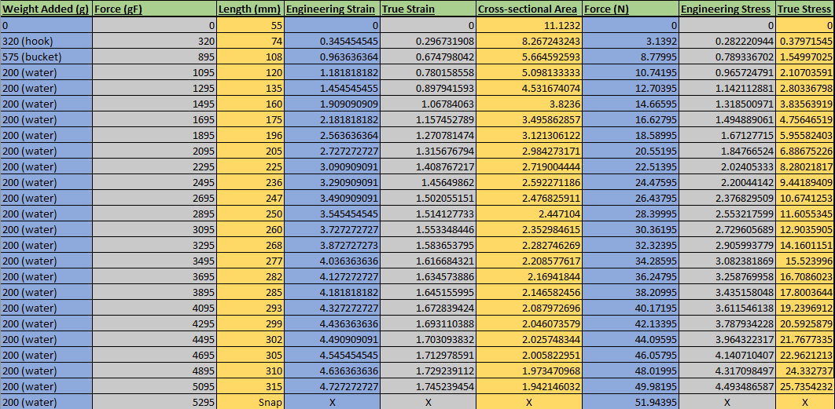

Fig 15

Analysis of Results
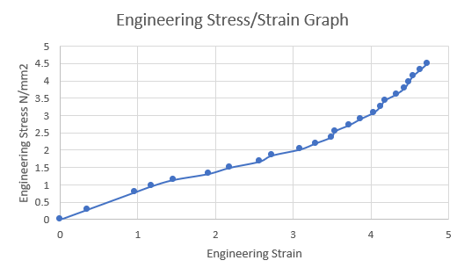
From the above data, an engineering stress/strain curve can be created, as shown in Figure 16:

Fig 16
As you can see, the first 9 data points form a straight line. From this graph, it is determined 4.6N/mm^2 is required before the band snaps.
Youngs Modulus can also be calculated from this graph, using the following formula:
$$Ε= \frac{σ}{ε}$$
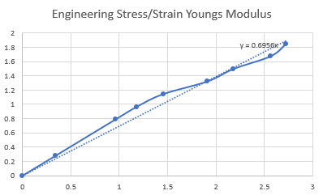
Where $Ε$ is Youngs Modulus, $σ$ is stress and $ε$ is strain. From the first 9 points of the graph above, a new graph was created, as shown in Figure 17:

Fig 17
A trendline was added via Excel and, as you can see in the top right corner of Figure 17, the Youngs Modulus, in terms of engineering stress and strain, comes in at 0.6956MPa (mega Pascals).

Again, using the data obtained from the experiment, a true stress/strain curve can be created, as can be seen in Figure 18:
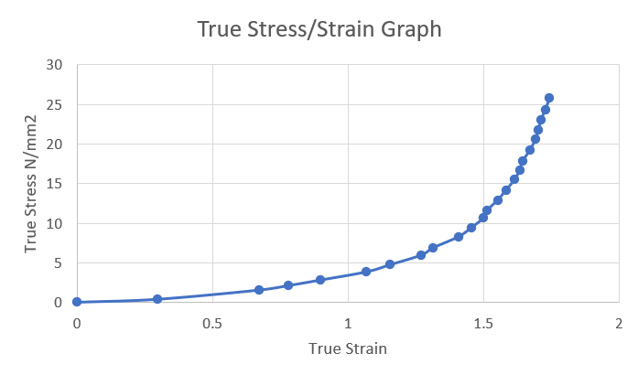

Fig 18
From this graph, it is determined that 25.735N/mm^2 is required before the rubber band snaps.
Youngs Modulus can also be calculated from this graph, using the following formula:
$$Ε= \frac{σ}{ε}$$
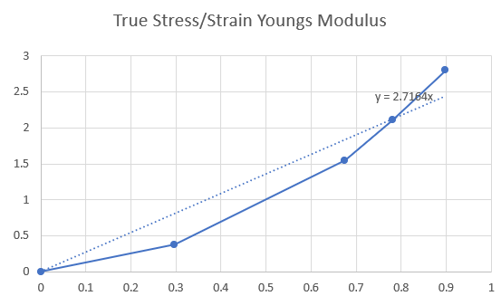
Where $Ε$ is Youngs Modulus, $σ$ is stress and $ε$ is strain. Using the first 5 points from the graph above, a new graph was created, shown in Figure 19:

Fig 19
A trendline was added via Excel and, as you can see in the top right corner of Figure 19, the Youngs Modulus, in terms of true stress and strain, is 2.7164MPa. From the two Youngs Modulus results, it can be determined that engineering stress and strain and true stress and strain values are very different. True stress/strain data is a lot higher in terms of this rubber band experiment.
As you can see below in Figure 20, the Ultimate Tensile Strength (UTS) of the rubber band, in terms of true stress/strain values is 25.735N/mm^2. As you can see by the shape of the curve, because of the chemical makeup of the rubber band, it gets harder as you increase the stress on it.

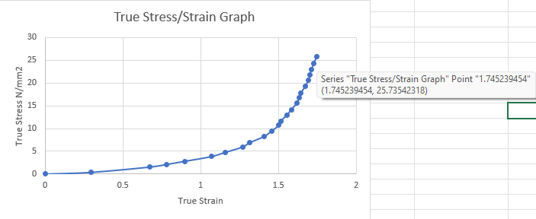

Fig 20
The same method of calculating the ultimate tensile strength can be used on the engineering stress/strain graph, as seen in Figure 21:

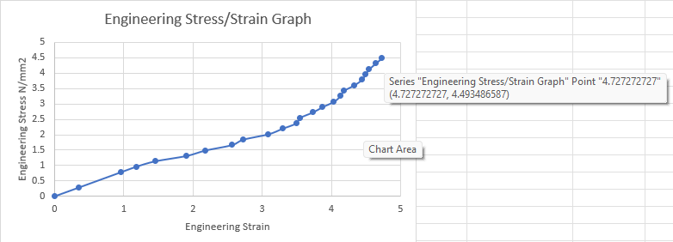

Fig 21
As you can see in Figure 21 above, the ultimate tensile strength in terms of engineering stress and strain is 4.493N/mm^2.

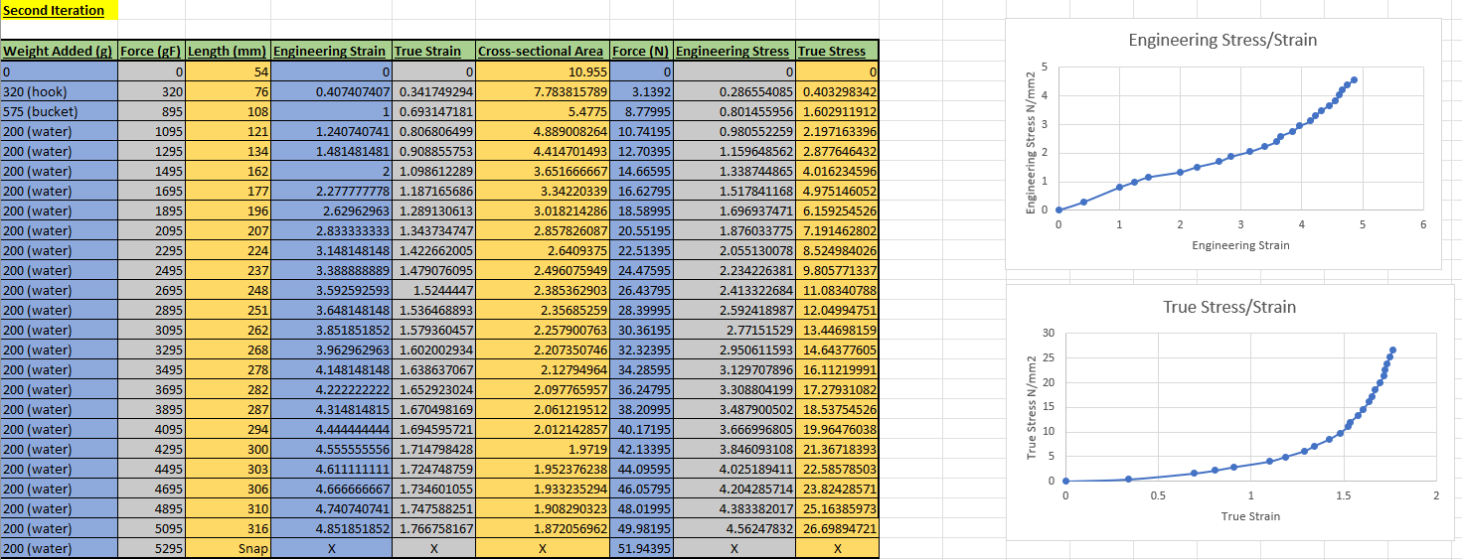
The experiment was repeated another two times, and produced similar results as you can see in Figure 22 and 23:

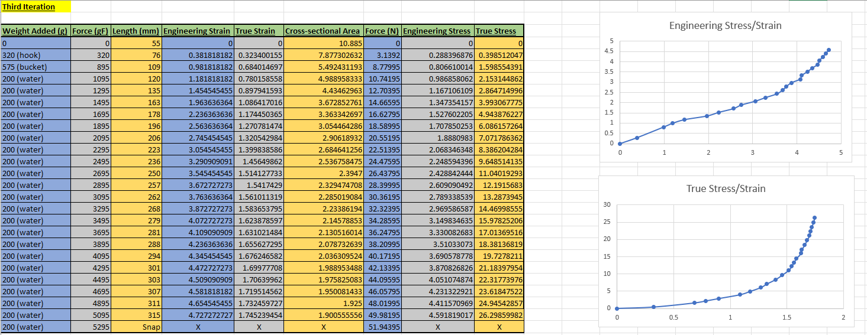
Fig 22

Fig 23
As you can see above, the results are similar to that of the first iteration. Below, in Figure 24, you can see the three Youngs Modulus and UTS. Alongside these values, using Excel, the mean and standard deviation can also be found.
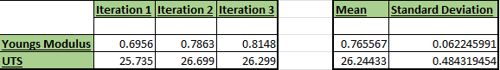

Fig 24

Fatigue Testing
Fatigue testing was carried out on a rubber band from the same sample. This was conducted by measuring the length, width and depth with a measuring tape and a digital calliper, the rubber band was then hooked on to the luggage weighing scales, as seen from the first experiment, and pulled to a force of 15.6N. The force is that figure because it is 0.3 X the breaking force of the first experiment.
This force was achieved by pulling on the band until 1600g showed on the scales, which is roughly 15.6N of force, until the rubber band snapped which, in this case, was 36 cycles.
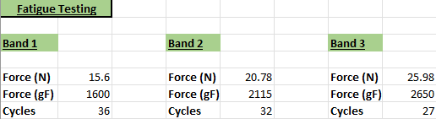
This was repeated another two times, the second time with the force being 0.4 X the breaking point and the third band with a force of 0.5 X the breaking point. Below, in Figure 25, are the results of the tests:

Fig 25
As you can see, the number of cycles it took to snap the elastic band were proportional to the force used per cycle.

Creep Testing
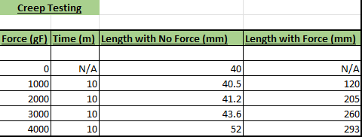
A creep test was also carried out on another rubber band. Using the same set up as the first experiment, the rubber band was loaded in 1000gF increments at 10 minute intervals. Between each interval, the weight was removed and the band was measured under no load. In Figure 26 below are the results of the creep test:

Fig 26
As you can see above, there has been permanent deformation in the rubber band caused by the continuous load. This is an example of creep, it is when a material is put under stress by a continuous load and undergoes permanent deformation once the load is removed.

Analysis of Experimental Inaccuracies and Cost/Quality Trade-off
Given that this experiment has a lot of different factors that could alter or influence the final results, there are going to be a few inaccuracies that will now be stated.
Using a digital calliper to measure the cross-section of the rubber band is quite an accurate way of measuring it, what should have happened though, is the measurements should have been taken at different points along the band and an average value taken.
Because a hook was used for this rubber band experiment, it caused a zone of higher stress, which is labelled in the drawing below, Figure 27:
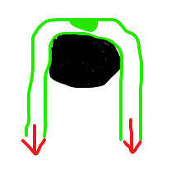
Higher stress zone

Fig 27
This causes different stress levels across the band. A solution to this problem would be to design specific test pieces for this experiment that would ensure that the stress was mostly in the middle of the band, rather than where the band was hooked.
There are other inaccuracies that are caused by material property variation. Even though the rubber bands used in this set of experiments were from the same bag, the same batch and made the same way, it does not mean that their material property values will be exactly the same. This is showcased in the results where the exact same experiment was done with differing results.
Temperature is another varying factor in this experiment, and something that could have been done the next time, given more time and money. The temperature should have been recorded in the original experiment, then compared with the experiment done in a colder and hotter setting.
Surprisingly, rubber bands would contract under heat, and stretch more when cold. This is because when warmed, the long polymer chains contract, making it shorter. Whereas when they are cooled down, the polymer chains relax and the rubber expands. (Finio, 2015)
If the temperatures are low enough, rubber bands become brittle and can shatter under impact. If the temperatures are too high, the rubber band becomes much harder.

Discussion
On reflection, it can be seen that the results of the experiment and the science behind rubber align. It is shown in the experiment that when a force is applied to the rubber band, it will stretch and stretch until it reaches its ultimate tensile strength, then it will snap.
From the stress/strain curves, it can be seen that rubber will get harder when a force is applied to it. You will also notice that the true stress/strain values are much higher than the engineering stress/strain values.
If the budget was not as constrained, a more accurate way of measuring the new lengths of the rubber bands would have been advantageous. A tool such as a longer digital calliper for example. A more accurate weighting scales would have made the results that much more accurate also.
If given more time, repeatability would have made the experiment more robust. Repeating the tests 8-10 times and taking a mean and standard deviation of the results would also be advantageous. As previously mentioned, using different temperature settings would have given a broader range of results.
The cost of this experiment, in terms of tooling and equipment, can be broken down below:
- Rubber bands (£1.20)
- Stepladder (£35)
- Metal hook (£3.50)
- Bucket (£5.45)
- Luggage weighing scales (£13)
- Weighing scales (£25)
- Knife (£1.50)
- Measuring tape (£5)
- Digital calliper (£120)
Total experiment cost: £209.65
In terms of quality, the experiment could have been carried out with a vernier calliper or a measuring tape. But the results would not have been as accurate as they were with the digital version.
Upon reflection, it can be determined that the more money you spend on equipment and tooling, the more robust and accurate the experiment will be. Conversely, the same experiment can be carried out at a lower cost and still have viable results.

Conclusion
To conclude, the results that were gained from this experiment were true to what was expected. As the force increased on the band, so did the length, stress and strain values (Figure 28). As this was a destructive test, the band snapped once it reached its ultimate tensile strength limit.

Fig 28
From the analysis, engineering stress/strain curves and true stress/strain curves were drawn (Figure 29 & 30), from that the Youngs Modulus was found for each and the ultimate tensile strength was also determined.

Fig 29 Fig 30

Finally, critical analysis showed that the experiment could have been done differently to make the readings more accurate, using long digital callipers to measure the length, for example. Costing could have been more or less, depending on how robust you want your results to be.

Acknowledgements
I would like to acknowledge Beth Johnson, for helping me carry out these experiments by writing the results down as I called them, and for letting me use the dining room to conduct the experiment.
I was also like to acknowledge Chris Wyatt for answering all of the questions I had on the assignment and showing me how to do the assignment correctly.

Bibliography
Bulldog Casters. (2016). Rubber Caster Wheels - Hysteresis. Retrieved from Bulldog Casters: https://www.bulldogcastors.co.uk/blog/rubber-caster-wheels-hysteresis/
Finio, B. (2015). Stretch It! How Does Temperature Affect a Rubber Band? Retrieved from Scientific American: https://www.scientificamerican.com/article/stretch-it-how-does-temperature-affect-a-rubber-band/
Vashchuk, A. (2020). Research Gate. Retrieved from Research Gate: https://www.researchgate.net/figure/Schematical-image-of-the-structure-of-thermoplastics-elastomers-and-thermosets_fig14_326737703
Wikipedia. (2022). Elastomers. Retrieved from Wikipedia: https://en.wikipedia.org/wiki/Elastomer

