Investigation on Business Plan

BMBM6020

Samuel Olaopa- 1702704

Introduction

Starting any type of business is not easy, especially when the idea may have been done before. It is essential that the business sets itself apart from the competition (entrepreneur, 2020).
The business plan/idea this report will be structuring itself around is creating a bakery. Starting your own bakery is not an easy task. Many people have tried and have failed to get their business ideas u and running, or even worse, their business ran under within the first year. This report will aim to show what sets a successful bakery apart from other which failed, it will also how if there are any gaps in the market and by using a survey given out to the public of the bakery we will know if the business is needed or if it is another failed idea.
Main Body
One of the best parts about creating a bakery is that you do not need any formal qualifications, all you need is a few basic skills and the passion to create products that are not commonly found. The more you bake the better you get at it, as the saying goes “practice makes perfect”. Before creating my business plan, I have had to decided what kind of shop I want to open. As briefly mentioned, creatin a bakery does not take up too much space, unlike other food businesses (Abudraham, 2010). Bread is a staple food for everyone around the old no matter how old or young they may be. Due to a bakery not needing much space there is an option of choosing to operate from home, it can save on capital cost. At most it may be some construction of shelves counter and most all a working oven, it can save on rental fees but to this I have to comply with the licensing requirements, additionally if I were to go along this route, I cannot overlook the health and safety requirement.
Location for any type of business is very important. Location plays a huge part in attracting and obtaining customers (BBC, 2021). When choosing a location there are factors that need to be taken into account such as customers, is it convenient for customers? With this bakery business one of the ideas is that if customers cannot make it to store there will be a local delivery system so the bake goods can still stay fresh by doing this, I am offering the customer something that they cannot get locally from any bakery business in the environment. The official location for the business will be Newport, Newport is a small city that is located in South East Wales. Due to it being an up-and-coming city and its small size compare to other cities it is easy to get around, this helps with the delivery system I am planning on implementing within the business. Since location is very important for any type of business, I thought it would be best to check how many competitors are in the area, after googling and researching how many bakery’s any in the most popular areas in Newport surprisingly apart from the mainstream bakery’s such as Greggs and coffee shops there are not many options (Tripadvisor, 2021). There may be many other businesses similar to the one I am proposing but that is why it is important to set your business apart from the others. Having a niche is important especially to small business such as the one I am proposing but finding a niche can be difficult so if found it can establish a loyal audience. By having a niche, the business is more memorable, and customers are likely to remember them, without having something that makes the business stand out the business will just blend in with others similar to them. Business can stand out by offering a different product or service that the competitors do not offer, my aim is to do both. One of the services my business may offer is the ability to go online and order what you want on there, since it is mostly local it will not cost too much. As for the product most bakeries usually priorities cakes, cookies, brownies but with the business I am hoping to start it will offer baked goods that taste good and are good for you too, this includes bread such as sprouted whole gain, sourdough, oat bread, flax bread, etc.
As mentioned, for any type of business to succeed there has to be a need for the product or service. With the way the world Is going most people want to live a healthy lifestyle, this includes eating healthy as well. Depending on what bread the business makes it can be an excellent source of grains which are very rich in fibre, B vitamins and many other nutrients. Even customers with diabetes, eating complex carbohydrates, this includes whole grain bread it can help them regulate blood sugar. Most bakeries located in Newport care more about offering sugary based project than healthy products, this also creates a gap within the market for a business to come and supply the products the customers are missing out on. Finding a gap in Newport’s bakery market will allow my business to establish itself due to its location. Newport is located between Cardiff and Bristol and only around a 30-minute drive from both locations, this can also help drive sales due to word of mouth, this happens when customers like a service or product so much they tell their family and friends which a great way is to get free advertisement.
Will my business succussed in the current market? to answer this question I thought it would be best to do a market research. “Market research is the process of de Market research is the process of determining the viability of a new service or product through research conducted directly with potential customers” (Twin, 2020). By using market research, I hope to find the correct target market and also get opinions and other feedback from the public about their interests in the product and service. There are many ways to gather such information, it can be done through surveys, product testing, and focus groups, one of the easiest ways to gather the information needed is a questionnaire, which is the way I used to gather information. Why a questionnaire? Online questionnaires are an invaluable resource in gathering information. Responses can provide great ways to engage a certain task. To get as many people as I can to do the survey I went online and posted the questionnaire composed of 16 questions on websites much as Facebook, twitter and snapchat. The first question that was of the questionnaire was whether they live in Newport or not, this questioned was asked to figure out what the opinions of the people who live in Newport are whether since this is the location that the business will be based. Surprisingly 90% of the 100 people who took part in the questionnaire said that they lived in Newport, this question was a success, this is because of now I know that the majority of the people who undertook the questionnaire are from Newport which means the rest of the questionnaire will determine if the people of Newport want or need this business. However, this question may be flawed due to the way the public got access to the questionnaire, this was because it was posted to friends and family and majority of them live in Newport. Below is what

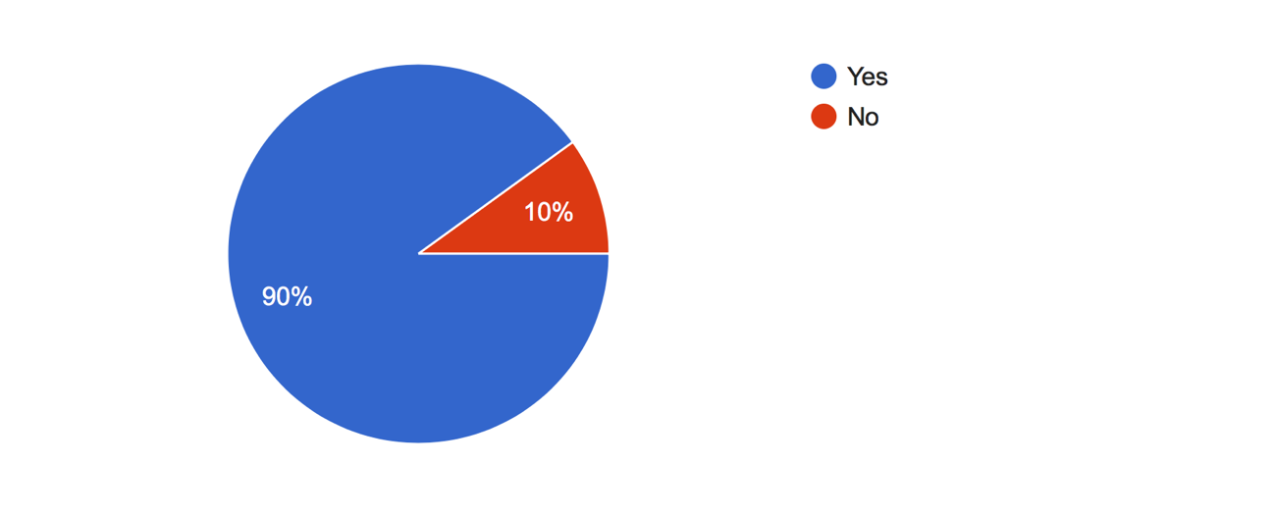
Do you live in Newport?
The second question was “how old are you” this question was to know what the core group of the people that could be interested in what the business as to offer, surprising 50% of the people who took apart in the questionnaire was 18-24, this might be because of the locations the questionnaires were published. By asking for their age, it can help determine what age group is the ideal target audience, if the product and service is carted more for young adults, it is very unlikely that a retired person might enjoy the same product or service.
How old are you?
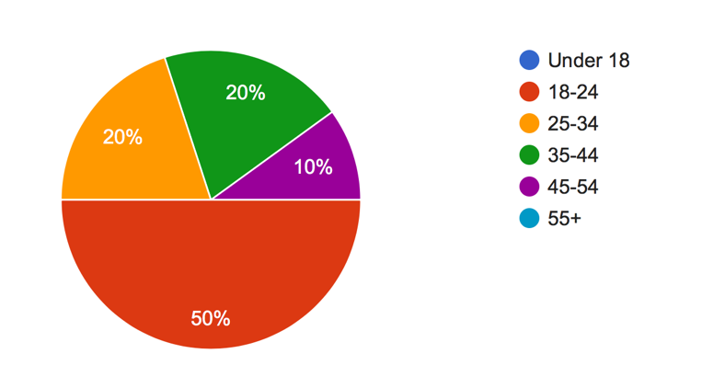

Another 2-part question I thought would is “Do you shop at a local bakery” this question was asked since the nature of the business is bakery with modern ideas, by knowing if people still buy products from the bakery, it gives the business an idea to see if the business is dead before even starting the second part of question was “If you don’t shop at a local bakery why not”. Since 70% said they do shop at a local bakery and 30% said they do not I wanted to know why. The statics shown from the questionnaire was almost split 4 ways with majority saying they don’t shop from local bakery because of the price and the fact that there is usually no parking. This gives my business another gap due to the service it could provide by delivering daily fresh baked food to those who order online, this eliminants the parking problem, 20% also said its out of the way from them which this service also takes care off since it is local and in time slots it should not stress the business.

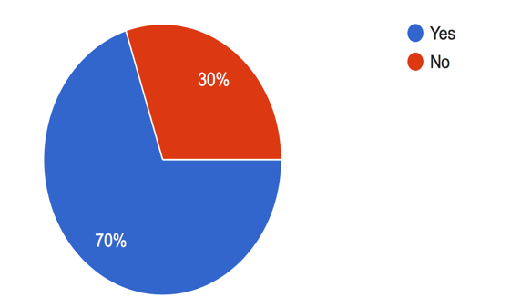
Do you shop at a local bakery? If you don’t shop at a local bakery, why not?
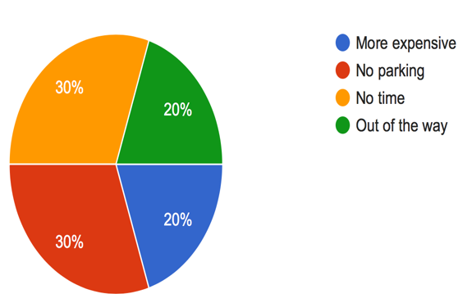

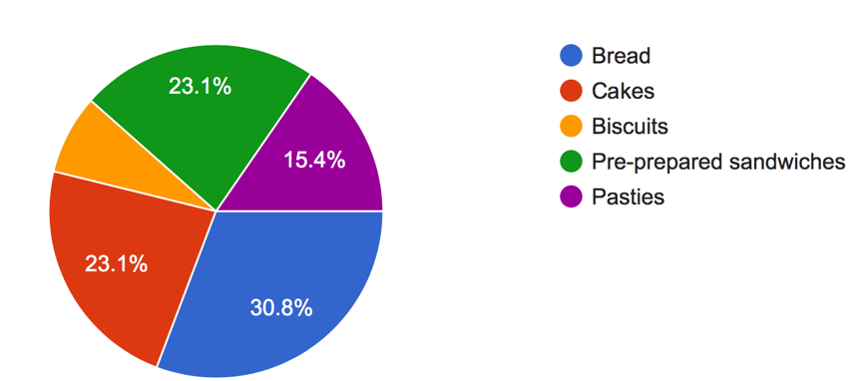
Additionally, knowing what type of baked good the public buy is important so that the business can plan accordingly to what product they should produce. The next question explores what normally buy if they do buy baked goods, once again the result was more or less split with most people buying cakes, pre prepared sandwiches, bread and pastie, with only 9% saying they buy biscuits, this information helps me know that the business could offer biscuits as one of its products, but it should not focus on it due to the lack of interest on the product

What type of bread do you buy?

Since bread is one of the most popular baked products, dating back to 8000BC, it was essential that the business knew what type of bread people were interested in. There was a clear winner in the result which was white bread at more than 50% of people said if they were to buy bread it would be the white type, this helps the business know to produce the popular option.

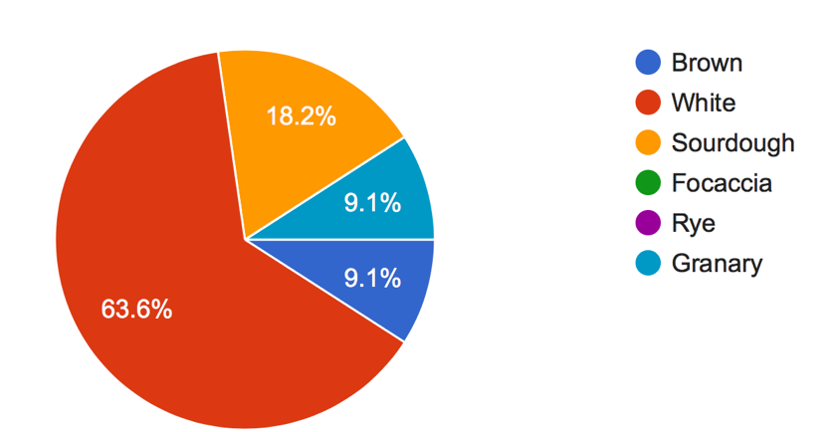
What type of bread do you buy?

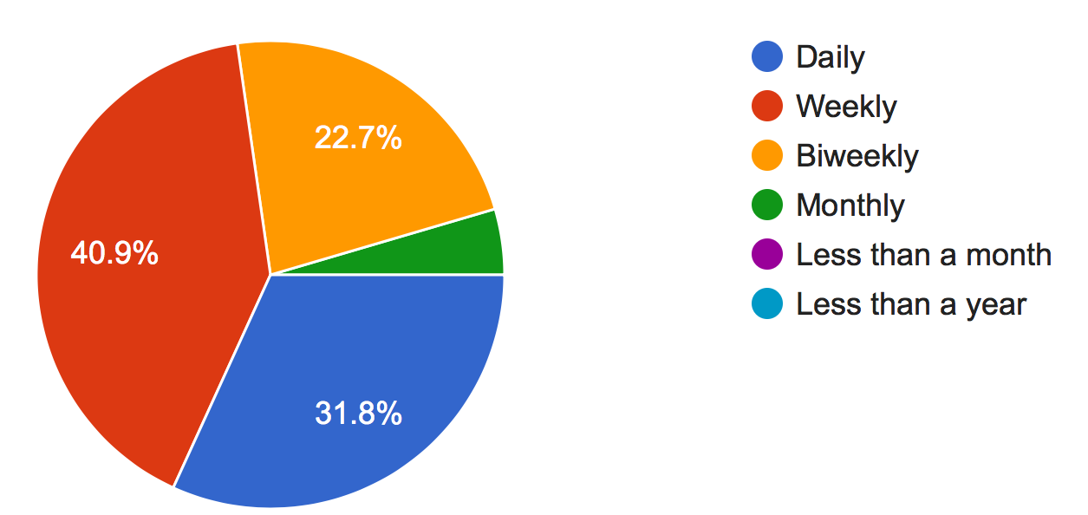
Knowing how often people buy baked good is an important information to have it can help a business know how to manage their stocks and products. The question asked to acquire the relevant information was “How often do you buy baked goods?” the result showed that 40% of people who undertook the questionnaire buy a baked product at least once a week and 30% buying a baked item daily or more than once a week, what this result shows is that people like to buy baked goods since majority of the random people buy baked goods, daily and weekly.

One of the most important information for a business to have is knowing why customers would rather go to your business rather than your competitors. To get such information I thought it would be best to ask “why would they shop at a local bakery rather than a supermarket. A massive 63% of people said they would rather go to a local bakery because of the freshness of the product, the business can use this information by making sure they bake as they go to keep the freshness of the product. Another reason why people would rather go to a bakery is because it is local and easy to. This makes location even more important, due to this this information; the business should try and locate itself in a public and easy to get to location, this could be close to retail parks, high roads and even town centres to maximise the number of customers that can reach the location.
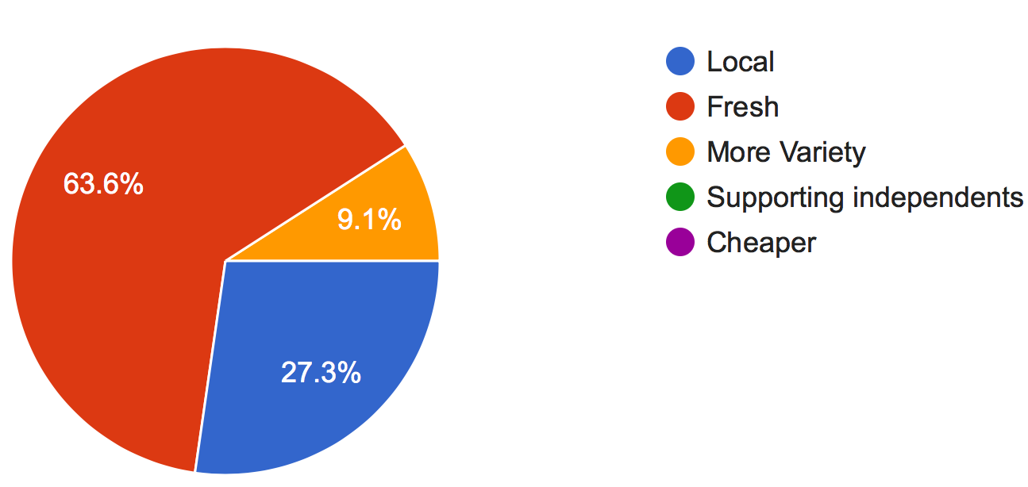

Why would you shop at a local bakery instead of a supermarket?

I wanted to gather more information on the other side to the business I am proposing which
Is the baked good delivery system. In order to know if the delivery system was a route worth pursuing it would be best to ask questions that could weigh in on it. The first question on this topic was “Do you shop online for any baked goods?” Not surprisingly 79% said that they never shop online for baked goods, this then leads to the next question “would you be interested in a baked goods delivery system?” Which 81% said yes, they would be interested in a delivery system, what the questionnaire has shown is the population of Newport do not shop online for their baked goods, but they would like the option and use it if it was presented.

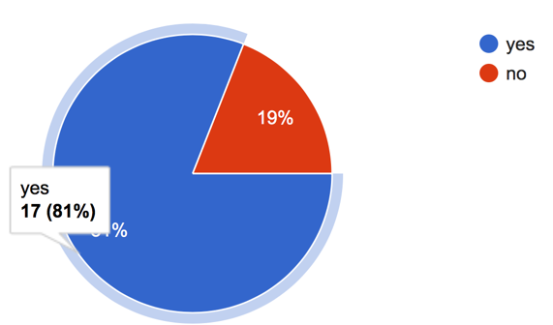
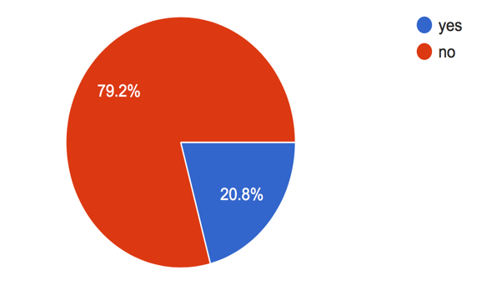
Do you shop online for baked goods?
Would you be interested in a baked goods delivery system?

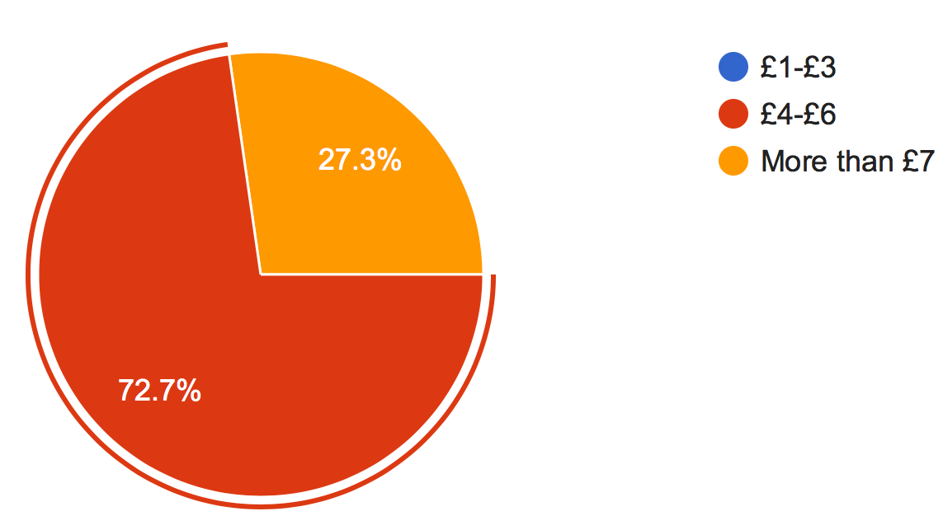
Towards the end of the questionnaire my aim was to figure out how much people spend at a time when visiting a bakery. 72% of the people who undertook the questionnaire said that they spent £4-£6 at a time. This information helps the business with an idea of how much to make the products so they can make profit, one of the advantages to a bakery is that the raw material does not cost a lot to buy.

How much are you willing to spend at a time when visiting a bakery?

Conclusion/Business plan

Doing a market research is very important. There are countless of examples of product and business failures simply because there was a lack of market research. By doing a questionnaire it helps to launch a new product or to join a new market. understanding your customers and competitors is necessary if a business wants to succeed. By doing market research it has helped decided which way I would like to push my busines, the questionnaire as given me an inside understanding and my potential customers and how I can bring something niche into the market because of the location of the business. This research has helped to identify who my potential audience is, it has helped with knowing what motivates them and whether they will be loyal to the business, by having loyal customers can only mean more sales. Having this power information will help minimise risks when it comes to making key business decisions. There are just too many benefits to doing a good market research which will show once the business is up and running.
However, having a good market strategy is only the beginning, having a business plan is also important. Here is an example of my business plan:
Business Plan
Business Description:
Sam’s Bakery shop creates different range of baked good. Our products range from Breads, Cakes, Brownies, Cupcakes and Sandwiches using the freshest and healthiest ingredient, they are also gluten free so there is no risk of contamination for customers with gluten allergies.
Mission Statement
The purpose of my bakery is to promote baked goods can be good for you, people have this idea that pastry’s and bread can be bad for you, this business is here to change their minds.
Company Description
The key employees are the bakers who make the dough, bake the product. The employees that look on our website to see if there are any deliveries to be made. The manager that ensures that everything operates smoothly.
Target Market
The target audience for Sam’s bakery shop are people who want to eat healthy but also want it to taste good. In Newport there are limited options when it comes to healthy baked goods. It is difficult for people with gluten allergies to get baked healthy good, we strive to give our customers the best money has to offer. There is no age discrimination as long as they want healthy products which range for sandwich’s to baked bread, muffins, cupcakes.
Marketing Plan
The marketing plan is simply, they can buy from store but also go online to order. Each day the customers can order what they want for that day and only a certain amount will be delivered daily, this will promote people to buy whilst they still can or lose the spot for that day.
Company Advantages
Because we are small, we have something that big brands such as Greg’s do not have, we have that home feeling, the rich ingredients that they do not have. We are fast because we are small. People may say being so small is a disadvantage, but we make it our advantage.
Financial Plan
The financial forecast on how to spend funds is pretty simply, once you buy the ovens and equipment needed and one has the space the cost to keep running is not has great as other businesses.

Bibliography
Abudraham, N., 2010. Business plan for a cake bakery. [Online]
Available at: https://www.theseus.fi/handle/10024/20765
[Accessed 7 April 2020].
BBC, 2021. The importance of location. [Online]
Available at: https://www.bbc.co.uk/bitesize/guides/z84kq6f/revision/1
[Accessed 7 April 2021].
entrepreneur, 2020. Positioning: Setting Your Business Apart. [Online]
Available at: https://www.entrepreneur.com/article/171496
[Accessed 4 April 2021].
Tripadvisor, 2021. Bakeries in Newport. [Online]
Available at: https://www.tripadvisor.co.uk/Restaurants-g186463-zfg9901-Newport_South_Wales_Wales.html
[Accessed 8 April 2021].
Twin, A., 2020. Market Research. [Online]
Available at: https://www.investopedia.com/terms/m/market-research.asp
[Accessed 8 April 2021].

