PPT Notes

BMIH6007
International Meetings Management for the Hotel Industry

Assessment 1

Event Theme: Technology and Innovation
Name: Estera Lautarescu
Student Id:2122252
Lecturer: Kathryn Flynn

Digital Disruption: Navigating the Tech Revolution


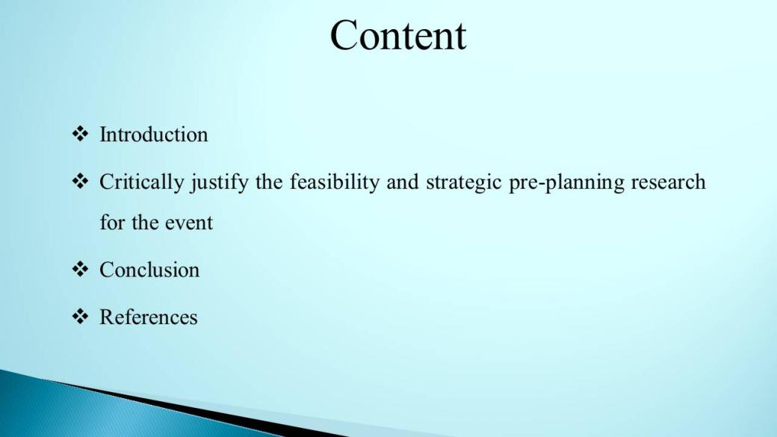

Table of Contents
Introduction 1
Market factors 2
Operational factors 4
Financial factors 5
SWOT analysis 7
PESTLE analysis 9
Conclusion 12
References 13

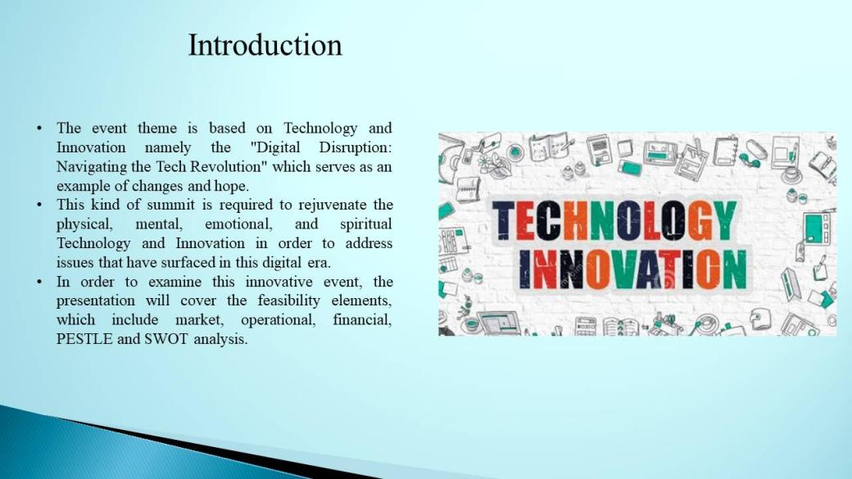

Introduction
The event theme is based on Technology and Innovation namely the "Digital Disruption: Navigating the Tech Revolution" which serves as an example of changes and hope. This kind of summit is required to rejuvenate the physical, mental, emotional, and spiritual Technology and Innovation in order to address issues that have surfaced in this digital era. In order to examine this innovative event, the presentation will cover the feasibility elements, which include market, operational, financial, PESTLE and SWOT analysis.
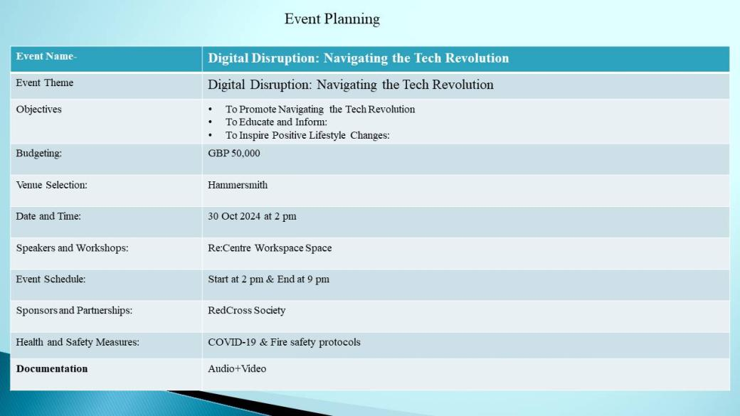

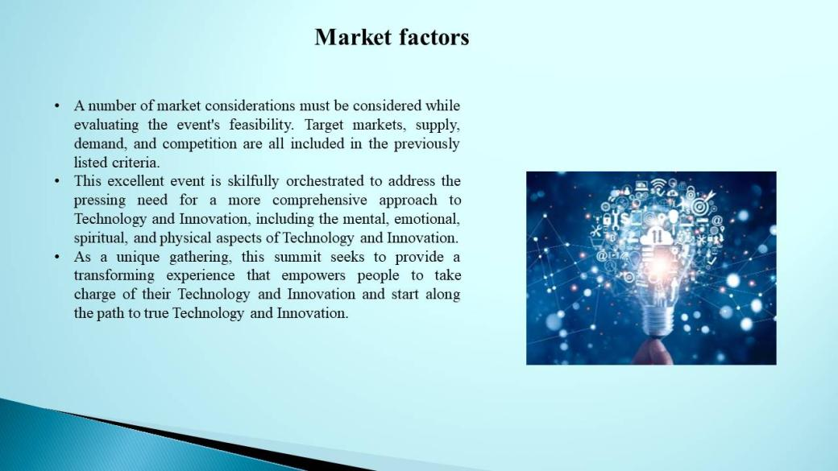

Market factors
A number of market considerations must be considered while evaluating the event's feasibility. Target markets, supply, demand, and competition are all included in the previously listed criteria. This excellent event is skilfully orchestrated to address the pressing need for a more comprehensive approach to Technology and Innovation, including the mental, emotional, spiritual, and physical aspects of Technology and Innovation. As a unique gathering, this summit seeks to provide a transforming experience that empowers people to take charge of their Technology and Innovation and start along the path to true Technology and Innovation.
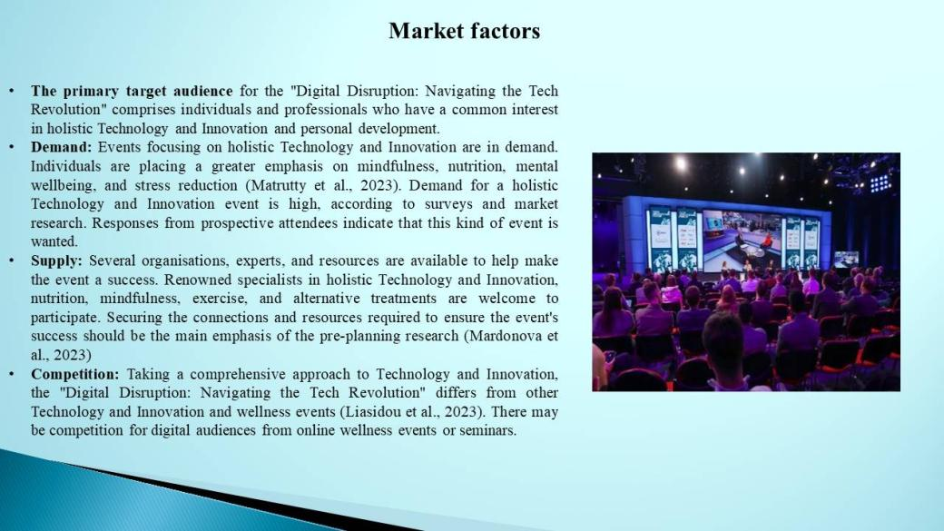
A few of them will be looked at in length in the debate that follows.
The primary target audience for the "Digital Disruption: Navigating the Tech Revolution" comprises individuals and professionals who have a common interest in holistic Technology and Innovation and personal development. The goal of this strategy for attracting possible attendees is to increase the event's attractiveness. According to Mohamed et al. (2023), the event will mainly target a number of groups, including those looking to improve their own Technology and Innovation professionals, lovers, advocates and enthusiasts, practitioners
Demand: Events focusing on holistic Technology and Innovation are in demand. This need is influenced by several factors. It's becoming more obvious how mental, emotional, and physical wellbeing are related. They look for comprehensive answers for Technology and Innovation. The COVID-19 epidemic has placed a strong focus on wellbeing and Technology and Innovation. Individuals are placing a greater emphasis on mindfulness, nutrition, mental wellbeing, and stress reduction (Matrutty et al., 2023). Demand for a holistic Technology and Innovation event is high, according to surveys and market research. Responses from prospective attendees indicate that this kind of event is wanted.

Supply: Several organisations, experts, and resources are available to help make the event a success. Renowned specialists in holistic Technology and Innovation, nutrition, mindfulness, exercise, and alternative treatments are welcome to participate. Appropriate locations with several workshop spaces and presentation halls are available to handle a large gathering. Securing the connections and resources required to ensure the event's success should be the main emphasis of the pre-planning research (Mardonova et al., 2023)
Competition: Taking a comprehensive approach to Technology and Innovation, the "Digital Disruption: Navigating the Tech Revolution" differs from other Technology and Innovation and wellness events (Liasidou et al., 2023). There may be competition for digital audiences from online wellness events or seminars.
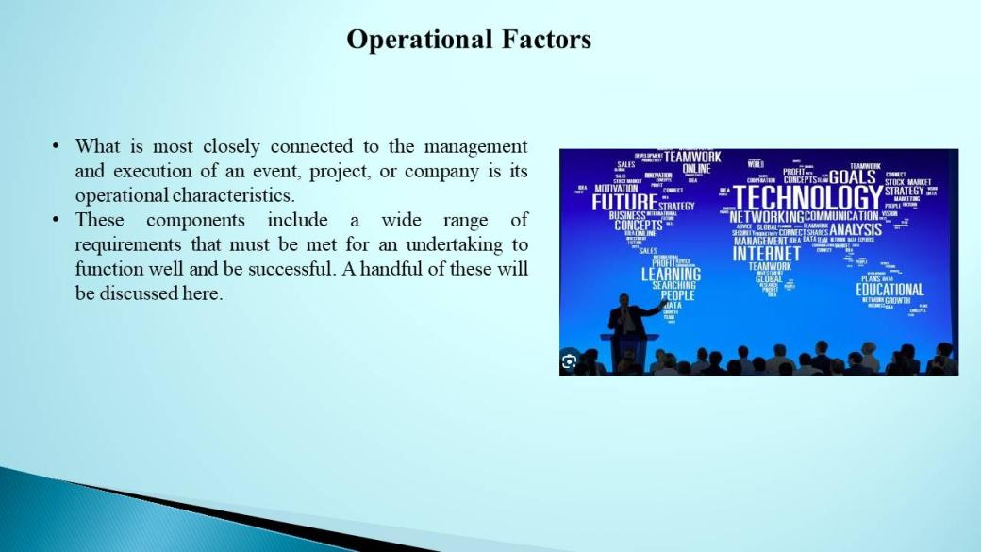

Operational factors

What is most closely connected to the management and execution of an event, project, or company is its operational characteristics. These components include a wide range of requirements that must be met for an undertaking to function well and be successful. A handful of these will be discussed here.
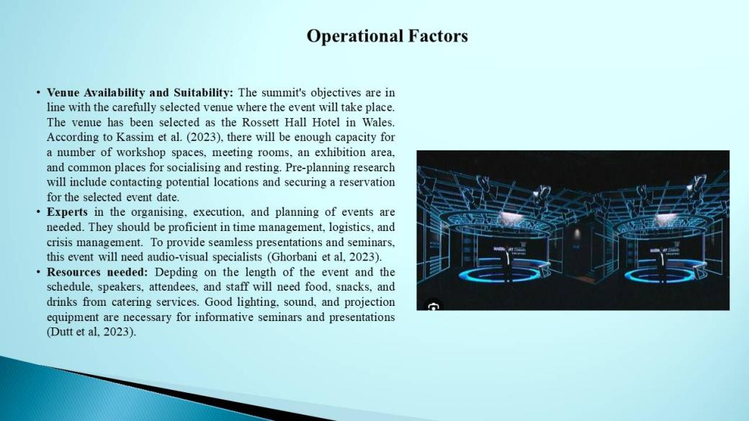
Venue Availability and Suitability: The summit's objectives are in line with the carefully selected venue where the event will take place. The venue has been selected as the Rossett Hall Hotel in Wales. According to Kassim et al. (2023), there will be enough capacity for a number of workshop spaces, meeting rooms, an exhibition area, and common places for socialising and resting. Pre-planning research will include contacting potential locations and securing a reservation for the selected event date.
Experts in the organising, execution, and planning of events are needed. They should be proficient in time management, logistics, and crisis management. To provide seamless presentations and seminars, this event will need audio-visual specialists (Ghorbani et al, 2023). Digital marketing, content development, and social media management specialists will be hired to promote the event. Event registration and ticketing professionals will handle participant check-in and inquiries.
Resources needed: Depending on the length of the event and the schedule, speakers, attendees, and staff will need food, snacks, and drinks from catering services. Good lighting, sound, and projection equipment are necessary for informative seminars and presentations (Dutt et al, 2023). A large amount of parking or close parking for attendees' cars, event management software, registration platforms, and event apps to help with logistics, a group of committed volunteers to assist with directions, guide attendees, and distribute materials, and security personnel and techniques to safeguard attendees and property are all necessary for this event.
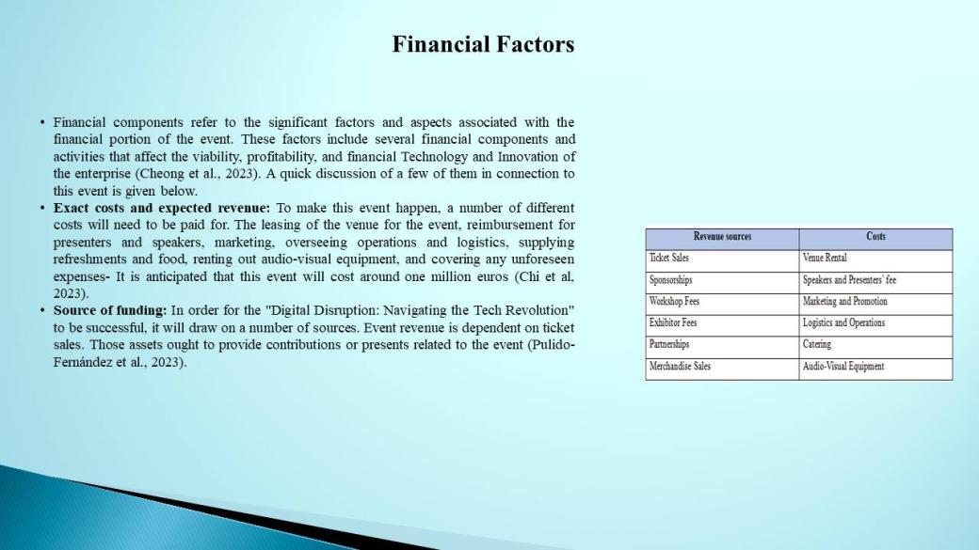

Financial factors
Financial components refer to the significant factors and aspects associated with the financial portion of the event. These factors include several financial components and activities that affect the viability, profitability, and financial Technology and Innovation of the enterprise (Cheong et al., 2023). A quick discussion of a few of them in connection to this event is given below.
Exact costs and expected revenue: To make this event happen, a number of different costs will need to be paid for. The leasing of the venue for the event, reimbursement for presenters and speakers, marketing, overseeing operations and logistics, supplying refreshments and food, renting out audio-visual equipment, and covering any unforeseen expenses- It is anticipated that this event will cost around one million euros (Chi et al, 2023).
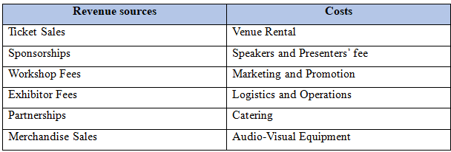
The money needed for this event will come from the ticket sales, exhibitor fees, workshop fees, sponsorships, item sales (including the selling of books and other goods), partnerships, and other related activities. This event is expected to bring in 1.5 million euros (Rather et al., 2023).
Source of funding: In order for the "Digital Disruption: Navigating the Tech Revolution" to be successful, it will draw on a number of sources. Event revenue is dependent on ticket sales. Tickets for early bird summits, general admission, and VIP are available. Securing funding from public, commercial, or non-profit groups that support community development, Technology and Innovation, and Technology and Innovation may provide extra funds. Those assets ought to provide contributions or presents related to the event (Pulido-Fernández et al., 2023). Its miles possible to shop prices and generate money via going into price-sharing or sponsorship preparations with event-related agencies or provider carriers, consisting of caterers, trip services, and event era suppliers
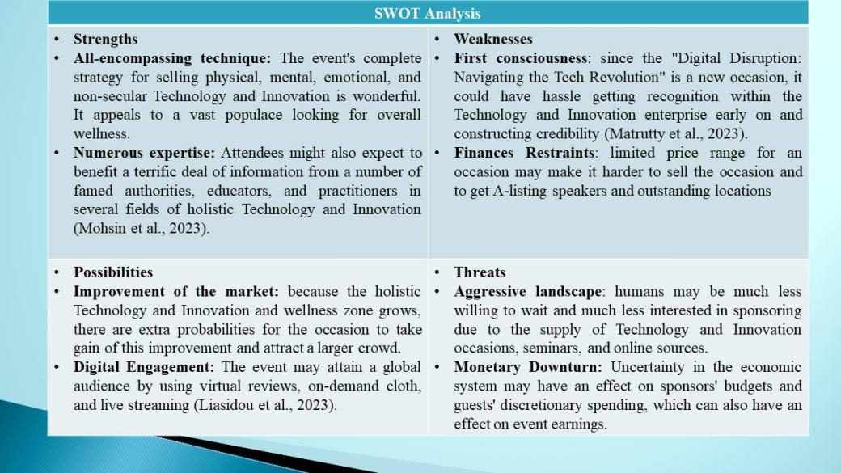

SWOT analysis
The "Digital Disruption: Navigating the Tech Revolution" might benefit substantially from a SWOT analysis, which is a helpful approach for assessing activities and stands for "strengths, weaknesses, opportunities, and threats." This analysis may additionally help discover regions that would require development and offer insights into the occasion's strategic planning (Patwary et al., 2023).
Strengths
All-encompassing technique: The event's complete strategy for selling physical, mental, emotional, and non-secular Technology and Innovation is wonderful. It appeals to a vast populace looking for overall wellness.
Numerous expertise: Attendees might also expect to benefit a terrific deal of information from a number of famed authorities, educators, and practitioners in several fields of holistic Technology and Innovation (Mohsin et al., 2023).
Sturdy market call for: research and surveys on the subject of Technology and Innovation and properly-being suggest a receptive audience, with call for holistic solutions expanding.
Diverse sales Streams: The occasion's income and capacity for growth are derived from the sale of tickets, sponsorships, exhibitor prices, merchandising, and workshop expenses, among other resources (Mohamed et al., 2023).

Weaknesses
First consciousness: since the "Digital Disruption: Navigating the Tech Revolution" is a new occasion, it could have hassle getting recognition within the Technology and Innovation enterprise early on and constructing credibility (Matrutty et al., 2023).
Finances Restraints: limited price range for an occasion may make it harder to sell the occasion and to get A-listing speakers and outstanding locations
Logistic Complexity: organising a massive event that includes several seminars and speeches can be hard and requires meticulous preparation and execution.
The finance of the event is typically established upon sponsorships and the hobby of these sponsors in addition to triumphing monetary circumstances impact this (Mardonova et al., 2023).
Possibilities
Improvement of the market: because the holistic Technology and Innovation and wellness zone grows, there are extra probabilities for the occasion to take gain of this improvement and attract a larger crowd.
Digital Engagement: The event may attain a global audience by using virtual reviews, on-demand cloth, and live streaming (Liasidou et al., 2023).
Collaborative enlargement: The event's impact can be amplified by means of exploring partnerships with different wellbeing businesses and by using increasing it to other towns or nations.
Consumer enters: by tailoring destiny activities and content to contributors' needs and tastes, user input may assist cause them to better (Kassim et al., 2023).

Threats
Aggressive landscape: humans may be much less willing to wait and much less interested in sponsoring due to the supply of Technology and Innovation occasions, seminars, and online sources.
Monetary Downturn: Uncertainty in the economic system may have an effect on sponsors' budgets and guests' discretionary spending, which can also have an effect on event earnings.
Logistical difficulties: event arrangements can be interfered with via logistical problems, which include venue availability, technological troubles, and unanticipated activities (Ghorbani et al., 2023).
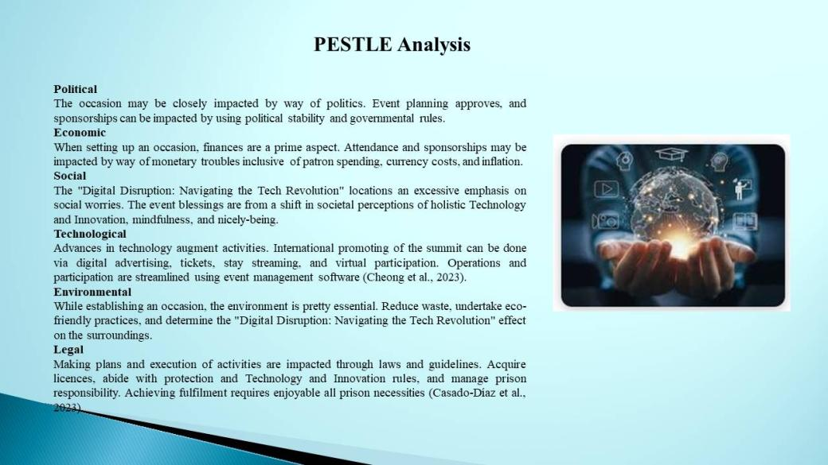

PESTLE analysis
The "Digital Disruption: Navigating the Tech Revolution" PESTLE examine appears at outdoor variables that might have an effect on fulfilment, execution, and planning. The components of PESTLE are Political, financial, Social, Technological, Environmental, and prison. The subsequent is a dialogue of every aspect:
Political
The occasion may be closely impacted by way of politics. Event planning approves, and sponsorships can be impacted by using political stability and governmental rules. A supportive political environment that promotes person and community Technology and Innovation is best for the "Digital Disruption: Navigating the Tech Revolution." financial assist and cooperation may be provided via government employer partnerships or wellbeing event incentives.
Economic
When setting up an occasion, finances are a prime aspect. Attendance and sponsorships may be impacted by way of monetary troubles inclusive of patron spending, currency costs, and inflation. Economic downturns may limit attendees' and company sponsors' discretionary expenditure (Dutt et al., 2023). At the plus side, sponsors may also input this market by virtue of the improved interest in holistic Technology and Innovation and wellbeing.
Social
The "Digital Disruption: Navigating the Tech Revolution" locations an excessive emphasis on social worries. The event blessings are from a shift in societal perceptions of holistic Technology and Innovation, mindfulness, and nicely-being. Demographics which includes age and interests are examples of social components. Chi et al. (2023) advice that strategically focused on millennials and Gen Z, who prioritise nicely-being, is probably beneficial
Technological
Advances in technology augment activities. International promoting of the summit can be done via digital advertising, tickets, stay streaming, and virtual participation. Operations and participation are streamlined using event management software (Cheong et al., 2023).In a aggressive market, the event would possibly stand out way to virtual reality for immersive experiences.
Environmental
While establishing an occasion, the environment is pretty essential. Reduce waste, undertake eco-friendly practices, and determine the "Digital Disruption: Navigating the Tech Revolution" effect on the surroundings. Eco-friendly practices and reusable substances supplement the holistic Technology and Innovation notion and appeal to folks that care approximately the environment.
Legal
Making plans and execution of activities are impacted through laws and guidelines. Acquire licences, abide with protection and Technology and Innovation rules, and manage prison responsibility. Achieving fulfilment requires enjoyable all prison necessities (Casado-Díaz et al., 2023). In the case that era, content introduction, or collaborations are worried, highbrow property and facts privateers need to be taken into consideration.
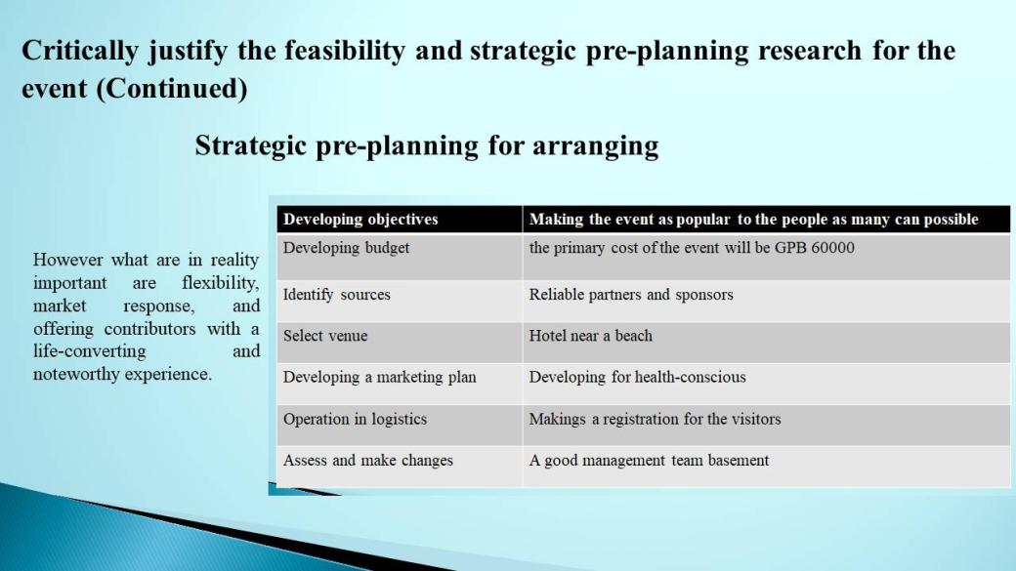

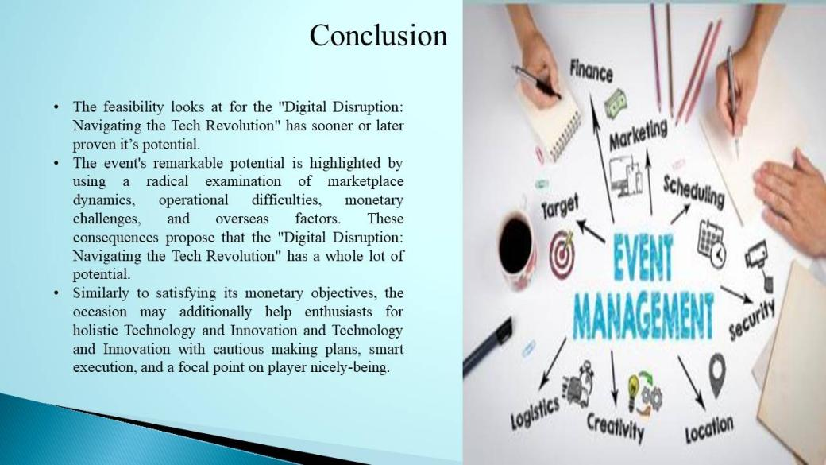

Conclusion
The feasibility looks at for the "Digital Disruption: Navigating the Tech Revolution" has sooner or later proven it’s potential. The event's remarkable potential is highlighted by using a radical examination of marketplace dynamics, operational difficulties, monetary challenges, and overseas factors. These consequences propose that the "Digital Disruption: Navigating the Tech Revolution" has a whole lot of potential. However what are in reality important are flexibility, market response, and offering contributors with a life-converting and noteworthy experience. Similarly to satisfying its monetary objectives, the occasion may additionally help enthusiasts for holistic Technology and Innovation and Technology and Innovation with cautious making plans, smart execution, and a focal point on player nicely-being.
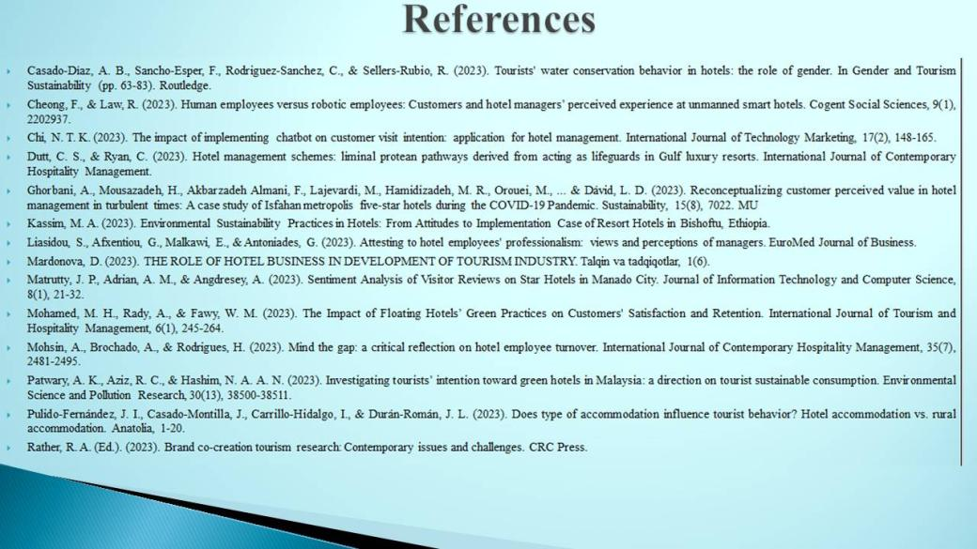

References
Casado-Díaz, A. B., Sancho-Esper, F., Rodriguez-Sanchez, C., & Sellers-Rubio, R. (2023). Tourists' water conservation behavior in hotels: the role of gender. In Gender and Tourism Sustainability (pp. 63-83). Routledge.
Cheong, F., & Law, R. (2023). Human employees versus robotic employees: Customers and hotel managers’ perceived experience at unmanned smart hotels. Cogent Social Sciences, 9(1), 2202937.
Chi, N. T. K. (2023). The impact of implementing chatbot on customer visit intention: application for hotel management. International Journal of Technology Marketing, 17(2), 148-165.
Dutt, C. S., & Ryan, C. (2023). Hotel management schemes: liminal protean pathways derived from acting as lifeguards in Gulf luxury resorts. International Journal of Contemporary Hospitality Management.
Ghorbani, A., Mousazadeh, H., Akbarzadeh Almani, F., Lajevardi, M., Hamidizadeh, M. R., Orouei, M., ... & Dávid, L. D. (2023). Reconceptualizing customer perceived value in hotel management in turbulent times: A case study of Isfahan metropolis five-star hotels during the COVID-19 Pandemic. Sustainability, 15(8), 7022. MU
Kassim, M. A. (2023). Environmental Sustainability Practices in Hotels: From Attitudes to Implementation Case of Resort Hotels in Bishoftu, Ethiopia.
Liasidou, S., Afxentiou, G., Malkawi, E., & Antoniades, G. (2023). Attesting to hotel employees' professionalism: views and perceptions of managers. EuroMed Journal of Business.
Mardonova, D. (2023). THE ROLE OF HOTEL BUSINESS IN DEVELOPMENT OF TOURISM INDUSTRY. Talqin va tadqiqotlar, 1(6).
Matrutty, J. P., Adrian, A. M., & Angdresey, A. (2023). Sentiment Analysis of Visitor Reviews on Star Hotels in Manado City. Journal of Information Technology and Computer Science, 8(1), 21-32.
Mohamed, M. H., Rady, A., & Fawy, W. M. (2023). The Impact of Floating Hotels’ Green Practices on Customers' Satisfaction and Retention. International Journal of Tourism and Hospitality Management, 6(1), 245-264.
Mohsin, A., Brochado, A., & Rodrigues, H. (2023). Mind the gap: a critical reflection on hotel employee turnover. International Journal of Contemporary Hospitality Management, 35(7), 2481-2495.
Patwary, A. K., Aziz, R. C., & Hashim, N. A. A. N. (2023). Investigating tourists’ intention toward green hotels in Malaysia: a direction on tourist sustainable consumption. Environmental Science and Pollution Research, 30(13), 38500-38511.
Pulido-Fernández, J. I., Casado-Montilla, J., Carrillo-Hidalgo, I., & Durán-Román, J. L. (2023). Does type of accommodation influence tourist behavior? Hotel accommodation vs. rural accommodation. Anatolia, 1-20.
Rather, R. A. (Ed.). (2023). Brand co-creation tourism research: Contemporary issues and challenges. CRC Press.

