University of Wales Trinity Saint David
Wales Institute of Science and Art



Application of CAE Processes
ACHA6010

Jack Purnell
2205053
December 2024
Claimed Word Count - 2521

Contents
1 Introduction 4
2 Kinematic Simulation and Structural Analysis 5
2.1 Kinematic Analysis 5
2.2 Thermal Study 7
2.2.1 Piston 7
2.2.2 Validation – Bi-Metallic Strip 9
2.3 Static Structural Study 13
2.3.1 Piston 13
2.3.2 Validation 15
3 Investigation 19
3.1 Change of Material 19
3.2 Piston Geometry Study 21
3.3 Combined Geometry and Material 23
4 Conclusion 26
5 Reference List 27

Figure 1 - Engineering Data to Rigid Dynamics System Link 5
Figure 2 - Crankshaft Assembly (Noble, 2024) 5
Figure 3 - Rigid Dynamics Force Load Output 6
Figure 4 - Standalone Steady State Thermal System 7
Figure 5 - Thermal Study Results 8
Figure 6 - Thermal Study Results Scale 8
Figure 7 - Full FEA System 9
Figure 8 - Bi-Metallic Strip Geometry Sketch (Dlubal, 2018) 9
Figure 9 - Bi-Metallic Strip Assembly 10
Figure 10 - Bi-Metallic Strip Mesh 11
Figure 11 - Bi-Metallic Strip Study Results 11
Figure 12 - Static Structural system linked to Rigid Dynamics System 13
Figure 13 - Piston Loads Displayed in Ansys 13
Figure 14 - Piston Mesh - Static Structural 14
Figure 15 - Deformation on Stock Piston 14
Figure 16 - Stress on Stock Piston 15
Figure 17 - Cantilever UDL Geometry Sketch (Dlubal, 2016) 15
Figure 18 - Cantilever Part 15
Figure 19 - Cantilever UDL Mesh 16
Figure 20 - Cantilever UDL Results 17
Figure 21 - Materials Study Thermal Result 20
Figure 22 - Materials Study Thermal Scale 20
Figure 23 - Material Study Deformation Results 20
Figure 24 - Material Study Stress Results 21
Figure 25 - New Piston Geometry 22
Figure 26 - Geometry Study - Thermal Scale 22
Figure 27 - Geometry Study Thermal Result 22
Figure 28 - Geometry Study Deformation Results 23
Figure 29 - Geometry Study Stress Results 23
Figure 30 - Combined Study Thermal Results 24
Figure 31 - Combined Study Thermal Scale 24
Figure 32 - Combined Study Deformation Results 24
Figure 33 - Combined Study Stress Results 25

Table 1 - Rigid Dynamics Analysis Settings 6
Table 2 – Rigid Dynamics Crankshaft Rotation Setting 6
Table 3 - Rigid Dynamics Maximum Load 7
Table 4 - Piston Crown Side Thermal Boundary Conditions 8
Table 5 - Piston Crown Thermal Boundary Condition 8
Table 6 - Oil Ring Thermal Boundary Conditions 8
Table 7 - Piston Rings Thermal Boundary Conditions 8
Table 8 - Piston Underside Thermal Boundary Conditions 8
Table 9 - Piston Skirt Thermal Boundary Conditions 8
Table 10 - Bi-Metallic Strip Geometry Table (Dlubal, 2018) 9
Table 11 – Invar & Copper Material Properties (Dlubal, 2018) 10
Table 12 - Bi-Metallic Strip Thermal Load (Dlubal, 2018) 11
Table 13 - Pressure Applied to Piston 14
Table 14 - Cantilever UDL Geometry Specification Table 15
Table 15 - Elastic-Plastic Material Information (Dlubal, 2016) 16
Table 16 - Cantilever UDL Load (Dlubal, 2016) 16
Table 17 - Al 6061 Material Properties (Rashmita et al., 2023) 19
Table 18 - Material Study - Rigid Dynamics Result 19
Table 19 - Geometry Study - Rigid Dynamics Result 22
Table 20 - Combined Study Rigid Dynamics Result 24

Equation 1 - K1 for Equivalent Stiffness (Dlubal, 2018) 12
Equation 2 - Deflection for Bi-Metallic Strip (Analytical Methods) (Dlubal, 2018) 12
Equation 3 - Bending Moment (M) 17
Equation 4 - Elementary Equation for Beam Deflection (Dlubal, 2016) 17
Equation 5 - Beam Deflection with Boundary Conditions Applied (Dlubal, 2016) 17
Equation 6 - Maximum Beam Displacement (Dlubal, 2016) 17

Introduction
This report will present the methodology and findings of a Finite Element Analysis (FEA) study on a piston head. A kinematic analysis will take place and generate a set of loading conditions that are realistic and comparable to real-world. Then, a Static Structural study will assess the structural properties of the component before a thermal study will account for a thermal loadings that the component receives. An iterative design process will then improve and optimise the component to reduce the mass whilst extending fatigue life.

Kinematic Simulation and Structural Analysis
Ansys Workbench 2023 will be used for the simulation and analysis of the piston head. The chosen materials. The first step in the process is to load the engineering data into workbench. MAHLE, an industry leading engine manufacturer recommends that aluminium silicon alloys are used, with M124 being the “classic” material for piston design (MAHLE International GmbH, 2016). I could not find this material in Ansys Granta, so an alternative that MAHLE also uses, Aluminium 2618, was used (Acosta, 2020).

Kinematic Analysis
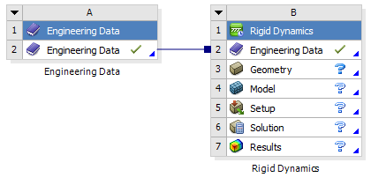
The Rigid Dynamics component in Ansys Workbench 2023 will be used to generate the loading conditions. And is linked directly to the engineering data as shown in Figure 1.
Figure 1 - Engineering Data to Rigid Dynamics System Link

The geometry is then imported into the system. For this report, a crankshaft and piston assembly, provided by Andrew Noble, is used, with focused attention to the piston itself. The geometry can be found in Figure 2 below (Noble, 2024b).
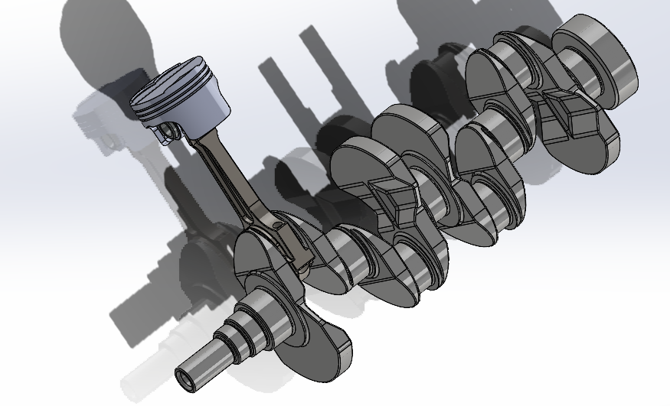
Figure 2 - Crankshaft Assembly (Noble, 2024)

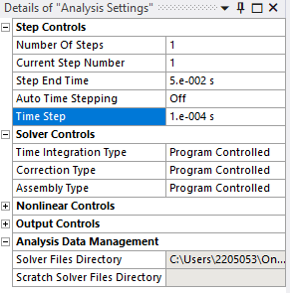
Once imported, the materials of each component are then set. For this example, it is assumed that all components are the default structural steel in Ansys, excluding the piston, which is set as the Aluminium 2618 as mentioned previously.
Table 1 - Rigid Dynamics Analysis Settings
The joints are then set in order to specify what parts can move and their degrees of freedom (DOF). This allows the model to become a single moving geometry. Following that, the analysis settings are then altered to ensure that the correct data is being recorded and a relevant time step. Table 1 shows the analysis setting used in this study.
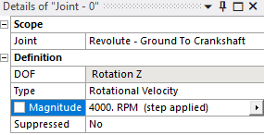
Once the analysis settings are specified, the software then needs to be told how the assembly is going to move. In this case, a rotational velocity is applied to the crankshaft at 4000RPM, in order to replicate an engine rotating. The specific settings are displayed in Table 2.
Table 2 – Rigid Dynamics Crankshaft Rotation Setting
It is then important to specify what the software needs to record, in this case it is specified that we want to record the joint load between the gudgeon pin and the piston. This will tell the software to map and record the forces on that joint. The software is now ready to solve the case.
Once solved, the system outputs the graph shown in Figure 3, displaying the forces in the x (red), y (green) and z axis (blue), and also the combined forces (purple).
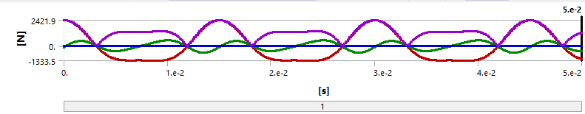
Figure 3 - Rigid Dynamics Force Load Output
When engineering a piston, you design for the highest possible load, so the data as found for the highest combined load on the piston head (Table 3)
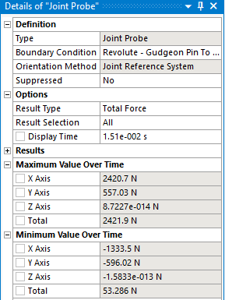
These loadings are then exported to include in later studies.
Table 3 - Rigid Dynamics Maximum Load

Thermal Study

Piston
Then, the steady state thermal solver is created as a standalone system, and the engineering data and model are manually linked over from the rigid dynamics as shown in Figure 4.
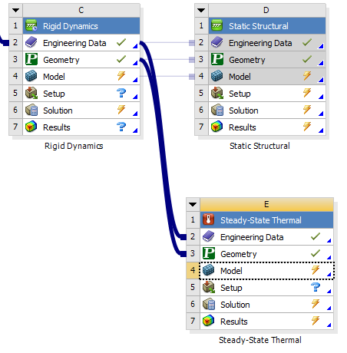
All bodies, other than the piston are then suppressed, and the piston values are checked to ensure consistency between the solvers. The next step is to generate a mesh for the piston head. A 0.004m (40mm) mesh size was used.
Figure 4 - Standalone Steady State Thermal System
Following the meshing of the piston, the thermal boundary conditions were then set, shown in the tables below, sourced from data provided (Noble, 2024c).
Table 4 - Piston Crown Side Thermal Boundary Conditions
Table 5 - Piston Crown Thermal Boundary Condition
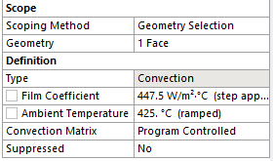
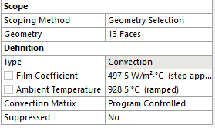

Table 6 - Oil Ring Thermal Boundary Conditions
Table 7 - Piston Rings Thermal Boundary Conditions
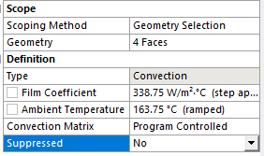
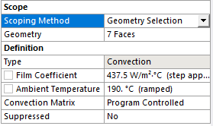

Table 8 - Piston Underside Thermal Boundary Conditions
Table 9 - Piston Skirt Thermal Boundary Conditions
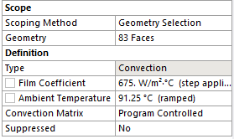
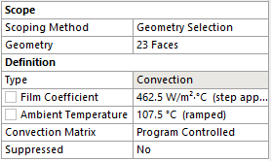

Once the boundary conditions were set, the next step was to setup the output conditions. The temperature of the piston is what we set out to record, so the temperature setting was selected and dropped into the solution folder. The case was then solved, with the following results:
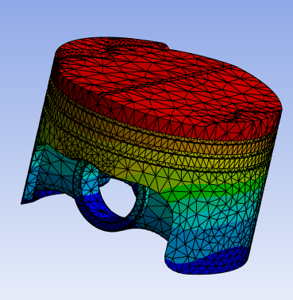
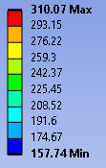
These results were then imported back into the static structural study as shown in Figure 7

Figure 5 - Thermal Study Results
Figure 6 - Thermal Study Results Scale
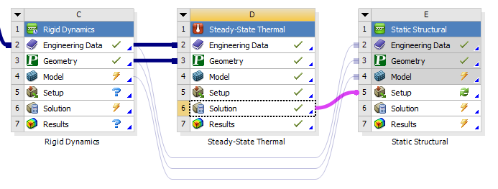
Figure 7 - Full FEA System

Validation – Bi-Metallic Strip

Computational
To validate the thermal study, a standardised case is calculated in Ansys. This will also help to build confidence within the software. For the thermal aspect, a Dlubal study on a bi-metallic strip will be used for validation purposes (Dlubal, 2018).
For this example, an assembly of two identical strips must be created using SolidWorks, to the specifications from the Dlubal study, as shown in below
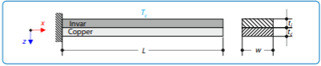
Figure 8 - Bi-Metallic Strip Geometry Sketch (Dlubal, 2018)

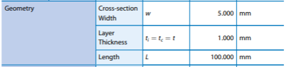
Table 10 - Bi-Metallic Strip Geometry Table (Dlubal, 2018)

The assembly created is shown in Figure 9
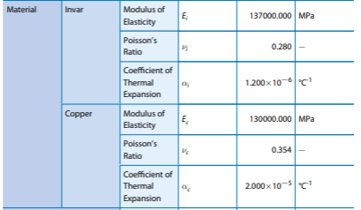
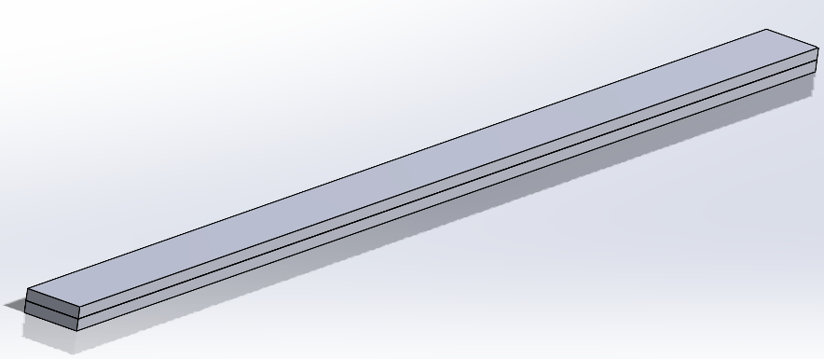
The next step is building the materials in Ansys, again taken from Dlubal. The material properties are shown in Table 11
Table 11 – Invar & Copper Material Properties (Dlubal, 2018)
Figure 9 - Bi-Metallic Strip Assembly
Once the materials have been set up in Ansys, the geometry is then imported into a Static Structural solver. This is used instead of the steady state thermal as a single thermal load is being applied over the whole assembly. The geometry is then checked over and ensured that the two parts of the strip are bonded together correctly. Once the correct contact conditions are set, the assembly is then meshed with a 0.5mm element size (Figure 10)

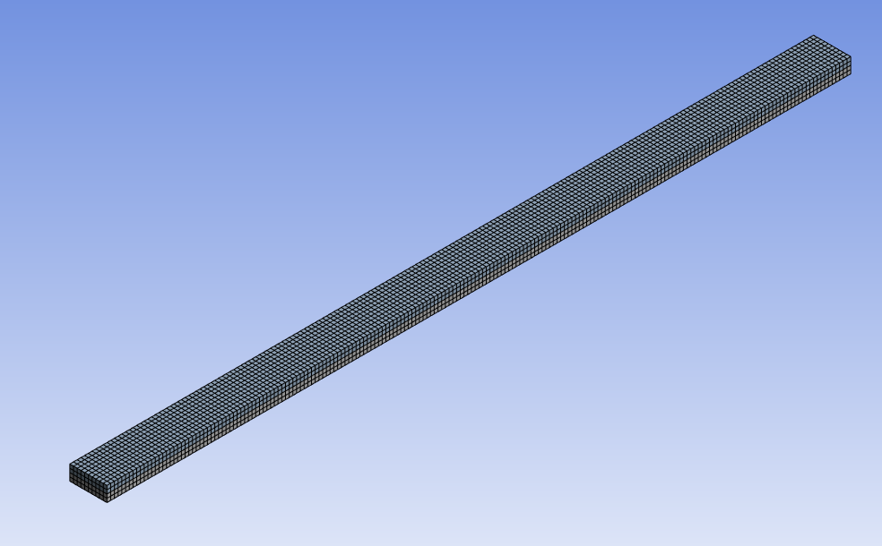
Now, the constraints for the study need to be set. Figure 8 shows us that one end of the strip must be fixed, so a fixed support is added in Ansys. Then, the thermal load must be added. A fixed temperature is applied to the whole part in accordance with Table 12 from Dlubal.
Table 12 - Bi-Metallic Strip Thermal Load (Dlubal, 2018)
Figure 10 - Bi-Metallic Strip Mesh

As the Dlubal report only looks at deformation, total deformation is added to the solution output and the result is shown below
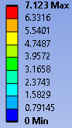
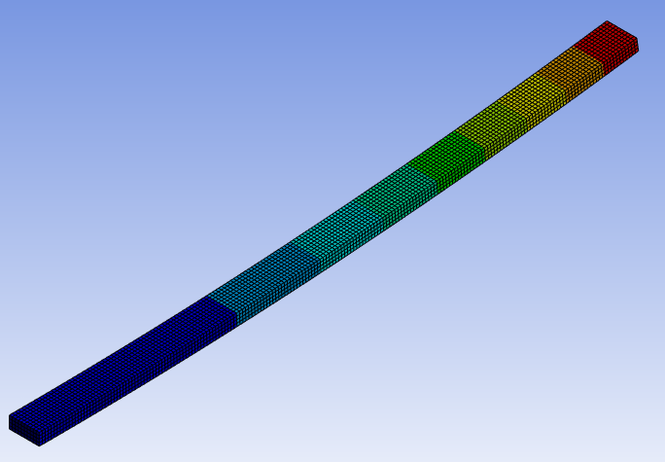
Figure 11 - Bi-Metallic Strip Study Results

As shown, the maximum deflection was computed to be 7.123mm.

Analytical Calculation
As shown in the Dlubal report, the analytical solution to the case is based from Equation 1, which is then used to solve Equation 2, for deflection.
Equation 1 - K1 for Equivalent Stiffness (Dlubal, 2018)
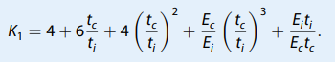
According to Dlubal, Equation 1 solves for $K_{1}$, a dimensionless coefficient that can be used to calculate equivalent stiffness.
Equation 2 - Deflection for Bi-Metallic Strip (Analytical Methods) (Dlubal, 2018)
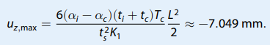
Dlubal calculated the deflection to be 7.049mm using analytical methods.
Comparing the computational solution to the analytical solution, there is a 0.047mm difference. When written as a percentage, there is a 1.04% difference, proving that the computational method is accurate and can be trusted.

Static Structural Study

Piston
Once the loadings from the rigid dynamics have been exported, the static structural system is then added connected to the existing system on workbench as shown in Figure 12.
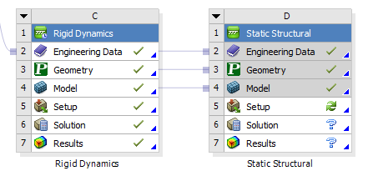
It is important to link these systems before introducing the thermal solver because it ensures that the geometry copies over correctly, as Ansys can have trouble with this if it is linked through too many systems (Noble, 2024a). Once the geometry is carried over and checked, all bodies other than the piston are suppressed, so the software ignores them. The piston is then set as flexible and the motion loads are imported. These are then displayed onto the piston as per Figure 13.
Figure 12 - Static Structural system linked to Rigid Dynamics System
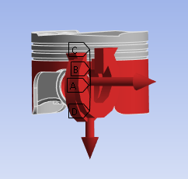
Once these have been displayed, it means that the software is recognising the correct loadings onto the piston. It is then important to turn inertia relief off. Due to some of the quirks in the Ansys workbench system, the next step is introducing the thermal loadings, which has already been covered in this report.
Figure 13 - Piston Loads Displayed in Ansys
Once the thermal loadings have been linked in, the mesh can be constructed using a 0.004m (40mm) element size. I then refined the mesh on the top of the piston crown to a 0.002m (20mm) mesh to more accurately record the stress and strain over the top of the piston, where combustion takes place. The final mesh is shown in Figure 14.
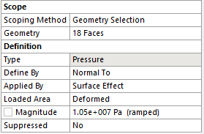
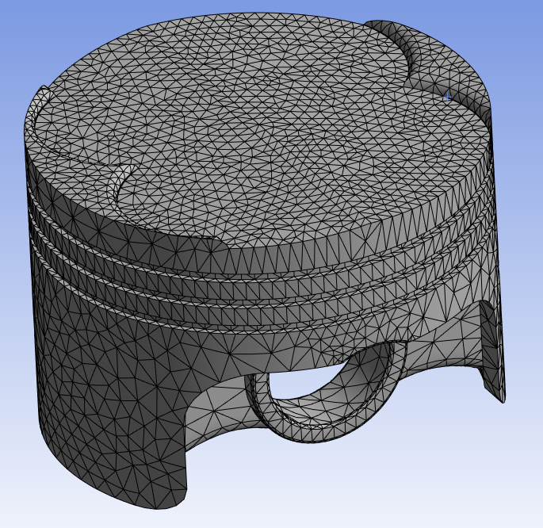
Once the mesh was created, it was double checked that the imported loads and carried over (both the rigid dynamic loads and the thermal loads) and then the outputs were set. A pressure was also applied to the top of the piston to simulate combustion pressure that a piston would usually see. The settings used for this can be seen in Table 13. I then had to constrain the piston in order for it not to move under load. Usually, weak springs would be used, but the maximum force exceeds the limits of a weak spring, so a fixed support was introduced where the gudgeon pin would be. The outputs the software was told to solve were total deformation and equivalent stresses. The case was then solved. And the results are displayed below.
Table 13 - Pressure Applied to Piston
Figure 14 - Piston Mesh - Static Structural

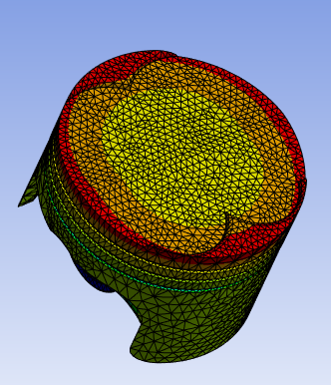
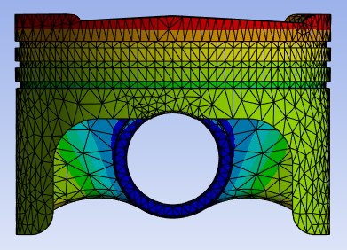
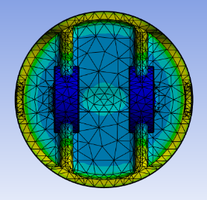
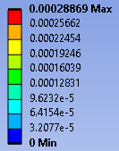
Figure 15 - Deformation on Stock Piston

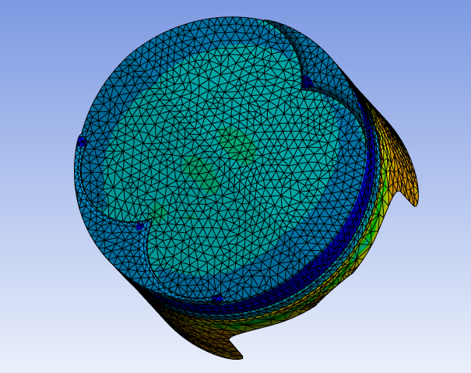
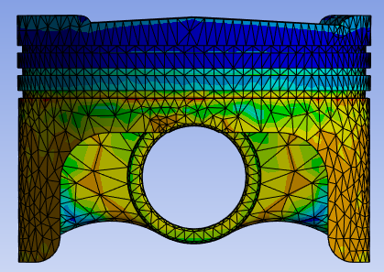
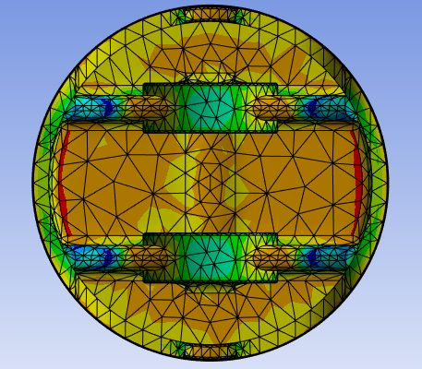
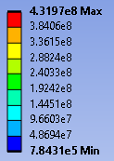
Figure 16 - Stress on Stock Piston

Validation

Computational
To validate the static structural study, another Dlubal case was used (Dlubal, 2016). This time a cantilever with uniform load was used as a piston head would receive a relatively uniform load.
A SolidWorks part was created for this case according to the specifications by Dlubal, shown below.
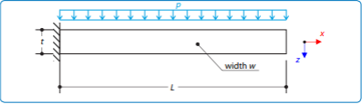
Figure 17 - Cantilever UDL Geometry Sketch (Dlubal, 2016)

Table 14 - Cantilever UDL Geometry Specification Table
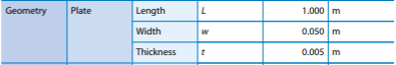

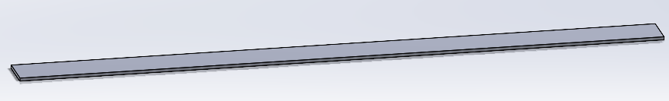
The part created is shown in Figure 18.
Figure 18 - Cantilever Part
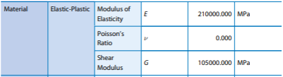
As with the thermal validation, the material for the cantilever beam also had to be built in Ansys, using values supplied by Dlubal (right). The geometry is then imported into the static structural solver in Ansys. The material is then set to elastic-plastic and the stiffness behaviour is checked to ensure the material is flexible. The part is then meshed with a 2.5mm mesh, shown below.
Table 15 - Elastic-Plastic Material Information (Dlubal, 2016)
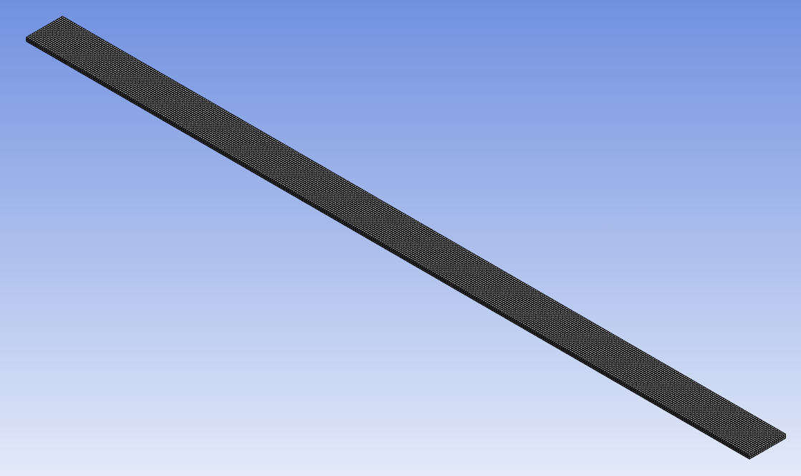
Setting the constraints and loadings are the next steps in the process. Figure 17 shows that the beam is fixed at one end, similar to the bi-metallic strip example shown earlier. A uniformly distributed load (UDL) is then applied to the part in accordance to Table 16.
Table 16 - Cantilever UDL Load (Dlubal, 2016)
Figure 19 - Cantilever UDL Mesh

Total deformation is then added to the solution output and the case is then solved, with the results presented below:

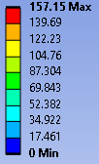
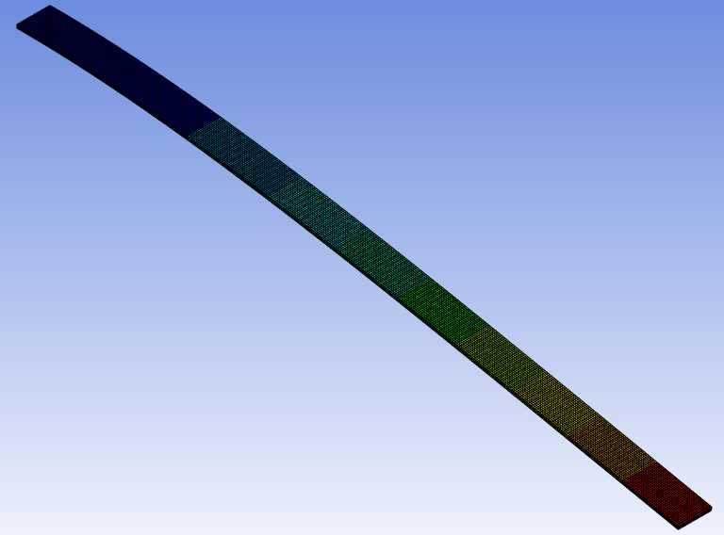
Figure 20 - Cantilever UDL Results

As shown, the maximum deflection is 157.15mm

Analytical Calculation
The Dlubal report then provides the following validation case, using Equations 3 through 6 to calculate the forces using analytical methods (Dlubal, 2016).
Equation 3 - Bending Moment (M)
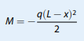
The Euler-Bernoulli theory is then used to recall the equation for beam deflection (Equation 4)
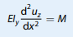
Equation 4 - Elementary Equation for Beam Deflection (Dlubal, 2016)
Following that, Equation 4 is then integrated twice, and the boundary conditions for a cantilever beam are applied, creating Equation 5
Equation 5 - Beam Deflection with Boundary Conditions Applied (Dlubal, 2016)
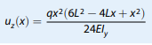
The equation is then modified for the maximum deflection (Equation 6)
Equation 6 - Maximum Beam Displacement (Dlubal, 2016)
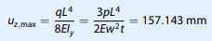

As shown above, Dlubal calculated the maximum beam deflection to be 157.43mm, a 0.28mm difference from the computational equivalent of the same beam. As a percentage, there is a negligible 0.17%, massively boosting confidence in the software.

Investigation

Change of Material
The first change investigated into the piston was a material change. A study conducted in 2023 compared a range of materials and found that out of the materials tested, Aluminium Alloy Al 6061–1.5% B₄C- 1.5% SiC MMC performed the best (Rashmita et al., 2023). The properties for this material can be found in Table 17 labelled “Material 1”
Table 17 - Al 6061 Material Properties (Rashmita et al., 2023)
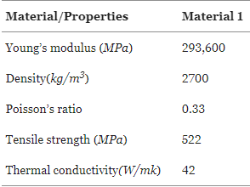
As this paper did not specify the coefficient of thermal expansion, an alternative with similar properties was searched for in Ansys Granta. The closest material found was the aluminium alloy 2618a, T6. This material was then imported into the engineering data tab in Ansys workbench and was ran through an identical FEA system as shown in Part 2 of this report.

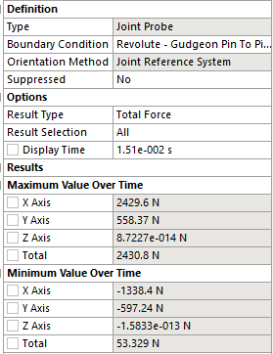
The Rigid dynamics results are shown on the left and are very similar to the stock result. This is because the material used for both are an Aluminium 2618 alloy, just treated in different ways. It is expected that all results should be very similar.
Table 18 - Material Study - Rigid Dynamics Result
The next page shows the results of the steady-state thermal solver, using the new material. It is assumed that the materials have the same thermal boundary conditions as the materials are so similar.

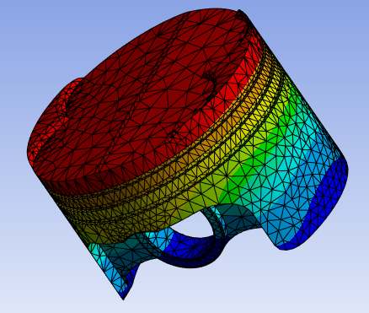
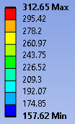
It is very clear to see that the thermal distribution is very similar to the original model used, despite the maximum temperature being slightly higher.
Figure 21 - Materials Study Thermal Result
Figure 22 - Materials Study Thermal Scale
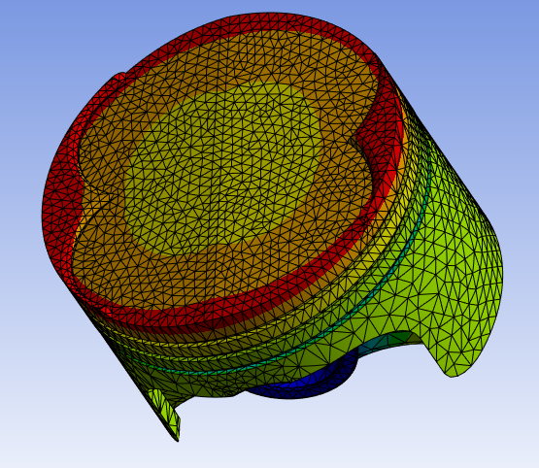
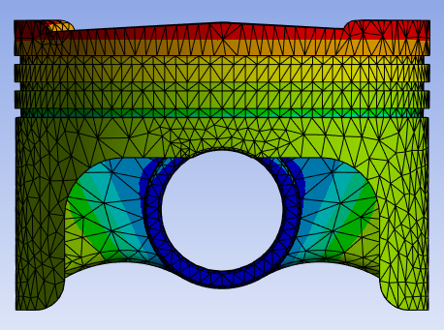
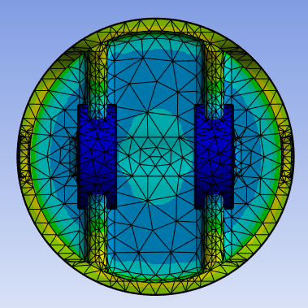
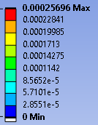
Figure 23 - Material Study Deformation Results

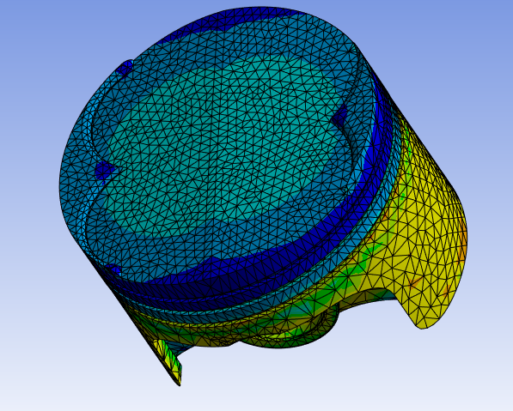
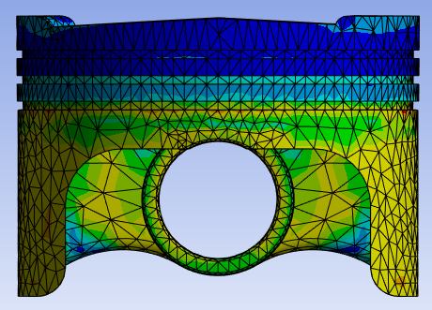
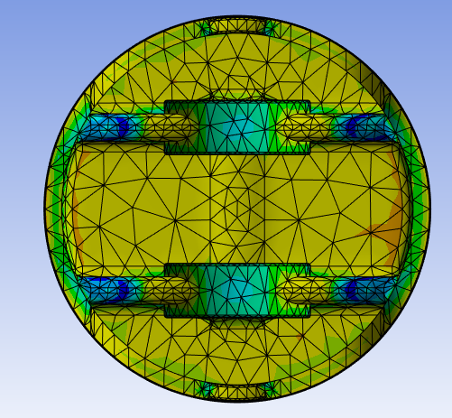
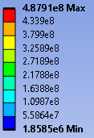
Figure 24 - Material Study Stress Results
The maximum deformation of the piston is shown in to be 0.257mm, which is 0.03173mm (10.99%) less than the original 0.2887mm; a much more rigid structure.
Looking at the stress values, the new material has a maximum stress of 487.91MPa compared to the 431.97MPa in the original material. That’s a 55.94MPa or an 11.49% increase in stress. What the new material loses in deformation, it gains in stress.

Piston Geometry Study
The other change investigated was the geometry of the piston itself. In an effort to reduce mass, the following material was removed from the piston:
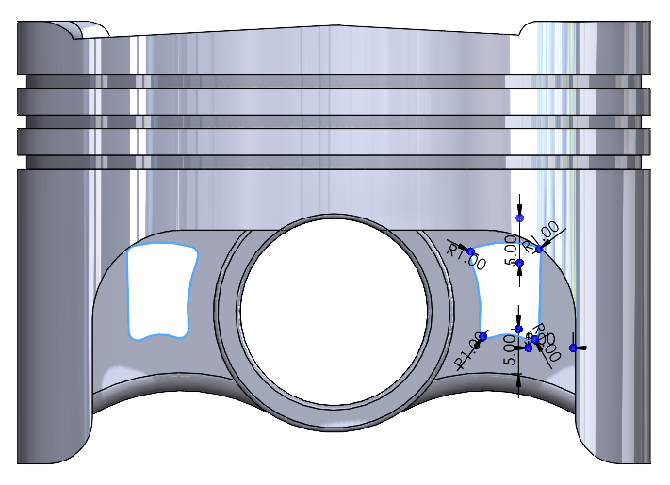
The philosophy behind the cut is that in a standard case, the lowest stresses are seen in the cut region. This does not line up with the results in this report as the gudgeon pin holes being set as fixed supports throws off both the deformation and stress values massively. Despite this, a realistic approach was taken to constructing a new piston geometry, which was then run through the FEA process, using the material used in the original study.
Figure 25 - New Piston Geometry
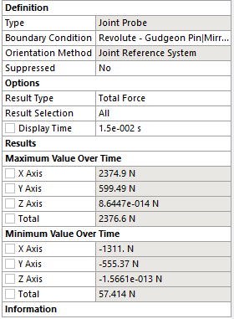
The rigid dynamics result can be seen on the left hand side. This time there is more of a difference between the stock and altered piston geometries. We see ~50N less maximum load in the x axis, and ~50N more on the y axis. This may be due to the reduction in mass changing the inertia of the piston itself.
Table 19 - Geometry Study - Rigid Dynamics Result
These new loads were exported and saved for to use in the static structural study. The results of both the thermal and static structural studies can be found below.

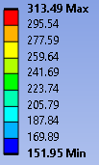
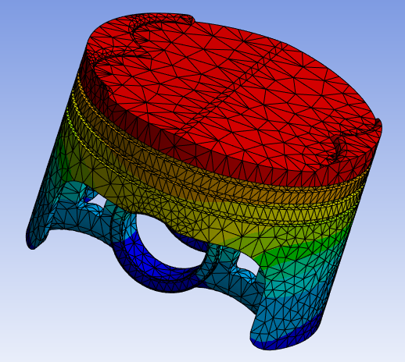
Despite there being less mass, the maximum temperature increases. This is because there is less area for the heat to spread through, so it is more highly concentrated.
Figure 26 - Geometry Study - Thermal Scale
Figure 27 - Geometry Study Thermal Result
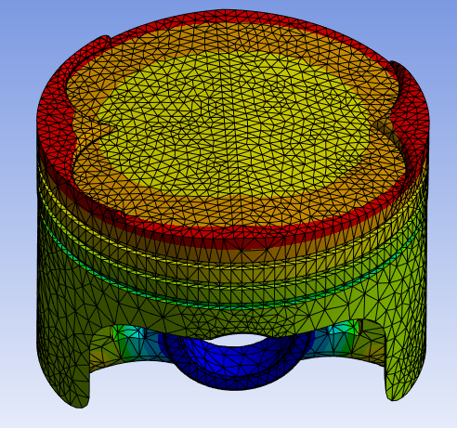
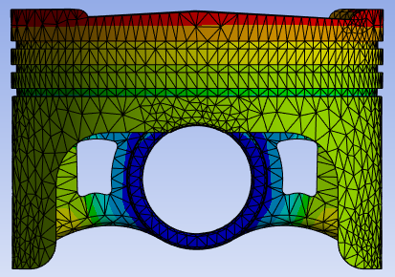
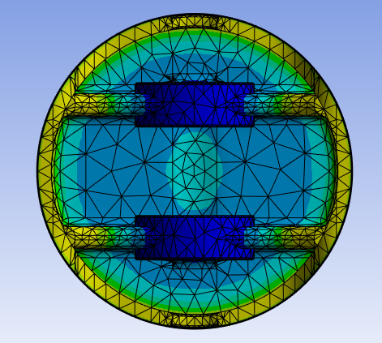
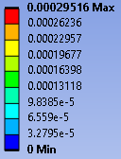
Figure 28 - Geometry Study Deformation Results
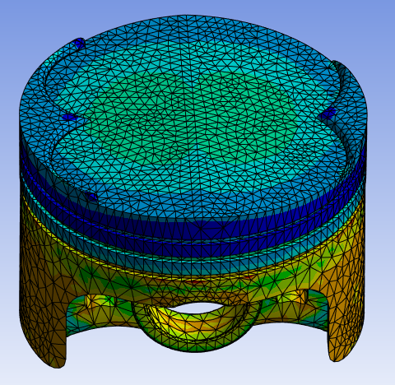
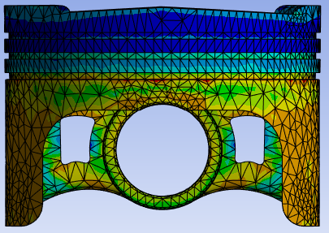
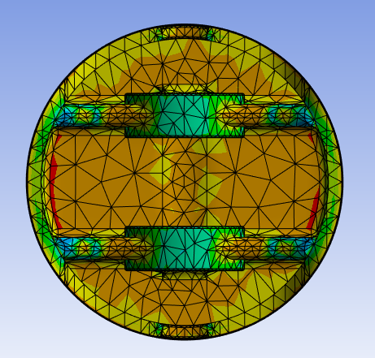
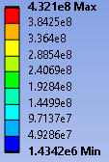
Figure 29 - Geometry Study Stress Results

Comparing the maximum values for deformation (0.2951mm) and stress (432.1MPa) to the stock piston design, there is a gain of 0.64mm of deformation (2.2% gain) and also a gain of 0.13MPa (0.03%) in stress.

Combined Geometry and Material
The following results are from a study combining both the new aluminium 2618a T6 alloy and the new geometry.

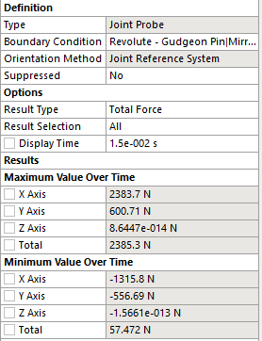
Table 20 - Combined Study Rigid Dynamics Result
As seen previously, the forces in the x axis are shown to decrease, whilst forces in the y axis increase, in line with the previous results, however the total load decreases by 60N.
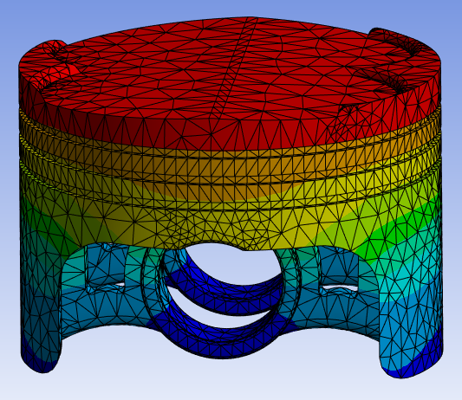
Figure 30 - Combined Study Thermal Results
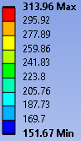

Figure 31 - Combined Study Thermal Scale

The temperature is shown to have increased by 3.89°C (1.25%) from the original stock model.

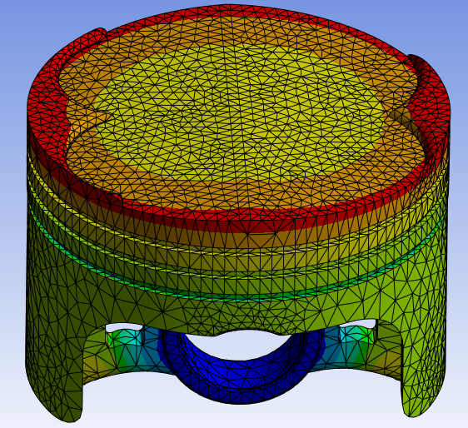
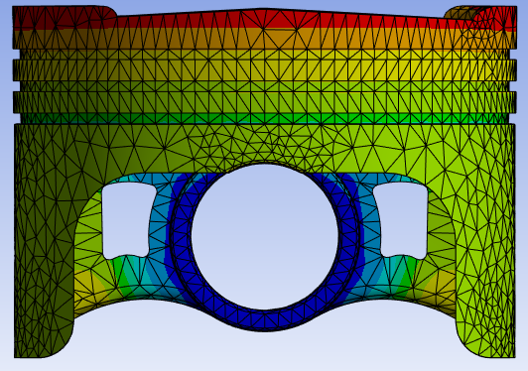
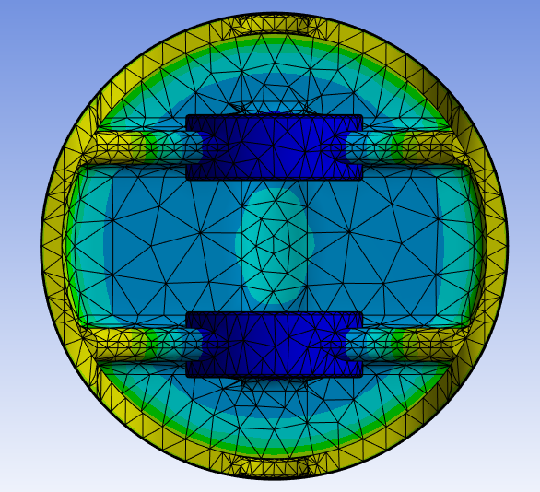
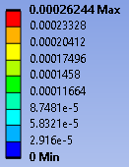
Figure 32 - Combined Study Deformation Results

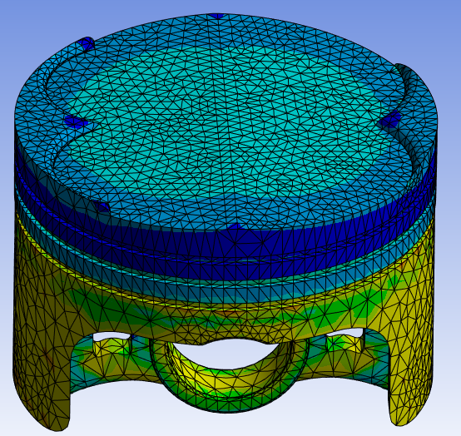
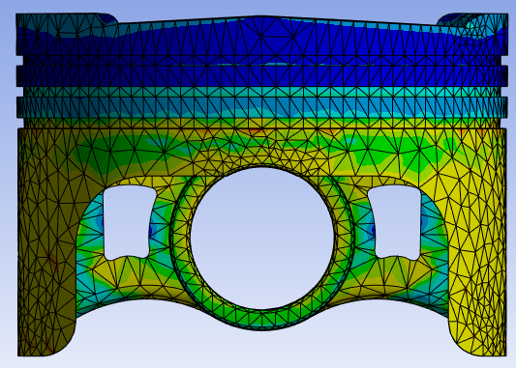
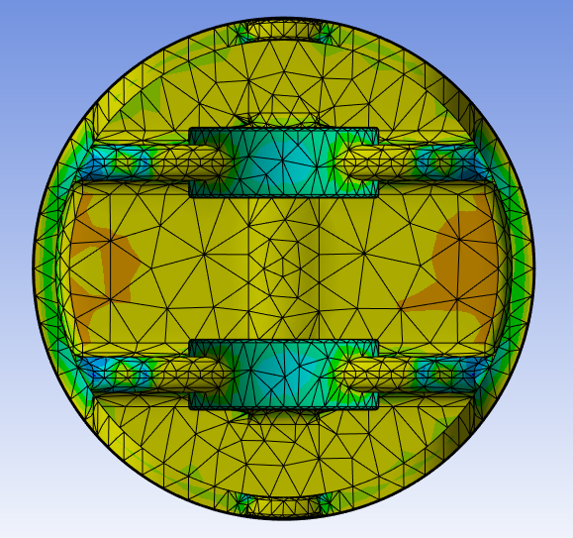
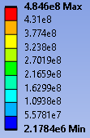
Figure 33 - Combined Study Stress Results
After the final study, we see the deformation decrease by 9.09%, from 0.29mm to 0.26. This comes at the cost of additional stresses, an increase of 12% (52.63MPa).

Conclusion
To conclude this report, it’s clear that a change in material and a change in geometry has an effect on the structural properties of the piston. It is unfortunate that due to limitations, and not being able to find another solution, the gudgeon pin hole had to be a fixed support. This has massively influenced all results, and caused huge inaccuracies. Despite this, the software has been validated and confidence in the software has been gained, however user error has rendered the study near useless.

Reference List
Acosta, G. (2020, June 11). Unique Slugs: MAHLE Motorsports Ramps Up Its Custom Piston Program. EngineLabs. https://www.enginelabs.com/news/unique-slugs-mahle-motorsports-ramps-up-its-custom-piston-program/
Dlubal. (2016). Verification Example - 0016.
Dlubal. (2018). Verification Example - 0078.
MAHLE International GmbH. (2016). Pistons and Engine Testing (2nd ed.). Springer.
Noble, A. (2024a). 6 - Fully Linked Systems. University of Wales Trinity Saint David.
Noble, A. (2024b). Crankshaft Assembly. University of Wales Trinity Saint David.
Noble, A. (2024c). Piston Thermal Study Data.
Rashmita, Singh, S., Kumari, A., & Aggarwal, S. (2023). Optimization of piston material with aluminium alloy based metal matrix composites. Materials Today: Proceedings, 103, 366–373. https://doi.org/10.1016/j.matpr.2023.09.019

